Alpha Generation Report

# Price Predictions

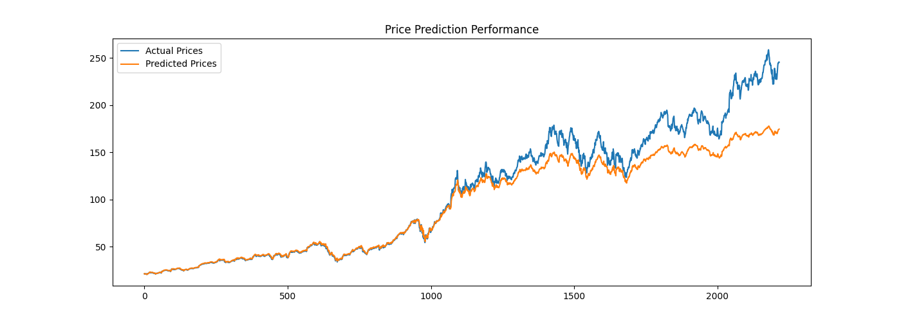

# Feature Importance

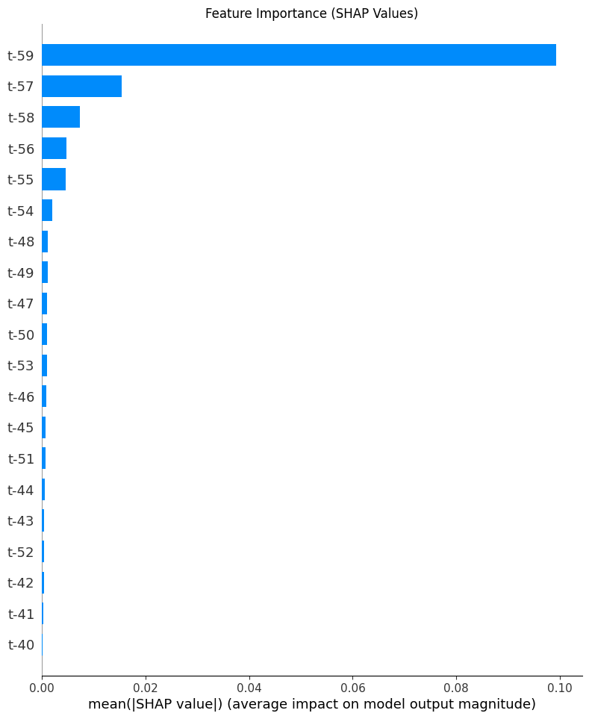

# Risk Metrics

|  |  |  |
| --- | --- | --- |
| 95% VaR: -0.0270 | 95% CVaR: -0.0409 | Max Drawdown: -0.3852 |

# Trading Performance

Initial Capital: $100,000.00

Final Value: $91,513.67