**AWS Final Documentation 2**

**Initialize terraform and provider**

**Terraform init :**

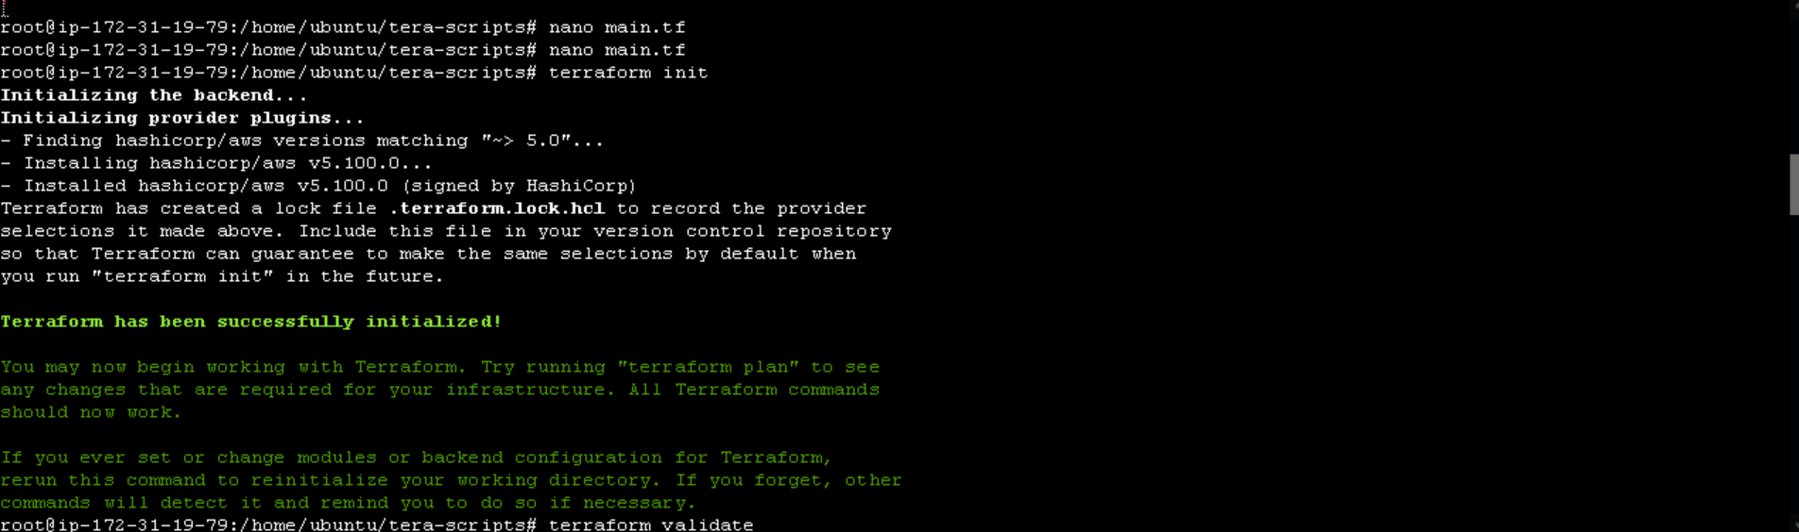

**Terraform validate**



**Aws configure for terraform**

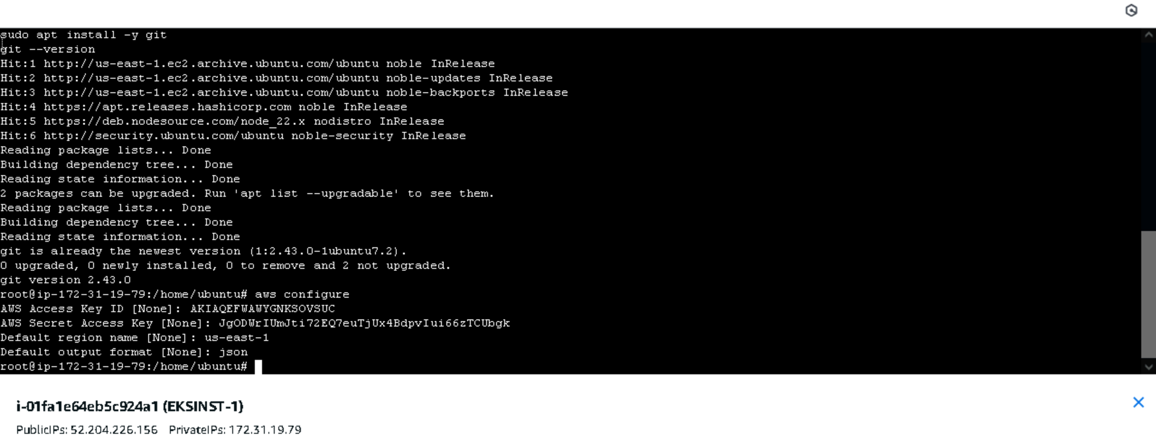

**Storing all the terraform scripts in aws codecommit**

**Creating a repo in aws code commit to store all terraform scripts**

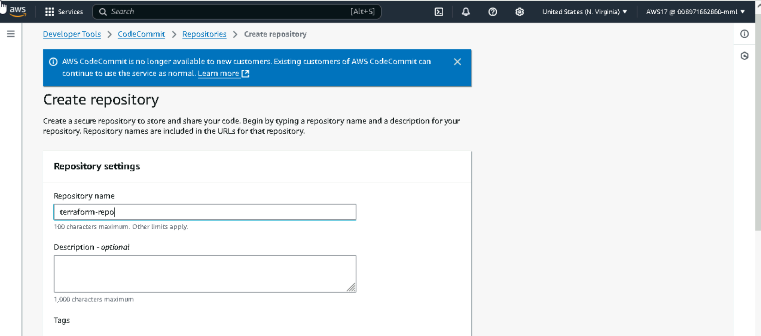

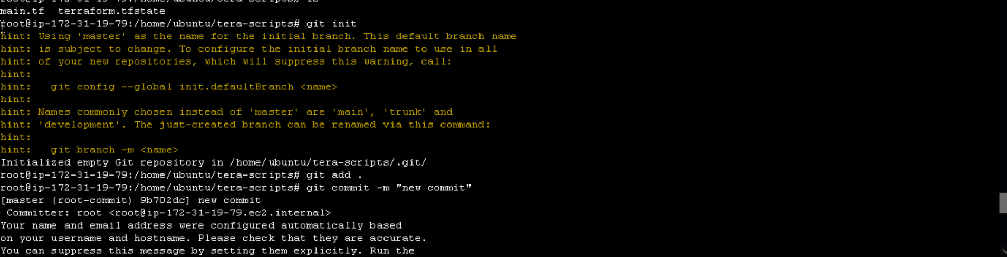

**Pushed terraform sricpts to codecommit**

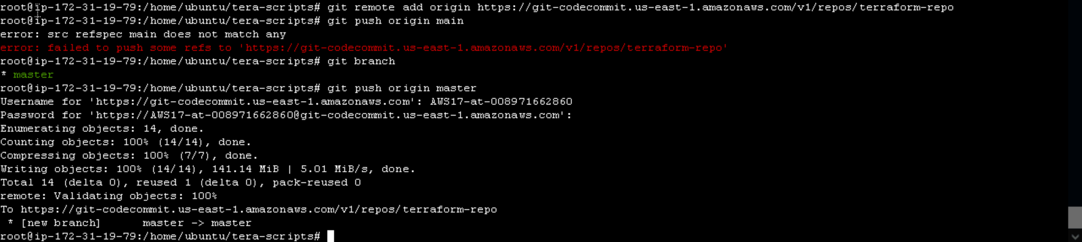

**Scripts have been added to codecommit**

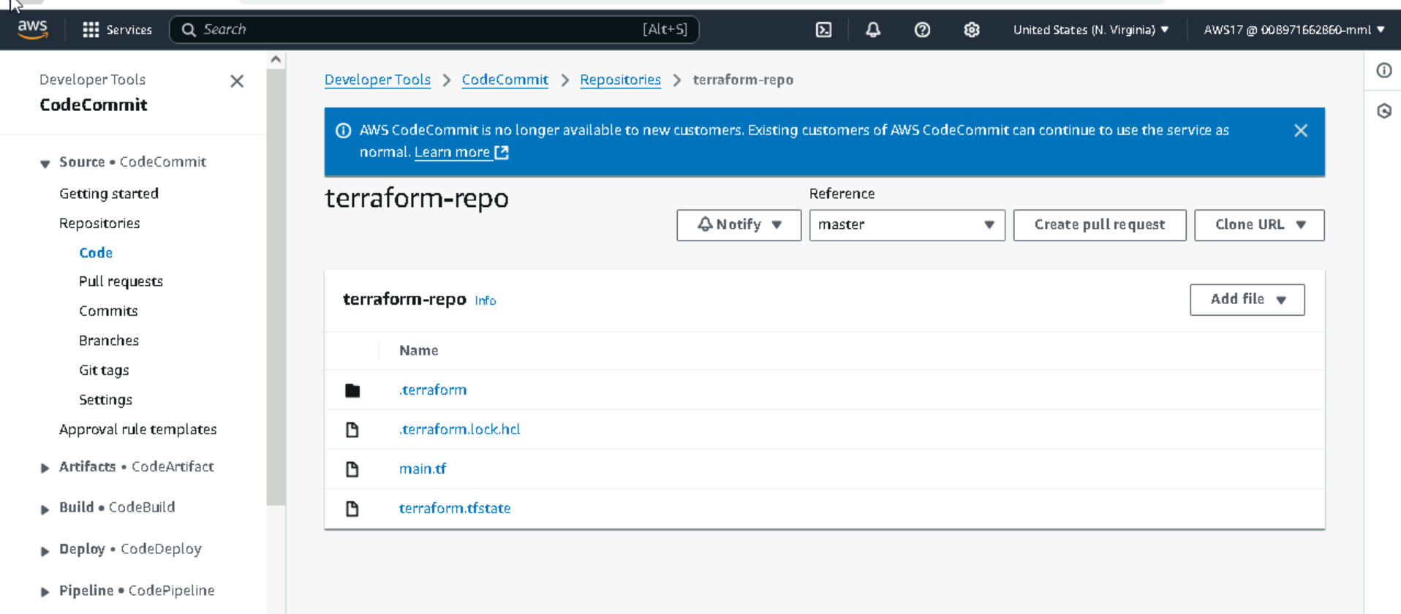

**Creating code pipeline with using Codecomit and Codebuild**

**Creating Pipeline**

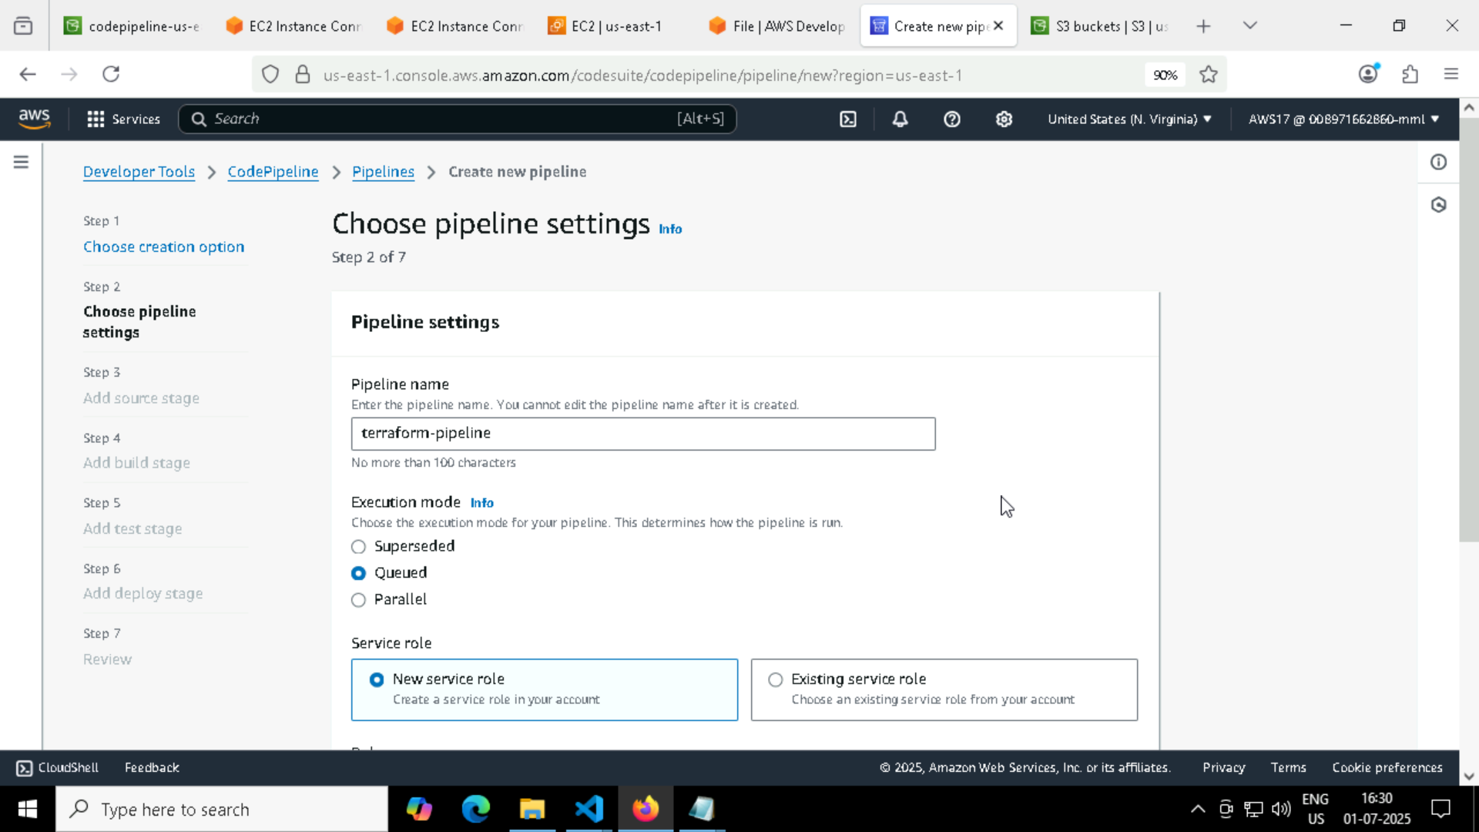

**Using Codecommit as the source in the pipeline**

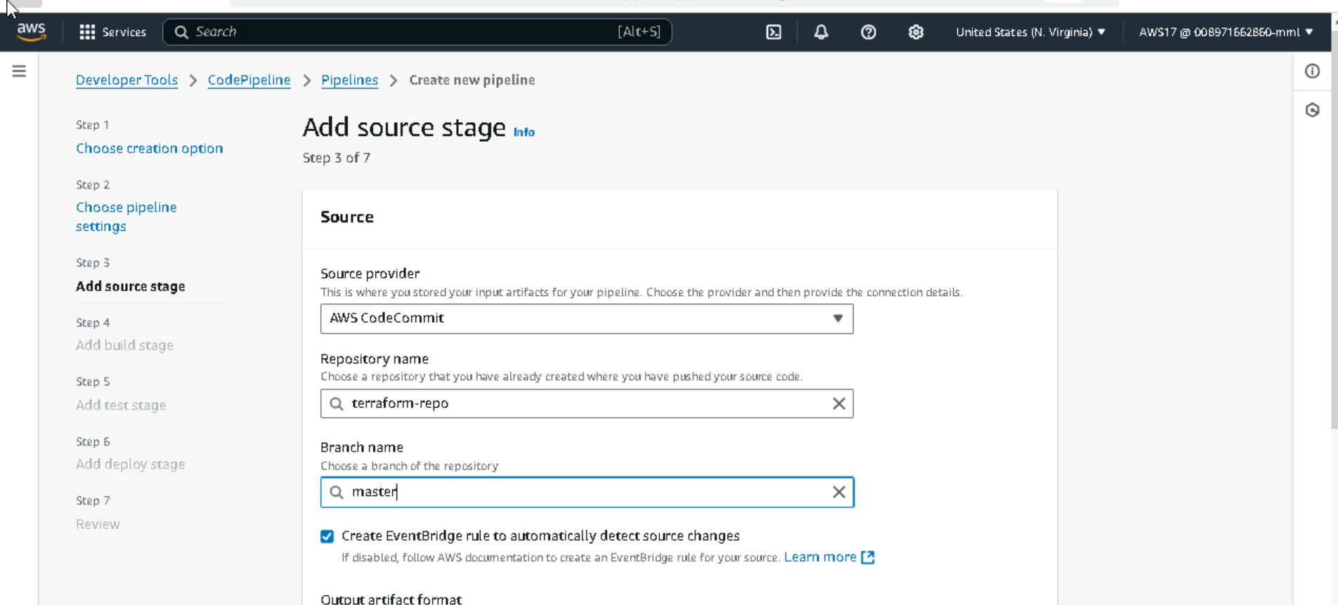

**Creating a build for terraform:**

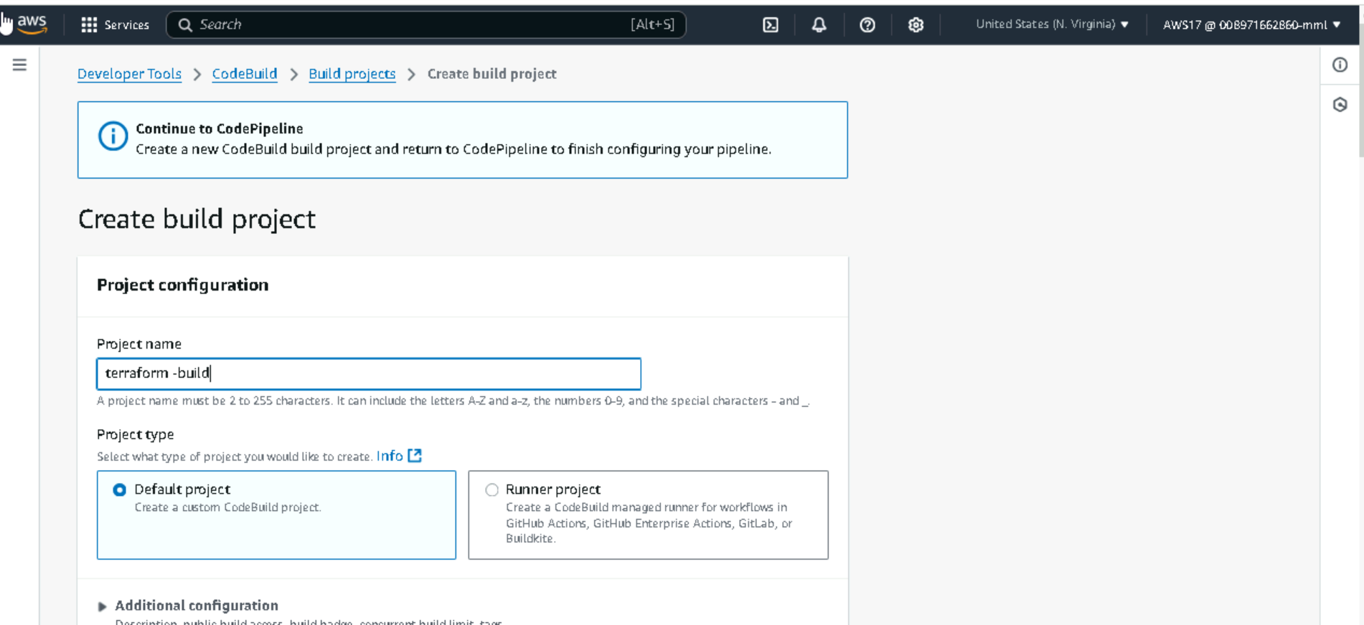

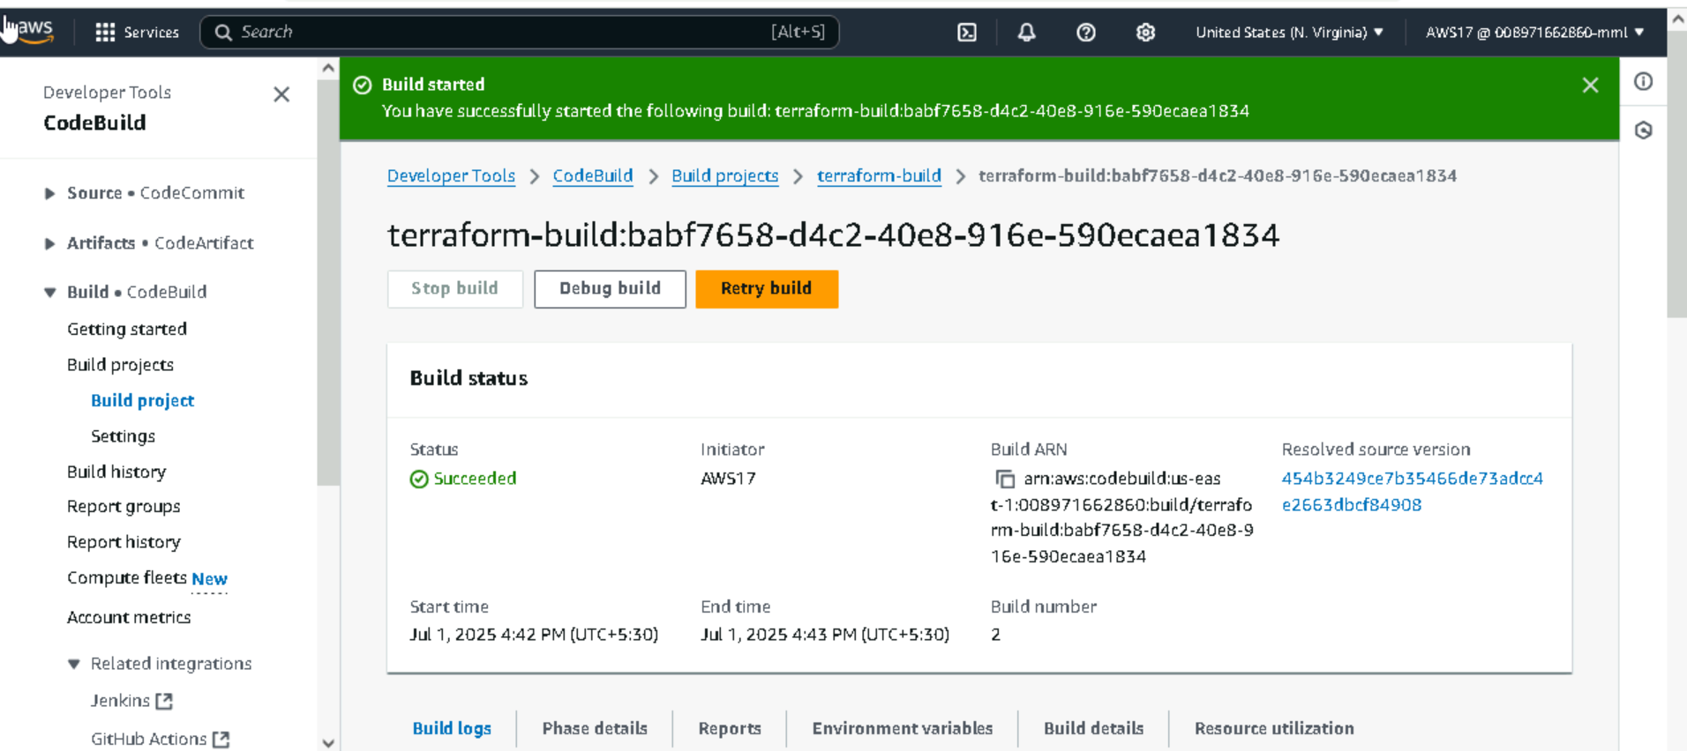

**Codepipeline for terraform scripts**

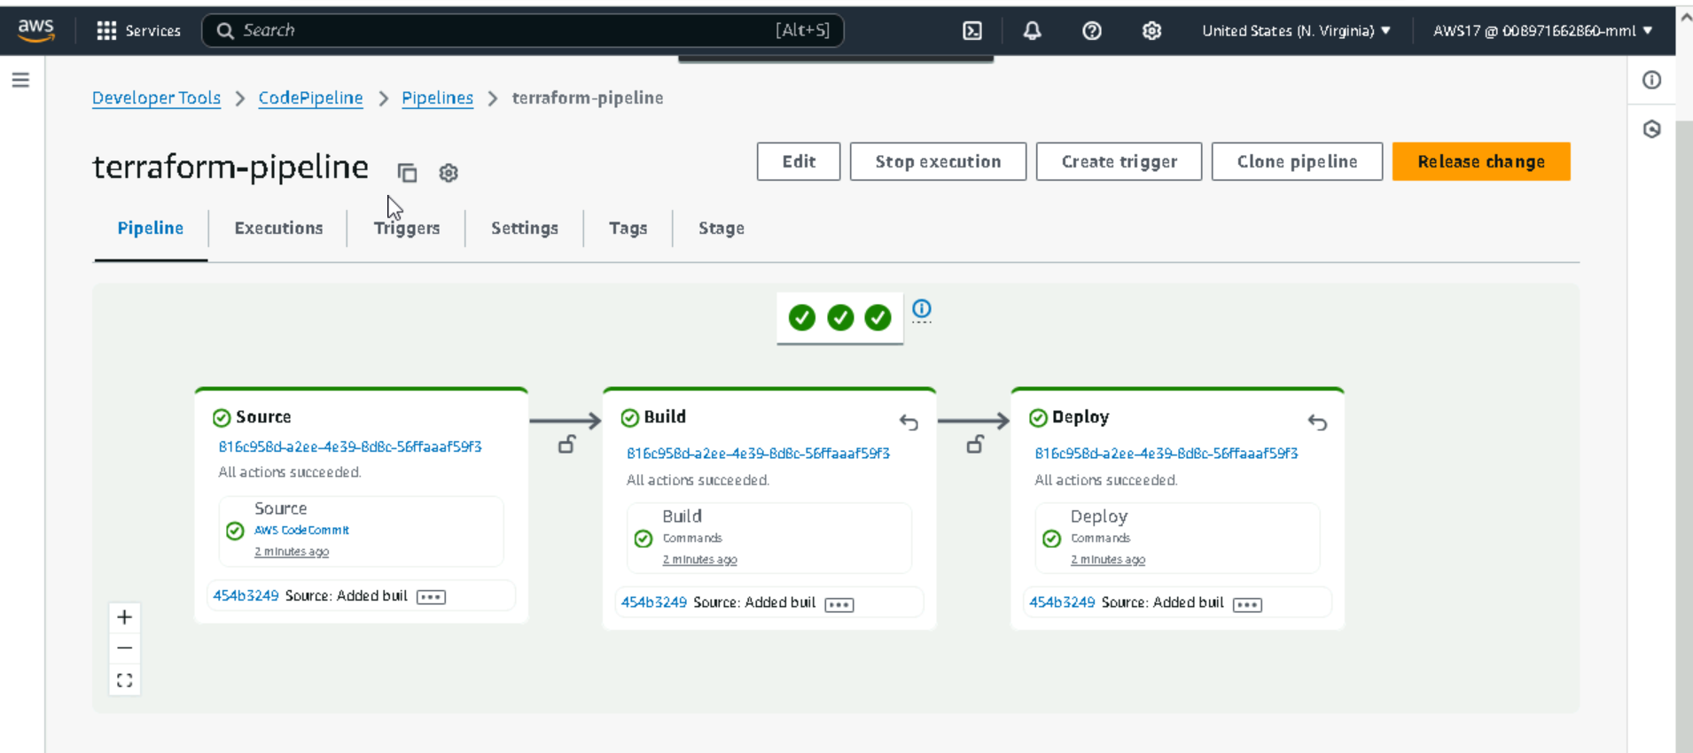

**Create an s3 bucket with storage folder**

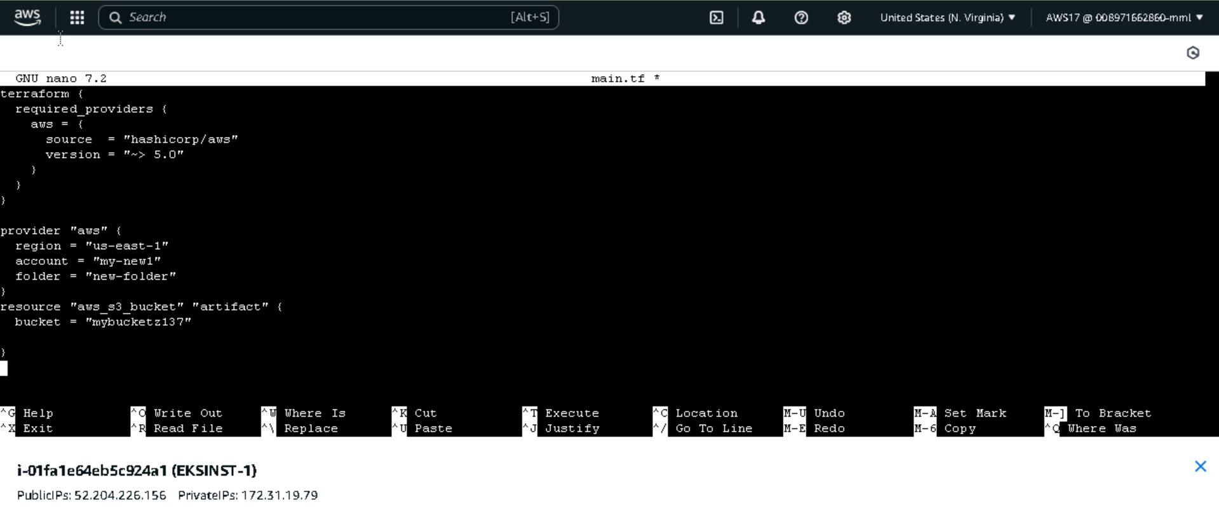



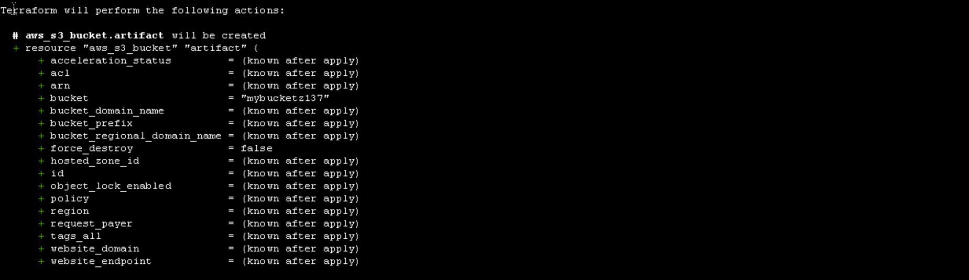

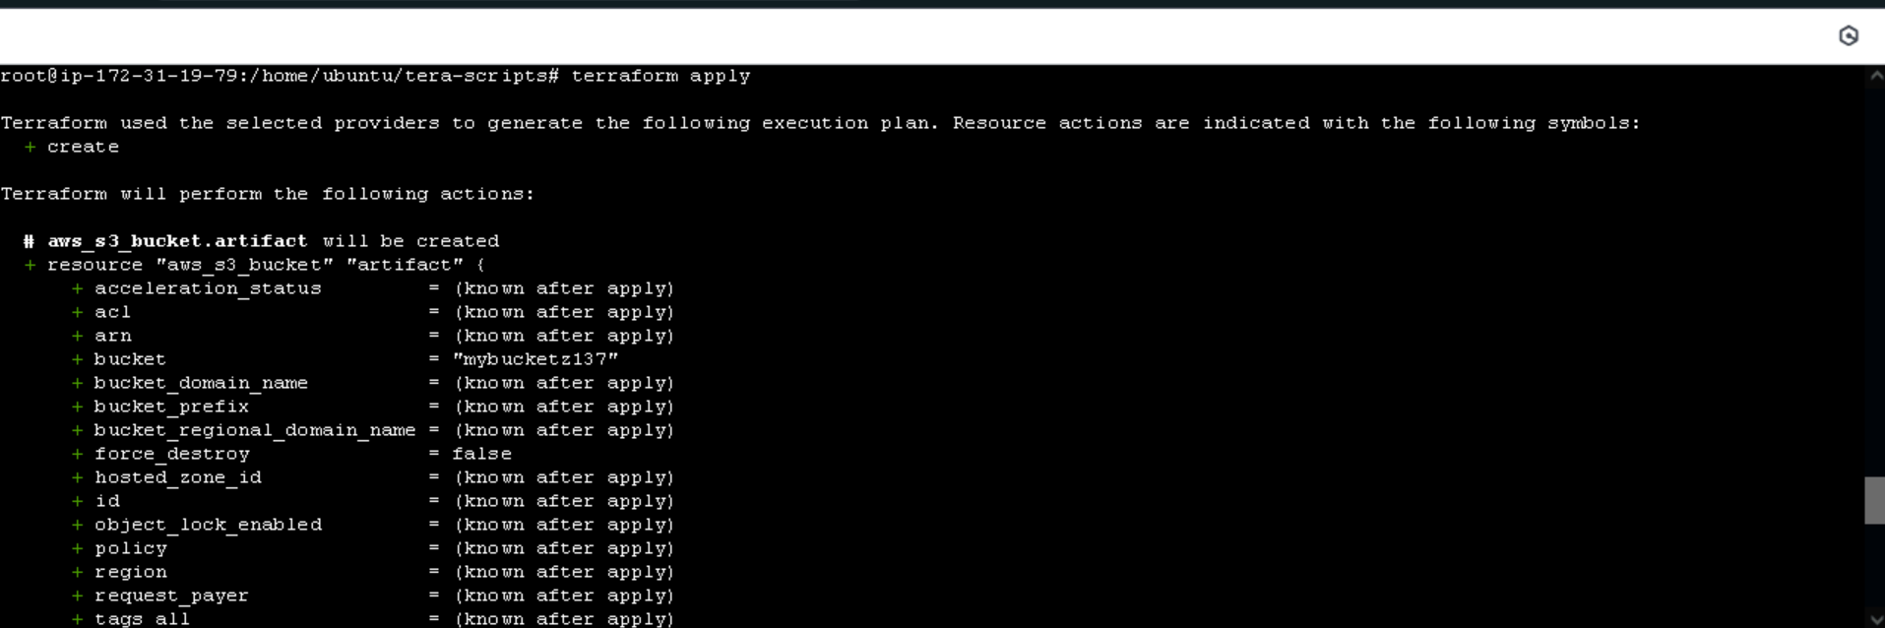

**Bucket created**

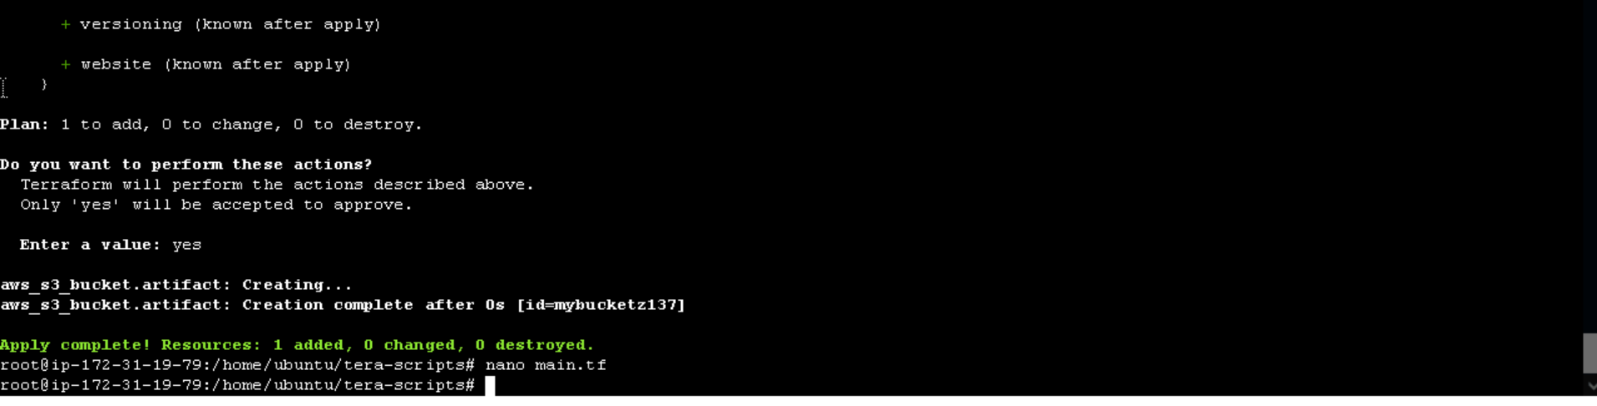

**Verifying s3 bucket creation through aws console**

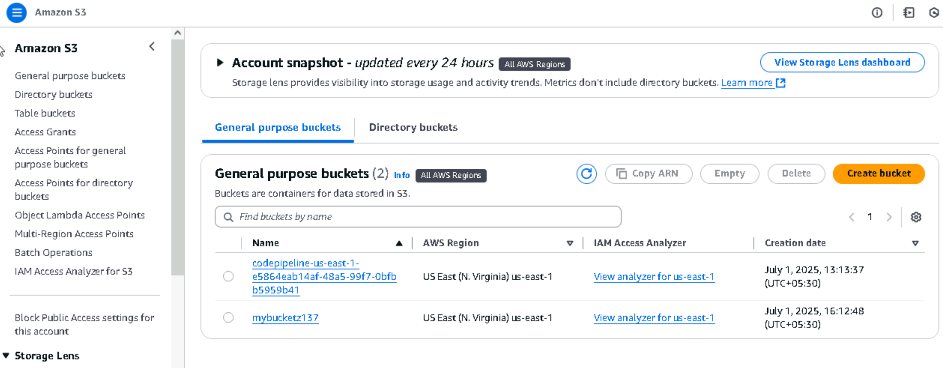

**Upload a sample Blob:**

**Create a simple text file in some working directory**

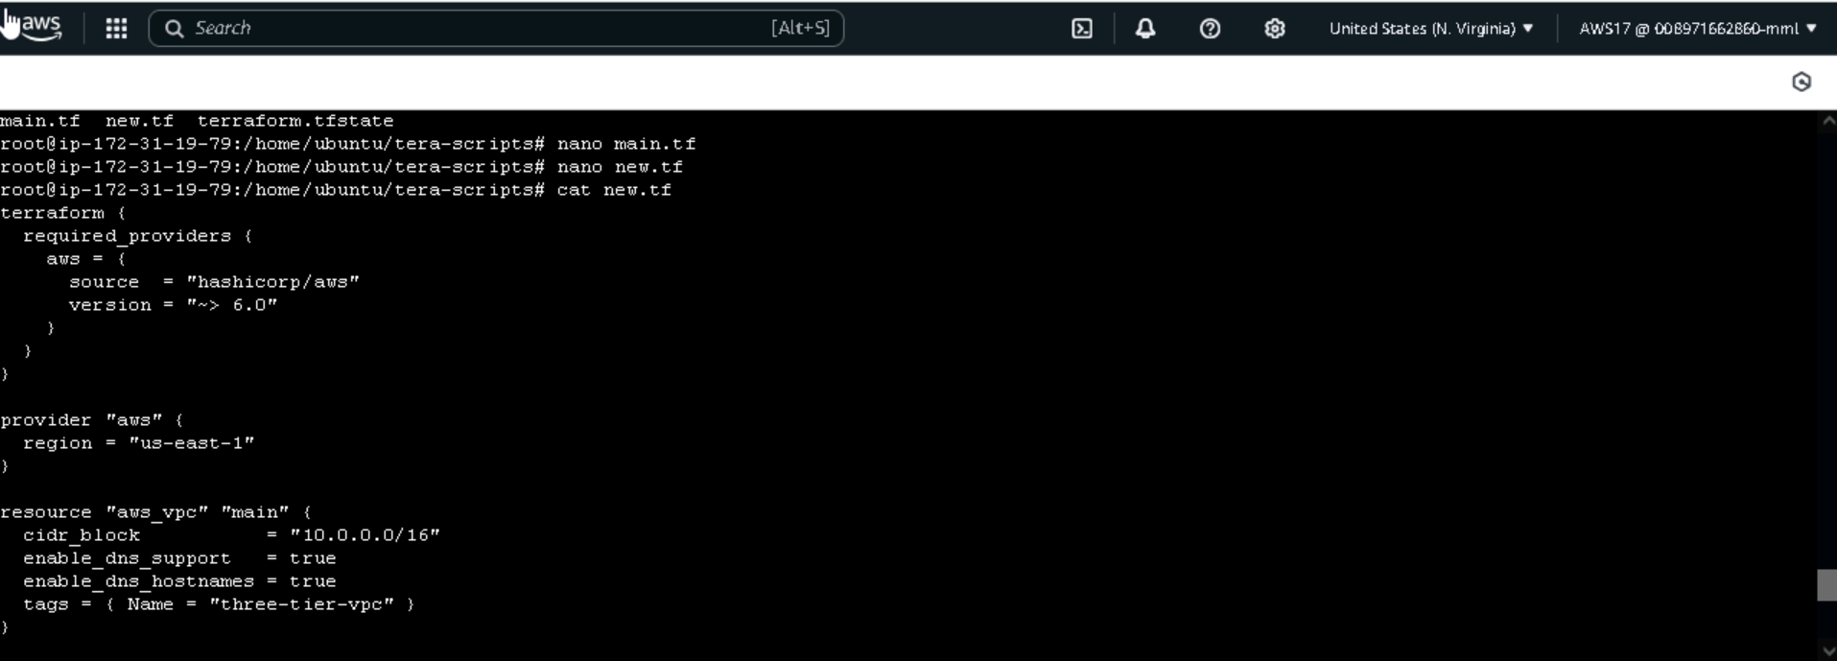

**Creating a vpc with two subnets**

**Uploading this file into s3 bucket**

**File is being uploaded into out s3 bucket**

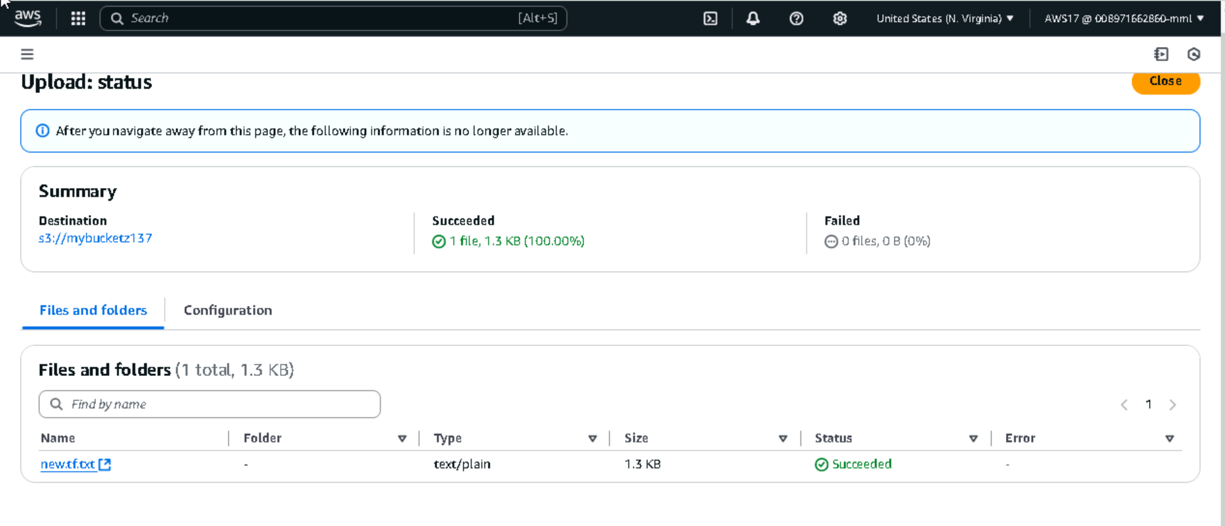

**Deploy and verification:**

