**Ansible Document**

Create the Project Structure

-Create an inventory file listing all the target machines.

- Structure the project using role (e.g., Apache, MySQL, PHP, Firewall) for modular configuration.

- Define a main playbook (site.yml) to orchestrate the setup.

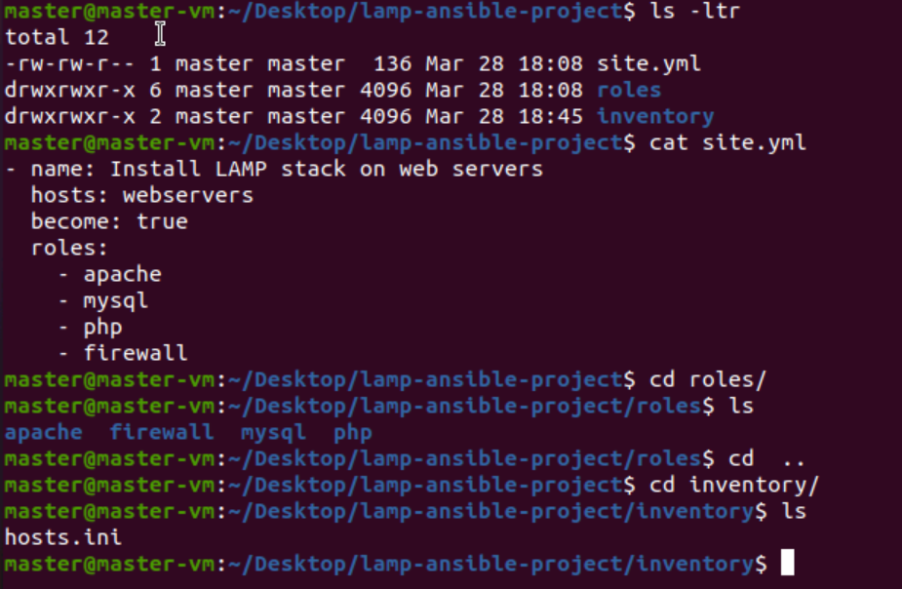

Organize the Project Structure

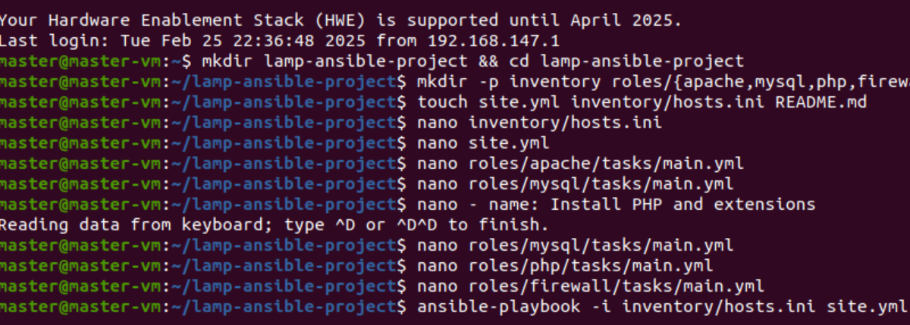

Apache file :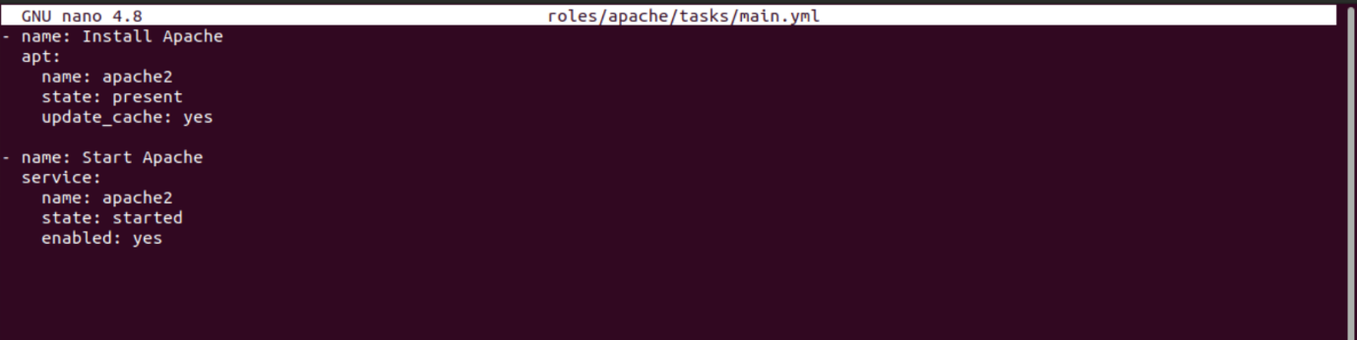

mysql file:-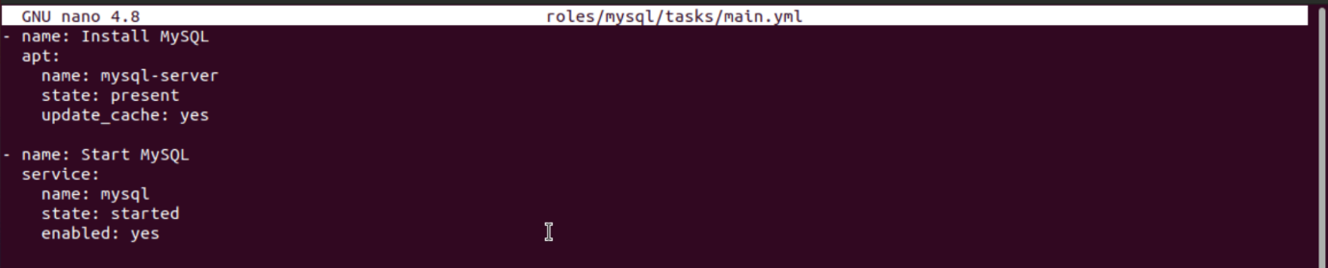

Php file :-

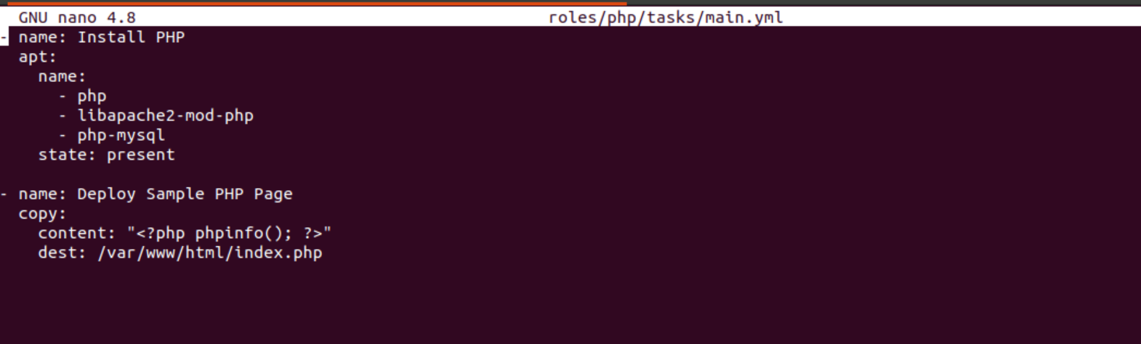

Firewall File: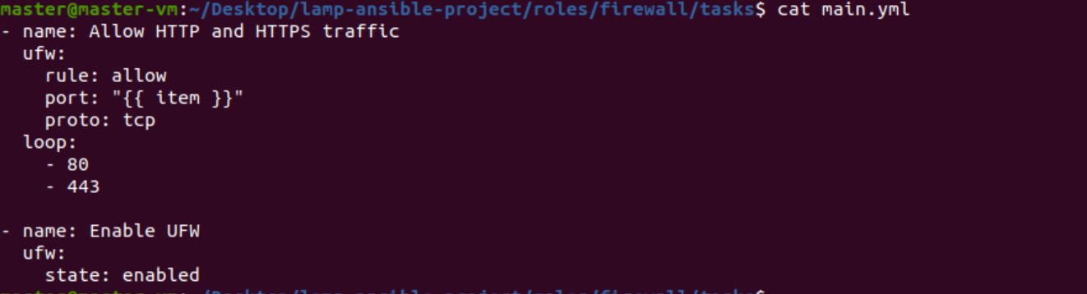

OUTPUT:-

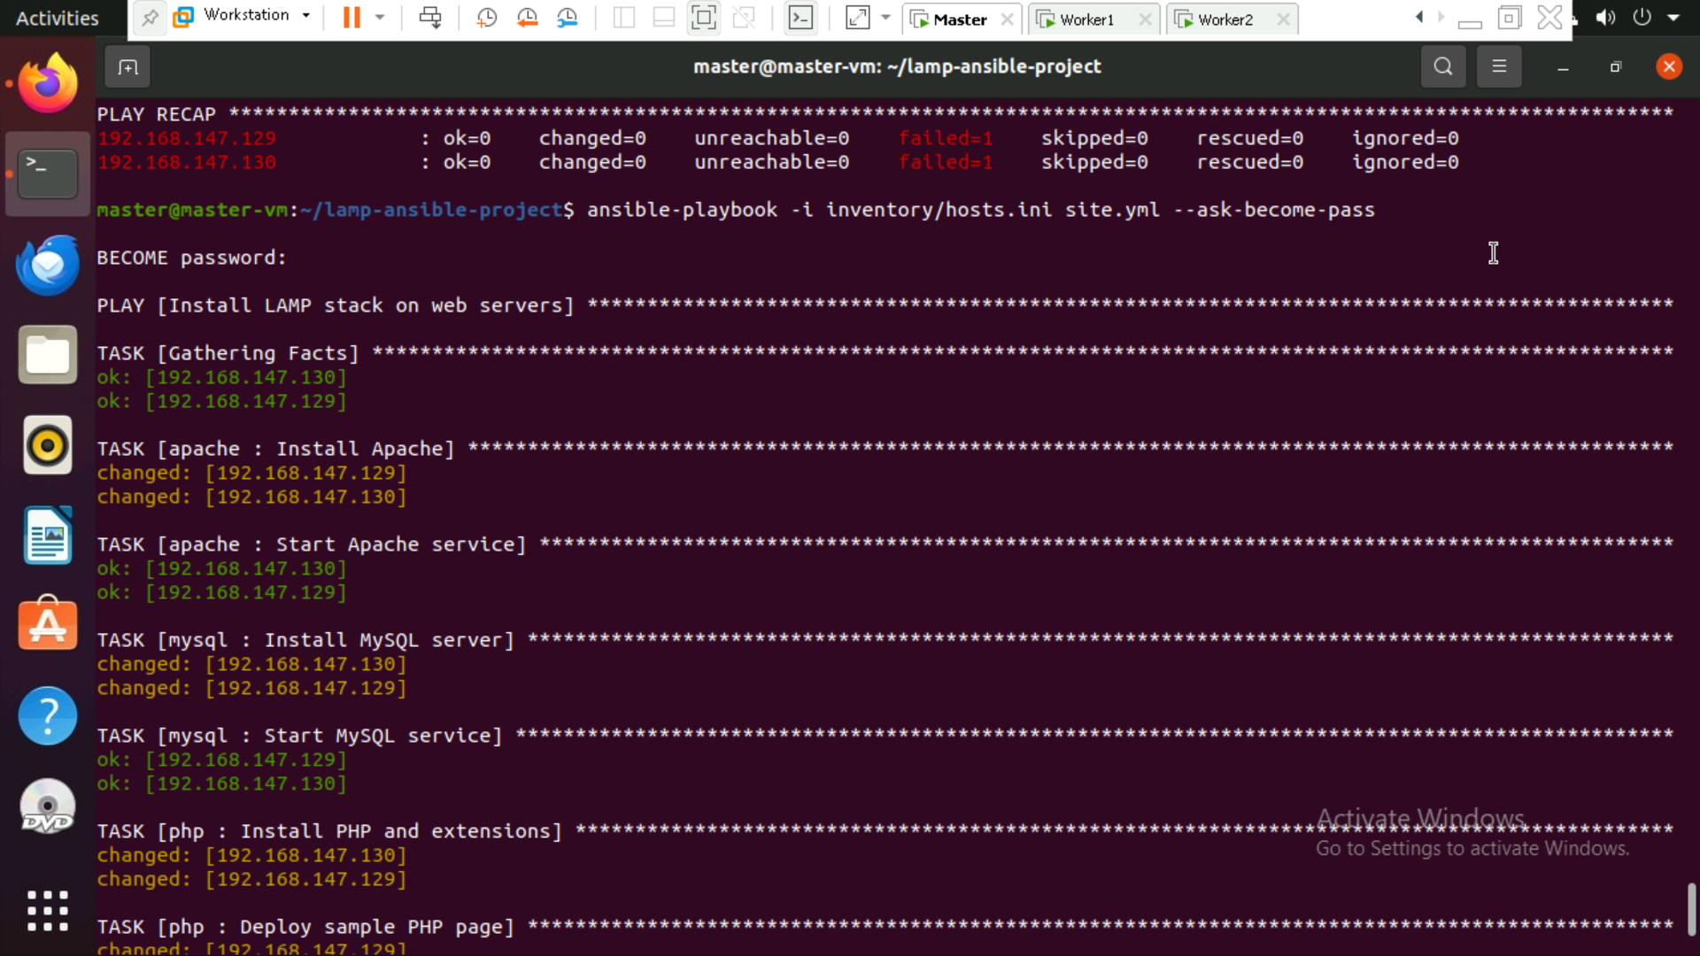

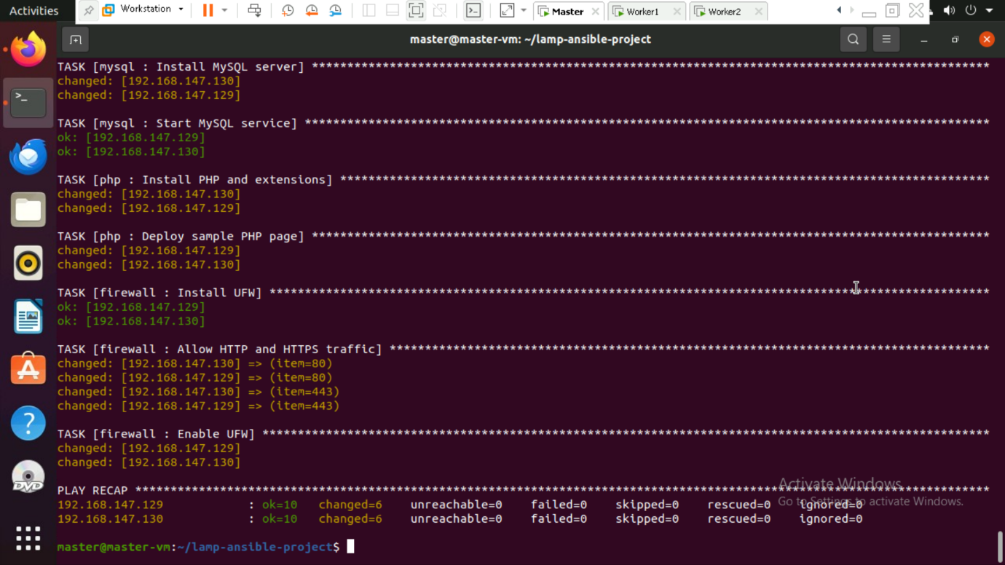

Output:



