**Q1 -CICD DOCUMENT**

**Repository creation:**

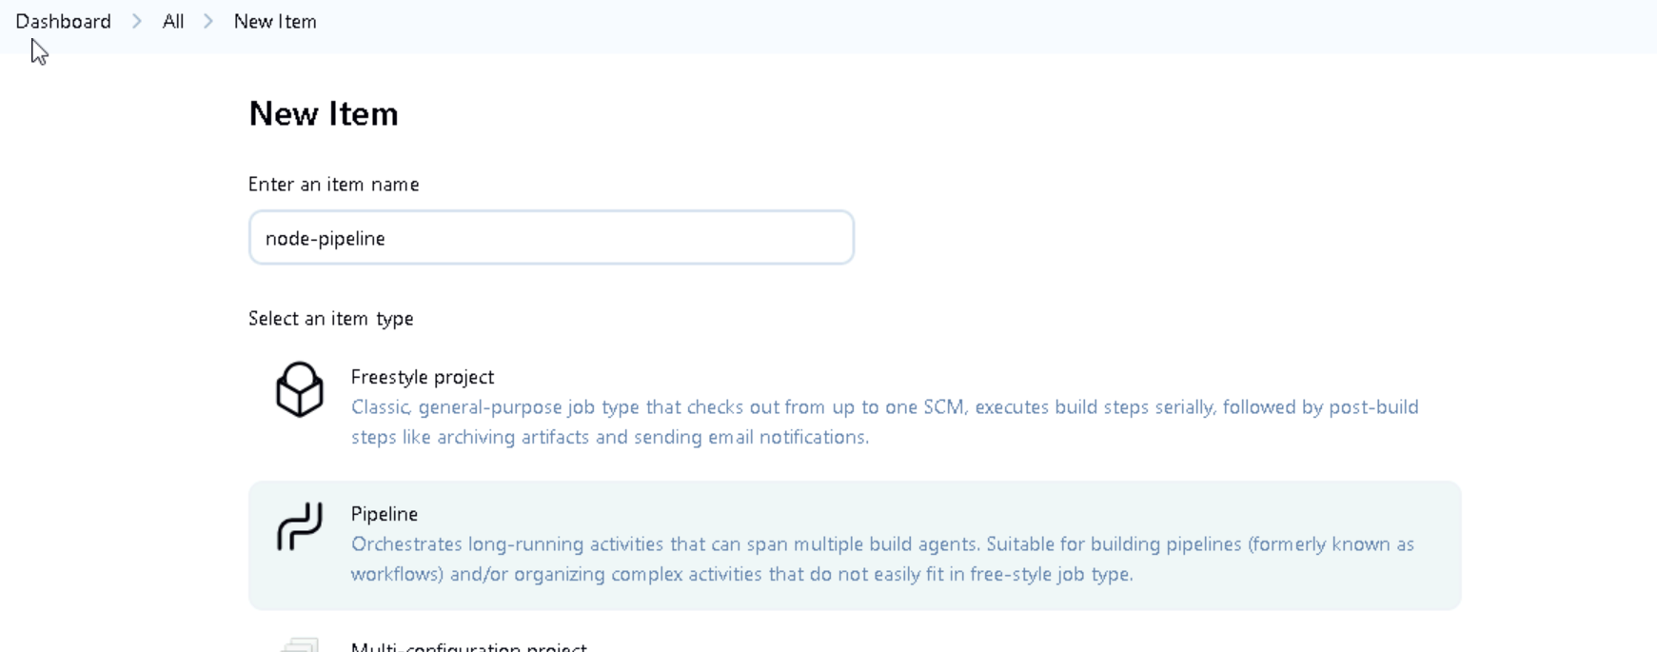



**Building docker image**

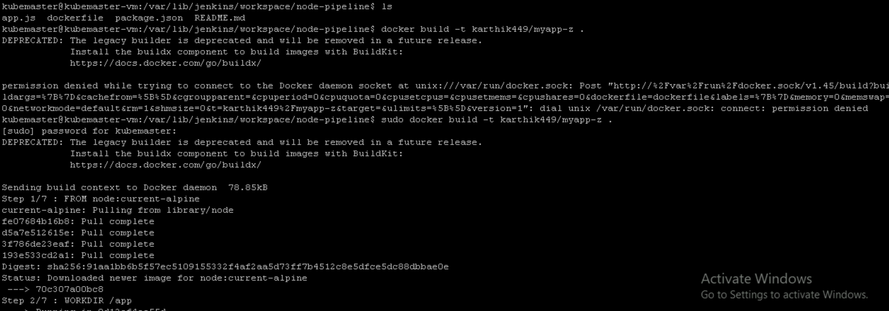

**Creating deployments and service :**

**Deployment.yaml file**

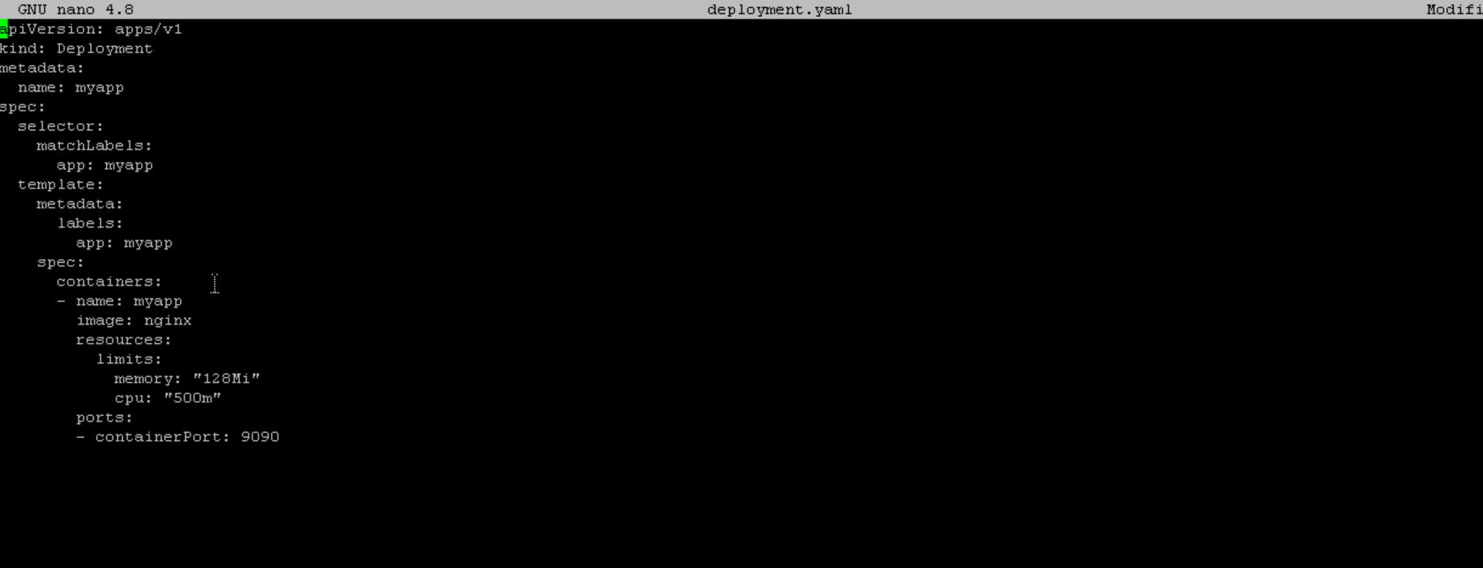

**Service.yaml**

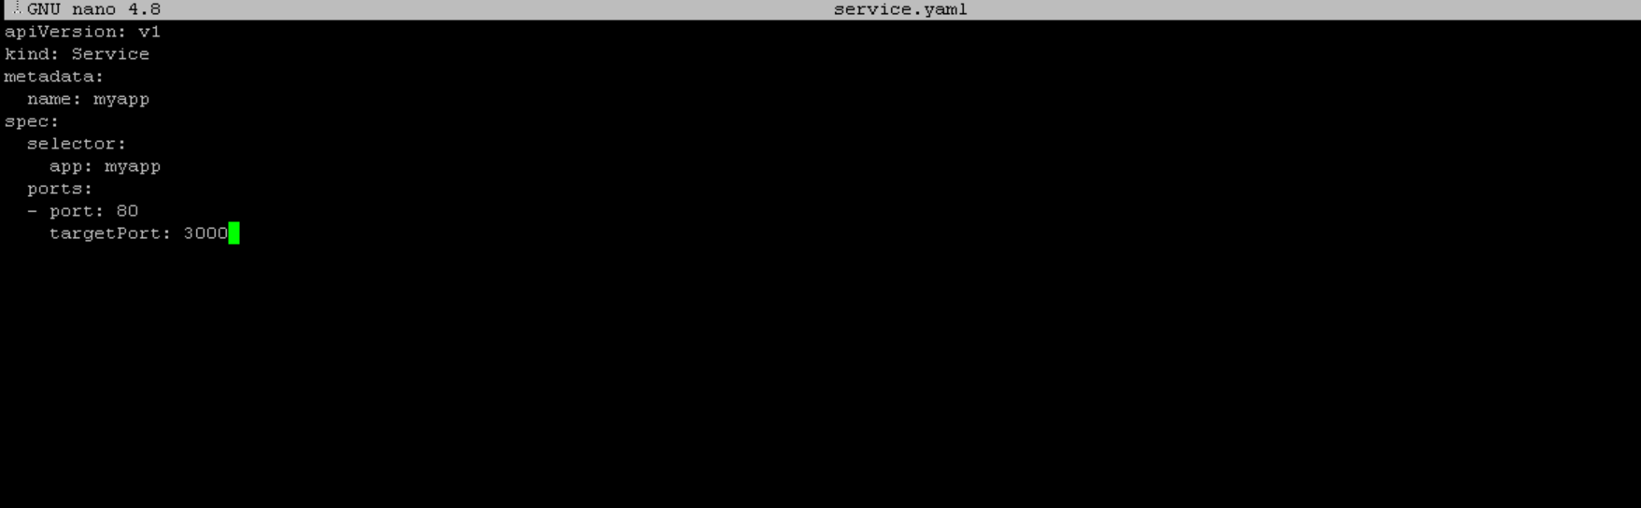

**Jenkins pipeline**

**Build and Test stage:**

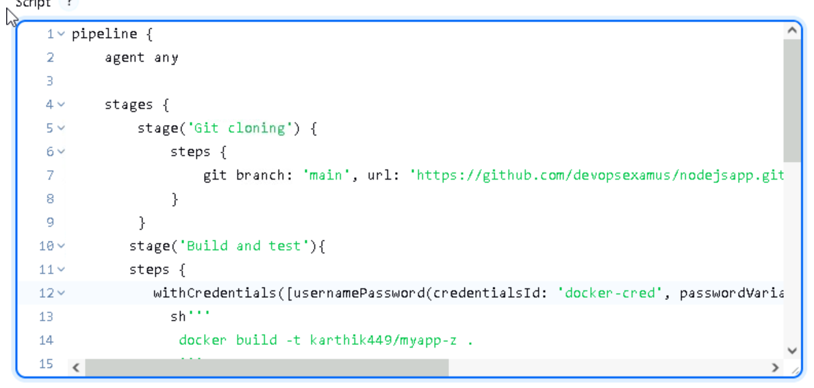

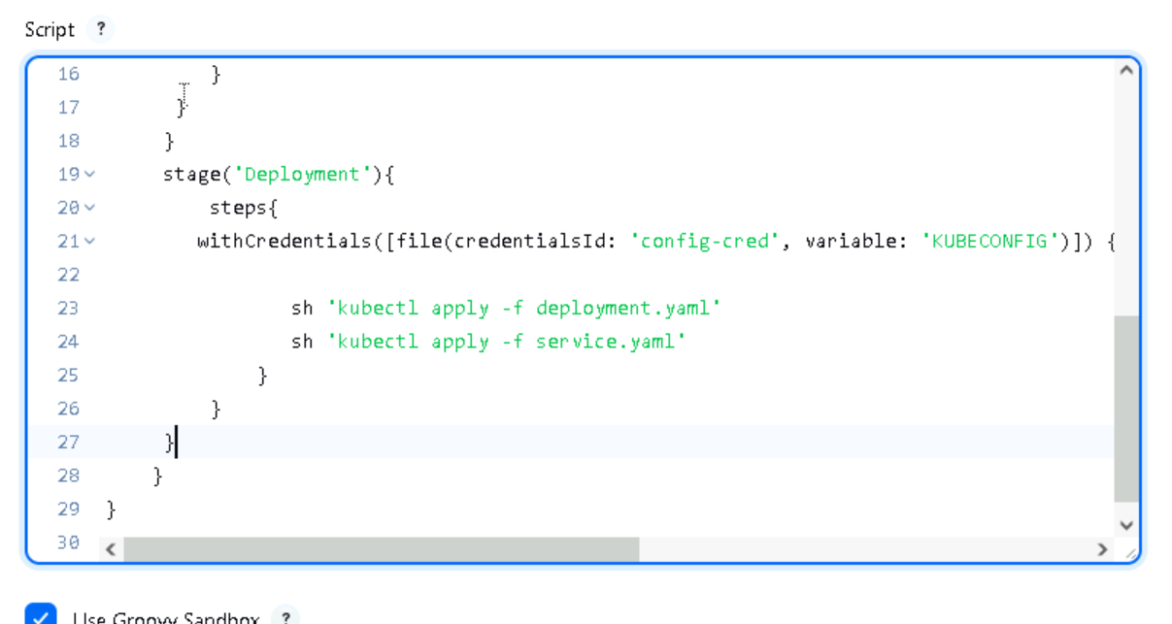

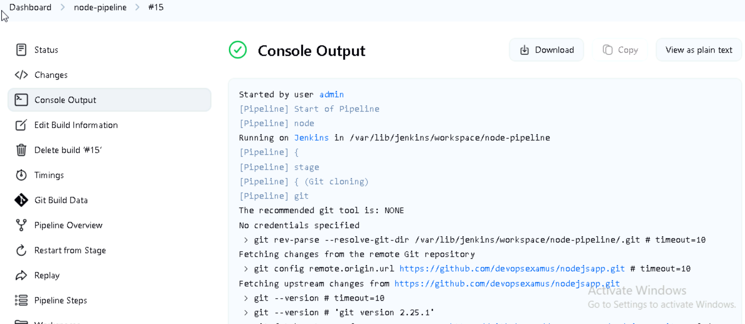

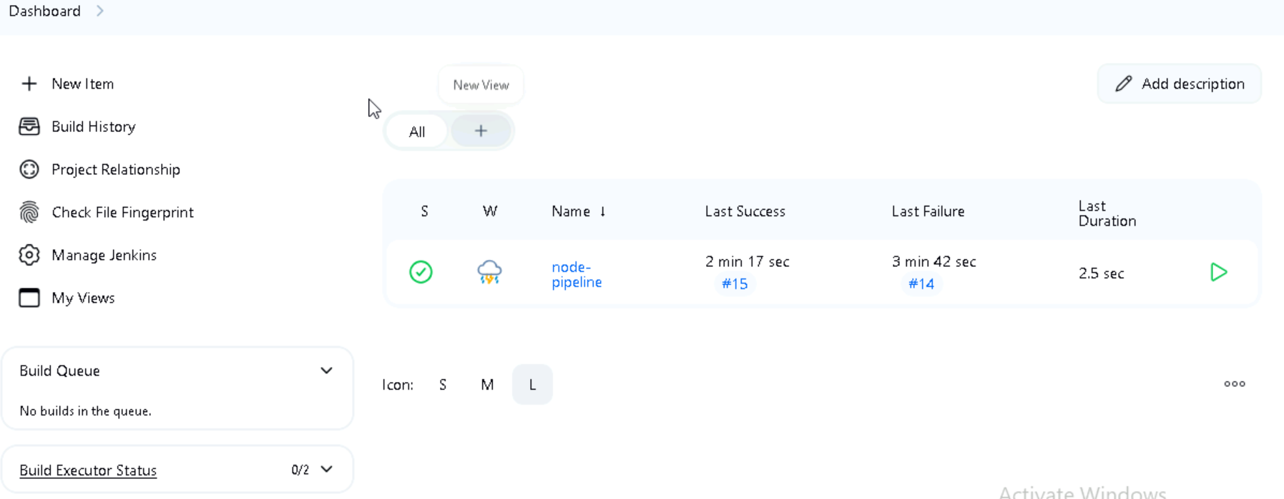

**Verifying service and deployment**

