**ANSIBLE DOCUMENT**

**My ansible inventory file:**

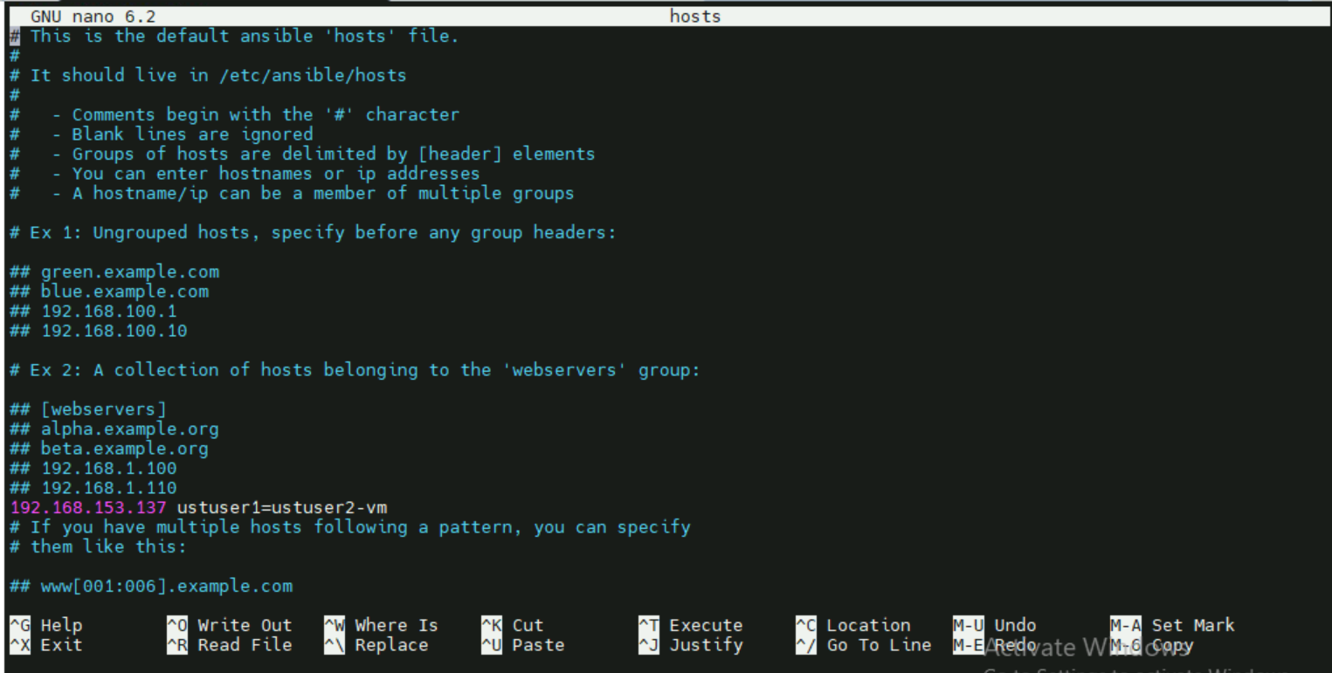

**My playbook file**

**Creating multiple users with password less authentication**

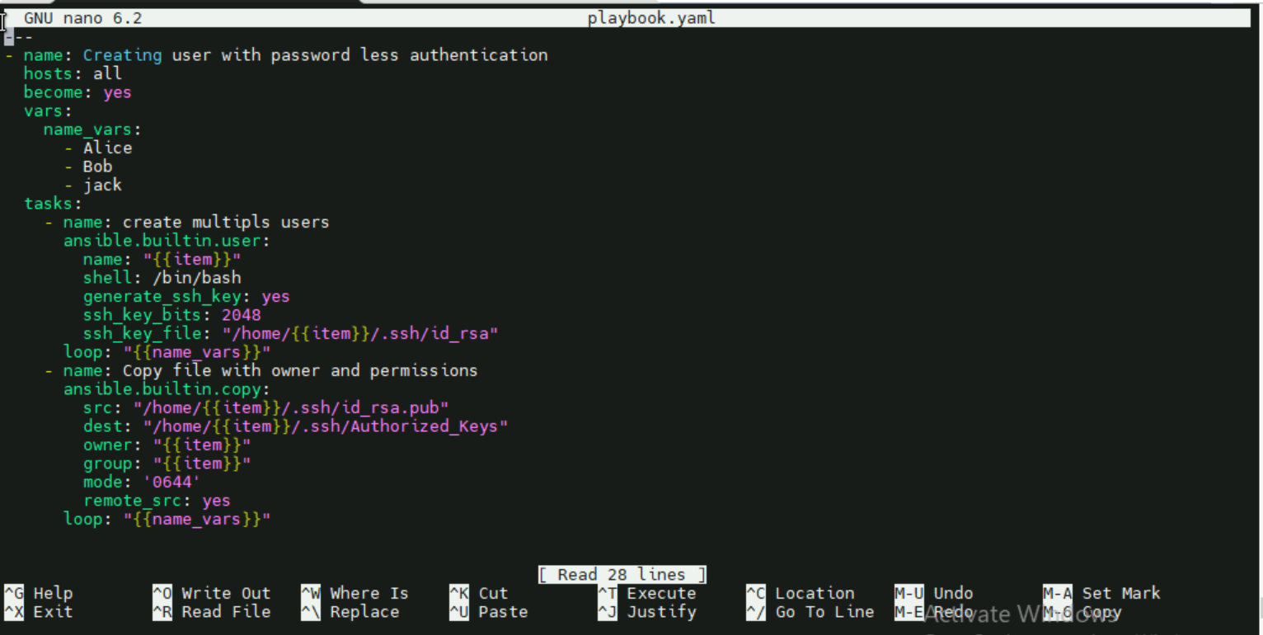

**Running the playbook using ansible-playbook command:**

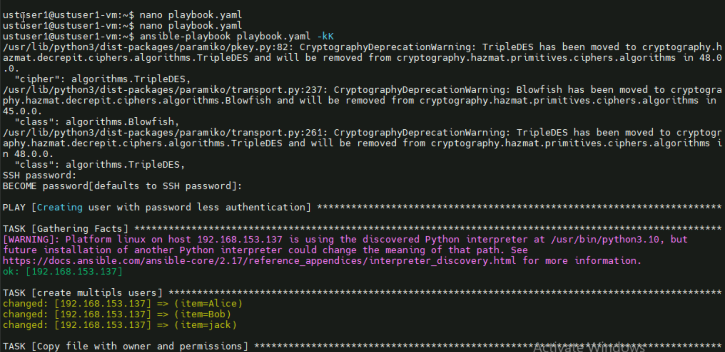

**Output:**

**Multiple user alice,bob,jack created in home directory and also with passwordless authentication**

