**Q1 Kubernetes**

**Deployment Configuration file**

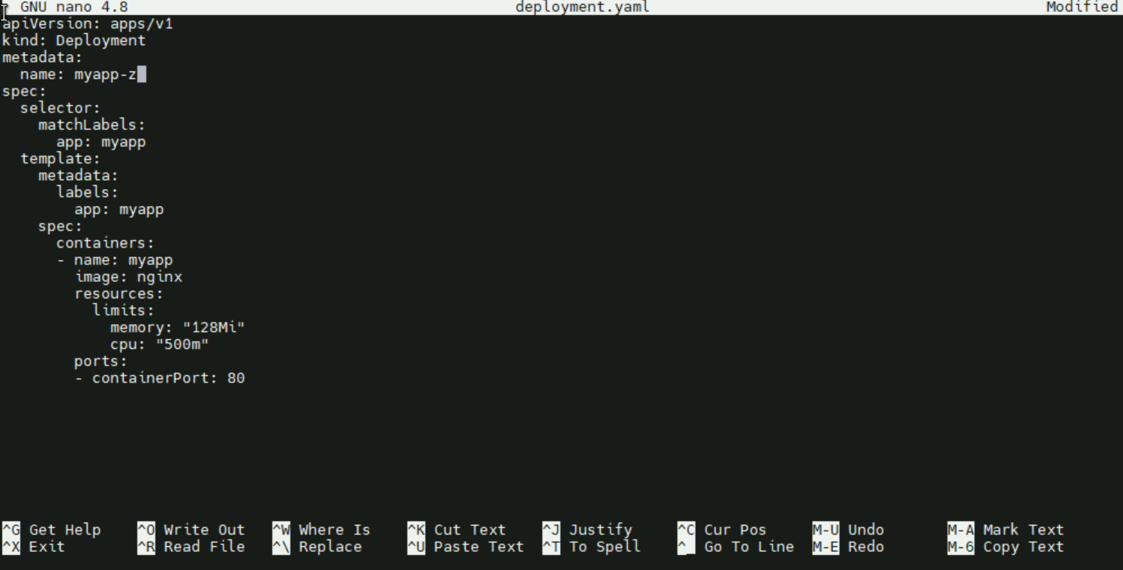

**Applying deployment file and Exposing deployment to service**



**Verifying Deployment:**

**Myapp-z pod is up and running   
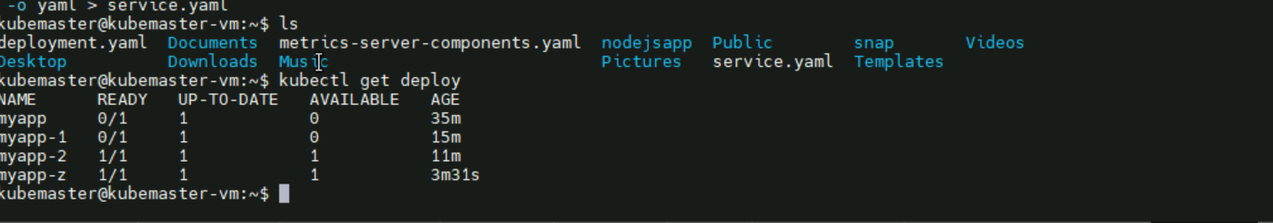**

**Applying service file and verifying**

**Service configuration:**

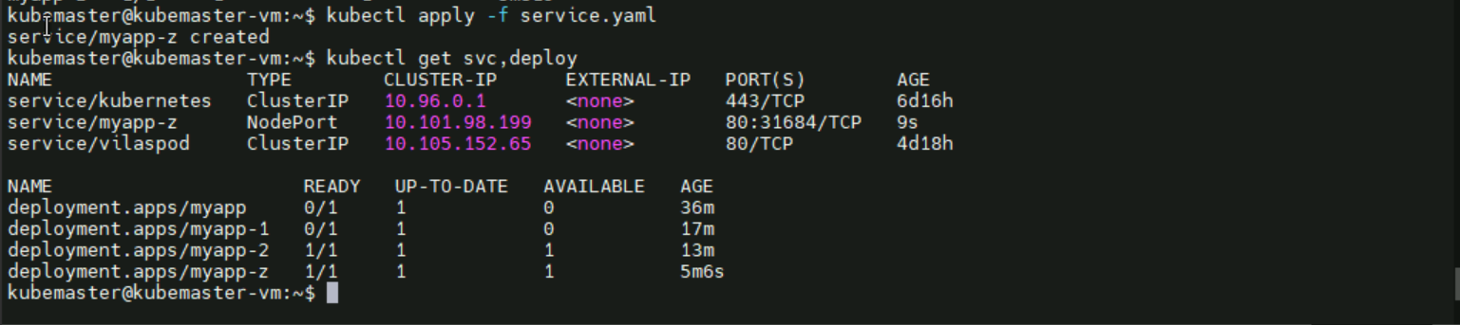

**After curling default nginx page is visible locally**

**Curling with workerip and nodeport**

