**Q2 Ansible Document**

**Initializing ansible role**

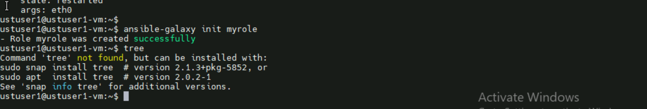

**Navigating to it**

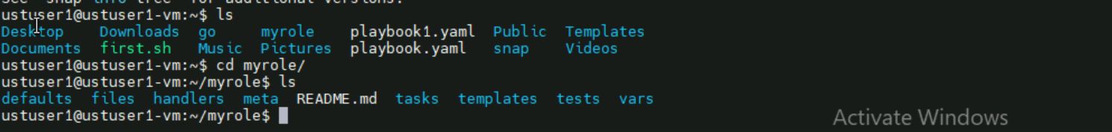

**My playbook:**

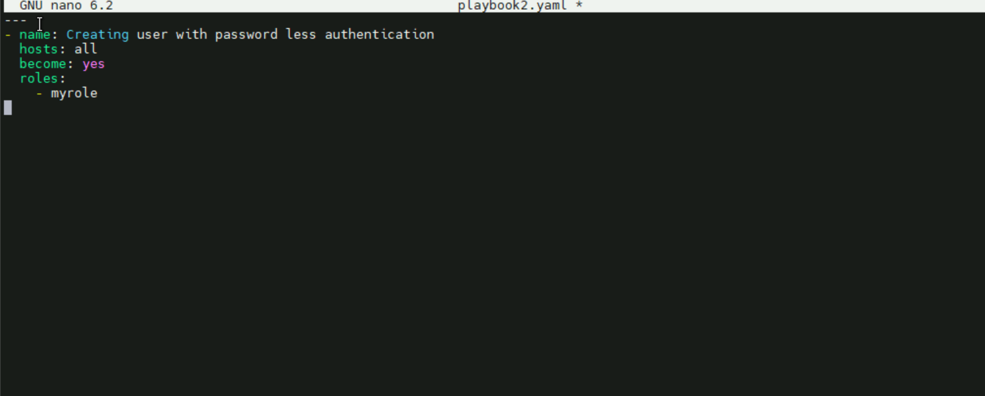

**Running it**

