**Q2 Kubernetes**

**Cloning the given repo to our local machine**

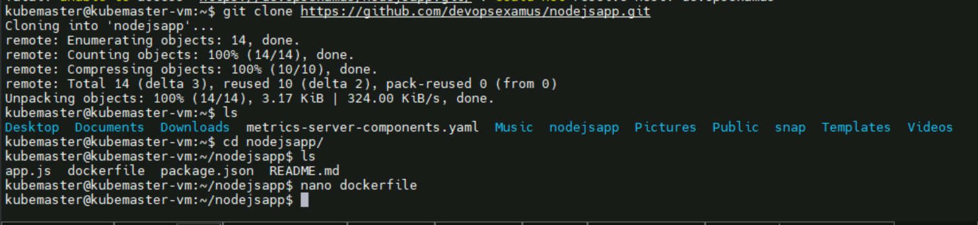

**Building image from dockerfile**

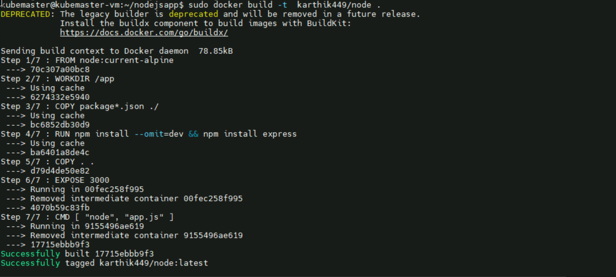

**Deployment Configuration:**

Deployment.yaml file:

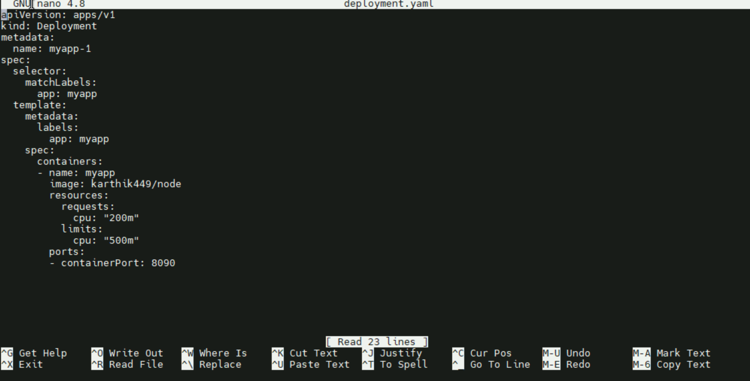

**Applying the deployment file**

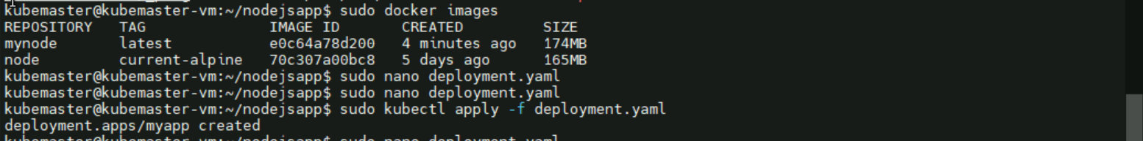

**Autoscale configured :**

**Deployment is up and running and also Hpa**

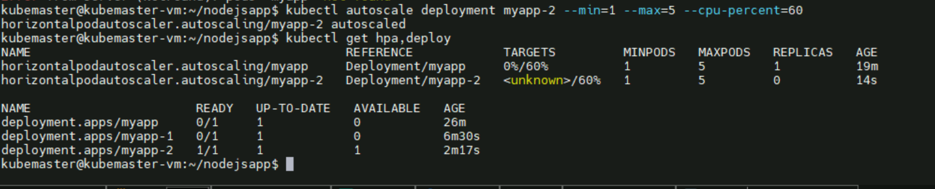

**Pod is up and running now get into it and test**

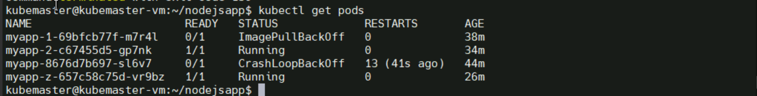

**Hpa:**

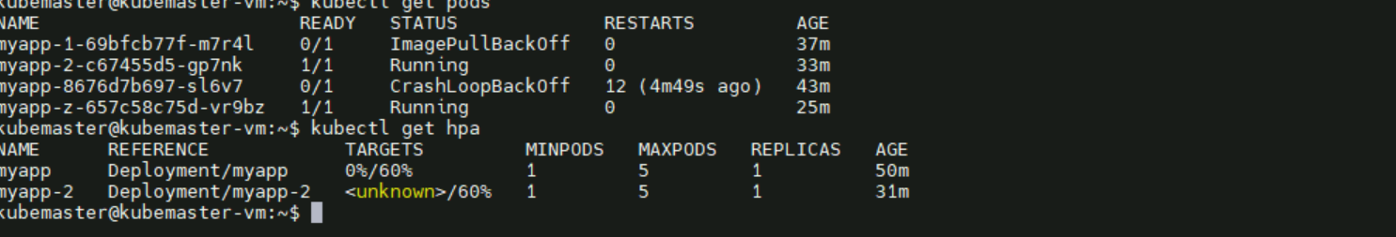

**This is command you need to paste**

