**Q3 Python Doc**

**1.Monitoring a directory for a file change**

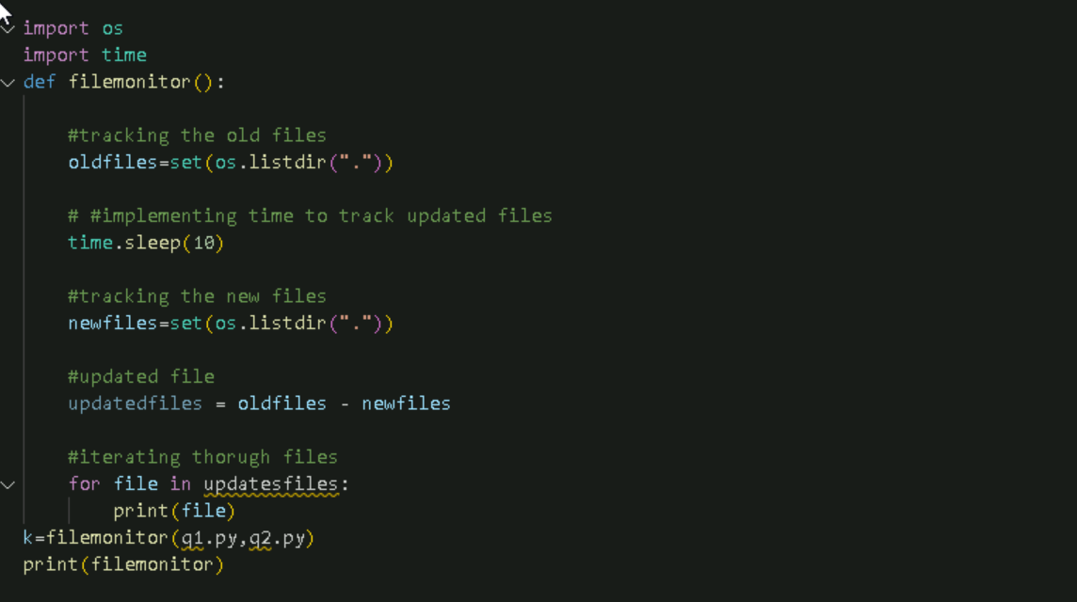

**2 HASHING FILES**

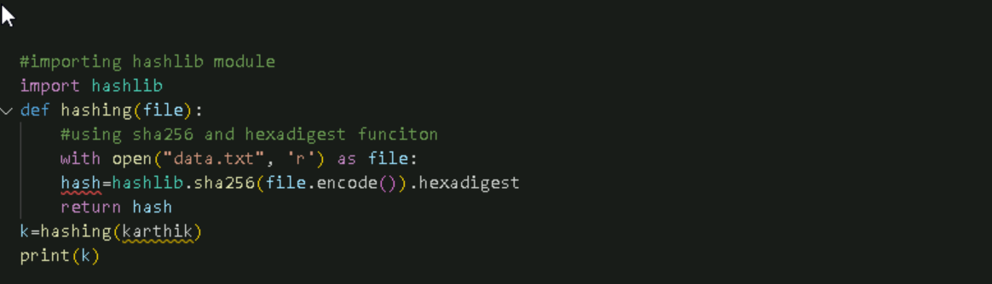

**3.Alert**

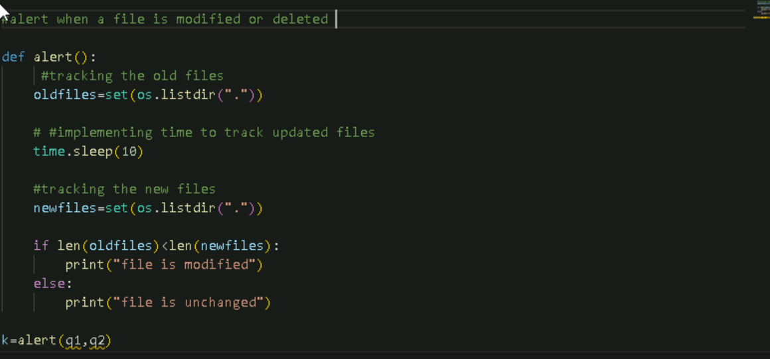

**4.Auditing logs**

