**Q6 -Hook**

**First create a new file**

**Then initializing git repo using “git init” command**

**Then go to hooks directories where you can find all sample files**

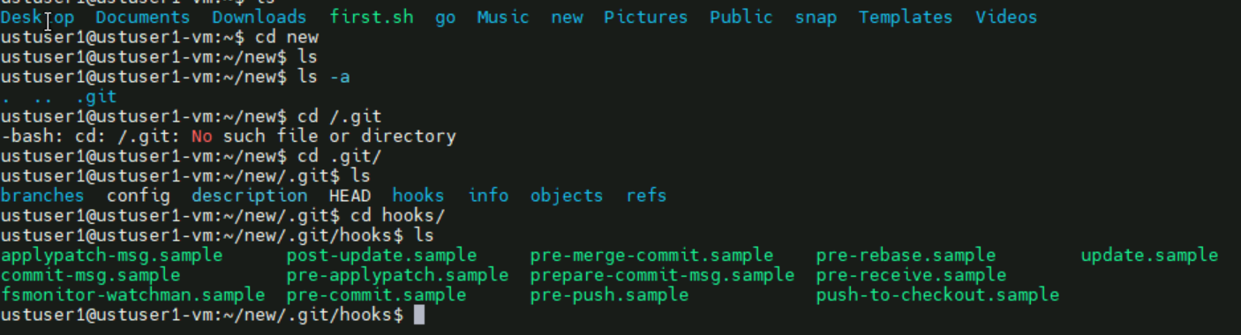

**Providing commit message format using script**



