**Q5 Powershell Document**

**Listing all the local user using Get-LocalUser**

**There are few user displayed below**

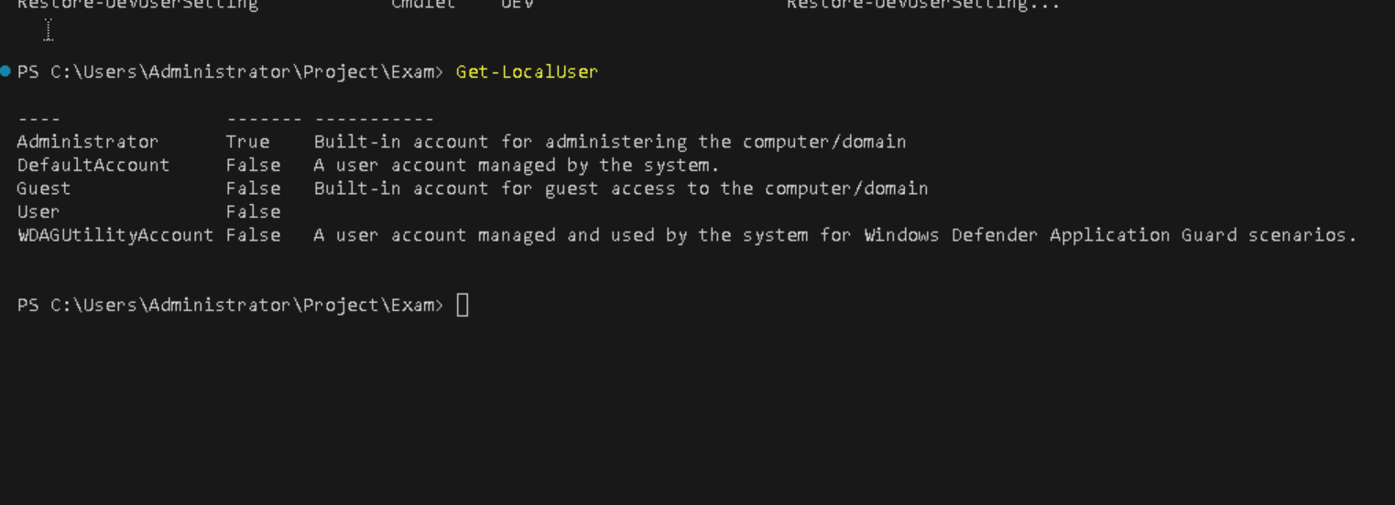

**Exporting csv file and grouping users in it**

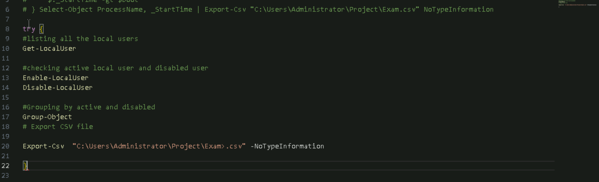

**Listing all the active process**

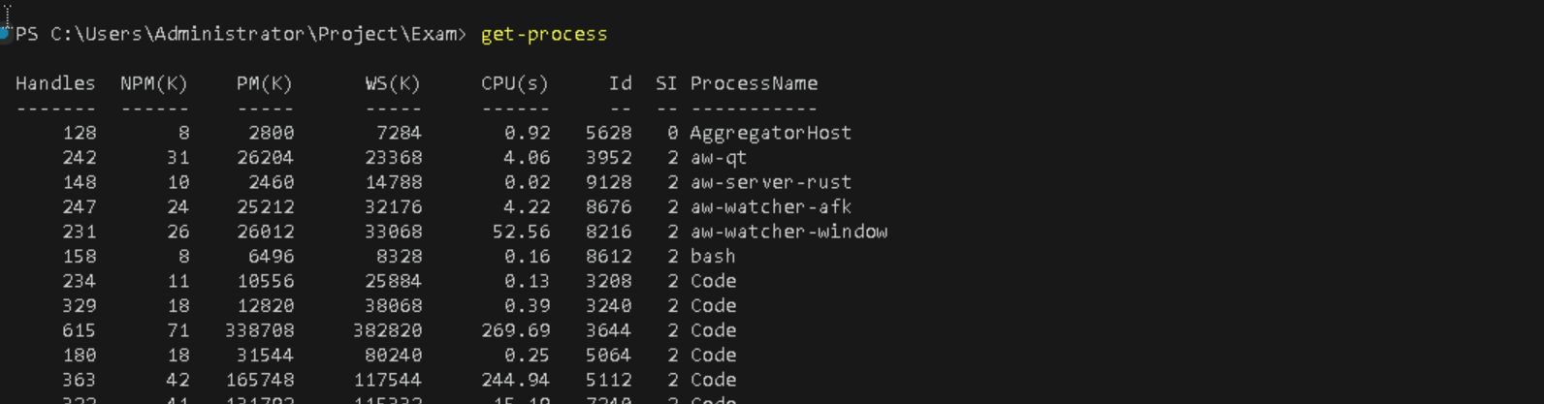

**Booting process**

