Hands-on 1:

Design Pattern and Principles :

Exercise 1 : Implementing the Singleton Pattern :

Logger class(Singleton Class):

public class Logger {

private static Logger instance;

private Logger(){

System.out.println("Initialized");

}

public static Logger getInstance(){

if(instance==null){

instance=new Logger();

return instance;

}

return instance;

}

public void log(String message){

System.out.println("Log :"+message);

}

}

Main class :

public class Main {

public static void main(String[]args){

Logger logger1=Logger.getInstance();

logger1.log("First message");

Logger logger2=Logger.getInstance();

logger2.log("Second message");

if(logger1==logger2){

System.out.println("Both instances are same (Singleton class confirmed) ");

}else{

System.out.println("Both instances are not same (Singleton class confirmed)");

}

}

}

OUTPUT:

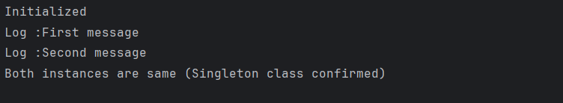

Exercise 2: Implementing the Factory Method Pattern :

Document interface:

public interface Document {

void open();

}

WordDocument.java

public class WordDocument implements Document {

public void open() {

System.out.println("Opening Word Document");

}

}

PdfDocument.java

public class PdfDocument implements Document {

public void open() {

System.out.println("Opening PDF Document");

}

}

ExcelDocument.java

public class ExcelDocument implements Document {

public void open() {

System.out.println("Opening Excel Document");

}

}

Implementing the Factory Methods :

DocumentFactory.java

public abstract class DocumentFactory {

public abstract Document createDocument();

}

WordDocumentFactory.java

public class WordDocumentFactory extends DocumentFactory {

public Document createDocument() {

return new WordDocument();

}

}

PdfDocumentFactory.java

public class PdfDocumentFactory extends DocumentFactory {

public Document createDocument() {

return new PdfDocument();

}

}

ExcelDocumentFactory.java

public class ExcelDocumentFactory extends DocumentFactory {

public Document createDocument() {

return new ExcelDocument();

}

}

Main.java

public class Main {

public static void main(String[] args) {

DocumentFactory wordFactory = new WordDocumentFactory();

Document wordDoc = wordFactory.createDocument();

wordDoc.open();

DocumentFactory pdfFactory = new PdfDocumentFactory();

Document pdfDoc = pdfFactory.createDocument();

pdfDoc.open();

DocumentFactory excelFactory = new ExcelDocumentFactory();

Document excelDoc = excelFactory.createDocument();

excelDoc.open();

}

}

OUTPUT:

