Module Process

Module Description:
Geolocate an user with an ip address and redirecting to the appropirate language page.

Constraints:
Applicable only for Drupal 6.

Files Needed:
- geolocation.zip

Before Applying the patch:
- Take backup of existing codebase, DB .

Instructions to apply the patch:
- Download the Geo_settings , Geolocation, i18n and lightbox2.
- Enable only Geo_settings module

Clear the Cache using the below commands

After enabling the Geo_settings module

Please follow the configuration steps below

Configuration steps

Steps to enable file paths
- Navigate to Site configuration -> SDM Administration , Click SDM portal settings and Save configuration
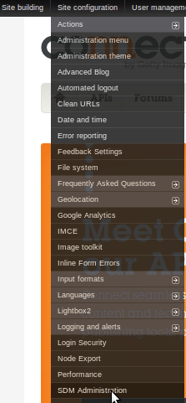

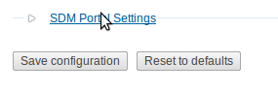

Steps to enable modules i18n and Geolocation

- Login as admin and navigate to Sitebuilding -> modules ->list

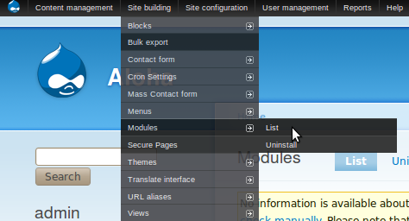

- Please enable the modules as per specified in the below image ( Check the mentioned check box and Save configuration )

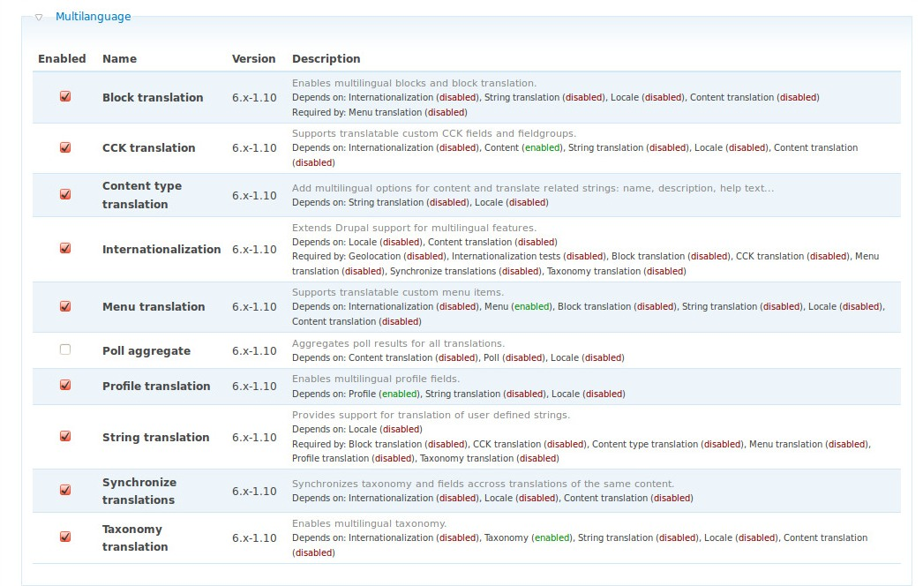

Note: Save Configuration

Steps to configure i18n module

- Navigate to Site configuration -> Languages -> Configure

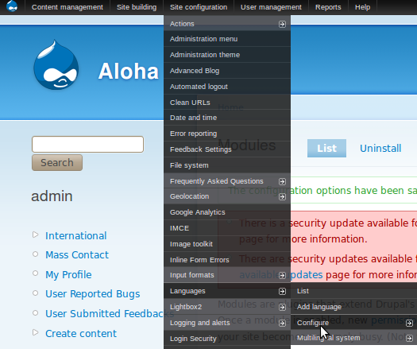

  - Select Path prefix only option in Language negotiation and Save configuration.
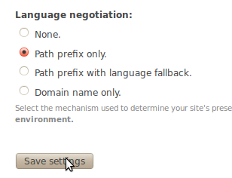

Navigate to Site configuration -> Languages -> Configure (Refer step 1)

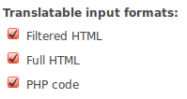
    - Select String transaltion tab , Check all the three format types and Save configuration

Select Multilingual system tab

  - Select Current language and language neutral option in Content selection mode and Save configuration
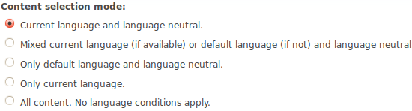

- Click configure content types hyperlink
  - Click edit hperlink in Page content type
    - Click workflow settings and select Enabled ,with translation option in Multilingual support, Set up the multilanguage option as per the below image and Save content type
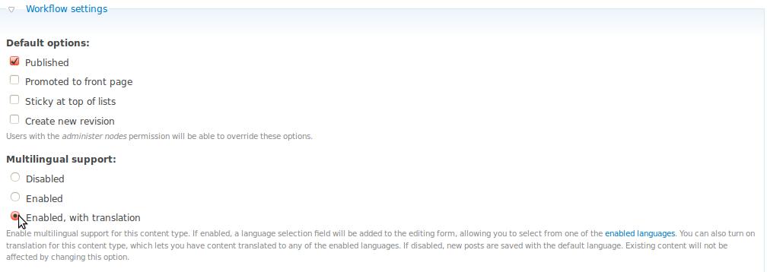

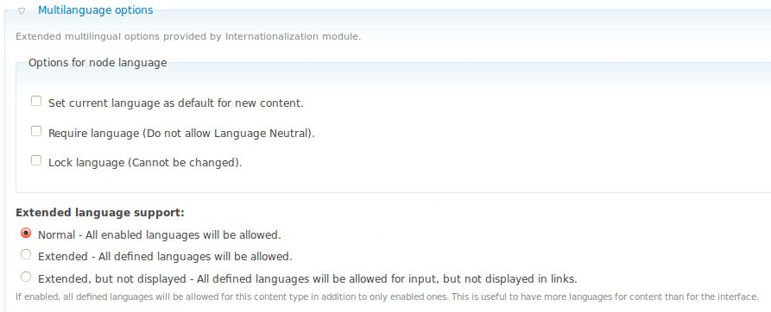

- Navigate to Site Configuration ->Languages -> list and select Add language tab
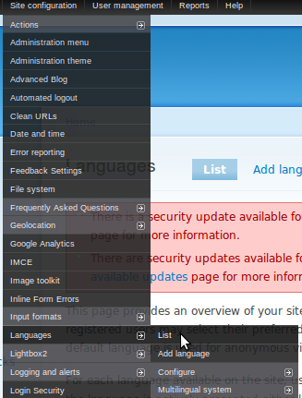

- Add french language from select box and Save configuration
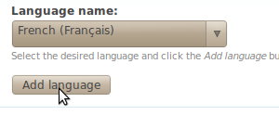

- Again select the Add language tab

  - Add all the following languages same as above steps
Dutch
Japanese
Spanish
French (already added in above step)
German
Italian
Portuguese, Portugal

- Select the Add language tab , click Custom language hyperlink configure as it as per the image , Add custom language and Save configuration.

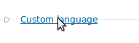

Add custom UK-english language , Since English language only available in drupal , Please set language as per below image and Save configuration

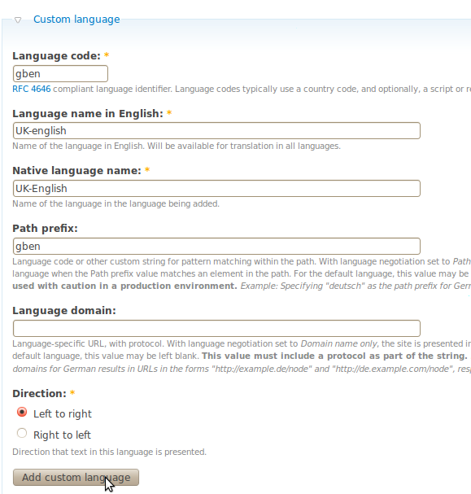
The language list will be appear like this image, Save configuration

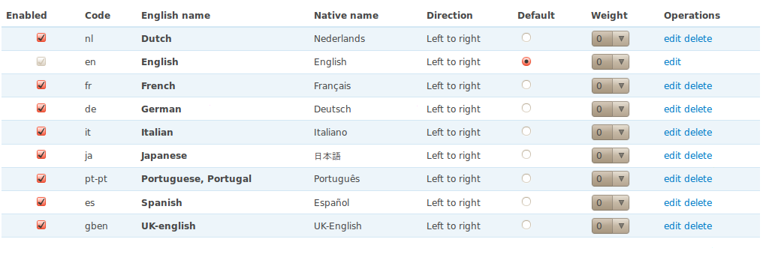

Steps to Configure Geolocation module

- Navigate to Site configuration -> Geolocation -> Geolocation files

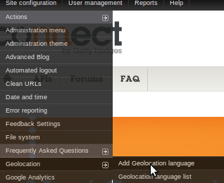

- Enter the country code , language code and add language for all 8 languages as per the below image

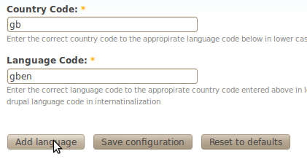

  - Repeat the same for all languages

Country code | Language code
gb | gben
es | es
de | de
fr | fr
pt | pt-pt
jp | ja
it | it
nl | nl

- After completion of adding language , select Geolocation language list tab it shows the added lanauges as per the following images

Geolocation table shows the added language and also admin can delete it, No need to consider about geoid and order, verify the contry code and language code are added as per the above table

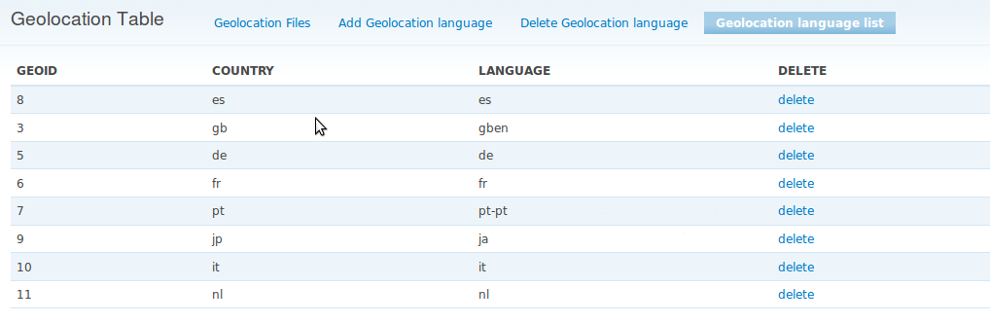

Steps to add terms of use page in all languages

- Navigate to Content management -> content ->list

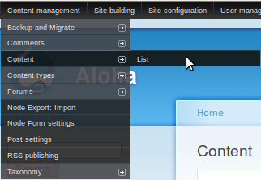

- Edit the Terms of use page
  - Please select the language english in Language select box

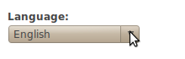

  - Click the Url path settings hyperlink , uncheck the Automatic alias box , make the path as page/terms-use and Save (Please note: This step is same for all languages)

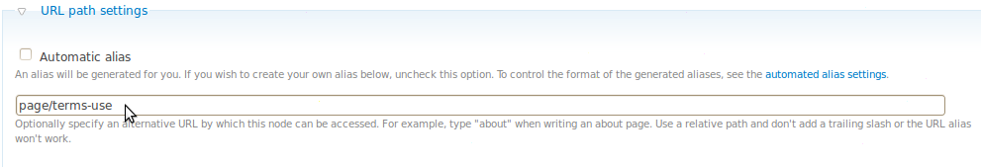
- Edit the Terms of use english page
- Select the Translate tab



- Click add translation hyperlink in dutch language

- Paste dutch content of Terms of use page in body, ( Client is not yet provided the dutch content ,So copy and paste the english content (body) of Terms of use page by edit the english Terms of use page) Refer step 5.
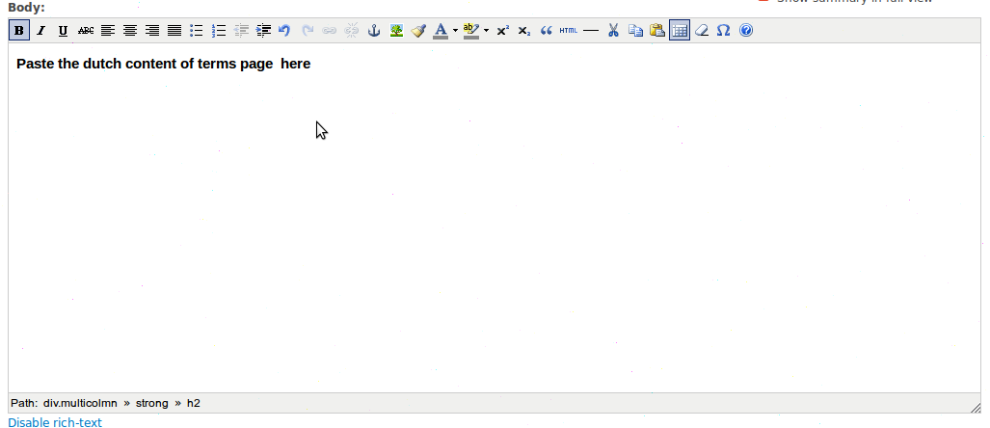

- Click the Url path settings hyperlink , uncheck the Automatic alias box , make the path as page/terms-use and Save (Please note: This step is same for all languages)

- Navigate to Content management -> content -> list

- Repeat the 5 , 6, 7, 8 , 9 ,10 for all languages showing in below image. (Please note that make sure that step 9 has the path page/terms-use)

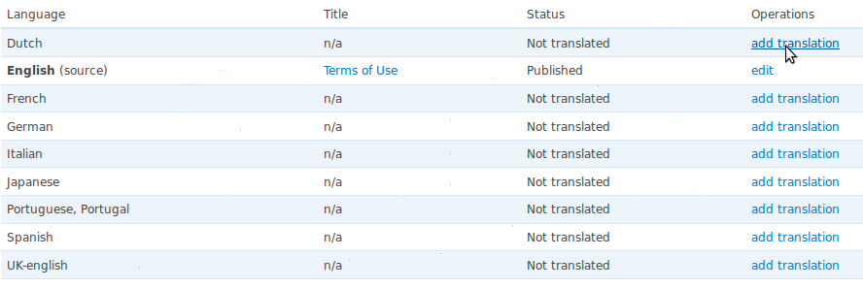

Steps to enable Internalizatioin block

- Navigate to Site building -> Blocks -> List -> getty_images

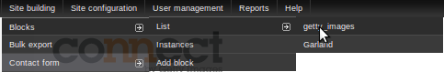

- Select Add block Tab

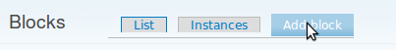

- Select the language as All languages (translatable) , Add description as International, Click the input format link next to block body , Make the option as php code and paste the below code in block body

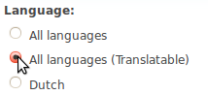

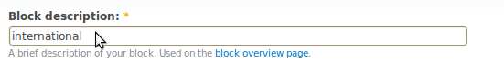

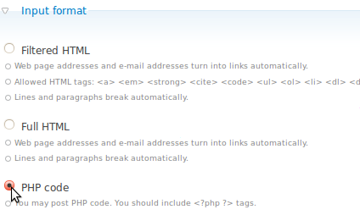

Paste this code in block body:

<div class="nav-right">
<?php
global $base_url,$language;
if($language->language == language_default()->language) {
echo '<a href="'.$base_url.'/international" rel="lightmodal[|width:400px; height:200px; scrolling: auto;]" id="regionPickerTrigger" align="right">International</a>';
}
else {
echo '<a align="right" id="regionPickerTrigger" href="'.$base_url.'/'.$language->language.'/international" rel="lightmodal[|width:400px; height:200px; scrolling: auto;]">International</a>';
}
?>
</div>

- Select the User specific visiblity settings as per below image
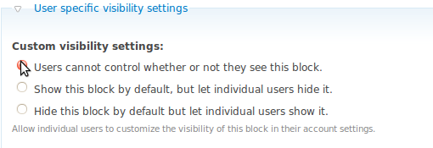

- Make the Page specific visiblity settings option as show on only the listed pages , Enter the below mentioned paths in Pages text box and Save block.

<front>
contact
page/terms-use
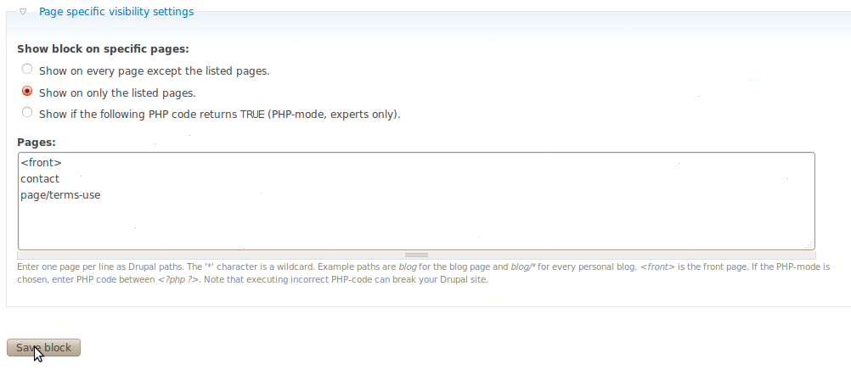
- The block will be present in disabled region, Assign that International block to header region by selecting the select box option to header and Save Blocks .

Will be appear like this image

When selecting the header option it will assigned in Header Region, then Save blocks

Steps to enable Internalizatioin to some example blocks here home top content block

- Click configure link in home top content block

- Select the Language as All languages (translatable) and Save block
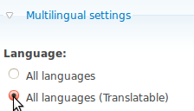

- Click configure link in home bottom content block
- Select the Language as All languages (translatable) and Save block

- Click configure link in Home_Connect block
- Select the Language as All languages (translatable) and Save block

- Click configure link in header block
- Select the Language as All languages (translatable) and Save block

- Click configure link in footer block

- Select the Language as All languages (translatable) , Save block and Save blocks

