

**College code: 5113**

**Batch members:**

**1. JEEVANANDHAN.T (au511321104037)** [**tjeevanandhanjaya2004@gmail.com**](mailto:tjeevanandhanjaya2004@gmail.com)

**2. KABILAN.K (au511321104038)** [**kabilan0701@gmail.com**](mailto:kabilan0701@gmail.com)

**3. LOKESH KUMAR.V (au511321104049)** [**lokeshkumarlucky06@gmail.com**](mailto:lokeshkumarlucky06@gmail.com)

**4. JAYABALAJI .A (au511321104033)** [**jayabalaji445@gmail.com**](mailto:jayabalaji445@gmail.com)

**5. KARTHIKEYAN.S (au511321104041)** [**karthikeyan2003b3@gmail.com**](mailto:karthikeyan2003b3@gmail.com)

**CLOUD APPLICATION DEVELOPMENT**

**PROJECT 10: Media Streaming with IBM Cloud Video Streaming**

**INTRODUCTION:**

**Phase 3: Development Part 1**

***In this part begin building your project.***

***Start building the virtual cinema platform using IBM Cloud Video Streaming.***

***Define the platform's features and design an intuitive user interface.***

***Set up user registration and authentication mechanisms to ensure secure access to the platform***

**STEP 1:**

*login our IBM CLOUD ACCOUNT

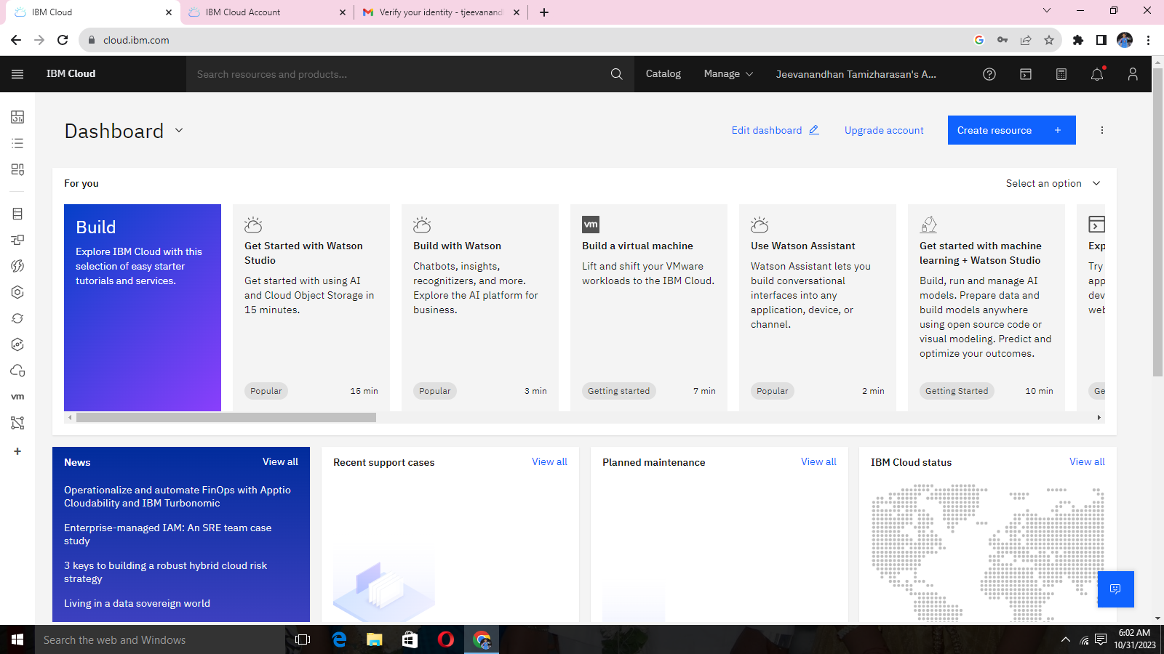

**STEP 2:**

*Open Dashboard overview

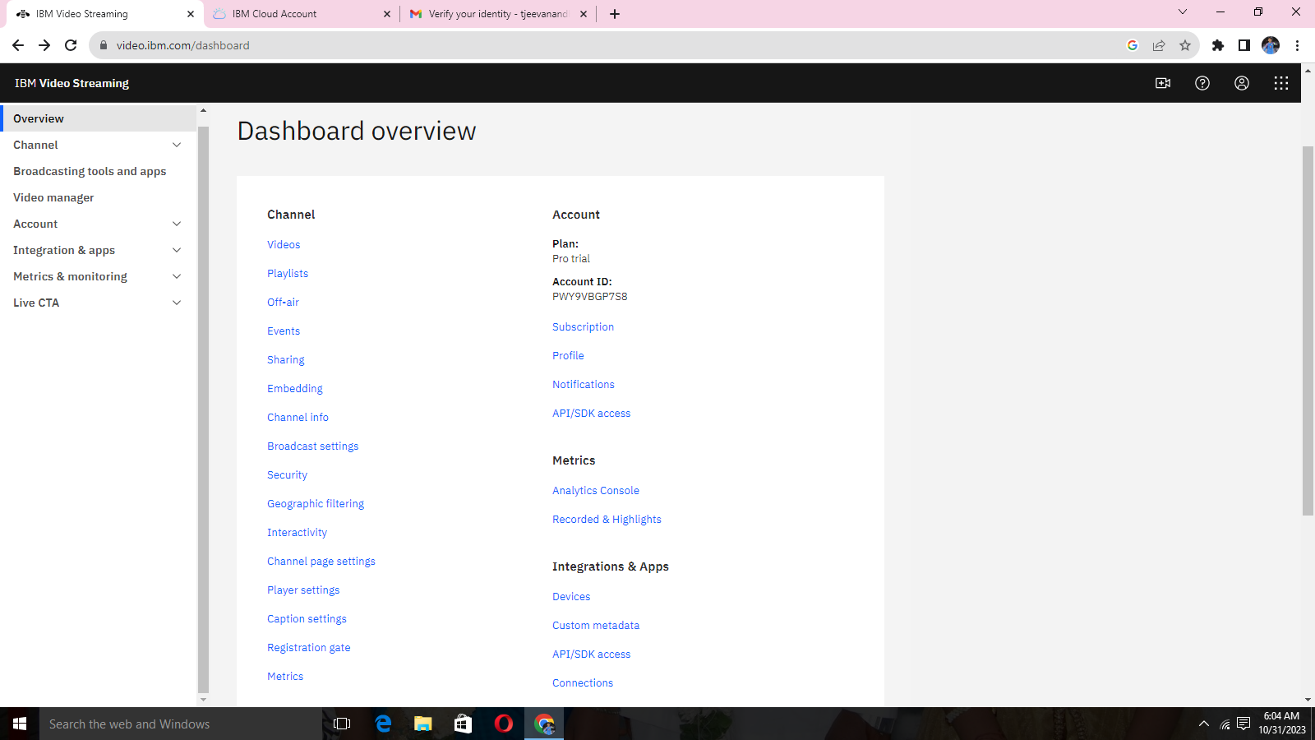

**STEP 3:**

*Upload videos

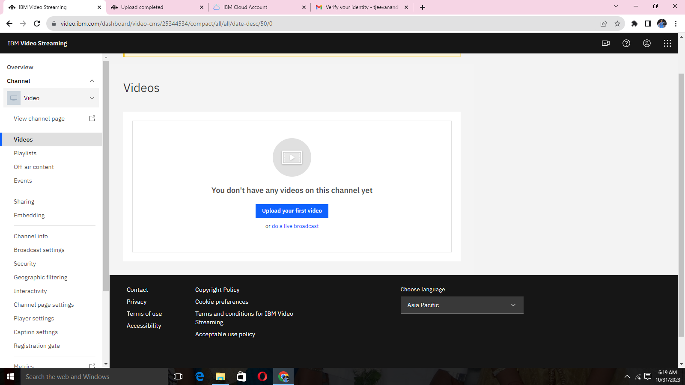

**STEP 4:**

*Video interface for uploading video

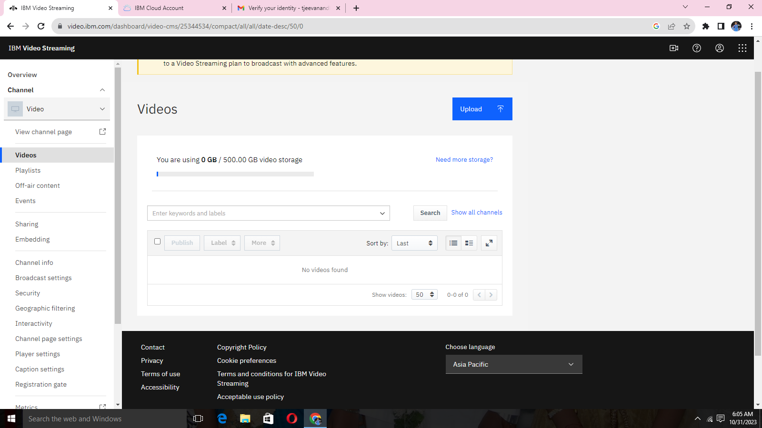

**STEP 5:**

*Select from your computer (file)

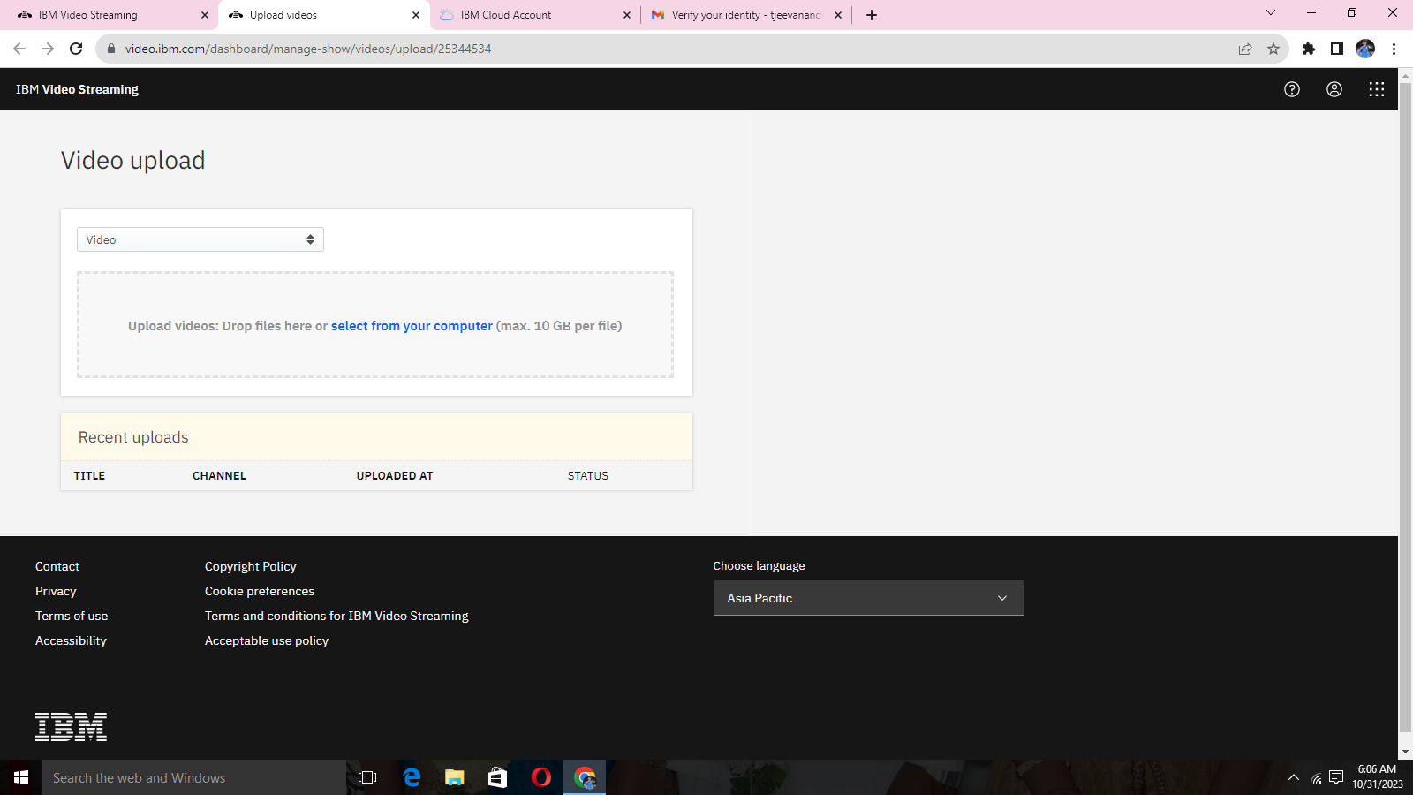

**STEP 6:**

*Select given video file

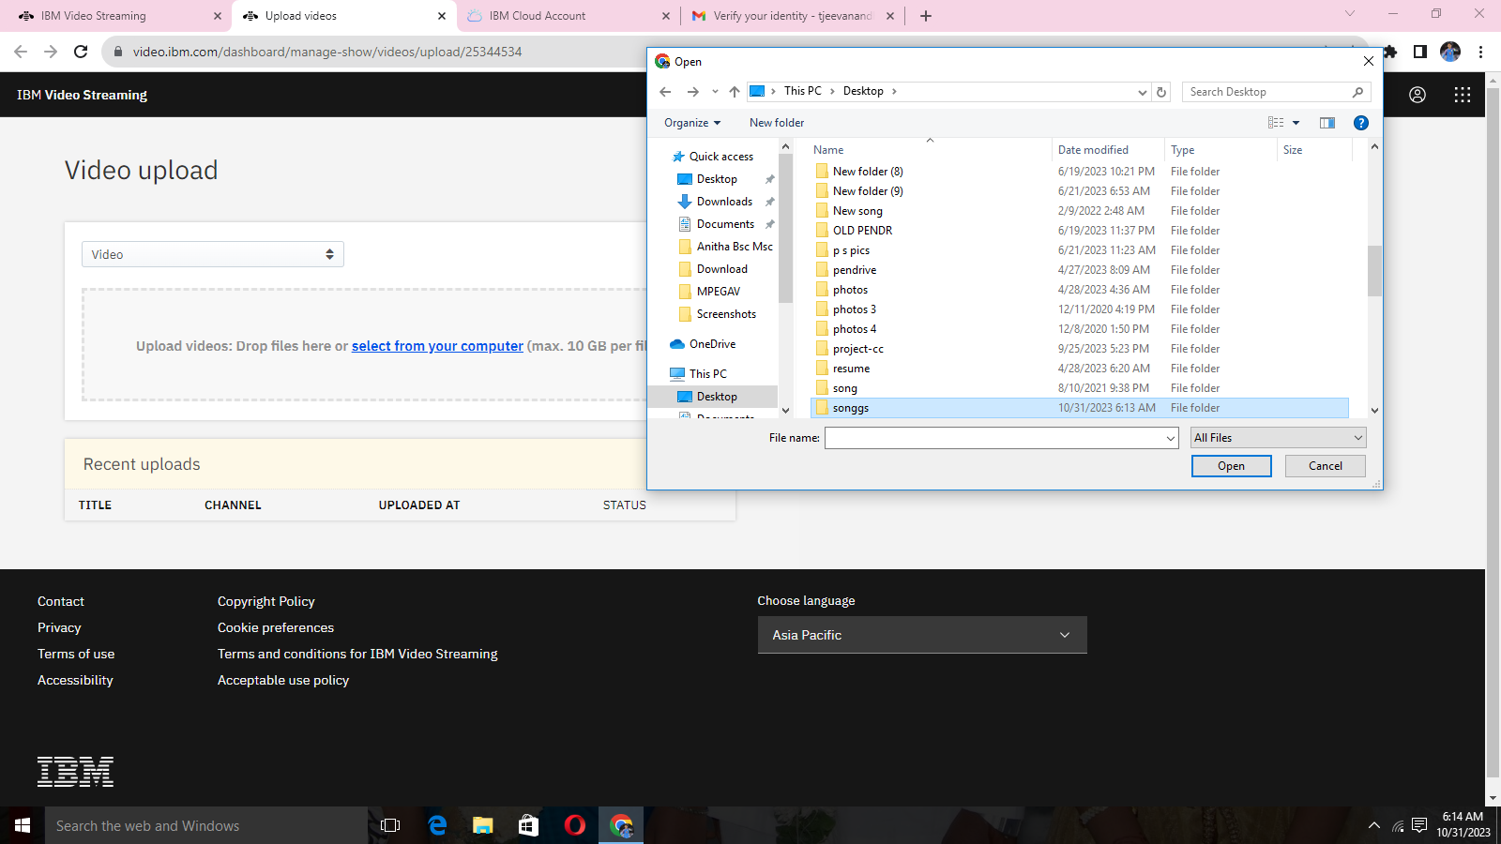

**STEP 7:**

*Add topic name and description of the video

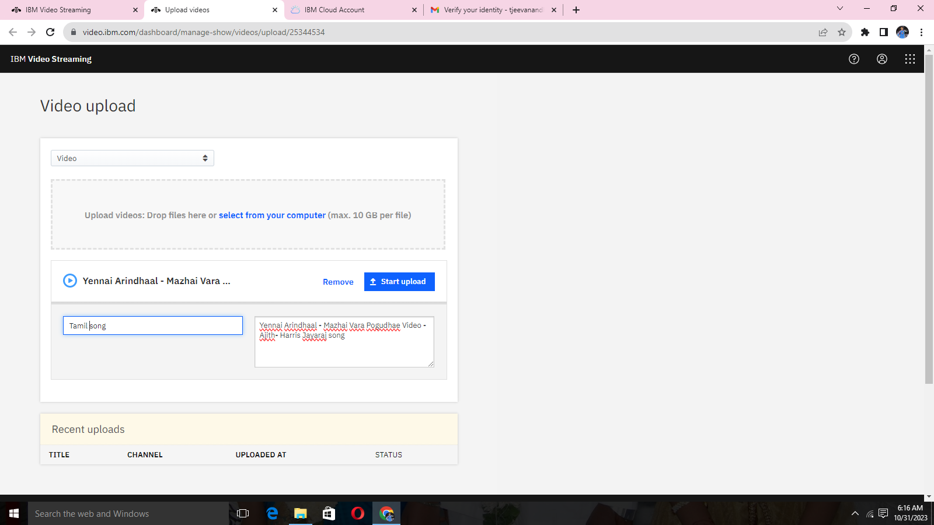

**STEP 8:**

*uploading video on process

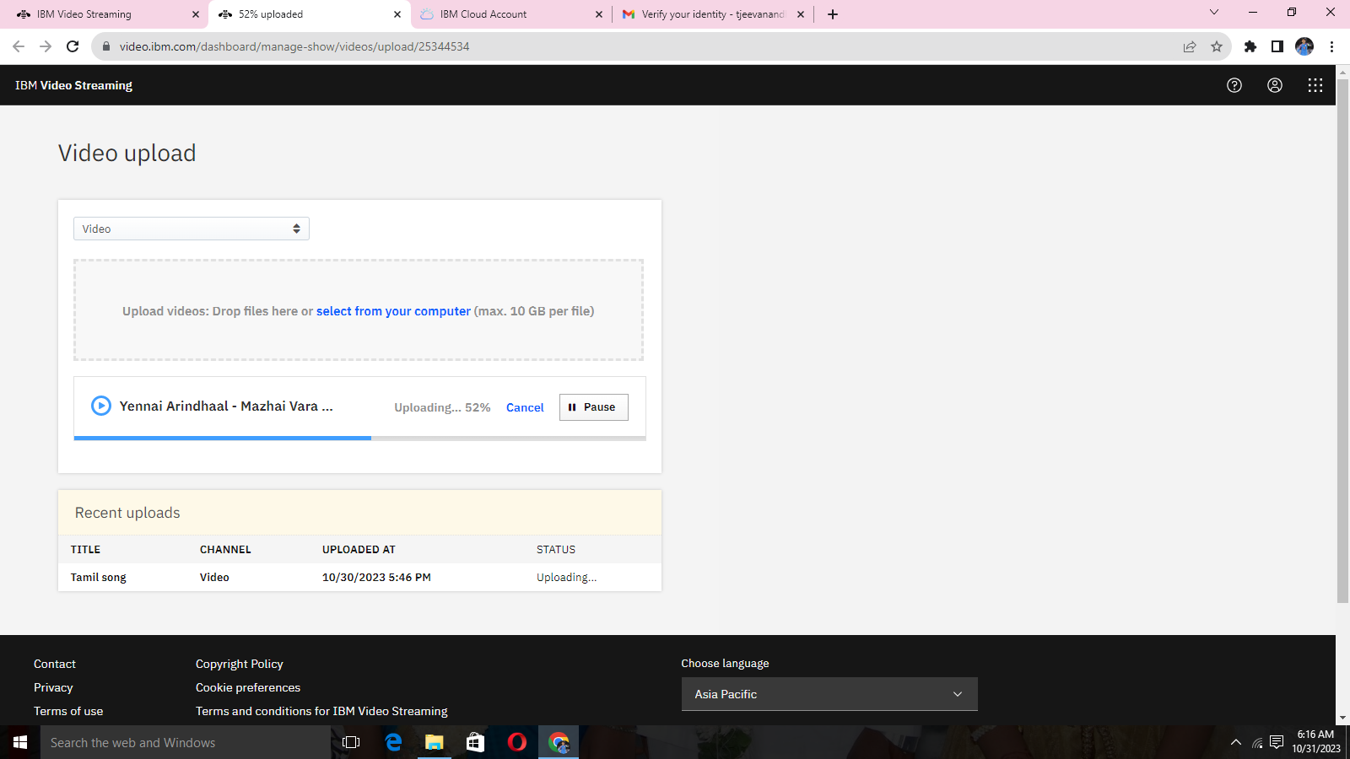

**STEP 9:**

*Publish the video to internet platform.

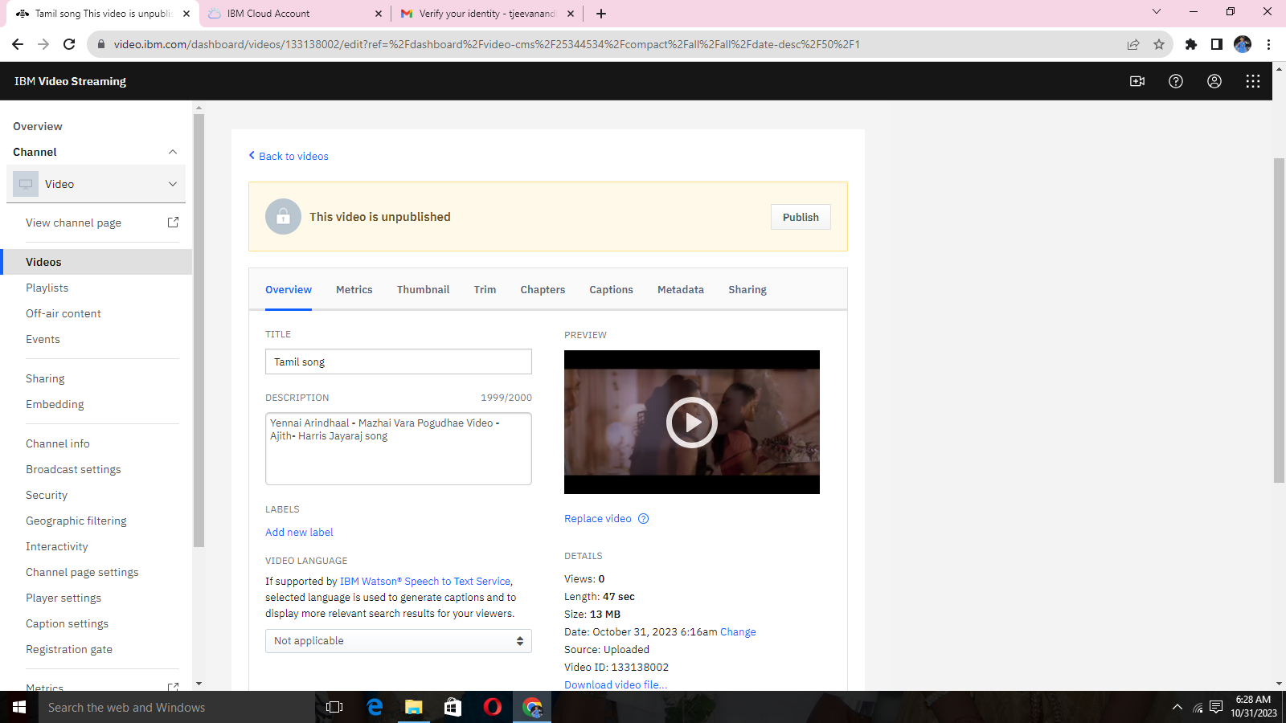

**STEP 10:**

*video information

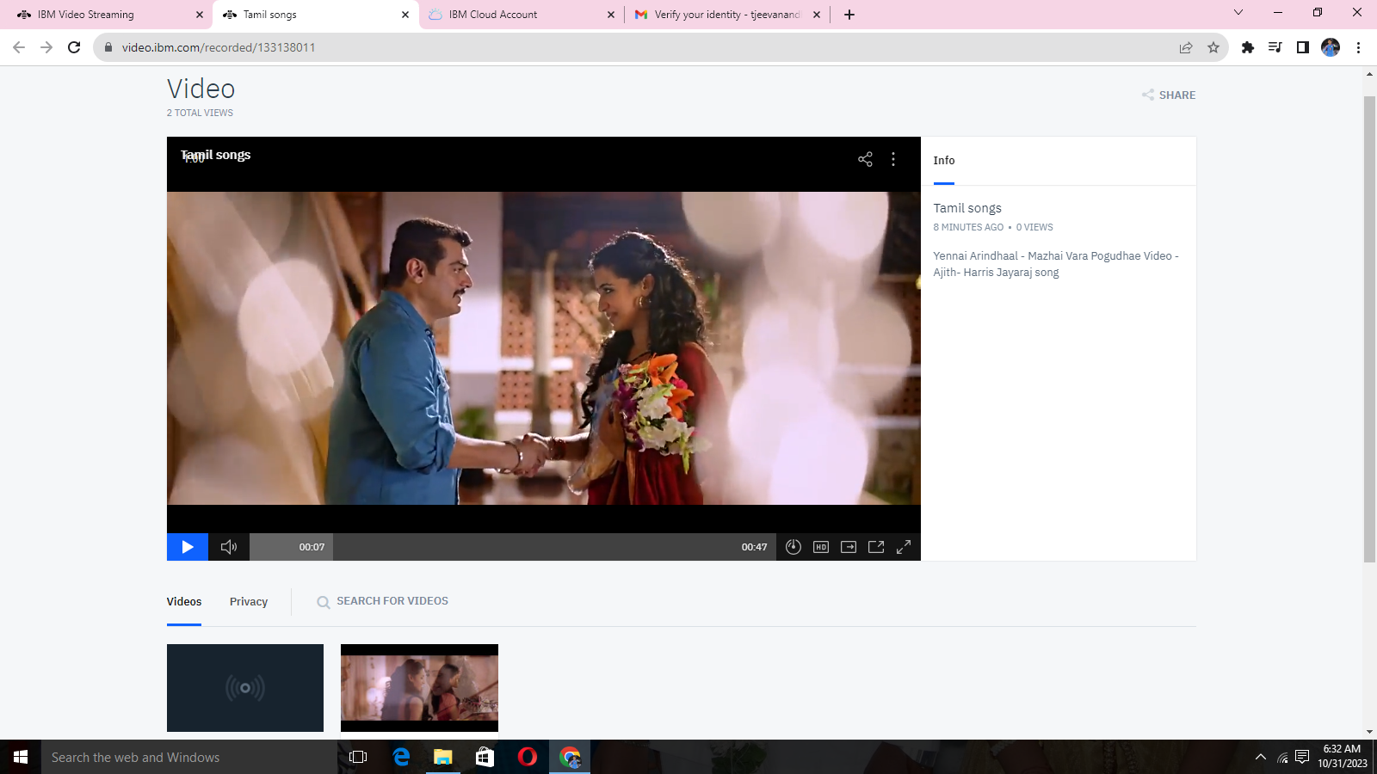

**STEP 11:**

*Metrics of uploaded video

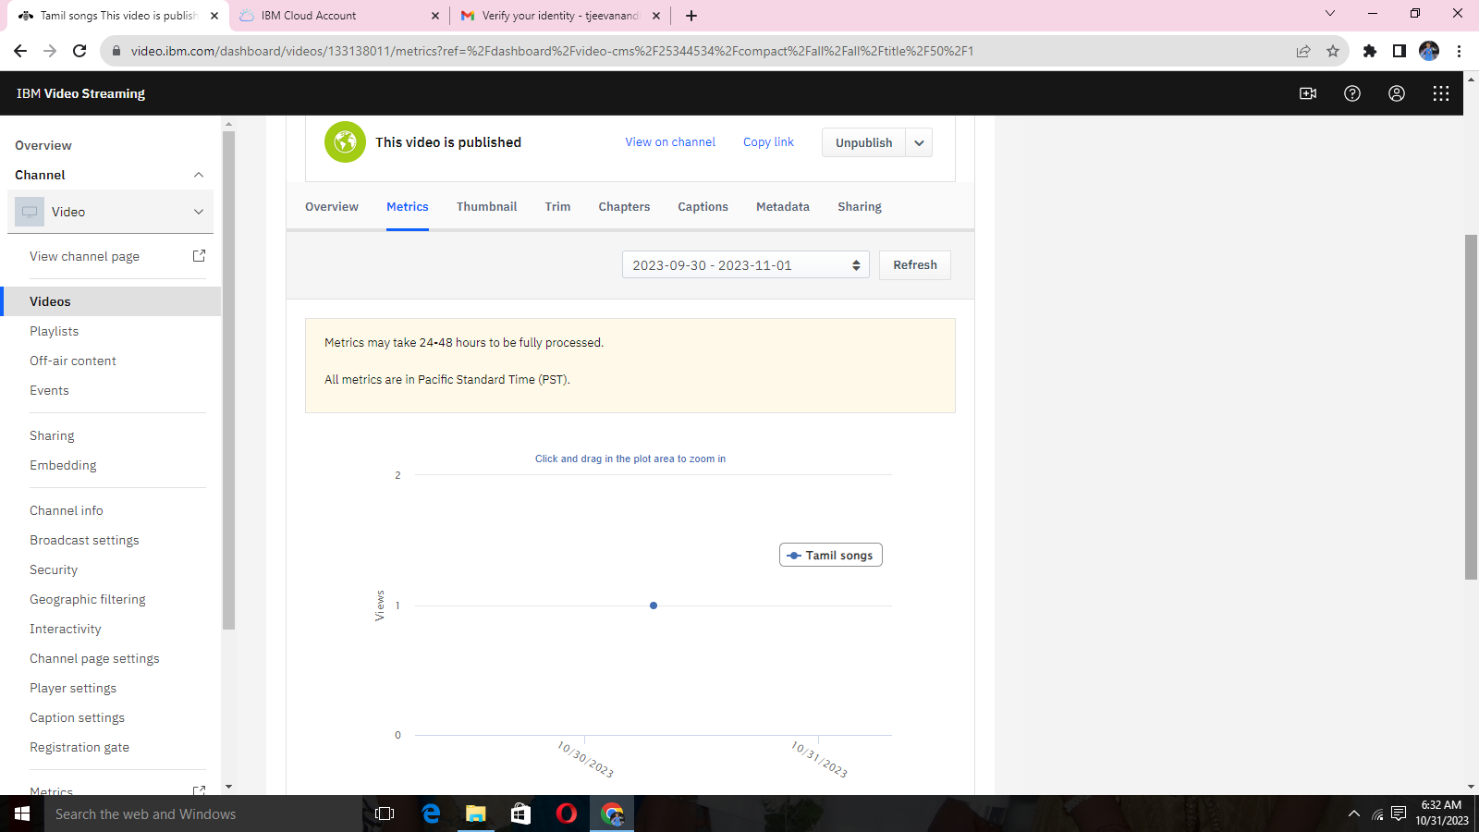

**STEP 12:**

*Thumbnail for setting the frame

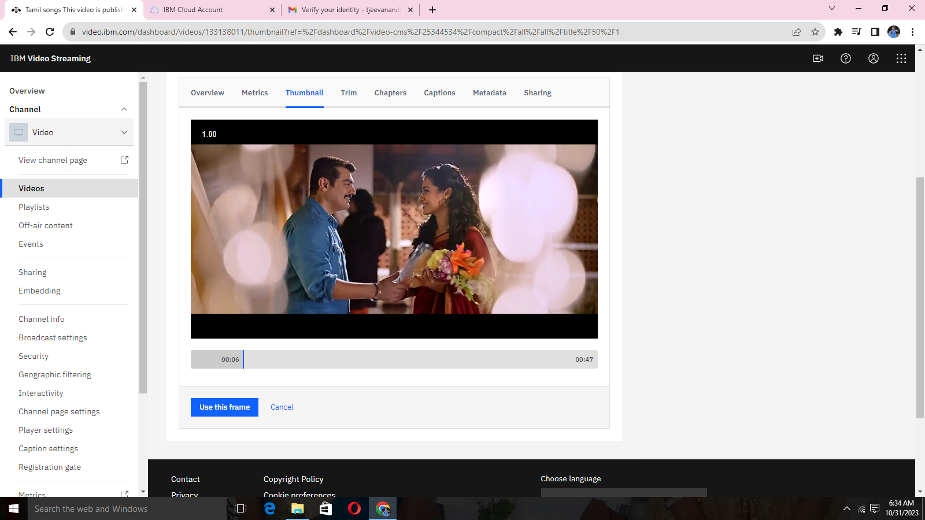

**STEP 13:**

*TRIM the uploaded video

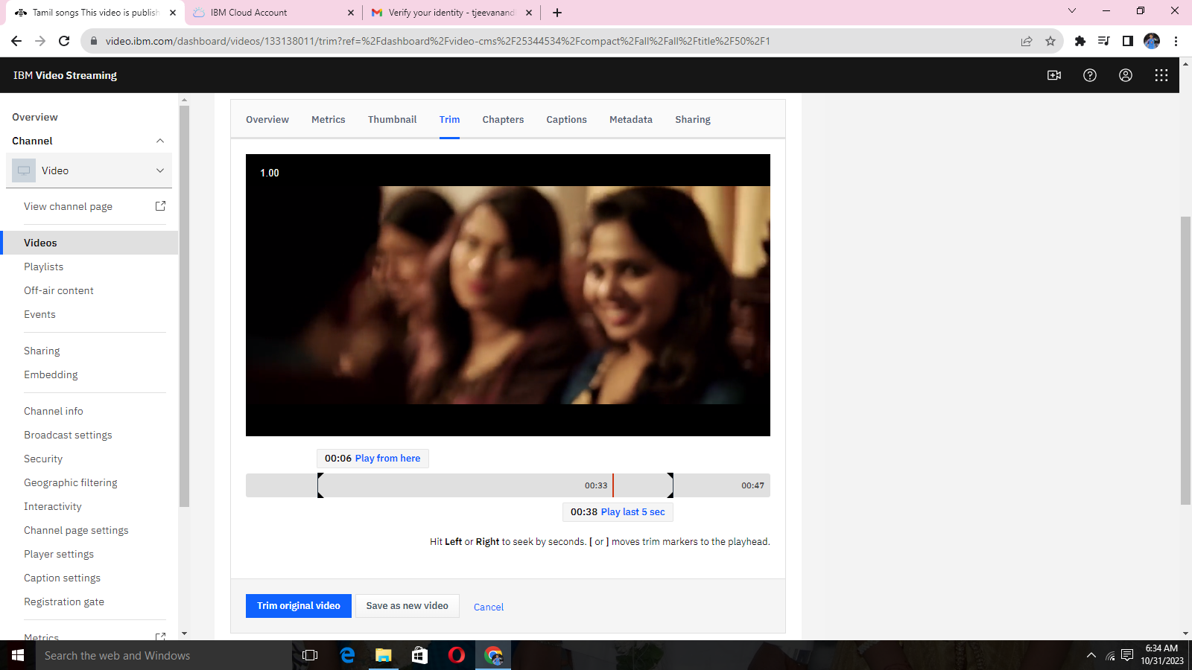

**STEP 14:**

*Add captions for the uploaded video

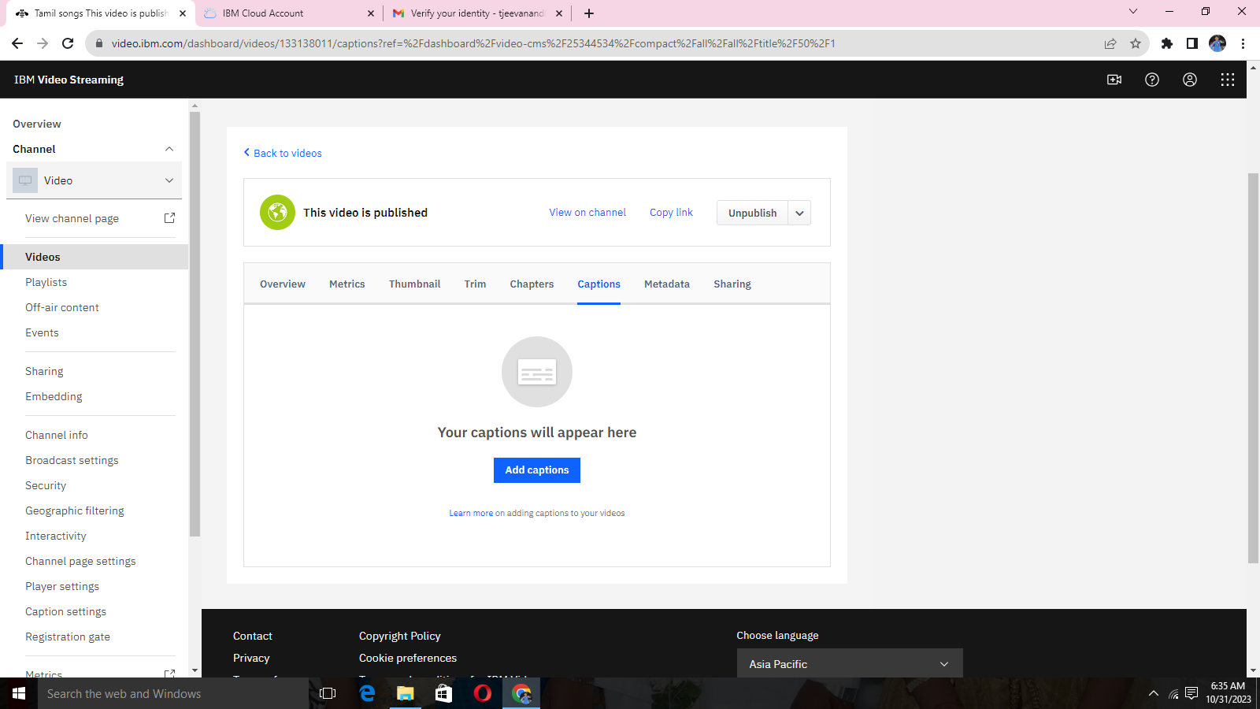

**STEP 15:**

*Security protection

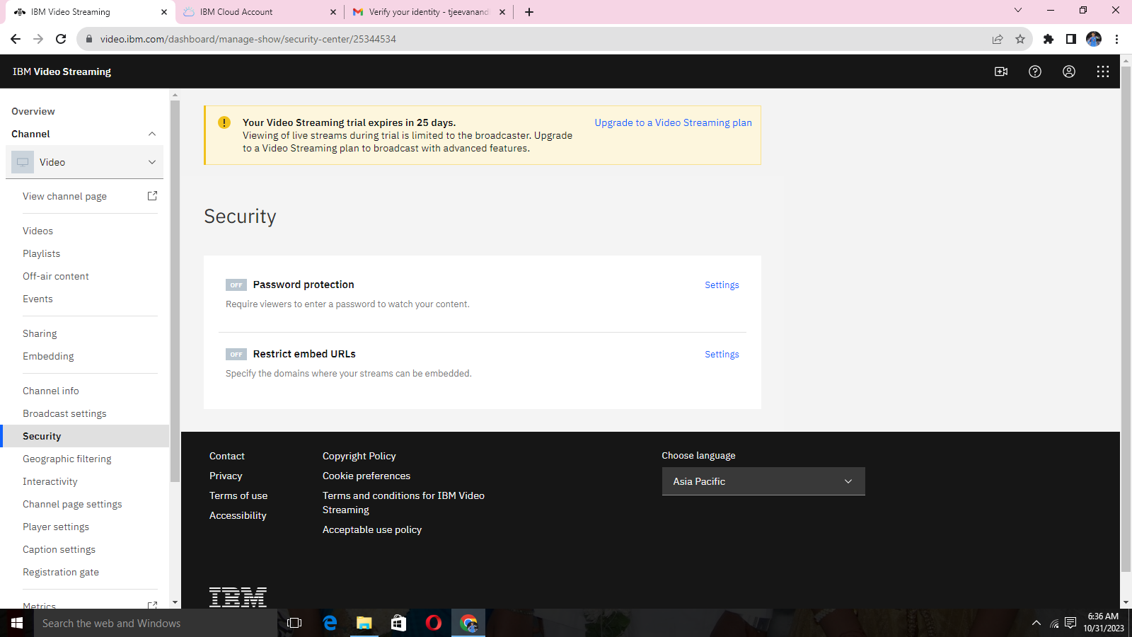

**STEP 16:**

*Set password for protection

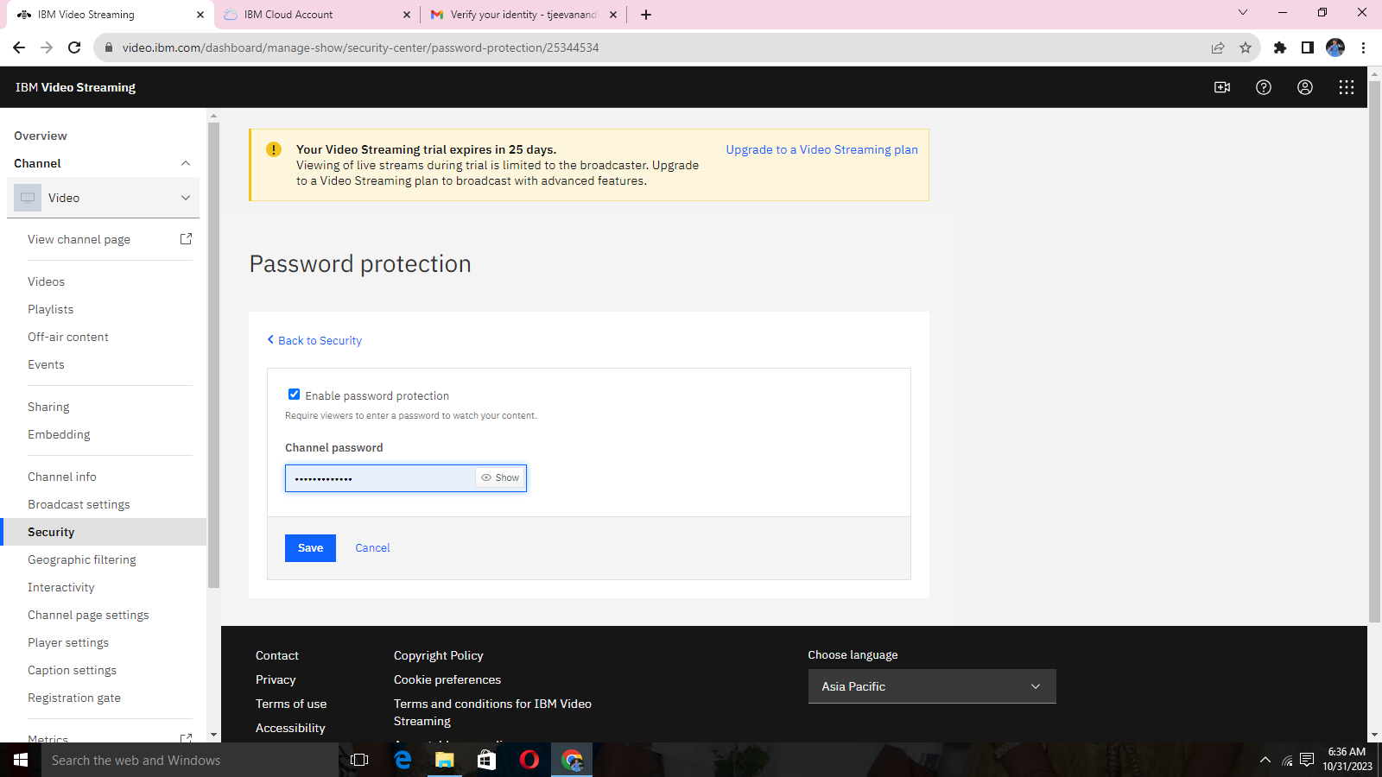

**STEP 17:**

*Embed restriction for manual URL

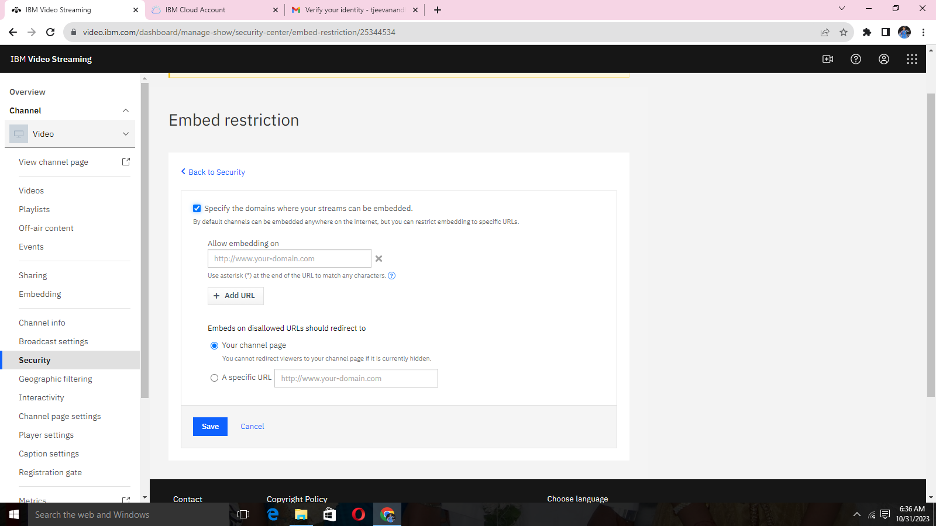

**STEP 18:**

*Interactivity for interactions with viewers

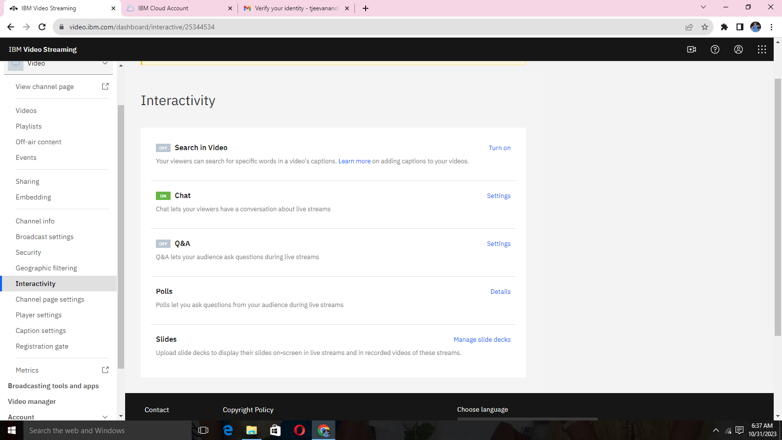

**STEP 19:**

**\***Create playlists

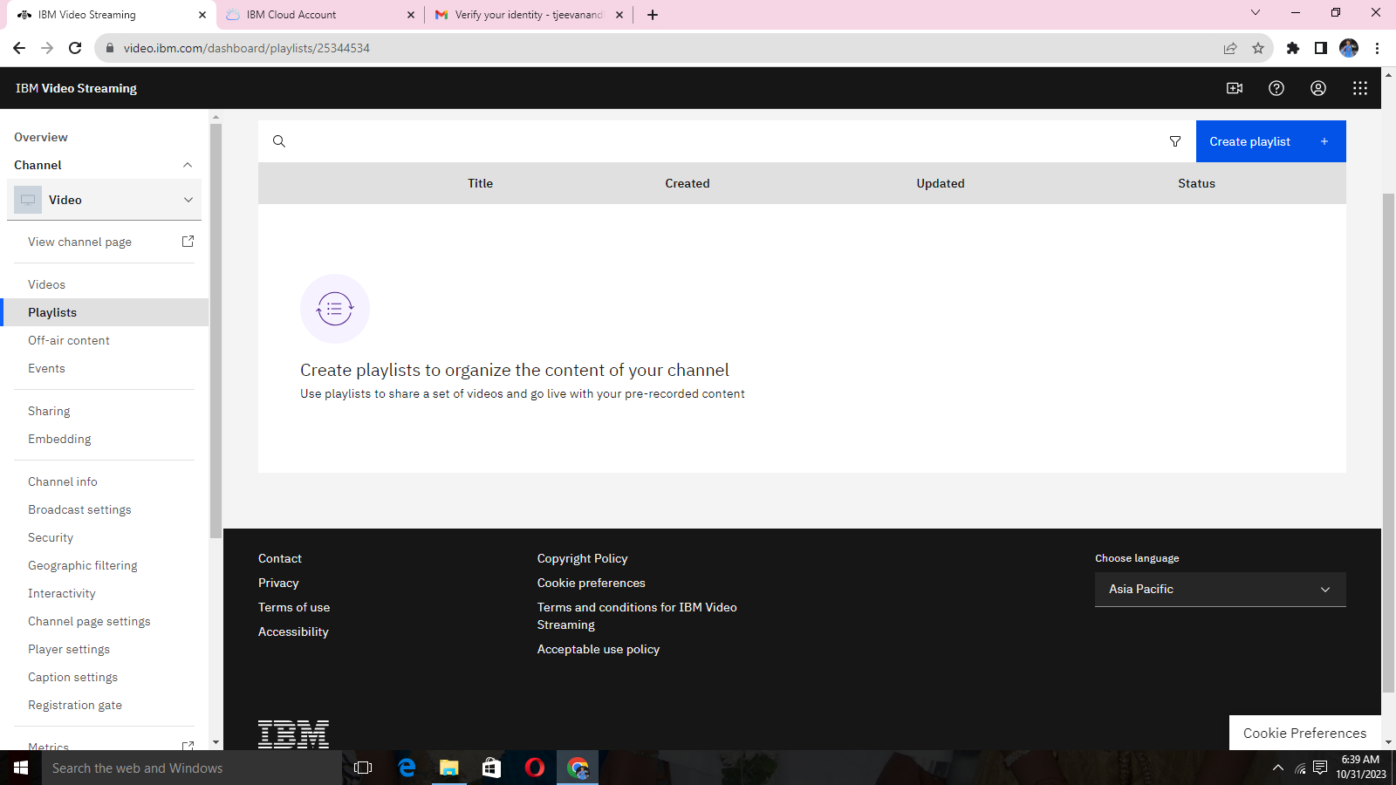

**STEP 20:**

*Playlist created

d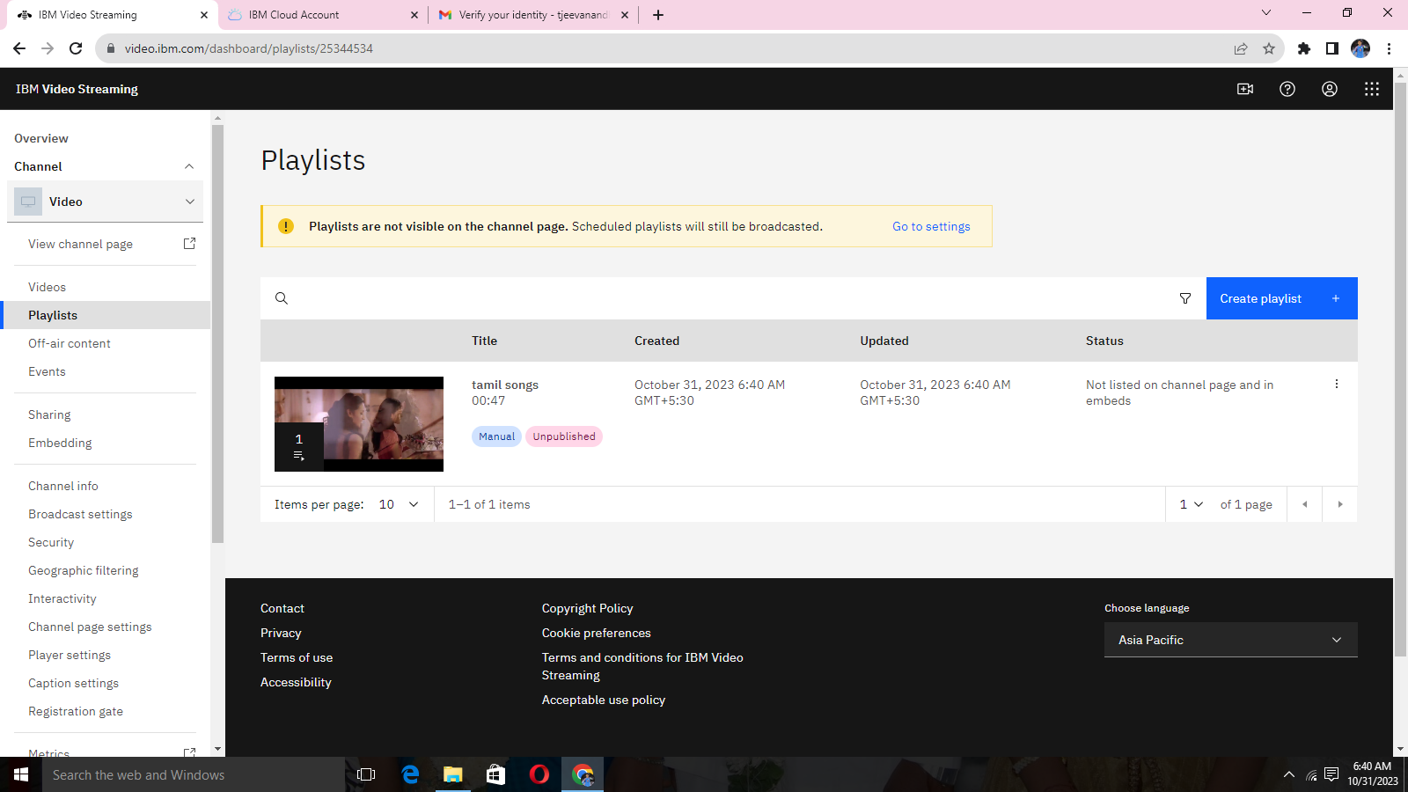

CONCLUSION:

***In this part we successfully built the project. By the virtual cinema platform using IBM Cloud Video Streaming we had uploaded the video.***

***Defined the platform's features and design an intuitive user interface.***

***User registration and authentication mechanisms has been ensured the secure access to the platform.***

*Interactivity platform for interactions with viewers about the uploaded video.*