

**College code: 5113**

**Batch members:**

**1. JEEVANANDHAN.T (au511321104037)** [**tjeevanandhanjaya2004@gmail.com**](mailto:tjeevanandhanjaya2004@gmail.com)

**2. KABILAN.K (au511321104038)** [**kabilan0701@gmail.com**](mailto:kabilan0701@gmail.com)

**3. LOKESH KUMAR.V (au511321104049)** [**lokeshkumarlucky06@gmail.com**](mailto:lokeshkumarlucky06@gmail.com)

**4. JAYABALAJI .A (au511321104033)** [**jayabalaji445@gmail.com**](mailto:jayabalaji445@gmail.com)

**5. KARTHIKEYAN.S (au511321104041)** [**karthikeyan2003b3@gmail.com**](mailto:karthikeyan2003b3@gmail.com)

**CLOUD APPLICATION DEVELOPMENT**

**PROJECT 10: Media Streaming with IBM Cloud Video Streaming**

**INTRODUCTION:**

**Phase 4:**

.  Continue building the platform by integrating video streaming services and enabling on-demand playback.

By implement the functionality for users to upload their movies and videos to the platform.

Integrate IBM Cloud Video Streaming services to enable smooth and high-quality video playback.

**STEP 1:**

**\*Login our IBM CLOUD ACCOUNT**

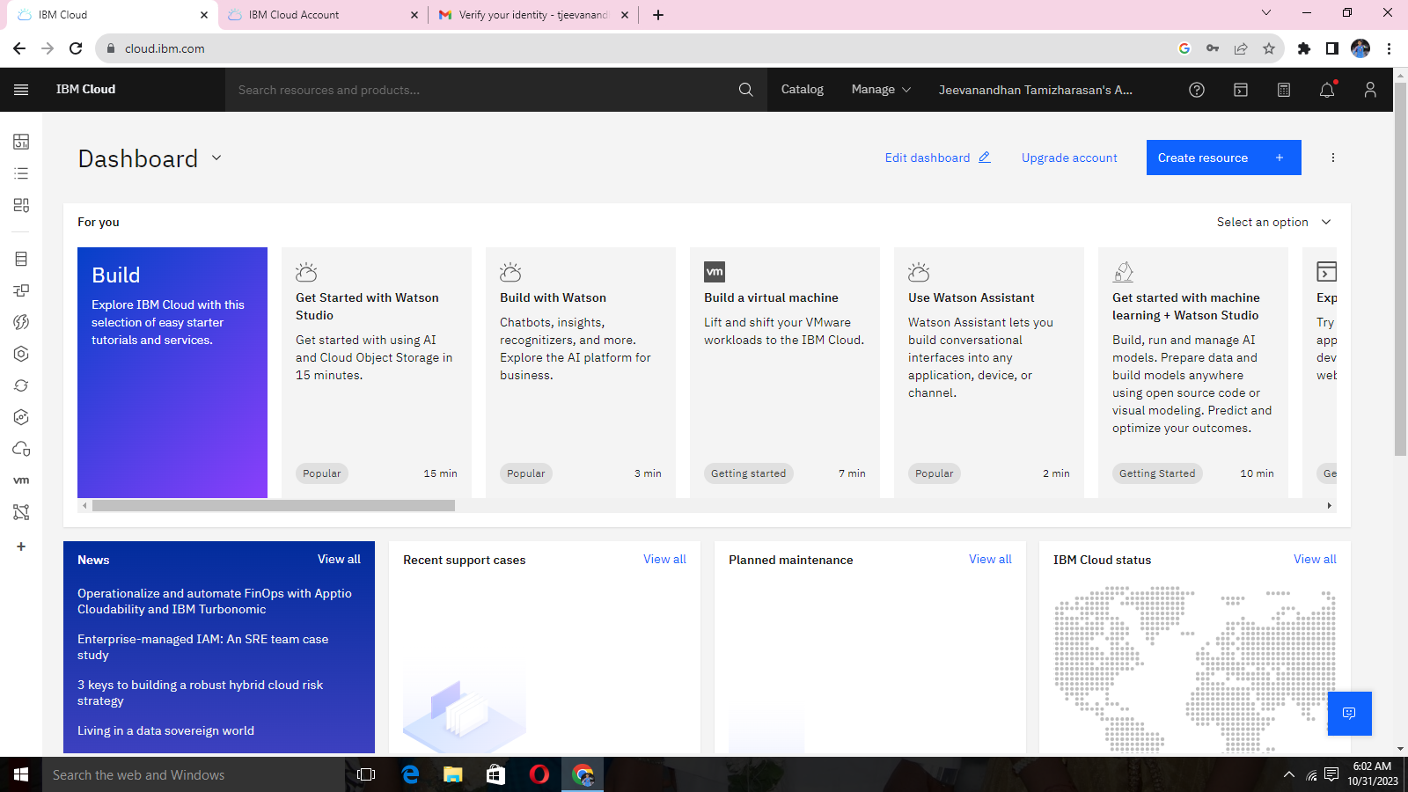

**STEP 2:**

**\*Overview of Dashboard**

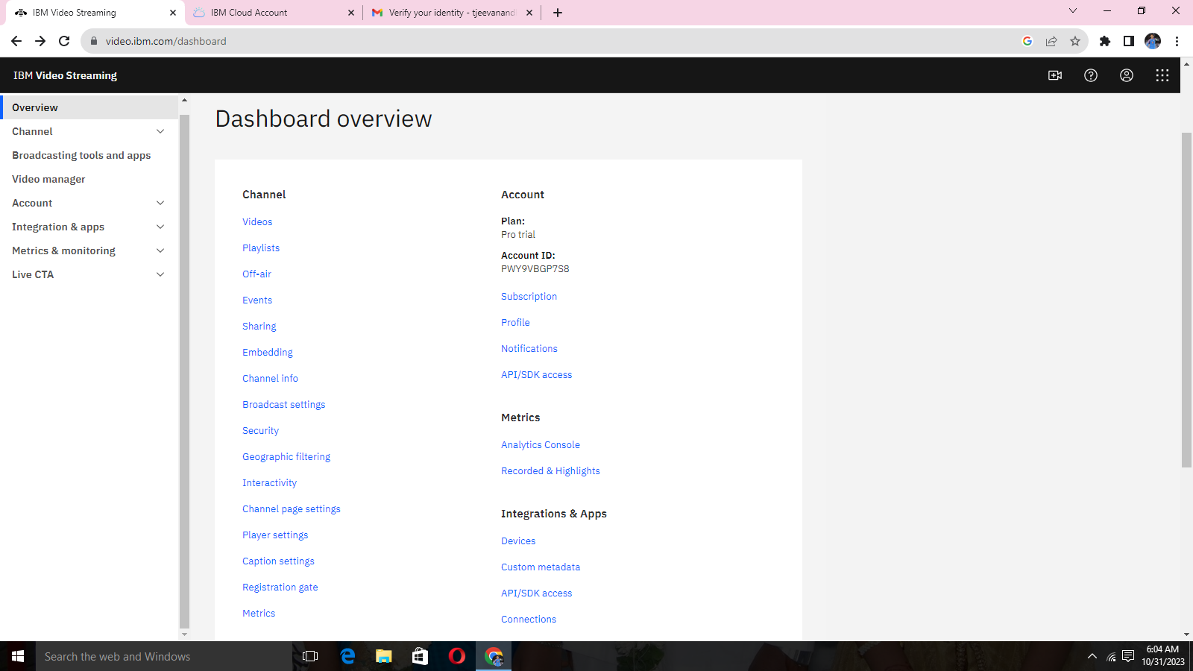

**STEP 3:**

**\*video uploading option**

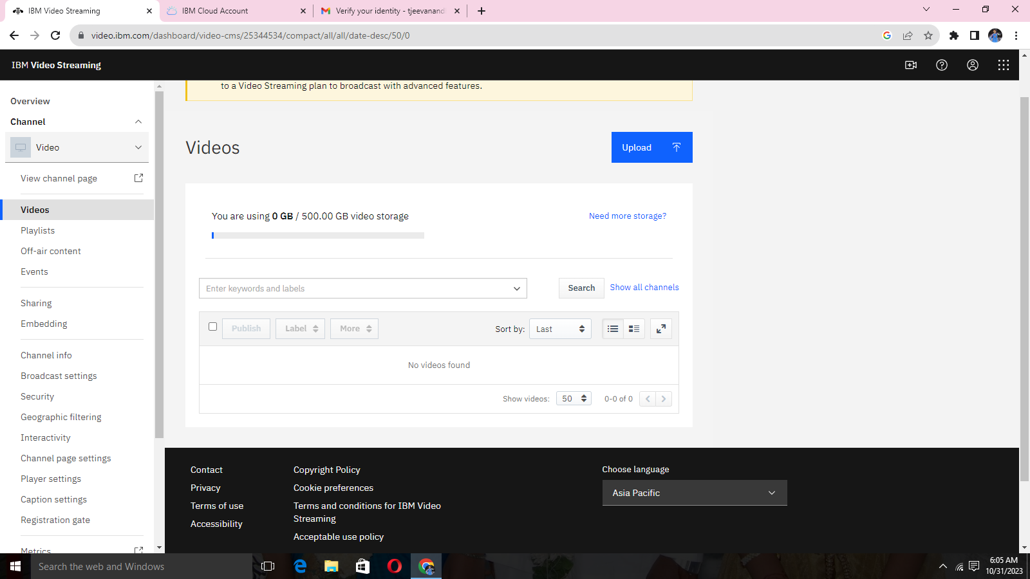

**STEP 4:**

**\*Select the file or video to be uploaded.**

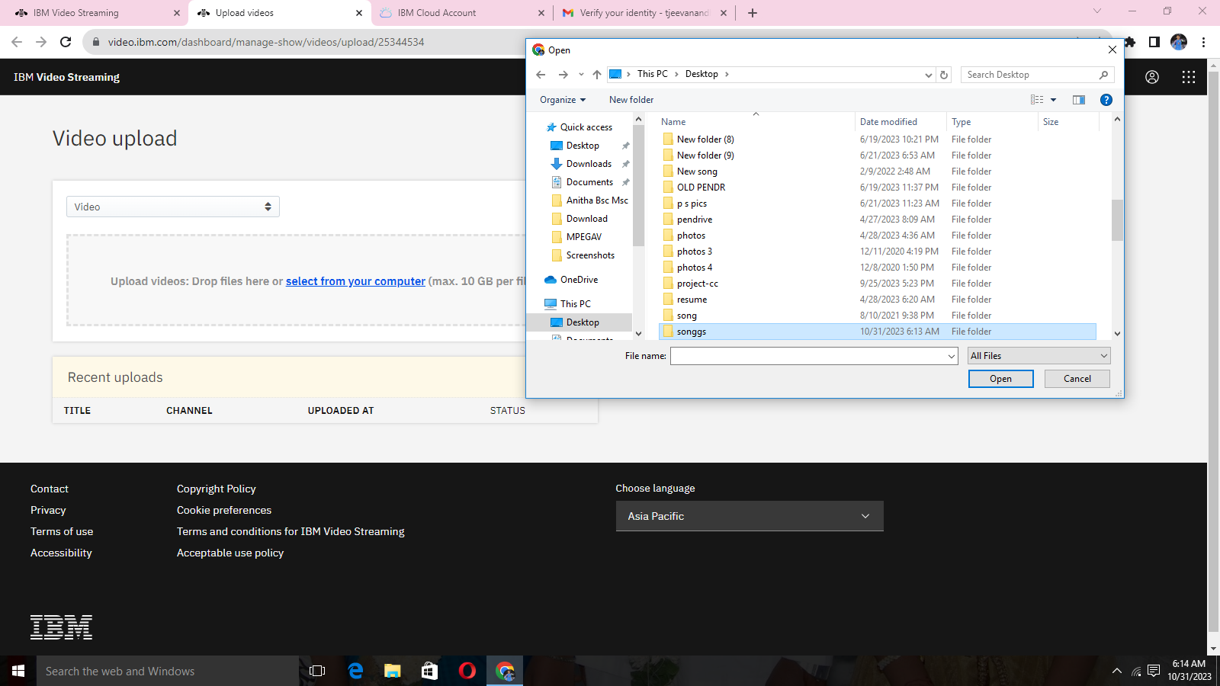

**STEP 5:**

**\*Upload of video on process.**

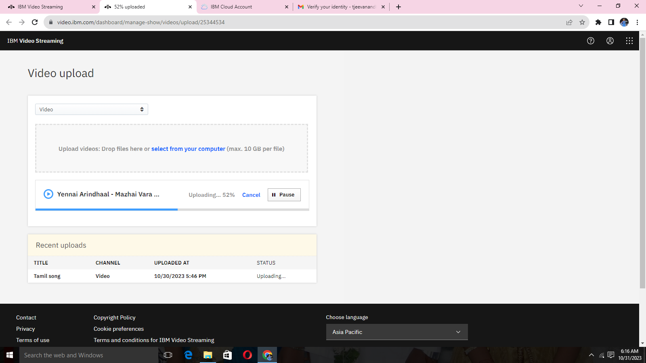

**STEP 6:**

**Video description with proper topic name.**

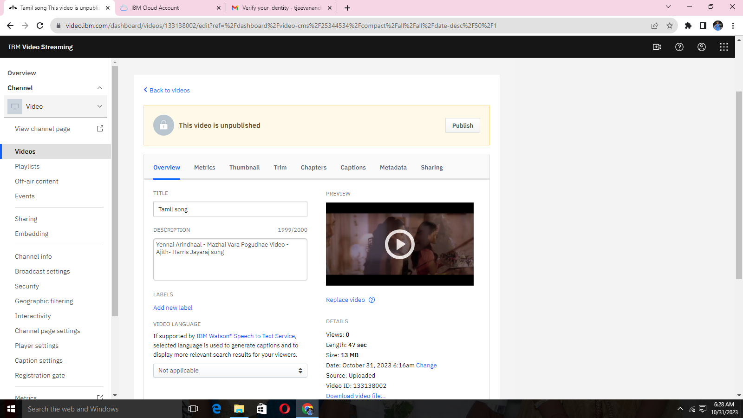

**STEP 7:**

**\*Video information about all the video uploaded information.**

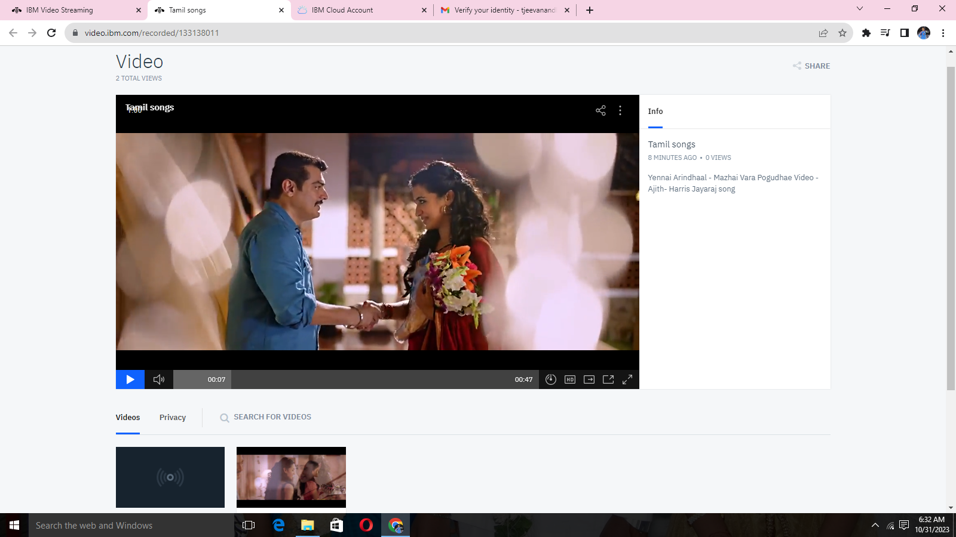

**STEP 8:**

**\*Sharing the direct link to the channel**

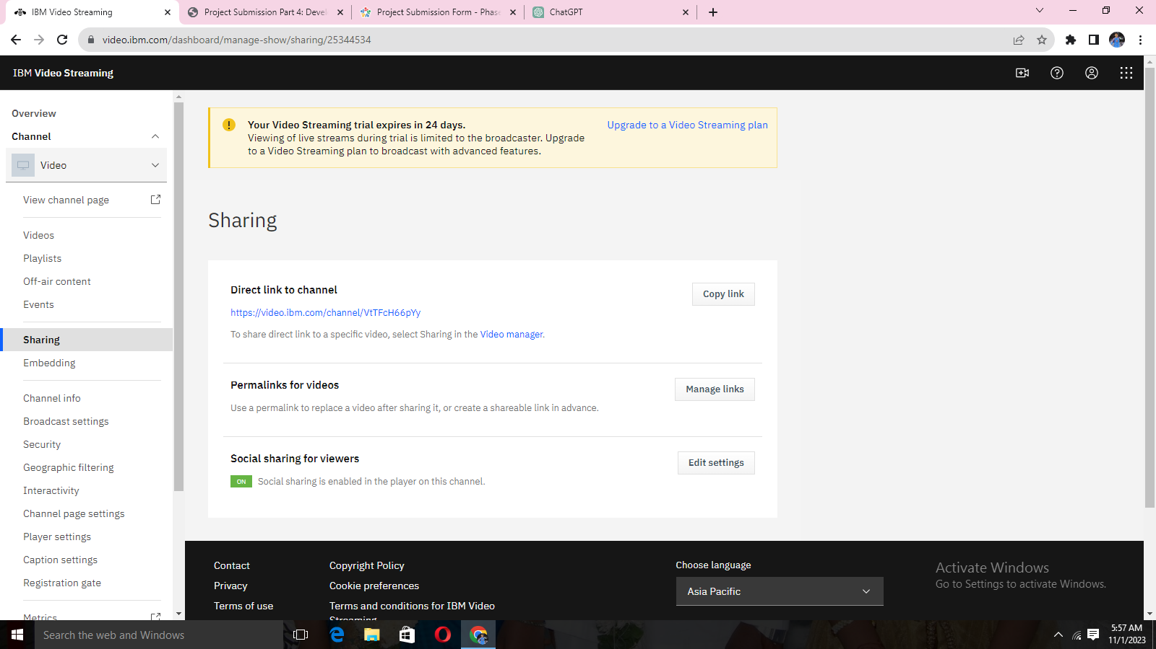

**STEP 9:**

**\*customize the sharing button in your video player.**

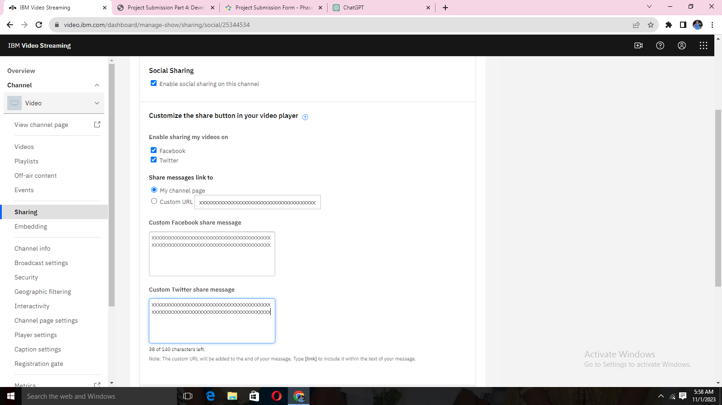

**STEP 10:**

**\*Broadcast setting in auto-recording, multi-quality streaming end encoder setting will be performed.**

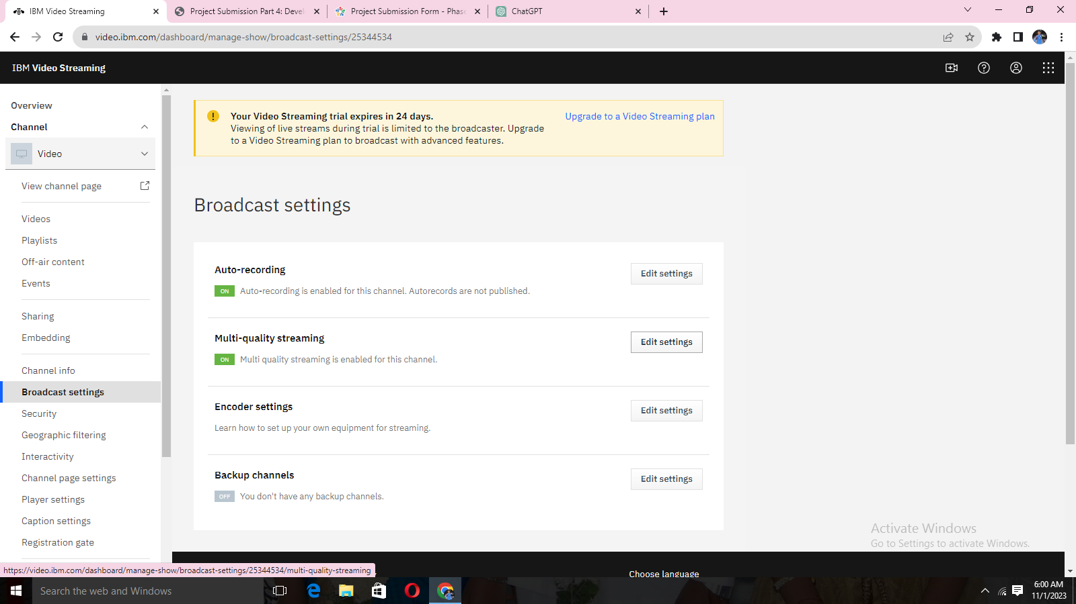

**STEP 11:**

**\*Multi-quality streaming will apply to live broadcasts. When uploaded videos will also be processed with actual setting.**

**\*for the resolutions available for viewers**

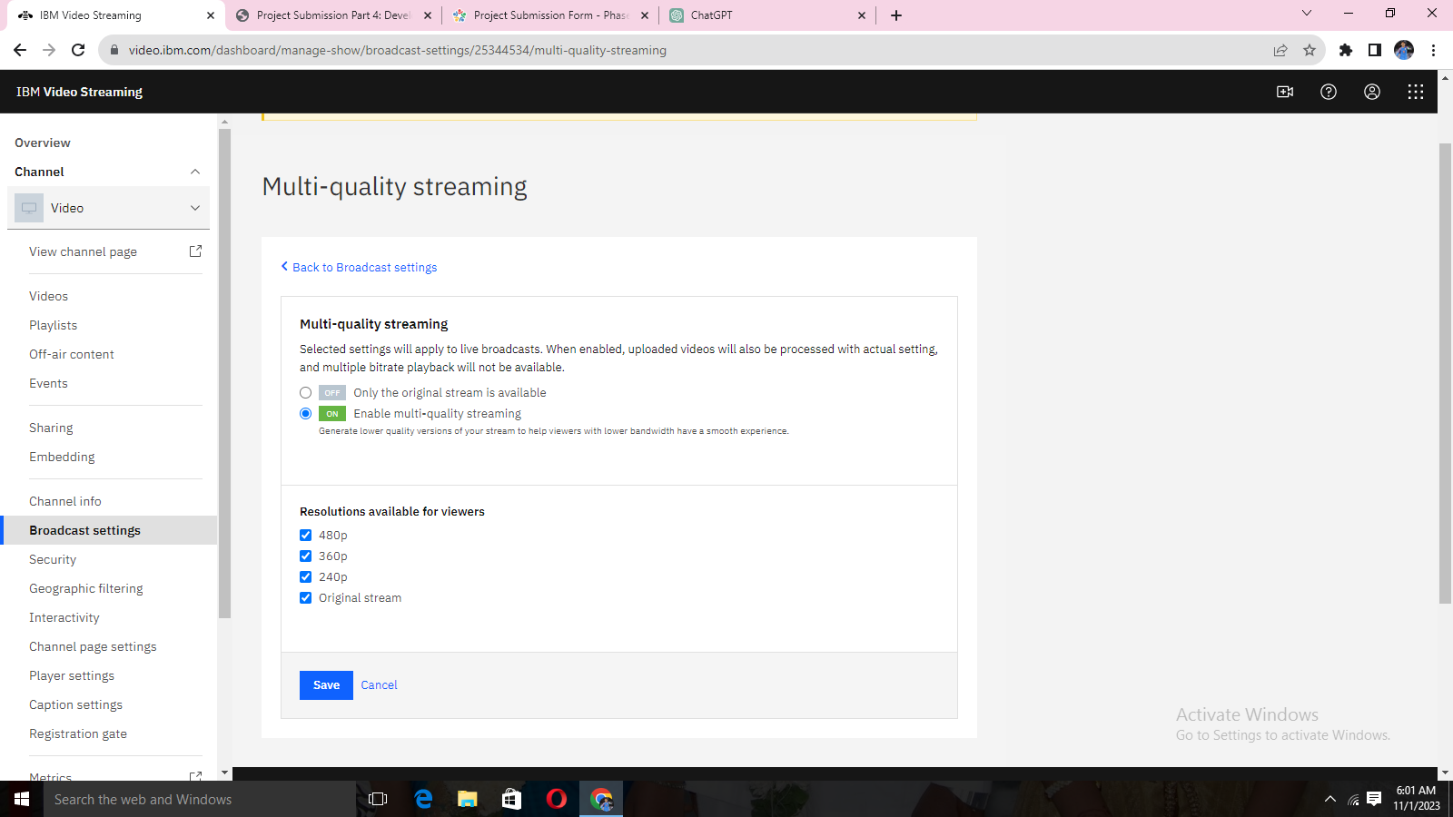

**STEEP 12:**

**\*Manual entry where values into the appropriate fields in your encoder’s configuration interface.**

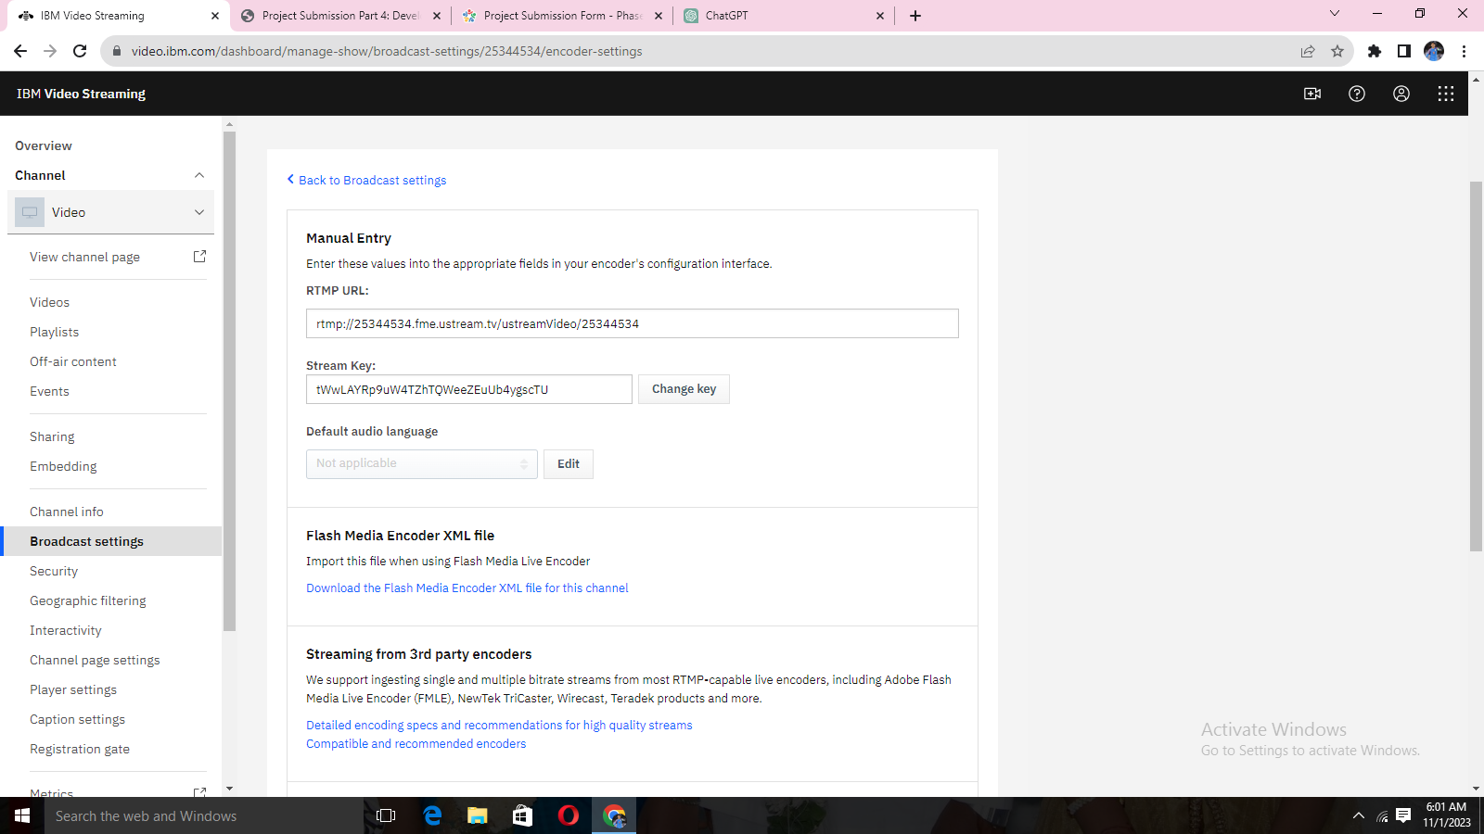

**STEP 13:**

**\*Manage interactions with your viewers during your broadcast and setup your streaming software and monitor your live broadcast.**

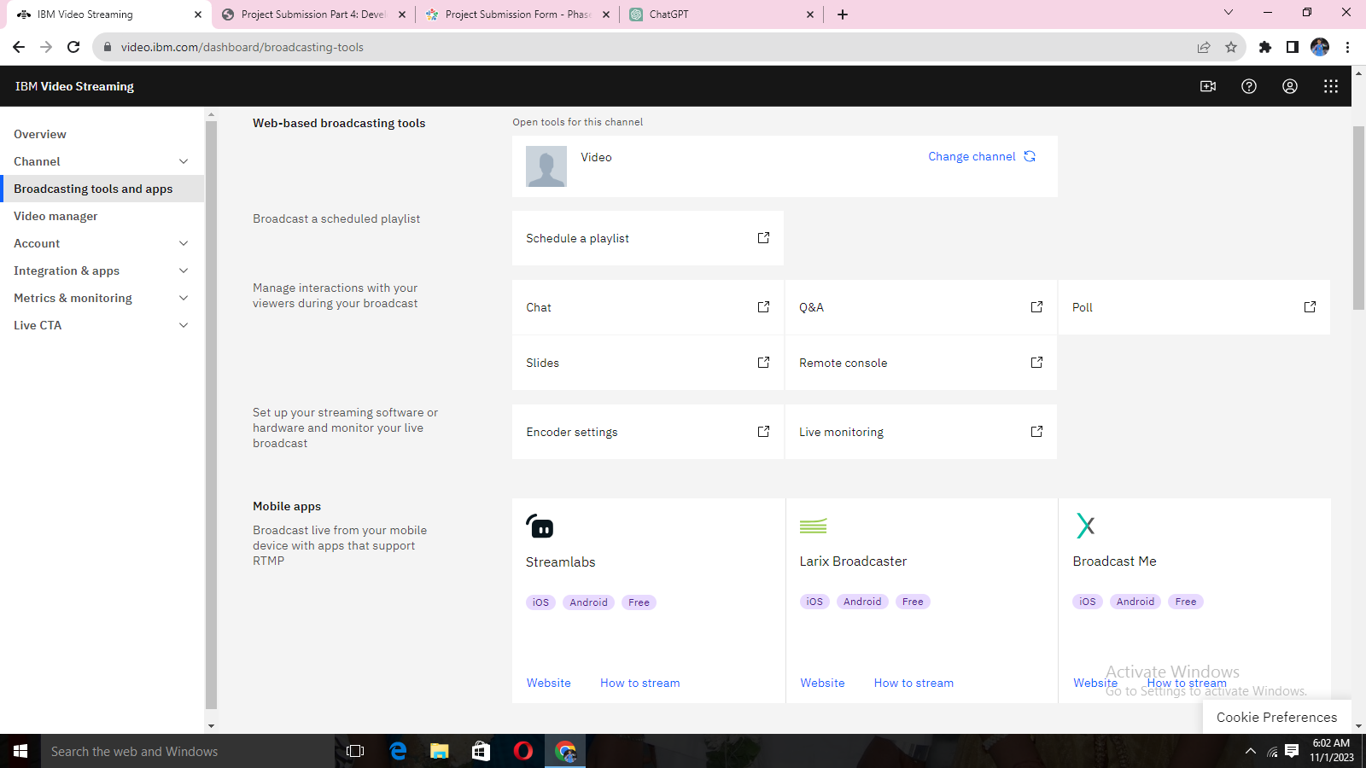

**STEP 14:**

**\*Add custom data field with type of string, numeric value, data, Boolean, tag list and link**

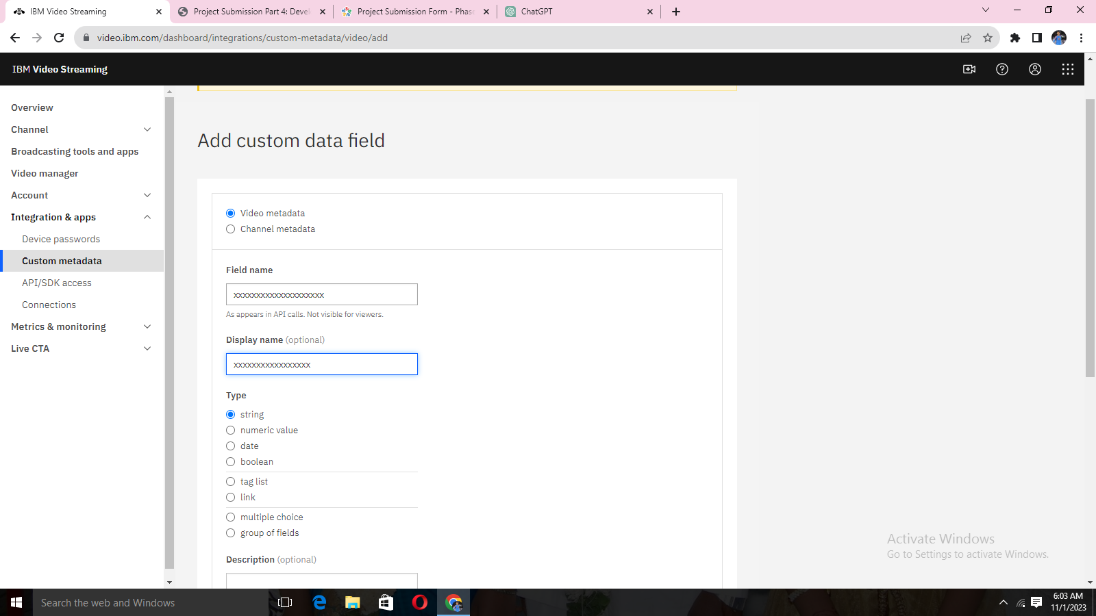

**STEP 15:**

**\*APK/SDK access to the channel in your applications need credentials, which you can create here. For detailed usage instructions, visit the documentation.**

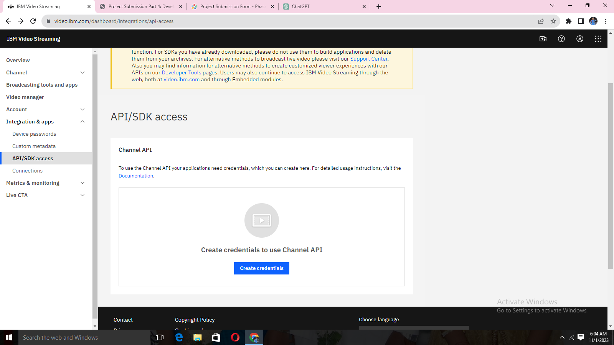

**STEP 16:**

**\*Create new credentials with application name and with redirect URL.**

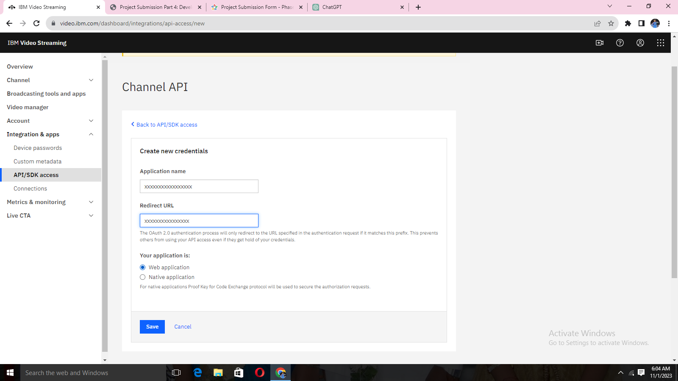

**STEP 17:**

**\*Statistics for recorded videos and highlights.**

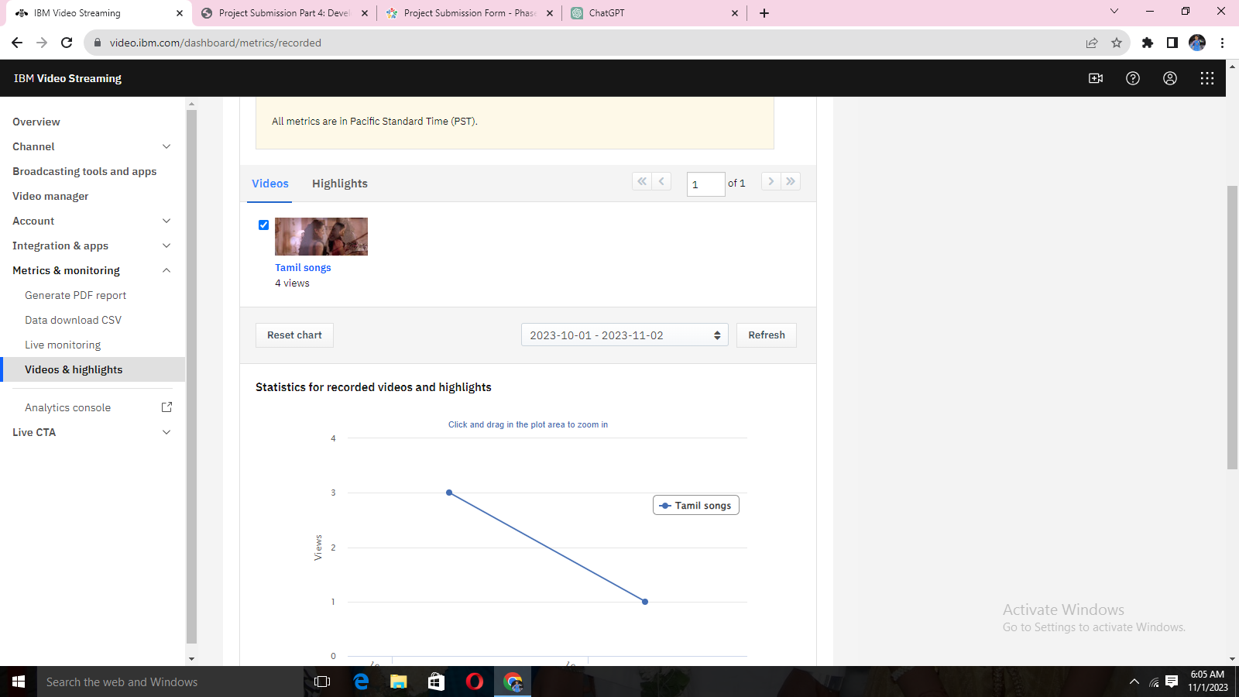

**STEP 18:**

**\*Video uploaded with high quality option. Many qualities with the speed adjust option**.

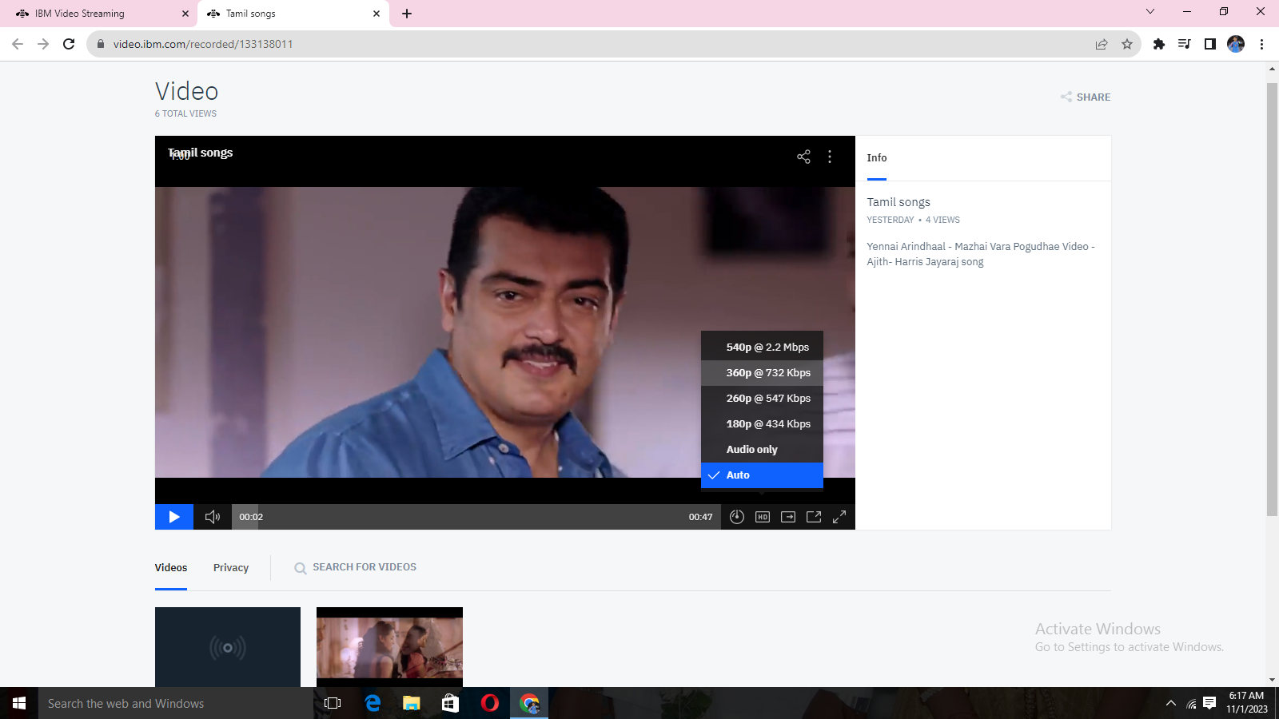

**CONCLUSION:**

.  Successfully built platform by integrating video streaming services and enabling on-demand playback.

And also by implement the functionality for users to upload their movies and videos to the platform.

IBM Cloud Video Streaming services to enable smooth and high-quality video playback. 