1. create database sts;
use sts;

DELIMITER //
CREATE PROCEDURE total_one(IN data1 decimal(10,2), IN data2
decimal(10,2), OUT total decimal(10,2))
BEGIN
SET total = data1 + data2;
SELECT total;
END //
DELIMITER ;
Call total_one(10,20,@total)


2. create database sts;
use sts;

create table drone(drone_id int,model varchar(20),capacity int,batterylife int);
DELIMITER //
CREATE PROCEDURE add_drone(
IN d INT,
IN m VARCHAR(50),
IN c decimal(5,2),
IN b decimal(5,2) )
BEGIN
INSERT INTO drone(drone_id, model, capacity, batterylife)
VALUES (d, m, c, b);
END //
DELIMITER ;
CALL add_drone(104, 'lattice', 650.00, 27.00);
select * from drone;

3. create database student;
use student;
CREATE TABLE Employee(id INT,name VARCHAR(50),salary INT);
INSERT INTO Employee VALUES(1,'A',10000),(2,'B',20000),(3,'C',30000),(4,'D',40000),(5,'E',50000);
drop table employee;

SELECT * FROM Employee WHERE id = 3;

CREATE INDEX idx_emp_id ON Employee(id);
SELECT * FROM Employee WHERE id = 2;
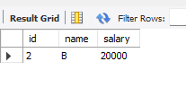
4. create database student;
use student;
create table stdun(sid int,sname varchar(20),dept varchar(20));

insert into stdun values(101,"riya","CSE");
insert into stdun values(102,"ram","ECE");
insert into stdun values(103,"sam","CSE");

select * from stdun;

create table mark(sid int,subject_ varchar(20),marks_ int);

insert into mark values(101,"DBMS",80);
insert into mark values(102,"DBMS",90);
insert into mark values(103,"DBMS",95);

select * from mark;
inner join
SELECT sname, marks_
FROM stdun INNER JOIN mark ON stdun.sid = mark.sid;
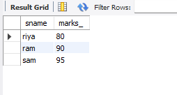
5. -- >> INNER JOIN WITH WHERE
SELECT sname, marks_ FROM stdun S INNER JOIN mark M ON S.sid = M.sid
WHERE M.marks_ > 80;

6. -- >> LEFT JOIN
SELECT * FROM stdun S LEFT JOIN mark M ON S.sid = M.sid;
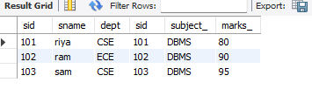
7. -- >> RIGHT JOIN
SELECT * FROM stdun S RIGHT JOIN mark M
ON S.sid = M.sid;
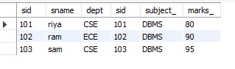
8. -- >> JOIN WITH ORDER
SELECT sname,marks_ FROM stdun S INNER JOIN mark M ON S.sid = M.sid
ORDER BY marks_ DESC;
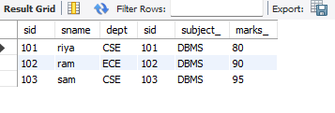
8. -- >> JOIN WITH GROUP BY
SELECT dept, AVG(marks_) AS avg_marks FROM stdun S INNER JOIN mark M ON S.sid = M.sid GROUP BY dept;
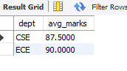
9. -- >> SELF JOIN
SELECT A.sname AS Stdun1, B.sname AS Stdun2, A.dept FROM stdun A JOIN stdun B ON A.dept = B.dept AND A.sid < B.sid;
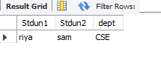
10. -- >> JOIN WITH DISTINCT
SELECT DISTINCT dept FROM stdun S JOIN mark M ON S.sid = M.sid WHERE marks_ > 80;


11. create database sts;
use sts;
CREATE TABLE Student(id INT PRIMARY KEY,name VARCHAR(50),dept VARCHAR(20));
CREATE TABLE Course(id INT,course VARCHAR(50));

INSERT INTO Student VALUES(1,'Arun','CSE'),(2,'Ravi','IT'),(3,'Kiran','CSE');

INSERT INTO Course VALUES(1,'DBMS'),(2,'Networks'),(3,'OS');

SELECT name,course FROM Student, Course WHERE Student.id = Course.id AND dept = 'CSE';

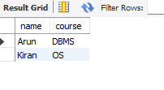
SELECT name,course FROM (SELECT * FROM Student WHERE dept='CSE') S JOIN Course C ON S.id = C.id;
12.create database sts;
use sts;
create table students(st_id int PRIMARY KEY , std_name varchar(50) , course varchar(40));
insert into students values(1,"vicky","btech");
select * from students;
alter table students add age int;
rename table students to courselist;
select * from courselist;
SET SQL_SAFE_UPDATES = 0;
DELETE FROM std WHERE st_id=001;
ROLLBACK;
select * from std;


