WEEK 3 TASK
ADVANCED DATA ANALYSIS AND VISUALIZATION IN LOGISTICS

Python-based Exploratory Data Analysis of a Hypothetical Logistics Dataset

1. Objective
The objective of this task is to apply Python-based exploratory data analysis (EDA) and visualization techniques to a hypothetical logistics dataset. The analysis focuses on delivery performance, shipment volume, transportation distance, logistics costs, delays, and transport modes. The purpose is to demonstrate how data can support operational decision-making in logistics.

2. Dataset Design and Methodology
A simulated dataset containing 200 shipments was created for this analysis. The data represents realistic logistics operations and includes shipment, geographic, transportation, delivery, delay, and cost variables.
Variable | Type | Purpose
Shipment_ID | Categorical | Unique shipment identifier
Region | Categorical | Geographic operating region
Transport_Mode | Categorical | Road, Rail, Air or Sea
Priority | Categorical | Standard or Express shipment
Shipment_Volume_kg | Numeric | Shipment quantity in kilograms
Distance_km | Numeric | Transportation distance
Delivery_Time_days | Numeric | Time taken to deliver shipment
Delay_days | Numeric | Number of delay days
On_Time | Categorical | Whether shipment was delivered on time
Transport_Cost_INR | Numeric | Primary transportation cost
Fuel_Cost_INR | Numeric | Estimated fuel-related cost
Warehouse_Cost_INR | Numeric | Estimated warehousing cost
Total_Logistics_Cost_INR | Numeric | Combined logistics cost

3. Exploratory Data Analysis
The EDA began with descriptive statistics, central tendency measures, distributions, and correlation analysis. Mean and median values were examined to understand typical logistics performance, while standard deviation and ranges were used to identify variability.
Metric | Mean | Median | Std. Dev. | Minimum | Maximum
Shipment_Volume_kg | 1009.05 | 985.00 | 543.03 | 128.00 | 1999.00
Distance_km | 1252.56 | 1239.00 | 709.95 | 61.00 | 2492.00
Delivery_Time_days | 21.69 | 19.24 | 15.42 | 0.50 | 71.35
Delay_days | 1.35 | 1.29 | 0.98 | 0.00 | 3.83
Transport_Cost_INR | 120.84 | 80.00 | 71.77 | 80.00 | 480.66
Fuel_Cost_INR | 31.69 | 24.32 | 21.09 | 14.56 | 133.83
Warehouse_Cost_INR | 25.19 | 23.62 | 15.01 | 2.16 | 60.26
Total_Logistics_Cost_INR | 177.71 | 136.76 | 94.83 | 98.05 | 635.33

4. Key Descriptive Findings
• The average delivery time was 21.69 days, while the median was 19.24 days.
• The average shipment delay was 1.35 days.
• The overall on-time delivery rate was 41.0%.
• Average total logistics cost per shipment was approximately ₹177.71.
• Shipment volume and distance showed positive relationships with total logistics cost, indicating that larger and longer shipments generally require greater logistics spending.

5. Correlation Analysis
Correlation analysis was used to examine linear relationships between numerical logistics variables. A positive correlation indicates that two variables tend to increase together, while a negative correlation indicates an inverse relationship. Correlation does not by itself establish causation.
Transport_Cost_INR vs Total_Logistics_Cost_INR: correlation = 0.98
Fuel_Cost_INR vs Total_Logistics_Cost_INR: correlation = 0.96
Transport_Cost_INR vs Fuel_Cost_INR: correlation = 0.95
Shipment_Volume_kg vs Warehouse_Cost_INR: correlation = 0.91
Distance_km vs Delivery_Time_days: correlation = 0.72

6. Visualizations and Interpretation

Distribution of Delivery Time
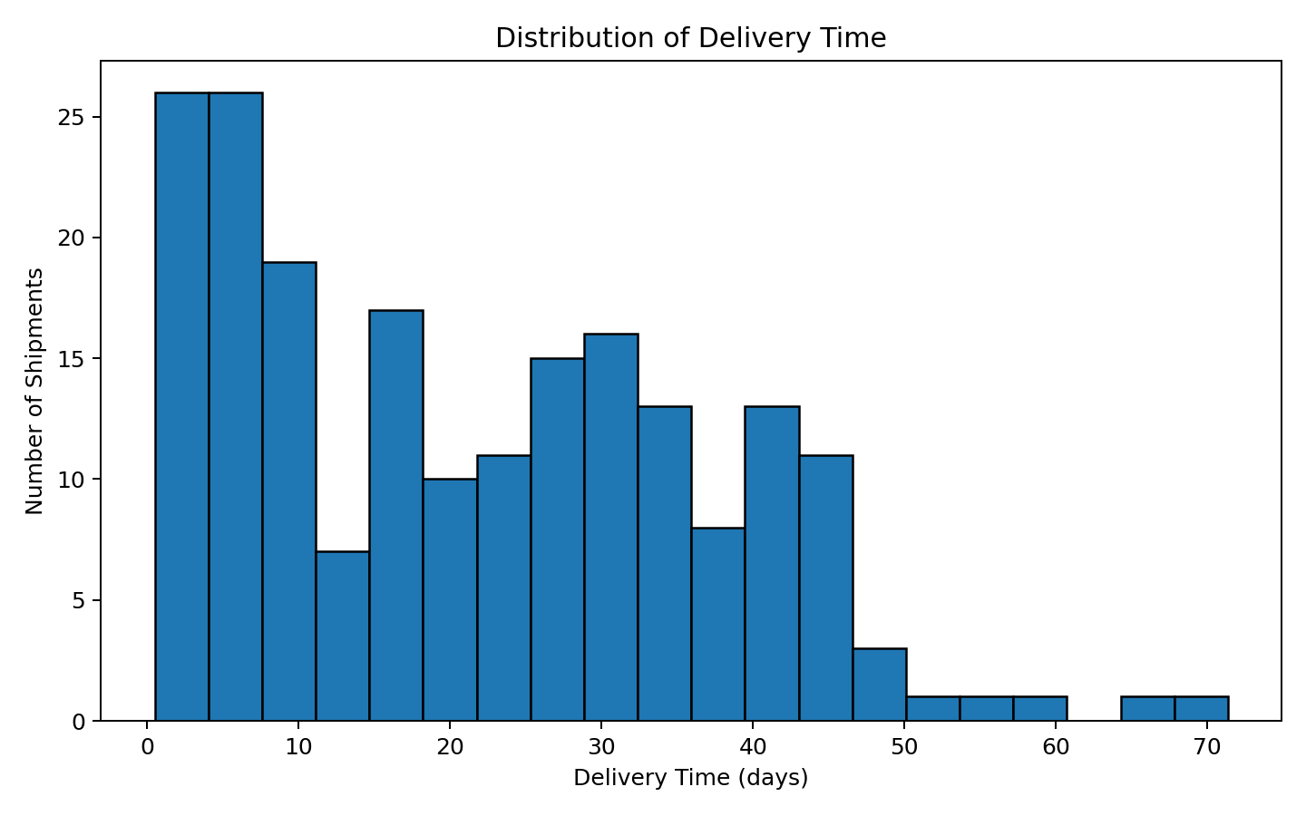
Histogram shows the distribution of shipment delivery times.
Why this visualization was chosen: A histogram was selected because it clearly shows the distribution, concentration, and spread of delivery times. It helps identify whether delivery performance is concentrated around the typical value or affected by longer delivery cases.
Interpretation: The distribution provides a direct view of normal delivery patterns and potential outliers. A logistics manager can use this to investigate unusually long deliveries.

Total Logistics Cost by Transport Mode
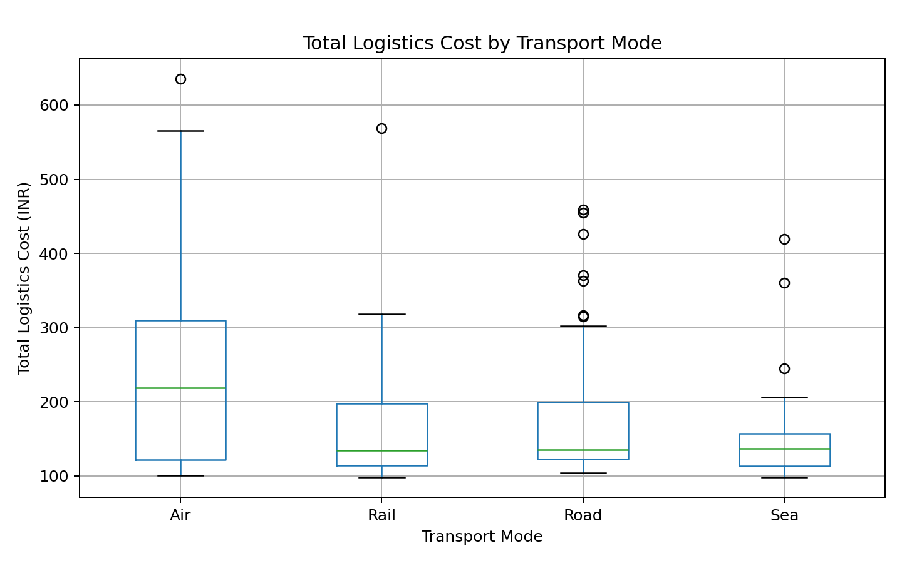
Box plot comparing total logistics costs across transport modes.
Why this visualization was chosen: A box plot was selected because it compares the central tendency, spread, and extreme values of logistics costs across transport modes.
Interpretation: The chart helps compare the cost structure and variability of Road, Rail, Air, and Sea shipments. Higher cost modes may be appropriate for urgent shipments but should be evaluated against service requirements.

Shipment Volume vs Total Logistics Cost
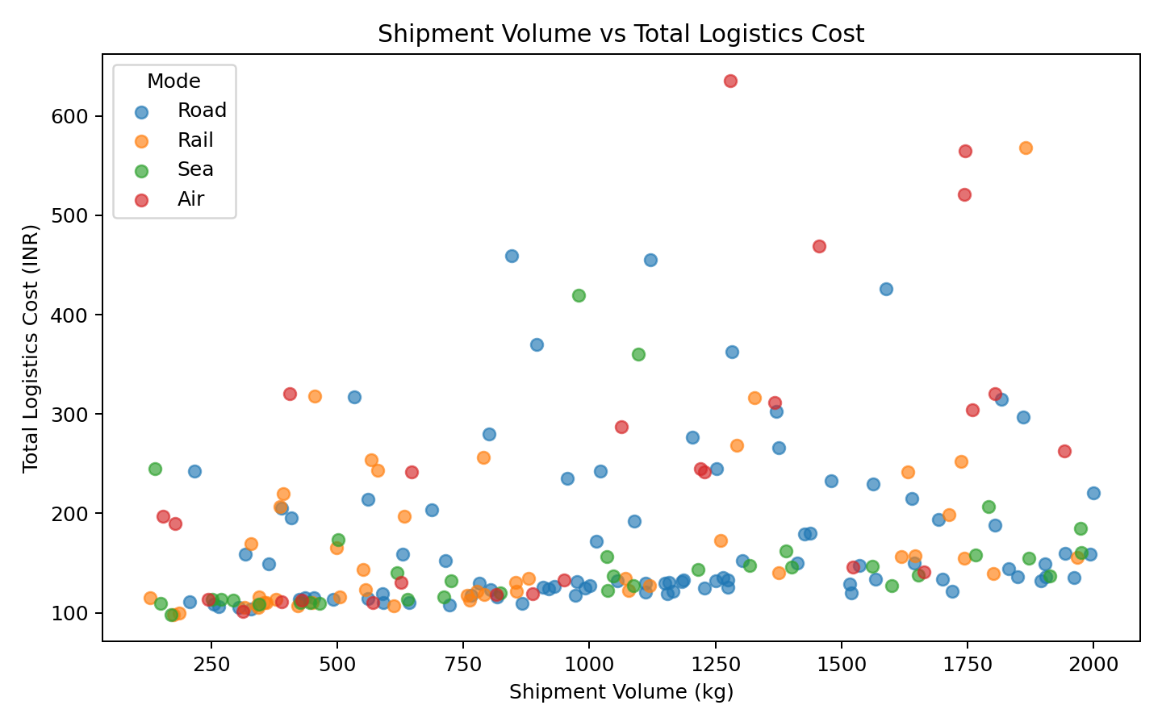
Scatter plot examining the relationship between shipment volume and total logistics cost.
Why this visualization was chosen: A scatter plot was selected to examine the relationship between shipment size and total cost. Different transport modes are shown separately to make operational patterns easier to identify.
Interpretation: The plot indicates that larger shipments generally require more total logistics spending. It can support cost planning and shipment consolidation decisions.

Average Delay by Region
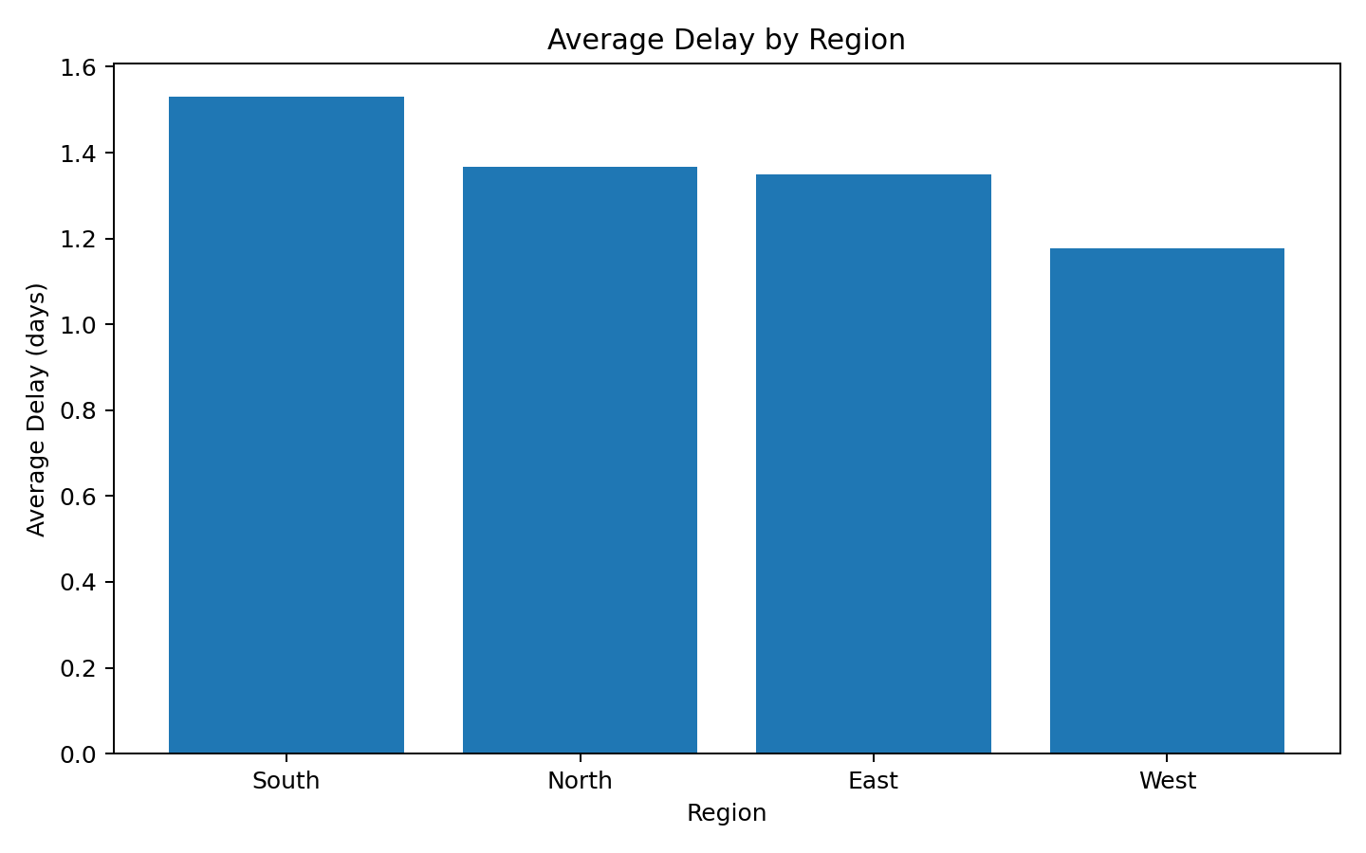
Bar chart identifying regions with higher average shipment delays.
Why this visualization was chosen: A bar chart was selected because it makes regional differences in average delay easy to compare.
Interpretation: Regions with higher average delay require further investigation. Possible areas include route planning, local infrastructure, warehouse handoffs, or carrier performance.

Distance vs Delivery Time
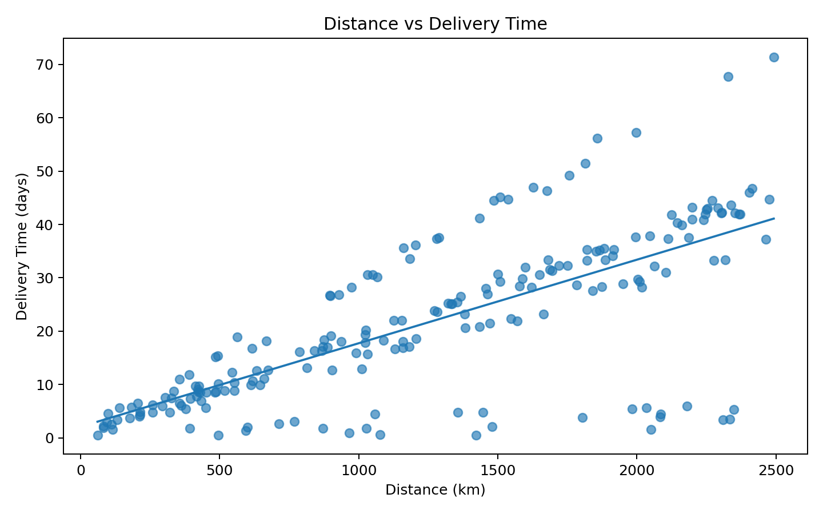
Scatter plot showing how shipment distance is associated with delivery time.
Why this visualization was chosen: A scatter plot with a fitted trend line was selected to examine whether longer transportation distances are associated with longer delivery times.
Interpretation: The positive trend indicates that distance is an important operational factor in delivery time. This can support more realistic delivery-time estimates and service-level planning.

7. Transport Mode Analysis
Mode | Shipments | Avg Delivery (days) | Avg Cost (INR) | On-Time Rate
Sea | 35.0 | 32.3 | 153.2 | 48.6
Rail | 48.0 | 16.7 | 166.3 | 45.8
Road | 91.0 | 25.6 | 173.1 | 34.1
Air | 26.0 | 3.0 | 248.1 | 46.2
The transport-mode table provides a practical comparison between service speed, cost, and reliability. It should be used to match transport choices with shipment priority and customer service requirements rather than focusing on cost alone.

8. Regional Performance Analysis
Region | Shipments | Avg Delay (days) | Avg Cost (INR) | On-Time Rate
South | 46.0 | 1.5 | 175.4 | 23.9
North | 46.0 | 1.4 | 180.6 | 37.0
East | 54.0 | 1.4 | 180.8 | 46.3
West | 54.0 | 1.2 | 174.1 | 53.7

9. Key Analytical Insights
• Delivery performance: the overall on-time delivery rate is 41.0%, providing a useful baseline for operational monitoring.
• Regional bottleneck: South has the highest average delay in the simulated dataset, so its routes and carrier/warehouse handoffs should be reviewed.
• Regional comparison: West has the lowest average delay among the four regions in this dataset.
• Cost driver: Air has the highest average total logistics cost, while Sea has the lowest average cost in the simulation.
• Shipment volume is an important cost factor. Larger shipments generally require higher total logistics spending.
• Distance is associated with longer delivery times, so delivery promises should account for route distance.
• The dataset suggests that logistics performance should be evaluated using multiple KPIs together: cost, delivery time, delay, on-time rate, volume, and distance.

10. Recommendations
• Monitor regional delay rates regularly and investigate locations that consistently perform below the overall service baseline.
• Use transport-mode selection based on a balance between cost, delivery urgency, shipment volume, and required service level.
• Improve delivery-time estimates by incorporating route distance and historical delay patterns.
• Analyze high-cost shipments individually to determine whether costs are driven by distance, mode, low shipment utilization, or additional handling.
• Consider shipment consolidation where service requirements allow it, especially for smaller shipments travelling similar routes.
• Build a logistics dashboard that tracks on-time delivery, average delivery time, average delay, cost per shipment, cost per kilogram, and regional performance.

11. Python Tools and Techniques Used
Python was used for data simulation, data manipulation, descriptive statistics, correlation analysis, and visualization. Pandas were used for tabular data processing, NumPy for numerical simulation, and Matplotlib for visualization. The workflow demonstrates how Python can convert raw logistics records into operational insights.

12. Sample Python Code
import pandas as pd
import matplotlib.pyplot as plt
df = pd.read_csv("week3_logistics_dataset.csv")
print(df.describe())
# Correlation analysis
print(df.select_dtypes("number").corr())
# Delivery-time distribution
plt.hist(df["Delivery_Time_days"], bins=20, edgecolor="black")
plt.title("Distribution of Delivery Time")
plt.xlabel("Delivery Time (days)")
plt.ylabel("Number of Shipments")
plt.show()
# Cost by transport mode
df.boxplot(column="Total_Logistics_Cost_INR", by="Transport_Mode")
plt.suptitle("")
plt.title("Total Logistics Cost by Transport Mode")
plt.show()

13. Conclusion
This analysis demonstrates how exploratory data analysis and visualization can support logistics decision-making. The simulated dataset shows that delivery performance and logistics cost are influenced by operational factors such as transport mode, shipment volume, distance, and region. Visual analysis makes these relationships easier to identify than reviewing raw records alone. The findings can be used as a foundation for further analysis using real logistics data, predictive models, and interactive dashboards.

14. Deliverables Included
✓ Hypothetical logistics dataset with 200 shipment records.
✓ Descriptive statistics and central tendency analysis.
✓ Correlation analysis.
✓ Five logistics-focused visualizations.
✓ Interpretation and justification for each visualization.
✓ Operational insights and recommendations.
✓ Python analysis script.

