WEEK 4 TASK
PREDICTIVE MODELING AND OPTIMIZATION IN LOGISTICS SYSTEMS

Forecasting Delivery Time Using Python and Scenario-Based Optimization

1. Objective
This project applies predictive modeling and optimization techniques to a logistics problem. The aim is to forecast shipment delivery time before completion and use the predictions to support transport-mode and service-level decisions. The project extends the previous descriptive analysis into predictive analytics using Python.

2. Problem Definition
The prediction problem is to estimate Delivery_Time_days using information that is available before delivery is completed. Accurate delivery-time forecasting can support customer communication, service-level management, transport planning, and operational resource allocation.
The simulated dataset contains 200 shipment records. The target is Delivery_Time_days and the predictors are Region, Transport_Mode, Priority, Shipment_Volume_kg and Distance_km.

3. Dataset and Features
Feature | Type | Role
Region | Categorical | Geographic operating region
Transport_Mode | Categorical | Road, Rail, Air or Sea
Priority | Categorical | Standard or Express
Shipment_Volume_kg | Numerical | Shipment size
Distance_km | Numerical | Transportation distance
Delivery_Time_days | Numerical | Target to forecast

Data leakage was considered during feature selection. Delay_days and final logistics costs were excluded from the predictive feature set because they may represent information generated during or after the delivery process.

4. Data Preparation
• Load the CSV dataset using Pandas.
• Separate predictors and target.
• Encode categorical variables using OneHotEncoder.
• Standardize numerical variables within the modeling pipeline.
• Split the data into 80% training and 20% test sets.
• Keep preprocessing inside a scikit-learn Pipeline.

5. Model Selection
Three regression models were compared. Linear Regression provides a simple baseline. Decision Tree Regression can represent nonlinear decision rules. Random Forest Regression combines many decision trees and can capture nonlinear relationships and interactions.
Based on the simulated test data, Tuned Random Forest was selected for the final scenario analysis. This selection is specific to this dataset and should be re-evaluated when real logistics data is available.

6. Model Performance
Model | MAE (days) | RMSE (days) | R²
Linear Regression | 3.046 | 4.754 | 0.916
Decision Tree | 2.963 | 4.387 | 0.929
Random Forest | 2.451 | 3.796 | 0.947
The selected model achieved a test MAE of 2.300 days, RMSE of 3.460 days and R² of 0.956. MAE represents the average absolute error in days. RMSE penalizes larger errors more strongly. R² measures how much variation in delivery time is explained relative to a baseline.

7. Cross-Validation and Hyperparameter Tuning
A 5-fold cross-validation procedure was used. For the selected model, the mean cross-validation MAE was 1.772 days (SD 0.314), mean RMSE was 2.501 days, and mean R² was 0.972.
Random Forest hyperparameters were searched with GridSearchCV. The best parameter combination was: {'model__max_depth': 8, 'model__min_samples_leaf': 1, 'model__n_estimators': 100}. The search varied in the number of trees, maximum depth and minimum samples per leaf.

Figure 1. Actual vs Predicted Delivery Time
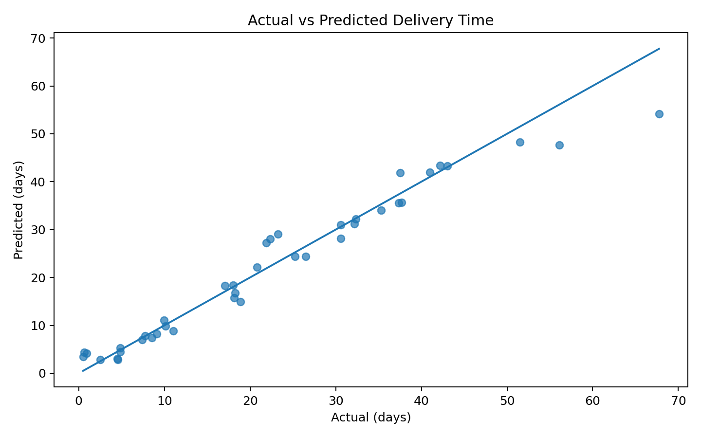
Points close to the diagonal reference line indicate predictions close to actual delivery times. The chart helps identify unusually large prediction errors.

Figure 2. Prediction Residuals
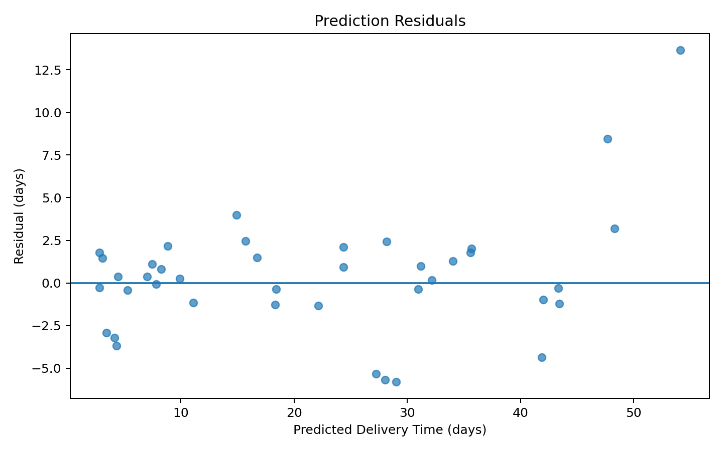
Residuals show the difference between actual and predicted delivery time. Values distributed around zero indicate errors in both directions.

Figure 3. Predictive Model Comparison
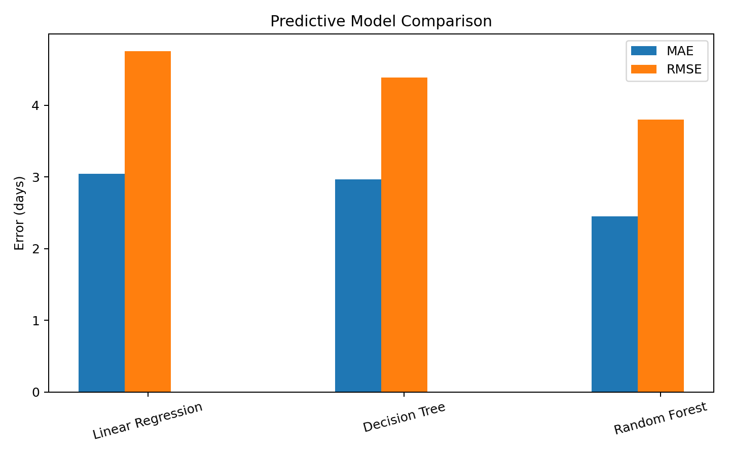
The chart compares MAE and RMSE across the candidate models and provides visual support for model selection.

Figure 4. Top Predictive Features
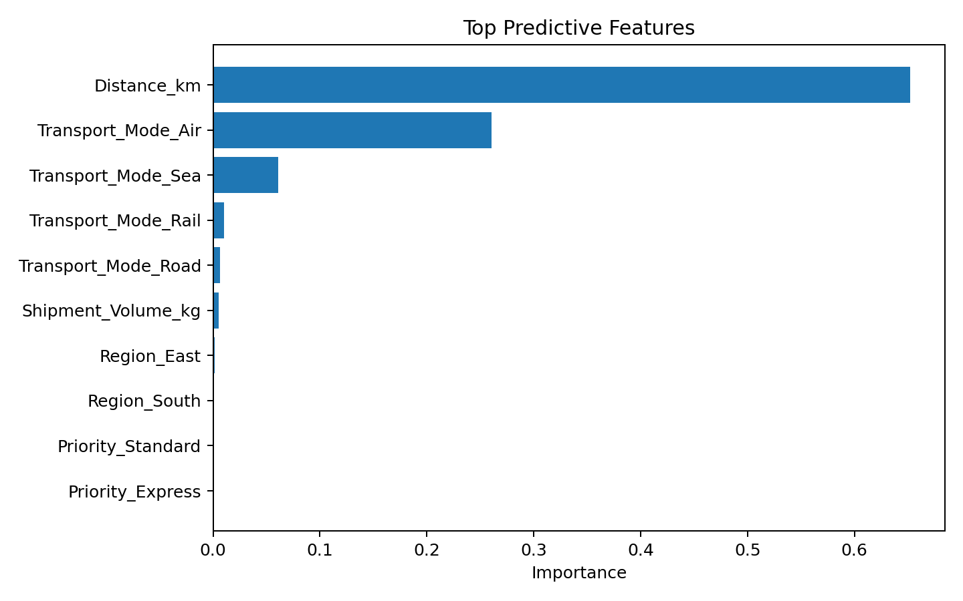
The tree-based model's feature importance shows which encoded inputs contributed most to its predictions. Importance is predictive association, not proof of causation.

8. Optimization Strategy
Prediction becomes operationally useful when it is connected to an action. A scenario-based transport-mode optimization was therefore created. For each test shipment, Road, Rail, Air and Sea were simulated as alternatives. The final model predicted delivery time for each alternative, while a simple mode-specific cost rate derived from the simulated data estimated the cost.
A 5-day service-level target was used. Among modes predicted to meet the target, the lowest estimated-cost option was recommended. If no option met the target, the fastest predicted option was selected. This is a demonstration framework rather than a production optimizer.
Optimization indicator | Result
Test shipments evaluated | 40
Shipments with recommended mode change | 34
Cases with positive estimated saving | 9
Total estimated saving in positive cases | ₹304.61
Average saving per positive case | ₹33.85
Recommended options predicted to meet 5-day SLA | 92.5%

These savings are scenario estimates, not guaranteed financial results. Actual implementation would need real carrier rates, capacity constraints, route availability, fuel prices, weather, traffic and service agreements.

9. Analytical Insights and Recommendations
• Use delivery-time predictions as an early-warning indicator for shipments at risk of missing a service target.
• Choose transport modes by balancing predicted delivery time, estimated cost and shipment priority.
• Investigate shipments with unusually high prediction errors because they may contain operational factors missing from the dataset.
• Collect additional features such as carrier, traffic, weather, route, warehouse processing time and historical carrier performance.
• Retrain the model periodically as new shipment outcomes become available.
• Integrate predictions into a logistics dashboard showing predicted delivery time, SLA risk, estimated cost and recommended transport mode.
• Validate model recommendations against real operational constraints before implementation.

10. Python Code – Training and Validation
X_train, X_test, y_train, y_test = train_test_split(
X, y, test_size=0.20, random_state=42)
model = Pipeline([
("prep", preprocessor),
("model", RandomForestRegressor(
n_estimators=250, max_depth=8,
min_samples_leaf=2, random_state=42))
])
model.fit(X_train, y_train)
pred = model.predict(X_test)
mae = mean_absolute_error(y_test, pred)
rmse = np.sqrt(mean_squared_error(y_test, pred))
r2 = r2_score(y_test, pred)
print(mae, rmse, r2)

11. Conclusion
This project demonstrates the progression from descriptive logistics analytics to predictive modeling and optimization. Delivery time was selected as the forecasting target because it is relevant to customer service and operational planning. Linear Regression, Decision Tree and Random Forest models were compared using MAE, RMSE and R². Five-fold cross-validation and hyperparameter tuning were applied. A scenario-based optimization method then connected predictions with transport-mode choices under a delivery-time SLA. The results demonstrate how predictive analytics can support logistics planning while also showing the need for richer real-world data and operational constraints.

