[Index of /war-stable/2.346.1 (jenkins.io)](https://get.jenkins.io/war-stable/2.346.1/)

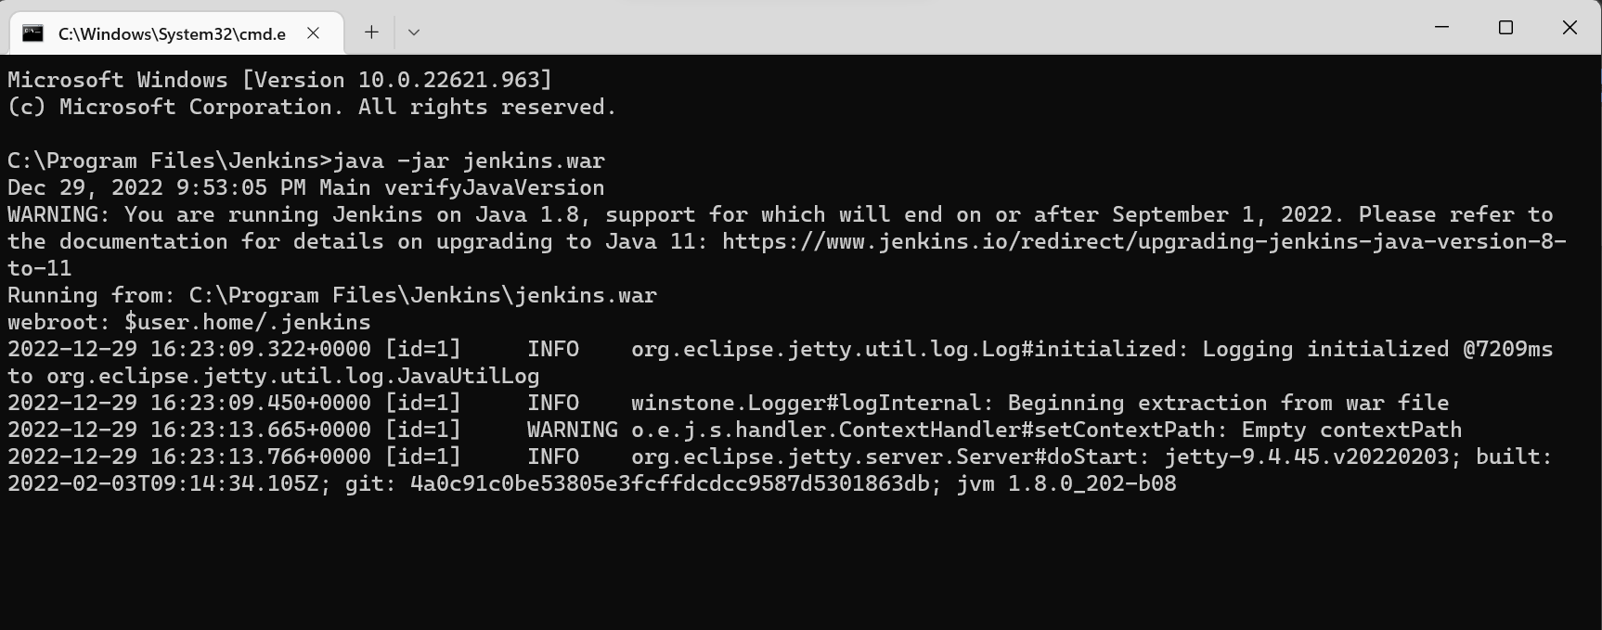

In Browser hit url <http://localhost:8080>

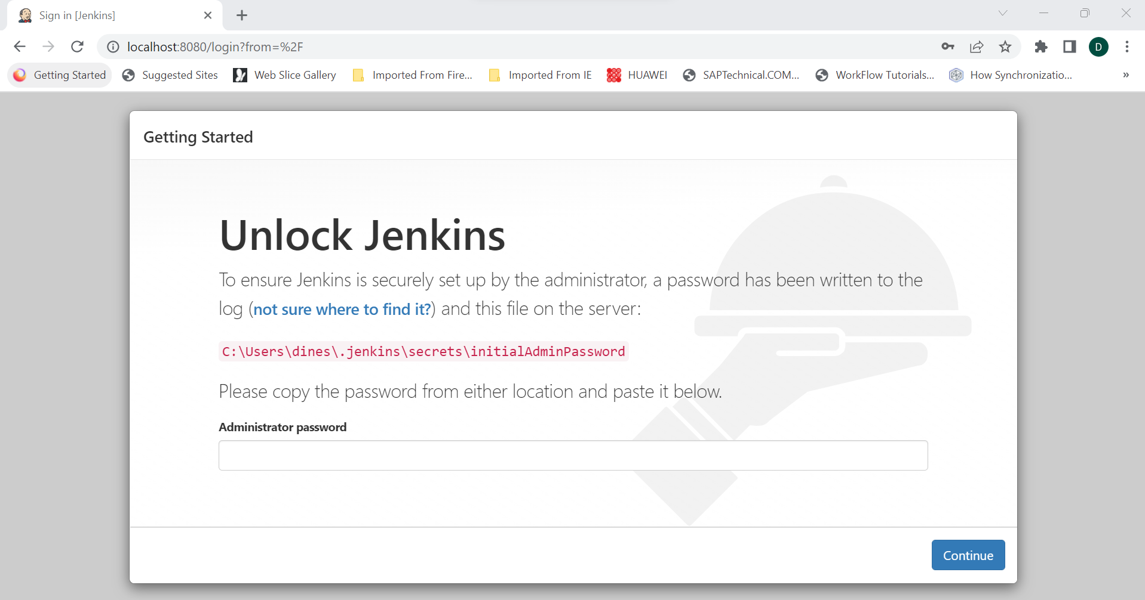

Admin password will be available in “C:\Users\{systemusername} \.jenkins\secrets\initialAdminPassword”

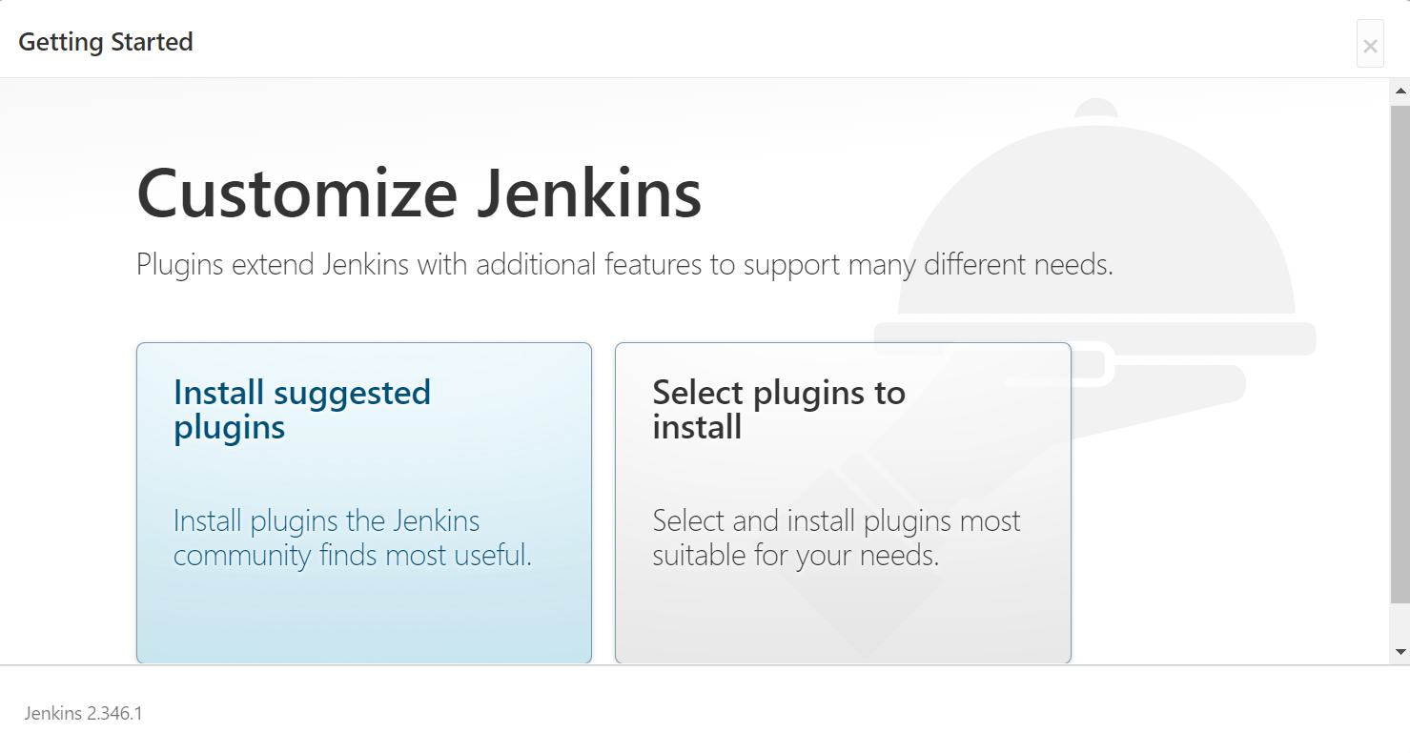

Click on “Install suggested plugins” plugins will install

