

19PHY113

COMPUTATIONAL ENGINEERING MECHANICS - 2

BTECH CSE(AI) 2020-2024

AMRITA VISWA VIDHYAPEETHAM, COIMBATORE

**SUBMITTED BY**

TEAM- 14

KARTHIKEYAN M

KARTHIK RAJA B

NALIN M R

PRAGADISHWARAN K

ACKNOWLEGEMENT

We would like to thank to our professor Dr.Gopalakrishnan E.A who gave us his valuable suggestions and ideas when we needed them to work on our project “CHANGE POINT MECHANISM.”

We are also grateful to our university, Amrita Vishwa Vidyapeetham for giving us the opportunity to work on this project. Last but not the least we would like to thank our group members, Nalin MR, Karthikeyan.M, Karthik Raja.B, Pragadishwaran K without their effort and co-operation, we would not have been able to complete the project within the prescribed time.

ABSTRACT

The project here is developed to synthesis and analyse a given mechanism.

Here it is done using a well-developed app.

This app can differentiate change point mechanism from other mechanisms and also identifies the type of change point mechanism. Then it proceeds to simulate the working of the mechanism. The app helps to analyse the given mechanism based on velocity analysis and acceleration analysis and produces a plot for the analysis.

The development of the app is based on the synthesis and analysis topics of this semester.

INDEX

S. no TITLE Page No.

1 INTRODUCTION 5

2 ANALYSIS 12

3 CODE LOGIC 15

4 GUI OUTPUT 16

5 CONCLUSION 18

6 REFERENCE 19

**INTRODUCTION**

**Four Bar Linkage: -**

A four-bar linkage, also called a four-bar, is the simplest movable closed chain linkage. It consists of four bodies, called bars or links, connected in a loop by four joints. Generally, the joints are configured so the links move in parallel planes, and the assembly is called a planar four-bar linkage.

**Degree Of Freedom Of 4 Bar Linkage**

Degree Of Freedom Of 4 Bar Linkage Planar four-bar linkages are constructed from four links connected in a loop by four one-degree-of-freedom joints. A joint may be either a revolute, that is a hinged joint, denoted by R, or a prismatic, as sliding joint, denoted by P.

**Four Bar Change Point Linkage: -**

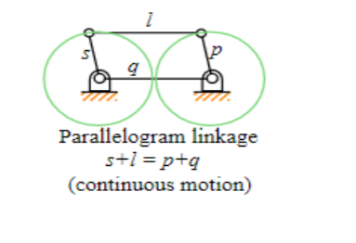

If it is possible for all four bars to become simultaneously aligned, such a state is called a change point.

Condition for a change point mechanism is S+L=P+Q

Where S= Smallest link

L= Longest link

P&Q = Other two respective Links

In the range of planar mechanisms, the simplest group of lower pair mechanisms are four bar linkages. A **four-bar linkage** comprises four bar-shaped links and four turning pairs as shown in figure

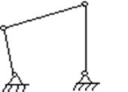

The link opposite the frame is called the **coupler link**, and the links which is hinged to the frame are called **side links**. A link which is free to rotate through 360 degrees with respect to a second link will be said to **revolve** relative to the second link (not necessarily a frame). If it is possible for all four bars to become simultaneously aligned, such a state is called a **change point**.

**CLASSIFICATION OF FOUR BAR LINKAGES**

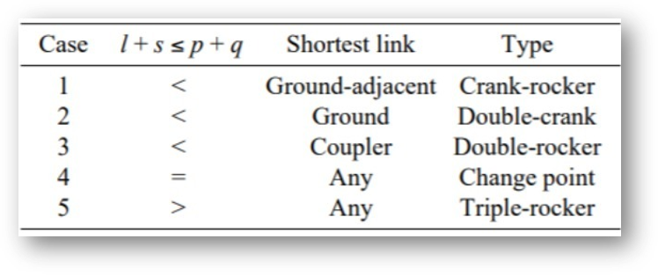

**CHANGE POINT FOUR BAR MECHANISM**

The change point four-bar mechanism is used for the back and forth motion of the walking machine leg. As the change point mechanism´s sum of two sides is equal to the sum of the other two, the change point mechanism can be positioned such that all of the links become collinear.

|  |  |  |
| --- | --- | --- |
| (a + b) < (c + d) |  | Grashof mechanism |
| (a + b) > (c + d) |  | non‐Grashofian mechanism |
| (a + b) = (c + d) |  | Extreme case (sometimes called Change‐point mechanism) |

**EXAMPLE MODELS:**

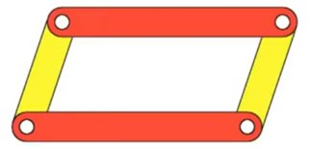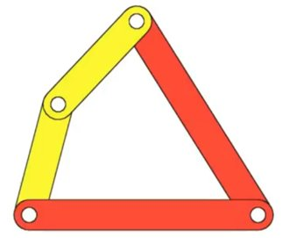

In such kinematic chain, the links become collinear at least once per revolution of input crank.  
This case is further divided into two cases: -  
Case 1: - The length of all links is distinct  
In this case, the inversions obtained are same as in the case S + L < P + Q. which are: - double crank, double rocker and crank rocker.  
  
Case 2: - The length of any two link is same  
If the length of any two links is same, then the length of remaining two links will also be same due to equation S + L < P + Q.  
  
In such case, two linkages are possible base on placement of links: -

**a) Parallelogram Linkage: -** In this linkage, links of equal lengths are placed opposite to each other.  
  
**b) Deltoid Linkage**: -In this linkage, links of equal lengths are placed adjacent to each other.

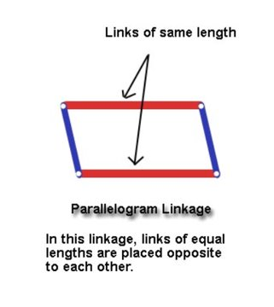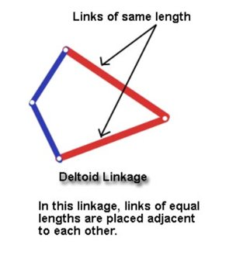

In both cases, the inversions obtained are either a crank rocker or double crank mechanism.  
Both these linkages suffer change point conditions at the time when the links become collinear.  
In the change point condition, the motion of the output crank becomes unpredictable. It can go any of the two ways. Based on the motion of the output crank at change point condition, the inversion is a crank rocker or double crank.

FEW EXAMPLES OF CHANGE POINT MECHANISM

 

APPLICATIONS OF CHANGE POINT MECHANISMS

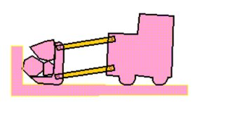

* In a parallelogram four-bar linkage, the orientation of the coupler does not change during the motion. The figure illustrates a loader. Obviously, the behavior of maintaining parallelism is important in a loader. The bucket should not rotate as it is raised and lowered.

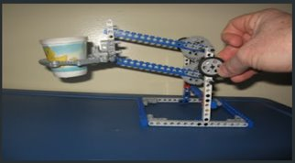

* The design features two pair of opposite beams of equal length; that determines the parallelogram. Then, as the sides move in response to the turning axle, the opposite sides remain parallel. The cup of water does not spill because it maintains its orientation with respect to the floor for the entire lifting process.

**TRANSMISSION ANGLE**

Transmission angle is the angle between the coupling member and the output member in a mechanism. The angle between the direction of absolute motion and. direction of the relative motion of the point in which the. driven member gets the motion impulse. Transmission angle of mechanism.

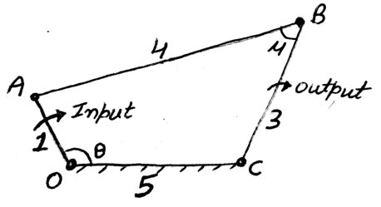

**TRANSMISSION ANGLE CALCULATION**

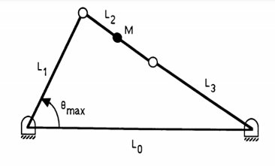

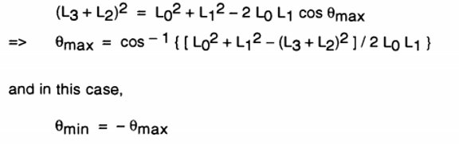

**ANALYSIS**

POSITION ANALYSIS

Position analysis is the first step when we are analyzing a mechanism. We first determine the position of the links by the triangular law of vector addition and represent the links in terms of sin and cos terms.

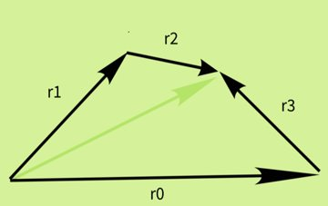



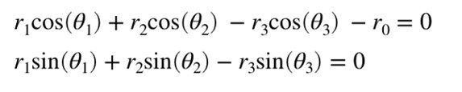

**IN CASE OF SOLVING NON LINEAR EQUATIONS IN THE POSITION ANALYSIS STEP**

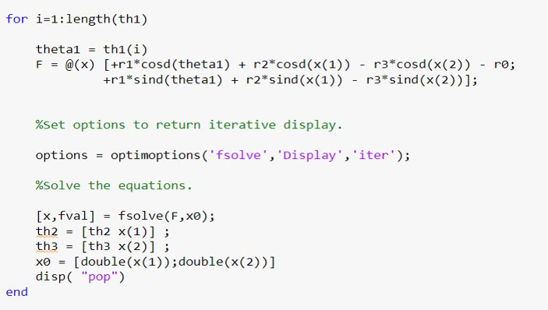

**VELOCITY ANALYSIS**

We differentiate the position analysis to find out velocity equations.

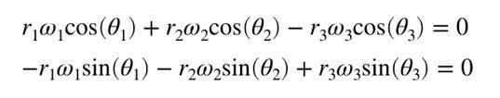

The equation is in the form AX=b Since the unknowns are present in the matrix X. We solve the unknowns using X=(A^-1) *B

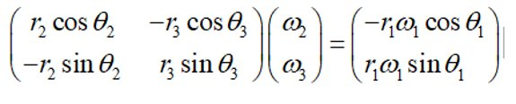

**ACCLERATION ANALYSIS**

We differentiate the Velocity analysis step to find out acceleration equations.

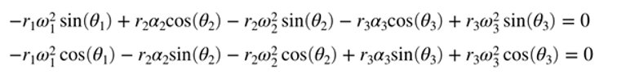

Following the similar process to that of velocity analysis we find out the unknowns that is **α**2, **α**3.

The acceleration of the driving link will be 0.

**CODE LOGIC**

* First, we take the link lengths as input s
* Next, we check whether it satisfies: s+l = p+q condition
* We perform the positional analysis of the mechanism by representing the links in the form of sin and cos components and finding the unknowns where we have initial angular velocity taken at a particular value
* We follow a fsolve method in matlab by giving an initial guess value for solving the nonlinear equations and finding the unknowns corresponding to that.
* We differentiate the position analysis step to get velocity equations and then we get acceleration by differentiating velocity equations.

**GUI OUTPUT**

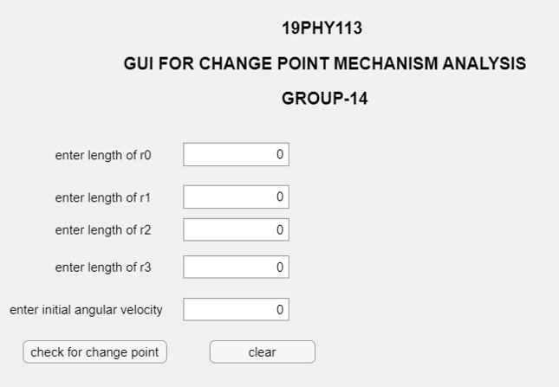

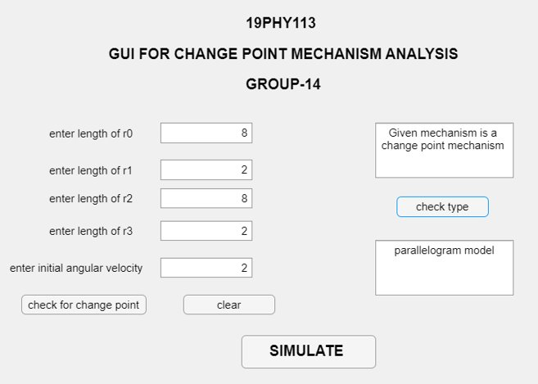

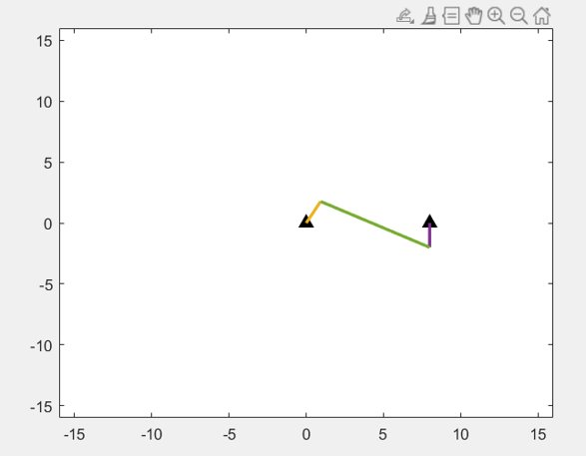

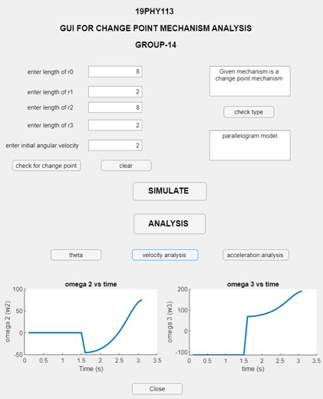

**CONCLUSION**

In the attempt to solve four bar mechanism problem, sets of equations were generated and MATLAB computer programming language was developed from the equations to solve the mechanism problem. When the program was tested, the following advantages were discovered:

1) It provides an approach which is so simple and labour saving in a way that if the simple rules are strictly adhered to a worker with most elementary knowledge of the computer will be able to get the desired result.

2) It eliminates the possibilities of errors if the simple rules are known and strictly adhered to.

3) It reduces the time consumption which are required by the other methods.

4) It reduces the high skill requirement by the other methods.

5) It guarantees the accurate result of velocity and acceleration in the mechanism.

**REFERENCES:**

1.Khumi, R.S and Gupta J.K. (2003), Theory of Machine, Eurasia Publishing House Ltd, 7361, Ram Nagar, New Delhi.

2. Robert A. Becker (1954), Introduction to Theoretical Mechanism, MC Graw-Hill Book Company New-York, London, Toronto.

3. Shigley, J. (1980), Theory of Machines Mechanisms, MC GRAW-Hill Book New York, Toronto, London.

4. Natesan, Arun K., "Kinematic analysis and synthesis of four-bar mechanisms for straight line coupler curves" (1994). Thesis. Rochester Institute of Technology.