**Aim:**

To install and run citrix XenServer

**Procedure:**

1. Install citrix Xenserver

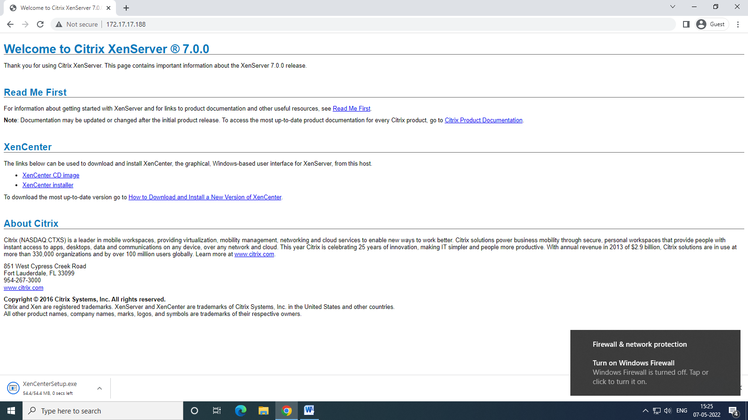

1. Setup Xen by clicking next until you see Finish button

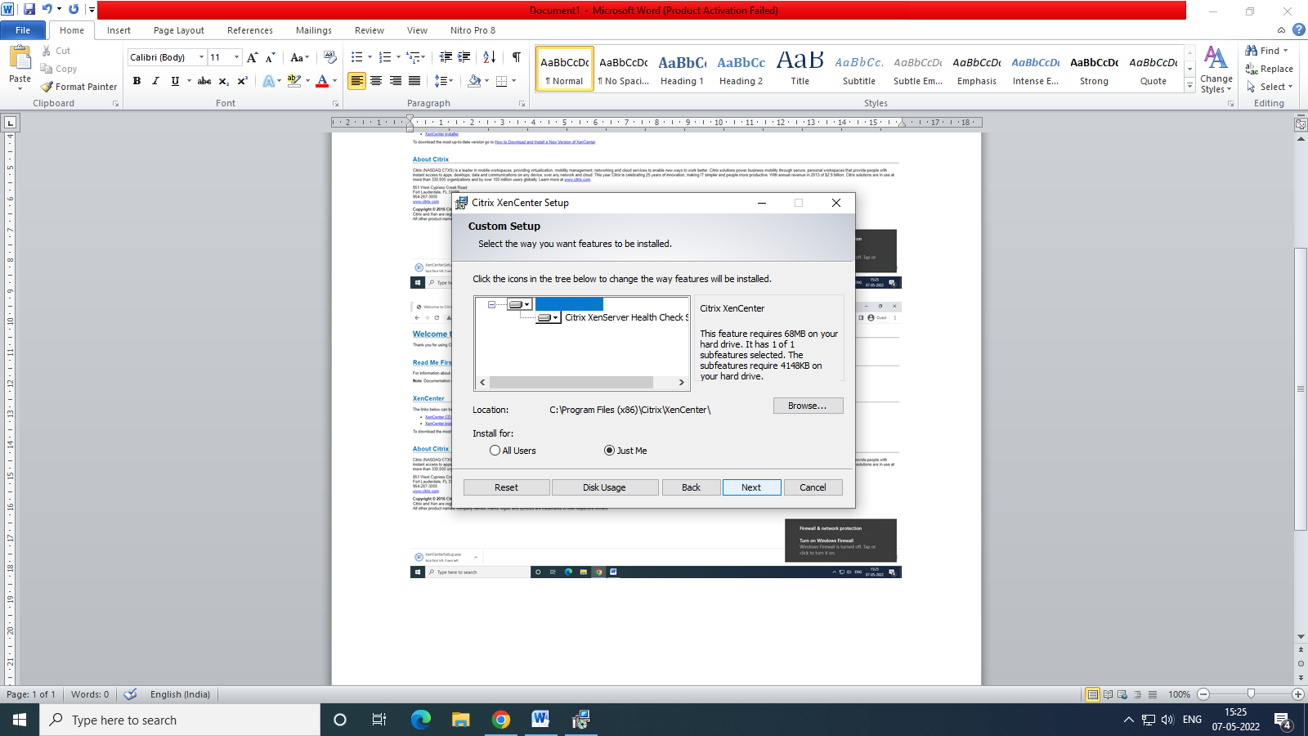

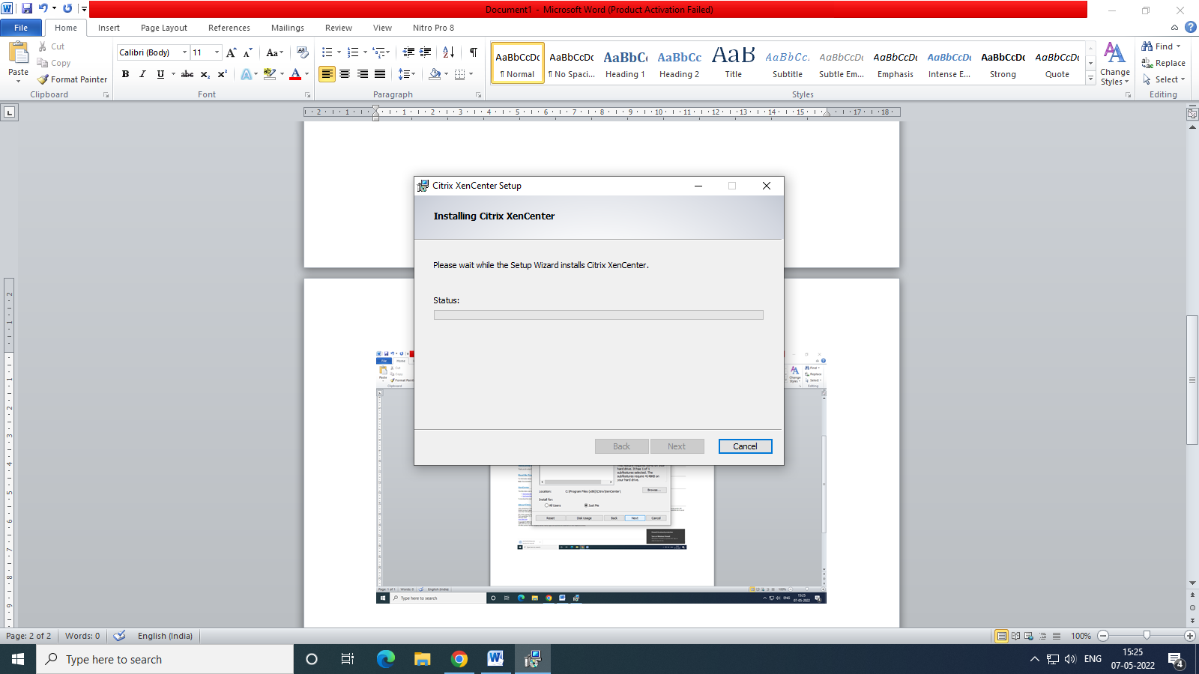

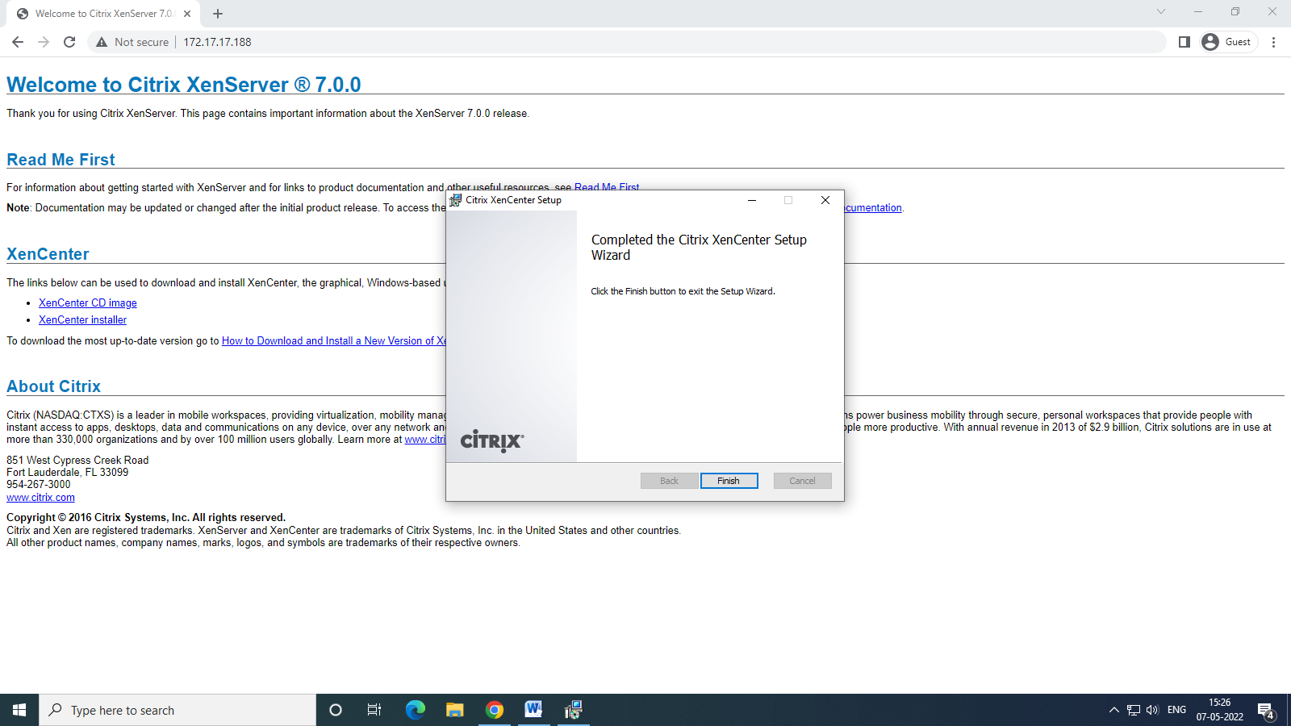

1. Open Xen Server.
2. Check save and restore server connection state on startup and click ok

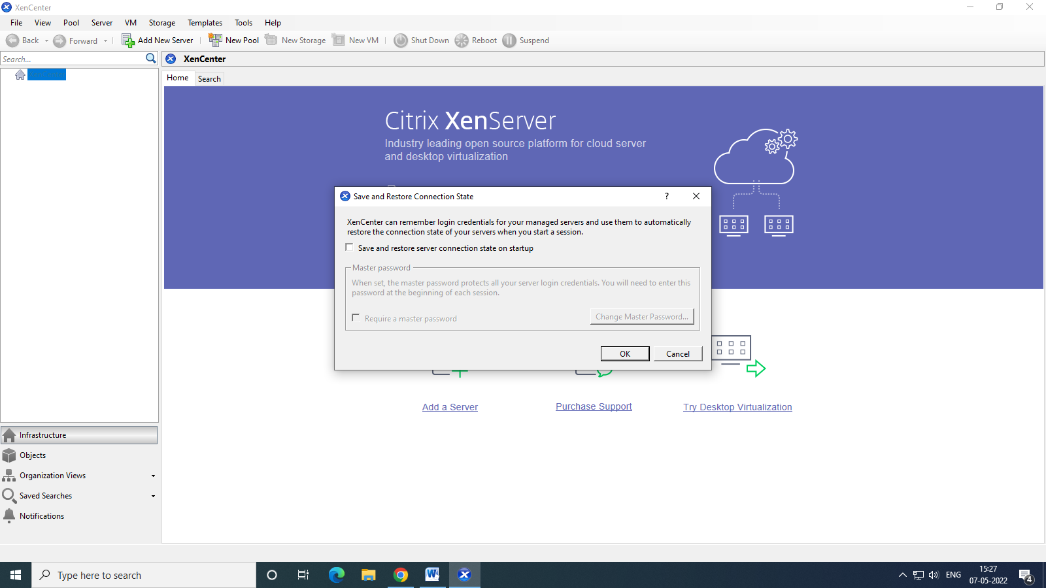

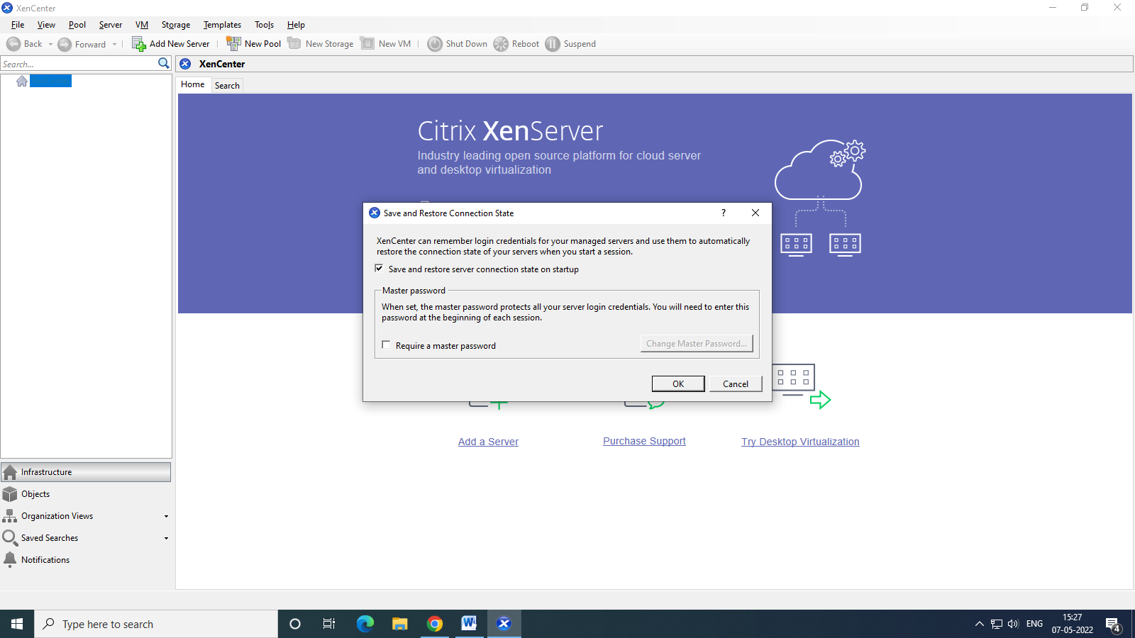

1. Click Add Server at top left corner
2. Select Ubutnu version

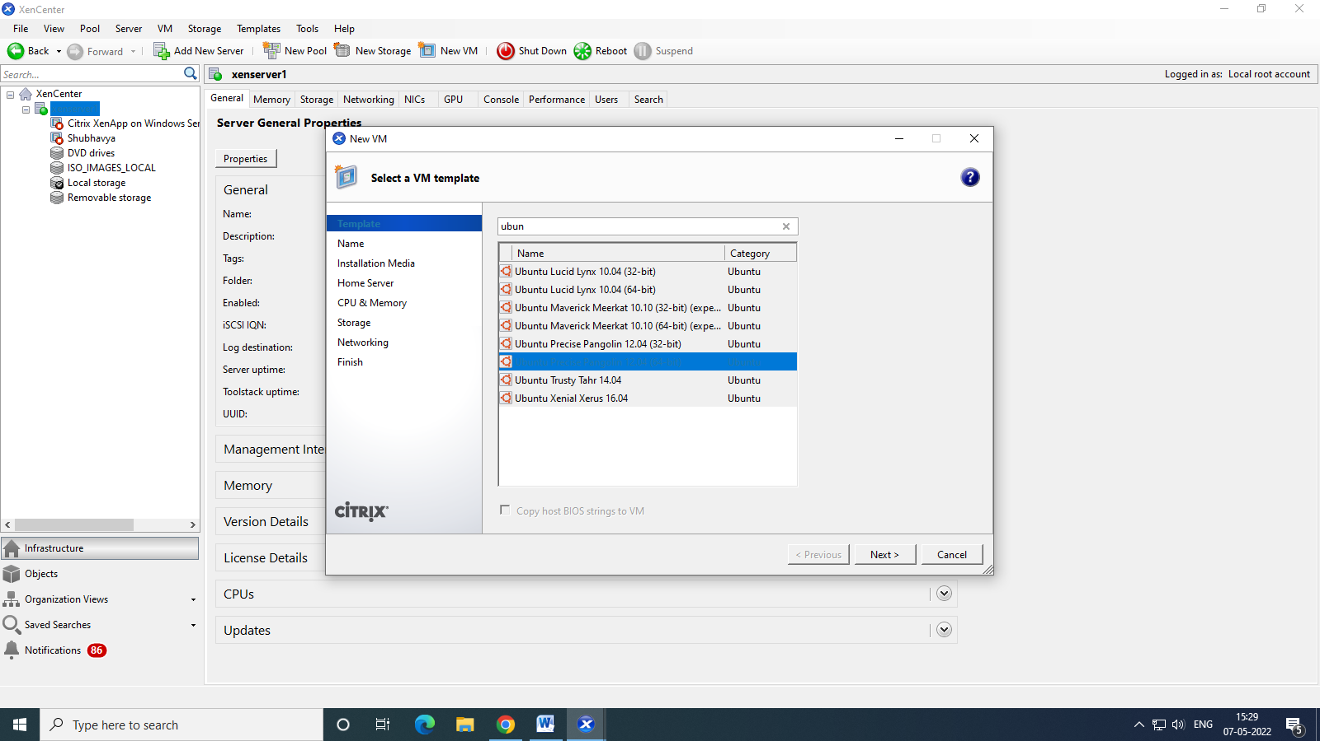

1. Give it a name

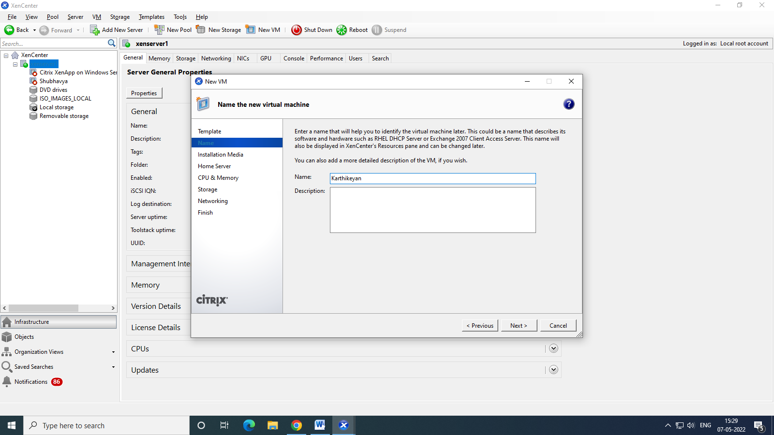

1. Click Next

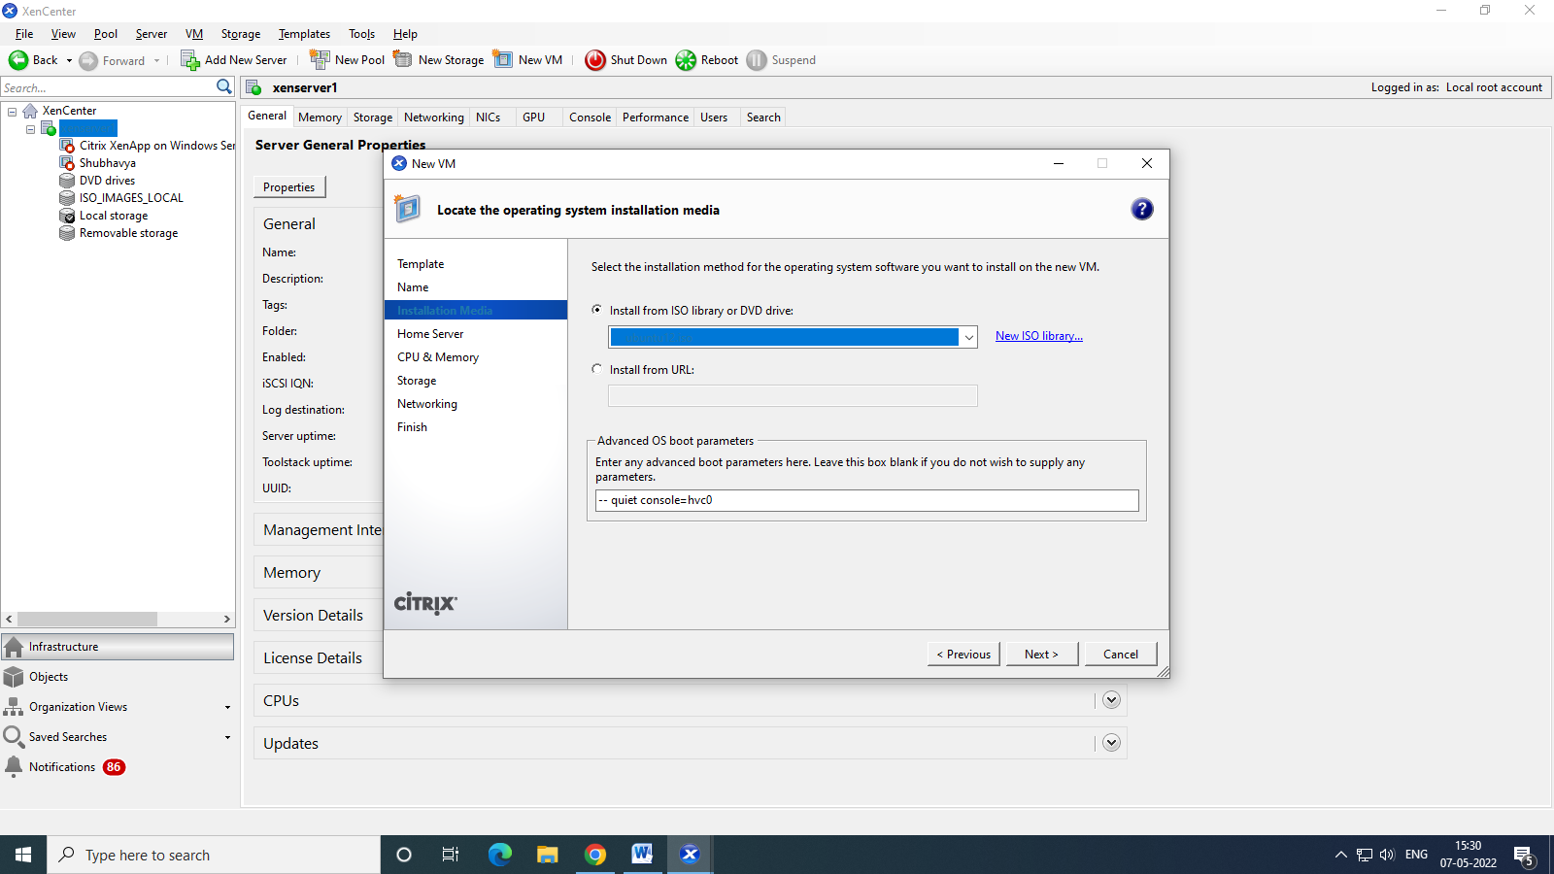

1. Set username and password

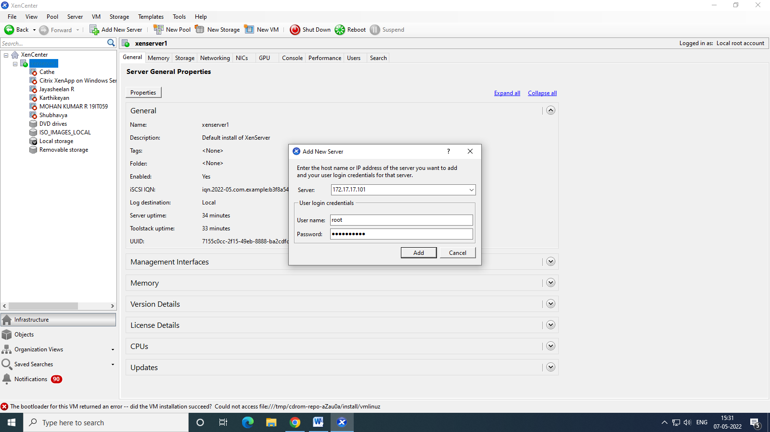

1. Now a new vm has been created in Xen Server 1
2. Now we are going to copy to server2
3. Right click on VM that is to be copied and click copy VM

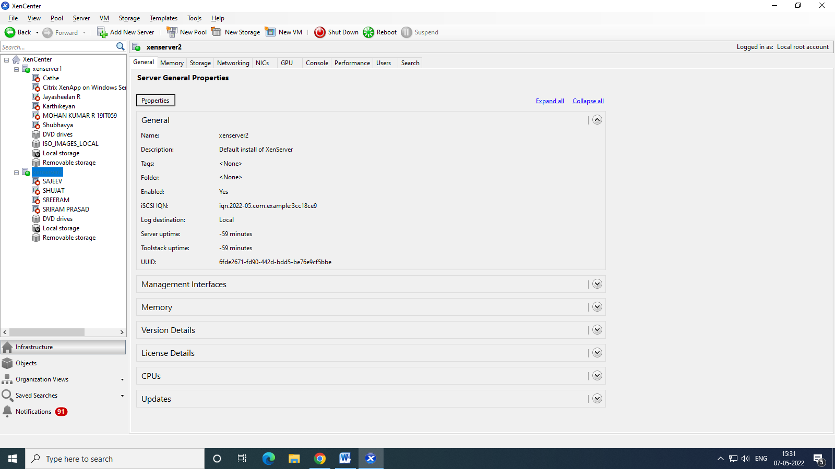

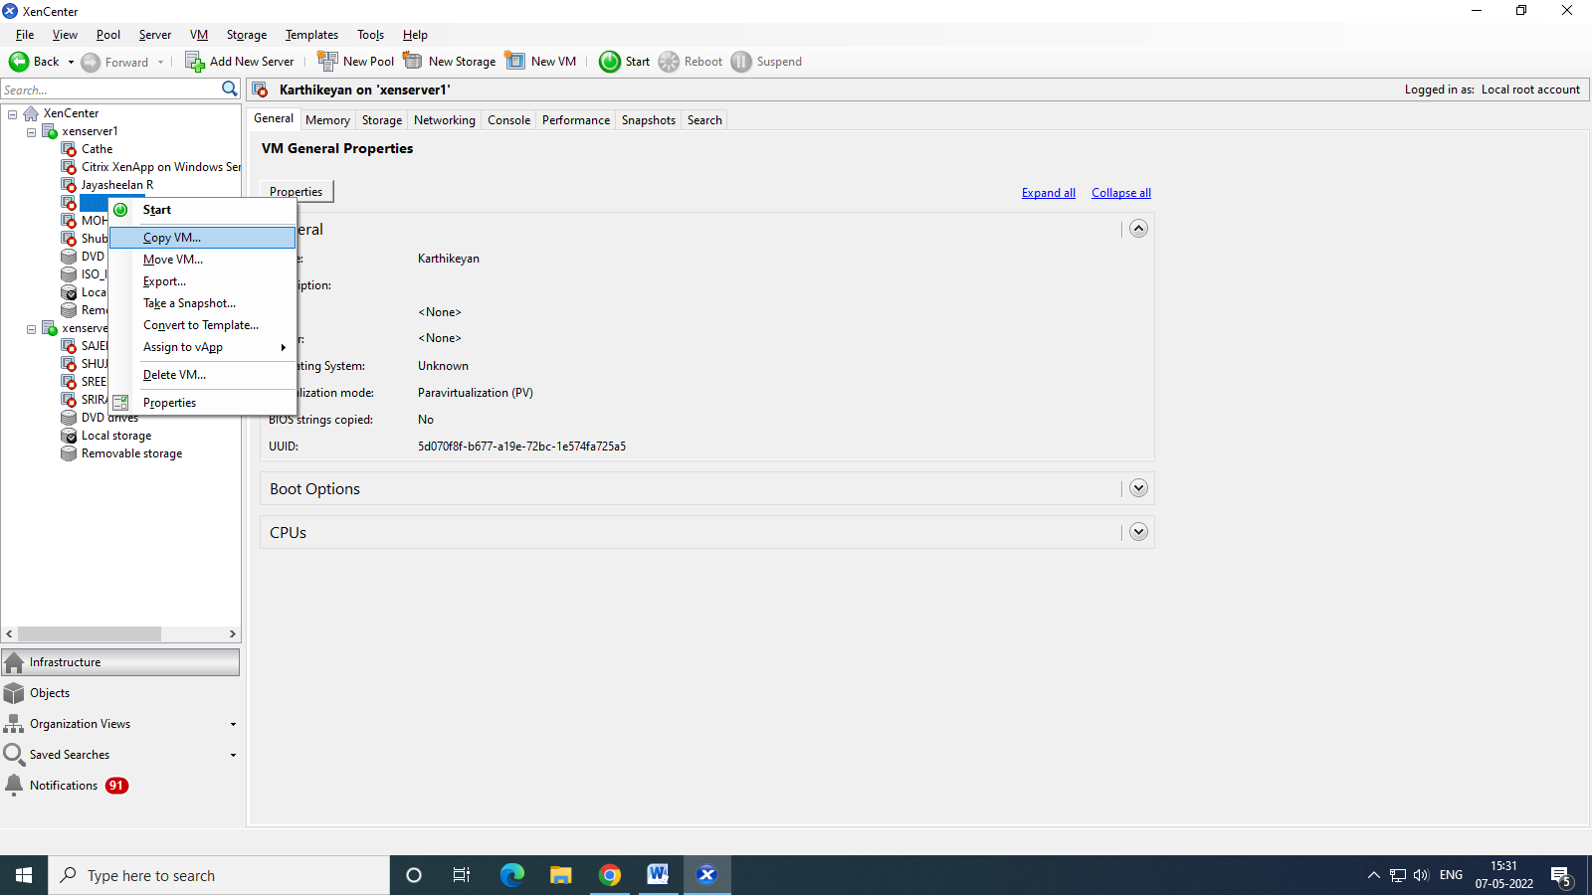

1. Select Xen Server 2 in destination
2. Click next and finish

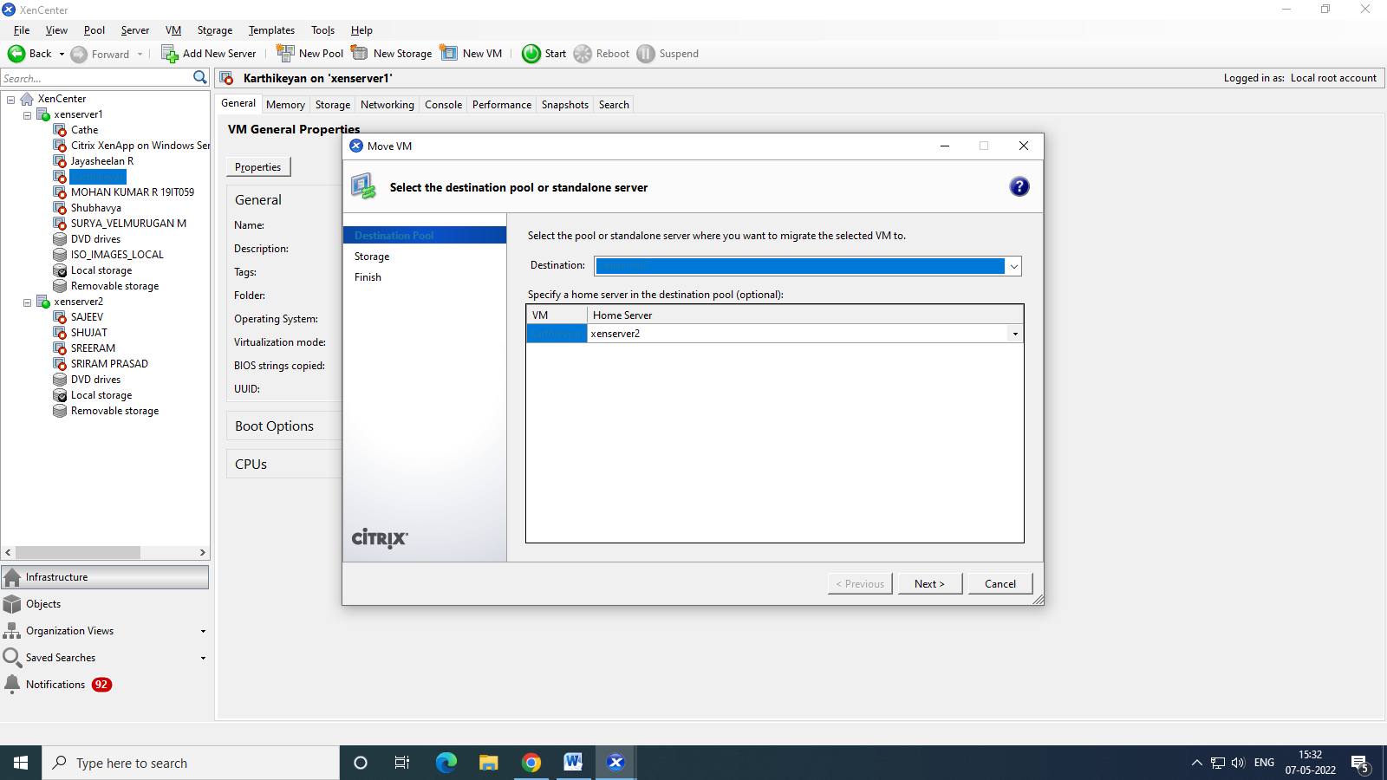

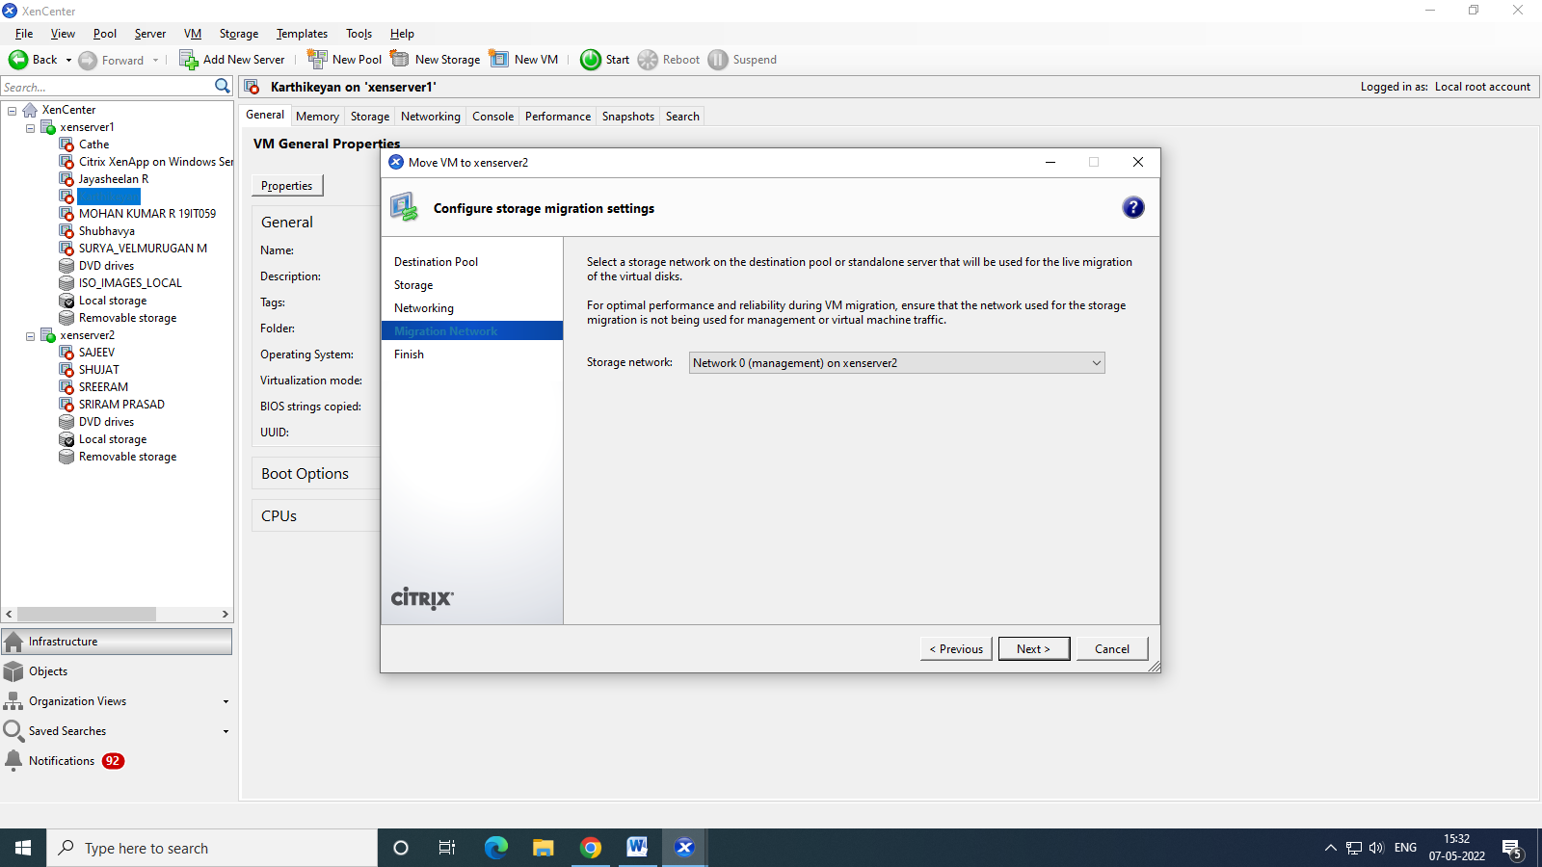

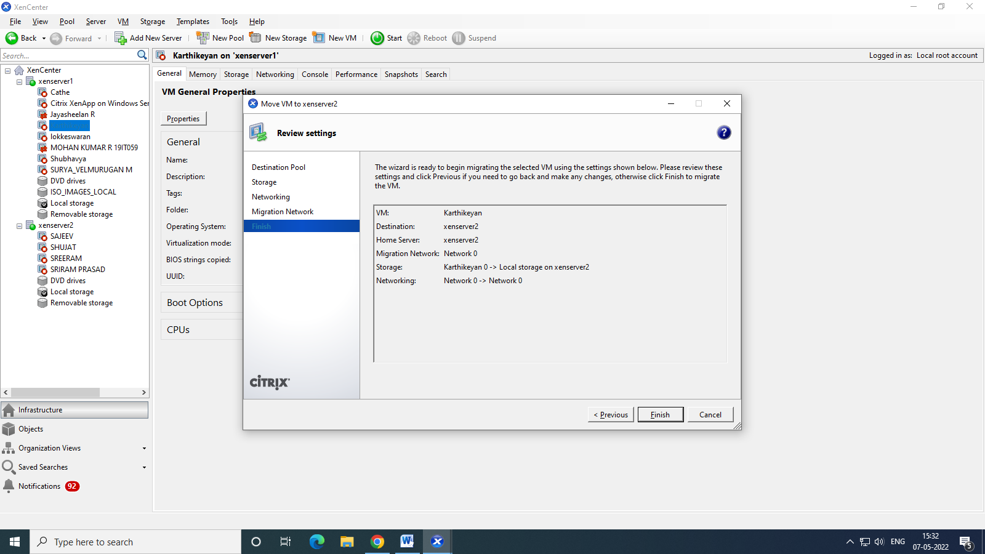

1. Now Karthikeyan folder is copied to xen server 2

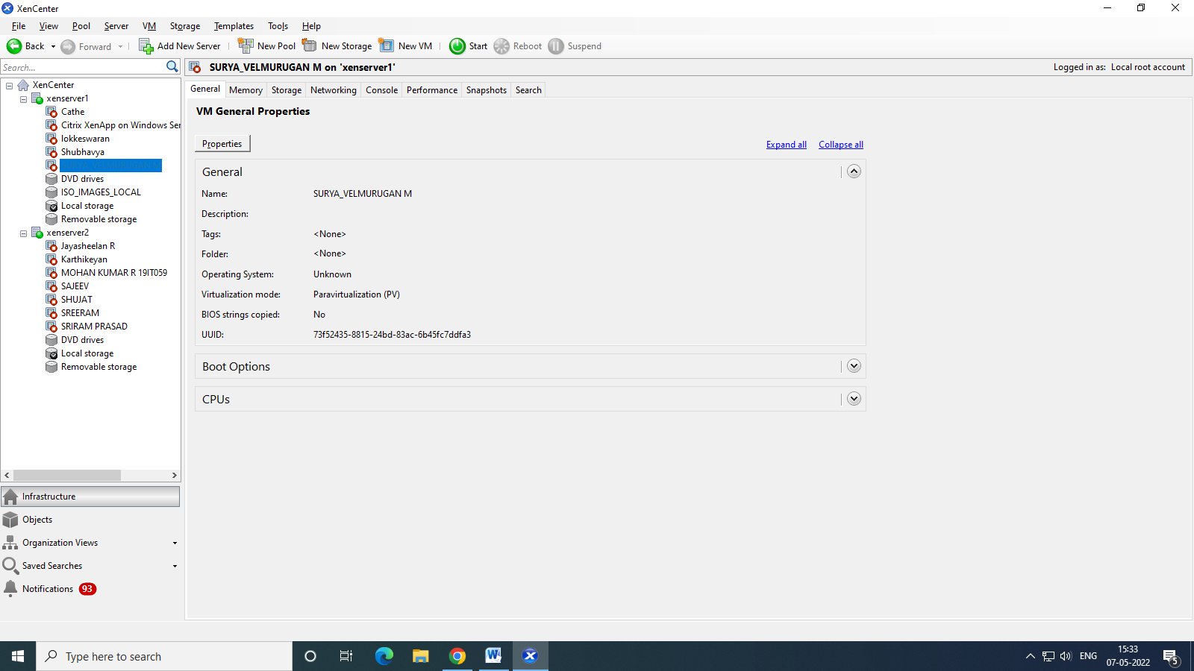

1. Now Check the Xen Server to check file has been moved to server or not

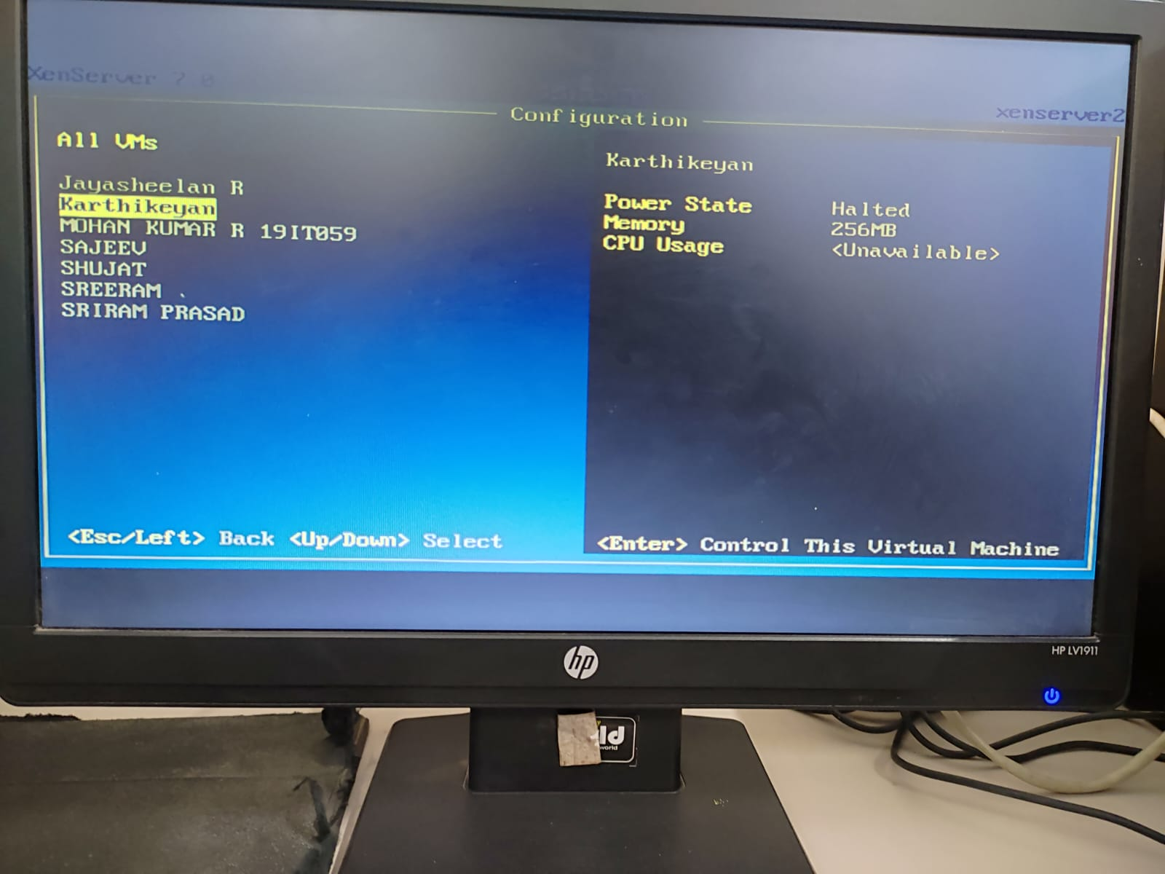

**Result:**

Thus, Xen has been installed and implemented successfully.