**EX NO: IMPLEMENTAION OF DBAAS**

**07/05/2022**

**Aim:**

To implement Dbaas in Application

**Tool Used:**

**Firebase**

**Procedure:**

1. Creating Account in Firebase
2. Create project under console

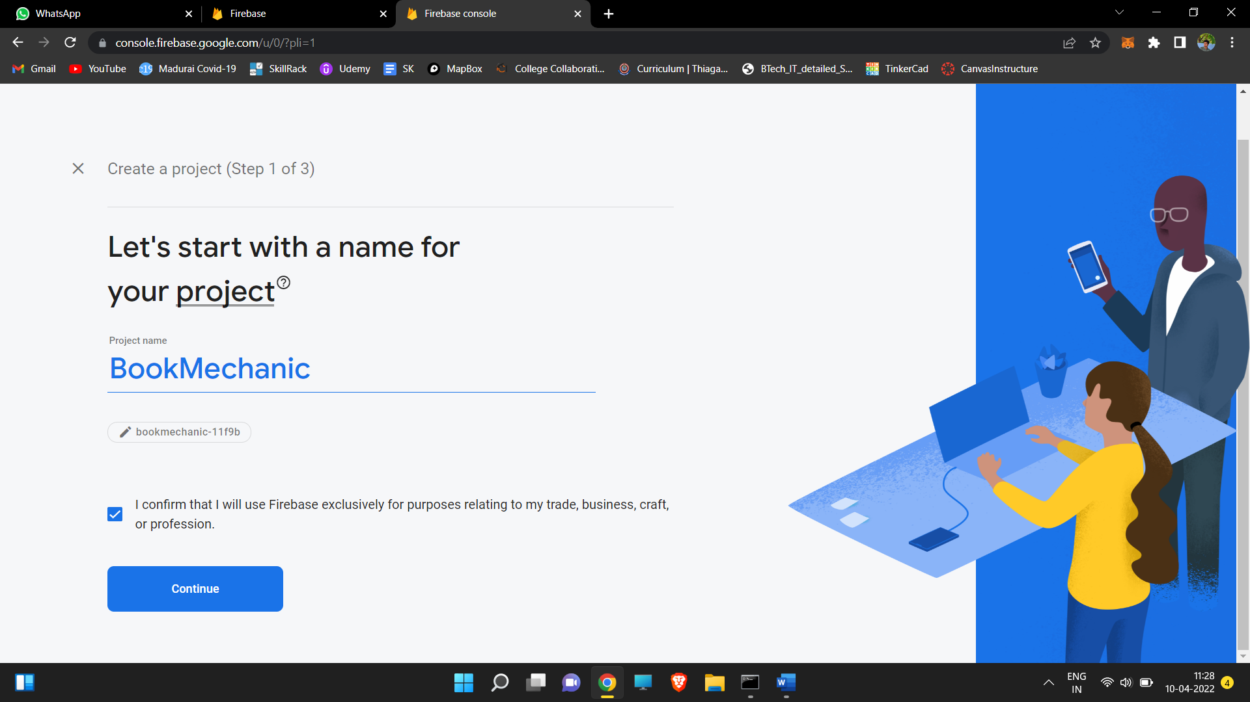

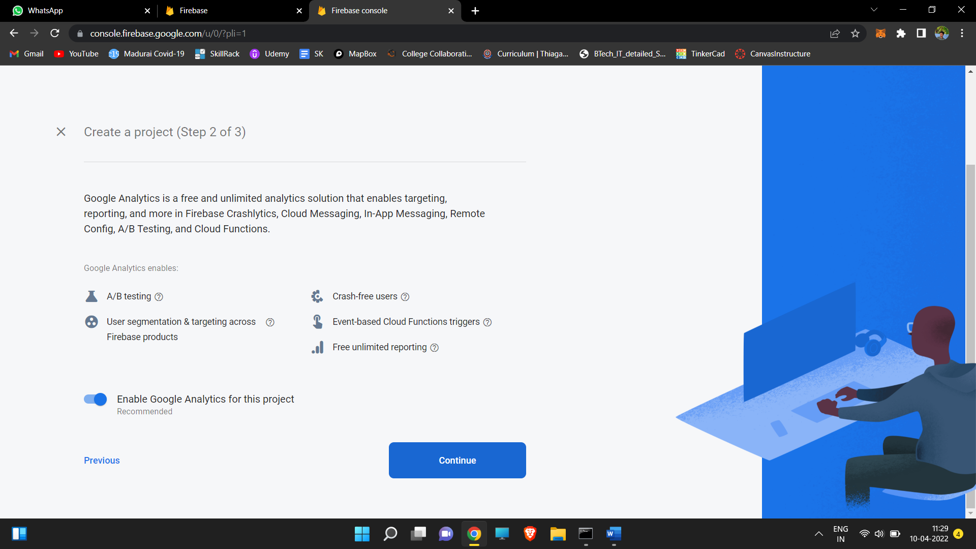

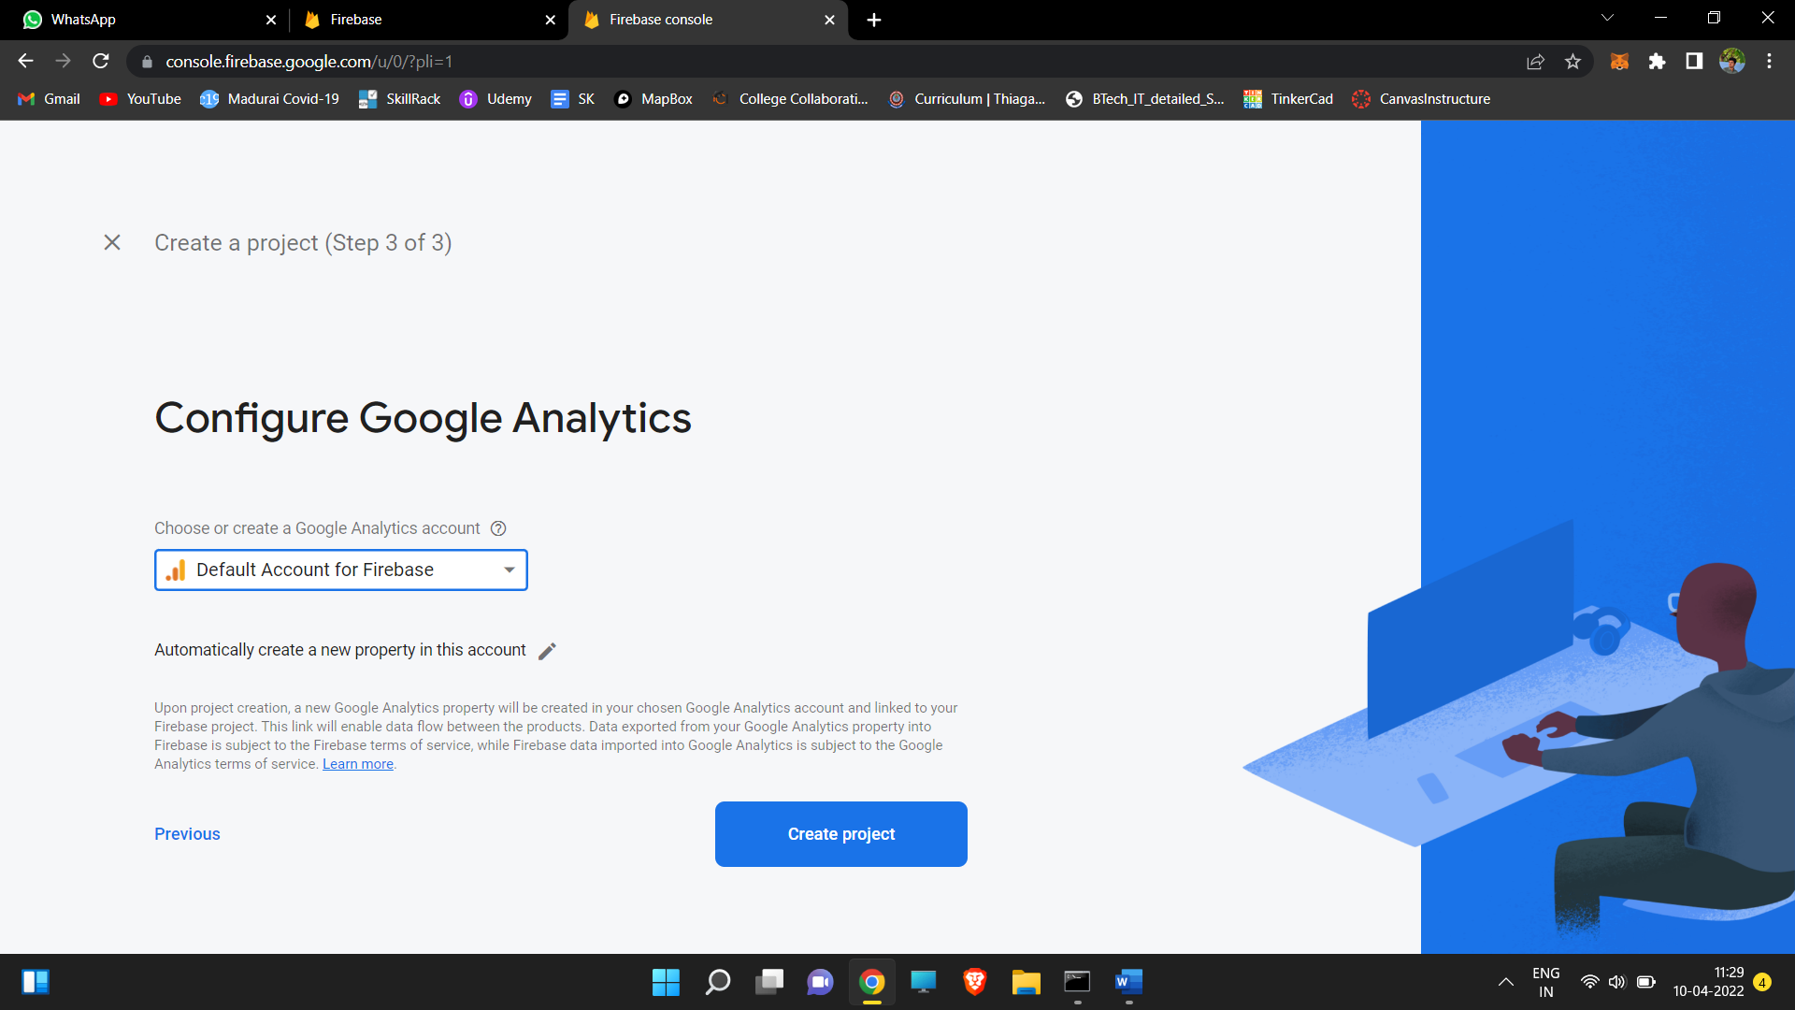

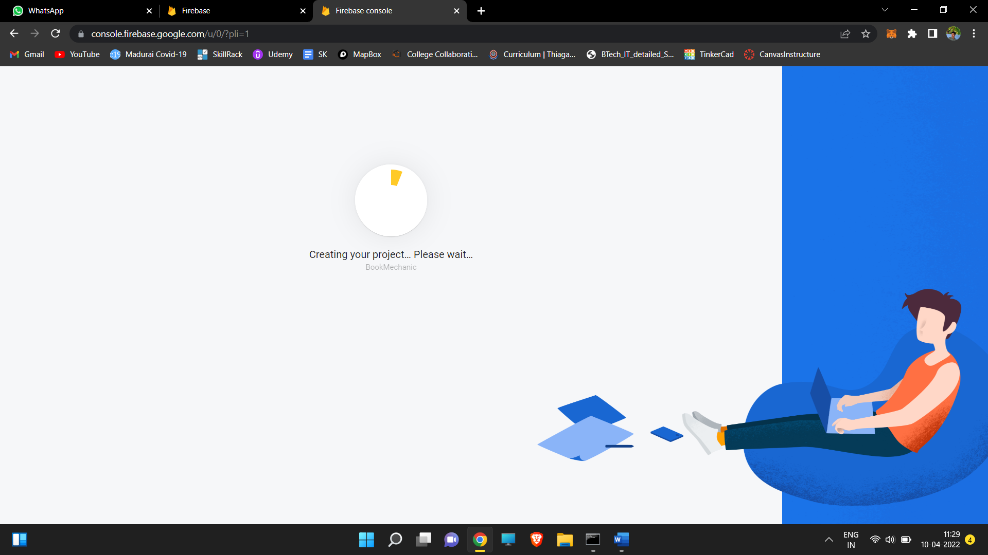

1. Click Firestore at left from list of menus

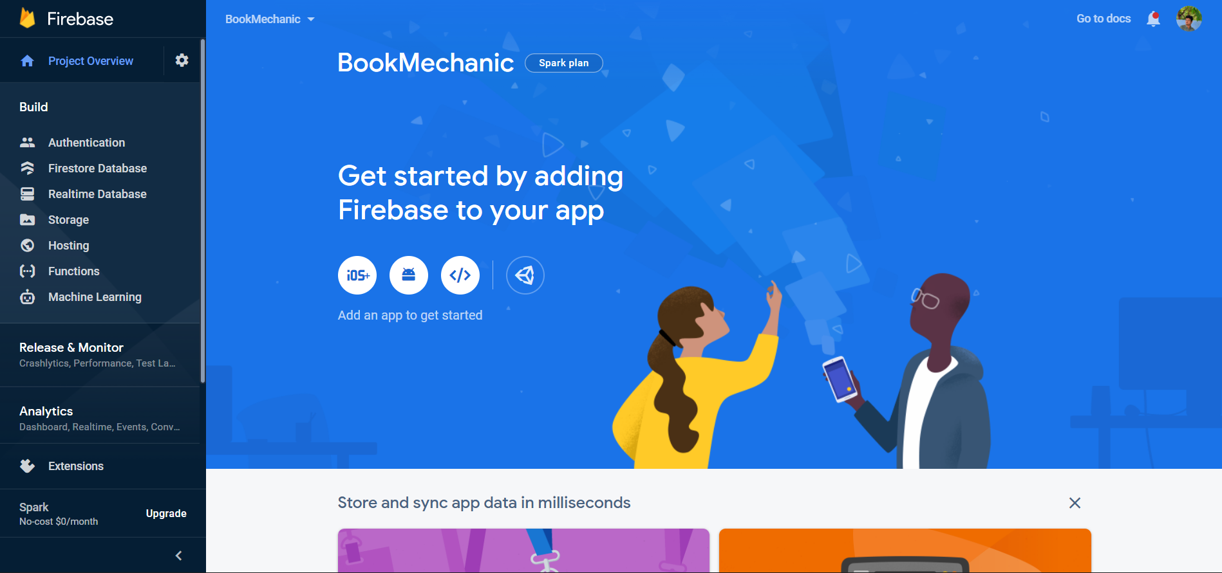

1. Click options as in screenshot

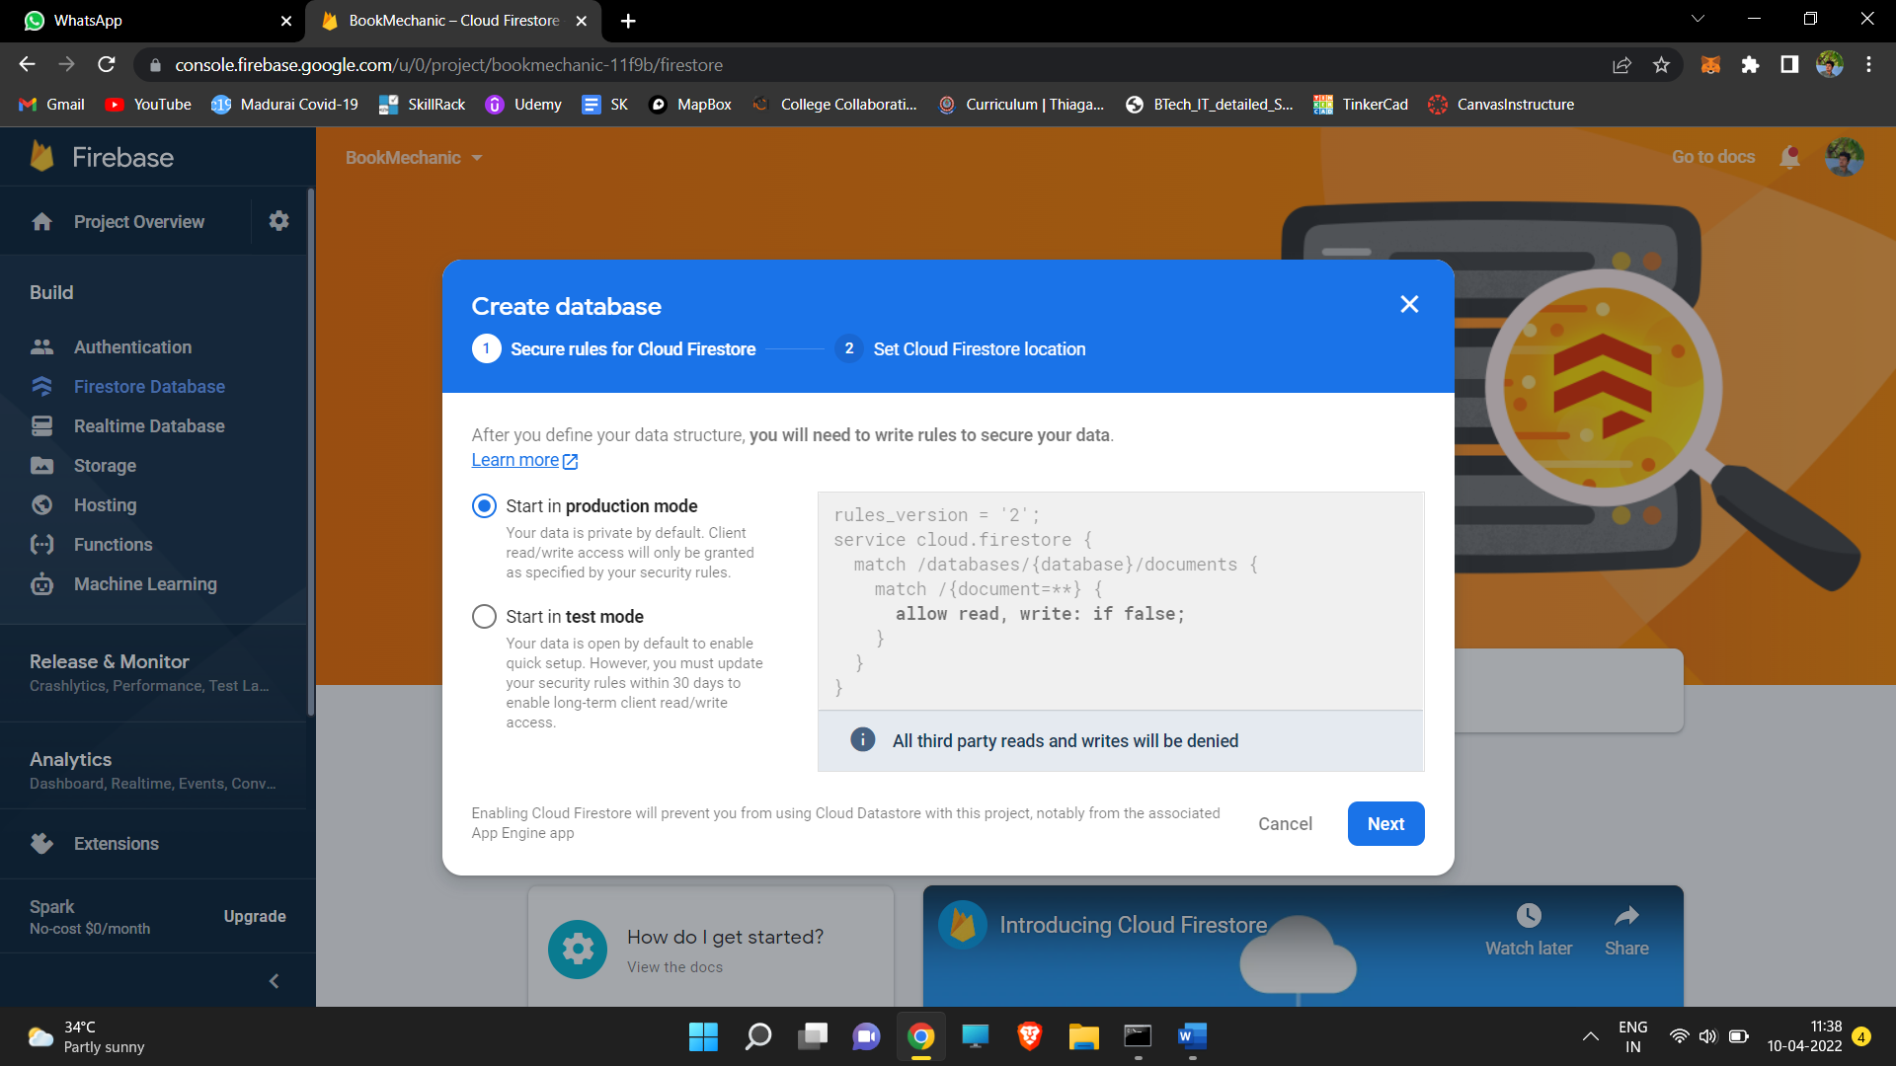

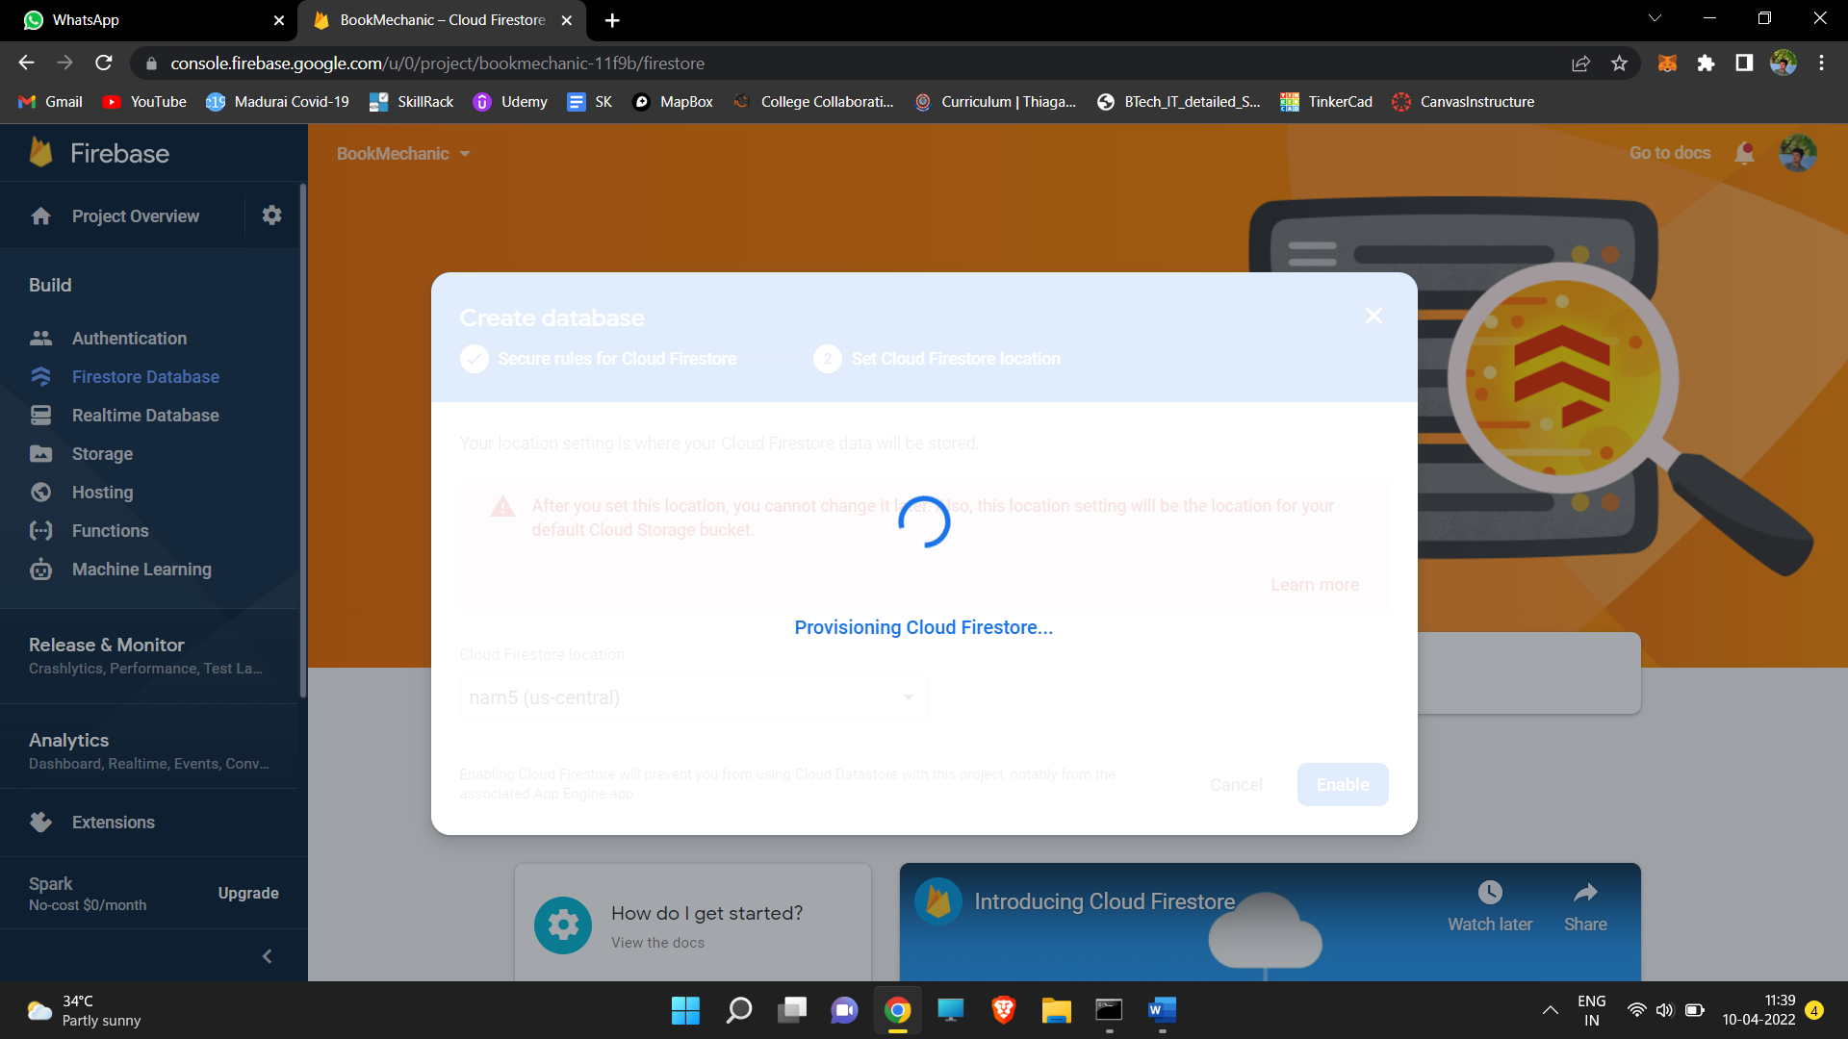

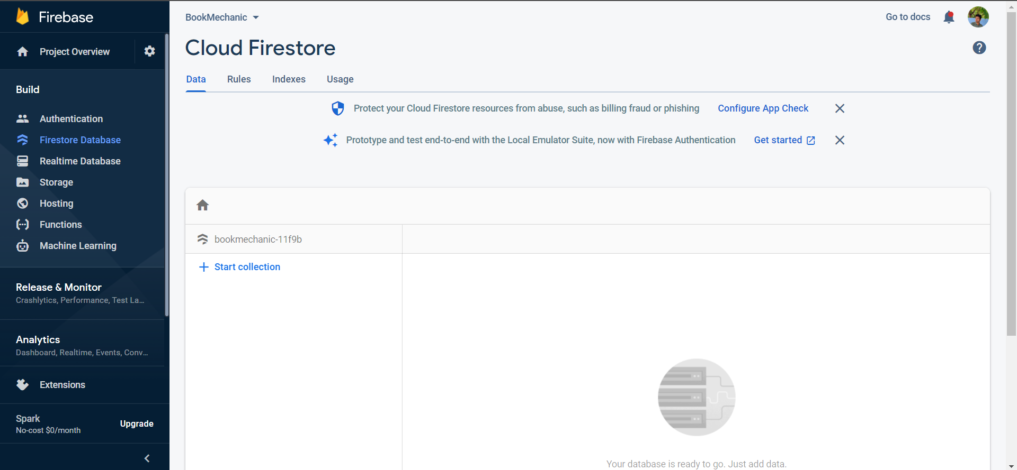

1. Import dependency files using node package manager
2. Create Form and submit button in application

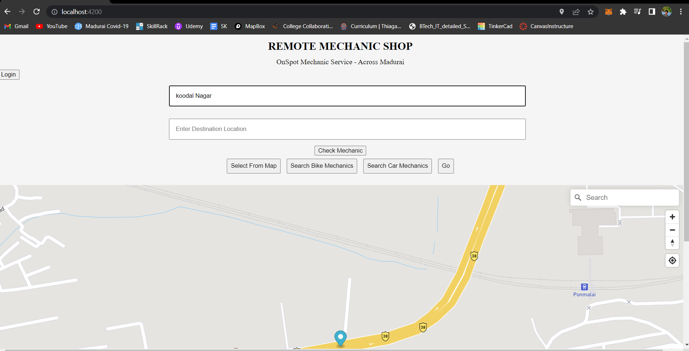

1. Add function to submit button that function must include collection name client id project id offered by firebase
2. Once that is done we will be able to see saved values in db

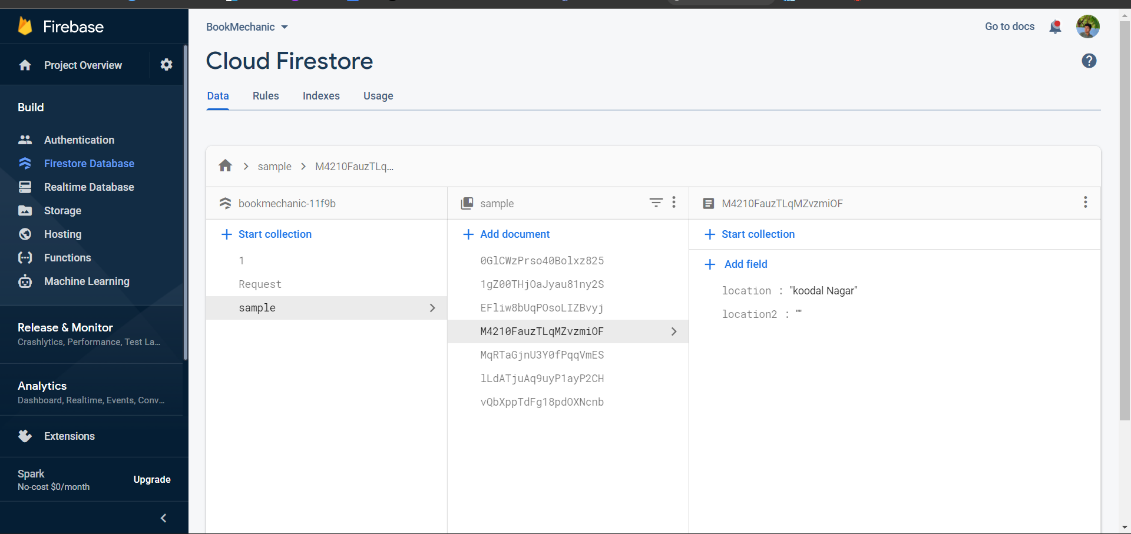

**Result:**

Thus, Dbaas has been implemented in Application