**EX NO 6** **Platform as a Service configuration using IBM Cloud Foundry**

**Date :**

**AIM:**

To implement the Platform as a Service using IBM Cloud Foundry by deploying the Web Application.

**Procedure**:

1.First you need a IBM cloud account for creating a php application in the cloud foundry:

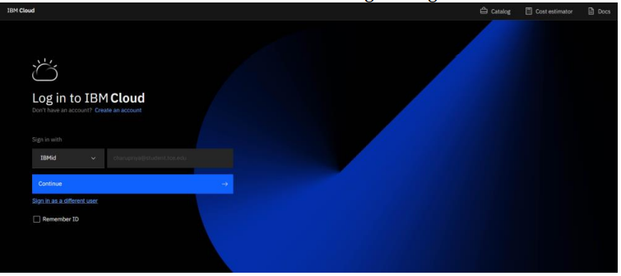

2. Click on cf (cloud foundry) to create a cloud foundry sample app

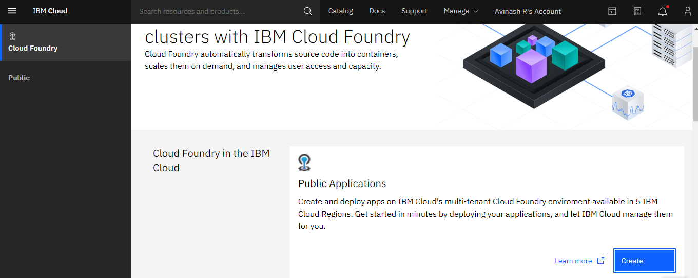

3. Create a sample app – choose PHP , give an App Name and click on “Create

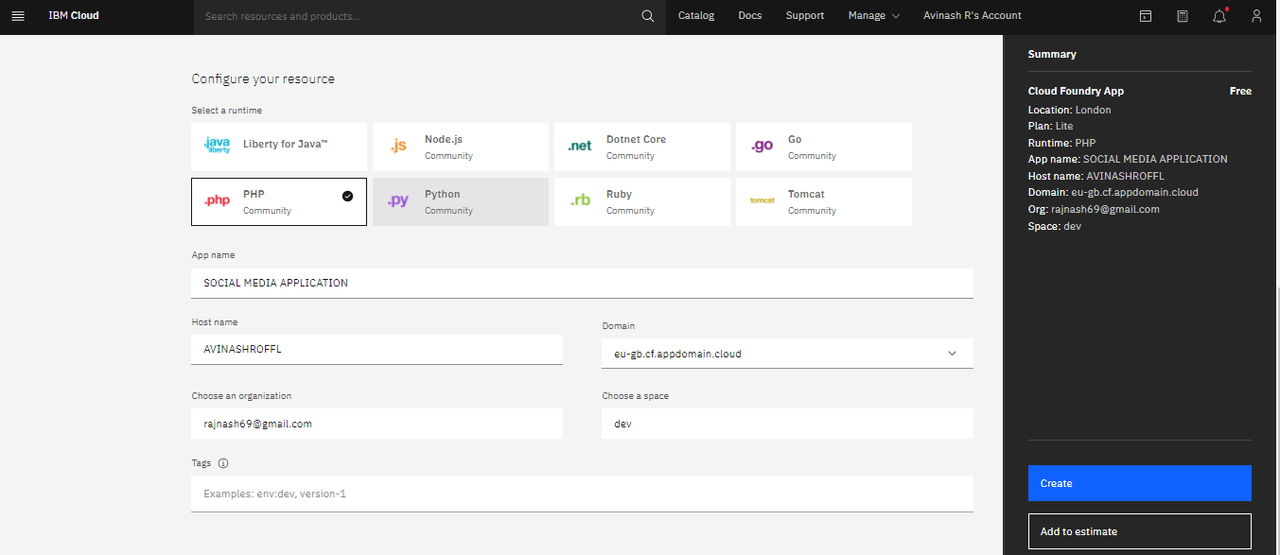

4. The application is created and the overview is displayed

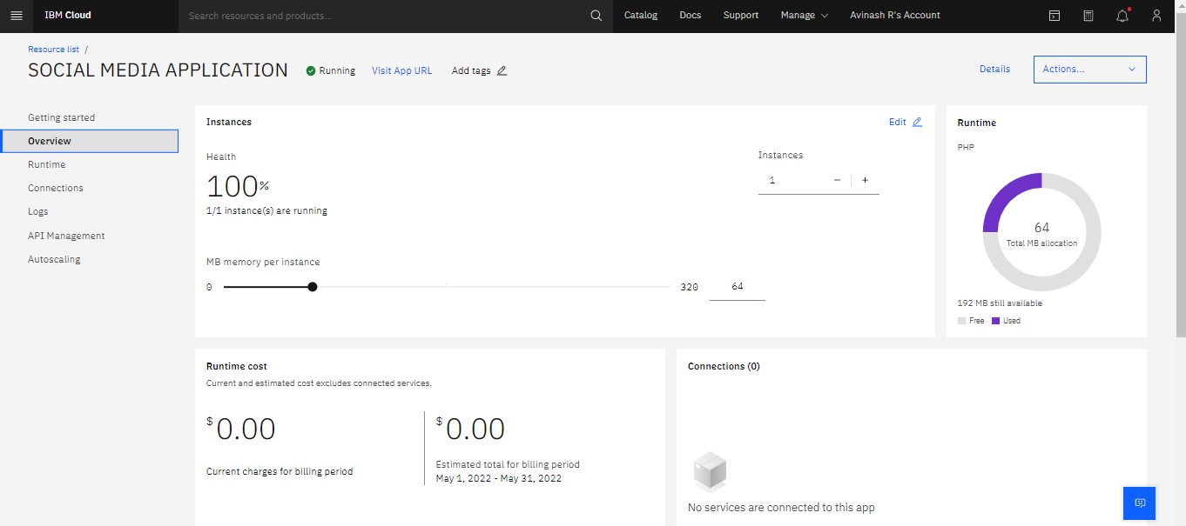

5. Click on “Enable Continuous delivery”

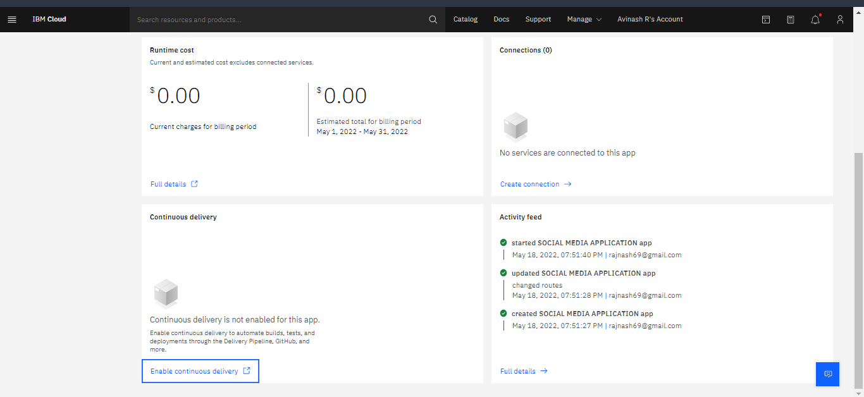

6. Choose the Delivery Pipeline option in Tool Integrations

7. Press on “+New” to generate a new API Key for the create app

8. Click on “ok”

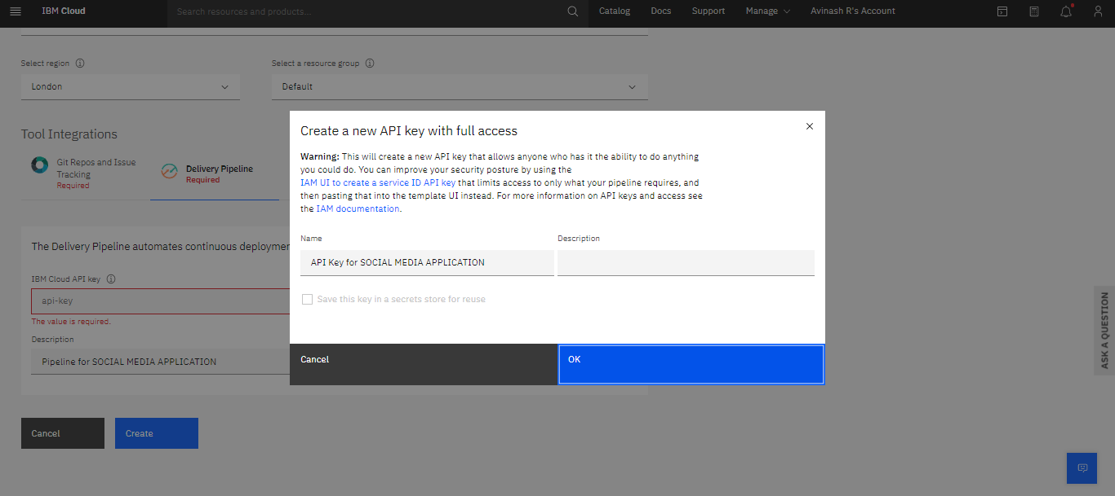

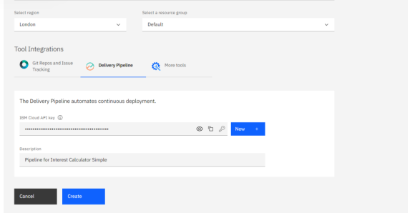

9. Then, click on “Create”

10. Now click on Eclipse Orion Web IDE

11. Then, a setting up window appears

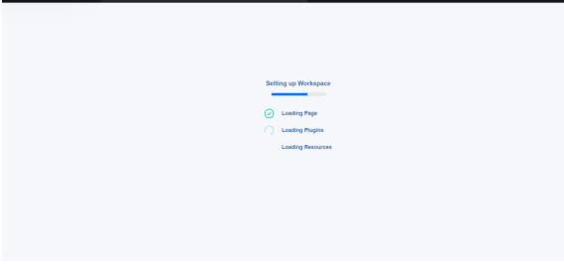

12. Click on the file index.php

13. And replace the default code with the code of your own application

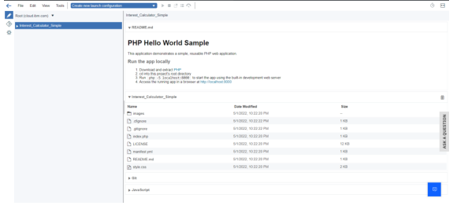

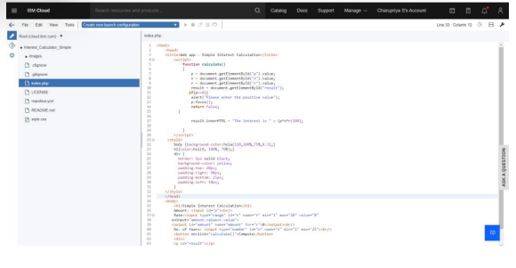

14. Then download and extract php from the link given, and click on Git (diamond icon)

15. Enter “commit” in the commit message box and click on commit button. Then chose push all from the push option and click on “Sync”

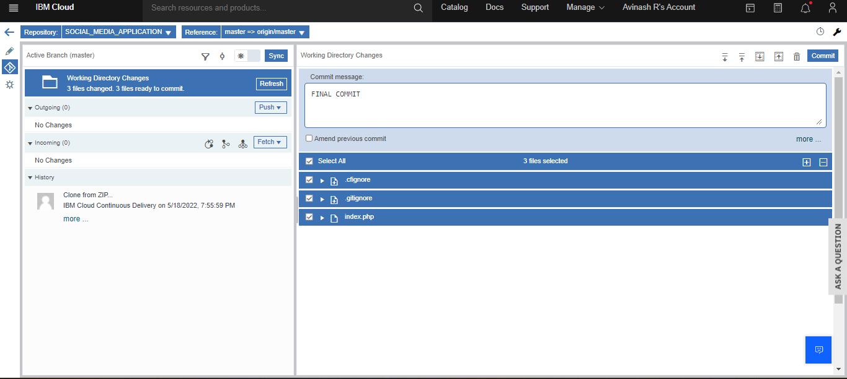

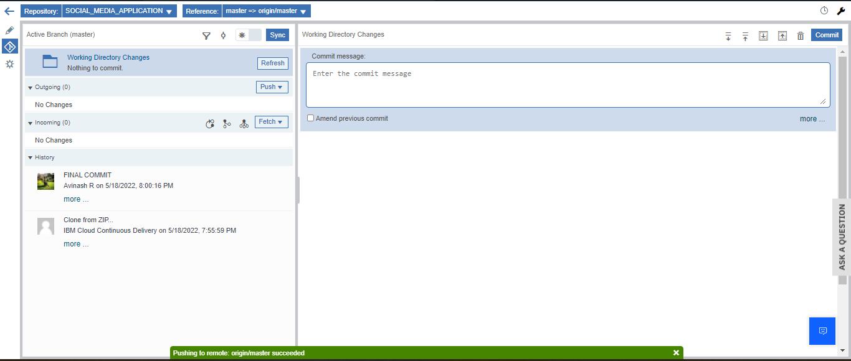

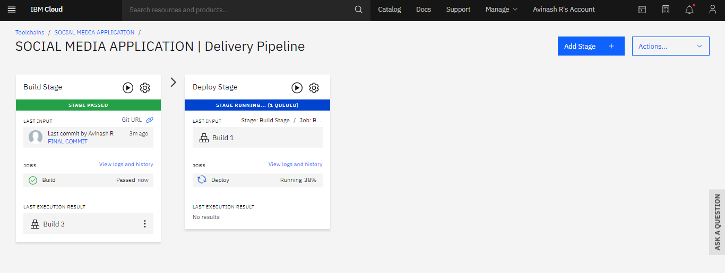

16. Then, go back using the back arrow option. Click on Delivery Pipeline and enable the Build Stage and Deploy Stage

17. Now click on “Visit App URL” to view your webpage

The site is live now

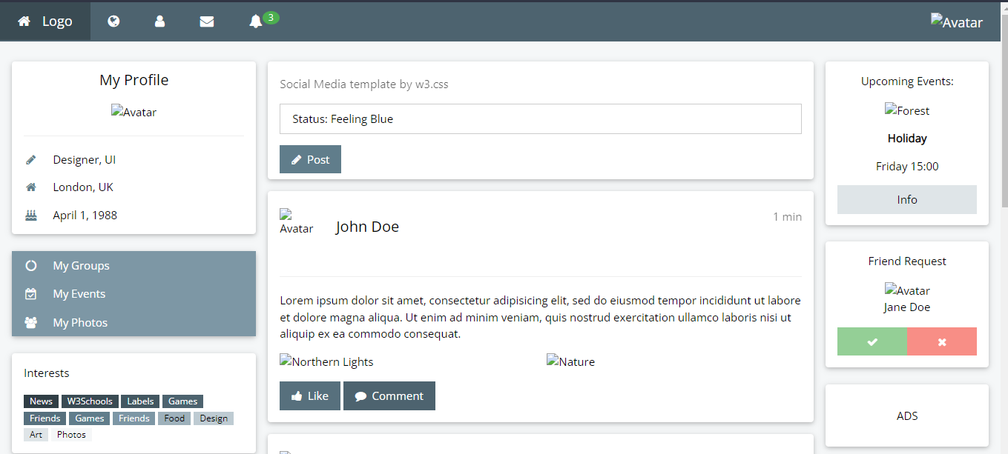

<https://avinashroffl.eu-gb.cf.appdomain.cloud/>

**Result**:

Hence PAAS is implemented using IBM cloud foundry