**EX NO: IMPLEMENTING ID AAS  
06/05/2022**

**Aim:**

To implement Identity As A Service in Application

**Tool used:**

Auth0

**Procedure:**

1. Installation of Necessary packages using node package manager in project folder(since it is a SPA)

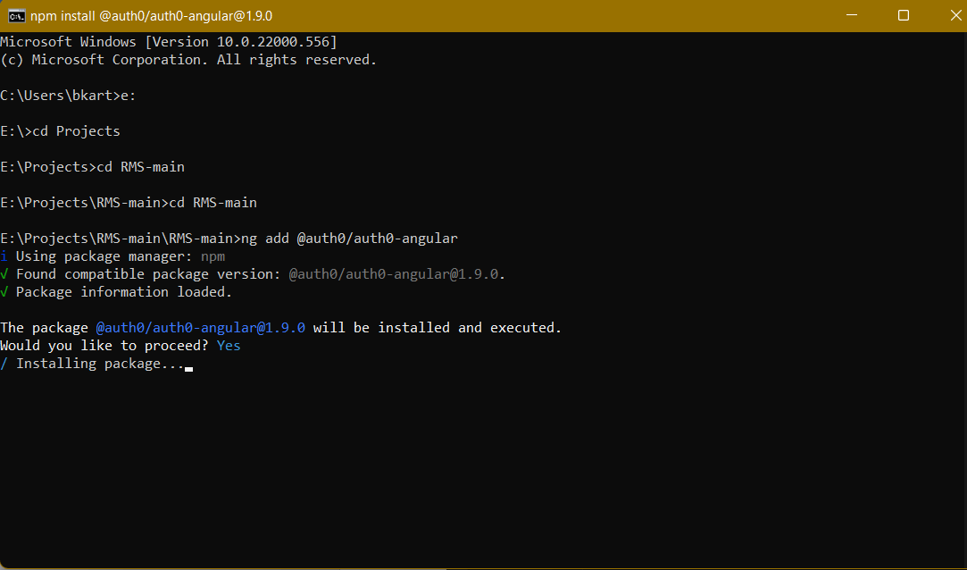

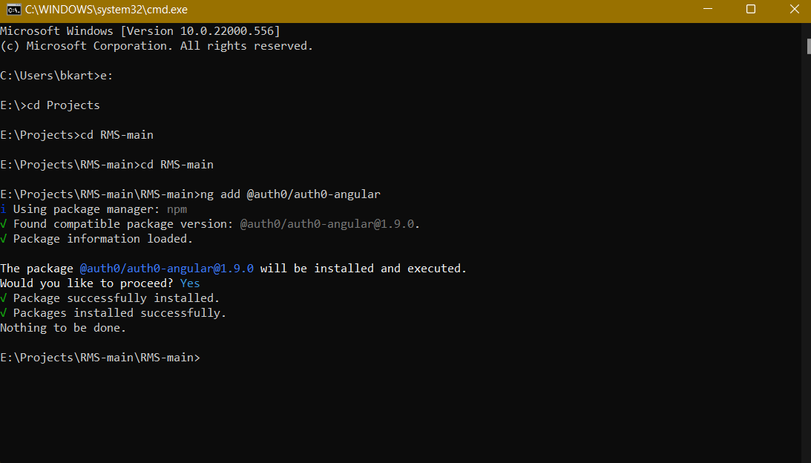

1. Dependences will be installed on the folder

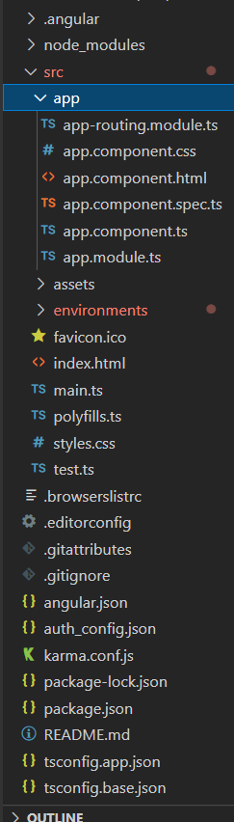

1. Creating Account in Auth0 to get credentials
2. Click Application at left from list of menus
3. Select type of application like SPA / Mobile APP/ Php basd app
4. Creating button for login in our Application
5. Adding Necessary code (By refering sample code given by Auth0)

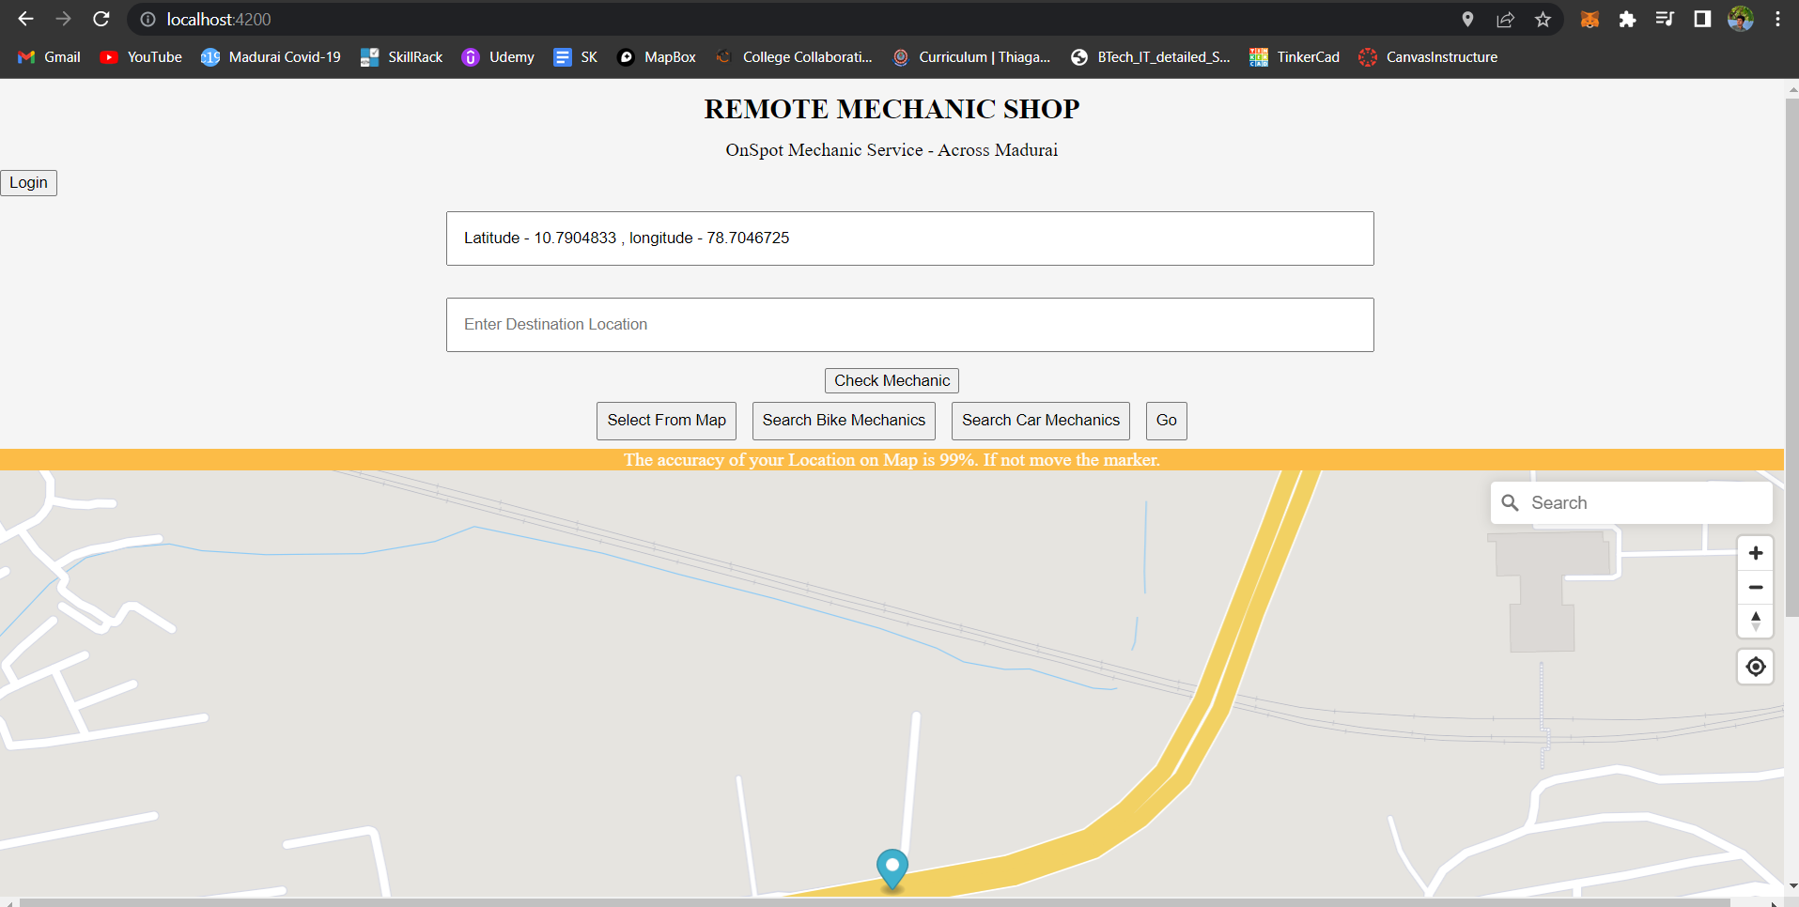

1. Now onclicking login btn we will be redirected to Auth0 site where we have to login / signup we can also login using SOA.

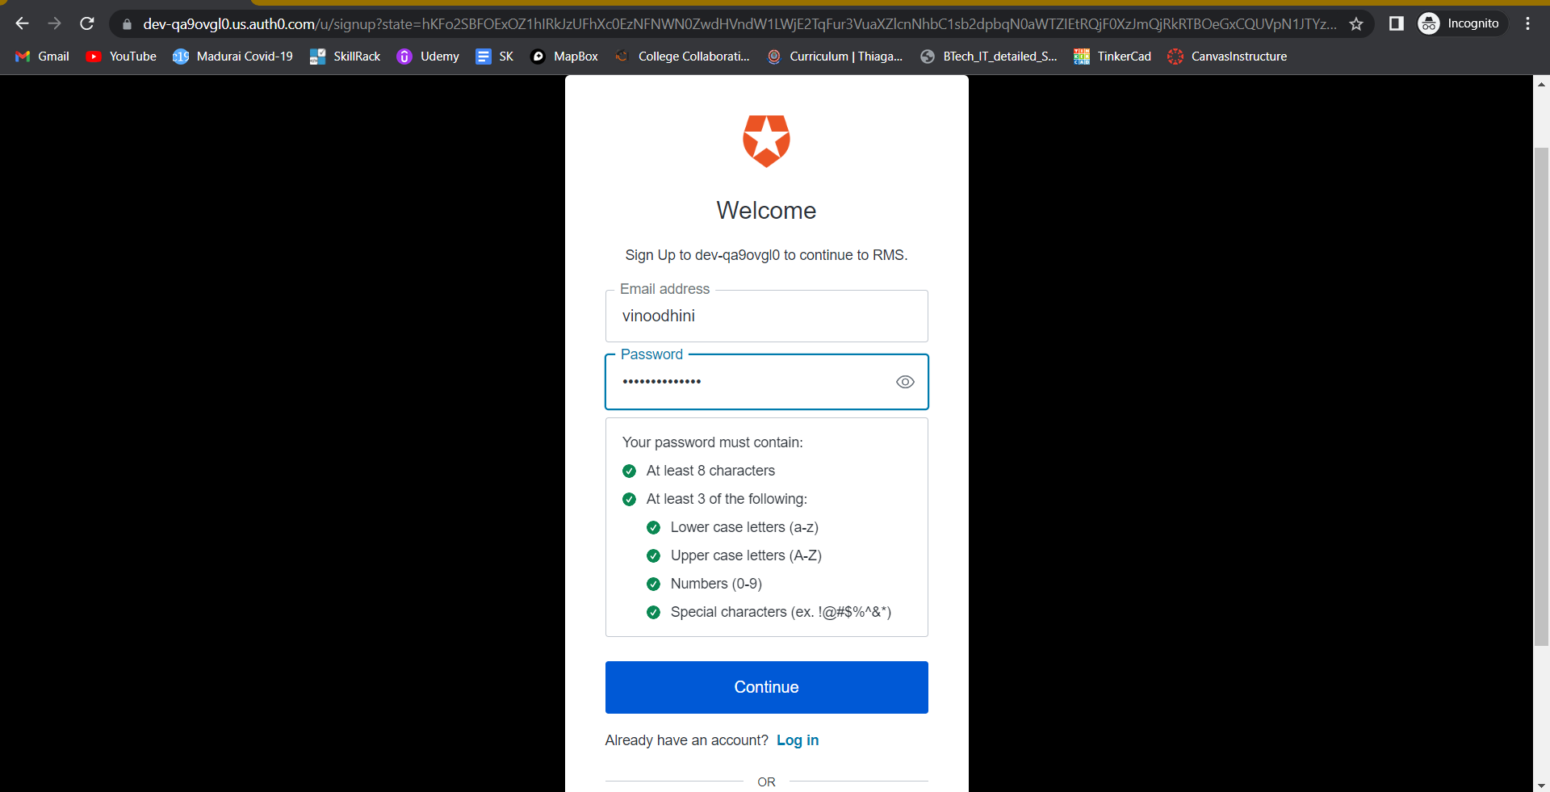

1. In the website we can see users they have loggedin in our Application

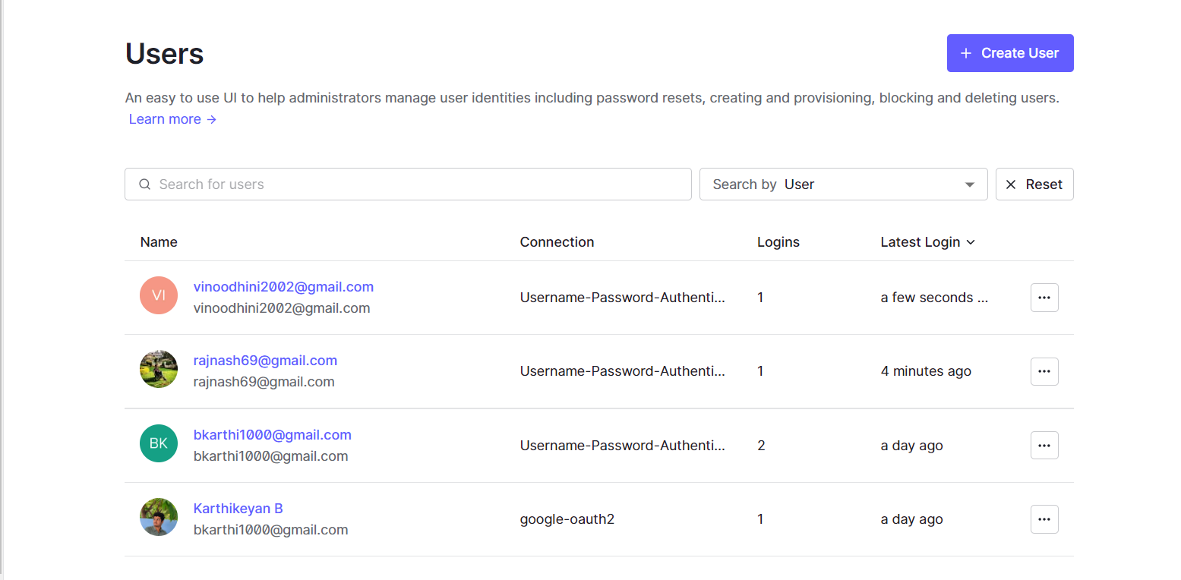

1. This also shows number of times we have loggedIn and time of logIn

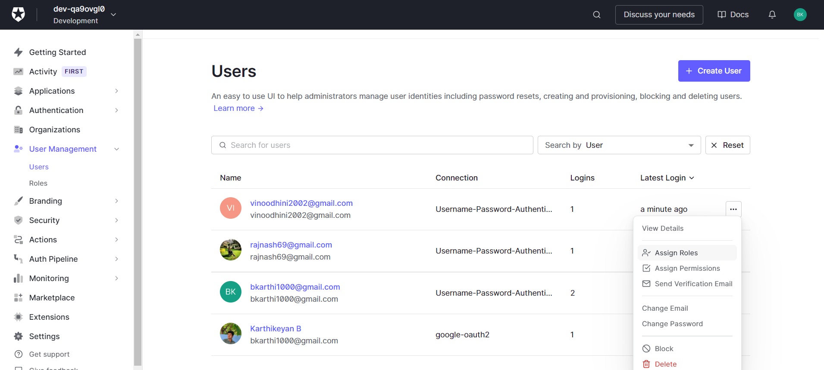

**Result:**

Thus, Idaas is implemented in Application using Auth0