User Interface and Design
Experiment 8 : Create storyboards to represent the user flow for your application using Balsamiq.

Roll no : 240701237
Name: Karthikeyan P

Student Profile & Academic Management System
Wireframe:

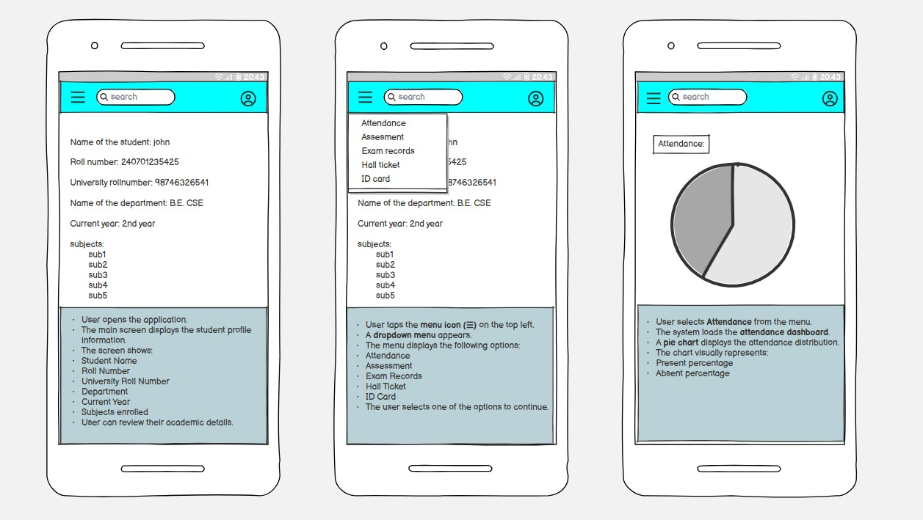

Description:
The storyboard shows a student viewing profile details, accessing the menu, and checking attendance through a visual dashboard in a simple mobile app flow.

1 . Storyboard Overview
- The storyboard represents the mobile application user flow consisting of three main screens:
- Student Profile Screen
- Navigation Menu Screen
- Attendance Dashboard Screen
- These screens demonstrate how a user interacts with the system to access academic details.

2 . Module Description
- Student Profile Screen
- Displays basic student information:
  - Student Name
  - Roll Number
  - University Roll Number
  - Department
  - Current Year
  - Subjects Enrolled
- This is the home screen after login.
- Allows students to quickly review their academic details.

3. Navigation Menu Screen
- Activated by tapping the menu icon .
- Displays a dropdown list of features:
  - Attendance
  - Assessment
  - Exam Records
  - Hall Ticket
  - ID Card
- Helps users navigate to different modules of the application.

4 . Attendance Dashboard Screen
- Displays attendance information using a pie chart.
- Shows:
  - Present Percentage
  - Absent Percentage
- Provides a visual representation for easy understanding of attendance status.

5 . User Flow
- User opens the application
- Student profile details are displayed
- User taps the menu icon
- Menu options appear
- User selects “Attendance”
- Attendance dashboard is displayed with a chart

