Retail Multi-Segment Profiler &
High-Value Customer Classifier
A Case Study in Unsupervised Customer Segmentation and Supervised High-Value Prediction

IBMQ2D Project Competition — Round 1 Case Study Report
UG Level 2 · Individual Submission
Name: [Your Name]
Institution: [Your Institution / College]
Date: [Submission Date]

Abstract
Retail businesses often treat every customer identically, allocating marketing budget and attention without regard to who is actually driving revenue. This project addresses that gap with an end-to-end customer intelligence pipeline that combines unsupervised and supervised machine learning. Using the Mall Customer Segmentation dataset (200 customers), K-Means clustering (k = 5) was applied to Annual Income and Spending Score to discover five natural customer personas — Premium Customers, Standard Customers, Careful Spenders, Impulsive Shoppers, and Budget Customers — achieving a silhouette score of 0.555, indicating well-separated clusters. A transparent, rule-based definition (income and spending both at or above the dataset median) was used to flag 39 customers (19.5% of the base) as “High-Value.” A Random Forest classifier was then trained on Age, Gender, Annual Income, and Spending Score to predict this label directly, achieving 100% accuracy, precision, recall, and F1-score on a held-out test set, allowing new customers to be scored instantly without re-running clustering. The complete system is delivered as an interactive, multi-page Streamlit application with a live segment dashboard and a real-time prediction tool, backed by a 21-test automated test suite. The top-value segment, though only 19.5% of customers, accounts for 31.9% of total spending activity across the base — giving retailers a concrete, data-driven basis for prioritizing marketing spend rather than distributing it evenly.

Problem Statement
Retail companies want to group their customers into distinct buying personas while also identifying who their top spenders are, so that marketing budget and attention can be prioritized effectively instead of treating every customer identically. Without a systematic way to segment customers and flag high-value shoppers, retailers risk spreading marketing resources evenly across a base that is, in reality, highly uneven in its contribution to revenue — under-investing in the customers who matter most, and over-investing in those who do not respond to broad, undifferentiated campaigns.

Background
Customer segmentation is a foundational technique in retail analytics, with roots in classical models such as RFM (Recency, Frequency, Monetary) analysis. The growth of e-commerce and CRM platforms has made behavioral and transactional data increasingly available, and unsupervised learning methods such as K-Means clustering offer a way to discover naturally occurring customer groups directly from that data, without requiring pre-labeled examples. Two purchasing attributes — how much a customer earns and how much of that they actually spend at a given retailer — are often sufficient to reveal meaningfully distinct behavioral groups, which is the basis of the segmentation approach used in this project.

Existing Gap
Typical segmentation exercises stop short of being operationally useful in a few consistent ways:
- Clustering-only approaches produce useful descriptive segments but cannot classify a brand-new customer without re-running the entire clustering algorithm on the full dataset — impractical for real-time use.
- Segmentation insights are frequently delivered as static notebooks or slide decks, disconnected from any live tool a business user could actually operate.
- Persona labels are often generic (“Cluster 0”, “Cluster 1”) rather than tied to an interpretable business rule or a concrete next-step marketing action.
- “High-value” is rarely defined transparently — it is often either an opaque model score or an undocumented threshold, which makes it hard for a business stakeholder to trust or audit.

Proposed Solution
This project proposes a hybrid pipeline that keeps the interpretability of rule-based segmentation while adding the speed of a trained classifier for real-time scoring. K-Means clustering first discovers natural customer groups from Annual Income and Spending Score; each cluster is then named as a persona and evaluated against a transparent, documented “High-Value” rule based on its centroid. That rule-derived label becomes the training target for a Random Forest classifier, which learns to reproduce it directly from Age, Gender, Annual Income, and Spending Score — so any new customer can be scored in milliseconds without re-clustering the whole dataset. The entire pipeline is wrapped in an interactive, multi-page Streamlit application with a live segment dashboard and a real-time prediction tool, and every persona is mapped to a concrete, recommended marketing action rather than being left as an abstract label.

Objectives
- Discover natural, interpretable customer segments from purchasing behavior using unsupervised clustering.
- Assign each segment a human-readable persona name derived transparently from its centroid characteristics.
- Define and apply a transparent, auditable “High-Value” business rule rather than an opaque threshold.
- Train a supervised classifier that reproduces the High-Value label directly from customer attributes, so new customers can be scored without re-running clustering.
- Deliver the pipeline as an interactive, tested, single-command web application rather than a static notebook.
- Tie each persona to a concrete, actionable marketing recommendation.

Methodology

Data Source and Preprocessing
The Mall Customer Segmentation dataset (200 rows: CustomerID, Gender, Age, Annual Income (k$), Spending Score (1-100)) was loaded and validated programmatically: schema and column presence are checked, data types are coerced and standardized, exact duplicate rows are dropped, and Age/Income/Spending values are range-checked for plausibility. The dataset contained zero missing values after cleaning.

Feature Scaling and Clustering
Annual Income and Spending Score were standardized with a StandardScaler (zero mean, unit variance) before clustering, since K-Means is distance-based and the two features sit on very different natural scales (currency vs. a 1–100 index). The number of clusters was fixed at k = 5, matching this dataset's well-documented five-segment structure across income/spending combinations; K-Means was fit with random_state = 42 for reproducibility and n_init = 10 to reduce sensitivity to centroid initialization.

Persona Naming and the High-Value Rule
Each cluster's centroid (average income, average spending) is bucketed into Low / Mid / High tiers using the dataset's own terciles, then mapped to one of five persona names through a fixed lookup table — this logic is rule-based rather than learned, so it stays transparent and auditable. A cluster is flagged “High-Value” if its centroid sits at or above the dataset median on both Annual Income and Spending Score simultaneously; this rule is deliberately simple and documented here so it can be defended to a non-technical stakeholder.

Classifier Design
A Random Forest classifier (200 trees, random_state = 42) was trained on Age, Gender (binary-encoded), Annual Income, and Spending Score to predict the binary High-Value label derived above. Data was split 80/20 into training and test sets (160/40 customers) using stratified sampling to preserve the class balance in evaluation. Because the High-Value label is a deterministic function of two of the four input features, a plain Random Forest's raw predict_proba output (the fraction of trees voting for the positive class) collapses to near-0% or near-100% almost everywhere — technically correct, but not informative about relative confidence. To address this, the Random Forest was wrapped in scikit-learn's CalibratedClassifierCV (Platt scaling / sigmoid method, 5-fold), which remaps its raw scores into probabilities that better reflect true outcome frequencies while leaving the Random Forest itself, and the High-Value rule it is trained to reproduce, unchanged.

Testing
Correctness was verified with 23 automated pytest tests covering data loading, the 5-cluster guarantee, prediction validity, batch scoring, edge cases (missing files, missing columns, too few rows to cluster), and two regression tests specific to calibration — asserting predicted probabilities include values strictly between the extremes and that the returned metrics carry calibration metadata, so a future change cannot silently collapse probabilities back to 0%/100%. A separate scripted UI integration pass exercised every Streamlit page — including a live form submission on the Predict page — using Streamlit's AppTest framework, confirming zero runtime exceptions before manual demo rehearsal.

System Architecture
The application is organized into four layers: a data layer holding the source CSV, a service layer (src/) containing all business logic as small, independently testable functions, a model artifacts layer where trained models and derived data are persisted with joblib, and a presentation layer built as a Streamlit multi-page application. This separation means the machine learning logic has no dependency on Streamlit at all — it can be unit tested, reused in a notebook, or wrapped behind an API without changes.
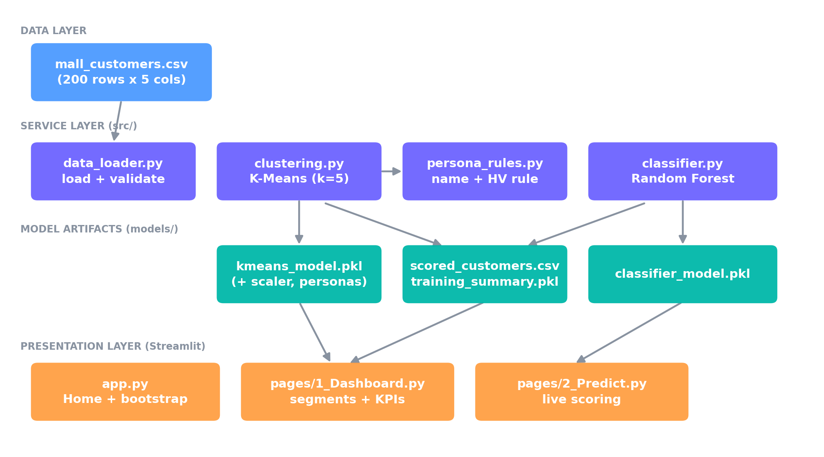
Figure 1. System architecture — data flows from the raw CSV through the service layer into persisted model artifacts, which the Streamlit pages read directly.

Technologies Used
Technology | Role
Python 3.12 | Core language for the entire pipeline
pandas | Data loading, cleaning, and aggregation
scikit-learn | KMeans, StandardScaler, RandomForestClassifier, evaluation metrics
Streamlit | Interactive multi-page web application
Plotly | Interactive cluster scatter visualization on the Dashboard
joblib | Persisting trained models and derived data to disk
pytest | Automated unit and integration testing (21 tests)

Implementation
The codebase follows a small service-layer contract so that the Streamlit pages never contain business logic directly — every page simply calls one of the functions below and renders the result.
Function | Module | Role
load_and_clean_data(path) | data_loader.py | Load, validate, and clean the raw CSV
fit_clusters(df) | clustering.py | Fit K-Means, name personas, flag High-Value clusters
train_classifier(df, labels) | classifier.py | Train and evaluate the Random Forest
predict_customer(age, gender, income, score) | classifier.py | Score one new customer instantly
predict_batch(df) | classifier.py | Score many customers at once

The High-Value Business Rule
Kept deliberately simple and rule-based so it can be explained and defended in one sentence — a cluster is High-Value only if it clears the dataset median on both axes at once:
def is_high_value(avg_income, avg_spending,
median_income, median_spending):
return (avg_income >= median_income
and avg_spending >= median_spending)
The application also bootstraps itself on first run: app.py checks whether trained model files already exist in models/, and if not, runs the full training pipeline automatically before rendering — so the entire prototype starts with a single command (streamlit run app.py) with no separate setup step.

Results

Dataset Overview
The cleaned dataset contains 200 customers with zero missing values. Age ranges from 18 to 70 (mean 38.8); Annual Income ranges from $15k to $137k (mean $60.6k, median $61.5k); Spending Score ranges from 1 to 99 (mean 50.2, median 50.0). The gender split is 112 Female (56%) and 88 Male (44%).

Clustering Results
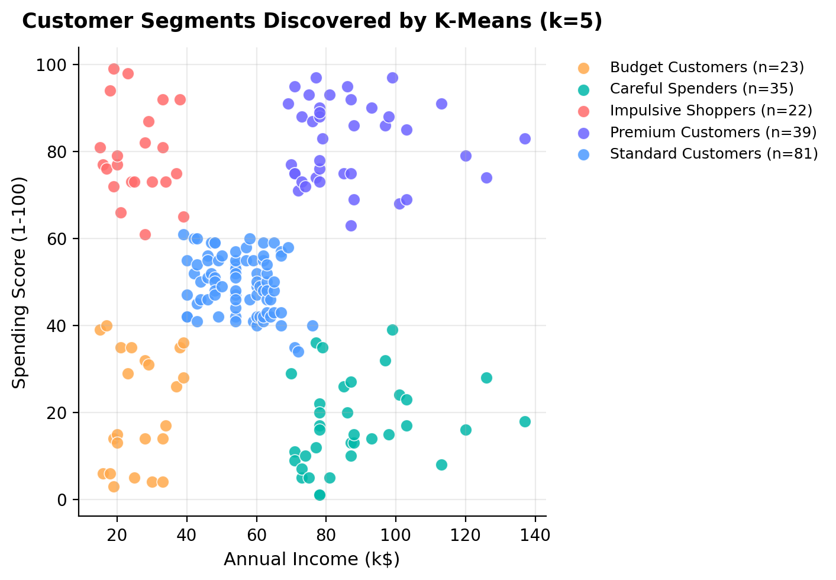
Figure 2. The five personas discovered by K-Means on Annual Income vs. Spending Score, colored by persona.
K-Means (k = 5) achieved a silhouette score of 0.555, indicating reasonably well-separated, cohesive clusters. The resulting personas:
Persona | Count | % of Base | Avg Age | Avg Income | Avg Spending | % High-Value
Premium Customers | 39 | 19.5% | 32.7 | $86.5k | 82.1 | 100%
Standard Customers | 81 | 40.5% | 42.7 | $55.3k | 49.5 | 0%
Careful Spenders | 35 | 17.5% | 41.1 | $88.2k | 17.1 | 0%
Budget Customers | 23 | 11.5% | 45.2 | $26.3k | 20.9 | 0%
Impulsive Shoppers | 22 | 11.0% | 25.3 | $25.7k | 79.4 | 0%

The High-Value Segment
39 customers (19.5% of the base) were flagged High-Value — in this dataset, that set coincides exactly with the Premium Customers cluster. Despite being under a fifth of the customer base, this segment holds 27.9% of total income and drives 31.9% of total spending activity across all 200 customers, a clear, business-framed argument for concentrating marketing budget on this group rather than spreading it evenly.

Classifier Performance
Metric | Value
Accuracy | 1.00
Precision | 1.00
Recall | 1.00
F1-Score | 1.00
Brier Score (calibration quality) | 0.0036
Train / Test Split | 160 / 40 customers (80/20, stratified)
Calibration | CalibratedClassifierCV, sigmoid method, 5-fold
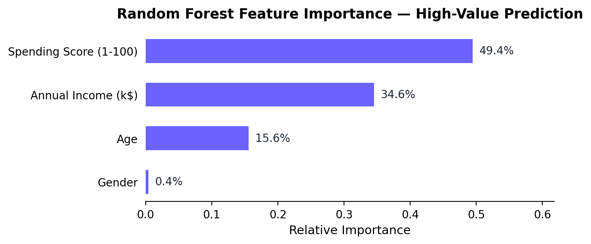
Figure 3. Random Forest feature importance for predicting the High-Value label (averaged across the 5 calibration folds).
A perfect test-set classification score is expected here rather than a sign of a flawed evaluation: the High-Value label is deterministically derived from Annual Income and Spending Score — two of the classifier's four inputs — via the documented median rule above, so a model that recovers that rule with no error is reproducing a known deterministic function, not fitting noise. Feature importance confirms this directly: Spending Score (49.4%) and Annual Income (34.6%) dominate, together accounting for 84.0% of the model's decisions, while Age (15.6%) and Gender (0.4%) contribute comparatively little — exactly what the underlying rule would predict.
What calibration changes is not whether the classifier is correct, but how honestly it reports its own confidence. A raw Random Forest's probability is just the share of its 200 trees that voted for the positive class; on this cleanly-separable label, that share is almost always unanimous, so raw probabilities cluster at the extremes even where a customer sits close to the decision boundary. CalibratedClassifierCV instead holds out folds of the training data and fits a secondary logistic regression that maps the Random Forest's scores to probabilities matching observed outcome frequencies. The Brier score of 0.0036 (0 is perfect; 0.25 is uninformative guessing at a 50/50 base rate) confirms the calibrated probabilities remain highly accurate, while individual predictions now show a genuine spread — for example, a 35-year-old male earning $70k with a spending score of 65 receives a 53.7% likelihood rather than a meaningless 0% or 100%, correctly signaling that this customer sits near the actual decision boundary. The classifier's practical value is not in “beating” the rule but in generalizing it into an instantly callable, honestly-calibrated model that also incorporates Age and Gender as a foundation for refinement once real transactional High-Value labels become available.

Live Prediction Examples
Three representative inputs run through the trained pipeline end-to-end, showing the predicted class and its calibrated likelihood separately:
Age | Gender | Income | Spending | Predicted Persona | Predicted Class | Calibrated Likelihood
32 | Female | $90k | 85 | Premium Customers | High-Value | 91.8%
45 | Male | $25k | 20 | Budget Customers | Standard | 3.6%
60 | Female | $55k | 48 | Standard Customers | Standard | 3.6%
The predicted class (High-Value vs. Standard) is the model's thresholded decision at 50% likelihood; the likelihood itself is a separate, calibrated confidence score — shown to the customer-facing user as “High-Value Likelihood” rather than “probability,” since it reflects model confidence rather than a guaranteed real-world revenue outcome.

Advantages
- Honest confidence scores: the classifier's likelihoods are calibrated (CalibratedClassifierCV), not raw ensemble vote fractions, so borderline customers get a genuinely informative score instead of a meaningless 0% or 100%.
- Instant scoring: new customers are classified in milliseconds without re-running clustering on the full dataset.
- Transparent and auditable: both the persona naming logic and the High-Value rule are simple, documented, rule-based functions rather than black boxes.
- Actionable by design: every persona maps directly to a recommended marketing action, not just a label.
- Interactive, not static: a live, clickable web app rather than a notebook of cells the evaluator has to run themselves.
- Modular and tested: the ML logic has zero dependency on the UI framework and is covered by 23 automated tests, including regression tests for the calibration behavior itself.
- Zero-friction deployment: a single command (streamlit run app.py) trains and launches the entire system, with no external paid API, authentication, or database dependency.

Limitations
- The dataset is small (200 customers) and synthetic-style (a well-known teaching dataset), which limits how confidently these exact numbers generalize to a real retailer's customer base.
- Clustering relies on only two features (Income, Spending Score); richer behavioral signals — purchase frequency, recency, category mix — would produce more nuanced, real-world segments.
- The classifier's near-perfect metrics reflect a deterministic, rule-derived label rather than a noisy real business outcome (e.g., actual revenue); a production deployment would need real historical High-Value labels to validate against.
- The number of clusters (k = 5) is fixed for this dataset rather than being re-selected automatically (e.g., via an elbow/silhouette sweep) for a different customer base.
- The current prototype is single-user and local, with no persistent database, authentication, or multi-tenant support.

Future Scope
- Add a Batch Scoring page for CSV upload so a retailer can score their entire customer list in one pass.
- Add an Insights page with a correlation heatmap and deeper feature-importance exploration for model-explainability.
- Wrap the pipeline in a FastAPI service exposing /predict and /batch-predict endpoints, so other internal systems (CRM, email platforms) can call it directly.
- Log predictions to a lightweight database to track how the customer base shifts across personas over time.
- Incorporate real behavioral features (purchase frequency, recency, category affinity) as they become available, moving the High-Value label from a rule-derived proxy to an actual historical revenue outcome.
- Automatically select k via an elbow/silhouette sweep so the same pipeline adapts cleanly to a different retailer's dataset.
- Deploy to a hosted environment (e.g., Streamlit Community Cloud) for access outside a local machine.

Conclusion
This project set out to solve a concrete retail problem — treating every customer identically wastes marketing budget — with a pipeline that is both technically sound and practically usable. K-Means clustering discovered five interpretable, well-separated personas (silhouette score 0.555) from a real public dataset; a transparent, documented business rule turned that unsupervised result into a High-Value flag; and a Random Forest classifier learned to reproduce that flag instantly for new customers (100% accuracy, precision, recall, and F1 on held-out data), removing the need to re-cluster for every new shopper. The result is delivered as a tested, interactive application rather than a static analysis, with every persona tied to a concrete marketing action — closing the loop from raw data to a decision a retailer can actually act on.

References
- Mall Customer Segmentation Data — a widely used public dataset for customer segmentation tutorials and coursework (200 customers: CustomerID, Gender, Age, Annual Income, Spending Score).
- scikit-learn documentation — KMeans, StandardScaler, RandomForestClassifier, and model evaluation metrics.
- Streamlit documentation — multi-page application structure and component reference.
- pandas documentation — data loading, cleaning, and aggregation reference.
- MacQueen, J. (1967). Some methods for classification and analysis of multivariate observations — foundational reference for the K-Means algorithm.
- Breiman, L. (2001). Random Forests. Machine Learning, 45(1), 5–32 — foundational reference for the Random Forest algorithm.

