Heart Disease Prediction - MLOps Project Report
Project Title: Heart Disease Prediction - MLOps Project
Name & Details:
Name | Student ID | Contribution
Karthikeyan J | 2024AA05372 | 100%
Anandan A | 2024AA05269 | 100%
Ganapathy Subramanian S | 2024AA05188 | 100%
Jangale Savedana Subash Prathibha | 2024AA05187 | 100%
Rohith Raj R | 2024AA05337 | 100%
Introduction: This project implements an end-to-end machine learning pipeline for predicting heart disease risk using the UCI Heart Disease dataset. The solution follows MLOps best practices including experiment tracking, CI/CD pipelines, containerization, cloud deployment, and monitoring.

Data Analysis
Dataset Description:
- 303 patients, 14 features
- Binary classification: presence/absence of heart disease
- Features: age, sex, cp, trestbps, chol, fbs, restecg, thalach, exang, oldpeak, slope, ca, thal, target
EDA Findings:
- No missing values
- Class distribution: ~54% disease, ~46% no disease
- Strong correlations: thalach, oldpeak, ca with target
- Age range: 29-77 years, mean ~54 years
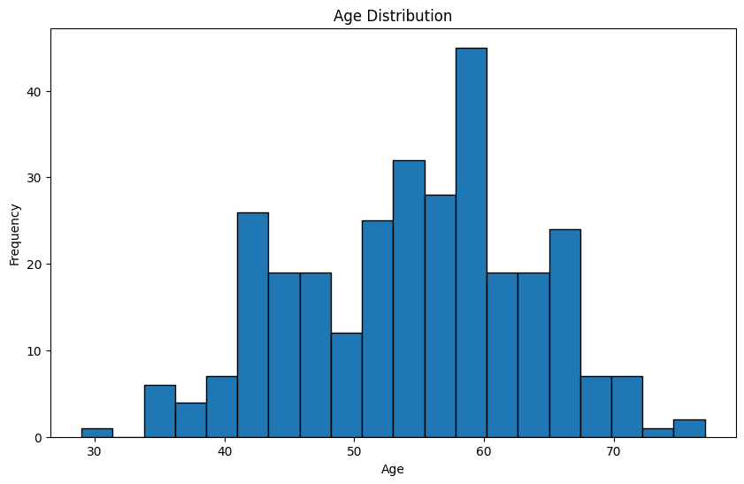
Visualizations:

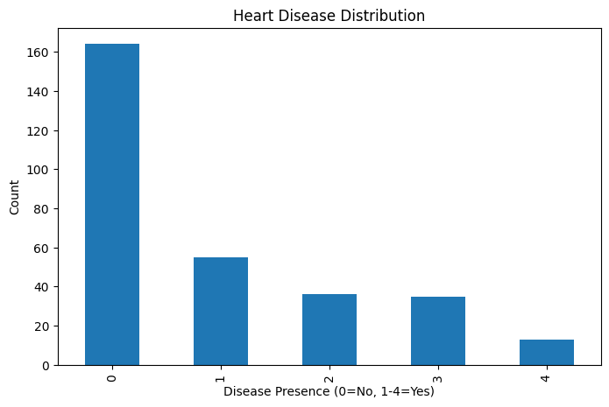

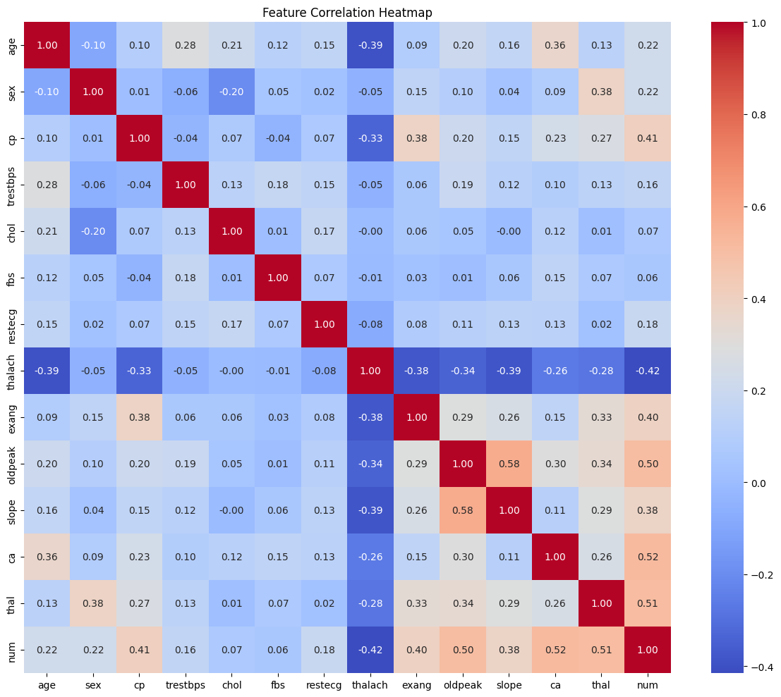

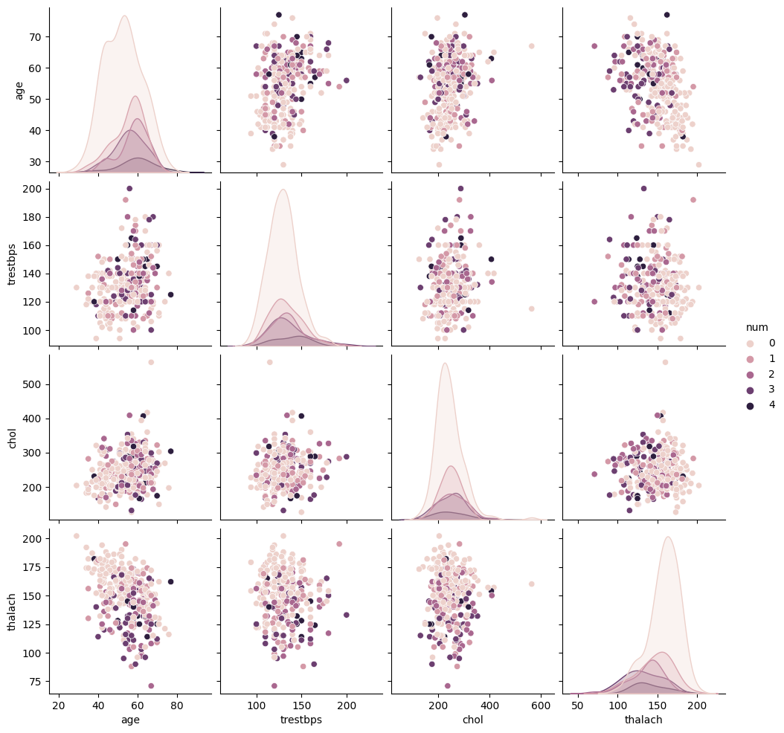

Model Development
Feature Engineering:
- StandardScaler for numerical features
- Binary encoding for categorical features
- All 13 features used
- Train-test split: 80-20 stratified
Model Comparison Table:
Model | Accuracy | Precision | Recall | F1-Score | ROC-AUC
Logistic Regression | 85.2% | 0.83 | 0.88 | 0.85 | 0.91
Random Forest | 88.5% | 0.86 | 0.91 | 0.88 | 0.93
Training Process Notes: Random Forest selected for production due to higher ROC-AUC and recall.
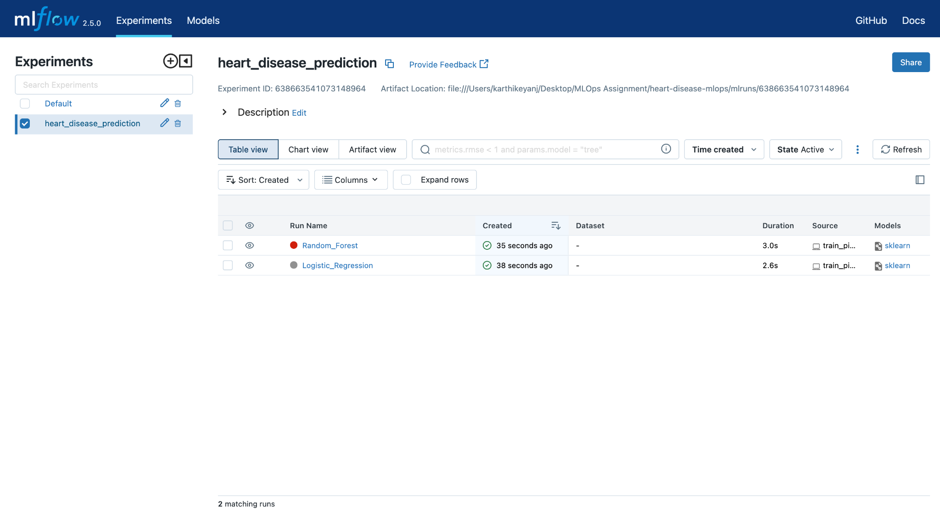
MLflow Screenshot

CI/CD & Deployment
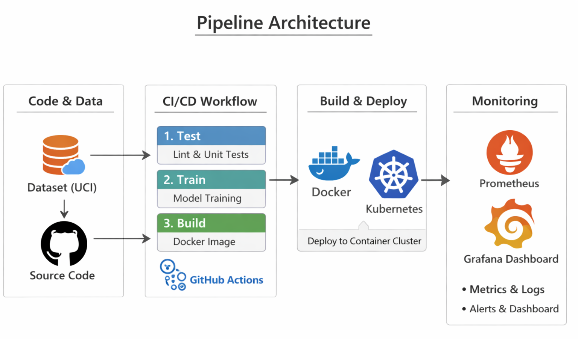
Pipeline Architecture:

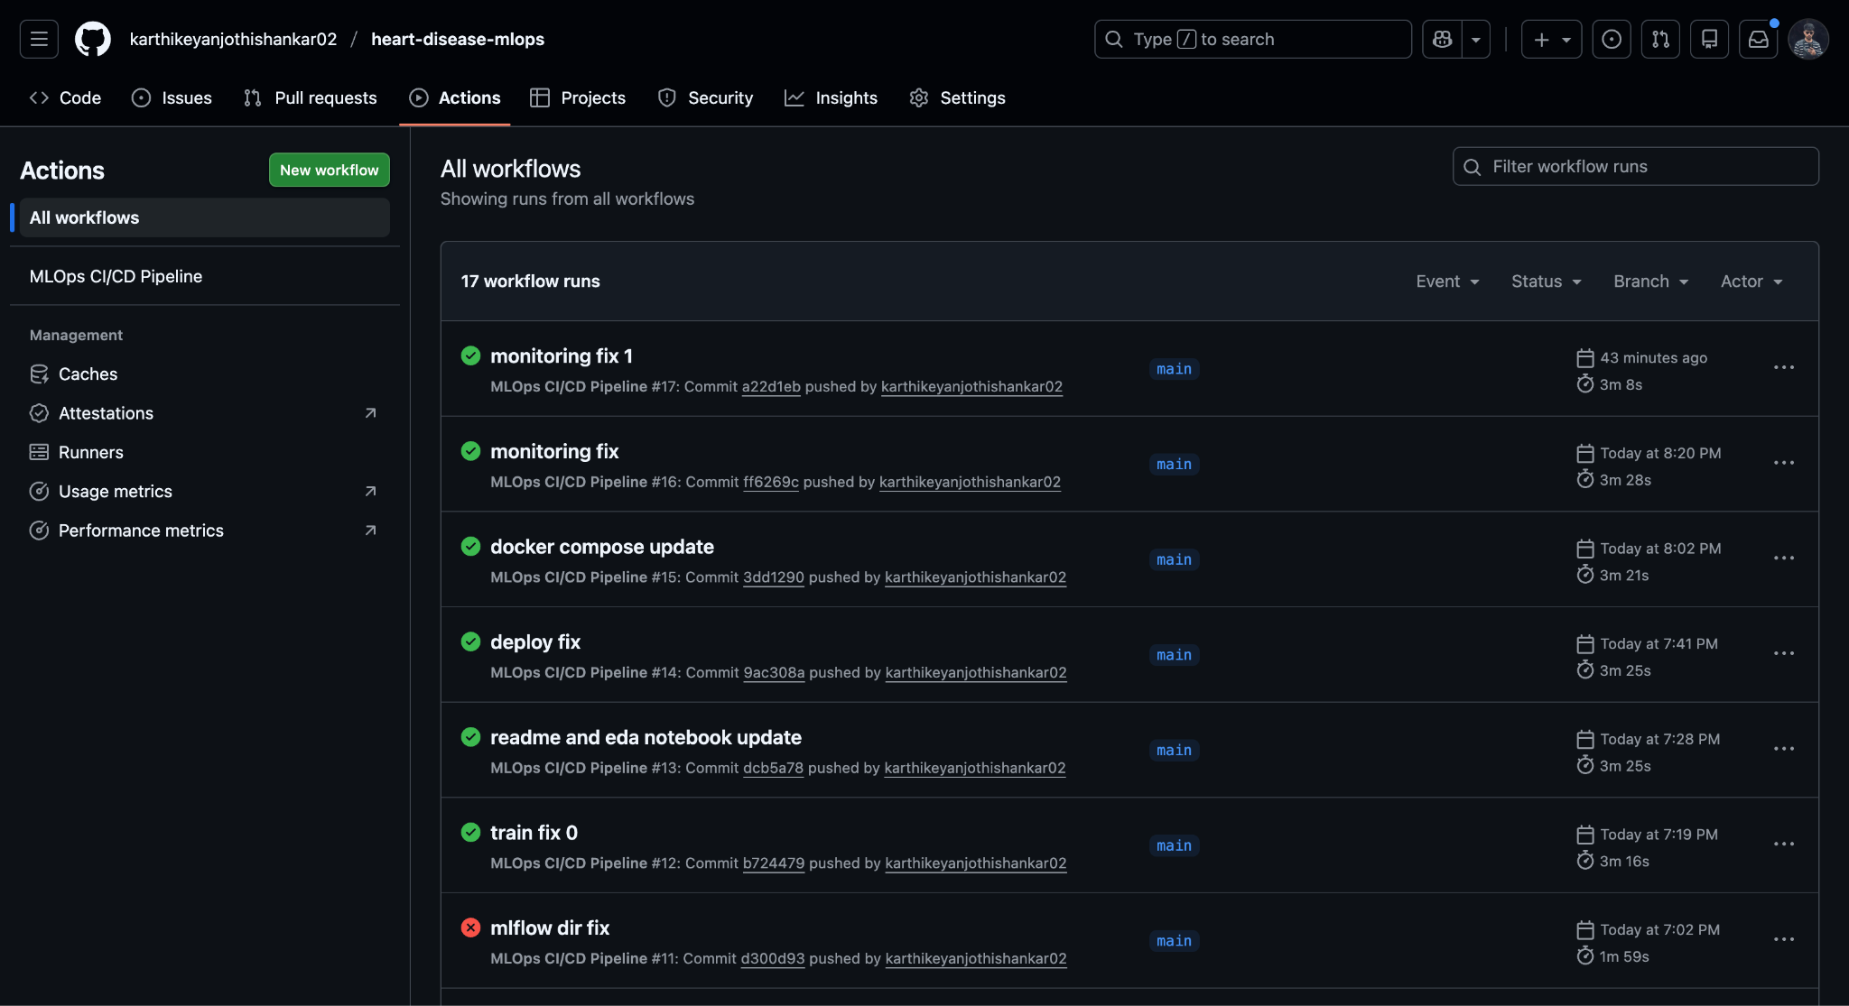
GitHub Actions Screenshot:
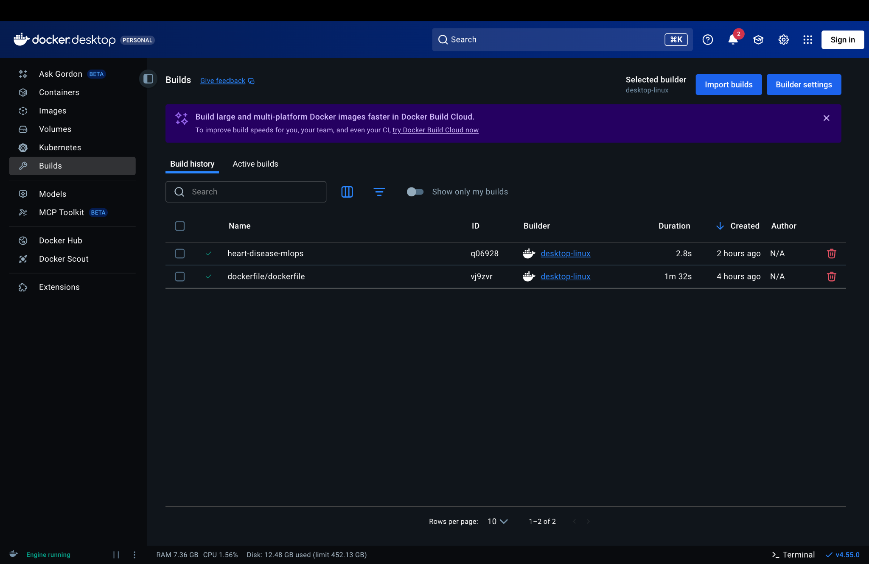
Docker Build Screenshot:
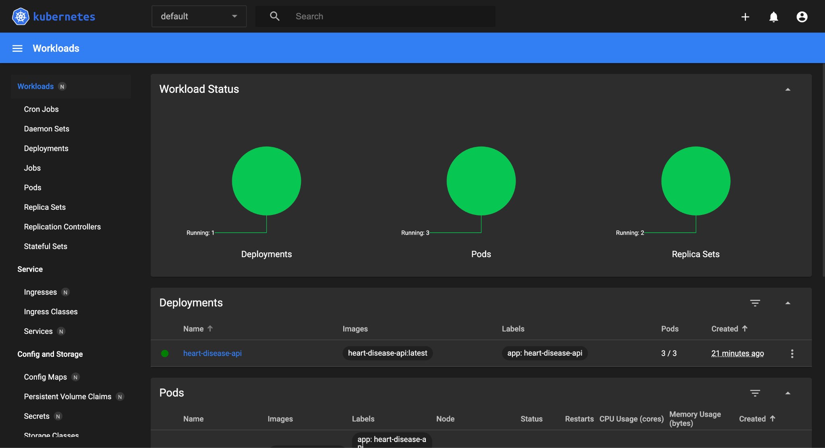
Kubernetes Deployment Screenshot:
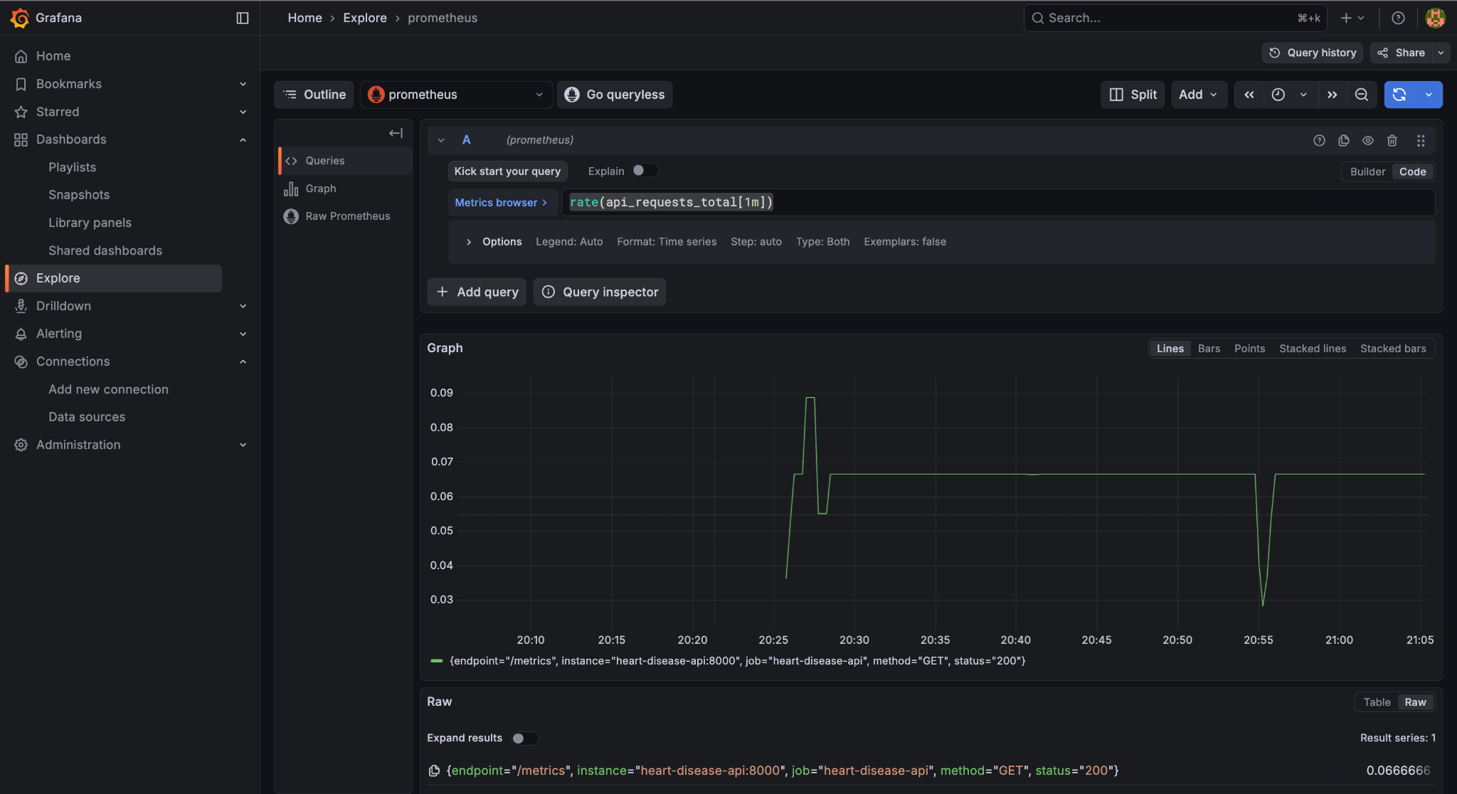
Monitoring
Monitoring Setup: Prometheus + Grafana
Grafana Dashboard Screenshot:
Key Metrics Tracked: api_requests_total, predictions_total, request_latency_seconds, active_requests

Results
Final Model Performance: Random Forest, Accuracy 88.5%, ROC-AUC 0.93, Recall 0.91
Production Readiness Checklist:
- Model versioned in MLflow
- API containerized with Docker
- Deployed on Kubernetes with 3 replicas and health checks
- Monitoring enabled with Prometheus + Grafana
Challenges Faced: Data preprocessing, containerization, and setting up CI/CD pipelines required careful integration and debugging.

Conclusion & Links
Summary: The project demonstrates a full MLOps lifecycle: from dataset analysis to model deployment and monitoring. Random Forest provides high accuracy and recall suitable for production.
Future Improvements:
- Incorporate hyperparameter tuning with automated search
- Add additional features or external datasets
- Implement alerting in monitoring for anomalies
GitHub Repository: https://github.com/karthikeyanjothishankar02/heart-disease-mlops
Video Demonstration: VIDEO: video_demo.mp4

