CIRCUIT DIAGRAM

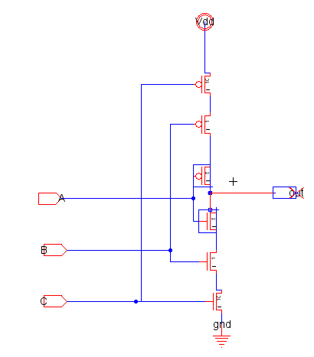

RESULTS:
FOR ASPECT RATIOS: C:B:A= 10:1:5
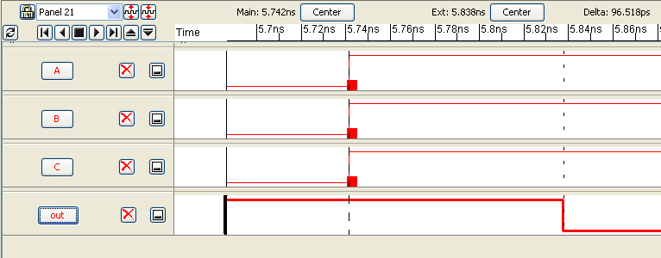
FOR ASPECT RATIOS: C:B:A= 1:5:10
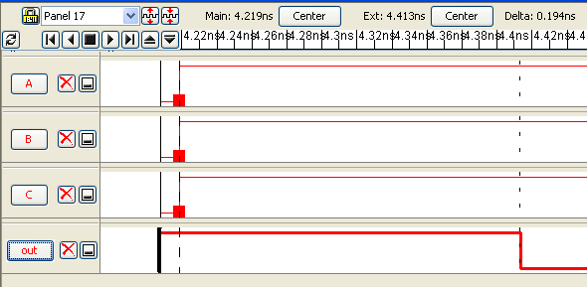
FOR ASPECT RATIOS: C:B:A= 1:10:5
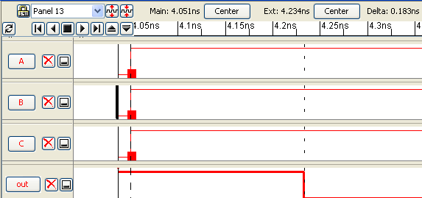

FOR ASPECT RATIOS: C:B:A= 5:10:1
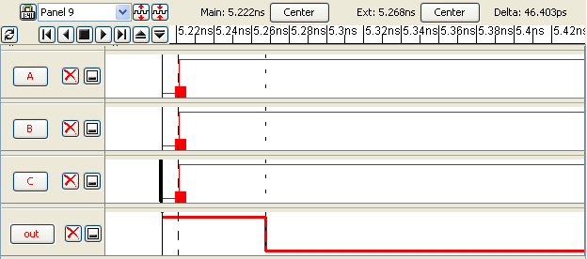
FOR ASPECT RATIOS: C:B:A= 10:5:1
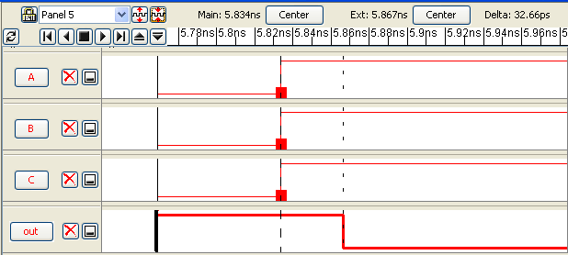
RATIO OF W/L | DELAY
10:1:5 | 96.5 ps
1:5:10 | 0.194 ns
1:10:5 | 0.183 ns
5:10:1 | 46.4 ps
10:5:1 | 32.66 ps

Hence the invertor with W/L ratio 1:5:10 has the minimum delay. This shows that the PMOSFET with largest W/L ratio should be connected to Vdd and NMOSFET with largest W/L ratio should be connected to ground so that the dalay is minimum.
That is, NMOS and PMOS should be connected in ascending order of W/L ratio from Ground and Vdd respectively to get minimum delay in the output with respect to input.
Here, the ratio should be 10:5:1 to get minimum delay

