- 15 Ω resistor using polysilicon, metal1 and metal2.
The width of the polysilicon layer is 2 um and the length of polysilicon layer is 6 um.
Total area covered by this resistor is 20 um including the metal1 and metal2.

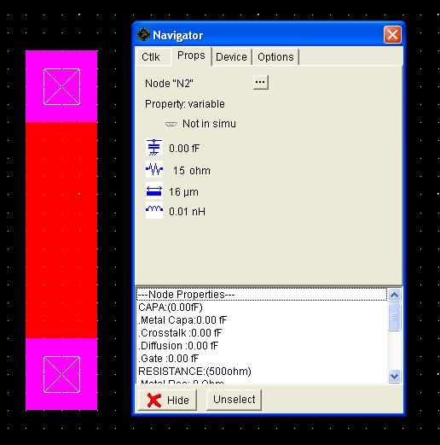
2.CMOS invertor
Delay during fall time is 280 ps.
Delay during rise time is 290 ps.
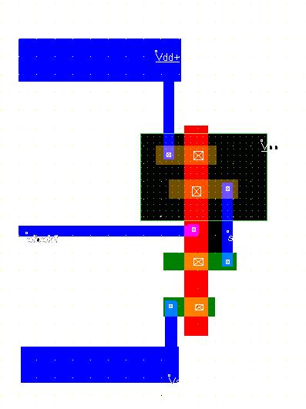
Output wave form:
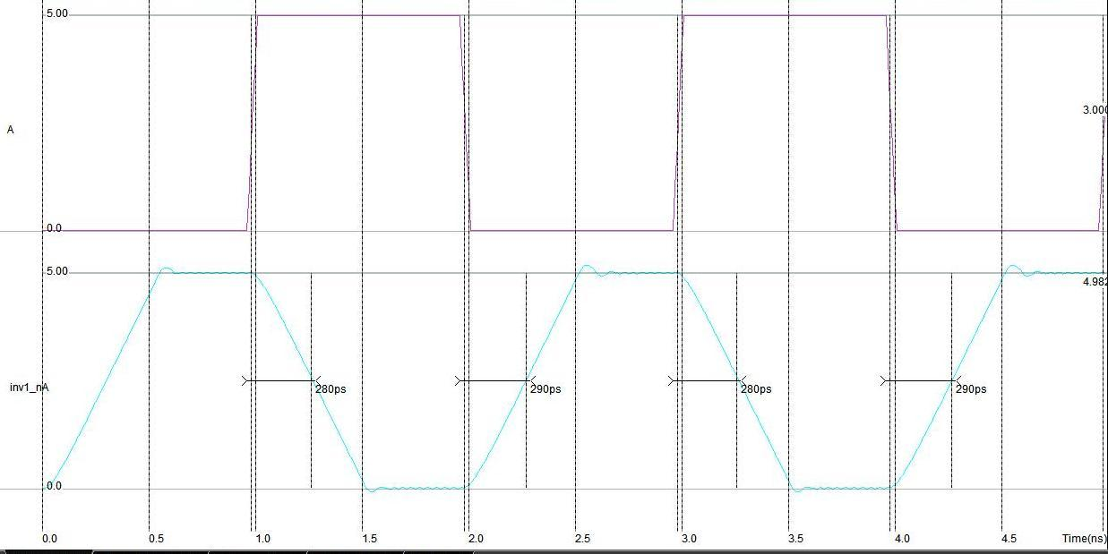
- Increasing drive capacity of inverter.
Drive capacity can be increased by
- Increasing the aspect ratio of the MOSFET
W/L is directly proportional to Drain current. Hence by increasing aspect ratio, drive capacity of inverter can be increased.
- Increasing the dimension or area of the MOSFET
- Cascading inverters of increasing size in series. Hence the drive capacity of inverter can be increased but the delay in the output will be increased.
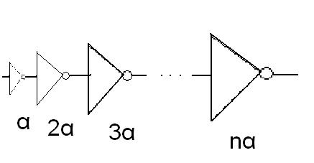
4 . Design rules used
- The extra diffusion surrounding contact should be greater than 2λ(R403).
- The metal2 width should be greater than 4 λ (R701).
- The contact width should be greater than 2 λ (R401).
- The spacing between the polysilicon should be greater than 3 λ (R301).
- The spacing between the diffusion should be greater than 4 λ (R201).
- The extra diffusion surrounding polysilicon should be greater than 4 λ (R306).
- The diffusion surface should be greater than 24 λ ²(R210).

