EuroData-ISRO Internship 2026
FINAL TECHNICAL REPORT
Cross-Modal Satellite Image Retrieval
Using Multi-Sensor Remote Sensing Data
EuroSAT RGB • EuroSAT Multispectral • EuroSAT-SAR

Project Item | Details
Competition | ISRO Internship Competition 2026
Problem Statement | Problem 11 – Cross-Modal Satellite Image Retrieval
Modalities | Optical RGB, Sentinel-2 multispectral and Sentinel-1 SAR
Core Tasks | Same-modal retrieval, cross-modal retrieval and land-cover classification
Report Status | Completed using exported experiment metrics and qualitative retrieval figures

Executive Summary
- Developed a multi-sensor satellite image retrieval framework for ISRO Internship Competition 2026 (Problem Statement 11) using geographically aligned EuroSAT RGB, Sentinel-2 multispectral, and Sentinel-1 SAR images.
- Supports same-modal retrieval (within RGB, multispectral, and SAR) and cross-modal retrieval (RGB↔SAR, RGB↔Multispectral).
- Uses a paired dataset of 27,000 samples per modality across 10 land-use/land-cover classes, with a 70:15:15 stratified train/validation/test split (18,900 / 4,050 / 4,050).
- Preserves identical sample IDs and split assignments across modalities to avoid pair mismatches and cross-modal data leakage.
- Achieved 98.20% test accuracy and weighted F1-score for the multispectral classifier; RGB models reached 95.33–95.53%, while SAR achieved 83.26% due to speckle noise and higher scene ambiguity.
- Retrieval performance was strongest for multispectral-to-multispectral and multispectral-to-optical searches, while SAR-based retrieval remained the most challenging.

1. Dataset Information

1.1 Dataset Composition
The project combines three aligned representations of the EuroSAT land-cover benchmark. EuroSAT-RGB contains three visible Sentinel-2 channels. EuroSAT multispectral retains all 13 Sentinel-2 bands. EuroSAT-SAR provides matched Sentinel-1 dual-polarization VV and VH patches. A shared file identifier links corresponding RGB, multispectral and SAR samples into a tri-modal index.
Dataset / Modality | Sensor | Channels / Bands | Format | Patch Size | Samples | Classes
EuroSAT-RGB (Optical) | Sentinel-2 | 3 (RGB) | JPEG | 64×64 | 27,000 | 10
EuroSAT Multispectral | Sentinel-2 | 13 bands | GeoTIFF | 64×64 | 27,000 | 10
EuroSAT-SAR | Sentinel-1 | 2 (VV, VH) | GeoTIFF | 64×64 | 27,000 | 10
Paired tri-modal index | S1 + S2 | Shared file IDs | CSV metadata | Aligned | 27,000 triplets | 10

1.2 Class Distribution and Shared Stratified Split
Class ID | Class Name | Total | Train 70% | Validation 15% | Test 15%
0 | AnnualCrop | 3,000 | 2,100 | 450 | 450
1 | Forest | 3,000 | 2,100 | 450 | 450
2 | HerbaceousVegetation | 3,000 | 2,100 | 450 | 450
3 | Highway | 2,500 | 1,750 | 375 | 375
4 | Industrial | 2,500 | 1,750 | 375 | 375
5 | Pasture | 2,000 | 1,400 | 300 | 300
6 | PermanentCrop | 2,500 | 1,750 | 375 | 375
7 | Residential | 3,000 | 2,100 | 450 | 450
8 | River | 2,500 | 1,750 | 375 | 375
9 | SeaLake | 3,000 | 2,100 | 450 | 450
— | Total | 27,000 | 18,900 | 4,050 | 4,050

3. Model and Evaluation Framework
Each modality is processed by its own encoder and projection head. The projection vectors are L2-normalized and compared using cosine similarity. Classification heads encourage the embeddings to preserve land-cover semantics, while triplet and alignment objectives bring matching or semantically related samples together in the common representation space.
Component | Method
Modality encoders | Separate optical, multispectral and SAR feature extractors.
Embedding head | Dense projection followed by L2 normalization.
Classification head | Ten-class softmax branch for semantic supervision.
Metric learning | Triplet loss for relative similarity structure.
Cross-modal alignment | Alignment loss for paired modality embeddings.
Ranking | Descending cosine similarity between query and gallery embeddings.
Relevance criterion | A gallery item is relevant when its land-cover label matches the query label.
Reported K values | K = 1, 5, 10, 20 and 50.

3.1 Retrieval Metric Interpretation
Metric | Interpretation
Precision@K | Proportion of the Top-K retrieved images that are relevant.
Recall@K | Proportion of all relevant gallery images recovered within the Top-K.
F1@K | Harmonic mean of Precision@K and Recall@K.
Classification precision | Among predictions assigned to a class, the proportion that is correct.
Classification recall | Among true samples of a class, the proportion correctly detected.
Classification F1-score | Balanced summary of class-level precision and recall.

3.2 Training Behaviour
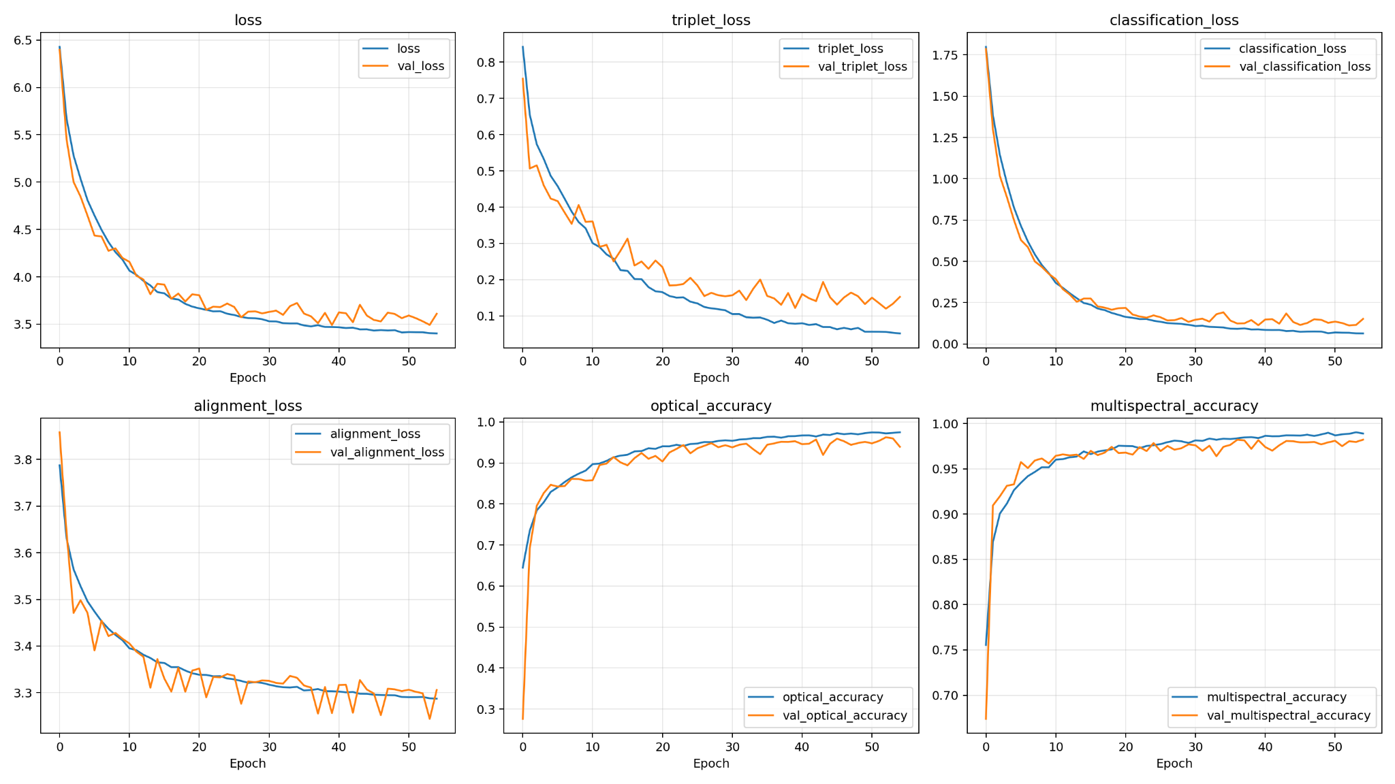
Figure 1. Optical–multispectral training history: total, triplet, classification and alignment losses with branch accuracies.
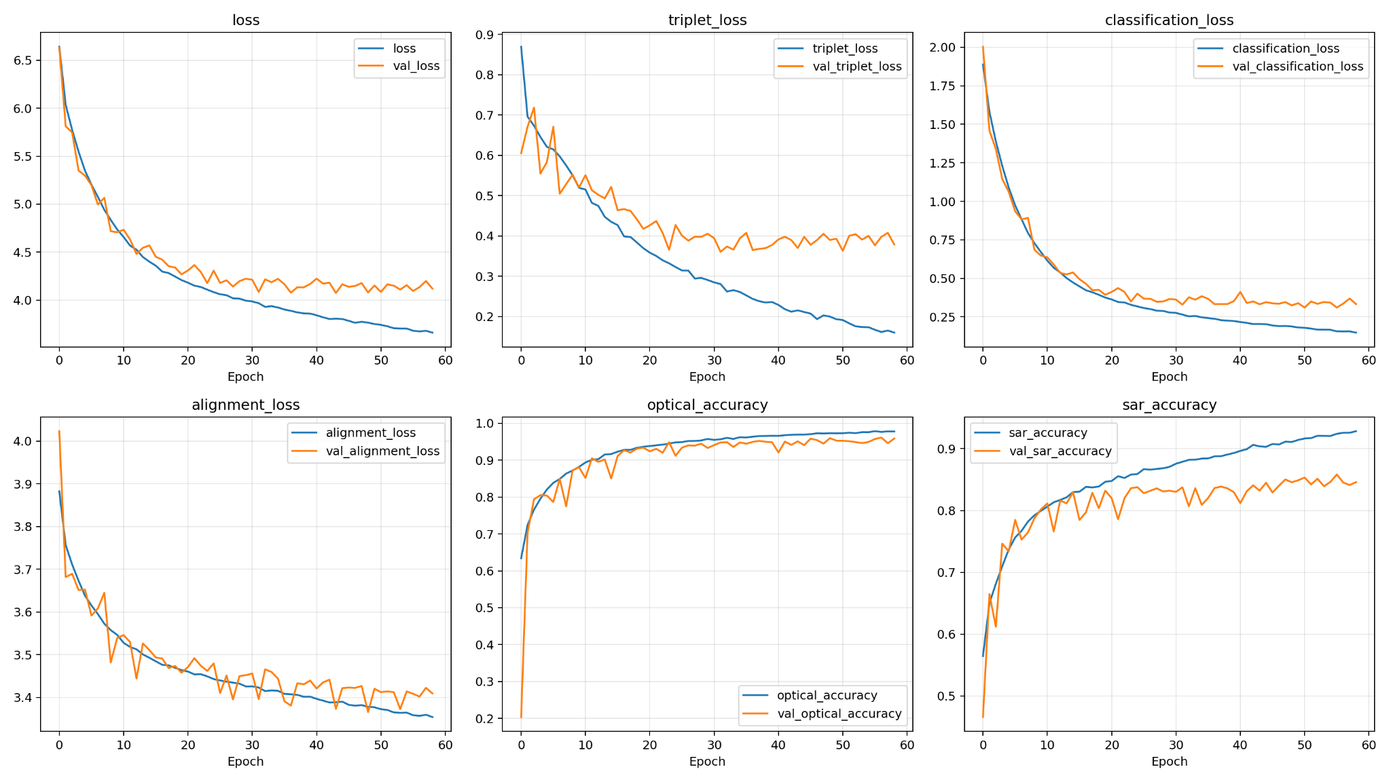
Figure 2. Optical–SAR training history: total, triplet, classification and alignment losses with optical and SAR accuracies.

4. Classification Results

4.1 Optical Classification – Optical/SAR Model
Class | Precision | Recall | F1-score | Support
AnnualCrop | 0.9546 | 0.9356 | 0.9450 | 450
Forest | 0.9719 | 0.9978 | 0.9846 | 450
HerbaceousVegetation | 0.9278 | 0.9133 | 0.9205 | 450
Highway | 0.9915 | 0.9387 | 0.9644 | 375
Industrial | 0.9806 | 0.9413 | 0.9605 | 375
Pasture | 0.9148 | 0.9667 | 0.9400 | 300
PermanentCrop | 0.9098 | 0.8880 | 0.8988 | 375
Residential | 0.9594 | 0.9978 | 0.9782 | 450
River | 0.9410 | 0.9787 | 0.9595 | 375
SeaLake | 0.9911 | 0.9867 | 0.9889 | 450
Accuracy | 0.9553 | 0.9553 | 0.9553 | —
Macro Average | 0.9543 | 0.9544 | 0.9540 | 4,050
Weighted Average | 0.9556 | 0.9553 | 0.9552 | 4,050

4.2 SAR Classification
Class | Precision | Recall | F1-score | Support
AnnualCrop | 0.8106 | 0.8844 | 0.8459 | 450
Forest | 0.7858 | 0.9378 | 0.8551 | 450
HerbaceousVegetation | 0.6184 | 0.8067 | 0.7001 | 450
Highway | 0.9103 | 0.7040 | 0.7940 | 375
Industrial | 0.9448 | 0.9120 | 0.9281 | 375
Pasture | 0.6698 | 0.7100 | 0.6893 | 300
PermanentCrop | 0.7424 | 0.3920 | 0.5131 | 375
Residential | 0.9391 | 0.9600 | 0.9495 | 450
River | 0.9749 | 0.9333 | 0.9537 | 375
SeaLake | 0.9844 | 0.9800 | 0.9822 | 450
Accuracy | 0.8326 | 0.8326 | 0.8326 | —
Macro Average | 0.8381 | 0.8220 | 0.8211 | 4,050
Weighted Average | 0.8402 | 0.8326 | 0.8277 | 4,050

SAR performs strongly on Residential, River, SeaLake and Industrial scenes. PermanentCrop is the most difficult category, with recall of 0.3920 and F1-score of 0.5131, suggesting substantial overlap with other vegetation classes in radar backscatter patterns.

4.3 Optical Classification – Optical/Multispectral Model
Class | Precision | Recall | F1-score | Support
AnnualCrop | 0.8935 | 0.9511 | 0.9214 | 450
Forest | 0.9844 | 0.9822 | 0.9833 | 450
HerbaceousVegetation | 0.9158 | 0.9422 | 0.9288 | 450
Highway | 0.9678 | 0.9627 | 0.9652 | 375
Industrial | 0.9706 | 0.9680 | 0.9693 | 375
Pasture | 0.9493 | 0.9367 | 0.9430 | 300
PermanentCrop | 0.8886 | 0.9147 | 0.9014 | 375
Residential | 0.9977 | 0.9578 | 0.9773 | 450
River | 0.9856 | 0.9120 | 0.9474 | 375
SeaLake | 0.9889 | 0.9911 | 0.9900 | 450
Accuracy | 0.9533 | 0.9533 | 0.9533 | —
Macro Average | 0.9542 | 0.9518 | 0.9527 | 4,050
Weighted Average | 0.9545 | 0.9533 | 0.9536 | 4,050

4.4 Multispectral Classification
Class | Precision | Recall | F1-score | Support
AnnualCrop | 0.9627 | 0.9756 | 0.9691 | 450
Forest | 0.9934 | 0.9978 | 0.9956 | 450
HerbaceousVegetation | 0.9954 | 0.9644 | 0.9797 | 450
Highway | 0.9810 | 0.9627 | 0.9717 | 375
Industrial | 0.9867 | 0.9893 | 0.9880 | 375
Pasture | 0.9340 | 0.9900 | 0.9612 | 300
PermanentCrop | 0.9731 | 0.9653 | 0.9692 | 375
Residential | 0.9956 | 0.9978 | 0.9967 | 450
River | 0.9839 | 0.9760 | 0.9799 | 375
SeaLake | 1.0000 | 0.9978 | 0.9989 | 450
Accuracy | 0.9820 | 0.9820 | 0.9820 | —
Macro Average | 0.9806 | 0.9817 | 0.9810 | 4,050
Weighted Average | 0.9823 | 0.9820 | 0.9820 | 4,050

Multispectral classification is the strongest branch. Every class has an F1-score above 0.96, and the weighted F1-score is 0.9820. The additional spectral bands improve separation among vegetation and built-up categories.

5. Same-Modal Retrieval Results

5.1 SAR → SAR Retrieval
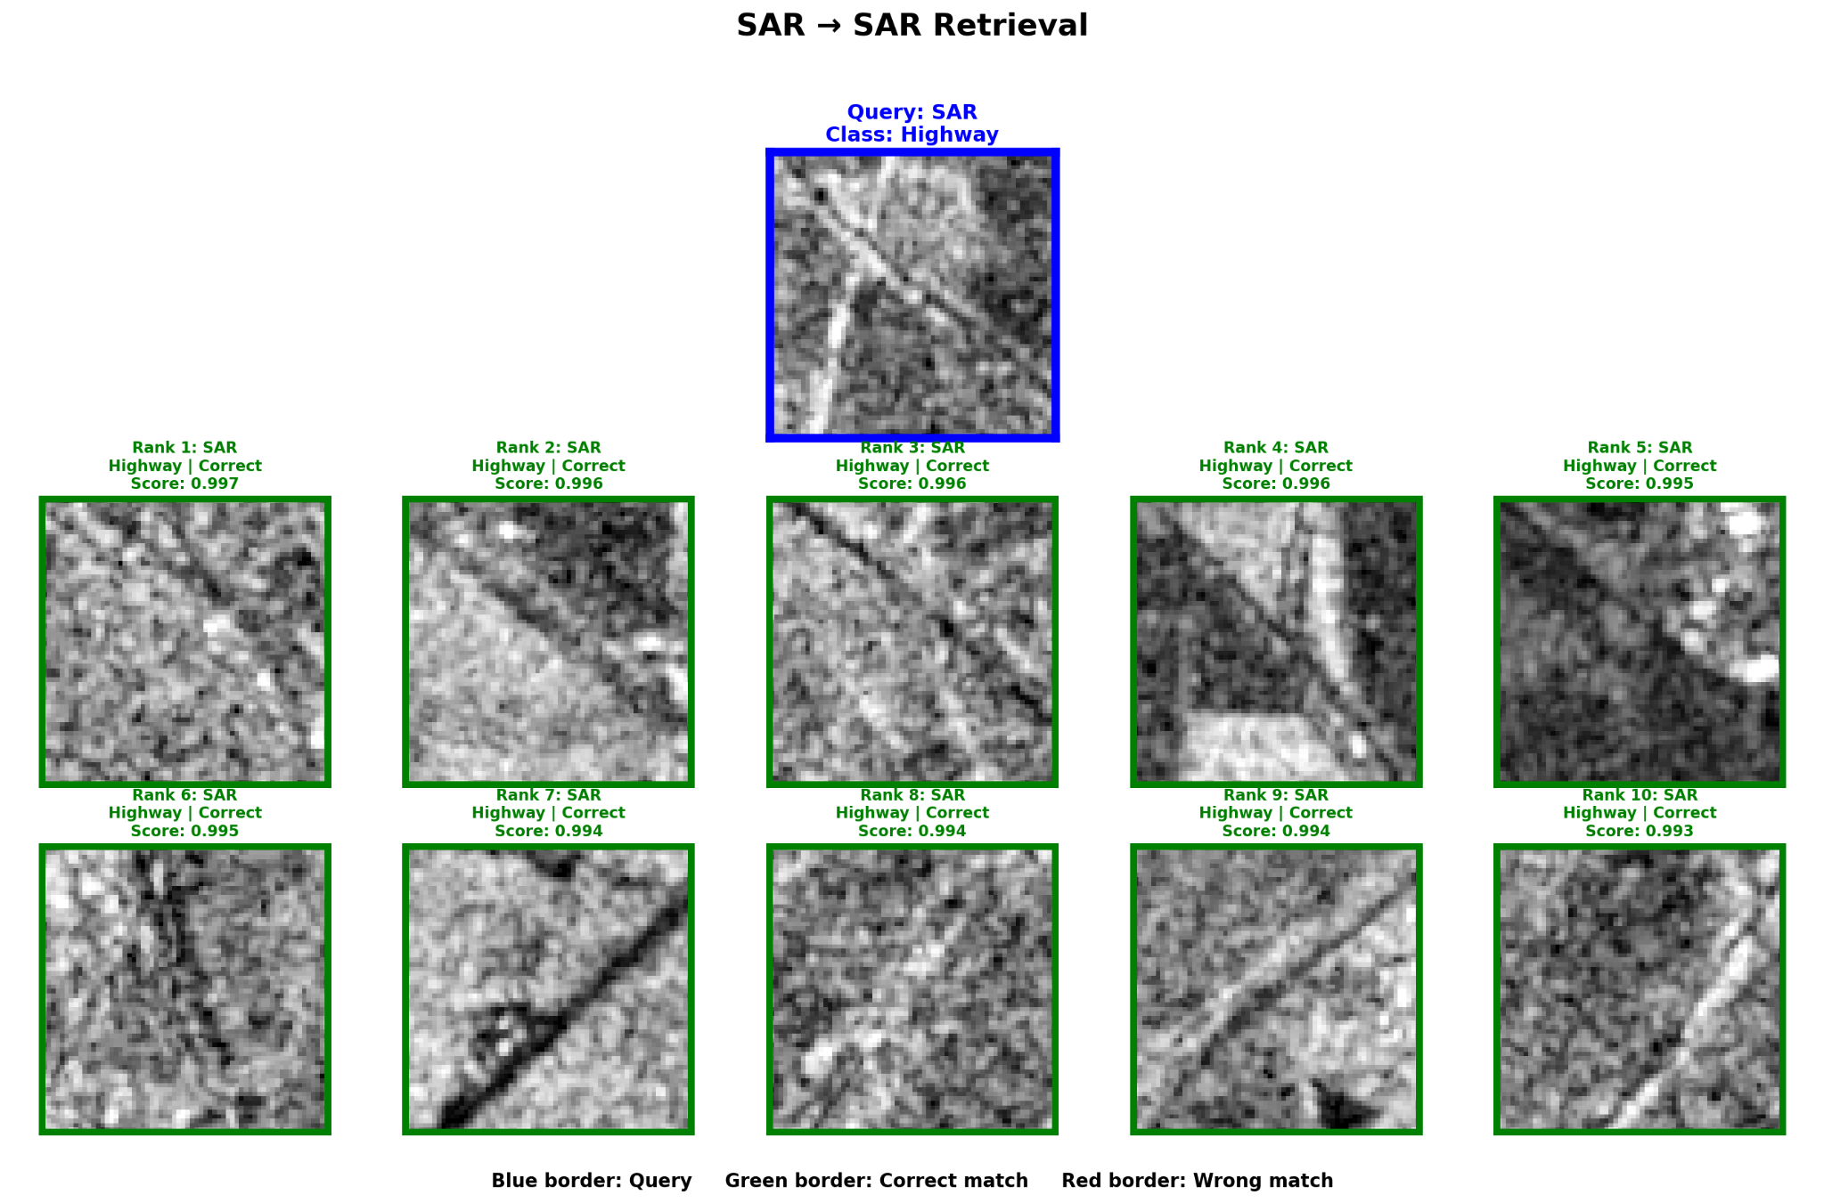
Figure 3. SAR query and Top-10 SAR retrieval results for the Highway class.
K | Precision@K | Recall@K | F1@K
1 | 0.8111 | 0.0020 | 0.0040
5 | 0.8043 | 0.0099 | 0.0195
10 | 0.8043 | 0.0198 | 0.0386
20 | 0.8038 | 0.0395 | 0.0752
50 | 0.8024 | 0.0985 | 0.1752

Precision remains close to 0.80 across K. The qualitative example retrieves ten correct Highway scenes, showing that individual high-confidence queries can perform better than the dataset-wide average.

5.2 Optical → Optical Retrieval
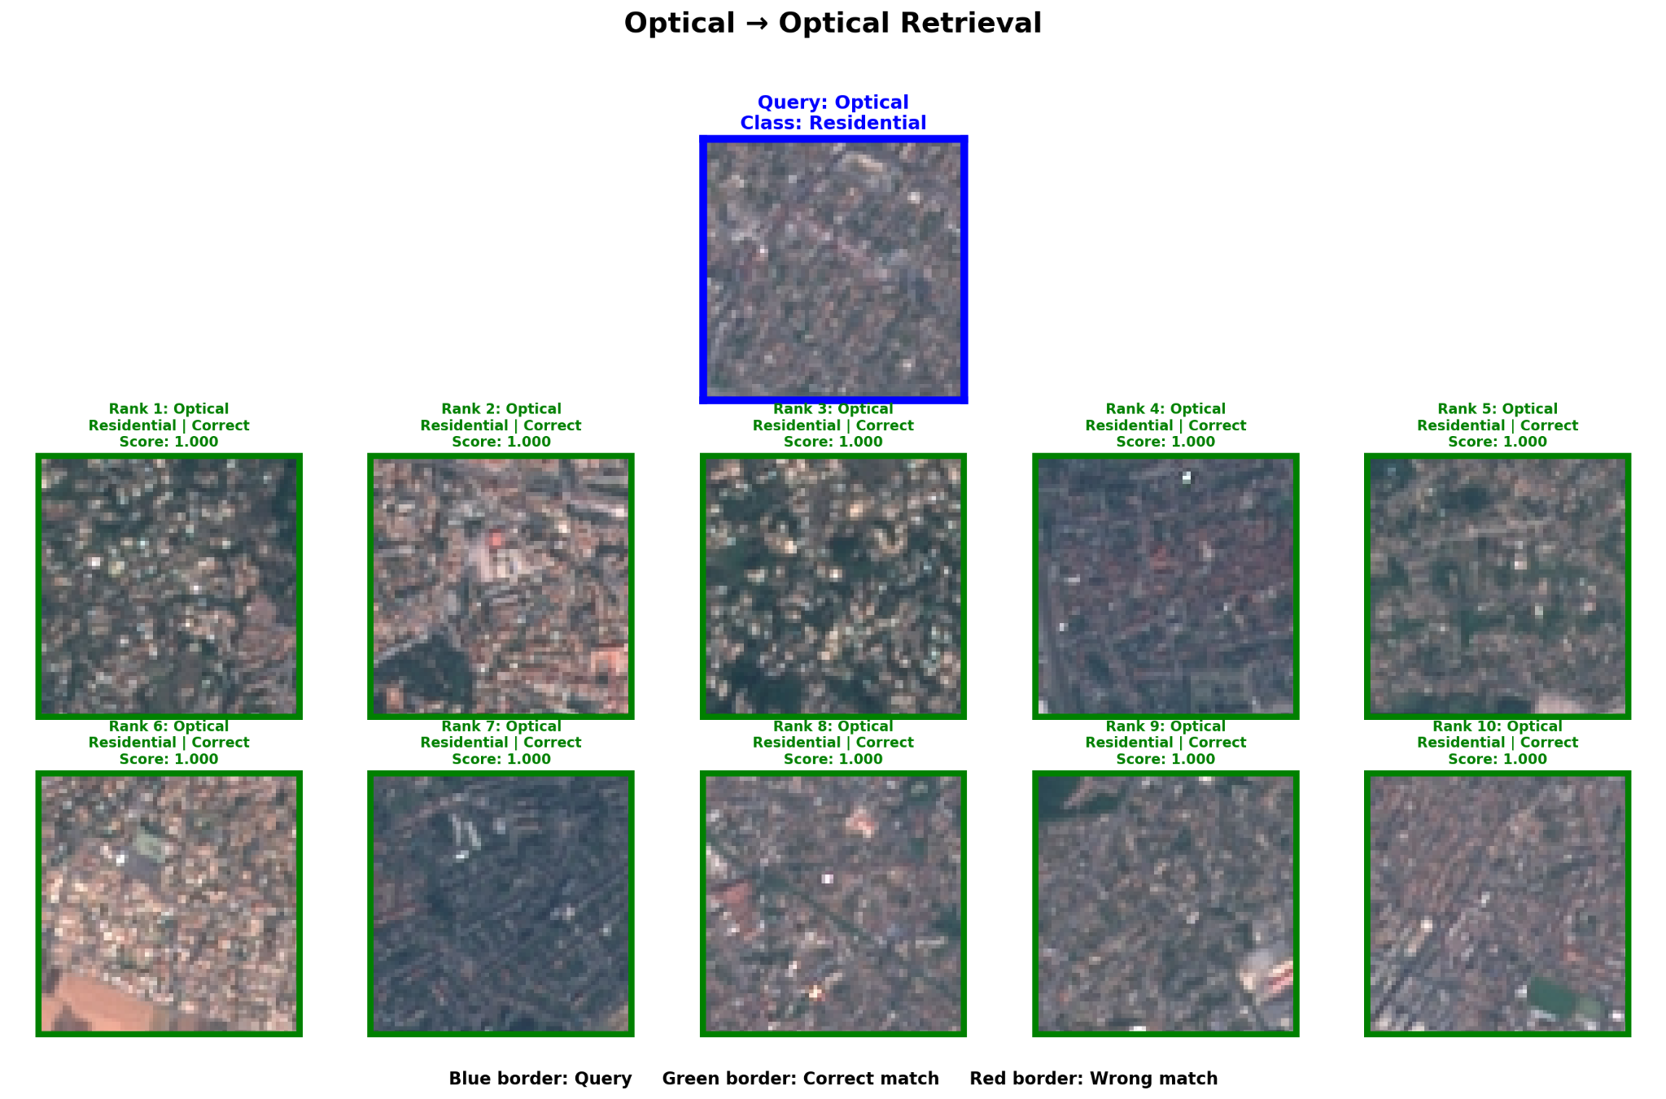
Figure 4. Optical query and Top-10 optical retrieval results for the Residential class.
K | Precision@K | Recall@K | F1@K
1 | 0.9548 | 0.0024 | 0.0047
5 | 0.9528 | 0.0118 | 0.0233
10 | 0.9514 | 0.0235 | 0.0459
20 | 0.9507 | 0.0470 | 0.0895
50 | 0.9509 | 0.1175 | 0.2088

Optical same-modal precision remains approximately 0.95 from K=1 to K=50. Recall rises with K because more relevant gallery samples are included, while precision remains stable.

5.3 Multispectral → Multispectral Retrieval
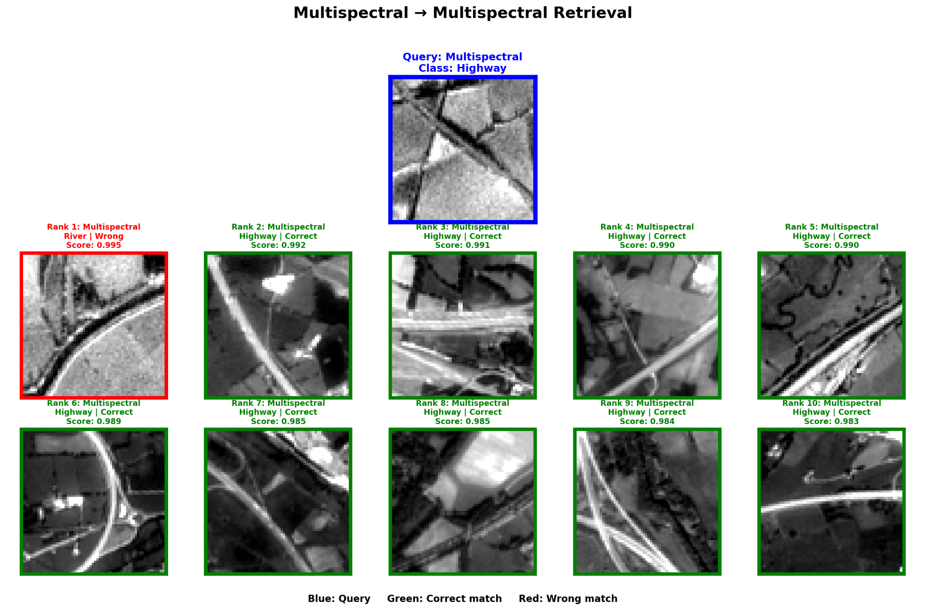
Figure 5. Multispectral query and Top-10 multispectral retrieval results for the Highway class.
K | Precision@K | Recall@K | F1@K
1 | 0.9768 | 0.0024 | 0.0048
5 | 0.9779 | 0.0121 | 0.0239
10 | 0.9781 | 0.0242 | 0.0472
20 | 0.9790 | 0.0484 | 0.0922
50 | 0.9799 | 0.1212 | 0.2154

This is the strongest same-modal direction, with Precision@1 of 0.9768 and Precision@50 of 0.9799. The displayed query has one River false positive at rank 1, followed by nine correct Highway results.

6. Cross-Modal Retrieval Results

6.1 Optical → SAR
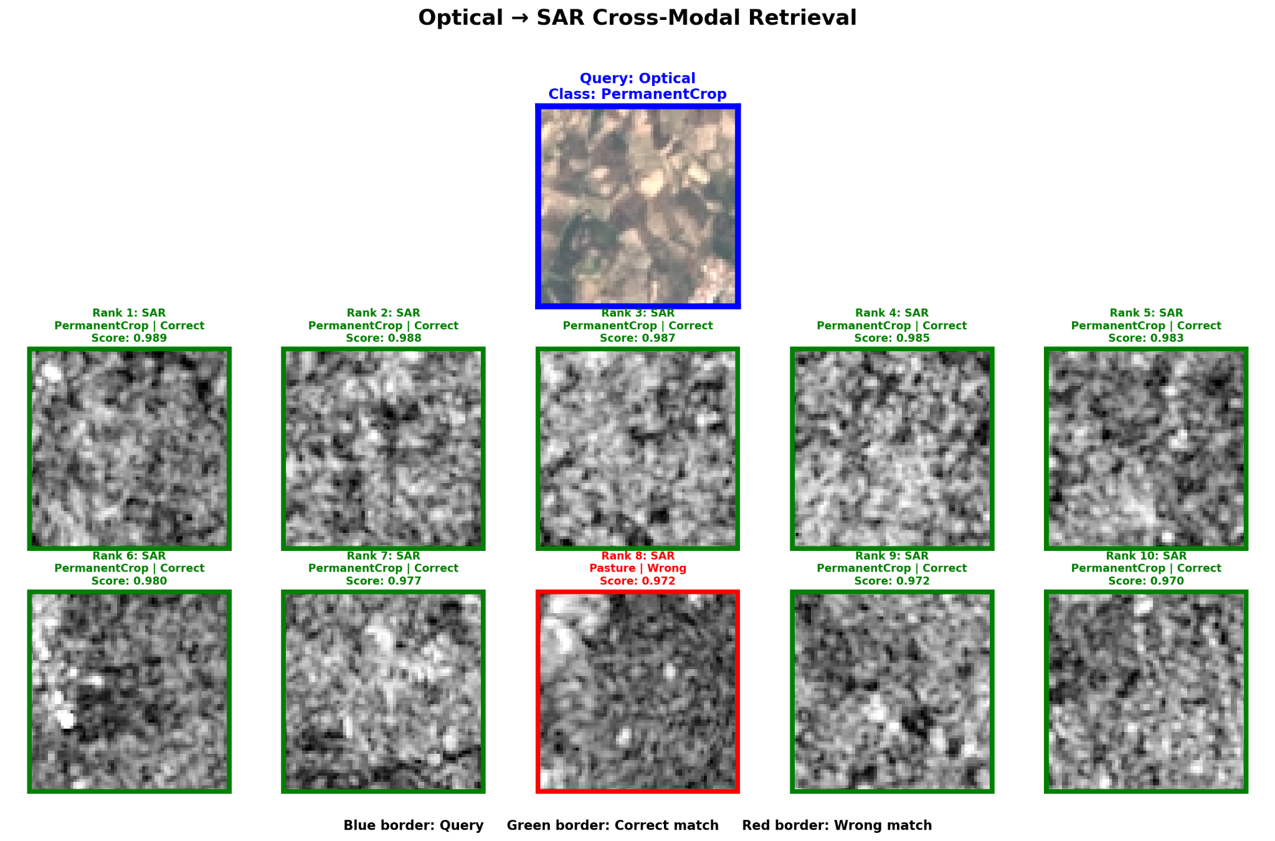
Figure 6. Optical PermanentCrop query with Top-10 SAR results.
K | Precision@K | Recall@K | F1@K
1 | 0.9262 | 0.0023 | 0.0046
5 | 0.9302 | 0.0115 | 0.0226
10 | 0.9268 | 0.0228 | 0.0445
20 | 0.9261 | 0.0456 | 0.0869
50 | 0.9195 | 0.1133 | 0.2014

The model achieves Precision@1 of 0.9262 and maintains precision above 0.919 through K=50. In the qualitative example, nine of ten retrieved SAR images are relevant; the only error is a Pasture sample at rank 8.

6.2 SAR → Optical
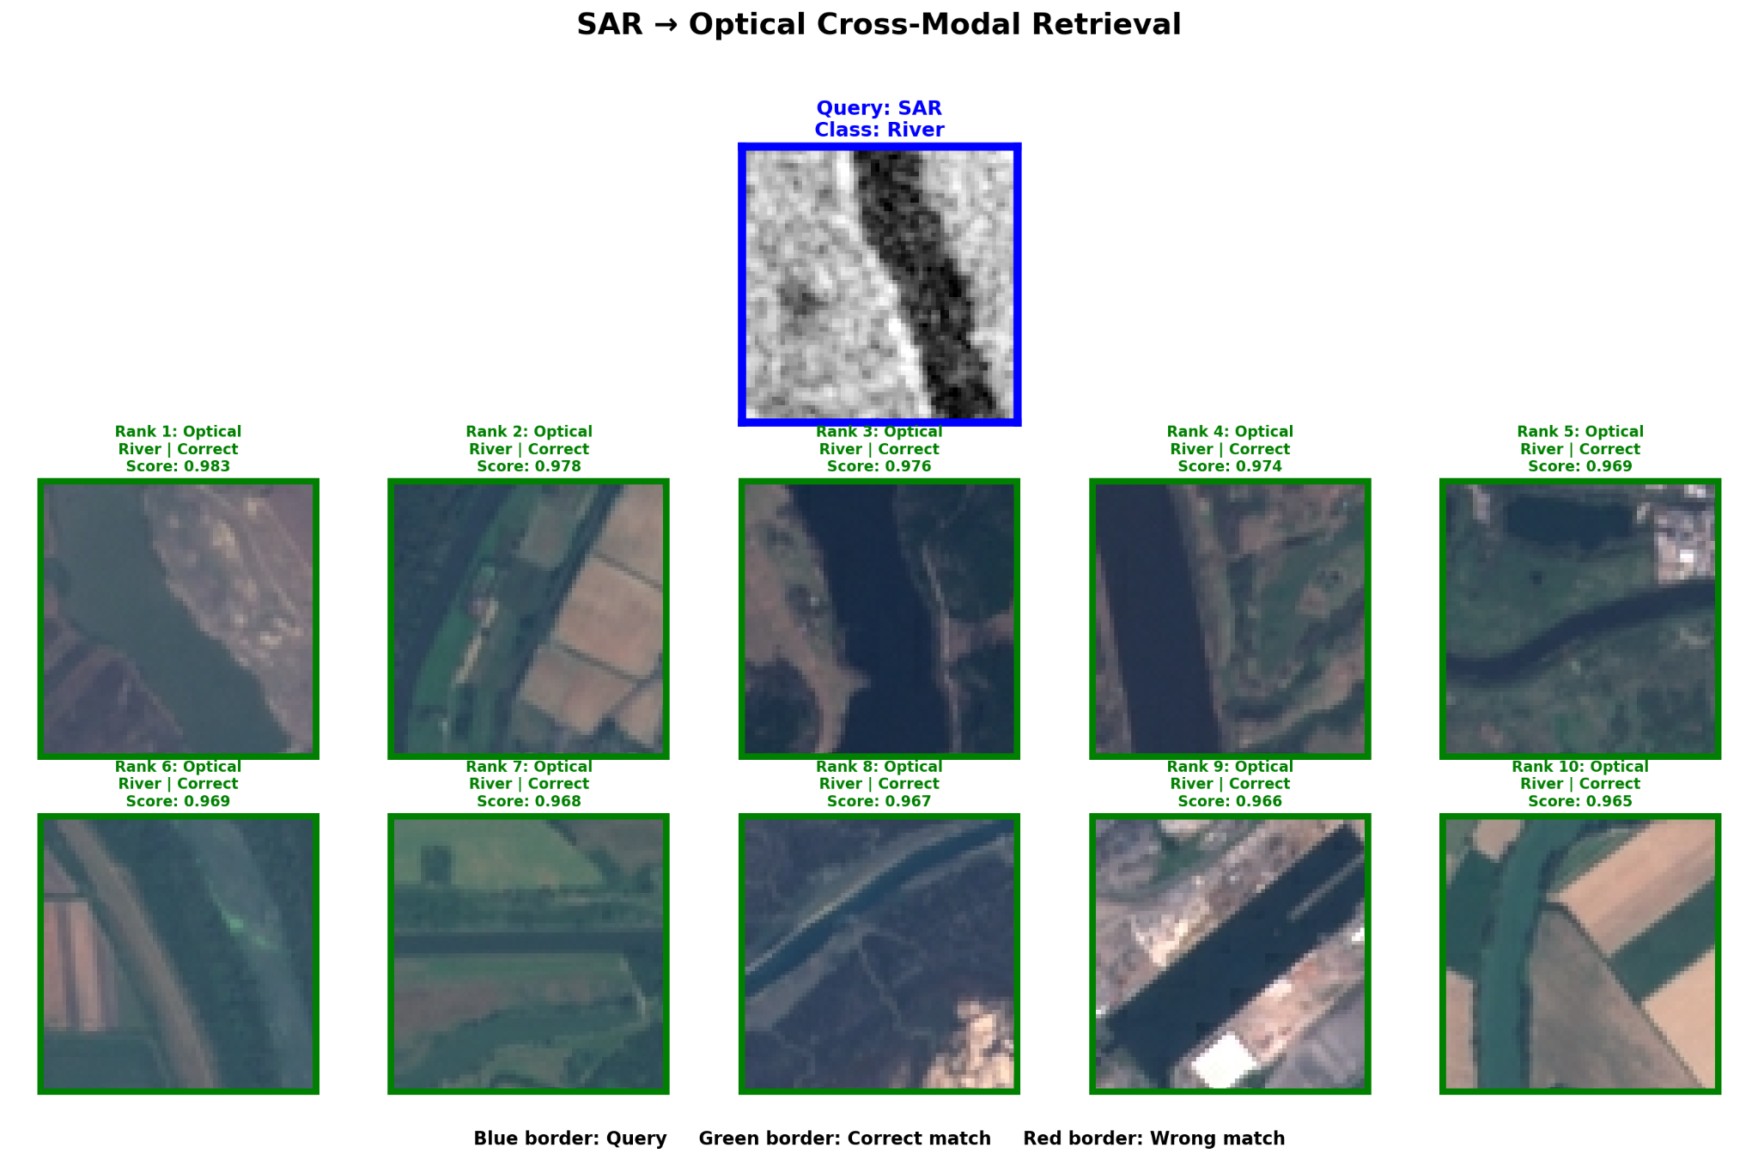
Figure 7. SAR River query with Top-10 optical results.
K | Precision@K | Recall@K | F1@K
1 | 0.7963 | 0.0019 | 0.0039
5 | 0.8053 | 0.0098 | 0.0193
10 | 0.8055 | 0.0195 | 0.0382
20 | 0.8071 | 0.0392 | 0.0747
50 | 0.8094 | 0.0984 | 0.1752

SAR-to-optical retrieval is more difficult than the reverse direction, with Precision@1 of 0.7963. Nevertheless, the selected River query retrieves ten correct optical River scenes, illustrating good performance for visually distinctive classes.

6.3 Optical → Multispectral
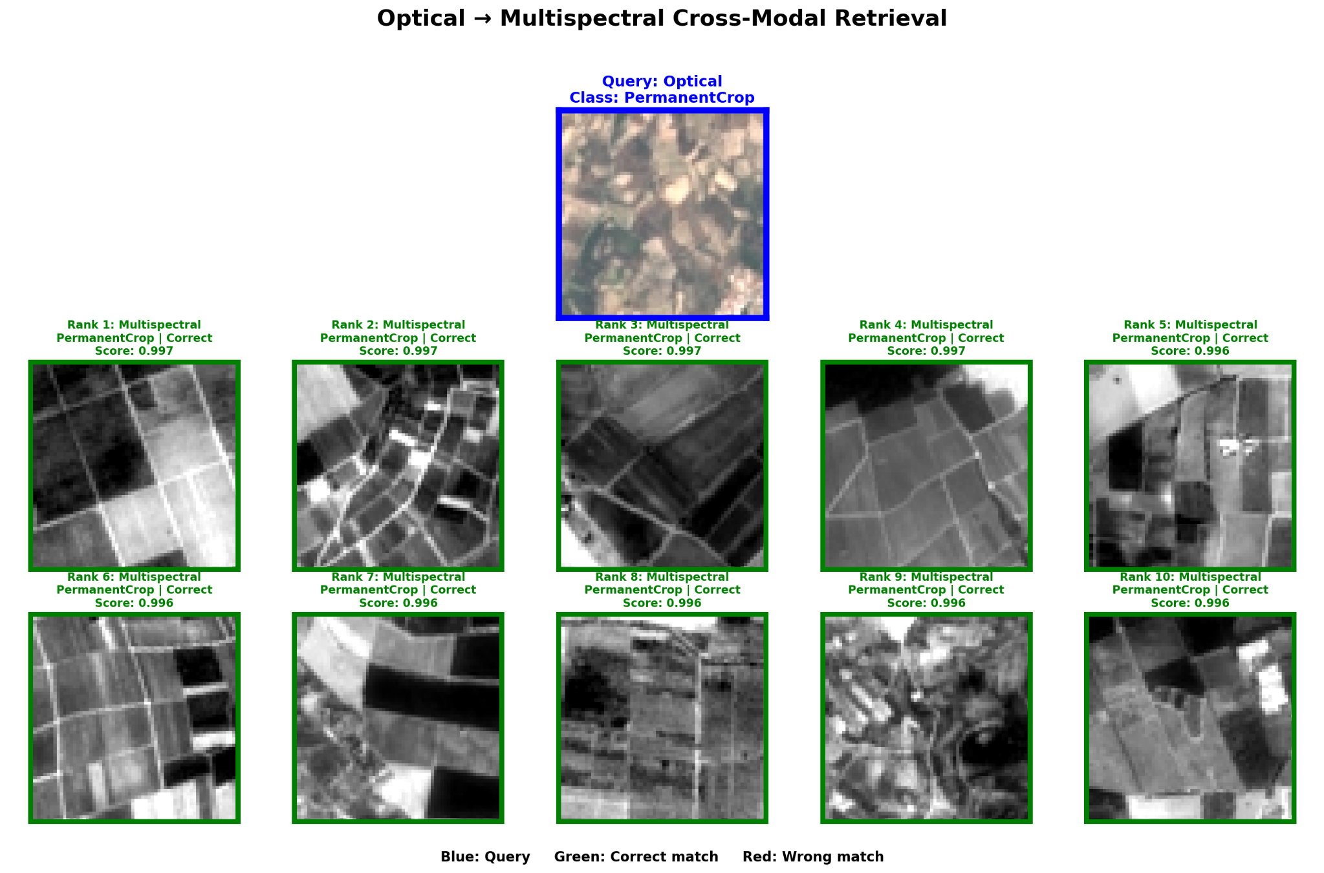
Figure 8. Optical PermanentCrop query with Top-10 multispectral results.
K | Precision@K | Recall@K | F1@K
1 | 0.9432 | 0.0023 | 0.0046
5 | 0.9388 | 0.0115 | 0.0228
10 | 0.9411 | 0.0232 | 0.0452
20 | 0.9434 | 0.0464 | 0.0885
50 | 0.9469 | 0.1166 | 0.2073

Precision ranges from 0.9388 to 0.9469 across the tested K values. The qualitative example returns ten correct PermanentCrop images, showing effective semantic alignment from visible RGB to full multispectral data.

6.4 Multispectral → Optical
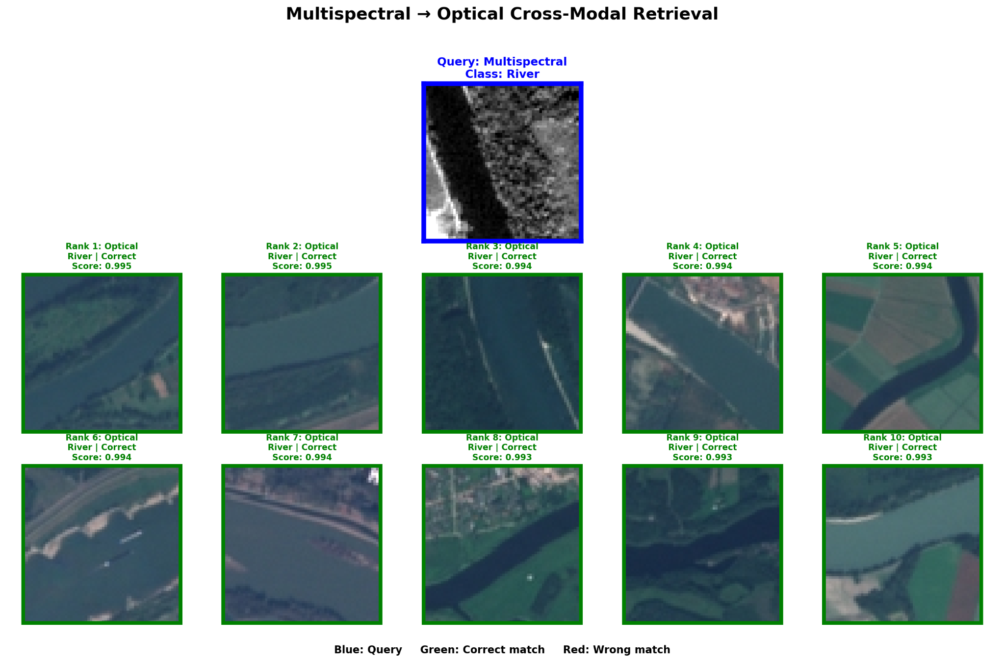
Figure 9. Multispectral River query with Top-10 optical results.
K | Precision@K | Recall@K | F1@K
1 | 0.9716 | 0.0024 | 0.0048
5 | 0.9728 | 0.0120 | 0.0237
10 | 0.9740 | 0.0240 | 0.0469
20 | 0.9755 | 0.0482 | 0.0917
50 | 0.9776 | 0.1207 | 0.2144

This is the strongest cross-modal direction, with Precision@1 of 0.9716 and Precision@50 of 0.9776. The selected River query retrieves ten correct optical images.

7. Discussion

7.1 Classification Summary
Modality / Model | Accuracy | Macro Precision | Macro Recall | Macro F1 | Weighted F1
Optical (Optical/SAR) | 0.9553 | 0.9543 | 0.9544 | 0.9540 | 0.9552
SAR | 0.8326 | 0.8381 | 0.8220 | 0.8211 | 0.8277
Optical (Optical/MS) | 0.9533 | 0.9542 | 0.9518 | 0.9527 | 0.9536
Multispectral | 0.9820 | 0.9806 | 0.9817 | 0.9810 | 0.9820

7.2 Precision@K Across Retrieval Directions
Direction | P@1 | P@5 | P@10 | P@20 | P@50
Optical → to → Optical | 0.9548 | 0.9528 | 0.9514 | 0.9507 | 0.9509
SAR → to → SAR | 0.8111 | 0.8043 | 0.8043 | 0.8038 | 0.8024
Multispectral → to → Multispectral | 0.9768 | 0.9779 | 0.9781 | 0.9790 | 0.9799
Optical → to → SAR | 0.9262 | 0.9302 | 0.9268 | 0.9261 | 0.9195
SAR → to → Optical | 0.7963 | 0.8053 | 0.8055 | 0.8071 | 0.8094
Optical → to → Multispectral | 0.9432 | 0.9388 | 0.9411 | 0.9434 | 0.9469
Multispectral → to → Optical | 0.9716 | 0.9728 | 0.9740 | 0.9755 | 0.9776

7.3 Recall@K Across Retrieval Directions
Direction | R@1 | R@5 | R@10 | R@20 | R@50
Optical → to → Optical | 0.0024 | 0.0118 | 0.0235 | 0.0470 | 0.1175
SAR → to → SAR | 0.0020 | 0.0099 | 0.0198 | 0.0395 | 0.0985
Multispectral → to → Multispectral | 0.0024 | 0.0121 | 0.0242 | 0.0484 | 0.1212
Optical → to → SAR | 0.0023 | 0.0115 | 0.0228 | 0.0456 | 0.1133
SAR → to → Optical | 0.0019 | 0.0098 | 0.0195 | 0.0392 | 0.0984
Optical → to → Multispectral | 0.0023 | 0.0115 | 0.0232 | 0.0464 | 0.1166
Multispectral → to → Optical | 0.0024 | 0.0120 | 0.0240 | 0.0482 | 0.1207

7.4 F1@K Across Retrieval Directions
Direction | F1@1 | F1@5 | F1@10 | F1@20 | F1@50
Optical → to → Optical | 0.0047 | 0.0233 | 0.0459 | 0.0895 | 0.2088
SAR → to → SAR | 0.0040 | 0.0195 | 0.0386 | 0.0752 | 0.1752
Multispectral → to → Multispectral | 0.0048 | 0.0239 | 0.0472 | 0.0922 | 0.2154
Optical → to → SAR | 0.0046 | 0.0226 | 0.0445 | 0.0869 | 0.2014
SAR → to → Optical | 0.0039 | 0.0193 | 0.0382 | 0.0747 | 0.1752
Optical → to → Multispectral | 0.0046 | 0.0228 | 0.0452 | 0.0885 | 0.2073
Multispectral → to → Optical | 0.0048 | 0.0237 | 0.0469 | 0.0917 | 0.2144

