# EC2 Instance and VPC via CloudFormation

**Step 1 (VPC Setup)**

Currently my VPC is being created in the us-east-1 region. If you’d like your VPC and other services to be created in a different region, you’ll need to make that change.

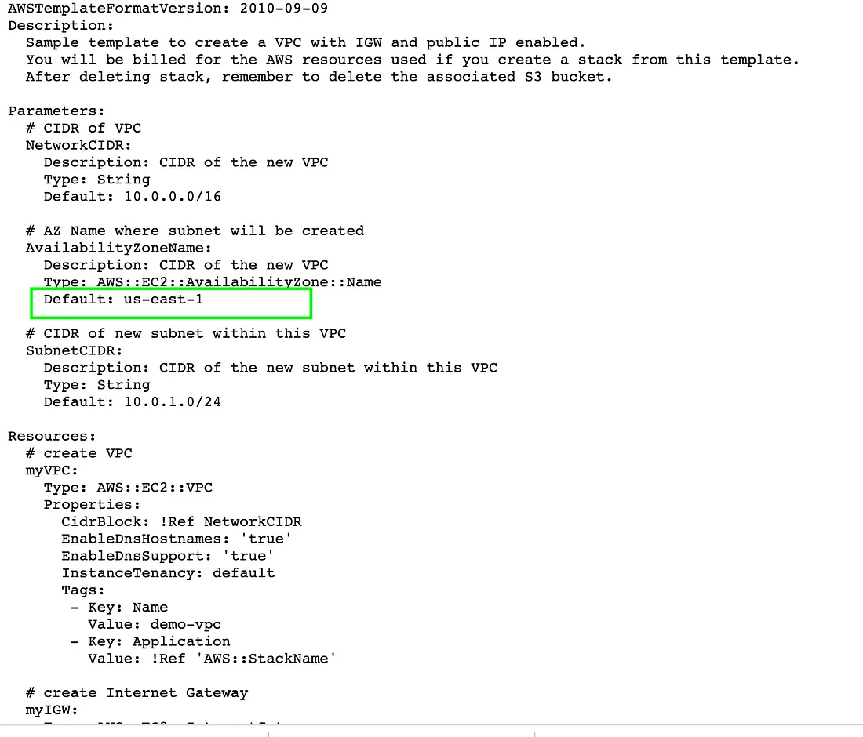‘

;

Select “Create Stack” and chose the option “With new resources”.

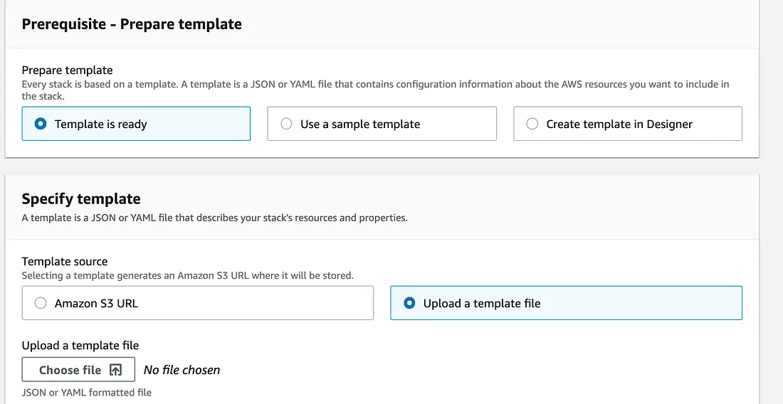,

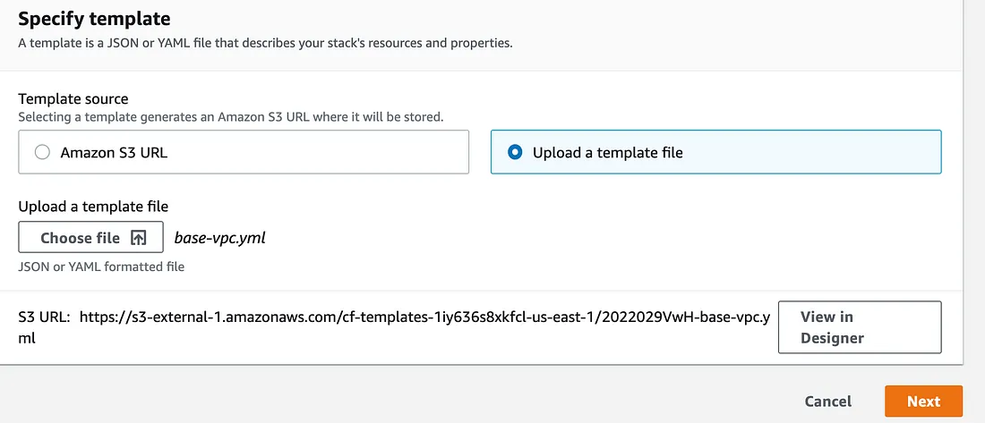,

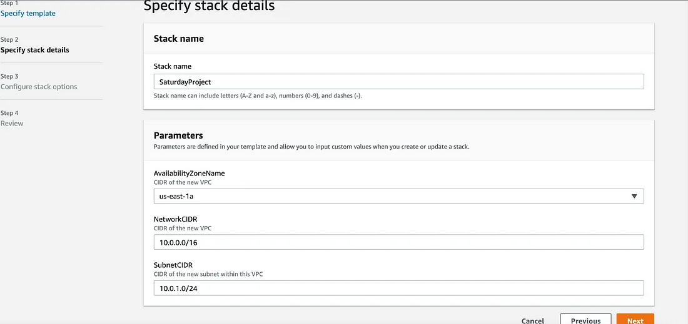,

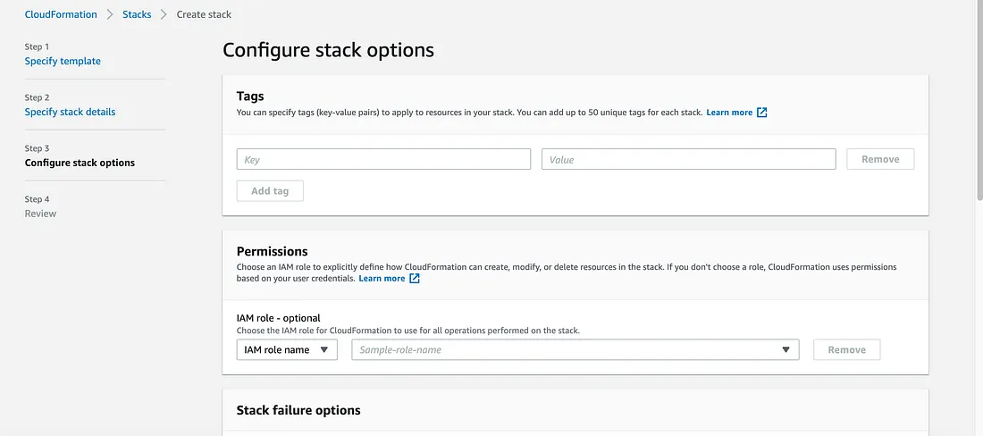,

Once we’re on the review screen, review that everything looks okay and hit “Create Stack”.

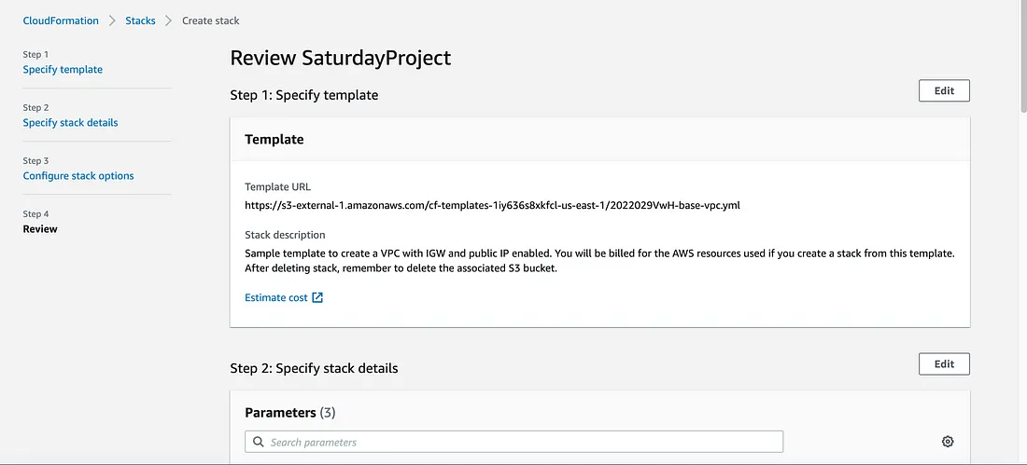,

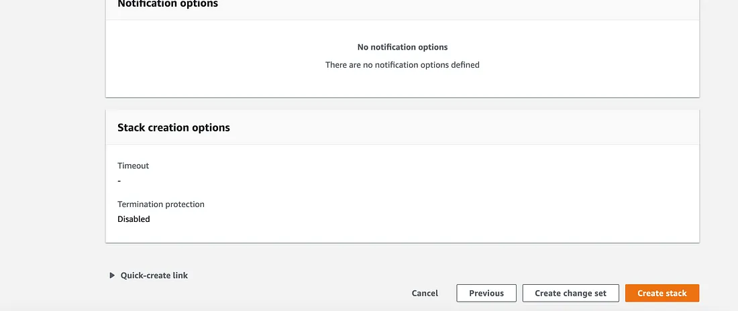,

You’ll be prompted back to your CloudFormation dashboard and will see that your stack is in progress of being created.

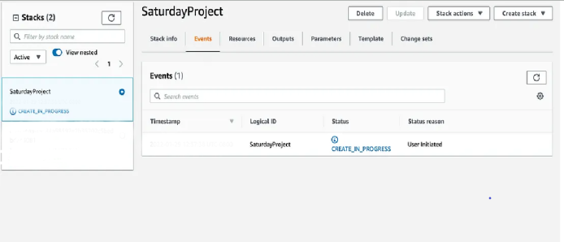,

,

**Step 2 (EC2 creation)**

First we’re going to create a Key 🔑 Pair. Later we will need to input the Key Pair information into our CloudFormation template.

Go to EC2 in the AWS console, scroll down and select Key Pair.

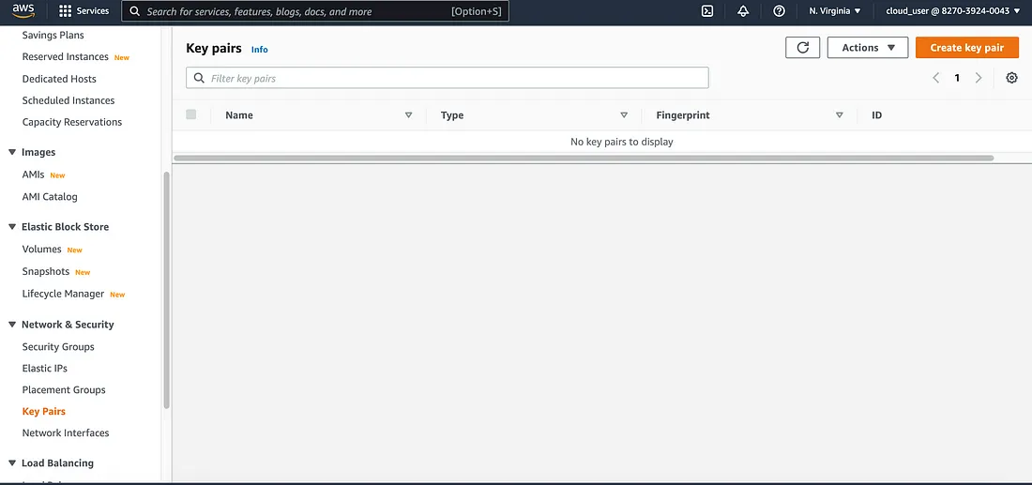Now select “Create key pair”.

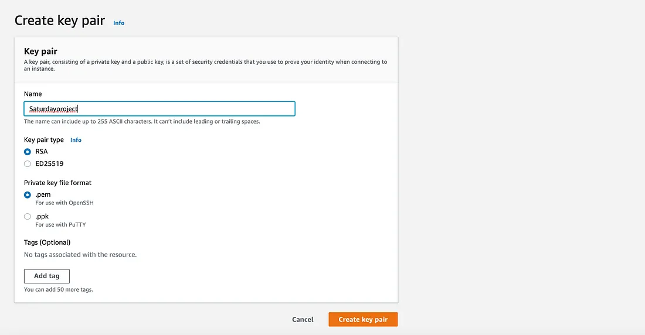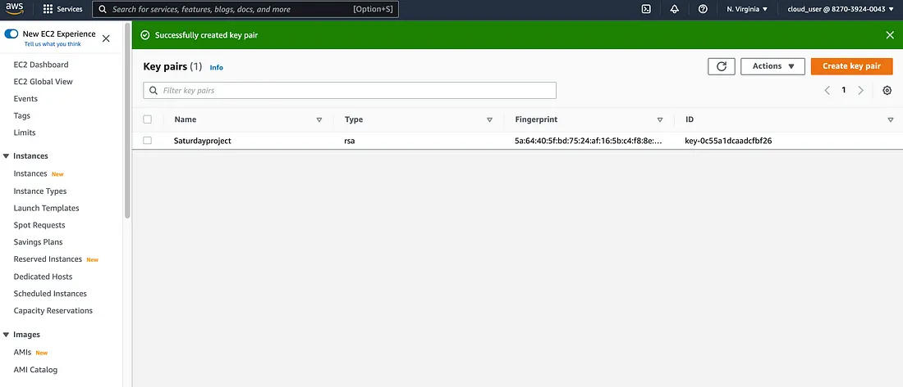.

alter the key pair in templete keypair and ami id

.

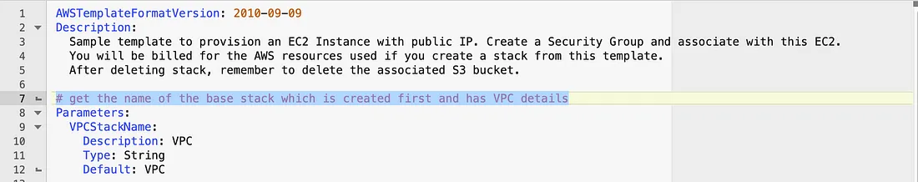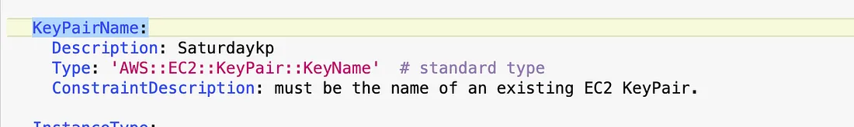

Now launch it with the stack

