1. Router Configuration:

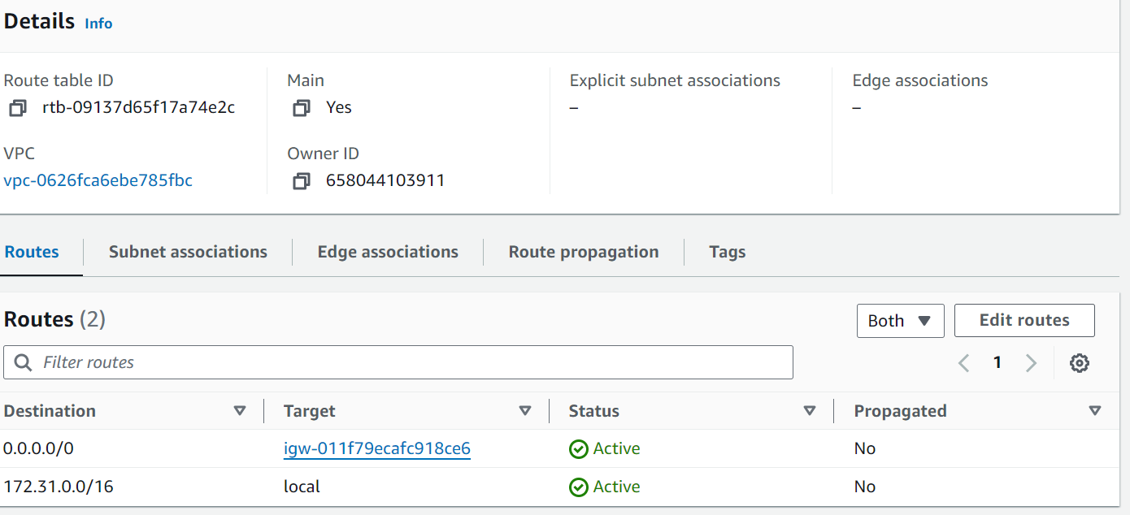Created Vpc and route table configuration

2.Firewall Rules Setup & 3. Load Balancer Configuration:

1. Create the 2 ec2 instance and install apache2 server  
 Allow ssh and http ports in the security group for the running instances

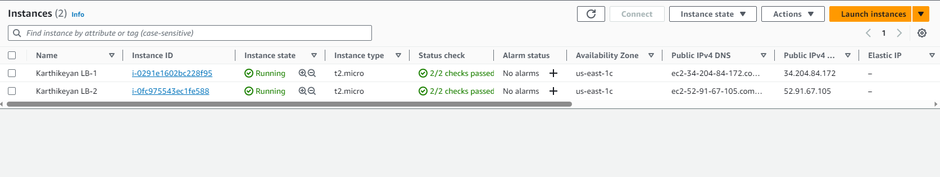

2.Login into the both of the instance and install apache2 web server

* For difference, make one of the instance to display the custom template page.
* Another one with the default Ubuntu page

3.Create and Configure ALB Target Group

* After the instances are running, navigate to the Load Balancer in the EC2 Dashboard.
* In the "Target Groups" tab, click "Create target group."

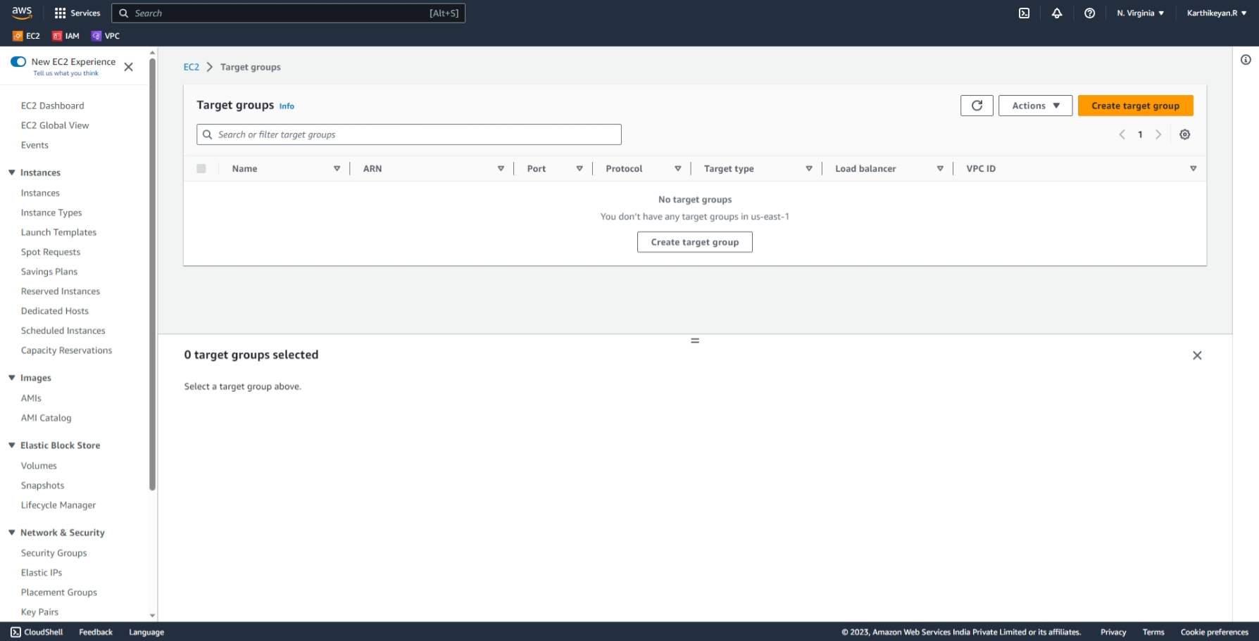

**Configure the target group:**

Target type: Instances

Protocol and port: Choose the appropriate protocol and port (HTTP on port 80).

Health checks: Configure health checks settings.

In the "Registered targets" section, register the instances you launched earlier.

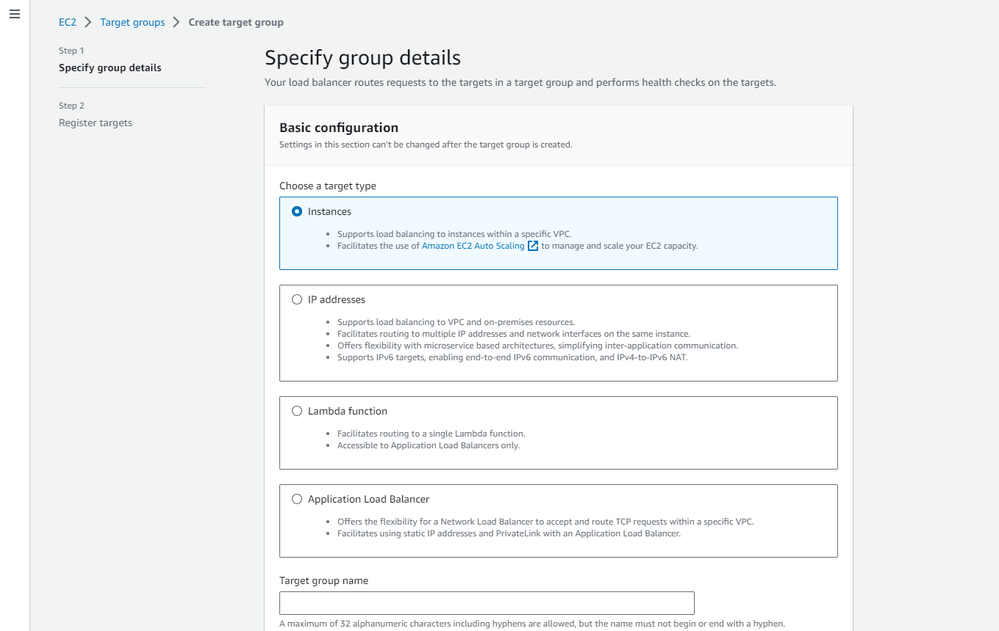

Enter Target group name , Protocol and Port , Choose the VPC and the Protocol version

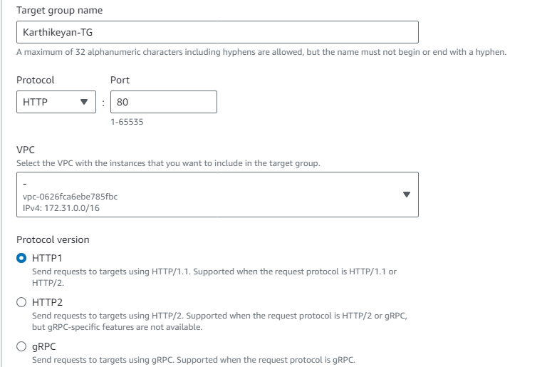

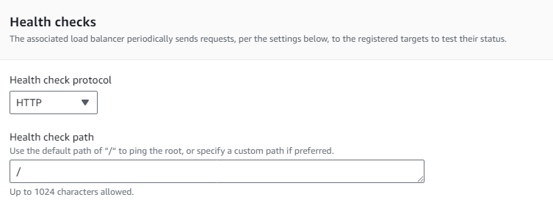

With the Advance health check settings we can specify values

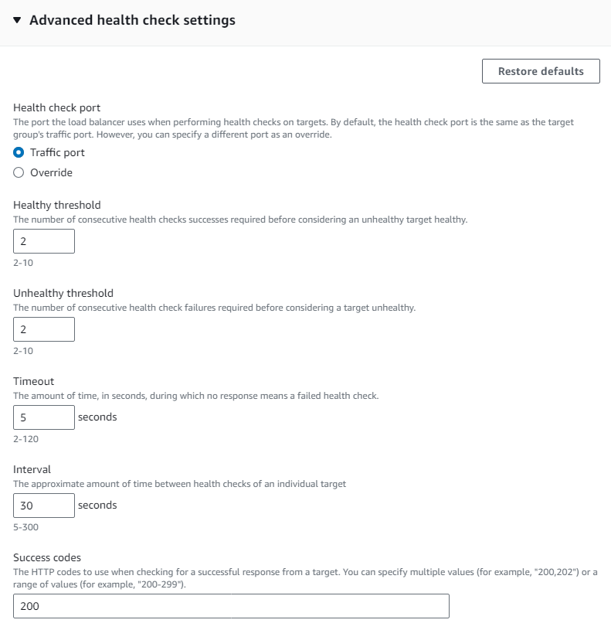

Click next to GOTO **register targets**

There we can able to the view instance that we created

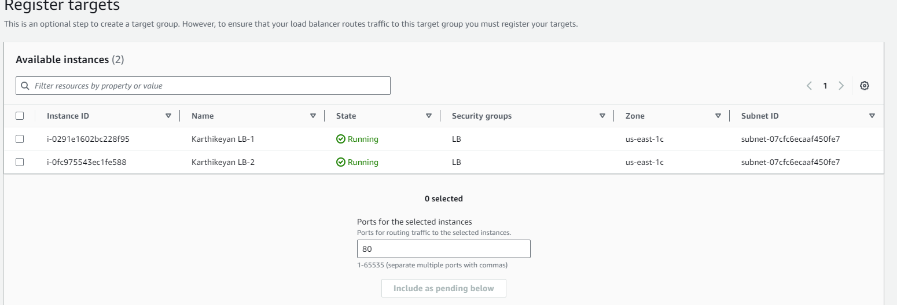

Enter the port and Select the instances and click include as pending below

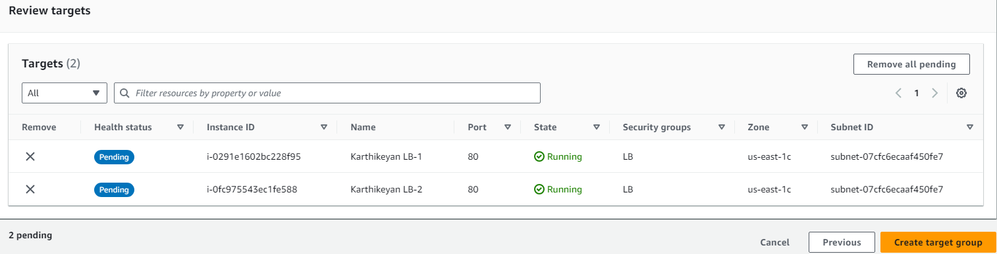

Click→ create target group

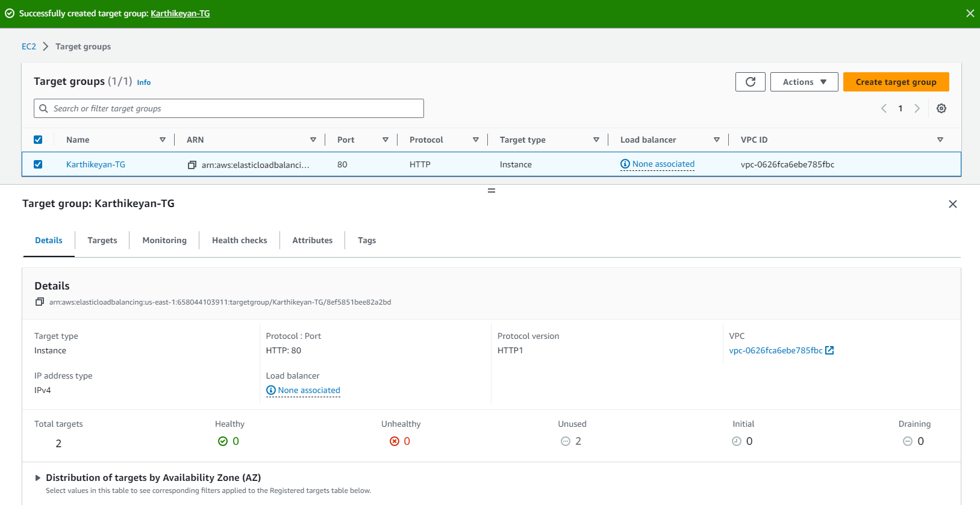

Now Create the load balancer --> Application Load Balancer

Enter name -->Choose internet facing ( it means the request coming from the public) -->IP address type→ IPV4

**Network mapping**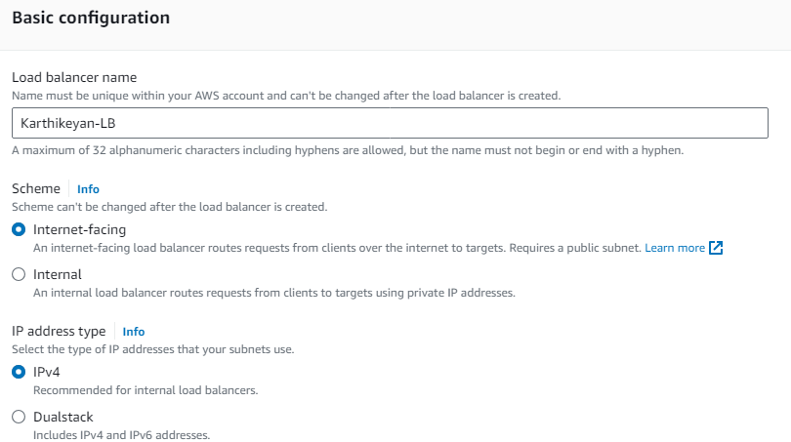

Here we have to choose the subnet in the AZ ,need to select atleast two different az’s

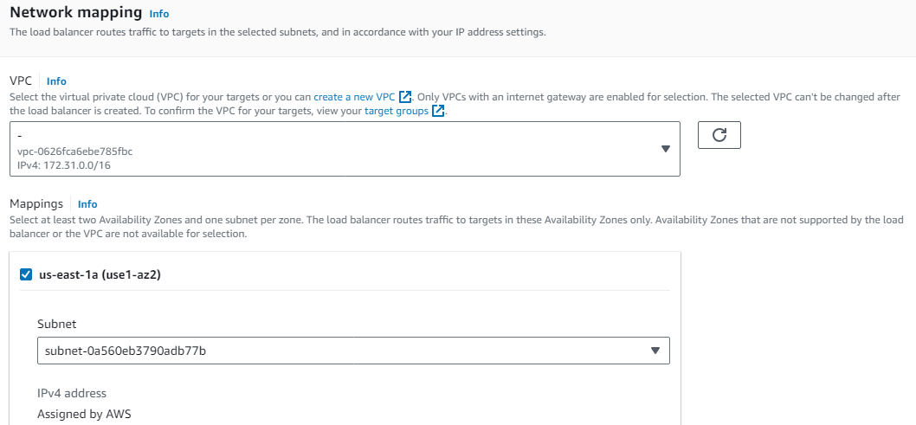

Need to create the security group for the Application load balancer

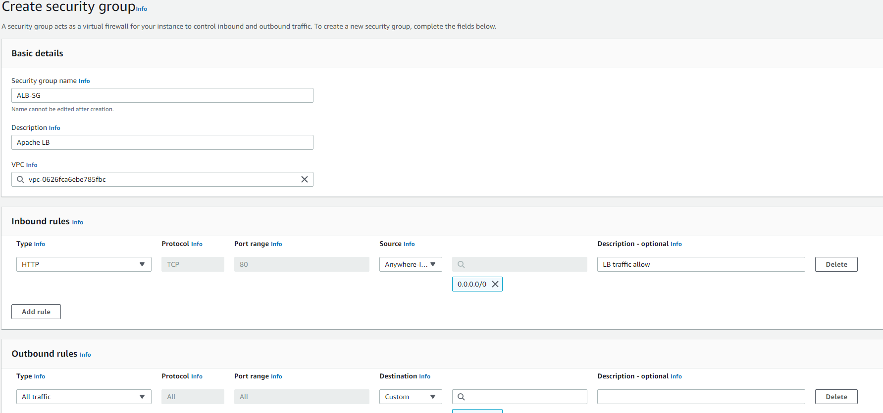

Assign it to the ALB

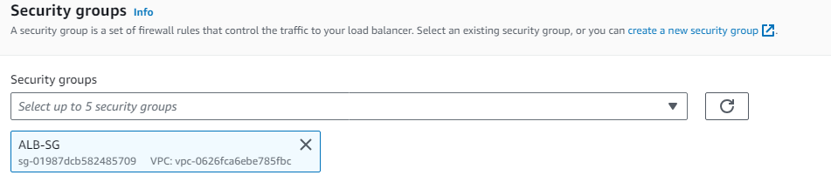

Assign the target group to the listener

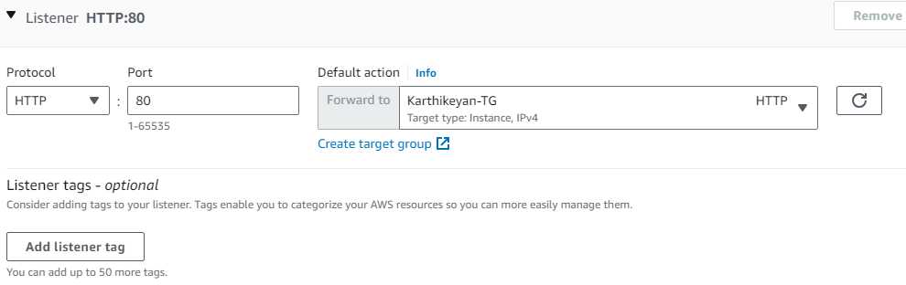

Summary: We can view what are the configuration done with the Load Balancer.

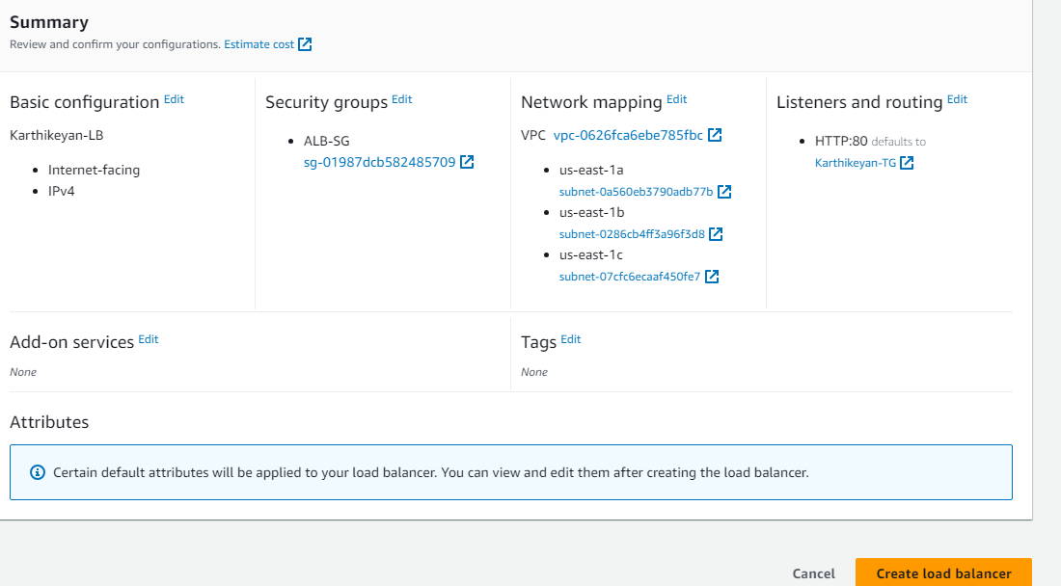

**Load Balancer created**

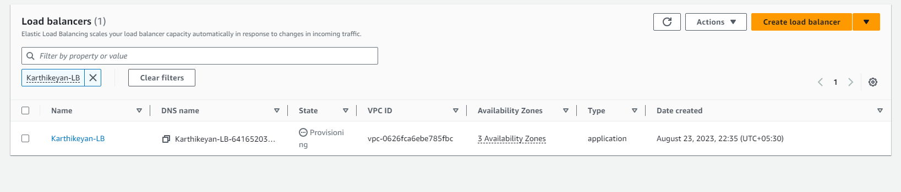

With the load balancer dns name we can check output in the browser

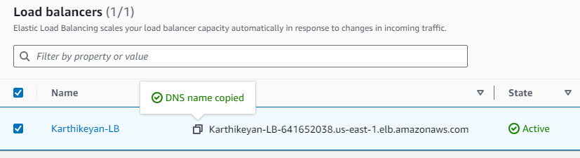

Now configure the Security group of the Ec2 instances

Allow **SSH** only from my ip

Allow the **HTTP** traffic only from the **application load balance security group**

Hence the we can access the web pages only via the application load balancer ip’s not from the instance public ip address

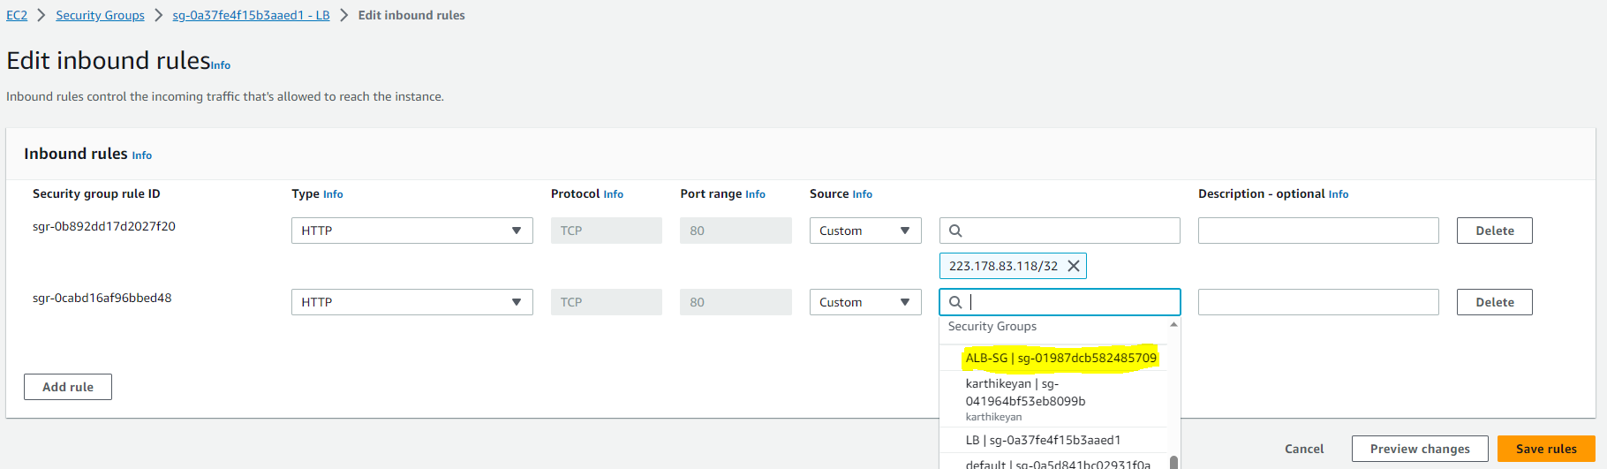

**Here is the output:**

**By using the nslookup command we can see the route ip’s**

C:\Users\karthikeyan.rajan>nslookup Karthikeyan-LB-641652038.us-east-1.elb.amazonaws.com

Server: dsldevice.lan

Address: 192.168.1.1

Non-authoritative answer:

Name: Karthikeyan-LB-641652038.us-east-1.elb.amazonaws.com

Addresses: 184.73.84.165

3.215.101.32

Webpages under the dns of ALB - Karthikeyan-LB-641652038.us-east-1.elb.amazonaws.com

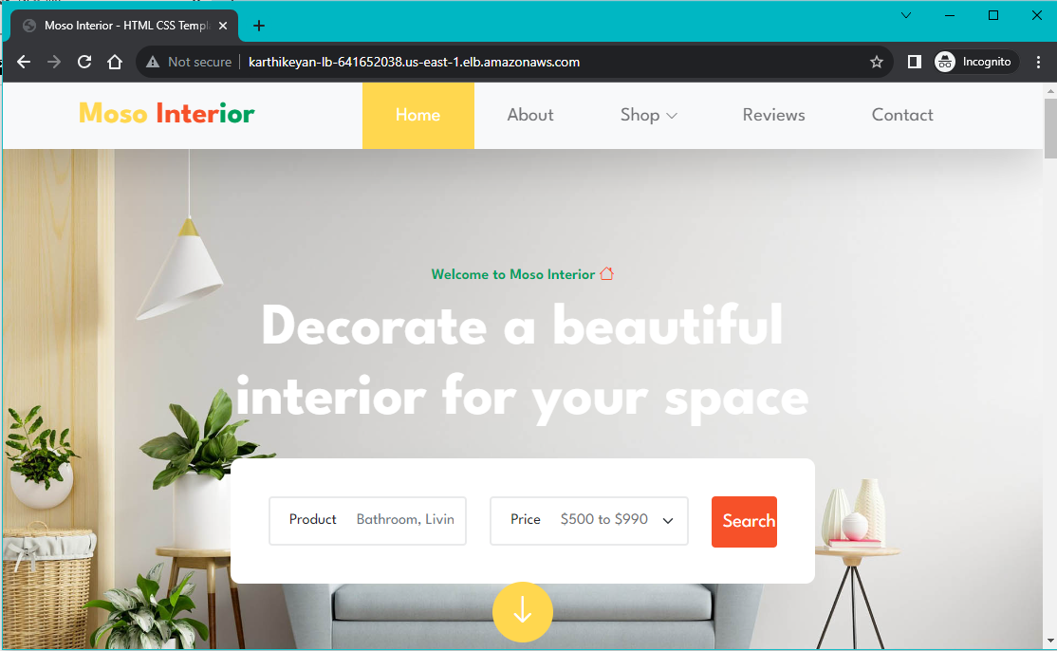

Another page under the same dns

