Department of Computer Science and Engineering

23CSE304 Embedded Systems

Experiment No. 2

Programming ARM Data Processing Instructions

Name of the Student | Manoj Mehra V
Registration Number | CH.SC.U4CSE23224
Due Date of Submission: 25.7.25 |  | Date of Submission: 24.7.25

Assessment Rubrics
Description | Mark Allotted | Mark Secured
Understanding of Concepts | 10
Code Functionality & Quality | 10
Hardware Integration | 10
Debugging Skills | 10
Innovation & Problem Solving | 10
Real-time Testing & Output | 10
Documentation & Report | 10
Viva/Oral Explanation | 10
Activity | 10
Adherence to Timely Submission | 10
Total Marks | 100

Signature of Lab in-charge

EXERCISE 2 Programming ARM Data Processing Instructions

Aim: To perform data processing tasks in an ARM processor using Embedded C programming.

Resources Required: Keil MDK ARM 3.24 Software, PC

- Open Keil MDK ARM Software in a PC.
- Create a new Project by clicking on Project menu followed by New Project submenu and give it a name.
- Select the target device as LPC2138.
- Do not allow to copy Startup.s to project folder and add file to project.
- Create a new source file by clicking on File menu followed by New submenu.
- Type the assembly code and save it as .s file.
- Add the required source files into the project by right mouse clicking on Source Group 1 in Project Window and select Add Files to Group ‘Source Group 1’.
- Set the Target Options by by right mouse clicking on Target 1 in Project Window and select
  - Target: Xtal(MHz) = 12
  - Linker: Uncheck Use Memory Layout from Target Dialog,
    - Scatter File entry must be blank.
- Build the target file by clicking on Project menu followed by Build target submenu.
- Correct the errors if any and debug the project by clicking on Debug menu followed by Start/Stop Debug Session submenu.
- Open the required peripherals and debug the project.

CODE

Building the Project:

1.ADD:
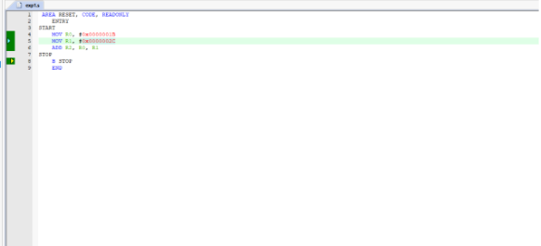

2.SUB:

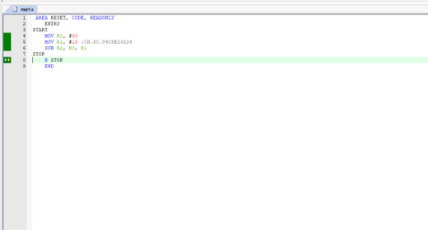

3.AND:

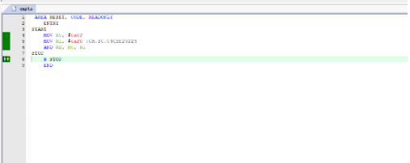
4.ORR:

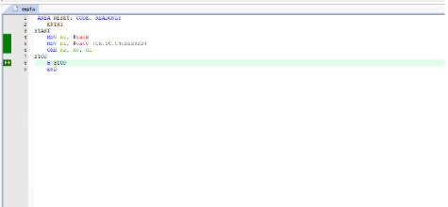

5.EOR:

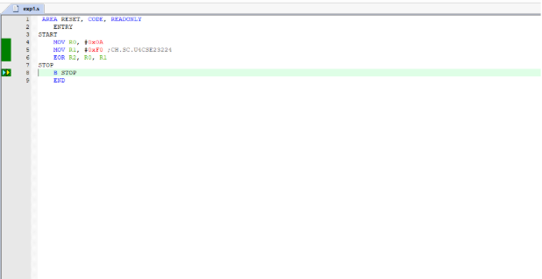
6.BIC:

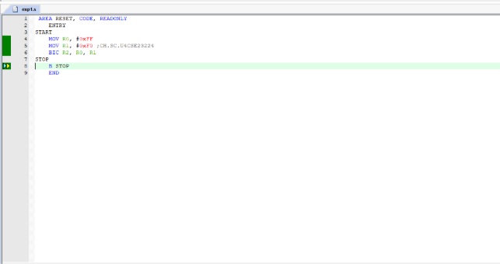

Debug Result:

1.ADD:

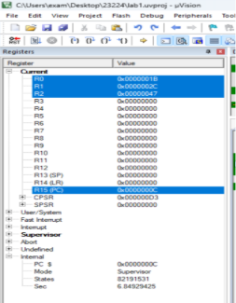
2.SUB:

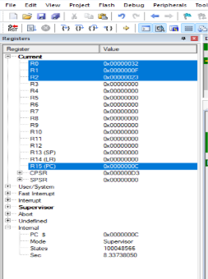
3.AND:

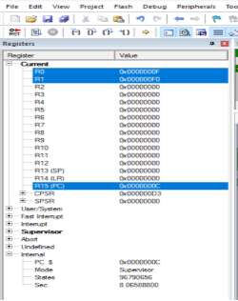
4.ORR:

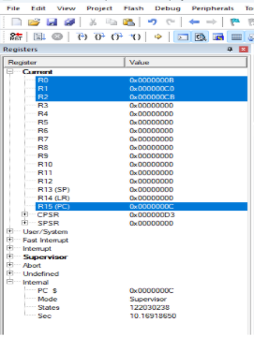

5.EOR:

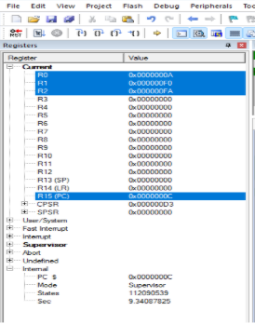
6.BIC:

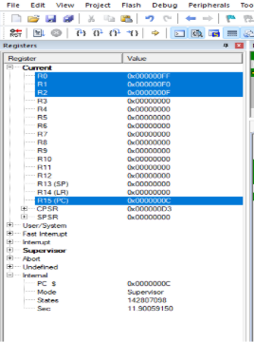

Result & Inference:
In this lab, we successfully performed ADD, SUB, ORR, and BIC operations in a Keil project, demonstrating essential arithmetic and bitwise functions of the ARM microcontroller. ADD and SUB enabled basic counting and timing functions, while ORR and BIC allowed precise bit-level control of registers. This hands-on experience highlighted the importance of low-level instruction handling for effective hardware control and embedded system optimization.
Viva Questions:

1. How many general-purpose registers does ARM have?
ARM has 16 general-purpose registers, named R0 to R15. R0 to R12 are general-purpose, while R13, R14, and R15 have special functions.
2. What is the use of R13, R14, and R15?
- R13: Stack Pointer (SP), used to manage the stack.
- R14: Link Register (LR), stores the return address during function calls.
- R15: Program Counter (PC), holds the address of the currently executing instruction.
3. What are the roles of LR and PC in function calls?
LR (Link Register) holds the return address when a function is called using the BL instruction.
PC (Program Counter) is updated to jump to the function. On return, LR is copied back to PC to continue execution.
4. What is the function of the CPSR register?
CPSR (Current Program Status Register) holds condition flags (Negative, Zero, Carry, Overflow), interrupt disable bits, and processor mode bits. It indicates the current state of the processor.
5. Explain the use of the stack in ARM programming.
The stack is used to store return addresses, local variables, and saved registers during function calls. It is accessed using the Stack Pointer (R13) and follows LIFO (Last In, First Out) order.
6. What is conditional execution in ARM?
In ARM, most instructions can be conditionally executed based on the flags in the CPSR. This allows instructions to run only if specific conditions are met, reducing branch instructions.

7. Explain the condition codes used in ARM.
ARM uses condition codes to determine whether to execute an instruction. Common ones include:
- EQ – Equal (Zero flag is set)
- NE – Not Equal (Zero flag is clear)
- LT – Less Than (N ≠ V)
- GE – Greater or Equal (N = V)
- GT – Greater Than (Z = 0 and N = V)
- LE – Less or Equal (Z = 1 or N ≠ V)
- AL – Always (default behavior)
8. What is the difference between BEQ and BNE?
- BEQ (Branch if Equal): Branches if the Zero flag is set (Z = 1).
- BNE (Branch if Not Equal): Branches if the Zero flag is clear (Z = 0).
9. Why is conditional execution useful in ARM?
Conditional execution reduces branching, which:
- Makes code more compact
- Improves execution speed
- Reduces pipeline flushes
10. What is the use of LDR and STR?
- LDR (Load Register): Loads data from memory into a register.
- STR (Store Register): Stores data from a register into memory.
11. What are the differences between LDRB and LDR?
- LDRB: Loads a single byte (8 bits) from memory.
- LDR: Loads a full word (usually 32 bits) from memory.
12. How is immediate data handled in ARM?
ARM allows immediate values to be encoded in instructions. These values are usually 8-bit constants rotated right by an even number of bits (up to 30), allowing flexible use of constants without memory access.

Activity: Programming ARM Data Processing Instructions
Task 1: Compute the Square of a Number Using Repeated Addition
Write an ARM assembly program to compute the square of a number using repeated addition.
Code:
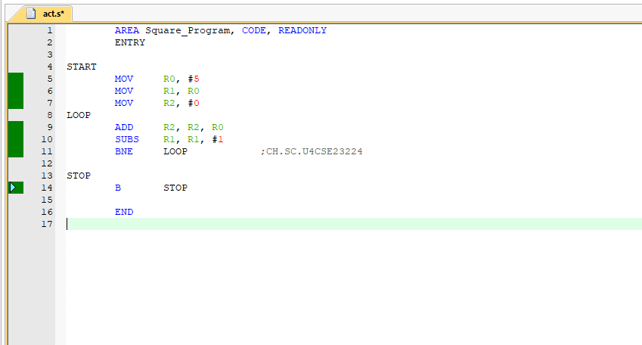

Output:

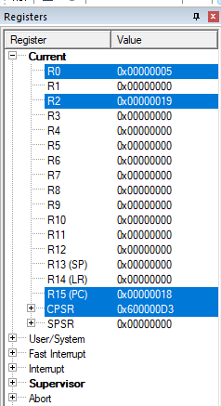

Task 2: Compute the Sum of the First N Even Numbers
Write an ARM assembly program to compute the sum of the first N even numbers using addition.
Code:

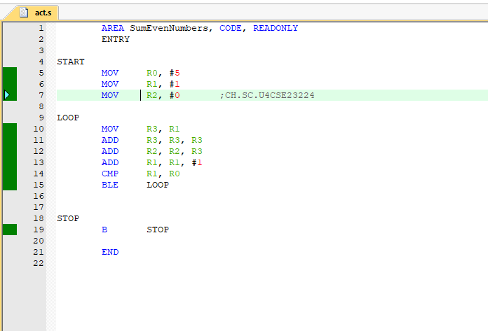

Output:

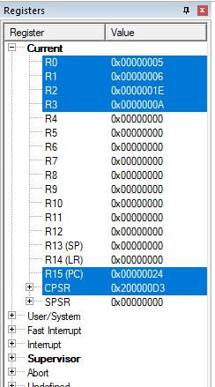

Task 3: Compute the Nth Triangular Number
Write an ARM assembly program to compute the Nth triangular number using addition.
Code:

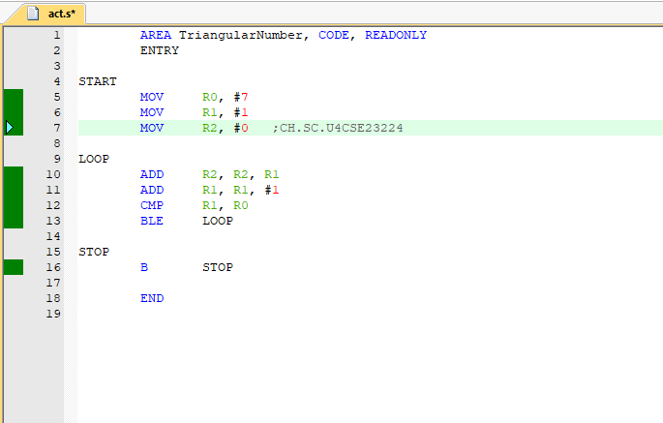

Output:

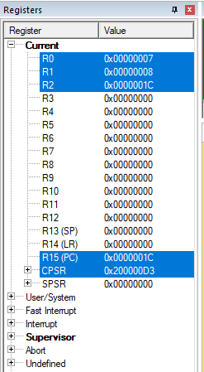

Task 4: Reverse an Array Using Addition and Subtraction
Write an ARM assembly program to reverse the elements of an array in place using addition
Code:

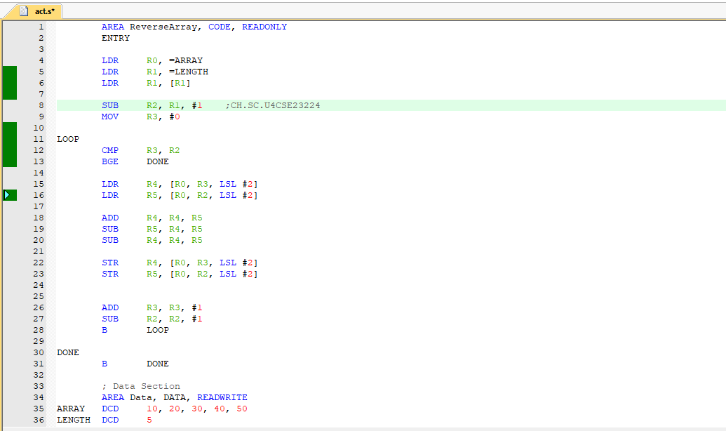

Output:

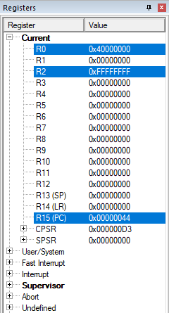

Task 5: Compute the Difference of Sums of Odd and Even Indexed Elements in an Array
Write an ARM assembly program to compute the difference between the sum of elements at oddindices and the sum of elements at even indices in an array.
Code:
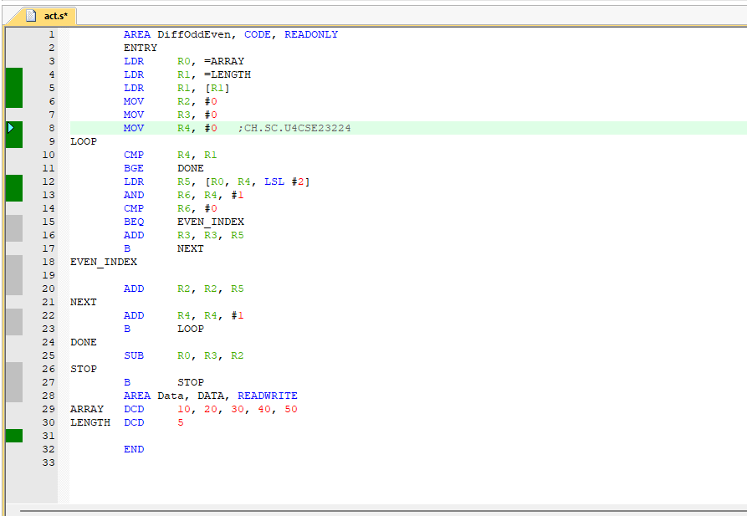

Output:
