# A Mini Project Report

on

# Online Blood donation System

Submitted in partial fulfillment of the requirements for the Degree of

## BACHELOR OF TECHNOLOGY

in

## COMPUTER SCIENCE AND ENGINEERING

by

**R. KARTHIKEYA 22FE1A05E9**

**P. SRINIVAS 22FE1A05D7**

**M. VAMSI KRISHNA 23FE5A0515**

**P. MANISHA 22FE1A05C3**

Under the guidance of

## Mr. B. MURALI KRISHNA, M.Tech

**Asst. Professor**

Department of Computer Science and Engineering



**DEPARTMENT OF COMPUTER SCIENCE AND ENGINEERING VIGNAN’S LARA INSTITUTE OF TECHNOLOGY & SCIENCE**

(Approved by AICTE New Delhi & Affiliated to JNTUK Kakinada)

(Accredited by NAAC ‘A+’ and NBA | ISO 9001 : 2015) Vadlamudi – 522 213, Guntur District

October-2024

**DEPARTMENT OF COMPUTER SCIENCE AND ENGINEERING**

**VIGNAN’S LARA INSTITUTE OF TECHNOLOGY & SCIENCE**

(Approved by AICTE New Delhi & Affiliated to JNTUK Kakinada)

(Accredited by NAAC ‘A+’ and NBA | ISO 9001 : 2015) Vadlamudi – 522 213, Guntur District

October-2024



**CERTIFICATE**

This is to certify that a Mini Project report entitled “**Online Blood donation System**” is a Bonafide work done by **R. Karthikeya(22FE1A05E9), P. Srinivas(22FE1A05D7), M. Vamsi Krishna(23FE5A0515), P. Manisha(22FE1A05C3)**, under my guidance and submitted in fulfillment of requirements for the degree of Bachelor of Technology in **COMPUTER SCIENCE AND ENGINEERING** from **JAWAHARLALA NEHRU TECHNOLOGICAL UNIVERSITY KAKINADA, KAKINADA**. The work embodied in this project report is not submitted to any University or Institution.

**Project Guide Head of the Department**

**Mr. B. Murali Krishna, M. Tech Dr. K. Venkateswara Rao, M. Tech**

**Asst. Professor Professor**

**External Examiner**

# DECLARATION

We hereby declare that a Mini Project report entitled **“Online Blood donation System”** is a record of an original work done by us under the guidance of **Mr. B. Murali Krishna, M. Tech** Asst.Professor of Computer Science and Engineering and this project report is submitted in the fulfillment of the requirements for the Degree of Bachelor of Technology in Computer Science and Engineering. The results embodied in this project report are not submitted to any other University or Institute.

**Project Members Signature**

1. **R. Karthikeya**
2. **P. Srinivas**
3. **M. Vamsi Krishna**
4. **P. Manisha**

**Place:** Vadlamudi

**Date:**

# ACKNOWLEDGEMENT

The satisfaction that accompanies with the successful completion of any task would be incomplete without the mention of people whose ceaseless cooperation made it possible, whose constant guidance and encouragement crown all efforts with success.

We are grateful to **Mr. B. Murali Krishna, M. Tech**, Asst. professor, Department of Computer Science and Engineering for guiding through this project and for encouraging right from the beginning of the project till successful completion of the project. Every interaction with him was an inspiration.

We thank **Dr. K. Venkateswara Rao, M. Tech,** Professor & HOD**,** Department of Computer Science and Engineering for support and Valuable suggestions.

We also express our thanks to **Dr. K. PHANEENDRA KUMAR, Principal**, Vignan’s Lara Institute of Technology & Science for providing the resources to carry out the project.

We also express our sincere thanks to our beloved **Chairman Dr. LAVU RATHAIAH** for providing support and stimulating environment for developing the project.

We also place our floral gratitude to all other teaching and lab technicians for their constant support and advice throughout the project.

## Project Members

**1. R. Karthikeya** 22FE1A05E9

**2. P. Srinivas** 22FE1A05D7

**3. M. Vamsi Krishna** 23FE5A0515

**4. P. Manisha** 22FE1A05C3

# TABLE OF CONTENTS

|  |  |
| --- | --- |
| **NAME OF THE CONTENT** | **PAGE NOs** |
| 1.ABSTRACT | 6 |
| 2.INTRODUCTION | 7 |
| 3.RELATED WORK | 8-9 |
| 4.PROPOSED SYSTEM | 10-12 |
| 5.MODULE DESCRIPTION | 13-16 |
| 6.RESULTS | 17-18 |
| 7.APPLICATIONS | 19 |
| 8.CONCLUSION | 20 |
| 9.REFERENCES | 21 |

**ABSTRACT**

The **Online Blood Donation System** is a web-based platform designed to streamline the process of blood donation by connecting donors and recipients in an efficient manner. The system allows users to register as donors, search for blood types, and request blood donations in case of emergencies. It includes features such as donor eligibility checks, and a search functionality based on location for nearby donors. The ultimate goal is to save lives by improving communication and donation management in times of critical need. The final outcome of our project is to make the user to either donate the blood or to request a specific blood type. This project helps us to make either of two decisions, i.e.,

**Donate or Request**.

# INTRODUCTION

# Blood is a complex fluid which plays an important role in human’s life. It flows to every part of human body which makes every organ functions effectively. Without blood, no organs and tissues would receive oxygen and nutrients. This blood is often essential at the time of surgeries, to cure cancer etc. Thus, the need of blood is universal. The donation of blood plays an important role in everyday life. For any type cases like Emergency scenarios, Accidental cases, Surgeries, etc., blood is needed. Our project aims to donate the blood for needy people in the above mentioned scenarios. There are mainly four types of blood groups. They are, “A”, “B”, “AB”, “O”. each group can be either RhD positive(+) or RhD negative(-). So, finally there exists 8 types of blood groups in universe. Irrespective of the RhD sign, based on the blood group, the person can either donate or seek the other blood groups.

|  |  |  |
| --- | --- | --- |
| Recipient blood group | Can donate to… | Can receive from… |
| O+ | O+, A+, B+, AB+ | O+, O- |
| O- | All blood types | O- |
| A+ | A+, AB+ | A+, A-, AB+, |
| A- | A+, A-, AB+, AB- | A+, A-, AB+, AB- |
| B+ | B+, AB+ | B+, B-, O+, O- |
| B- | B+, B-, AB+, AB- | B-, O- |
| AB+ | AB+ | All blood types |
| AB- | AB+, AB- | AB-, O-, A-, B- |

# 

# RELATED WORK

Now-a-days, The efficient and accessible blood donation systems are very needy. For this, many NGO organizations or hospital organizations are developed some online blood donation systems. These systems are helpful for connecting the donors with recipients, and improving response times during emergency scenarios.

One significant study discusses the integration of mobile applications with online databases, enabling users to register, search for, and connect with blood donors or donation centres nearby. These applications provide features like location-based search, and notifications about urgent blood needs. Such systems illustrate the value of mobile connectivity and user-friendly interfaces in enhancing user engagement and accessibility, which is major aspect of our online blood donation system. Our system is a web-based platform, where the users can publicly accessible with the recipients, and provides a way for the users to connect with the recipients directly through their nearby locations.

On the other hand, the database management and data security, similar systems incorporate frameworks for securely storing donor information, given the sensitive nature of health-related data. Security measures such as encryption, authentication, and regular data audits are implemented to prevent data breaches. Our project similarly addresses data security by following best practices in PHP and database management to ensure donor and recipient information remains confidential.

Other studies have explored AI-driven recommendations and predictive analytics to manage blood inventory better. These systems help predict which blood types are likely to be in demand in specific regions, which can inform donor recruitment strategies. While AI implementation is beyond the current scope of our project, the inclusion of these advanced features offers an excellent perspective for future enhancements.

Finally, open-source blood donation platforms have inspired our approach, as they provide flexible, customizable solutions for the individuals. These platforms typically focus on donor recruitment, engagement, and basic record-keeping but often lack a comprehensive system for managing health history and eligibility checks. Our project addresses this gap by incorporating detailed health-related fields to streamline the matching process.

In summary, Our system aims to provide a user-friendly, web-based platform accessible to the general public, with emphasis on security and comprehensive health tracking. This approach makes it well-suited for both local use and broader adoption across various community health initiatives.

# PROPOSED SYSTEM

We use the web-technologies like HTML, CSS for user interface and for backend, we use PHP, MySQL for our Online Blood donation System. This system is capable of interacting with the donors and recipients. The registered user can either donate the blood or request for blood. To make the decisions (Donate or Request), first the user or individual need to register. After successful registration, the user can decide the action to be performed based on the situation. If the user forgets his/her password while login, the user can click on ‘Forgot Password’ to update his/her password. When the given credentials are matched with the records of the database, the user can directly login to the website. After successful login, the user’s dashboard will be displayed. This user’s dashboard displays the details of the user like **Name**, **Register ID**, **Blood group**, **Number of donations,** and offers the **Donate and Request** options. For a new user, the number of donations are Zero(0) by default. When the user clicked on “Donate” option, the user can enter the details like his/her name, email, blood group. When the user clicked on donate button, the donation request will be sent to all the donors of the database. ie., the other donors and recipients. The recipients who are willing to take the specified blood, can be accept the donor’s request. When the donor’s donation option is successful, the count of the number of donations of the user will be **incremented by 1**. When the user clicked on “Request” option, the user can enter the details like, his/her name, the specified email to contact with him, the type of blood group, his/her city. When the user clicked on request button, the request will be sent to the donor’s email, whose blood group is matched with the requested blood group. The donors on the other side and accept the user’s request.

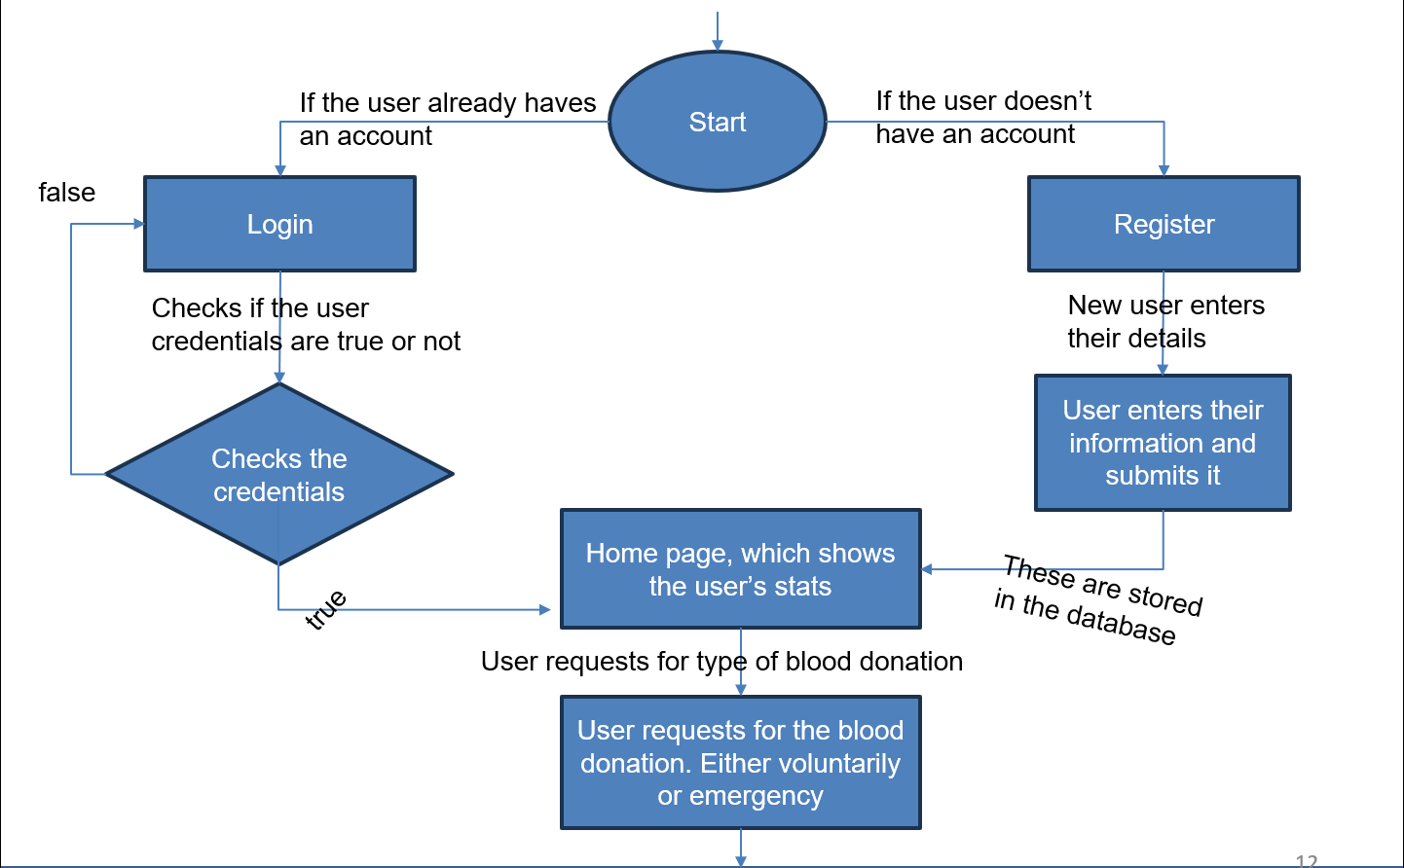

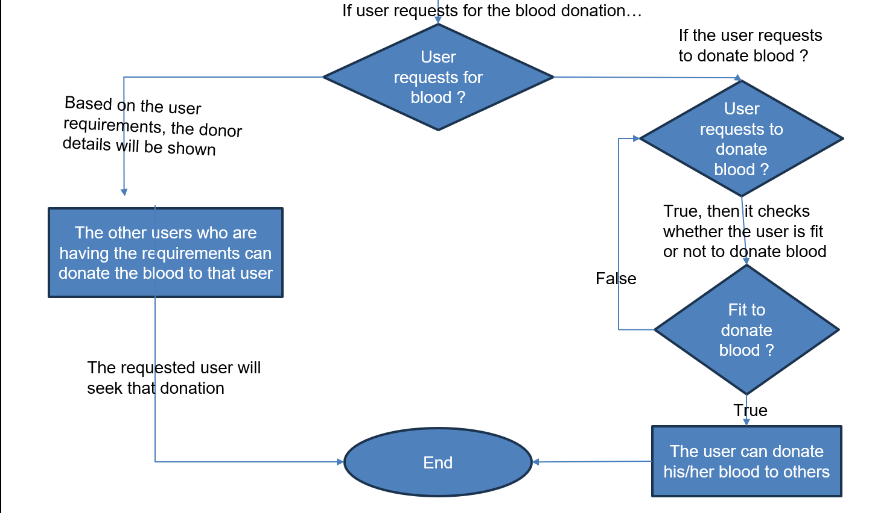

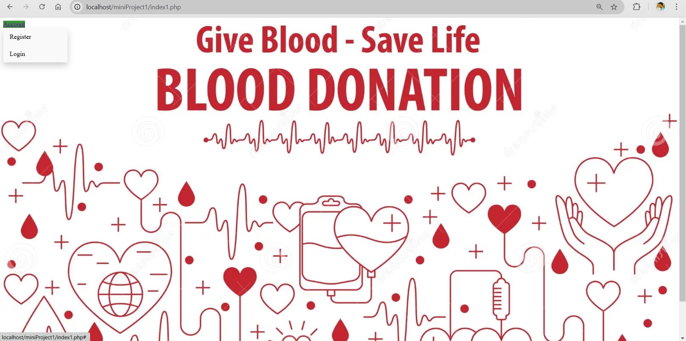

# MODULE DESCRIPTION

The proposed system is categorized as the following modules:

* 1. Input Credentials
  2. User Dashboard
  3. Donate option
  4. Request option

## Input Credentials:

The users who are new to this website are needed to register their details first. While registration process, the user needs to give his/her name, email, password (for security purpose), and needs to give his/her personal details like, address, gender, age, weight, etc. These details are stored in the database. after successful registration, the user can login to the website based on the given login credentials, ie., username(email) and password. After successful login, the dashboard of the user displays on the screen of his/her device.

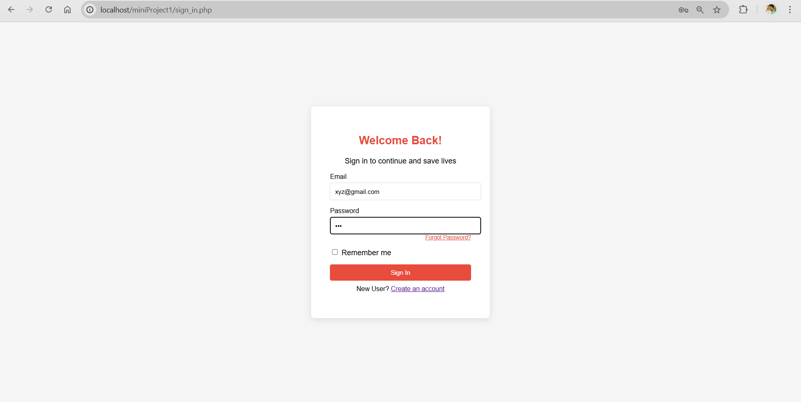

## User Dashboard:

In this, the user details are displayed on the screen of user’s device. This dashboard consists of the following details….

1. User’s name
2. User’s register ID
3. User’s blood group
4. User’s number of donations (by default, Zero for new users)

And also, this dashboard provides two options for the users. They are, **Donate** and **Request.**

## 

## 

## Donate Option:

This option provides the user’s request, who are willing to donate his/her blood to others. The various users of this webpage, ie., Recipients who need the specific blood group can accept the requested donation of a specific donor. When the donation made by the user is successful, the user’s count of number of donations will be incremented by 1.

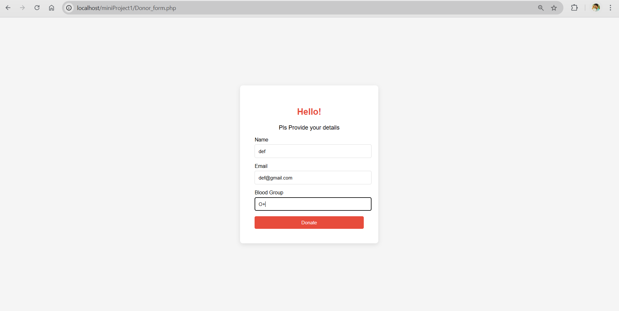

## Request Option:

This option provides the user’s request, who are seeking for a specific blood group from the other donors, who are registered in this website. When the user chooses this option, the user needs to give his contact details(email) and the blood type that user need. And also, the user can specify the case of request, like Emergency, Surgery, Trauma and Accidents, Cancer treatments etc. when the user request for the blood, the users who are having the requested blood group will get an email for their email address of the request. By this email message, the donor and recipient will directly contact each other.

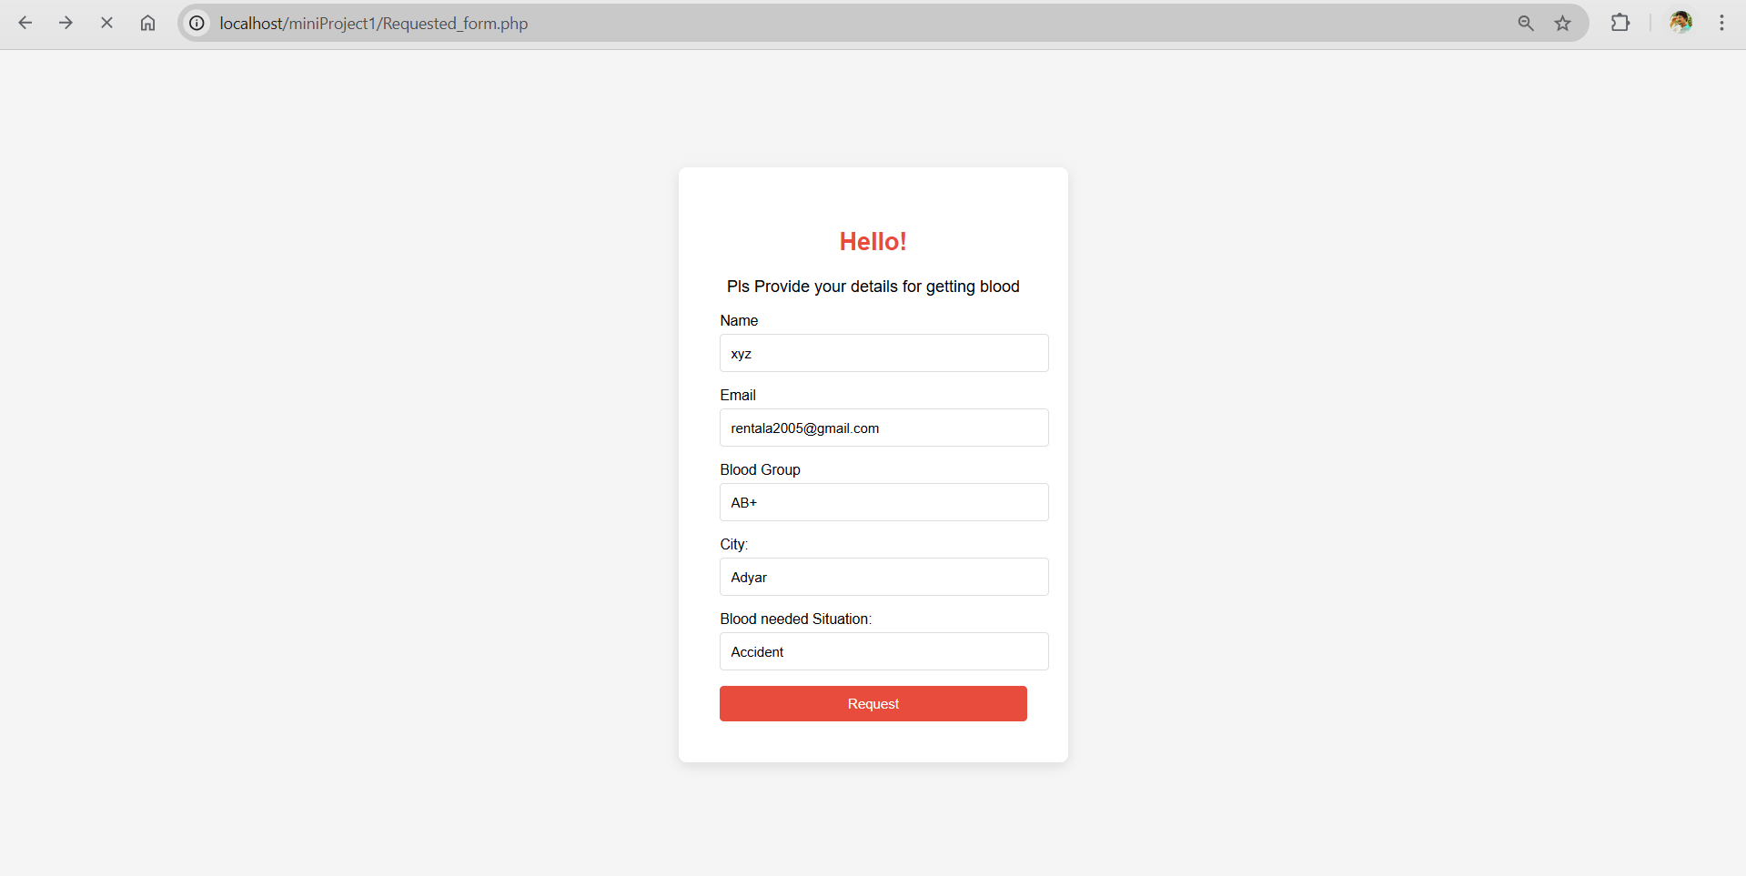

# RESULTS

**For Donation…**

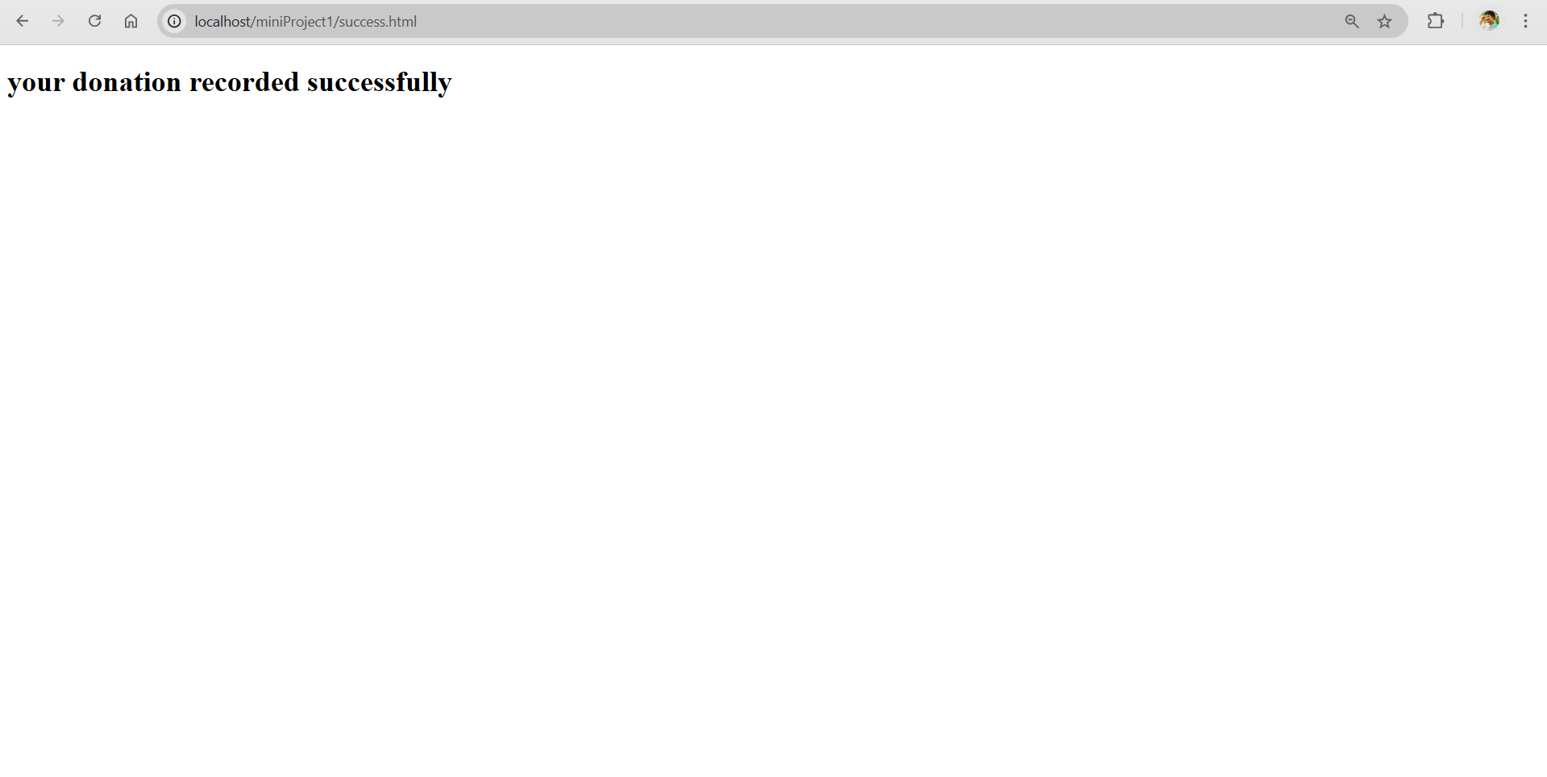

**For Request…**

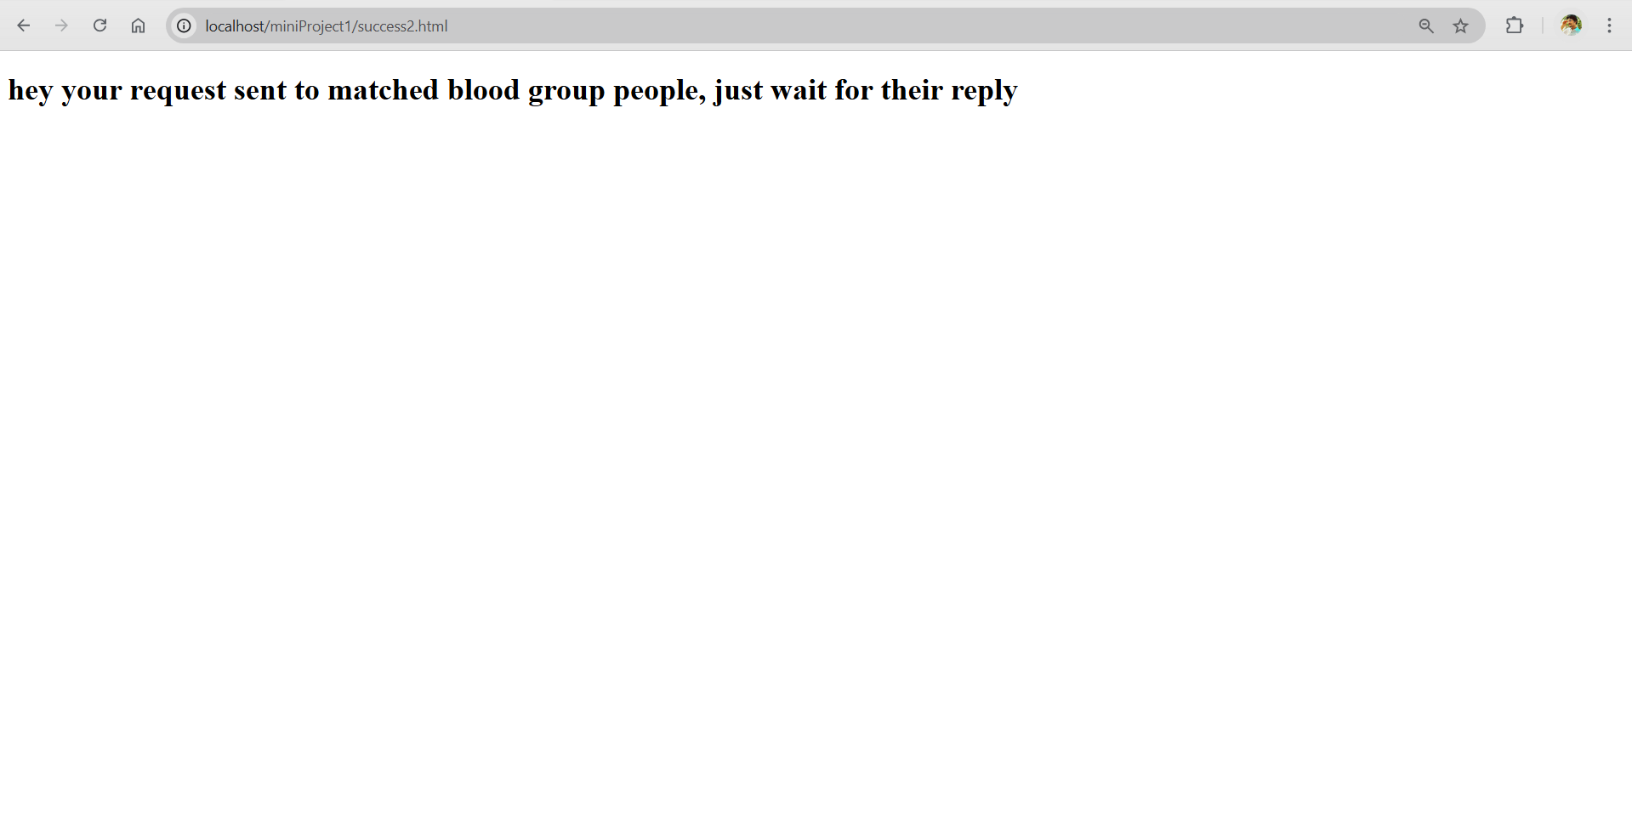

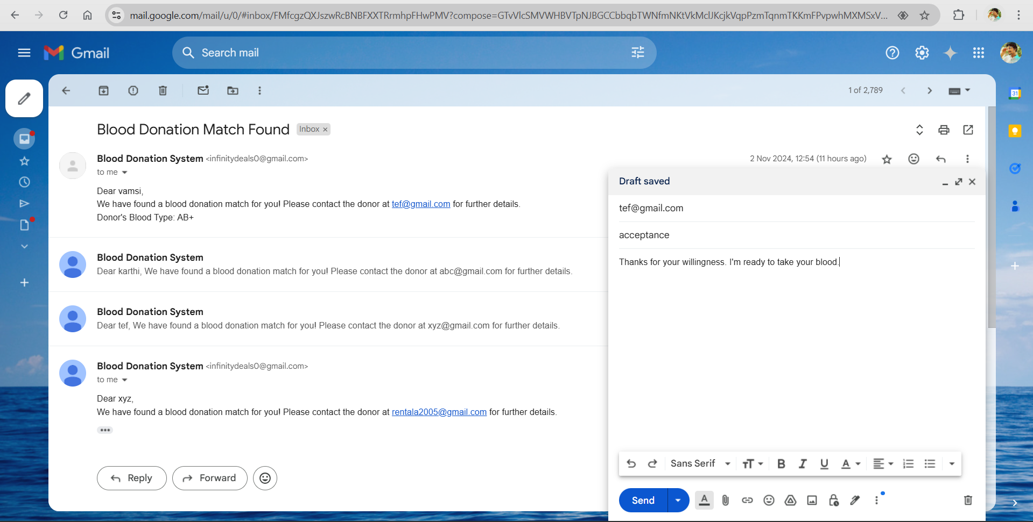

# APPLICATIONS

Our Proposed system will be used and applied on various fields, such as:

* 1. Hospitals
  2. Clinics
  3. Blood banks
  4. Non-Governmental organizations (NGOs)
  5. Laboratories

**REFERENCES**

The below are the references, which are used and very helpful for our project **Online Blood donation System…**

* [**https://www.who.int/**](https://www.who.int/)
* [**https://www.redcrossblood.org/**](https://www.redcrossblood.org/)
* [**https://medlineplus.gov/**](https://medlineplus.gov/)
* [**https://www.mayoclinic.org/**](https://www.mayoclinic.org/)
* [**https://www.nhp.gov.in/**](https://www.nhp.gov.in/)
* [**https://www.ncbi.nlm.nih.gov/**](https://www.ncbi.nlm.nih.gov/)
* [**https://ieeexplore.ieee.org/**](https://ieeexplore.ieee.org/)
* [**https://www.researchgate.net/**](https://www.researchgate.net/)
* [**https://www.in22labs.com/**](https://www.in22labs.com/)

# CONCLUSION

Our proposed system is an efficient system, which can be used to donate the blood to other users and request for a specific blood type from the users.This web-based system is very helpful for the people who are in need of blood. The main aspect of our proposed system is **direct interaction between the donors and recipients.** This proposed system is highly efficient in data storing and data management. This system provides effective security to the data of donors and recipients. This data is automatically updated while making the actions on the website.

As per recent study, on average, approximately 10000 to 15000 units of blood are needed to make survival of patients. And around 5 million units of blood is required to patients undergoing the major surgeries, treatments and other medical conditions. So, donating the blood is more essential to save a greater number of lives. By our project, **Online blood donation system**, a person can either donate the blood or can request to seek the blood. This website is user-friendly to donate blood and save lives of more people.

# 

# REFERENCES

1. A similar website of our proposed system – [www.simplyblood.com](http://www.simplyblood.com)
2. A mobile application, named as **Blood Bank**, by In22 labs