23CSE202 DATABASE MANAGEMENT SYSTEMS
S3 B.Tech CSE
Department of Computer Science and Engineering
Amrita School of Computing, Amritapuri Campus

PROJECT REPORT

Group No : D12
Team Members :
Roll No | Student Name
AM.SC.U4CSE25326 | KARTHIKEYA S ARUN
AM.SC.U4CSE25362 | GANGA J
AM.SC.U4CSE25322 | HARSHITA SANKA

Project Title :
SCHOOL MANAGEMENT SYSTEM

CONTENTS
Sl. No | Chapter | Page No
1 | Abstract | 3
2 | Introduction | 3,4
3 | Requirements (Functional & Non-functional) | 5,6
4 | UI Design | 6-12
5 | Database Design | 12-22
6 | Database Selection & Justification | 23-24
7 | Implementation | 24-28
8 | Testing & Validation | 28,29
9 | Results & Screenshots | 29-36
10 | Challenges faced & solutions | 36,37
11 | Conclusion & future enhancements | 37,38
12 | References | 38

1. Abstract :
The School Management System is a database-driven web application developed to simplify and organize the management of student information and academic activities in an educational institution. Traditional methods of maintaining school records can involve repetitive data entry, difficulties in retrieving information, and the possibility of errors and inconsistencies. The proposed system provides a centralized platform for managing student details, teacher information, classes, subjects, examination marks, attendance, timetables, announcements, and academic reports. The frontend is developed using HTML, CSS, and JavaScript, while Node.js and Express.js are used to implement the backend. PostgreSQL is used as the relational database management system for storing and retrieving structured information. The application provides separate access for administrators and teachers, with permissions based on their roles. Database concepts such as relational schema design, primary keys, foreign keys, constraints, normalization, SQL queries, and CRUD operations are applied to maintain data integrity and reduce redundancy. The project demonstrates how a database-driven application can improve the organization, accessibility, and management of school records while providing a foundation for future enhancements.

2. Introduction
2.1 Background:
Educational institutions manage large amounts of information related to students, teachers, classes, subjects, attendance, examination marks, timetables, and academic performance. Maintaining this information accurately is essential for the effective functioning of a school. Traditionally, many administrative activities have been performed using paper records, spreadsheets, or separate applications. Although these methods can be useful for small amounts of information, they become difficult to manage when the volume of data increases.
Manual record maintenance can lead to duplication of information, calculation errors, difficulties in updating records, and delays in retrieving important details. For example, finding a student's complete academic history may require checking multiple records. Similarly, preparing attendance summaries, calculating subject-wise averages, and maintaining teacher schedules can require considerable time and effort.
A database-driven School Management System helps address these difficulties by maintaining related information in a structured and centralized database. It allows authorized users to perform operations through a web interface while the backend processes requests and interacts with the database. This approach improves the organization of information and makes administrative operations more systematic.
2.2 Problem Statement:
Managing school information involves several interconnected activities, including maintaining student and teacher records, organizing classes and subjects, recording attendance, entering examination marks, and preparing academic reports. When these activities are handled using disconnected systems or manual methods, information may become inconsistent, records may be duplicated, and retrieving the required data may take considerable time.
Another important issue is maintaining relationships between different records. For example, examination marks must be associated with the correct student and subject, while timetable entries must refer to the appropriate teacher and class. Incorrect or incomplete relationships can affect the accuracy of academic information. Unauthorized access to student records is also a concern.
Therefore, a centralized School Management System is required to organize these activities, maintain relationships between records, validate data, and provide authorized users with convenient access to relevant information.
2.3 Proposed System:
The proposed School Management System is a web-based application that integrates a user interface, backend services, and a relational database. The frontend provides interfaces through which users can interact with the system. The backend processes user requests, performs validation, checks access permissions, and communicates with the PostgreSQL database.
The system supports student and teacher management, class and subject organization, teacher assignments, marks management, attendance recording, timetable management, announcements, and academic report generation. Administrators can perform administrative operations, while teachers can access the functions permitted by their roles and assignments.
The use of a centralized relational database helps maintain consistent information across the different modules. Primary keys, foreign keys, constraints, and appropriate table relationships support data integrity. SQL queries and database operations are used to retrieve, insert, update, and delete information as required by the application.
2.4 Objectives:
The main objectives of the School Management System are:
- To develop a centralized application for managing school information.
- To maintain student and teacher records in a structured database.
- To organize classes, subjects, and teacher assignments.
- To record, retrieve, and update examination marks.
- To maintain attendance records and generate attendance summaries.
- To manage timetables and reduce scheduling conflicts.
- To provide announcements and academic information to authorized users.
- To generate reports related to student performance and school activities.
- To maintain data integrity using keys, constraints, and relationships.
- To apply database management concepts such as normalization, SQL queries, and CRUD operations in a practical application.
2.5 Scope of the Project:
The scope of the project includes the management of student and teacher information and the organization of academic activities within a school. The application provides modules for managing classes, subjects, teacher assignments, examination marks, attendance, timetables, announcements, and academic reports.
The system focuses on the use of a relational database to maintain structured and interconnected records. It demonstrates how frontend interfaces can communicate with backend services to perform database operations. The project also incorporates access control and data validation to improve the reliability of administrative operations.
The current scope is limited to the modules implemented in the application. Additional features such as fee management, parent portals, online assignment submission, notification services, and mobile application support can be considered for future development.

3. Requirements (Functional & Non-functional) :
3.1 Functional Requirements:
Functional requirements describe the operations that the School Management System must perform.
- User Authentication: The system must allow authorized users to log in and access the appropriate functions according to their roles.
- Student Management: The system must support adding, viewing, updating, searching, and deleting student records.
- Teacher Management: The system must maintain teacher information and support the required teacher management operations.
- Class Management: The system must allow administrators to organize and maintain class information.
- Subject Management: The system must maintain subject details and support the association of subjects with relevant classes and teachers.
- Teacher Assignment: The system must maintain assignments connecting teachers with the classes and subjects they teach.
- Marks Management: The system must support recording, viewing, updating, and deleting examination marks associated with students and subjects.
- Attendance Management: The system must maintain student attendance records and allow authorized users to view and update attendance information.
- Timetable Management: The system must maintain timetable information and help prevent scheduling conflicts involving teachers and classes.
- Announcement Management: The system must allow authorized users to manage school announcements and their intended audiences.
- Report Generation: The system must provide academic reports and summaries related to student performance, attendance, and other supported school activities.
- Data Validation: The system must validate inputs and enforce database constraints to prevent invalid or inconsistent records.
3.2 Non-functional Requirements:
Non-functional requirements describe the quality attributes expected from the system.
- Security: The application should protect sensitive information through authentication, authorization, and secure password handling.
- Reliability: The system should perform database operations consistently and handle errors appropriately.
- Data Integrity: Primary keys, foreign keys, unique constraints, and check constraints should maintain the correctness of stored records.
- Usability: The user interface should provide clear navigation and understandable forms for different administrative operations.
- Performance: Database queries and application operations should retrieve and process information efficiently.
- Maintainability: The application should be organized into separate frontend, backend, and database components to simplify debugging and future modifications.
- Scalability: The system should support the addition of new modules and database functionality as requirements grow.
- Compatibility: The web application should work with supported modern web browsers and the required runtime and database environment.

4. UI Design :
The user interface provides navigation for the main operations of the School Management System. A common login portal with Administrator and Teacher tabs leads to a role-specific home page. The administrator interface groups related functions under student management, marks management, attendance management, teacher management, classes and subjects, timetable, announcements, and reports, while the teacher dashboard shows only the classes, subjects, student rosters, and schedule assigned to the logged-in teacher.
The interface is intended to help users move between operations easily. Sections 4.1 to 4.5 show the core administrator workflow; Section 4.6 covers the teacher, class, timetable, and announcement screens.
4.1 Administrator Login
The login portal contains Administrator and Teacher tabs, each with username and password fields and a Login button. It acts as the entry point to the system and issues a signed token that is checked on every protected request.
Passwords are stored as bcrypt hashes, and access to each module is restricted on the server according to the user's role.
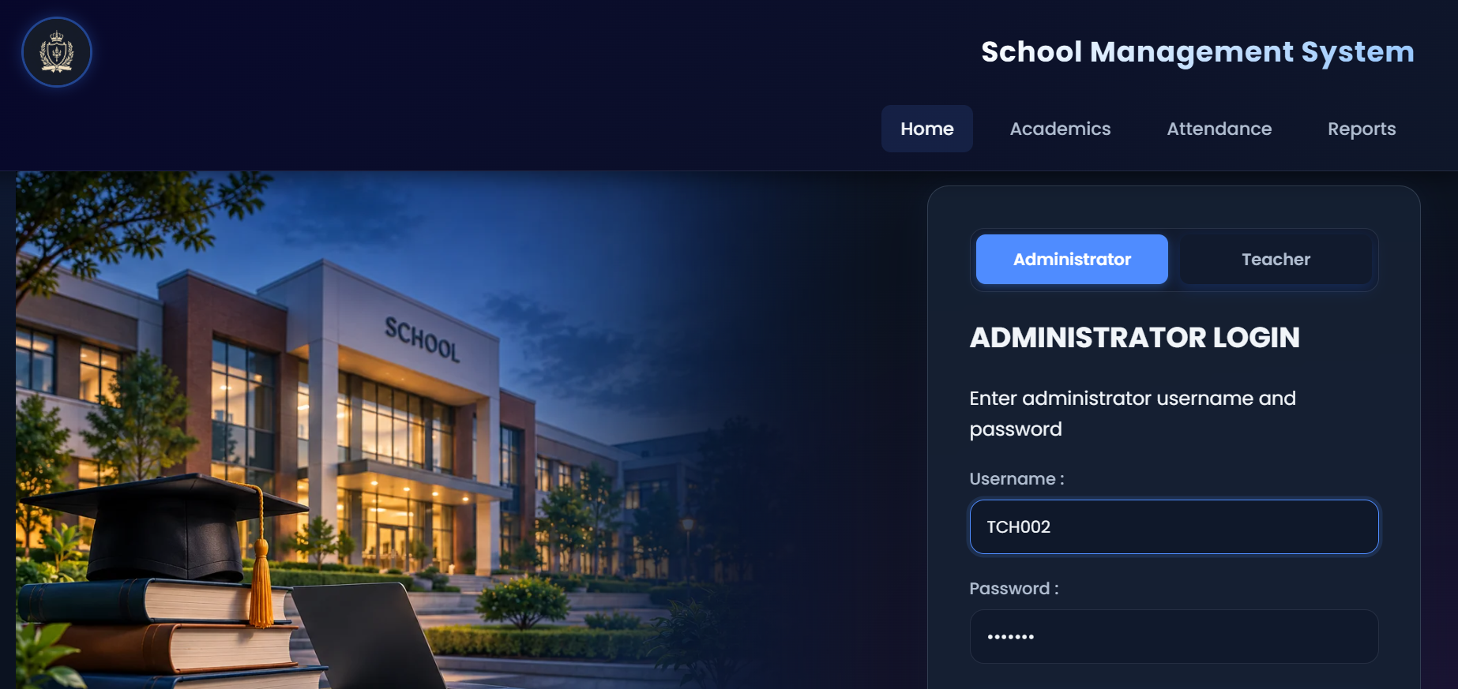
4.2 Student Management Screens
The student management module maintains student registration and personal information. The Add Student form includes fields such as registration number, full name, date of birth, gender, class, house number, city, PIN code, phone number, and email address.
The edit function allows existing details to be updated, while the delete function removes a selected record according to the database rules. The registration number uniquely identifies each student.
In the relational design, each student record stores the class label (for example '9 A') that corresponds to a record in the CLASSES table, and the address is stored as house number, city, and PIN code.
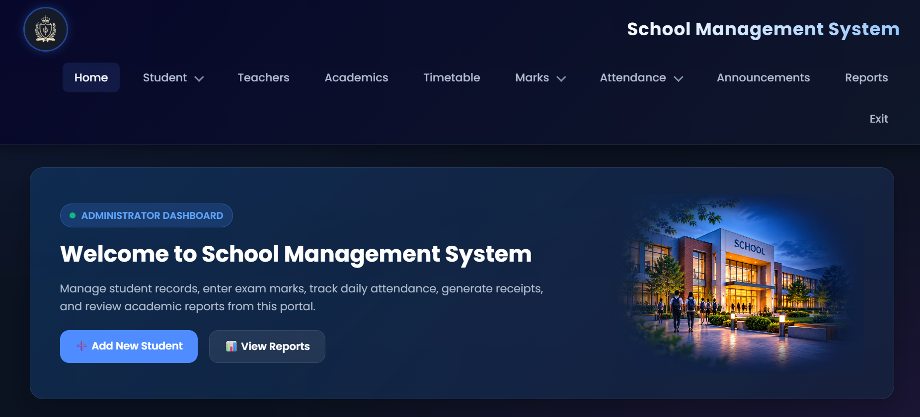
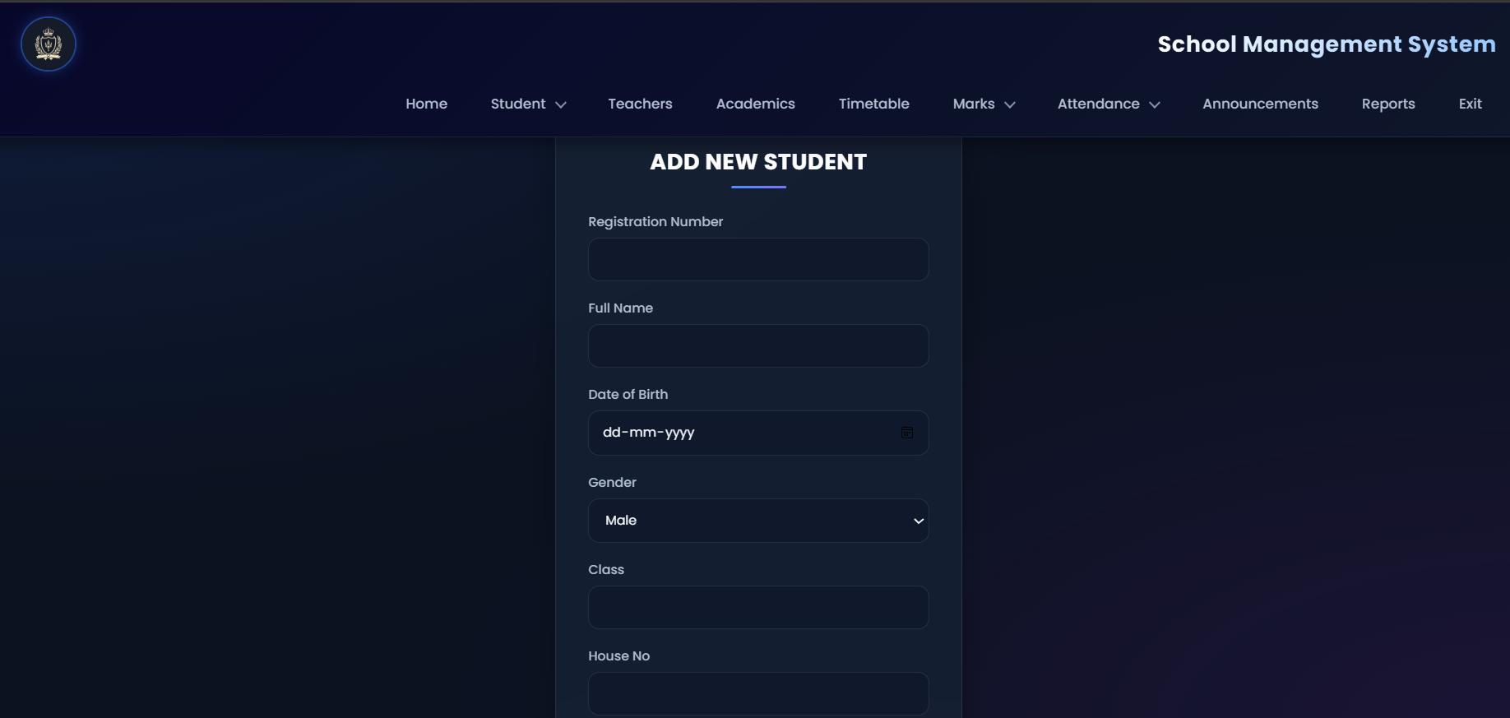
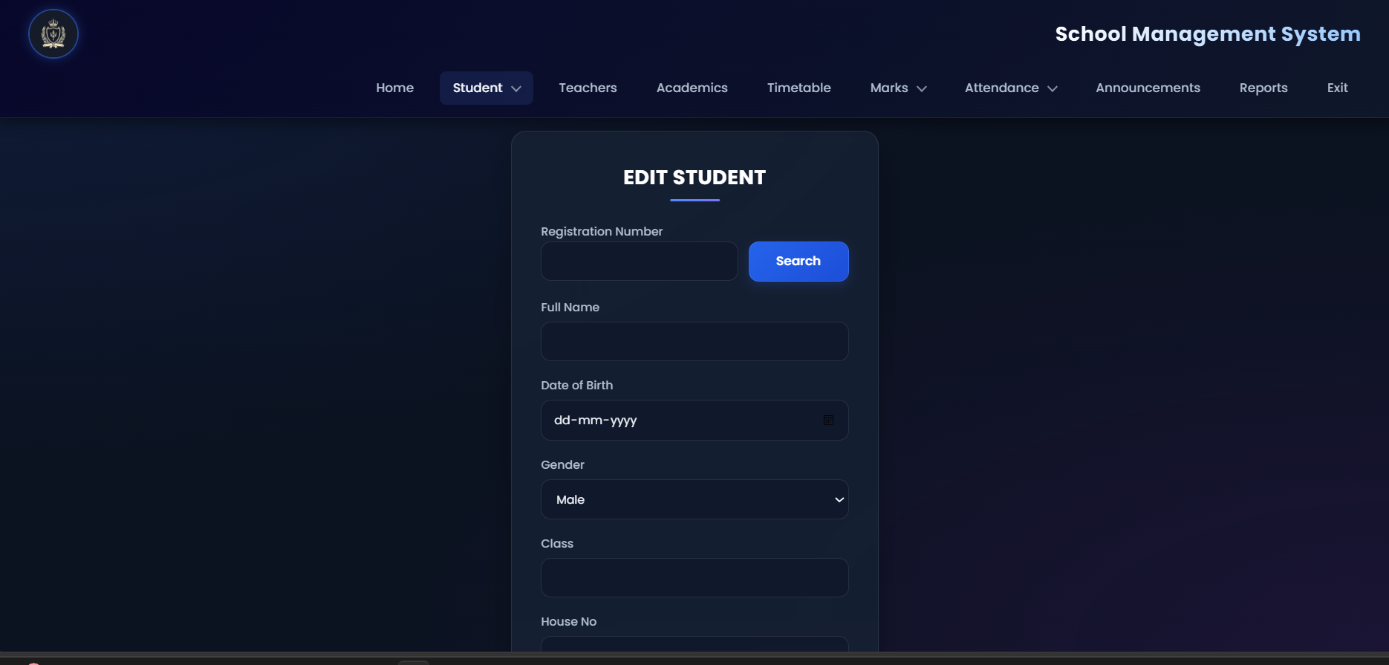
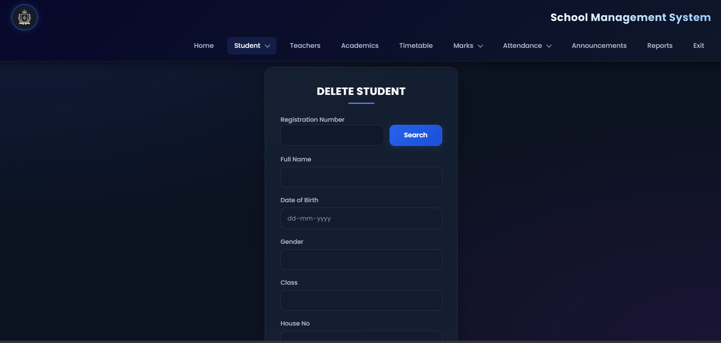

4.3 Marks Management Screens
The marks management module records examination results for students. The form accepts a student's registration number, the examination type, and marks for the five core subjects: First Language, Second Language, Mathematics, Science, and Arts.
Each subject mark is stored as a separate record in the STUDENT_SUBJECT_MARKS table, identified by mark_id and unique for a student, subject, examination type, academic year, and attempt number. The module also provides facilities to edit or delete existing marks records. Teachers can enter marks only for the classes and subjects assigned to them.
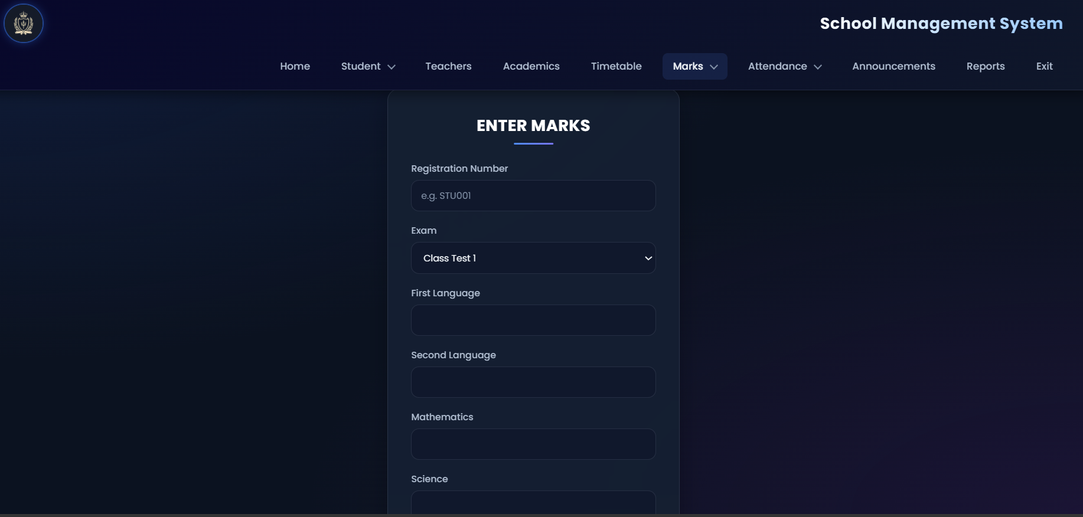
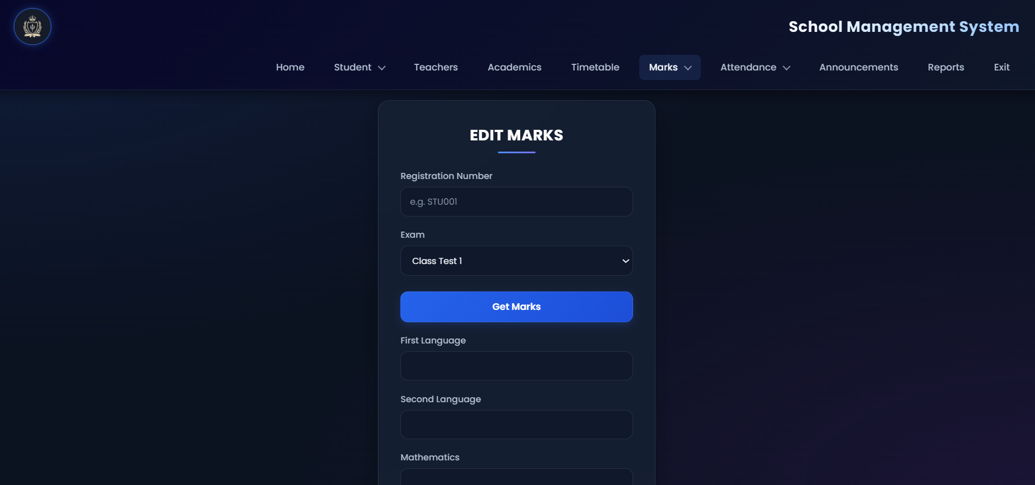
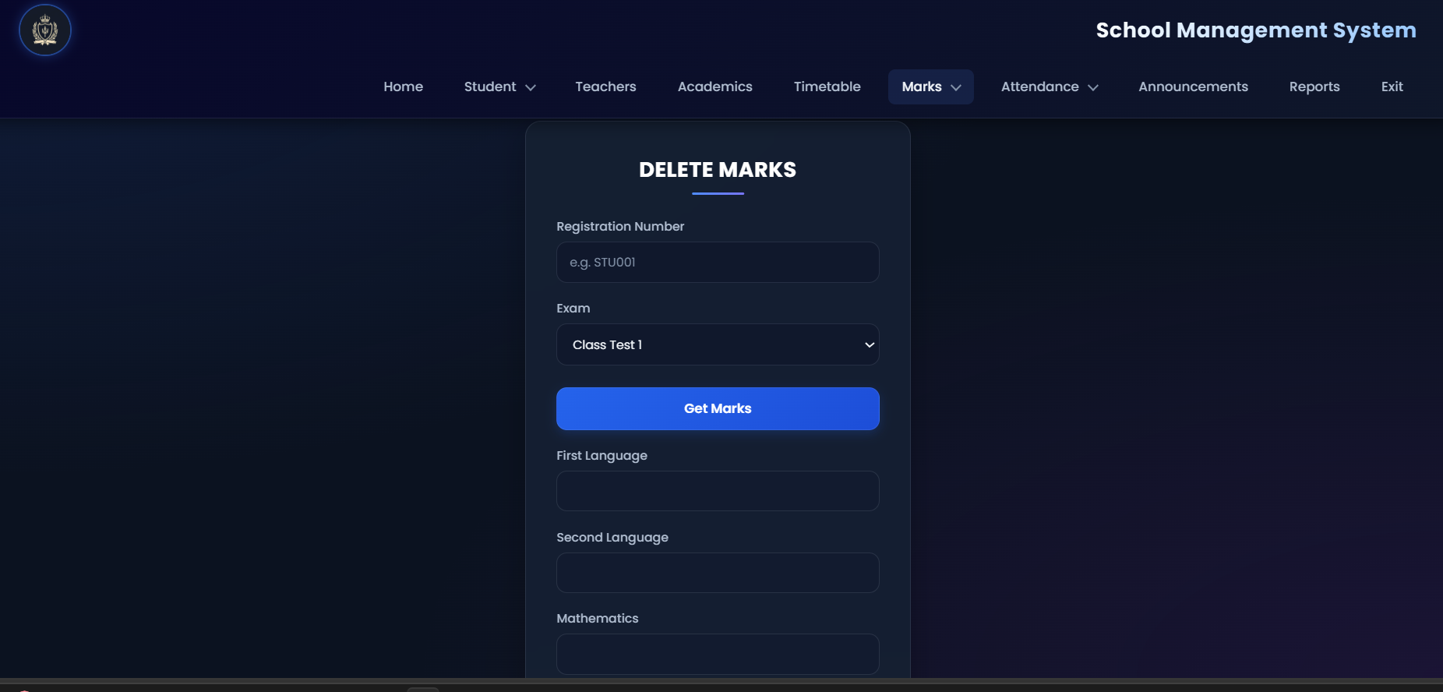
4.4 Attendance Management Screens
The attendance management module maintains attendance records. Each record contains an attendance ID, student registration number, date, status, and an attendance type. Subject attendance additionally records the subject and, optionally, the timetable period, while earlier daily records are preserved as General attendance.
The status indicates whether the student was Present or Absent. A student can have many attendance records. Partial unique indexes prevent duplicate General daily records, duplicate Subject daily records, and duplicate Subject period records for the same student.
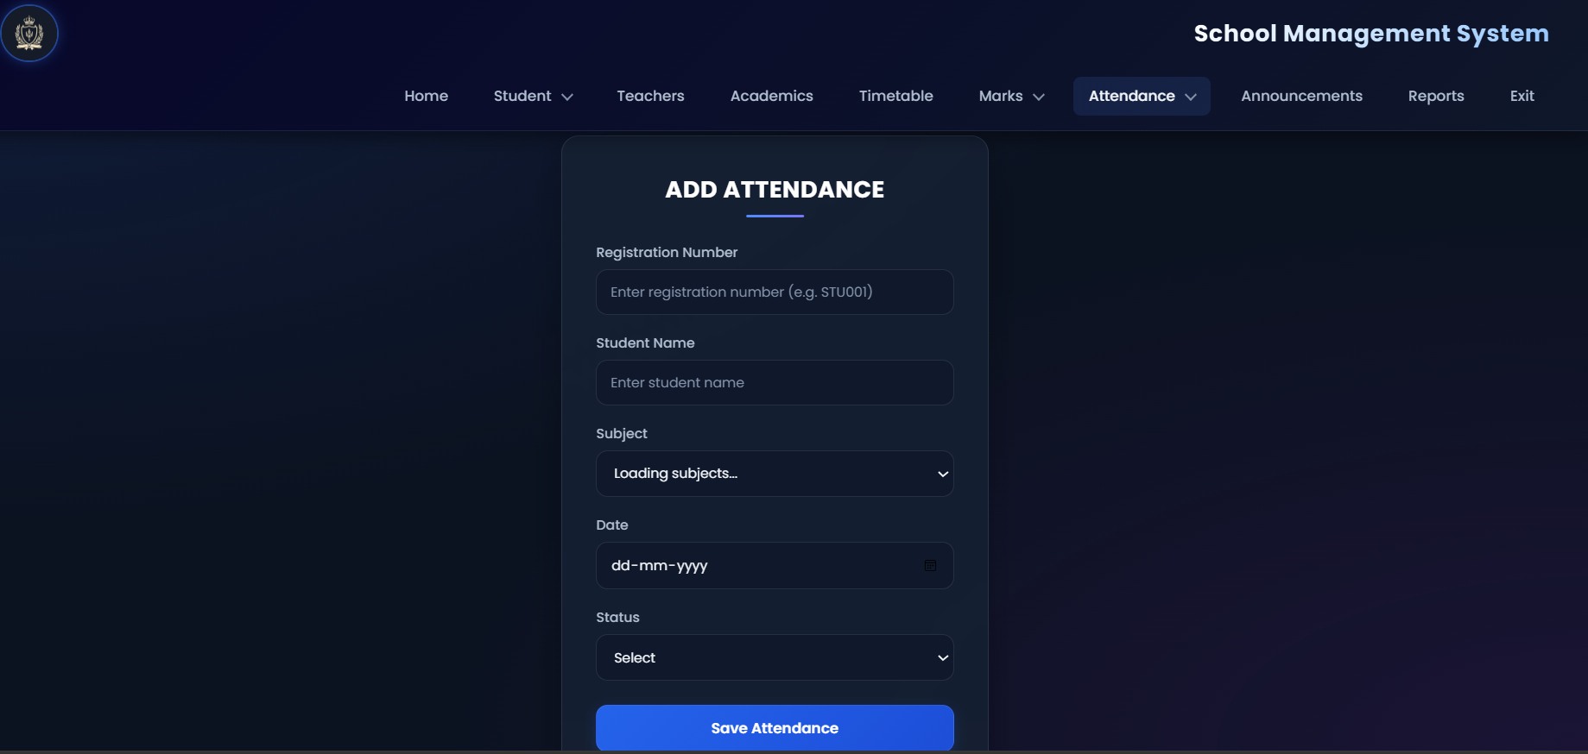
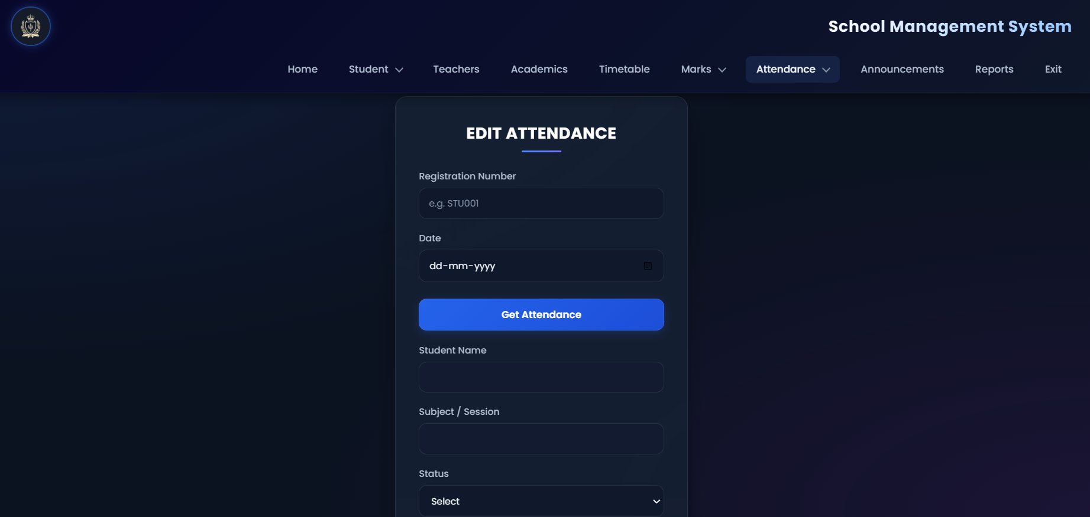

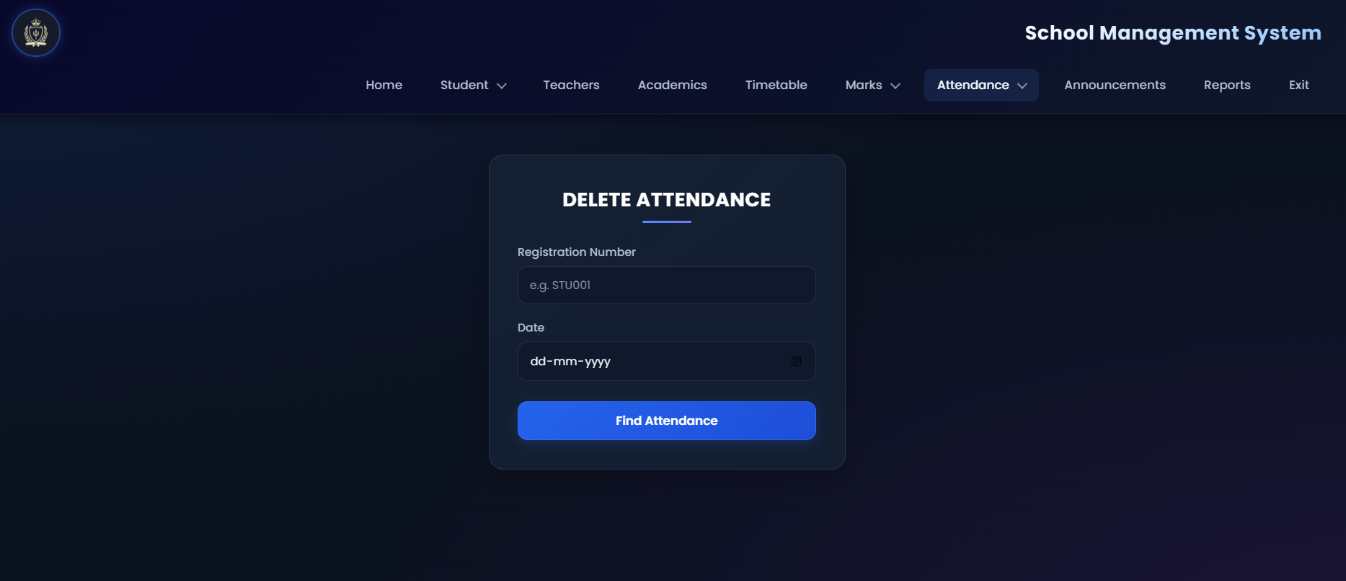
4.5 Reports Screen and Navigation Flow
The reports module allows an administrator to search for a student using the registration number. The report displays available student details, subject-wise marks, total marks, average, grade, and an attendance summary.
The attendance summary may contain the total number of recorded days, present days, absent days, and attendance percentage. A Print Report option is also shown in the interface.

Navigation flow:
Login (Administrator or Teacher) → Home/Dashboard → Student, Marks, Attendance, Timetable, Classes, or Announcements → Reports → Enter Registration Number → View or Print Report.
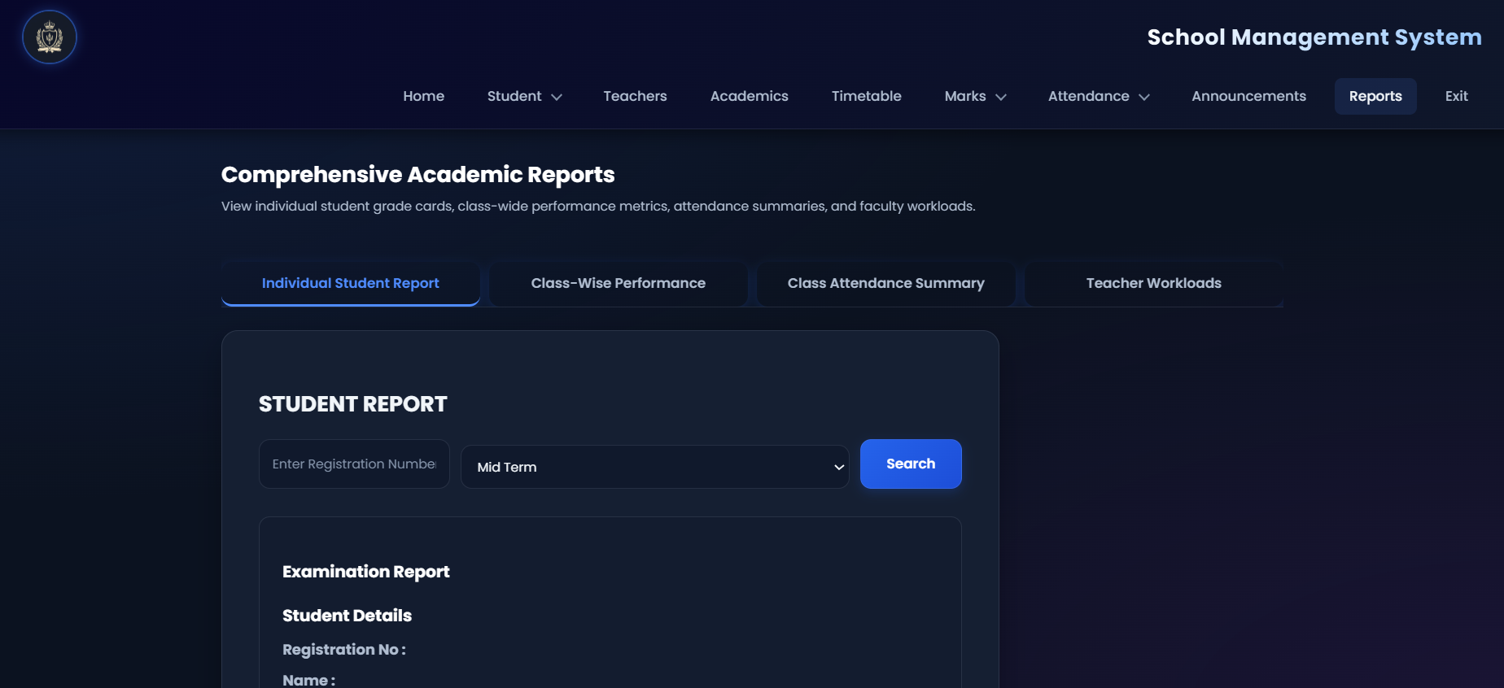
4.6 Teacher, Class, Timetable and Announcement Screens
Teacher management: the administrator can add, view, search, and edit teacher profiles and set the status to Active, Inactive, or Suspended.
Classes, subjects and assignments: classes and the five core subjects are maintained here, and teachers are assigned to class and subject pairs. Duplicate assignments are rejected.
Timetable: weekly slots are scheduled by class, subject, teacher, day, time, and room. A slot that overlaps an existing slot of the same class or the same teacher is rejected.
Announcements: administrators publish notices with a priority (Urgent, High, Normal, Low) and a target audience (All, Teachers, Students).
Teacher dashboard: a logged-in teacher sees the assigned classes and subjects, the students of those classes, the weekly schedule, and can record subject attendance and marks only for the assigned pairs.

5. Database Design :
5.1 Introduction:
Database design is an important component of the School Management System because the application manages different types of interconnected information related to administrators, students, teachers, classes, subjects, attendance, examination marks, timetables, reports, and announcements.
The database is designed using the relational database model, in which information is stored in tables consisting of rows and columns. Each table represents a particular entity or relationship in the system. Primary keys are used to uniquely identify records, while foreign keys establish relationships between related tables. Appropriate constraints help maintain data integrity and prevent invalid or inconsistent information.
The Entity-Relationship (ER) diagram represents the entities, their attributes, primary keys, foreign keys, and relationships within the School Management System. The ER model is converted into relational tables that can be implemented using PostgreSQL. The database design also includes a normalized structure for subject-wise marks, an archive for legacy marks, and relationships connecting academic records to the corresponding students, subjects, teachers, and classes.
The main objectives of the database design are to reduce unnecessary data redundancy, maintain referential integrity, support efficient data retrieval, and provide a reliable foundation for the application's administrative and academic operations.

5.2 Entity-Relationship:
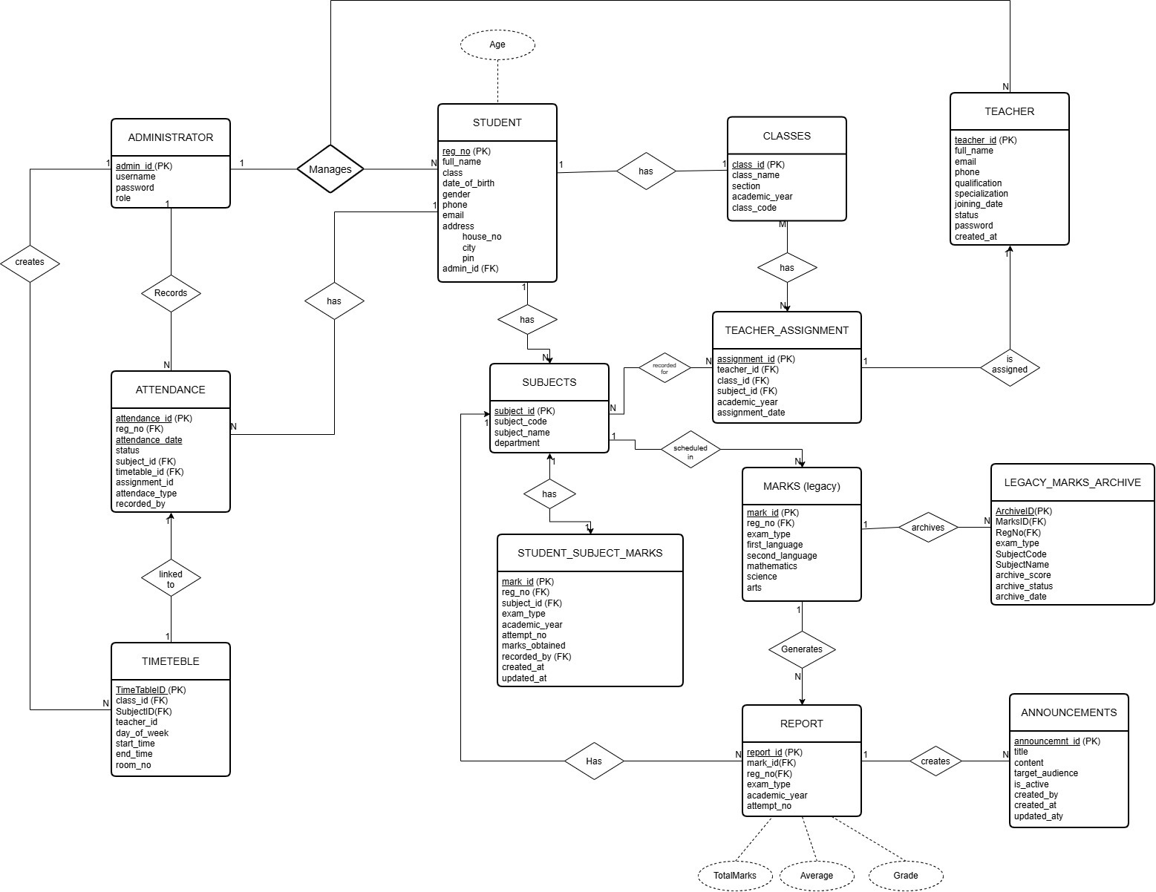
The ER diagram illustrates the structure of the School Management System database and the relationships among its entities. It contains thirteen entities: administrator, student, classes, teacher, attendance, subjects, teacher_assignment, timetable, student_subject_marks, marks (legacy), legacy_marks_archive, report, and announcements. Derived attributes are drawn with dashed ellipses: Age (derived from date_of_birth) on student, and TotalMarks, Average, and Grade on report. The address of a student is a composite attribute made of house_no, city, and pin.
The administrator entity maintains login information and manages student and teacher records. The student entity stores student details and is related to attendance, subject-wise marks, legacy marks, and report records through reg_no. The teacher entity stores teacher information, while teacher_assignment associates teachers with the classes and subjects they teach. The timetable entity schedules a class, a subject, and a teacher in a time slot.
The subjects entity stores academic subjects. The student_subject_marks entity maintains subject-wise examination marks, while marks (legacy) represents the older one-row-per-examination structure and legacy_marks_archive preserves archived values. The attendance and timetable entities maintain attendance and scheduling information, the report entity identifies each examination sitting of a student, and the announcements entity stores school notices.
Primary key (PK) and foreign key (FK) labels identify record identifiers and relationships, and the cardinality of each relationship is written as 1 or N beside it. Unique, NOT NULL, and CHECK constraints are defined in the SQL schema and are described in Section 5.7.

5.3 Entities and Attributes:
5.3.1 Administrator:
The administrator entity stores information required for administrator authentication and access management. It contains the attributes admin_id, username, password, and role. The admin_id attribute is the primary key, while username is unique. The password attribute stores a bcrypt hash and never the plain password, and the role attribute identifies the administrator's role in the system.
The student entity holds admin_id as a foreign key identifying the administrator who manages the record, and administrators also manage teacher records.
5.3.2 Student:
The student entity maintains information about students registered in the institution. Its attributes include reg_no, full_name, class, date_of_birth, gender, phone, email, address (house_no, city, pin), and admin_id. The reg_no attribute is the primary key, email is unique, and admin_id is a foreign key to the administrator entity. Age is a derived attribute calculated from date_of_birth and is not stored.
The class attribute stores the class label (for example '9 A') that corresponds to a record in the classes entity, and the application maps the label to the registered class. Students are associated with attendance, subject-wise marks, legacy marks, and report records through reg_no.
5.3.3 Classes:
The classes entity stores information about the classes offered by the institution. Its attributes include class_id, class_name, section, academic_year, and class_code. The class_id attribute is the primary key, and class_code is unique.
The classes entity is related to the student entity (one class has many students), the teacher_assignment entity, and the timetable entity. These relationships allow students to be associated with their classes, teachers to be assigned to particular classes and subjects, and timetable slots to be scheduled for each class.
5.3.4 Teacher:
The teacher entity stores information about the teachers working in the institution. Its attributes include teacher_id, full_name, email, phone, qualification, specialization, joining_date, status, password, and created_at. The teacher_id attribute is the primary key, email is unique, and password stores a bcrypt hash.
The status attribute represents the teacher's employment status and is restricted to Active, Inactive, or Suspended. One teacher can have many assignments and many timetable slots, so the teacher entity is connected to the teacher_assignment and timetable entities.
5.3.5 Attendance:
The attendance entity maintains student attendance information. Its attributes include attendance_id, reg_no, attendance_date, status, subject_id, timetable_id, assignment_id, attendance_type, and recorded_by. The attendance_id attribute is the primary key.
The reg_no attribute references the student entity, while subject_id, timetable_id, and assignment_id (used for Subject attendance) reference the subjects, timetable, and teacher_assignment entities. The status attribute is restricted to Present or Absent, and attendance_type distinguishes General attendance from Subject attendance. The recorded_by attribute stores the identifier of the user who recorded the entry. Partial unique indexes prevent duplicate General daily, Subject daily, and Subject period records.
This entity allows the system to maintain attendance records and retrieve attendance information for individual students, dates, subjects, and relevant assignments.
5.3.6 Subjects:
The subjects entity stores information about the subjects offered by the institution. Its attributes include subject_id, subject_code, subject_name, and department. The subject_id attribute is the primary key, while subject_code is unique. The core curriculum has five subjects: FL101 First Language, SL102 Second Language, MTH103 Mathematics, SCI104 Science, and ART105 Arts.
The subjects entity is associated with teacher_assignment, timetable, student_subject_marks, and the legacy marks structure. These relationships connect subjects with the teachers who teach them, the scheduled classes, and the examination records of students.
5.3.7 Teacher Assignment:
The teacher_assignment entity represents the assignment of teachers to classes and subjects. Its attributes include assignment_id, teacher_id, class_id, subject_id, academic_year, and assignment_date. The assignment_id attribute is the primary key.
The teacher_id, class_id, and subject_id attributes are foreign keys that connect the assignment to the teacher, classes, and subjects entities. The academic_year attribute identifies the academic year for the assignment, while assignment_date stores the assignment date.
This entity is important because a teacher may teach different subjects or classes, and a class may have different teachers for different subjects. A unique constraint (uq_teacher_class_subject) prevents the same teacher from being assigned twice to the same class and subject.
5.3.8 Timetable:
The timetable entity stores the schedule of academic activities. Its attributes include timetable_id, class_id, subject_id, teacher_id, day_of_week, start_time, end_time, and room_no. The timetable_id attribute is the primary key.
The class_id, subject_id, and teacher_id attributes are foreign keys that associate each timetable entry with the relevant class, subject, and teacher. The day_of_week attribute identifies the scheduled day, while start_time and end_time define the duration of the scheduled activity. The room_no attribute identifies the assigned room.
The timetable entity helps organize academic schedules and supports the identification of potential scheduling conflicts involving teachers and classes.
5.3.9 Student Subject Marks:
The student_subject_marks entity stores examination marks for individual students and subjects. Its attributes include mark_id, reg_no, subject_id, exam_type, academic_year, attempt_no, marks_obtained, recorded_by, created_at, and updated_at. The mark_id attribute is the primary key.
The reg_no and subject_id attributes are foreign keys that associate the marks record with the relevant student and subject. The exam_type attribute identifies the type of examination, while academic_year and attempt_no provide information about the academic period and examination attempt. The marks_obtained attribute stores the marks obtained by the student.
This structure supports maintaining separate records for different subjects, examinations, and attempts. A composite unique constraint on (reg_no, subject_id, exam_type, academic_year, attempt_no) prevents duplicate marks for the same sitting, and marks_obtained is restricted by a CHECK constraint to the range 0 to 100. The recorded_by attribute identifies the user who entered the marks.
5.3.10 Marks (Legacy):
The marks (legacy) entity represents the older structure used to maintain examination marks. Its attributes include mark_id, reg_no, exam_type, first_language, second_language, mathematics, science, and arts. The mark_id attribute is the primary key, and reg_no is a foreign key referencing the student entity. The former 'others' column has been retired and its historical values are preserved in legacy_marks_archive.
In this structure, marks for several subjects are stored as separate attributes within a single record. The updated design introduces the student_subject_marks entity to represent subject-wise marks in separate records. The legacy marks structure is retained in the ER diagram to represent the previous format and its relationship with the archival mechanism.
5.3.11 Legacy Marks Archive:
The legacy_marks_archive entity stores archived information associated with the older marks structure. Its attributes include archive_id, original_mark_id, reg_no, exam_type, subject_code, subject_name, archived_score, archive_status, and archive_date. The archive_id attribute is the primary key.
The original_mark_id attribute references the corresponding legacy marks record, while reg_no connects the archived information to the relevant student. The remaining attributes identify the examination, subject, archived score, archival status, and date of archiving.
This entity supports the preservation of historical examination information during changes to the database structure. It allows legacy information to be retained separately from the normalized subject-wise marks structure.
5.3.12 Report:
The report entity maintains information associated with academic reports. Its attributes include report_id, mark_id, reg_no, exam_type, academic_year, and attempt_no. The report_id attribute is the primary key.
The mark_id and reg_no attributes are foreign keys referencing the marks and student information shown in the ER diagram. The remaining attributes identify the examination, academic year, and attempt associated with the report.
Each report row identifies one examination sitting of a student, and the combination (reg_no, exam_type, academic_year, attempt_no) is unique. TotalMarks, Average, and Grade are derived attributes: they are not stored but computed from student_subject_marks by the student_reports view, with the average taken over the five core subjects (total marks divided by 5.0).
5.3.13 Announcements:
The announcements entity stores notices published through the School Management System. Its attributes include announcement_id, title, content, target_audience, priority, is_active, created_by, created_at, and updated_at. The announcement_id attribute is the primary key.
The title attribute stores the announcement heading, while content contains the details. The target_audience attribute specifies the intended audience: All, Teachers, or Students. The priority attribute is restricted to Urgent, High, Normal, or Low, and is_active indicates whether an announcement is displayed. The created_by attribute identifies the administrator who published it, and created_at and updated_at store the timestamps.
This entity allows announcements to be maintained in a structured format and displayed to the intended users of the application.

5.4 Relational Schema:
The relational schema represents each entity in the ER diagram as a table with defined attributes and key constraints.
- ADMINISTRATOR (admin_id, username, password, role)
- STUDENT (reg_no, full_name, class, date_of_birth, gender, phone, email, house_no, city, pin, admin_id)
- CLASSES (class_id, class_name, section, academic_year, class_code)
- TEACHER (teacher_id, full_name, email, phone, qualification, specialization, joining_date, status, password, created_at)
- SUBJECTS (subject_id, subject_code, subject_name, department)
- TEACHER_ASSIGNMENT (assignment_id, teacher_id, class_id, subject_id, academic_year, assignment_date)
- ATTENDANCE (attendance_id, reg_no, attendance_date, status, subject_id, timetable_id, assignment_id, attendance_type, recorded_by)
- TIMETABLE (timetable_id, class_id, subject_id, teacher_id, day_of_week, start_time, end_time, room_no)
- STUDENT_SUBJECT_MARKS (mark_id, reg_no, subject_id, exam_type, academic_year, attempt_no, marks_obtained, recorded_by, created_at, updated_at)
- MARKS_LEGACY (mark_id, reg_no, exam_type, first_language, second_language, mathematics, science, arts)
- LEGACY_MARKS_ARCHIVE (archive_id, original_mark_id, reg_no, exam_type, subject_code, subject_name, archived_score, archive_status, archive_date)
- REPORT (report_id, mark_id, reg_no, exam_type, academic_year, attempt_no)
- ANNOUNCEMENTS (announcement_id, title, content, target_audience, priority, is_active, created_by, created_at, updated_at)

Table Name | Primary Key (PK) | Foreign Key (FK)
administrator | admin_id | —
student | reg_no | admin_id
classes | class_id | —
teacher | teacher_id | —
subjects | subject_id | —
teacher_assignment | assignment_id | teacher_id, class_id, subject_id
attendance | attendance_id | reg_no, subject_id, timetable_id, assignment_id, recorded_by
timetable | timetable_id | class_id, subject_id, teacher_id
student_subject_marks | mark_id | reg_no, subject_id, recorded_by
marks (legacy) | mark_id | reg_no
legacy_marks_archive | archive_id | original_mark_id, reg_no
report | report_id | mark_id, reg_no
announcements | announcement_id | created_by

5.5 Relationships and Cardinalities:
The relationships between the entities establish how information is connected across the database.
Administrator, Student and Teacher: one administrator manages many students (1:N through student.admin_id) and also manages teacher records.
Classes and Student: one class has many students (1:N). Each student belongs to one class, recorded as the class label in the student record.
Student and Attendance: one student has many attendance records (1:N), and each attendance record belongs to one student.
Student, Subjects and Subject-Wise Marks: one student has many marks records (1:N) and one subject has many marks records (1:N). The student_subject_marks table therefore resolves the many-to-many relationship between students and subjects.
Teacher, Classes, Subjects and Assignment: the teacher_assignment entity connects teachers with classes and subjects. One teacher, one class, and one subject can each appear in many assignments (1:N each), and the combination of teacher, class, and subject is unique.
Classes, Subjects, Teachers and Timetable: a class, a subject, and a teacher can each appear in many timetable entries (1:N each). Each timetable entry belongs to exactly one class, one subject, and one teacher.
Timetable and Attendance: one timetable period can have many attendance records (1:N). The timetable reference is optional and is used for period-level Subject attendance.
Marks and Legacy Marks Archive: one legacy marks record can have many archive rows (1:N), which preserves historical examination values after the change in marks structure.
Student, Marks and Report: one student has many report rows (1:N), one for each examination sitting, and each report row is linked to the marks information of that sitting.
Announcements: an administrator can publish many announcements (1:N through created_by), and each announcement stores its target audience and priority.
These relationships help organize the school's academic information and allow the application to retrieve related records through SQL queries.
5.6 Primary Keys and Foreign Keys:
Primary keys and foreign keys are used to identify records and establish relationships between tables. Each primary key uniquely identifies a record within its table. For example, admin_id identifies an administrator, reg_no identifies a student, teacher_id identifies a teacher, and subject_id identifies a subject.
Foreign keys connect related tables. The admin_id attribute in the student table connects students with administrators. The teacher_id, class_id, and subject_id attributes in teacher_assignment connect the assignment with the appropriate teacher, class, and subject. Similarly, timetable records refer to classes, subjects, and teachers through their corresponding identifiers.
The attendance table references student and academic scheduling information, while student_subject_marks references students and subjects. The legacy_marks_archive table preserves references to original legacy marks records and students. The report table connects report information to students and marks.
These keys support referential integrity and help prevent relationships from referring to nonexistent records. They also make it easier to retrieve related information using joins.
5.7 Constraints and Data Integrity:
Constraints are used to maintain the correctness and consistency of information stored in the database.
Primary Key Constraint: Every table has a primary key that uniquely identifies its records.
Foreign Key Constraint: Foreign keys establish valid relationships between related entities and help prevent references to nonexistent records.
Unique Constraint: username in administrator; email in student and teacher; subject_code in subjects; class_code in classes; the composite key (reg_no, subject_id, exam_type, academic_year, attempt_no) in student_subject_marks; (reg_no, exam_type, academic_year, attempt_no) in report; and uq_teacher_class_subject in teacher_assignment.
NOT NULL Constraint: mandatory attributes such as identifiers, names, dates, and status values are declared NOT NULL, while subject_id, timetable_id, and assignment_id in attendance are nullable because General attendance has no subject.
Check Constraints: marks_obtained must lie between 0 and 100; attendance status is limited to Present or Absent; attendance_type to General or Subject; teacher status to Active, Inactive, or Suspended; and announcement priority and target audience to their permitted values.
Attendance Constraints: three partial unique indexes prevent duplicate General daily records, duplicate Subject daily records, and duplicate Subject period records for the same student.
Teacher Assignment Constraints: the constraint uq_teacher_class_subject prevents the same teacher from being assigned to the same class and subject more than once.
Timetable Validation: before a slot is saved, the backend rejects any slot that overlaps an existing slot of the same class or the same teacher, using the condition start_A < end_B AND end_A > start_B.
Archival Integrity: legacy_marks_archive references the original legacy mark and the student, so historical values, including the retired 'others' marks, remain linked to the student.
Deletion Safety: the backend refuses to delete a student who still has marks, attendance, or report records, and a teacher who still has assignments or timetable slots.
These constraints reduce the risk of inconsistent data and support the reliable operation of the School Management System.
5.8 Functional Dependencies:
A functional dependency represents a relationship in which one attribute or a group of attributes determines another attribute or group of attributes. It is written as X → Y, where X determines Y.
In the administrator entity, admin_id determines the other administrator attributes:
admin_id → username, password, role
In the student entity, reg_no determines the student information:
reg_no → full_name, class, date_of_birth, gender, phone, email, address, admin_id
In the teacher entity, teacher_id determines the teacher details:
teacher_id → full_name, email, phone, qualification, specialization, joining_date, status, password, created_at
In the classes entity, class_id determines the class attributes:
class_id → class_name, section, academic_year, class_code
In the subjects entity, subject_id determines the subject details:
subject_id → subject_code, subject_name, department
In the teacher_assignment entity, assignment_id determines the teacher, class, subject, academic year, and assignment date:
assignment_id → teacher_id, class_id, subject_id, academic_year, assignment_date
In the timetable entity, timetable_id determines the timetable attributes:
timetable_id → class_id, subject_id, teacher_id, day_of_week, start_time, end_time, room_no
In the student_subject_marks entity, mark_id determines the attributes of a marks record:
mark_id → reg_no, subject_id, exam_type, academic_year, attempt_no, marks_obtained, recorded_by, created_at, updated_at
In the attendance entity, attendance_id determines all other attributes:
attendance_id → reg_no, attendance_date, status, subject_id, timetable_id, assignment_id, attendance_type, recorded_by
In the legacy marks, archive, report, and announcements entities, the primary keys determine the remaining attributes:
mark_id → reg_no, exam_type, first_language, second_language, mathematics, science, arts
archive_id → original_mark_id, reg_no, exam_type, subject_code, subject_name, archived_score, archive_status, archive_date
report_id → mark_id, reg_no, exam_type, academic_year, attempt_no
announcement_id → title, content, target_audience, priority, is_active, created_by, created_at, updated_at
The unique constraints give additional candidate keys, and each also acts as a determinant:
username → admin_id, password, role
email → teacher_id, full_name, phone, qualification, specialization, joining_date, status, password, created_at
subject_code → subject_id, subject_name, department
class_code → class_id, class_name, section, academic_year
(reg_no, subject_id, exam_type, academic_year, attempt_no) → mark_id, marks_obtained
(reg_no, exam_type, academic_year, attempt_no) → report_id
(teacher_id, class_id, subject_id) → assignment_id
In every dependency listed above the determinant is a primary key or a candidate (unique) key. Two further dependencies exist outside these keys: timetable_id and assignment_id each determine subject_id, and the class label in student corresponds to a class record. These are examined in Section 5.9.
5.9 Normalization:
Normalization is the process of organizing data into relational tables to minimize unnecessary redundancy and prevent insertion, update, and deletion anomalies. The School Management System uses separate entities for administrators, students, teachers, classes, subjects, assignments, attendance, marks, timetables, and announcements.
First Normal Form (1NF):
A table satisfies First Normal Form when its attributes contain single values and repeating groups are eliminated. All tables hold atomic values. The composite address of a student is stored in separate columns (house_no, city, pin), and the subject-wise student_subject_marks table replaces the legacy structure in which six subject columns were held in one row.
Second Normal Form (2NF):
A table satisfies Second Normal Form when it is in 1NF and every non-key attribute depends on the whole of each candidate key. Every table has a single-column primary key, so no partial dependency on that key is possible. For the composite candidate keys, such as (reg_no, subject_id, exam_type, academic_year, attempt_no) in student_subject_marks, the attribute marks_obtained depends on the whole key and not on any subset of it. All tables are therefore in 2NF.
Third Normal Form (3NF):
A table satisfies Third Normal Form when it is in 2NF and non-key attributes do not depend transitively on a candidate key. Teacher details, class details, and subject details are stored once in their own tables and are referenced by identifiers in the assignment, timetable, and marks tables, so a change such as a new teacher phone number or subject name needs a single update. Derived values (Age, TotalMarks, Average, and Grade) are not stored; they are computed by the student_reports view.
Deliberate exceptions to 3NF:
- attendance.subject_id: timetable_id and assignment_id each determine the subject, so storing subject_id as well is a transitive dependency. It is kept because General attendance has no timetable or assignment, and the partial unique indexes need subject_id directly. The backend checks that the subject agrees with the timetable and assignment before saving.
- report.reg_no and report.exam_type: these also follow from mark_id. They are kept because the report row is the canonical identifier of an examination sitting used by the student_reports view.
- student.class: the class label is stored as text, so the database does not itself enforce that it matches a record in classes. The backend maps the label to the class record, and a class_id foreign key is listed as a future enhancement.
Normalization of Marks:
The older marks structure contains separate columns for first language, second language, mathematics, science, arts, and others. The student_subject_marks entity provides a subject-wise structure in which each record represents marks associated with a student and a subject. This design supports the storage of multiple subjects and examination attempts without adding a separate column for every subject.
Legacy Marks Archive:
The legacy_marks_archive entity provides a separate structure for retaining historical information associated with the previous marks design. This helps preserve old examination information while the current system uses the subject-wise marks structure.
In summary, all tables satisfy 1NF, 2NF, and 3NF except for the deliberate exceptions listed above. Normalization reduces duplication, improves consistency, and makes database operations easier to maintain.
5.10 Summary:
The database design of the School Management System organizes school information into related entities and tables. The ER diagram provides a representation of the entities, attributes, primary keys, foreign keys, and relationships required by the application.
The database includes structures for administrator and teacher authentication, student information, classes, subjects, teacher assignments, attendance, timetables, examination marks, legacy mark archival, reports, and announcements. Primary keys, foreign keys, unique constraints, and validation rules help maintain data integrity.
The subject-wise marks structure supports a more flexible organization of academic results, while the legacy marks archive preserves historical information from the previous structure. Normalization and appropriate relational design help reduce redundancy and support reliable data retrieval.
Overall, the database provides the foundation for the application's CRUD operations, academic management functions, and report generation.

6. Database Selection & Justification:
6.1 Introduction:
The School Management System requires a database to store and manage information about students, teachers, classes, subjects, attendance, marks, timetables, and announcements. A suitable database helps maintain data accuracy, avoid duplication, and retrieve information efficiently.
6.2 Database Selection
PostgreSQL is used as the database management system for the project. It is a relational database that stores information in tables and supports relationships between tables using primary keys and foreign keys.
6.3 Justification for Selecting PostgreSQL
PostgreSQL was selected for the following reasons:
- Data integrity: Constraints help maintain accurate and consistent data.
- Relationships: Foreign keys establish relationships between students, teachers, classes, subjects, and other records.
- Security: Database permissions help control access to data.
- SQL support: It supports queries, joins, grouping, sorting, and other database operations.
- Reliability: It provides transaction support to maintain consistent data.
- Scalability: It can manage increasing amounts of school information.
6.4 Advantages in the School Management System:
PostgreSQL allows the system to store student details, manage teacher information, assign teachers to classes and subjects, record attendance and marks, maintain timetables, and generate academic reports. It also supports efficient retrieval of information through SQL queries.
6.5 Comparison with Alternatives
Feature | PostgreSQL | MySQL | SQLite | MongoDB
Data model | Relational | Relational | Relational (single file) | Document
Foreign keys and CHECK constraints | Full support | Supported (CHECK from 8.0.16) | Supported (foreign keys must be enabled) | Not enforced like SQL; validation is optional
Partial unique indexes | Yes | No | Yes | Partial indexes with different semantics
Views and joins | Yes | Yes | Yes | Joins limited to $lookup
Multi-user web use | Designed for it | Yes | Limited write concurrency | Yes

The design relies on partial unique indexes for attendance, composite unique keys for marks and reports, CHECK constraints, and views for reports. PostgreSQL supports all of these natively together with strict relational integrity, which is why it was selected over the alternatives.
6.6 Deployment
The application is deployed on Render at https://school-management-system-fc7v.onrender.com/. During development and testing the project used PostgreSQL 18.

7. Implementation:
7.1 Overview
The system follows a three-tier architecture in which browser pages call a REST API, and the API runs parameterized SQL against the PostgreSQL database.
Layer | Technology | Role
Frontend | HTML5, CSS3, vanilla JavaScript (auth.js, dbms.css) | One page per module; requests carry a JWT bearer token.
Backend | Node.js, Express.js (server.js, routes/, middleware/auth.js) | REST API, validation, role checks, and SQL execution through a pg connection pool.
Database | PostgreSQL 18 | Tables, constraints, indexes, and views defined in database/schema.sql.
Security | bcryptjs, jsonwebtoken | Password hashing (10 rounds), 8-hour tokens, requireAdmin and requireTeacher guards.
Hosting | Render | Live deployment of the web application.

7.2 Database Implementation
7.2.1 Schema scripts. The database folder contains schema.sql (the canonical schema), queries.sql (a demonstration script of SQL queries), and a migrations folder with 001_safe_schema_extensions.sql, 002_normalize_marks_and_subject_attendance.sql, and rollback_002_migration.sql.
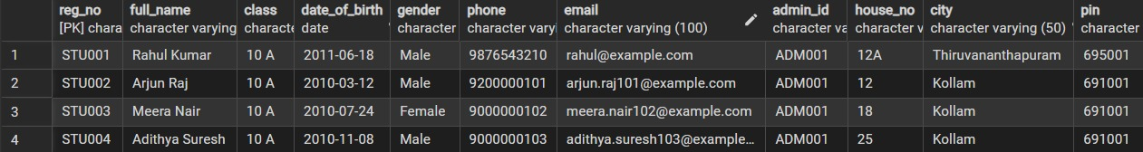
7.2.2 Constraints and indexes implemented.
- Primary keys on every table and foreign keys between related tables.
- Composite unique constraint on (reg_no, subject_id, exam_type, academic_year, attempt_no) in student_subject_marks.
- Composite unique constraint on (reg_no, exam_type, academic_year, attempt_no) for canonical report sittings.
- uq_teacher_class_subject on teacher_assignment.
- Three partial unique indexes on attendance for General daily, Subject daily, and Subject period records.
- CHECK constraints on marks range (0 to 100), attendance status, and announcement priority.
7.2.3 Views. The student_details view combines student information, and the student_reports view joins students, report sittings, and student_subject_marks to give the total marks, the average over the five core subjects (total divided by 5.0), and the grade for each sitting.
7.2.4 Data-safe migration. Migration 002 converts the one-row-per-exam marks structure into subject-wise rows, moves the retired 'others' marks into legacy_marks_archive, and marks all earlier attendance as General. The rollback script restores the previous structure without losing data.
7.3 SQL Queries Implemented
The following queries demonstrate the CRUD operations, joins, aggregation, and views of the system. Their outputs are shown in Section 9.3.
Q1. Retrieve all students (Read)
SELECT *
FROM student;
Q2. Search a student by registration number
SELECT reg_no, full_name, class
FROM student
WHERE reg_no = 'STU001';
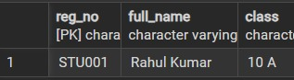
Q3. Insert a new student (Create)
INSERT INTO student (
reg_no, full_name, class, date_of_birth,
gender, phone, email, admin_id,
house_no, city, pin
)
VALUES (
'STU999', 'Test Student', '9 A',
'2012-05-10', 'Male', '9000000000',
'test.student@school.com', 'ADM001',
'10B', 'Kollam', '691001'
);
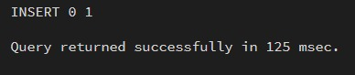
Q4. Update a student's phone number (Update)
UPDATE student
SET phone = '9111111111'
WHERE reg_no = 'STU999';
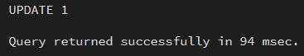
Q5. Count the students (Aggregation)
SELECT COUNT(*) AS total_students
FROM student;
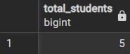
Q6. Subject-wise marks of each student (INNER JOIN)
SELECT
s.reg_no,
s.full_name,
sub.subject_name,
m.marks_obtained
FROM student s
INNER JOIN student_subject_marks m
ON s.reg_no = m.reg_no
INNER JOIN subjects sub
ON m.subject_id = sub.subject_id;
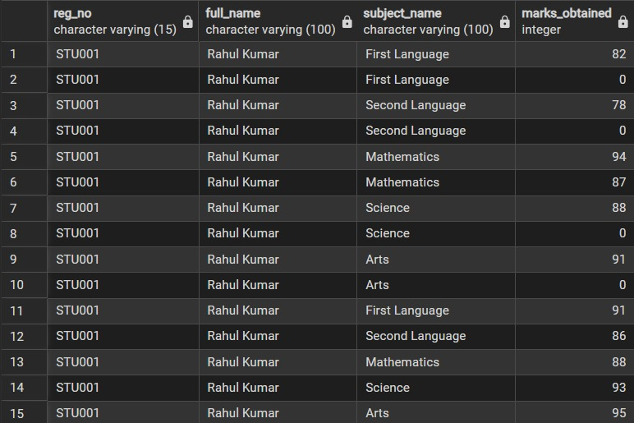
Q7. Attendance percentage of each student (GROUP BY with FILTER)
SELECT
reg_no,
ROUND(
100.0 * COUNT(*) FILTER (
WHERE status = 'Present'
) / NULLIF(COUNT(*), 0),
2
) AS attendance_percentage
FROM attendance
GROUP BY reg_no;
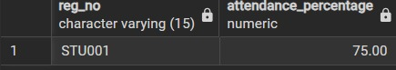
Q8. Student report cards (View)
SELECT *
FROM student_reports;
Q7 uses NULLIF to avoid division by zero for students with no attendance records. Q9 reads from the student_reports view, so the totals follow the same rule (average over five core subjects) as the individual report card.
7.4 Backend Implementation
The Express server exposes one route module for each area of the application. Every protected route first verifies the JWT and then applies a role guard, and every database call uses parameterized queries.
Route | Purpose
/api/auth | Administrator and teacher login, token issue.
/api/students | Student CRUD with dependency checks before deletion.
/api/teachers | Teacher CRUD and status management.
/api/classes, /api/subjects | Classes and the subject catalog.
/api/assignments | Teacher-to-class-and-subject assignment with duplicate prevention.
/api/timetable | Timetable slots with class and teacher conflict detection.
/api/marks | Normalized marks CRUD; teachers limited to assigned classes and subjects.
/api/attendance | General and Subject attendance with consistency checks.
/api/reports | Report cards, class performance, class attendance, teacher workloads.
/api/announcements | Notices with priority and audience.
/api/teacher-dashboard | Data scoped to the logged-in teacher.

7.5 Frontend Implementation
The frontend consists of HTML pages for each module (for example add_student.html, enter_marks.html, add_attendance.html, timetable.html, reports.html, and teacher_dashboard.html), the shared stylesheet dbms.css, and auth.js, which stores the token, attaches it to requests, and redirects users who are not permitted to open a page.

8. Testing & Validation
Testing covered three levels: SQL tests run directly against the database to check constraints and data integrity, API tests that check role-based access and business rules, and an offline automated suite (backend/test_suite.js) with 21 tests. Each test case lists the input, the expected output, the actual output observed, and the result.

8.1 Test Cases
ID | Test case and input | Expected output | Actual output | Result
TC01 | Insert a valid student (Q3, STU999) | 1 row inserted; the student appears in Q1. | Student STU999 was inserted successfully and appeared in the student query. | Passed
TC02 | Update the phone of STU999 (Q4) | 1 row updated; the new phone is returned. | observed | Passed
TC03 | Search reg_no = 'STU001' (Q2) | Exactly one matching row. | Insertion was rejected because the registration number already exists. | Passed
TC04 | Insert a student with an existing reg_no | Error: duplicate key violates the primary key. | observed | Failed
TC05 | Insert a student with an existing email | Error: unique constraint violation. | observed | Failed
TC06 | Insert marks_obtained = 150 | Error: CHECK constraint violation (0 to 100). | Insertion was rejected by the marks range constraint. | Failed
TC07 | Insert marks_obtained = -5 | Error: CHECK constraint violation. | observed | Failed
TC08 | Insert a second mark for the same student, subject, exam, year, and attempt | Error: unique violation; the same mark with the next attempt number is accepted. | observed | Passed
TC09 | Insert attendance for reg_no 'NOSUCH' | Error: foreign key violation. | Insertion was rejected because the referenced student does not exist | Failed
TC10 | Insert attendance with status 'Late' | Error: CHECK constraint violation. | observed | Failed
TC11 | Insert the same Subject attendance twice for one student, subject, and date | Error: partial unique index violation. | observed | Passed
TC12 | Insert an announcement with priority 'Critical' | Error: CHECK constraint violation. | observed | Passed
TC13 | Assign the same teacher to the same class and subject twice | Error: uq_teacher_class_subject violation. | observed | Passed
TC14 | Add a timetable slot overlapping an existing slot of the same teacher | Rejected with a conflict message. | observed | Passed
TC15 | Delete a student who has marks or attendance | Rejected; the student is not deleted. | observed | Passed
TC16 | Log in with a wrong password | Rejected with an invalid credentials message (HTTP 401). | Insertion was rejected because the referenced student does not exist | Failed
TC17 | Teacher enters marks for a subject not assigned to them | Rejected (HTTP 403). | Mark entry was rejected with HTTP 403 for an unauthorized subject. | Failed
TC18 | View the report card of a student (Q8) | Total, average (total / 5.0), and grade are shown. | observed | Passed
TC19 | Compute attendance percentage (Q7) | Matches a manual count of present days. | observed | Passed

9. Results & Screenshots
9.1 User Interface
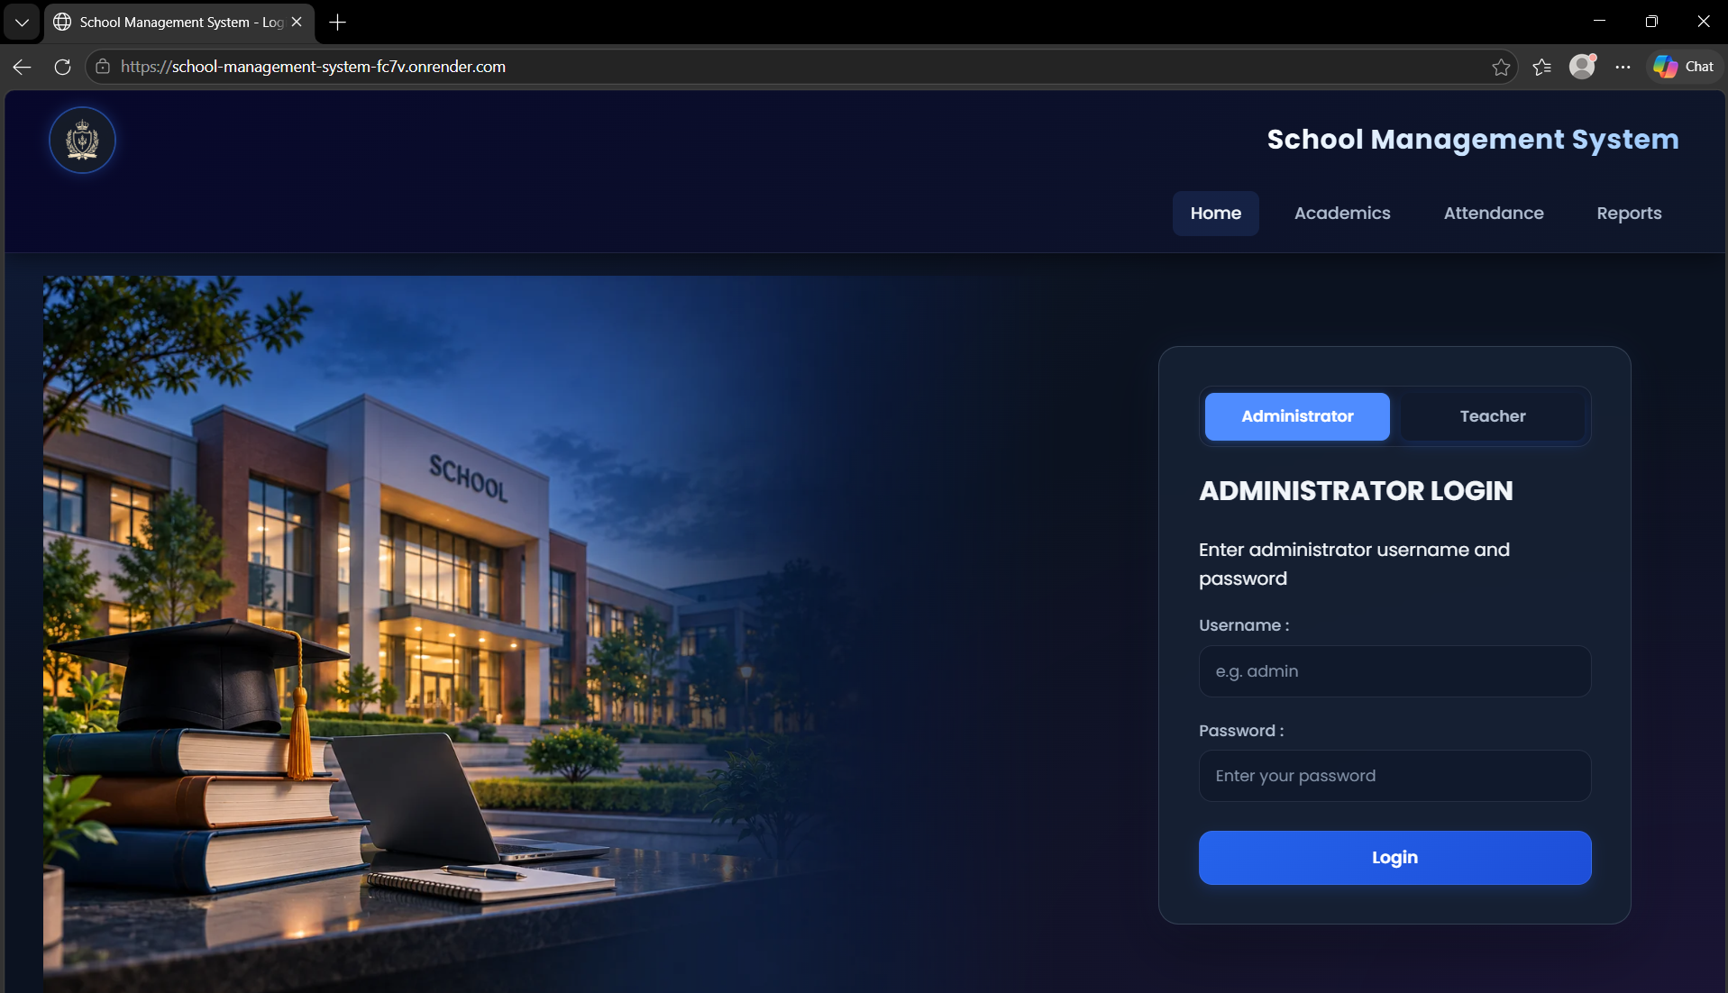 Figure 9.1: Login portal
Shows the common login page with Administrator and Teacher tabs.
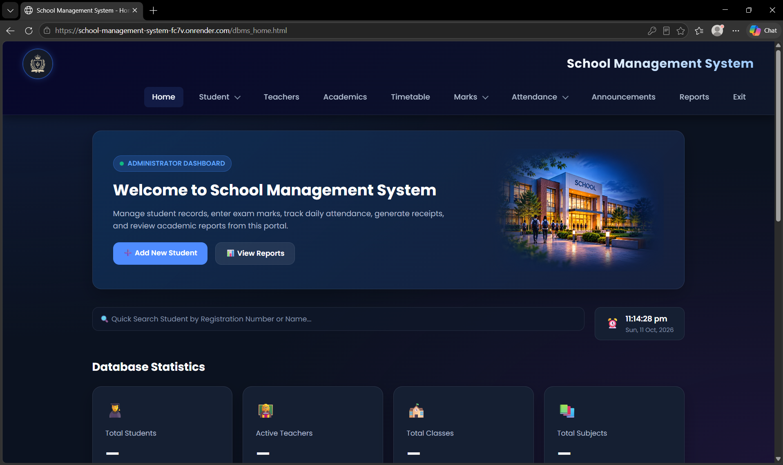
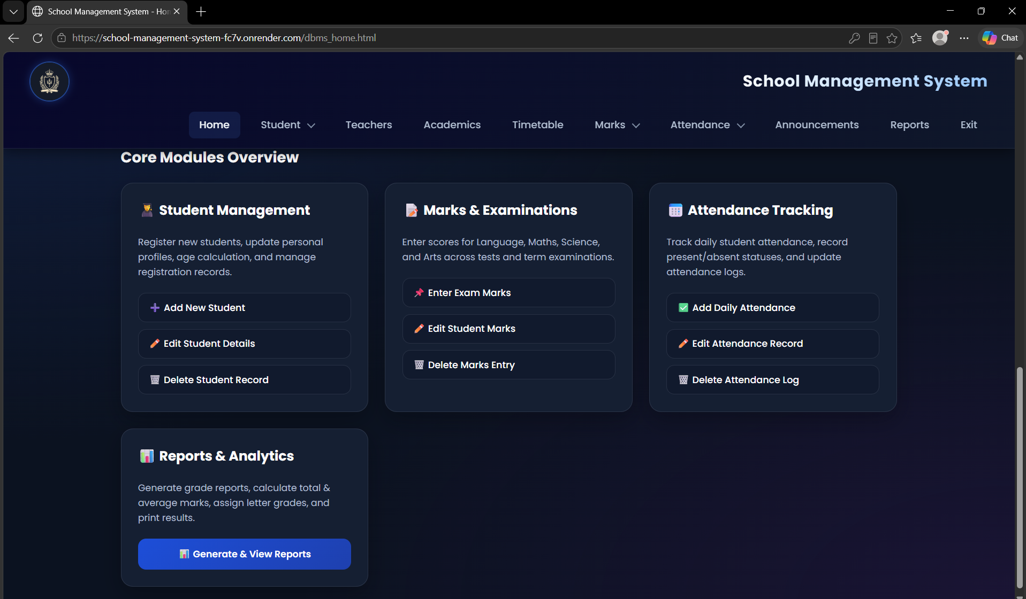
Figure 9.2: Administrator home page
Shows the dashboard and the links to every management module.
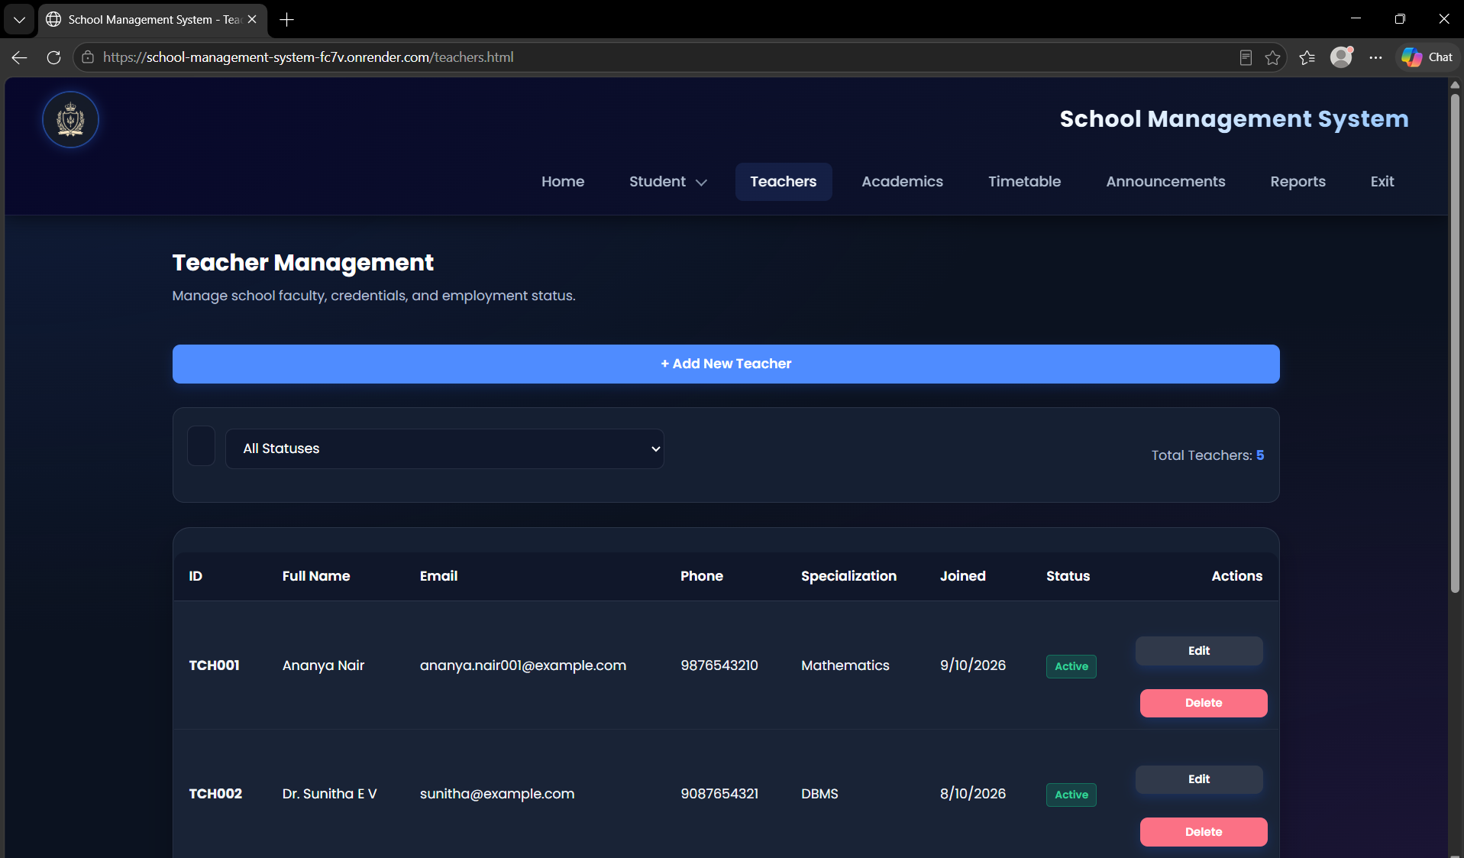 Figure 9.3: Teacher dashboard
Shows the classes, subjects, student roster, and schedule of the logged-in teacher.
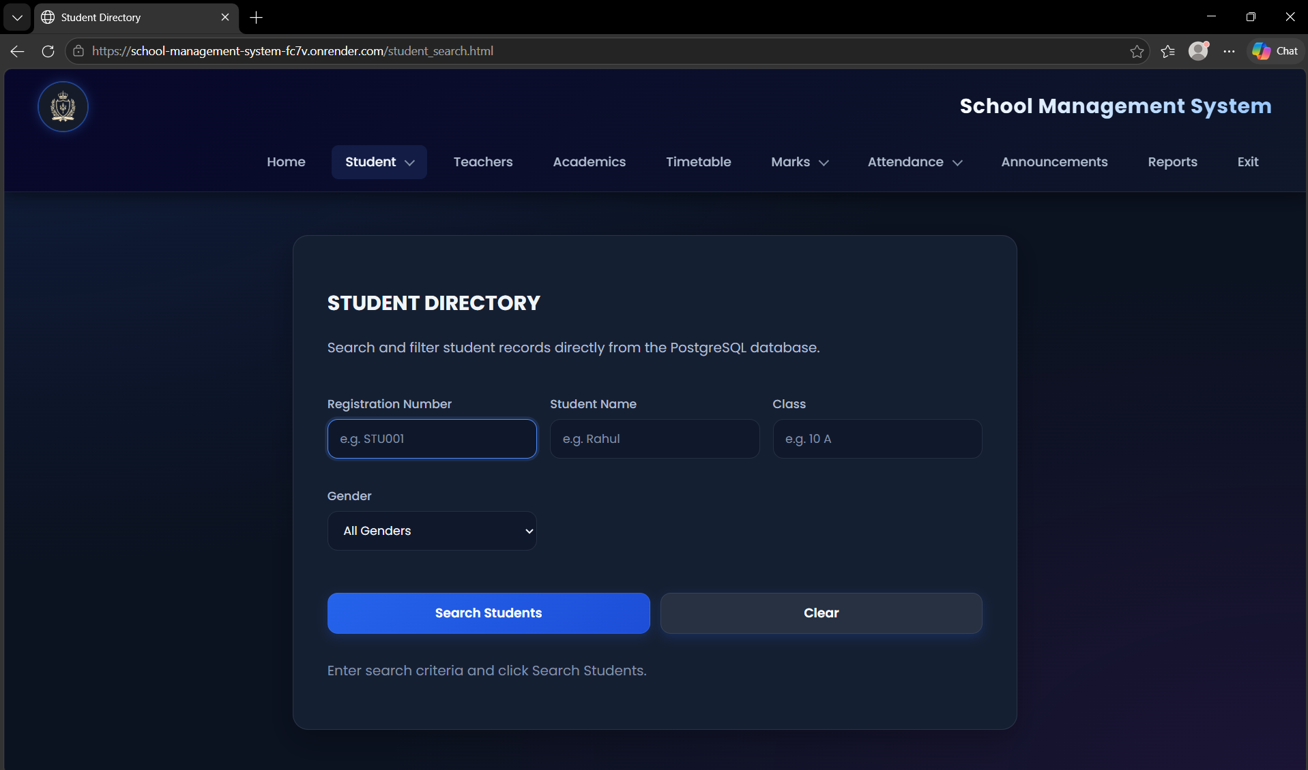
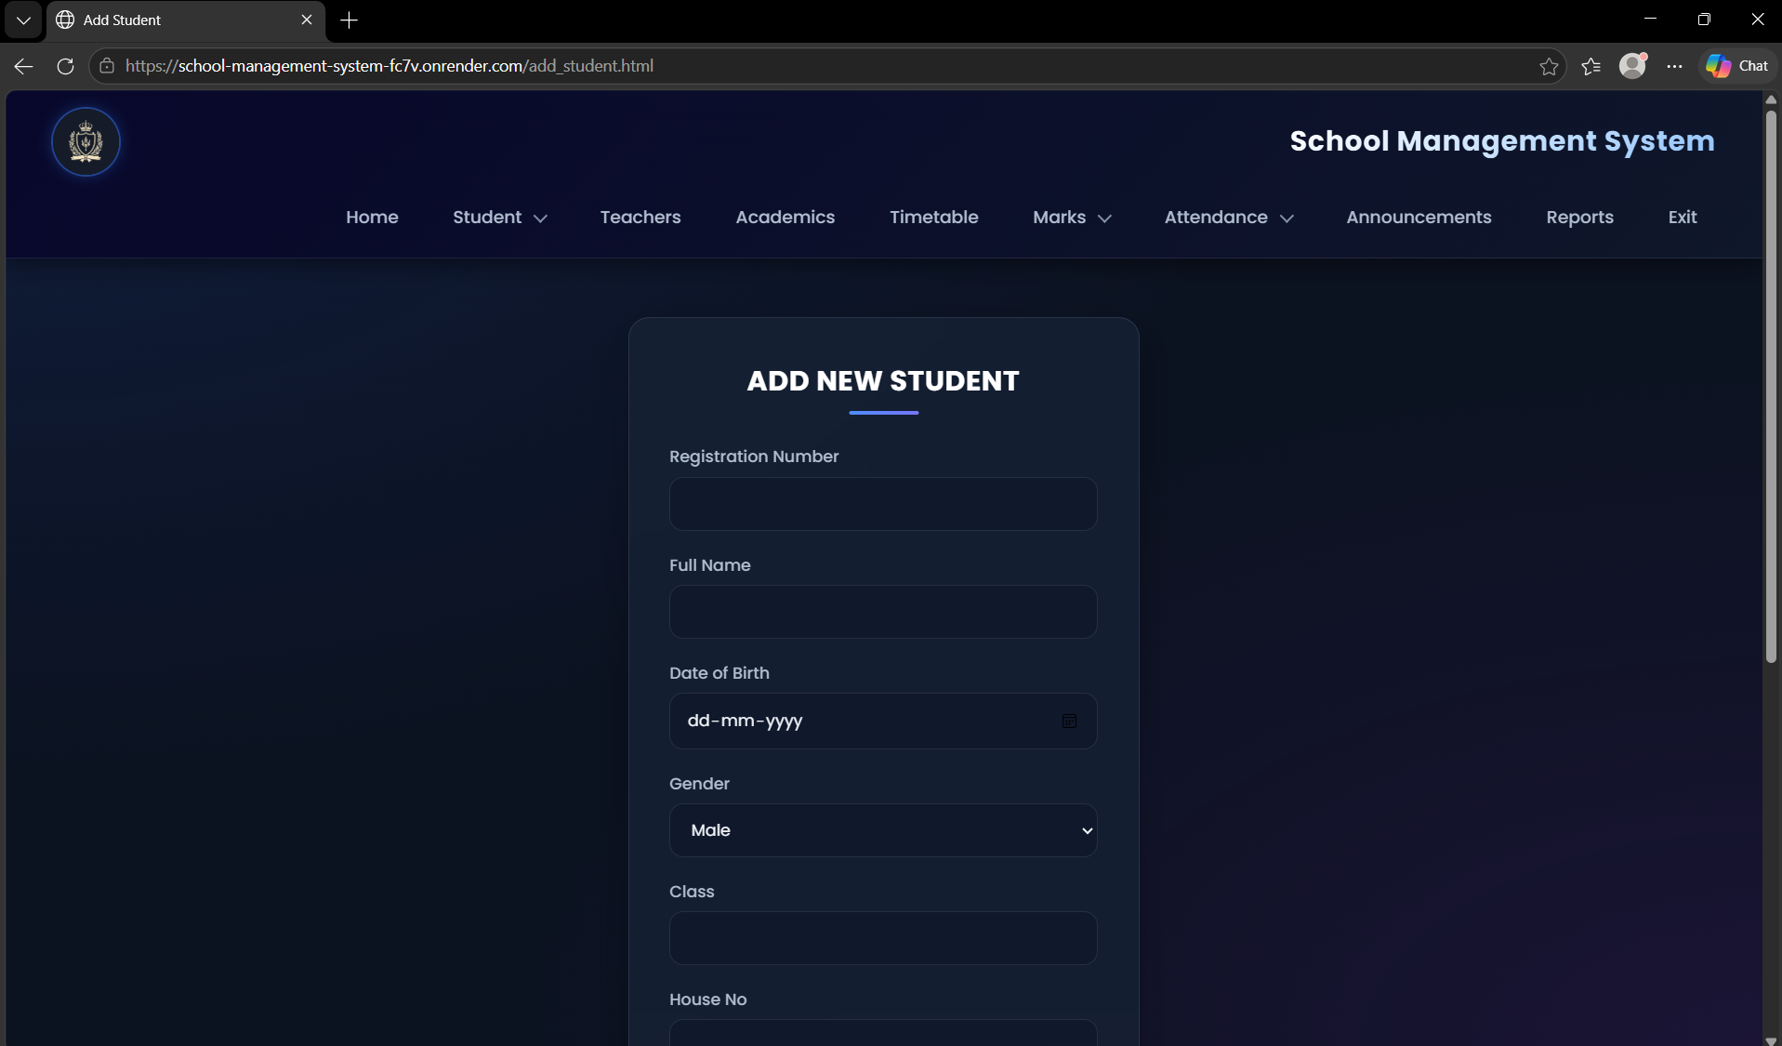
Figure 9.4: Student directory and add student form
Shows live search, class filter, and the form with house number, city, and PIN code.
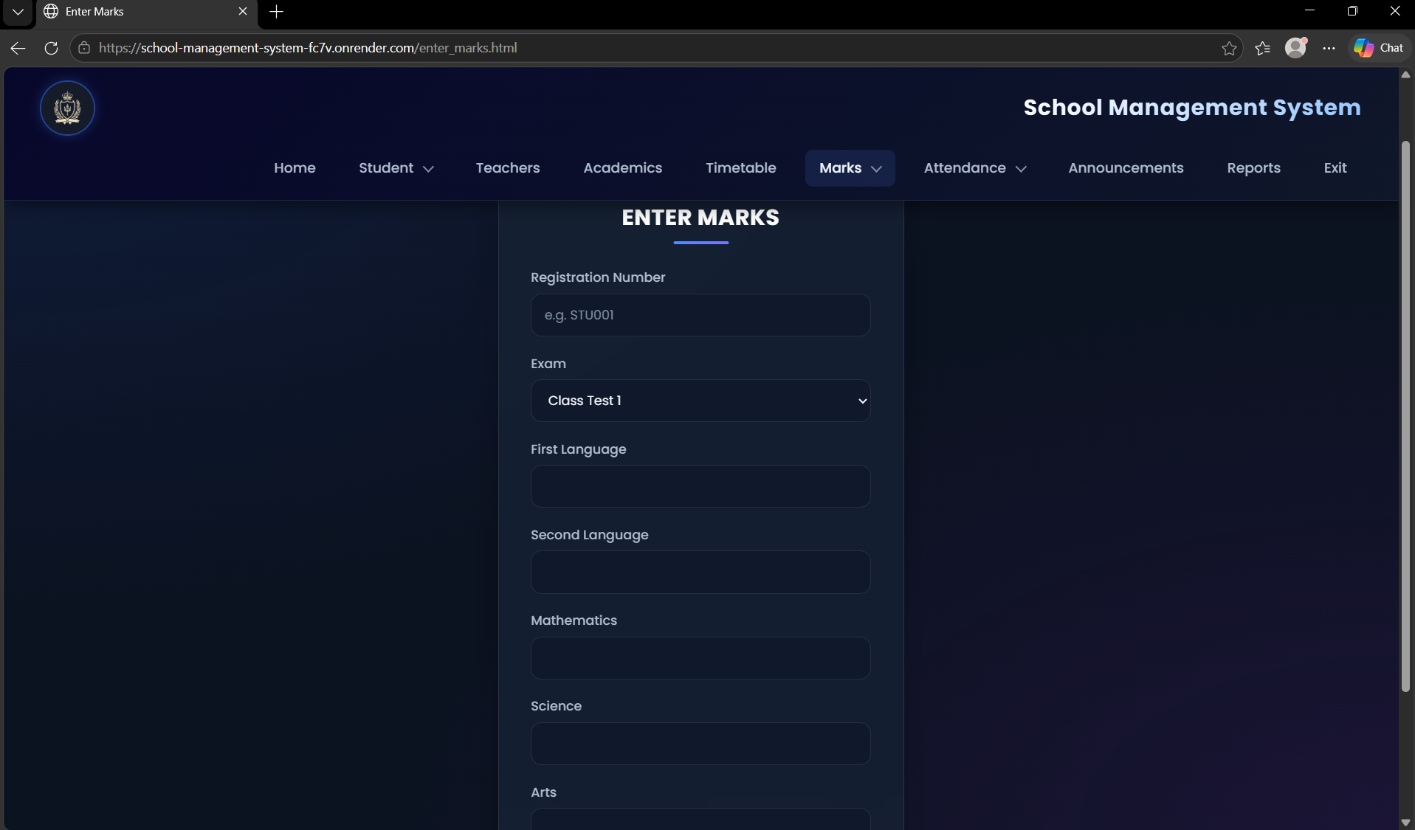 Figure 9.5: Marks entry
Shows entry of the five core subject marks for one examination sitting.
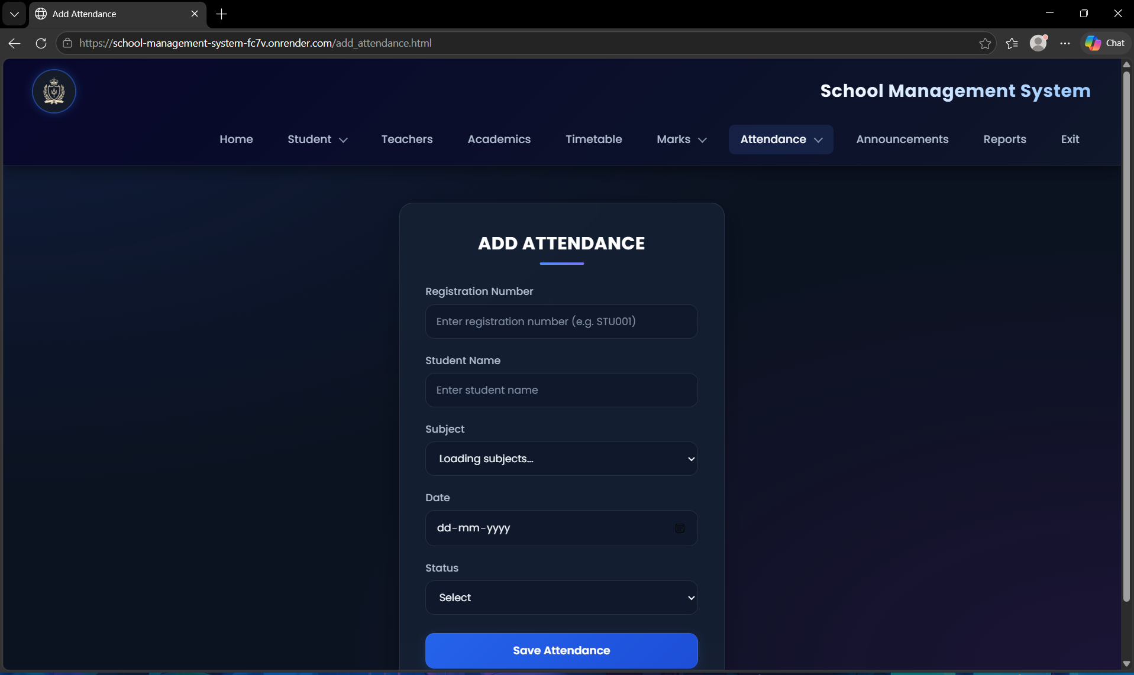 Figure 9.6: Subject attendance entry
Shows attendance recorded for a subject and date by an authorized teacher.
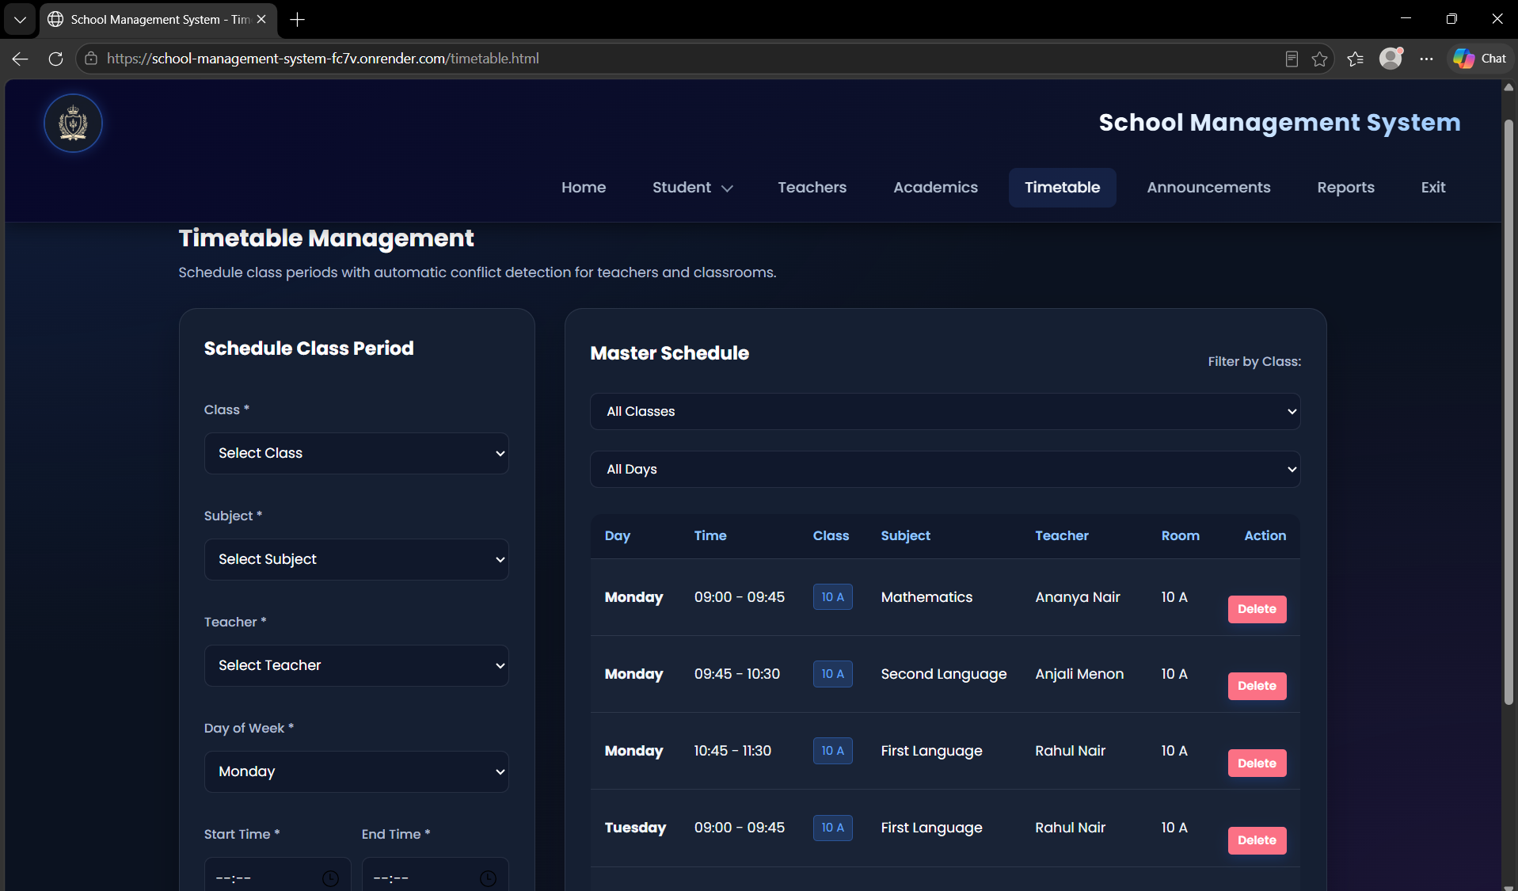 Figure 9.7: Timetable
Shows the weekly schedule and the rejection of an overlapping slot.
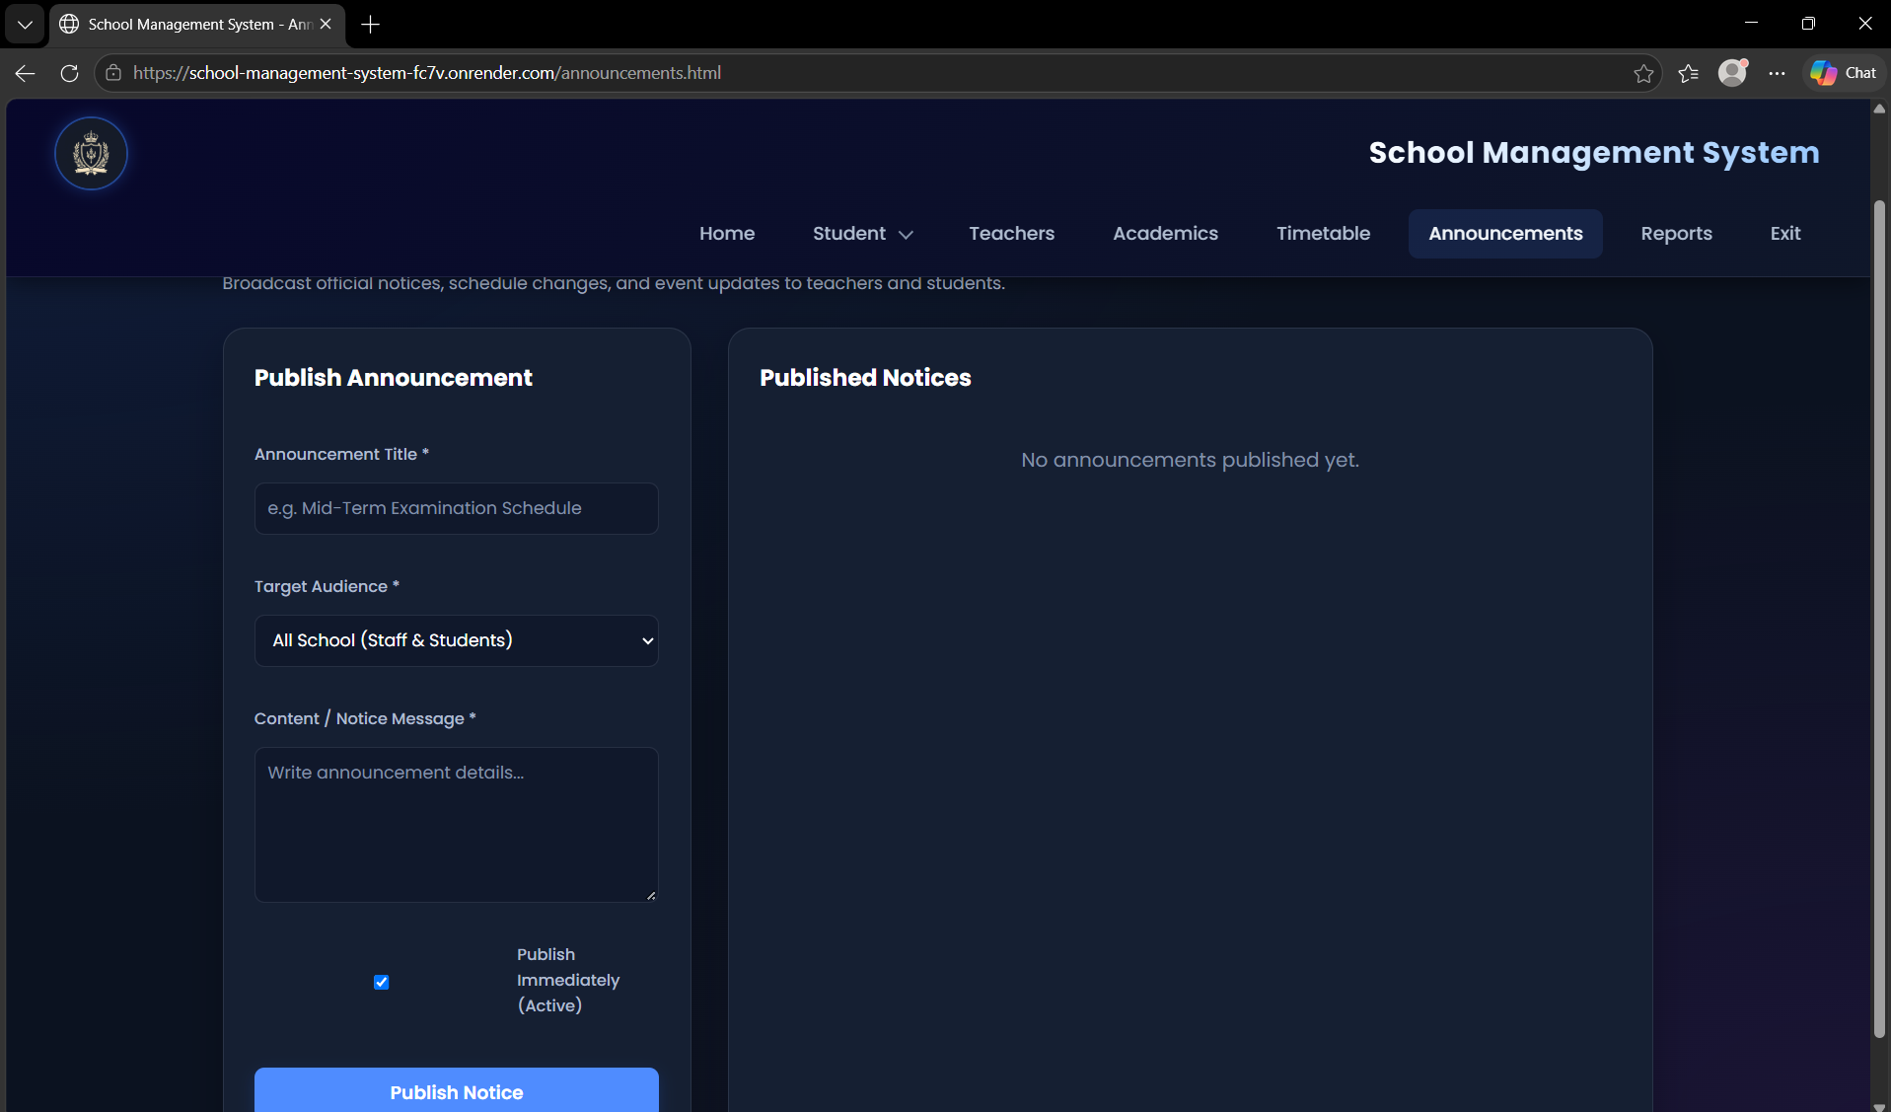 Figure 9.8: Announcements
Shows a notice with its priority and target audience.
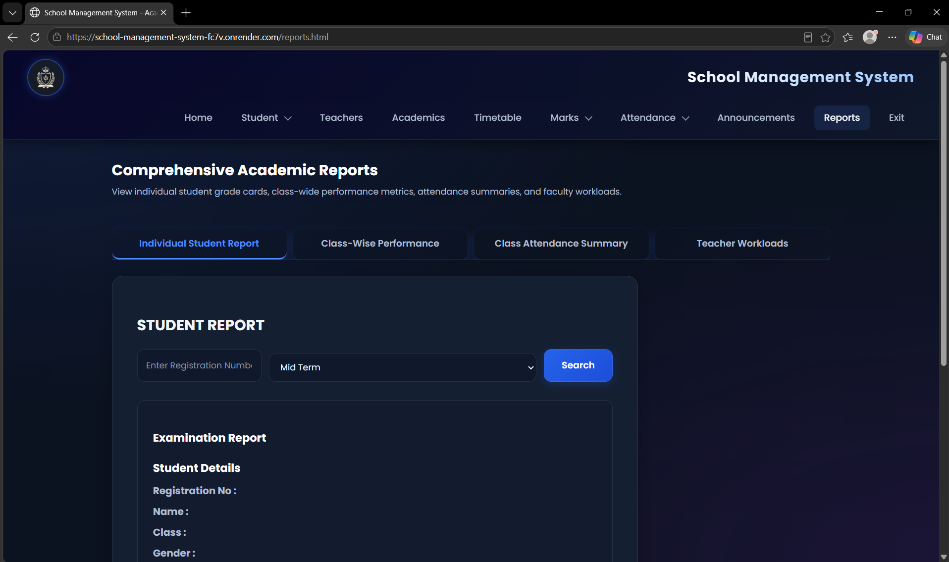 Figure 9.9: Student report card
Shows subject-wise marks, total, average, grade, and attendance summary.
9.2 SQL Query Results
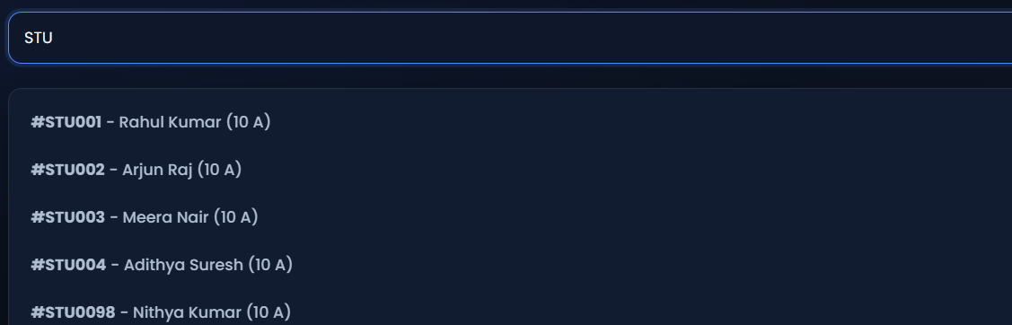Figure 9.14: Output of Q1 and Q2
Shows all students and the search by registration number.
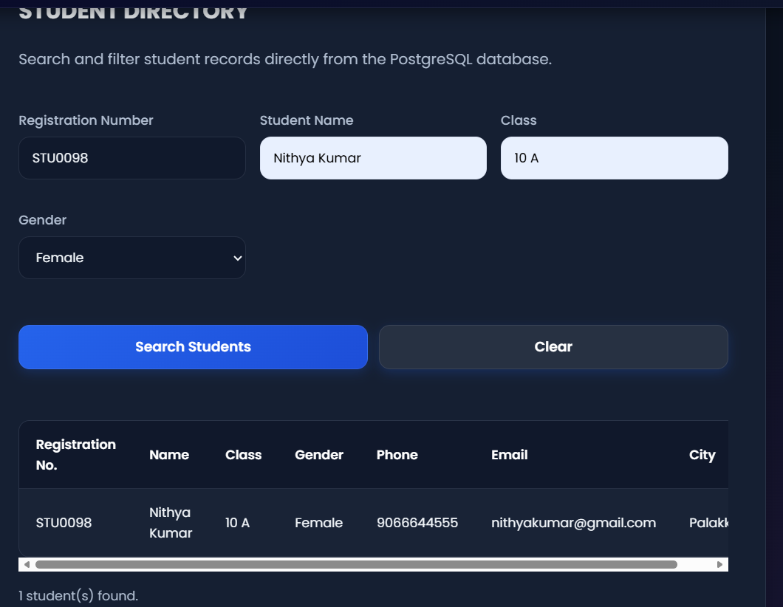Figure 9.15: Output of Q3 and Q4
Shows the insertion of student STU0098
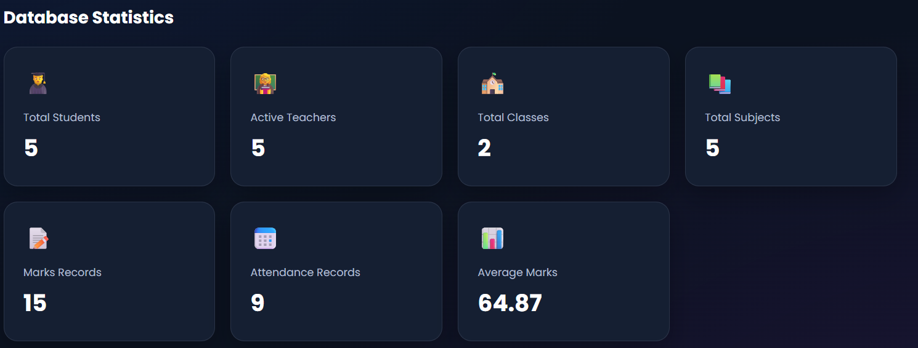Figure 9.16: Output of Q5
Shows the total number of students.
10. Challenges Faced & Solutions:
10.1 Database Design
Challenge: Designing tables for different school entities while maintaining appropriate relationships.
Solution: Separate tables were designed for students, teachers, classes, subjects, attendance, marks, and other entities. Primary and foreign keys were used to establish relationships.
10.2 Maintaining Data Consistency
Challenge: Related records must remain consistent when information is added, modified, or deleted.
Solution: Primary keys, foreign keys, unique constraints, CHECK constraints, and partial unique indexes prevent invalid references and duplicate records, and the backend refuses to delete records that other records depend on.
10.3 Frontend and Backend Integration
Challenge: Connecting the web interface to backend routes and database operations.
Solution: Node.js and Express.js provide the backend structure for handling requests, processing data, and interacting with PostgreSQL.
10.4 Record Management
Challenge: Managing the addition, retrieval, modification, and deletion of records across multiple modules.
Solution: CRUD operations are used to organize record-management functionality.
10.5 User Interface Design
Challenge: Presenting multiple management functions in a way that users can navigate easily.
Solution: Separate pages and organized navigation can make the different modules easier to access.
10.6 Migrating Marks Without Losing Data
Challenge: The original marks table stored every subject as a column, and moving to one row per subject risked losing historical values, including the retired 'others' column.
Solution: Migration 002 converts the data in one step, moves the 'others' marks into legacy_marks_archive, and a rollback script can restore the earlier structure.
10.7 Attendance Uniqueness
Challenge: A student may have one General record per day and several Subject records, so a single unique rule on student and date would reject valid rows.
Solution: Three partial unique indexes enforce uniqueness separately for General daily, Subject daily, and Subject period attendance.
10.8 Class Reference in the Student Table
Challenge: Students were first stored with the class as text, so the database cannot itself check that the class exists.
Solution: The backend maps the class label to the registered class record. Replacing the label with a class_id foreign key is listed as a future enhancement.
10.9 Teacher Authorization
Challenge: Teachers must change marks and attendance only for their own classes and subjects.
Solution: Each route checks the teacher_assignment table before saving, and role guards separate administrator and teacher functions.

11. Conclusion & Future Enhancements
11.1 Conclusion
The School Management System is designed to simplify the management of school-related information through a web-based application. It brings together important activities such as student management, teacher management, class management, subject management, attendance recording, marks management, timetable organization, announcements, and academic reporting.
The project uses HTML, CSS, and JavaScript to build the frontend, Node.js and Express.js for backend processing, and PostgreSQL for database management. Login uses bcrypt password hashing and JWT tokens with role-based access, and the use of a relational database helps organize information into related tables and maintain data consistency.
The system provides a foundation for reducing manual record-keeping, improving the organization of academic information, and making records easier to access and manage.
11.2 Future Enhancements
The system can be improved in the following ways:
- Parent portal: Allow parents to view attendance, marks, and announcements.
- Student portal: Enable students to access their academic records and timetables.
- Automated notifications: Send alerts for attendance, examinations, and announcements.
- Fee management: Add features for tracking fees and payments.
- Advanced analytics: Generate performance summaries and academic statistics.
- Referential integrity: Replace the class text in the student table with a class_id foreign key and move consistency checks such as attendance subject matching into database triggers.
- Exportable reports: Allow reports to be downloaded as PDF or Excel files.
- Account security: Add password reset and multi-factor authentication.

12. References
- PostgreSQL Global Development Group. PostgreSQL Documentation. https://www.postgresql.org/docs/
- OpenJS Foundation. Node.js Documentation. https://nodejs.org/docs/latest/api/
- Express.js. Express Documentation. https://expressjs.com/
- MDN Web Docs. HTML, CSS, and JavaScript Documentation. https://developer.mozilla.org/
- School Management System Project Repository. https://github.com/karthikeyasa/School-Managment-System
- Render. Render Documentation. https://render.com/docs
- Deployed application. https://school-management-system-fc7v.onrender.com/

