User Guide and How To Run
Devi Priya, Priyanka, Akshay and Bhaskar

User Guide and How To Run
Installing, running and using IntelliMetrics AI, with screenshots of every page
Project title | IntelliMetrics AI: A Governed Semantic Layer with TARA, an AI Assistant for Trusted Business Metrics
Document | User Guide and How To Run
Team members | Devi Priya, Priyanka, Akshay and Bhaskar
Institution | KL University
Academic year | 2026-27
Date | 26-Oct-2026 (IST)
Status | University project: academic capstone with synthetic demonstration data

Table of contents
- 1 About this guide
- 2 What you need
- 3 Run it without Docker (recommended, tested route)
  - 3.1 Step 1: back end
  - 3.2 Step 2: front end
  - 3.3 Step 3: reset the demonstration at any time
- 4 Run it with Docker Compose (tested on GitHub Actions)
- 5 Configuration
- 6 Demonstration accounts
  - 6.1 What each role can do
- 7 Tour of the application
  - 7.1 Public pages
  - 7.2 Main application
  - 7.3 Phone-sized screens
- 8 A ten-minute walkthrough
- 9 Understanding Indian conventions in the application
- 10 Troubleshooting
- 11 Running the tests

1 About this guide
IntelliMetrics AI is a university project (academic capstone) with synthetic demonstration data. This guide explains how to run it on a Windows computer, how to sign in, what each page does, and a ten-minute walkthrough that reproduces the main results. All screenshots were captured from the running application by the automated script frontend/e2e-docs/screens.spec.ts.

2 What you need
Requirement | Version used in development | Needed for
Python | 3.11 | Back end
Node.js and npm | Node 22 | Front end
A modern browser | Chrome or Edge | Using the application
Docker Desktop | not used on the development machine | Optional: the Compose route (Section 5)
Everything else (database, analytics engine, background jobs) is installed by the commands below. No internet connection is needed to run the application, except to download the packages the first time and to show the stock photographs on the public pages (a gradient is shown instead when they cannot load). No paid service, account or API key is required.

3 Run it without Docker (recommended, tested route)
This is the route that was run and tested for this report. It uses SQLite for application data and a background thread for dataset processing, so Redis and PostgreSQL are not needed.

3.1 Step 1: back end
Open PowerShell in the project folder:
cd backend
python -m venv .venv
.venv\Scripts\activate
pip install -r requirements.txt
python -m app.seed
uvicorn app.main:app --reload --port 8000
python -m app.seed creates the database and the demonstration data (about 2.7 seconds on the development machine). Leave the window open. The API documentation is at http://localhost:8000/docs and the health check at http://localhost:8000/health.

3.2 Step 2: front end
Open a second PowerShell window:
cd frontend
npm install
npm run dev
Open http://localhost:5173. The development server forwards /api requests to port 8000.

3.3 Step 3: reset the demonstration at any time
scripts\reset-demo.ps1 # Windows
./scripts/reset-demo.sh # Git Bash / Linux / macOS
This deletes the local database and uploaded files and seeds again. Stop the back end first, because Windows locks the SQLite file while it is running.

4 Run it with Docker Compose (tested on GitHub Actions)
cp .env.example .env # set SECRET_KEY and POSTGRES_PASSWORD
docker compose up --build
Open http://localhost:3000. This starts PostgreSQL, Redis, the API, a Celery worker and an Nginx front end. This path is tested automatically on GitHub (the stack is built, started and smoke-tested on every push) but was not run on the authors’ own computers, where Docker is not installed. If a step fails, the Deployment Guide has a troubleshooting table.

5 Configuration
Settings are environment variables, listed in full in the Deployment Guide. The ones a student is likely to touch:
Variable | Default | Meaning
AI_PROVIDER | none | none = TARA’s offline deterministic mode (no key needed). openai or gemini plus the matching *_API_KEY turns on live AI planning
AUTO_SEED | true in .env.example | Seeds demo data when the database is empty
USE_CELERY | false | true uses Celery and Redis for dataset processing
DATABASE_URL | local SQLite file | Use a postgresql:// URL for PostgreSQL
MAX_UPLOAD_MB | 500 | Upload size limit
If no AI key is set, every TARA screen says that it is in offline deterministic mode. It still answers all the suggested questions below, because the questions are interpreted by a rule-based planner and the numbers always come from the data.

6 Demonstration accounts
All accounts are marked DEMO, and the login page has a Demo accounts panel that fills the form when clicked.
Role | Person (fictional) | Email | Password | Company
Admin | Aarav Menon | admin@intellimetrics.demo | Admin@12345 | Bharat Retail Pvt Ltd
Data Analyst | Diya Reddy | analyst@intellimetrics.demo | Analyst@12345 | Bharat Retail Pvt Ltd
Business User | Rohan Sharma | business@intellimetrics.demo | Business@12345 | Bharat Retail Pvt Ltd
Reviewer | Meera Iyer | reviewer@intellimetrics.demo | Reviewer@12345 | Bharat Retail Pvt Ltd
Admin (isolation demo) | Suresh Naidu | admin@sagarfoods.demo | Admin@12345 | Sagar Foods & Beverages Ltd
Analyst (isolation demo) | Kavya Raju | analyst@sagarfoods.demo | Analyst@12345 | Sagar Foods & Beverages Ltd
The two companies are separate workspaces. Sign in as Suresh Naidu to confirm that none of Bharat Retail’s metrics, datasets or conversations are visible.

6.1 What each role can do
Capability | Admin | Data Analyst | Business User | Reviewer
View metrics catalog, datasets, dashboards (catalog.view) | Yes | Yes | Yes | Yes
Upload datasets / manage connections (dataset.write) | Yes | Yes | - | -
Delete datasets and connections (dataset.delete) | Yes | - | - | -
Create and edit metrics (metric.write) | Yes | Yes | - | -
Approve / reject / publish / deprecate metrics (metric.review) | Yes | - | - | Yes
Roll back a metric (creates a new version) (metric.rollback) | Yes | - | - | Yes
Use TARA metric generator (ai.generate) | Yes | Yes | - | -
Ask TARA (natural-language BI) (chat.ask) | Yes | Yes | Yes | Yes
View conflicts (conflict.view) | Yes | Yes | Yes | Yes
Run conflict detection (conflict.detect) | Yes | Yes | - | Yes
Assign / review / resolve conflicts (conflict.manage) | Yes | - | - | Yes
Formula Lab: validate and execute (formula.run) | Yes | Yes | - | Yes
Create / edit dashboards (dashboard.write) | Yes | Yes | Yes | -
View performance evaluation (evaluation.view) | Yes | Yes | - | Yes
Run performance evaluation (evaluation.run) | Yes | Yes | - | -
Export reports (report.export) | Yes | Yes | Yes | Yes
Manage users and roles (user.manage) | Yes | - | - | -
Manage workspace and settings (workspace.manage) | Yes | - | - | -
View audit log (audit.view) | Yes | - | - | -

7 Tour of the application

7.1 Public pages
Landing page
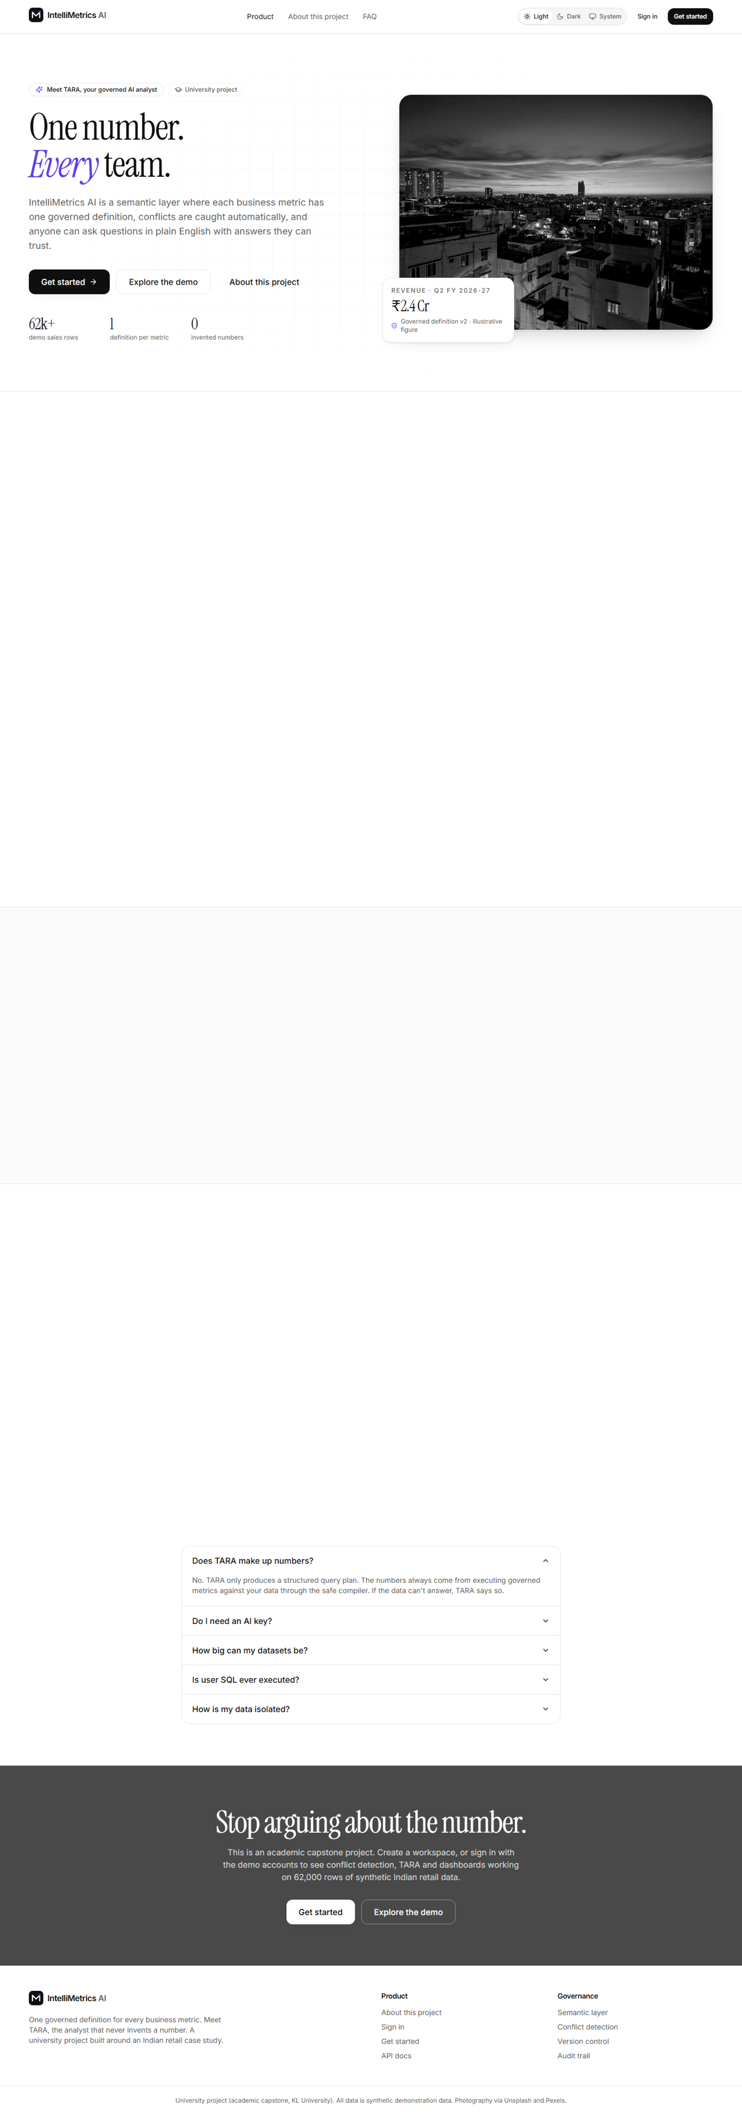
Landing page, light mode
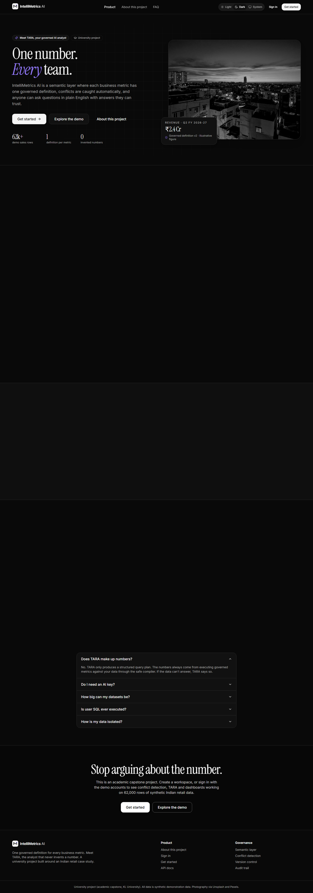
Landing page, dark mode
About / product tour
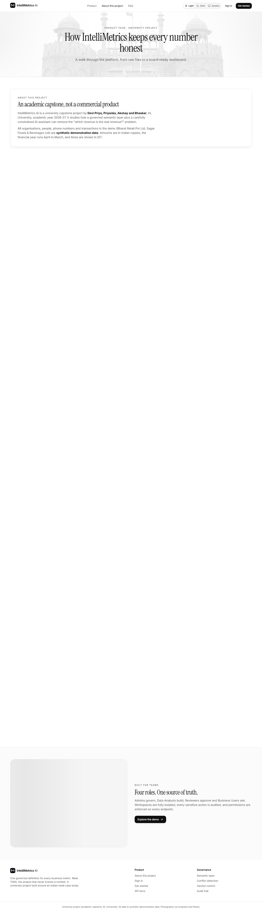
About / product tour, light mode
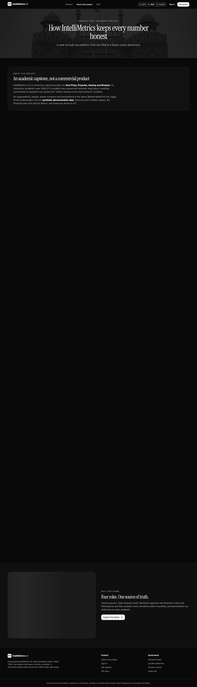
About / product tour, dark mode
Login with demo accounts panel
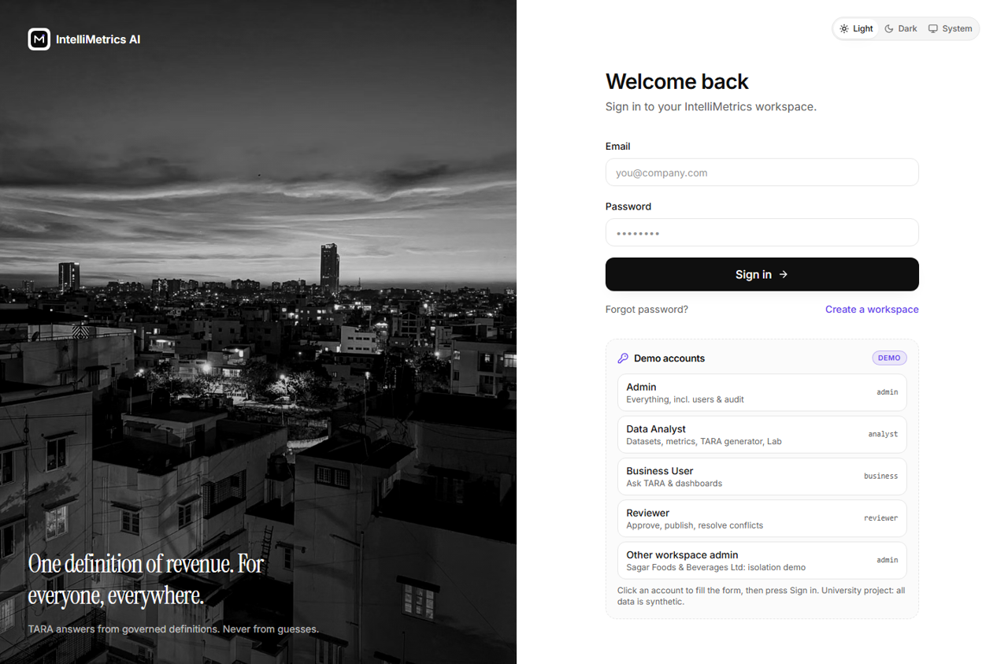
Login with demo accounts panel, light mode
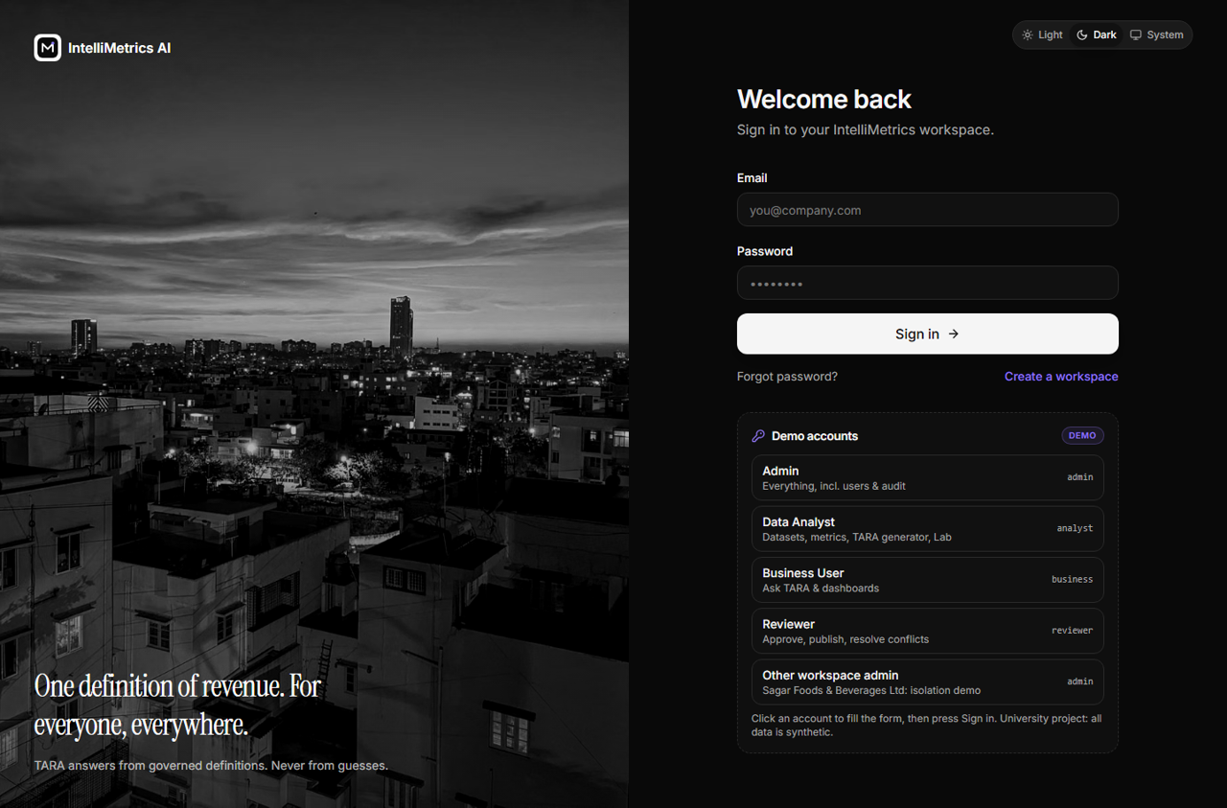
Login with demo accounts panel, dark mode
Register
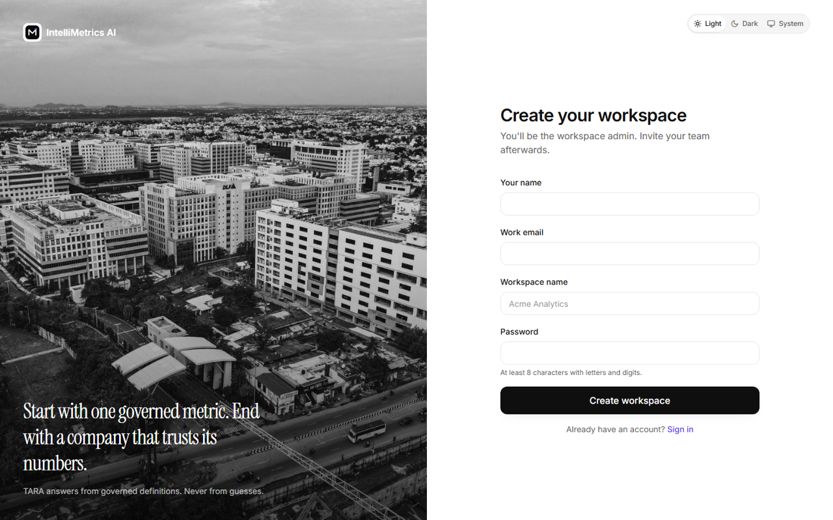
Register, light mode
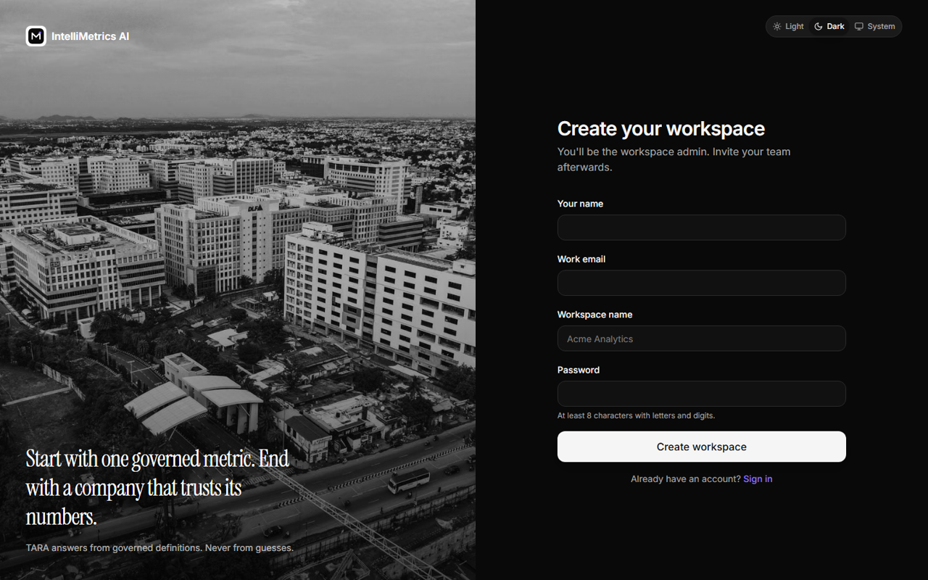
Register, dark mode
Forgot password
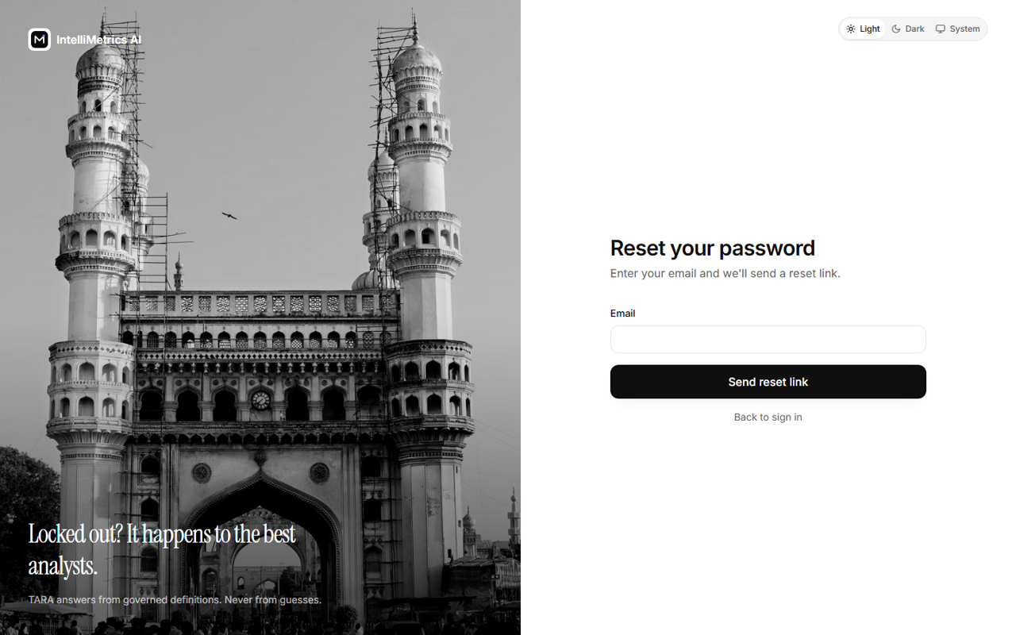
Forgot password, light mode
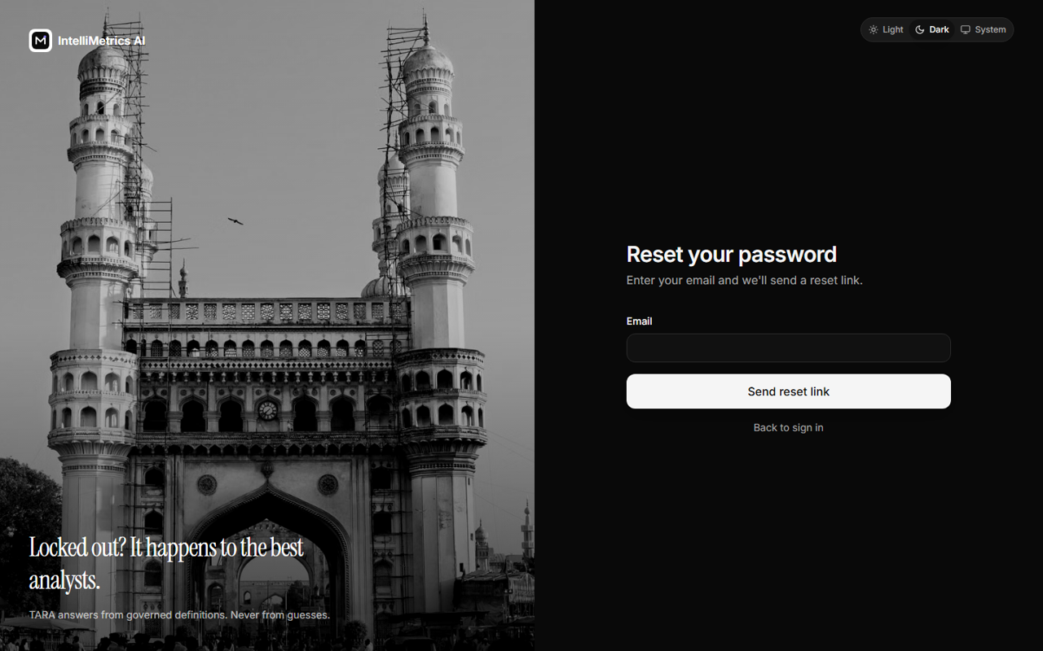
Forgot password, dark mode
Reset password
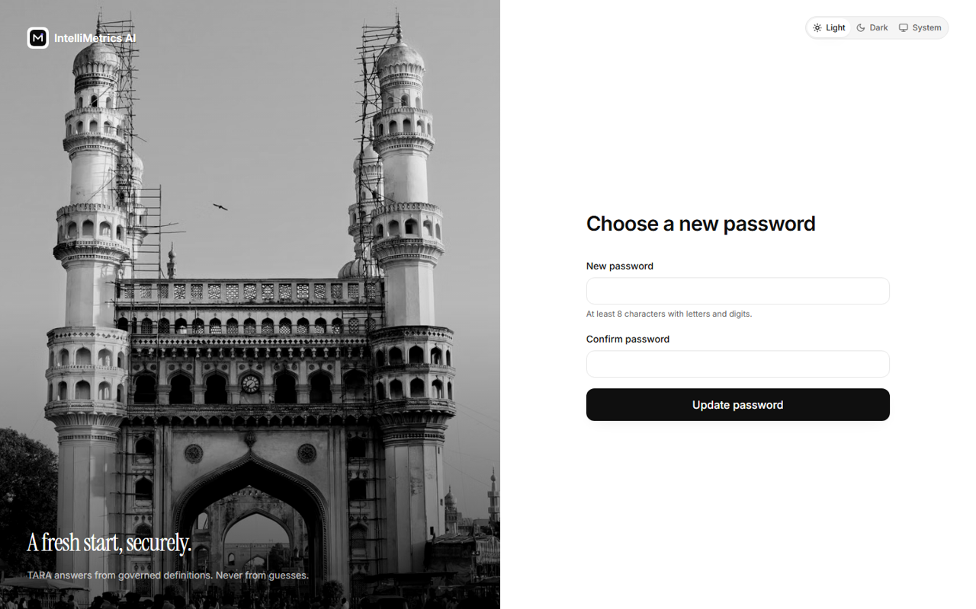
Reset password, light mode
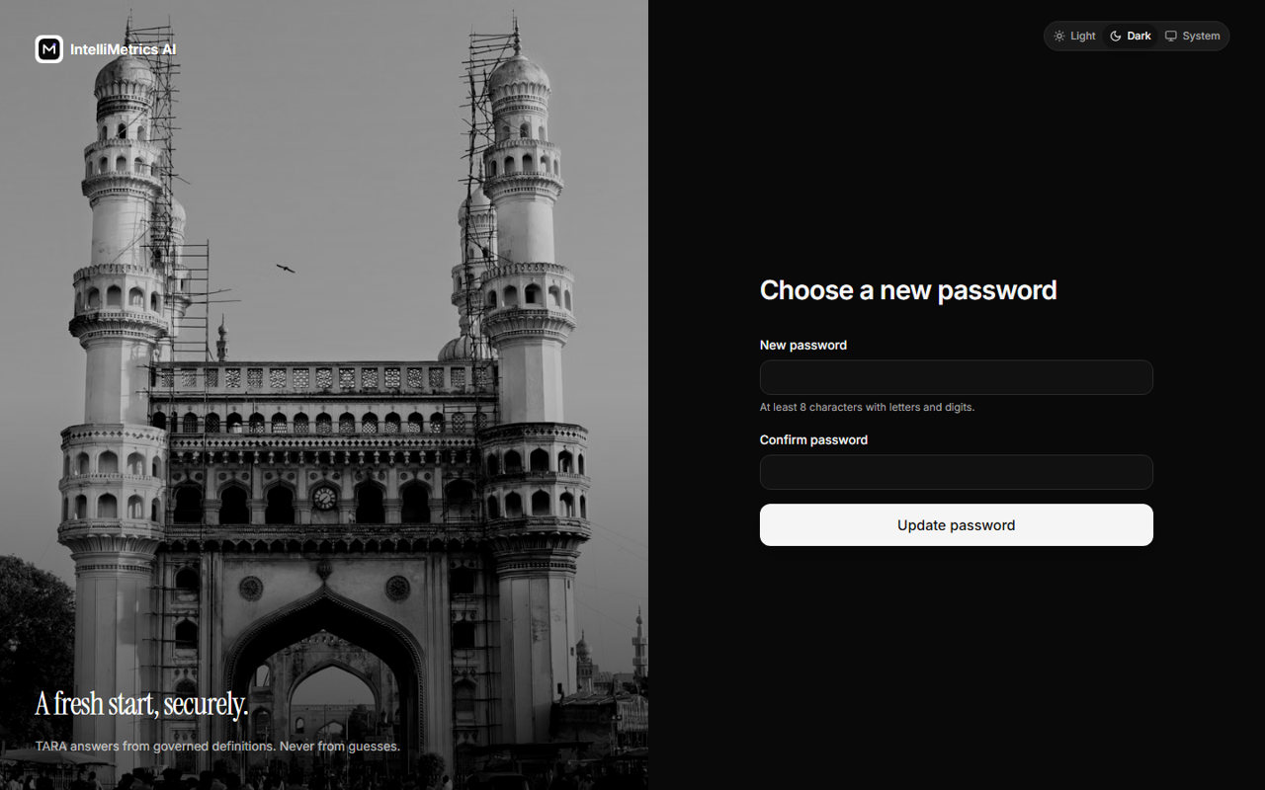
Reset password, dark mode
403 Forbidden
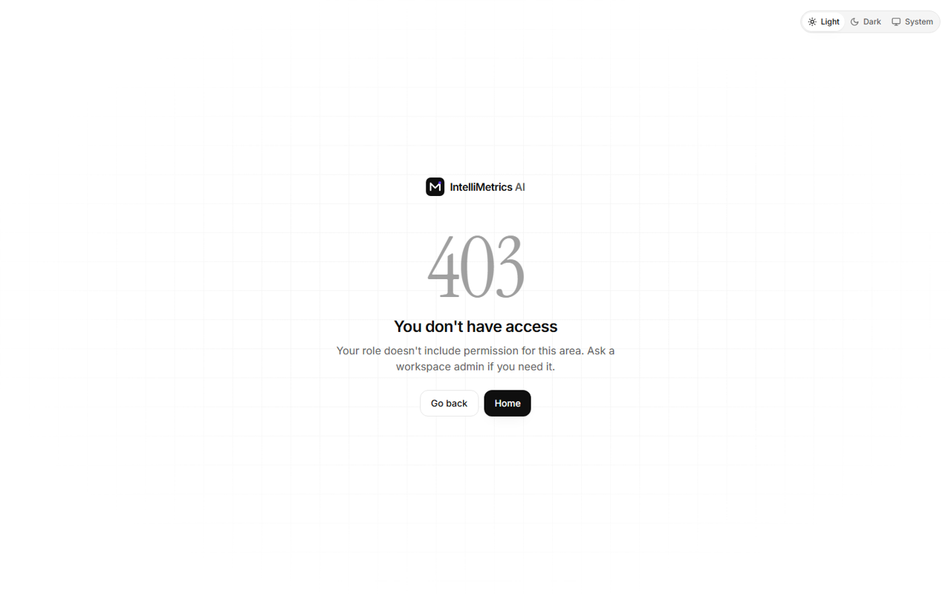
403 Forbidden, light mode
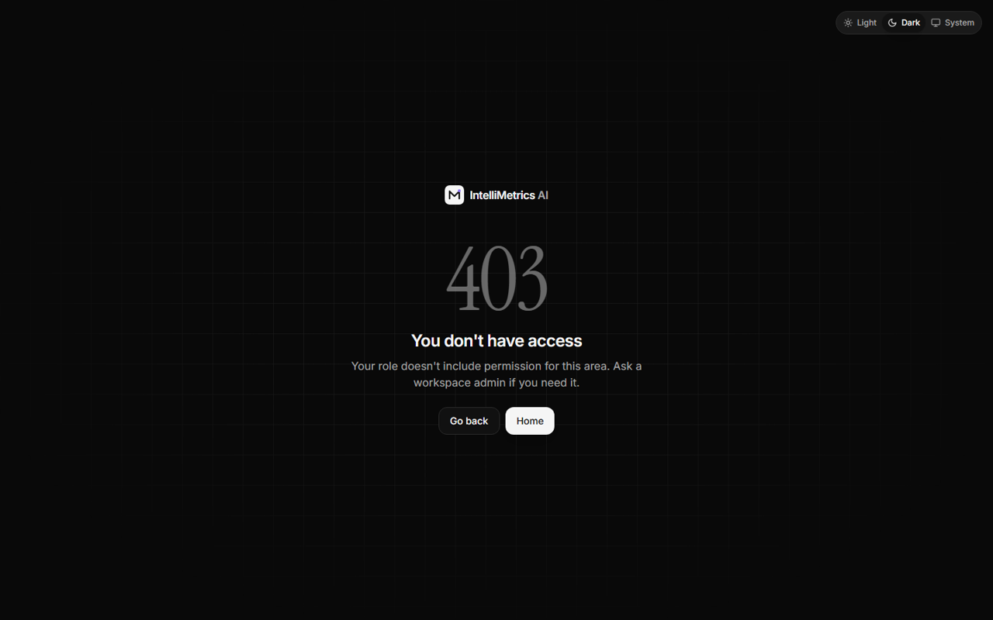
403 Forbidden, dark mode
404 Not found
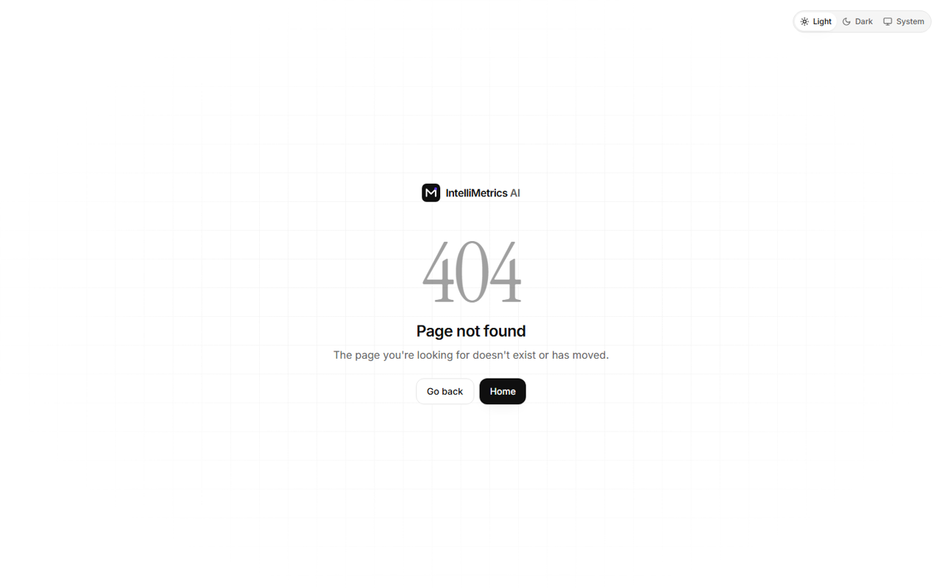
404 Not found, light mode
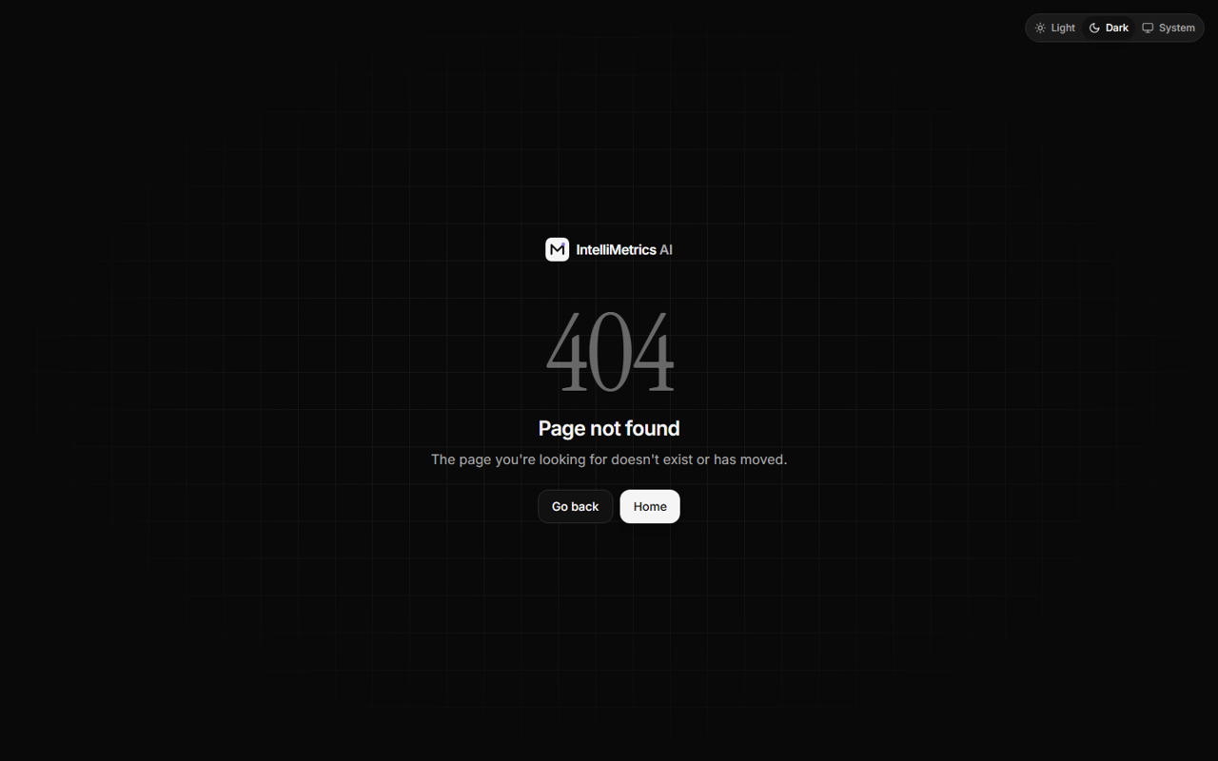
404 Not found, dark mode

7.2 Main application
Pages are listed in the order of the sidebar. Screenshots are shown in light and dark mode; the sun/moon button in the top bar switches theme (Light, Dark or System) and the choice is remembered.

7.2.1 Dashboard
The first page after login: four key figures (all computed from real data), recent conflicts and activity, and the dataset status. Amounts are in rupees with lakh/crore grouping (for example ₹12,45,300) and compact forms (₹1.2 Cr). Dates are DD-MMM-YYYY and times are in IST.
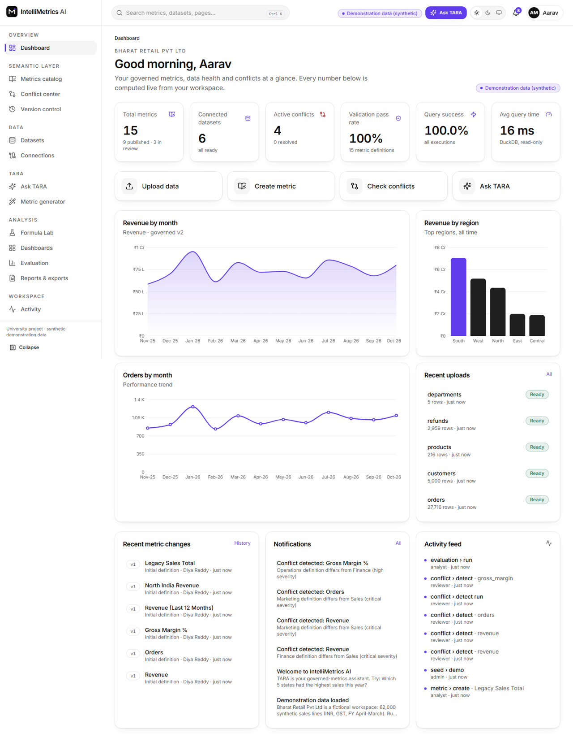
Main dashboard, light mode
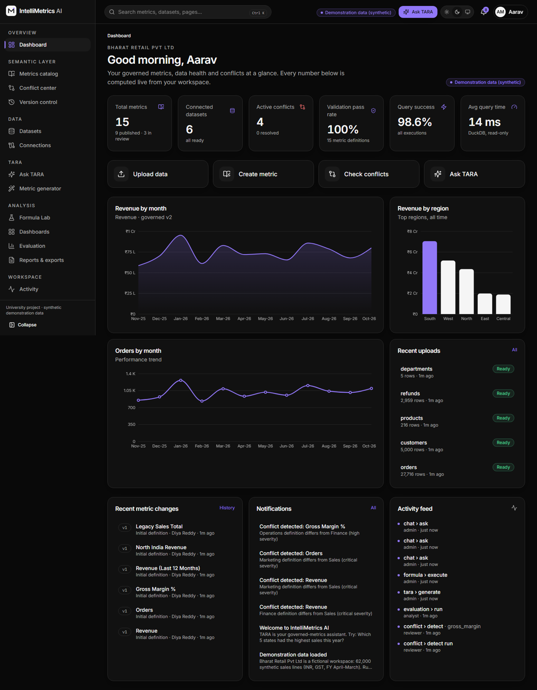
Main dashboard, dark mode

7.2.2 Metrics catalog and metric detail
Search, filter and sort all metrics. A metric has a formula, a unit, a department, a status (Draft, In review, Approved, Published, Deprecated) and an owner. The detail page shows the live SQL preview, dependencies on other metrics, the latest value, conflicts and a link to the version history.
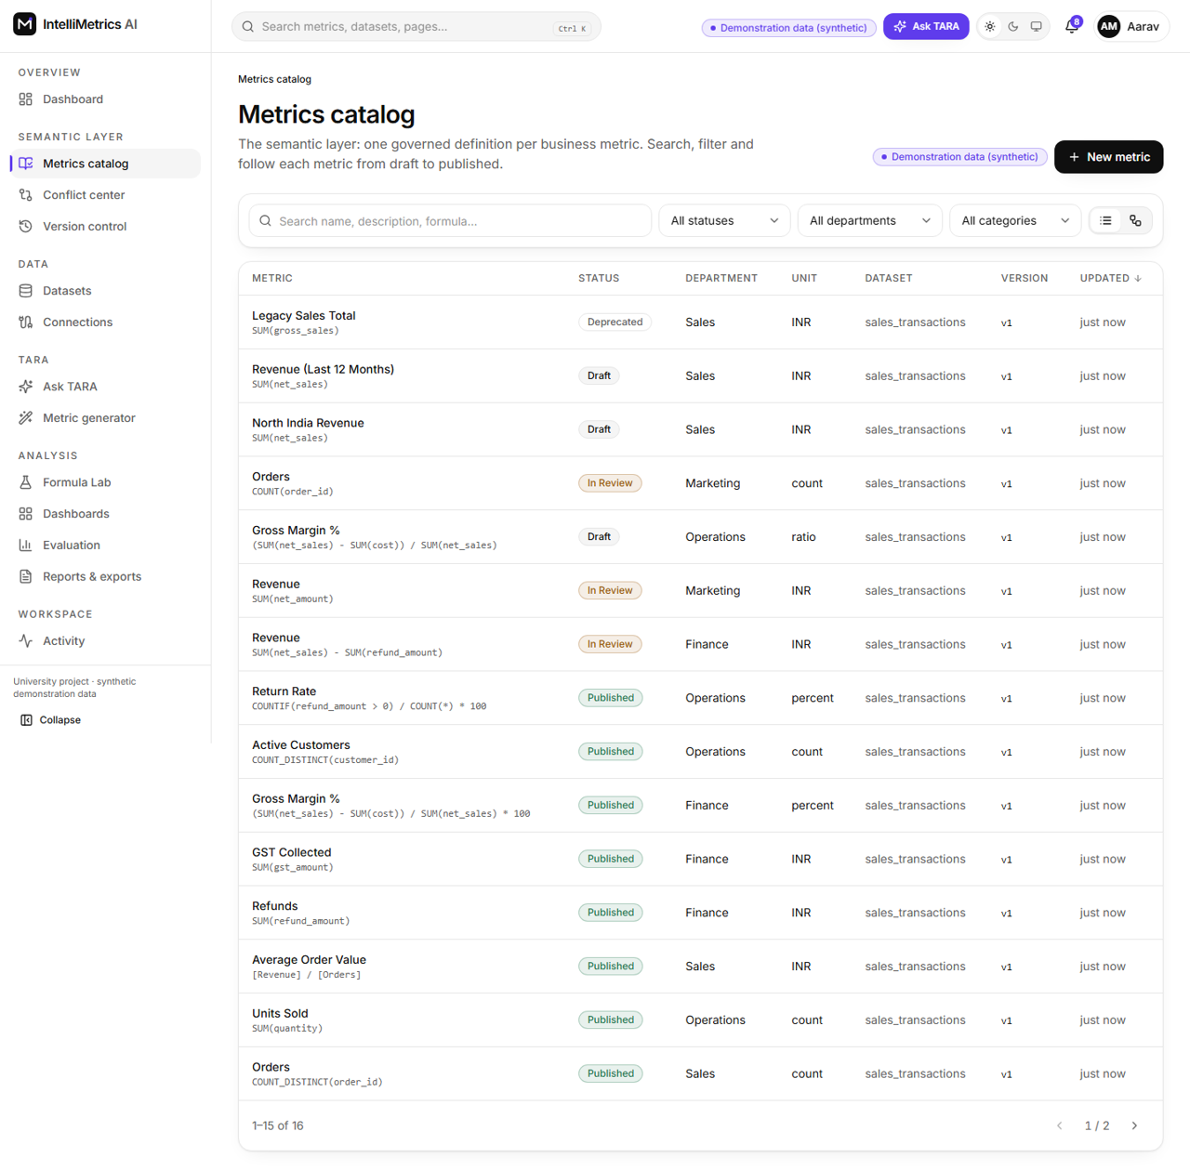
Metrics catalog, light mode
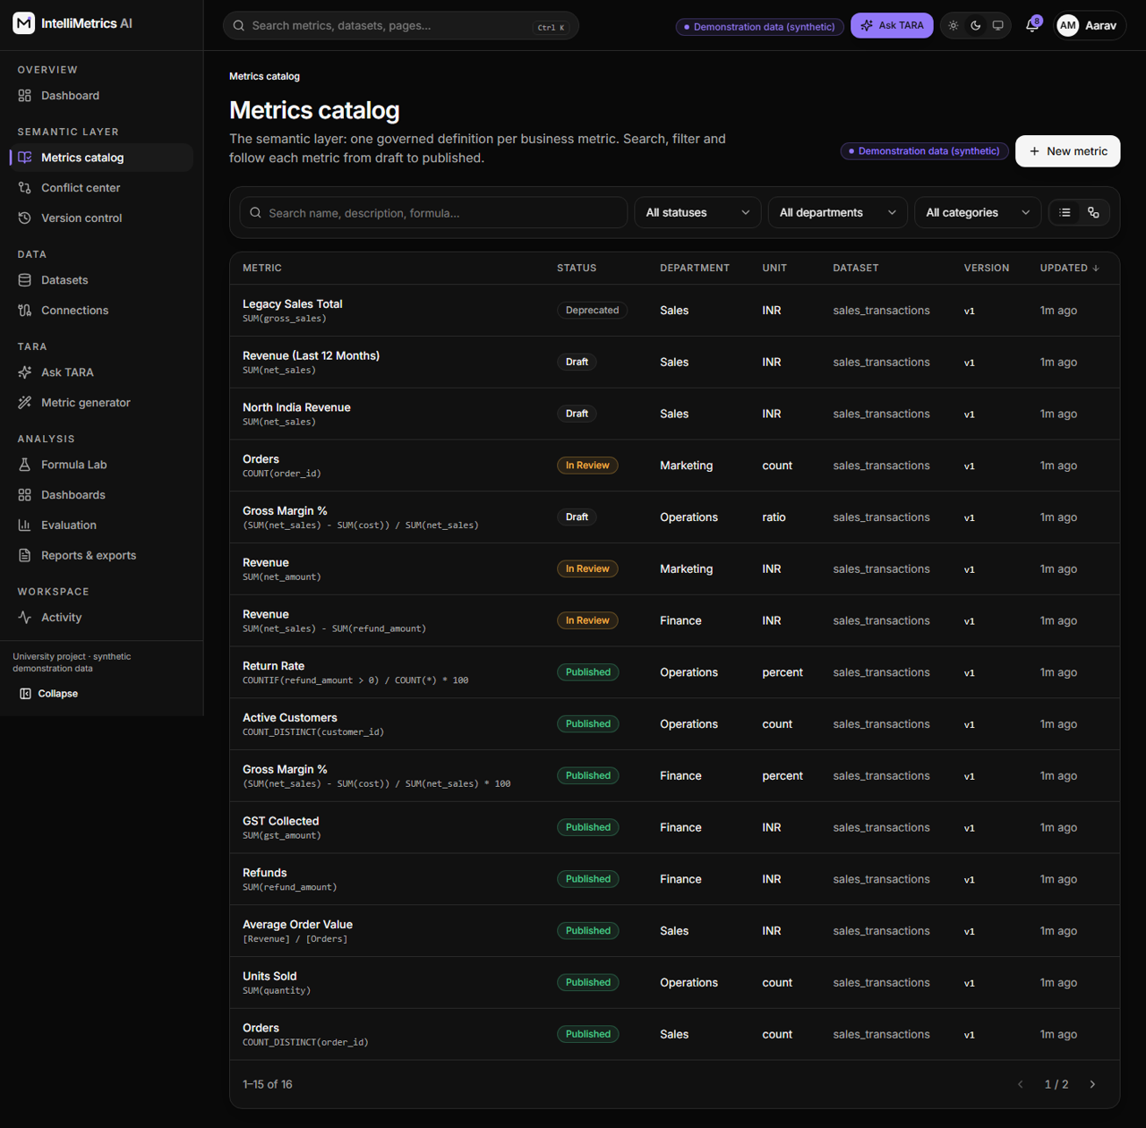
Metrics catalog, dark mode
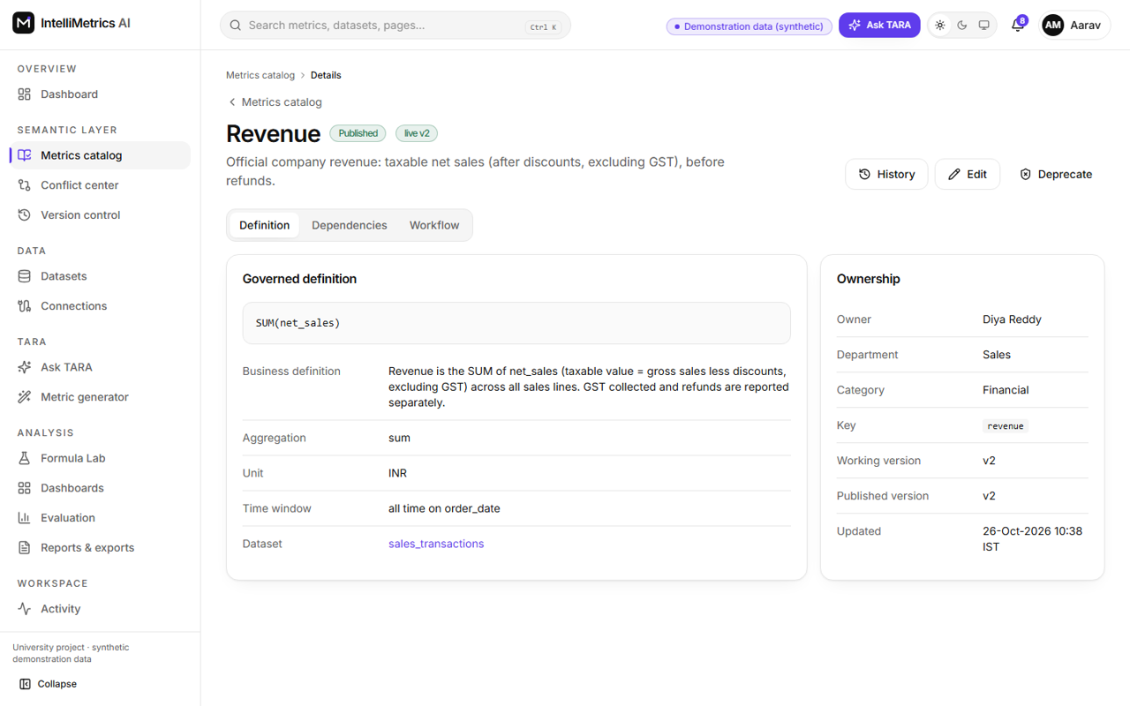
Metric detail (Revenue), light mode
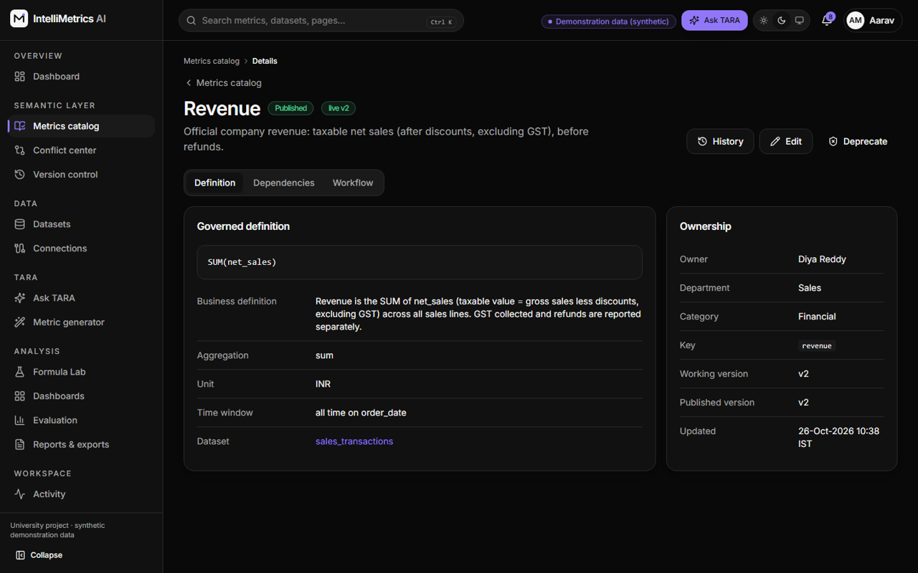
Metric detail (Revenue), dark mode

7.2.3 Datasets and connections
Upload a CSV, TSV, Excel, JSON, JSON-Lines or Parquet file, or connect to a PostgreSQL or MySQL database. Processing runs in the background: pending, processing, ready. The dataset page then shows a preview, the detected schema (with the date column) and a per-column profile (nulls, distinct values, minimum, maximum, mean, most frequent values, duplicates).
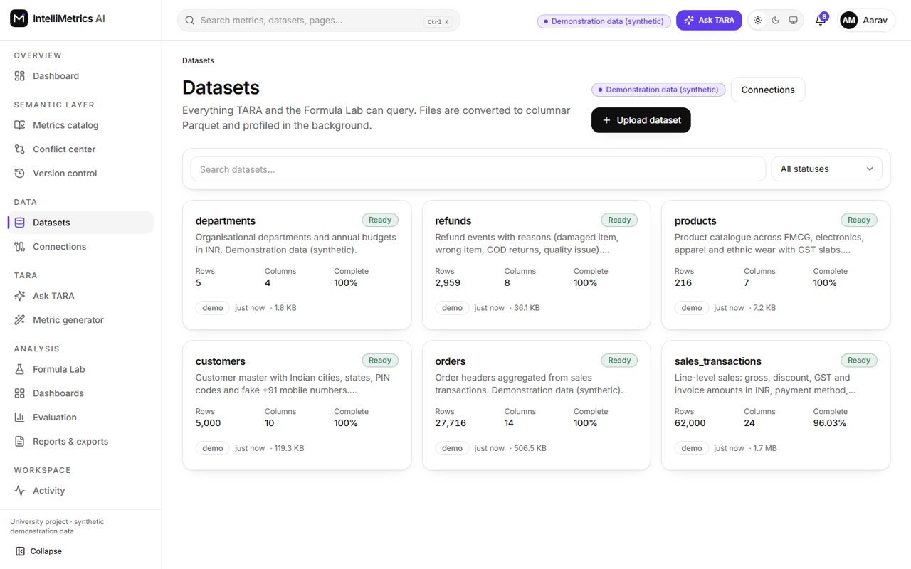
Datasets catalog, light mode
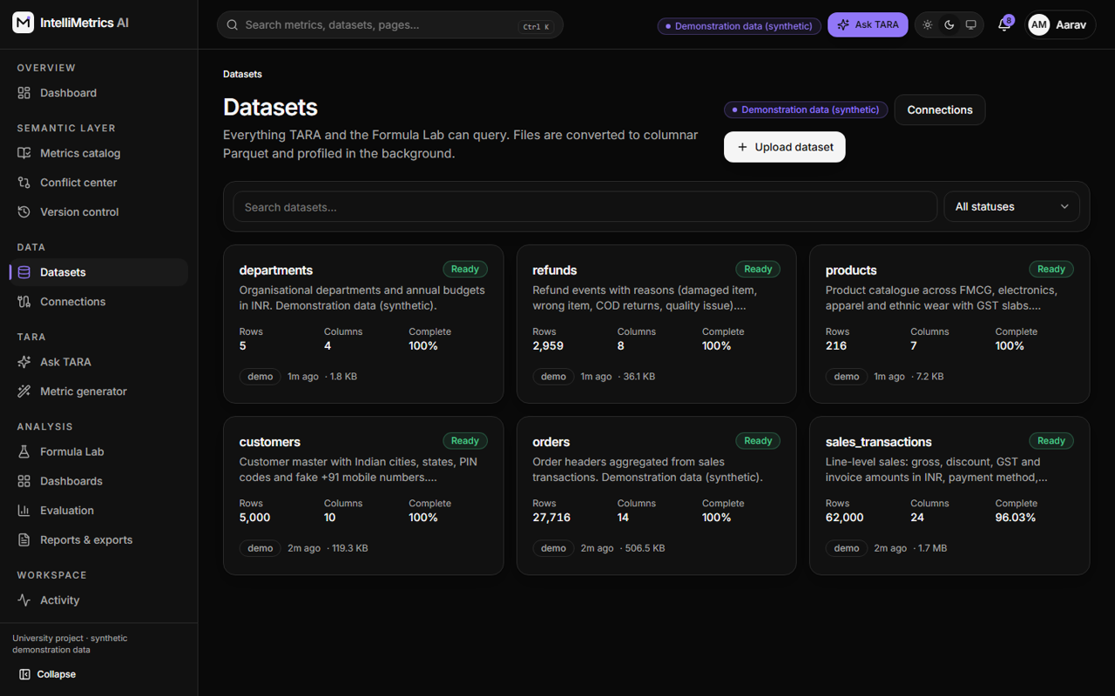
Datasets catalog, dark mode
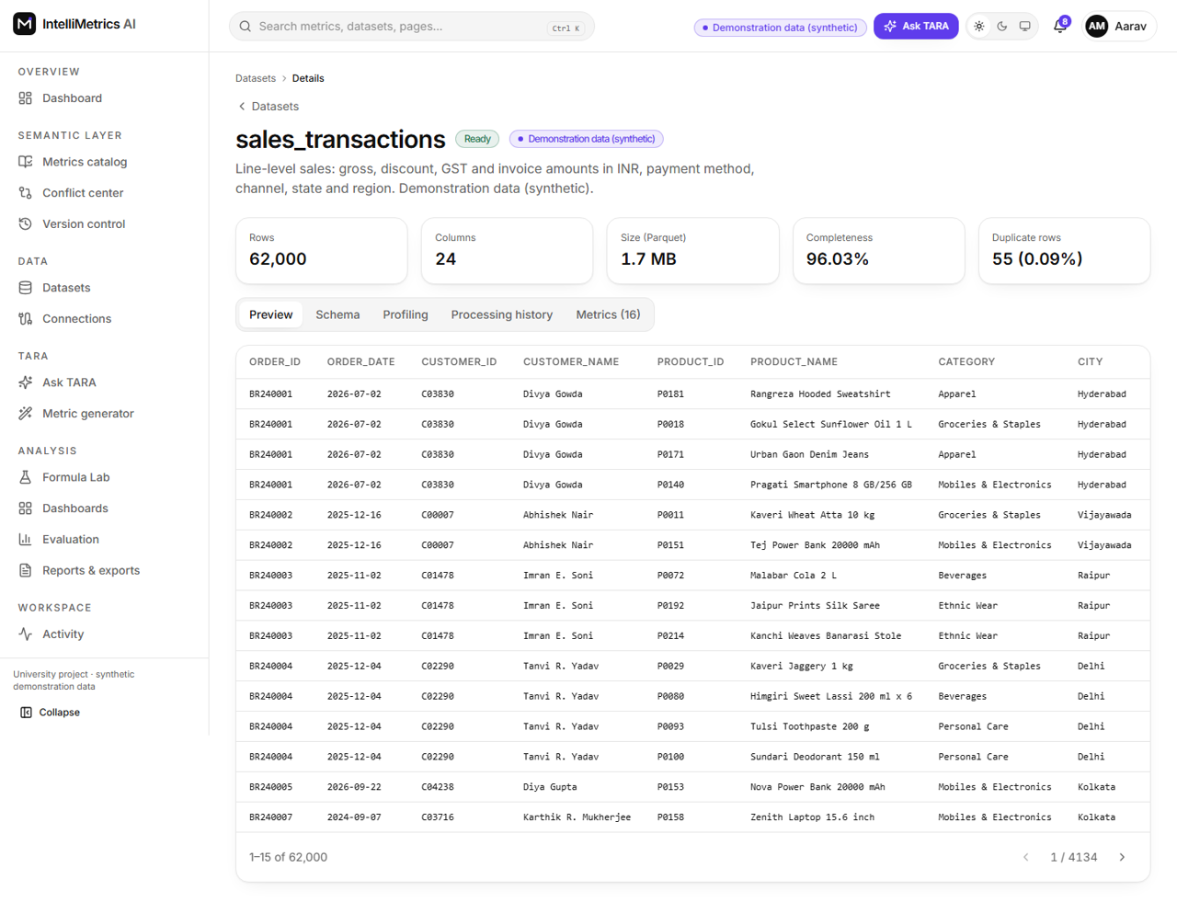
Dataset detail (preview), light mode
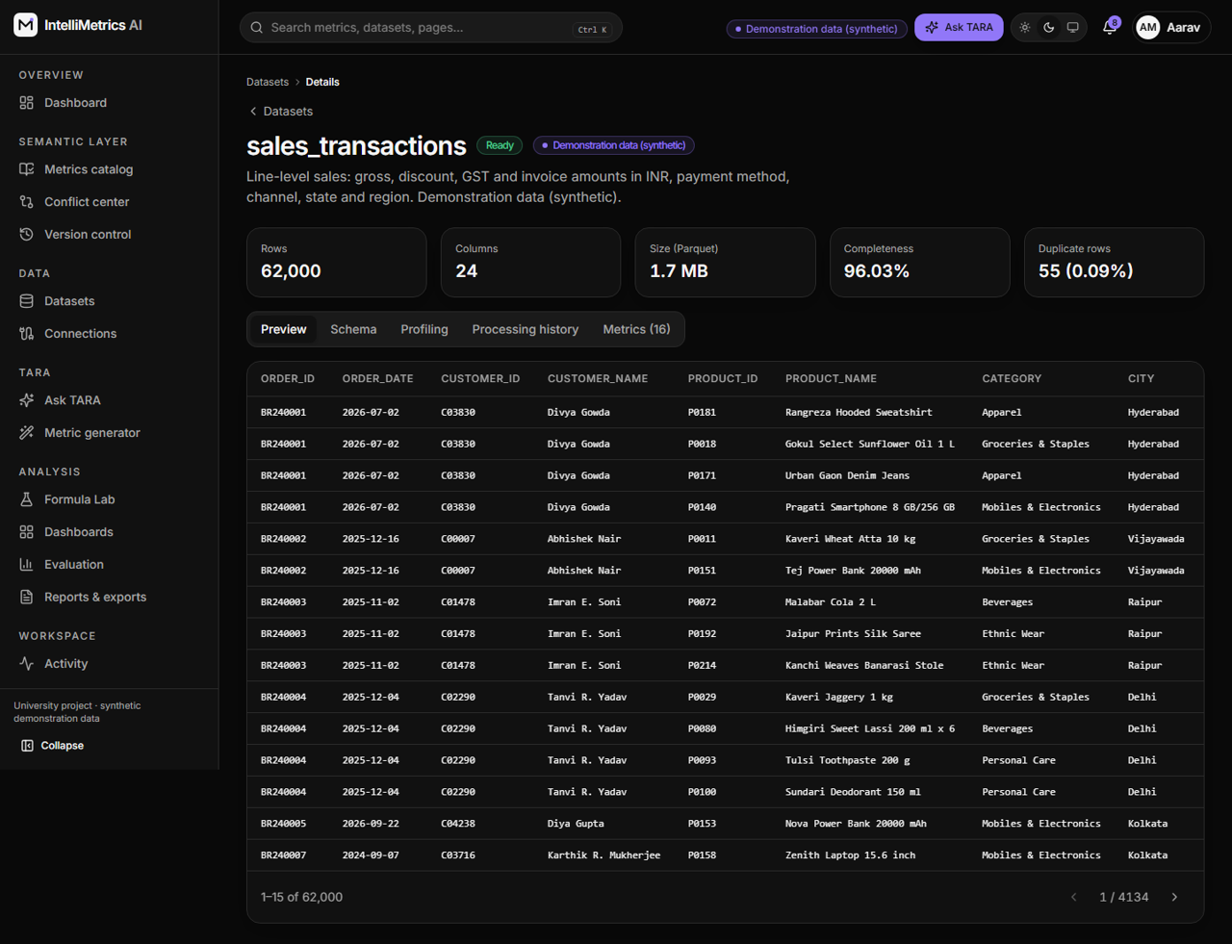
Dataset detail (preview), dark mode
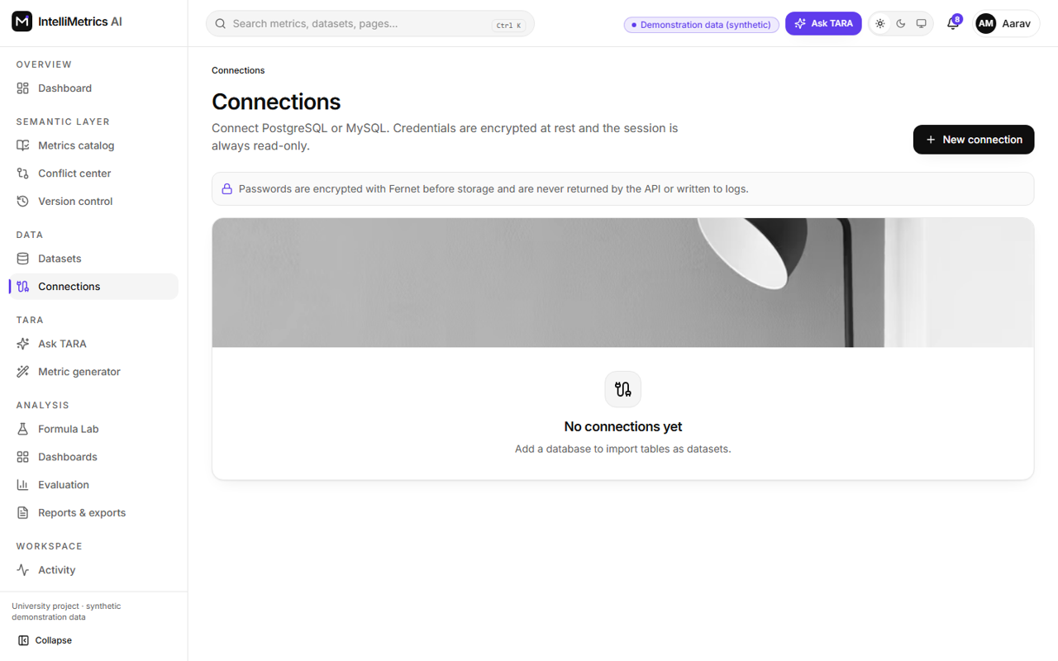
Database connections, light mode
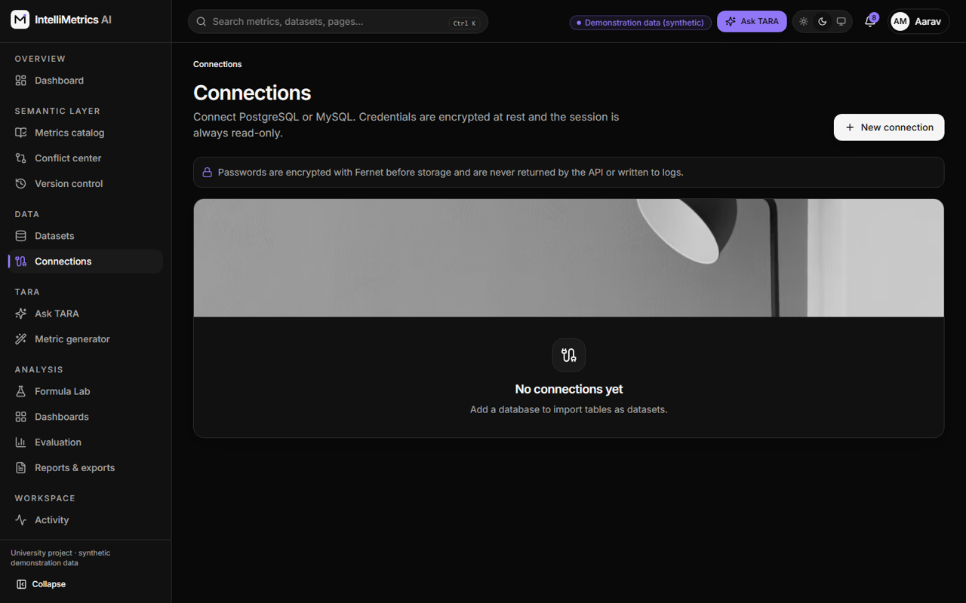
Database connections, dark mode

7.2.4 TARA metric generator
Choose a dataset and describe a metric in English. TARA returns an editable formula, explanation and warnings. Nothing is saved or published automatically; the analyst saves a draft or submits for approval.
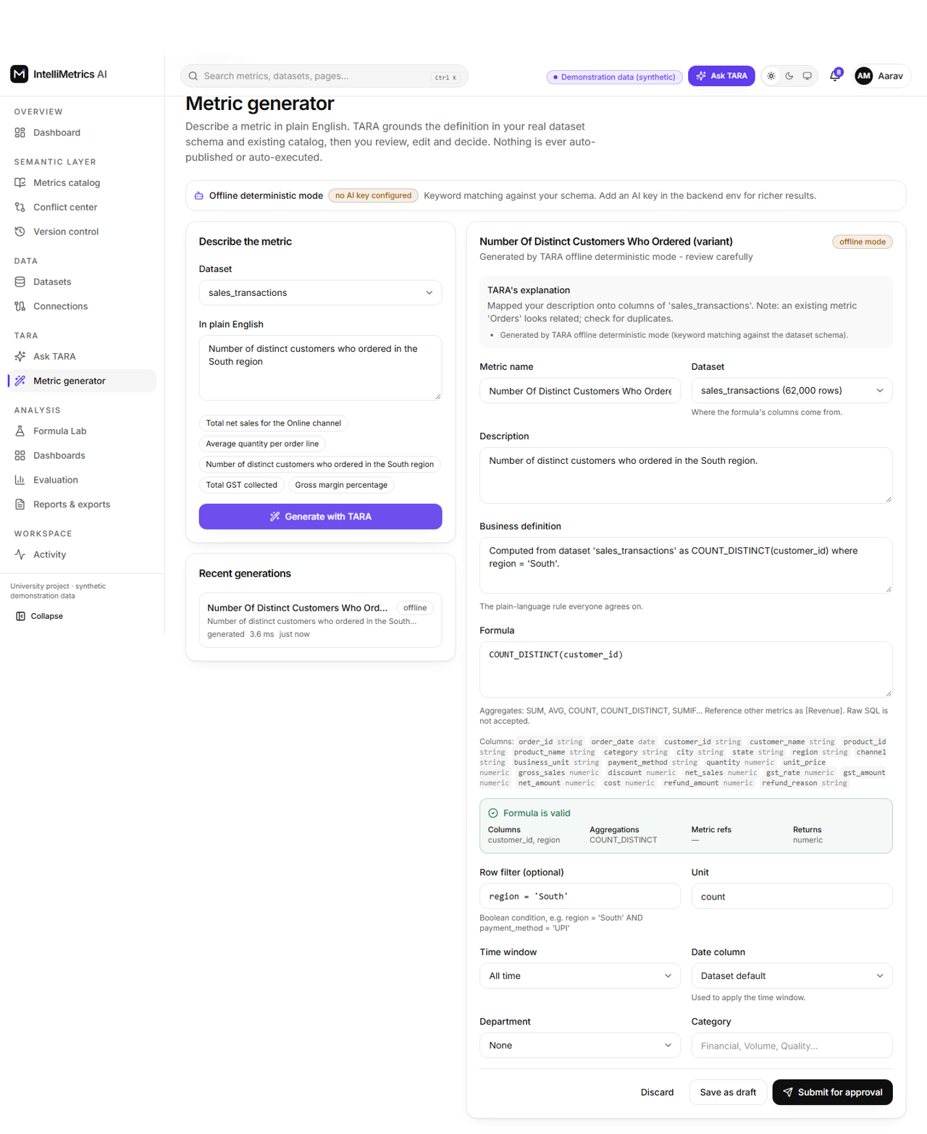
TARA metric generator (offline deterministic mode, editable suggestion), light mode
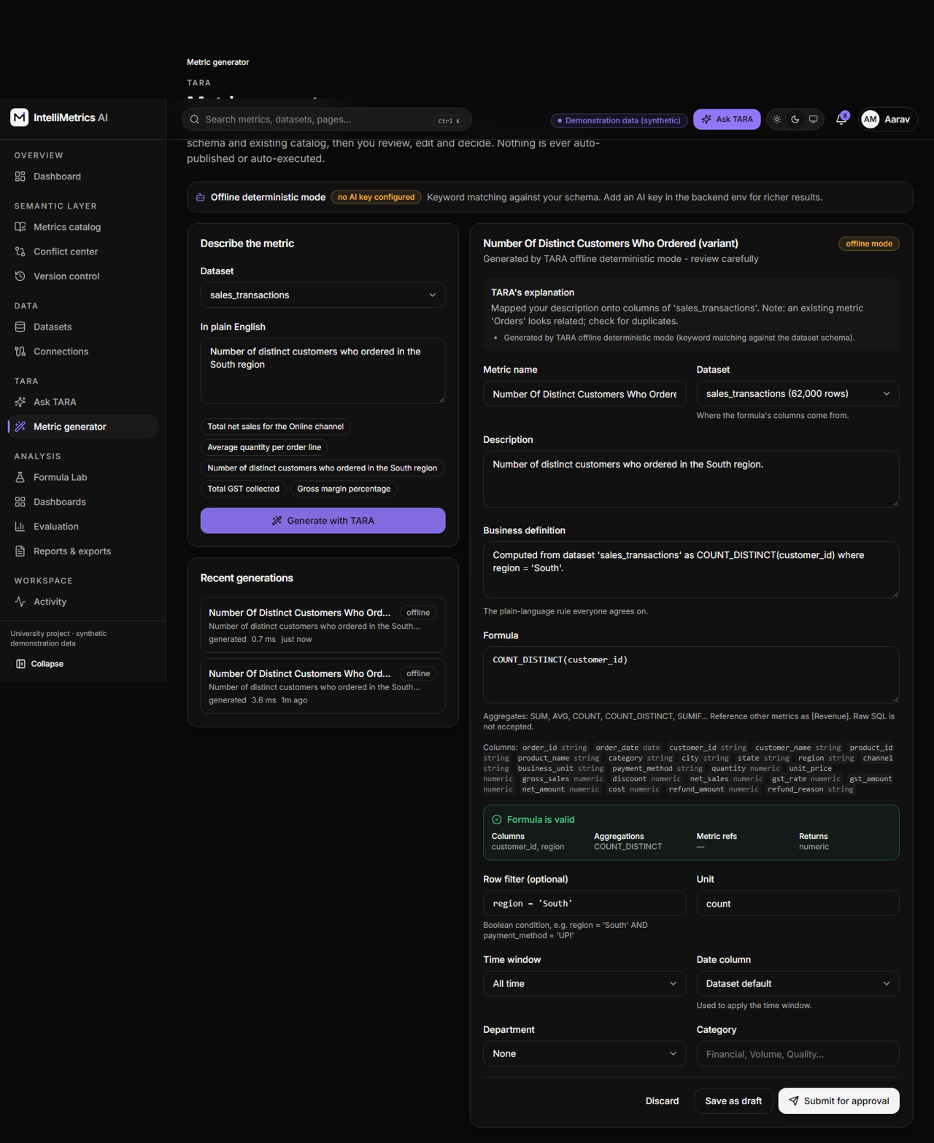
TARA metric generator (offline deterministic mode, editable suggestion), dark mode

7.2.5 Formula Lab
A safe place to try formulas. Metrics are written as [Revenue], columns by name, and the grammar allows only whitelisted functions. The Lab validates syntax, columns and types, shows the generated parameterised SQL, executes it on the real data with a time limit, and reports rows scanned and duration. Hostile input is rejected without running.
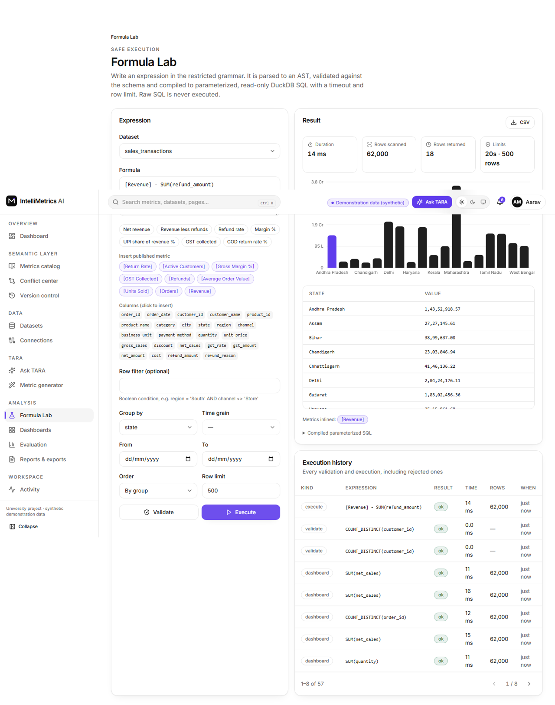
Formula Lab: validate and execute (Revenue less refunds by state), light mode
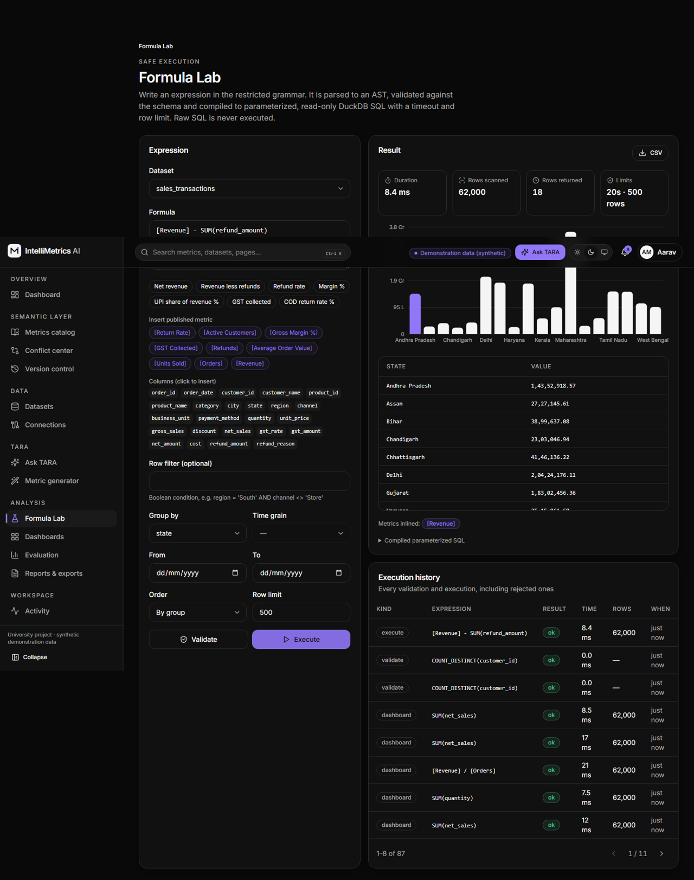
Formula Lab: validate and execute (Revenue less refunds by state), dark mode
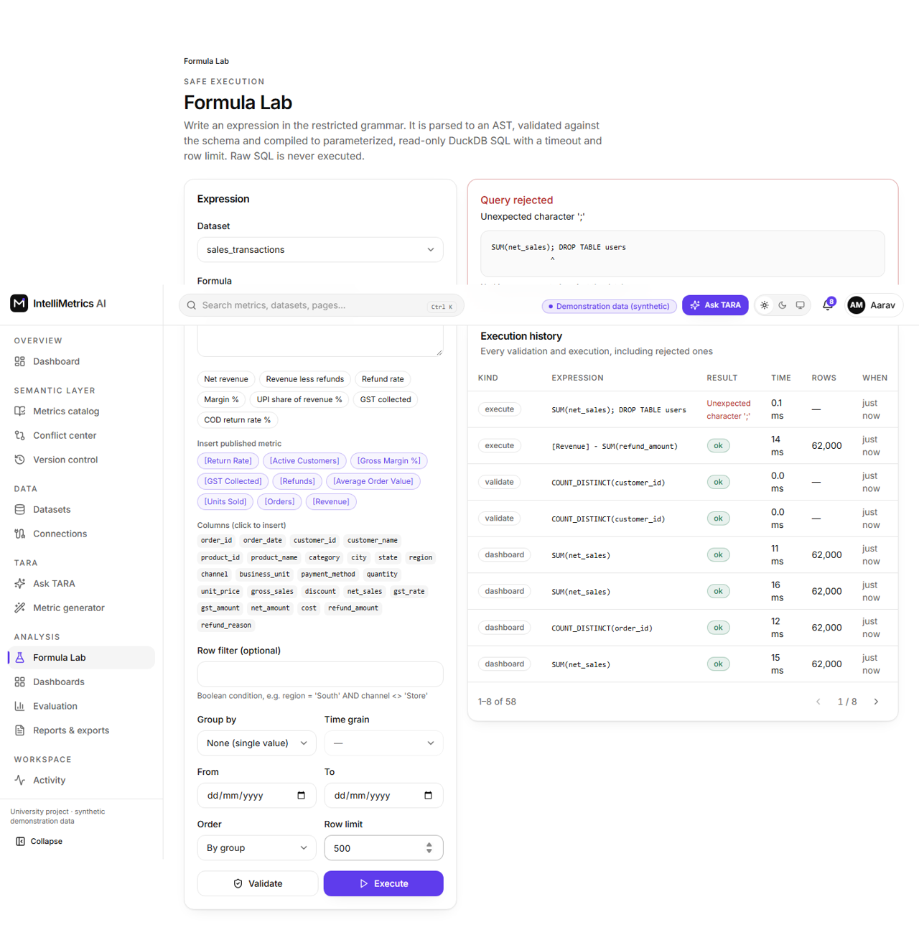
Formula Lab rejecting an injection attempt, light mode
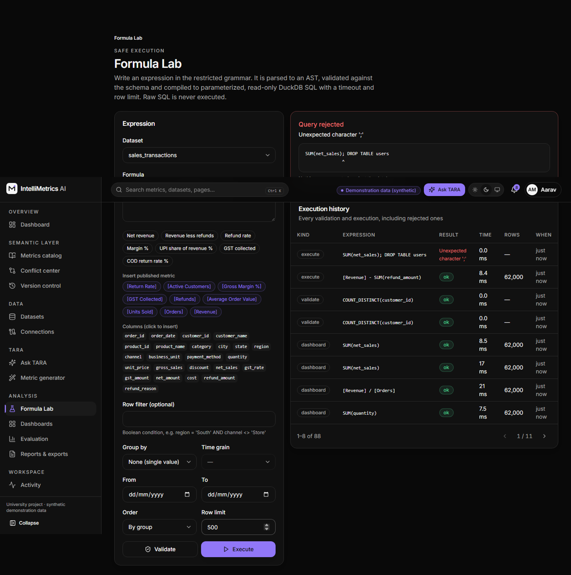
Formula Lab rejecting an injection attempt, dark mode

7.2.6 Conflict detection center
Run conflict detection compares every pair of definitions of the same business idea, and lists conflicts with a type (formula, aggregation, filter, unit, time window, dataset), a severity and a recommendation. The detail page shows the two definitions side by side with the differences highlighted, then the workflow: assign, review, approve, resolve, each step recorded.
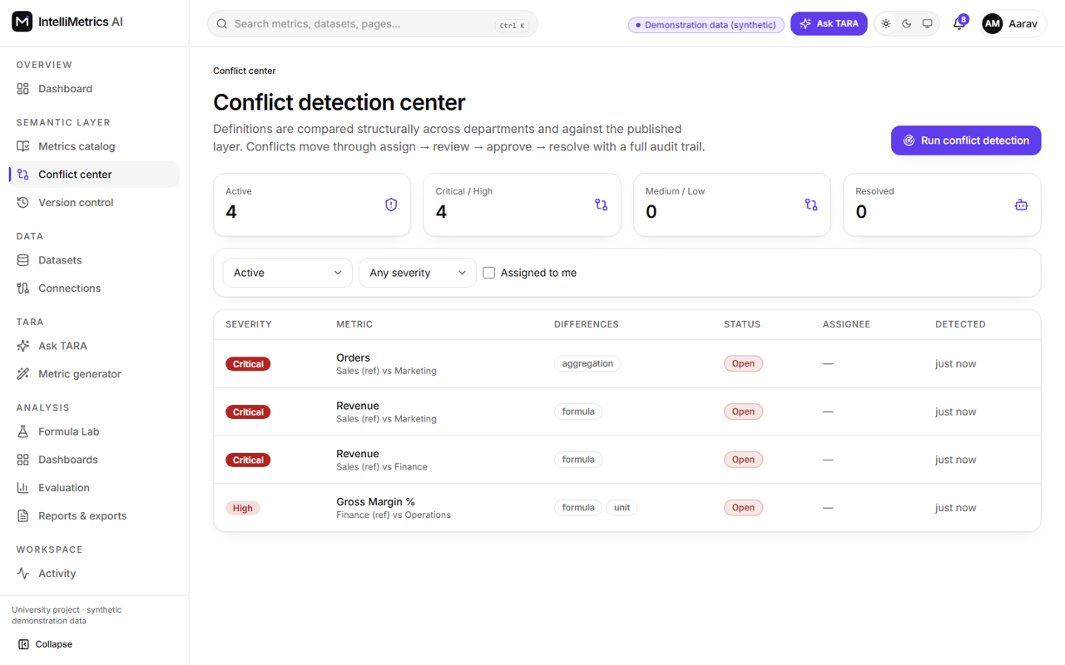
Conflict detection center, light mode
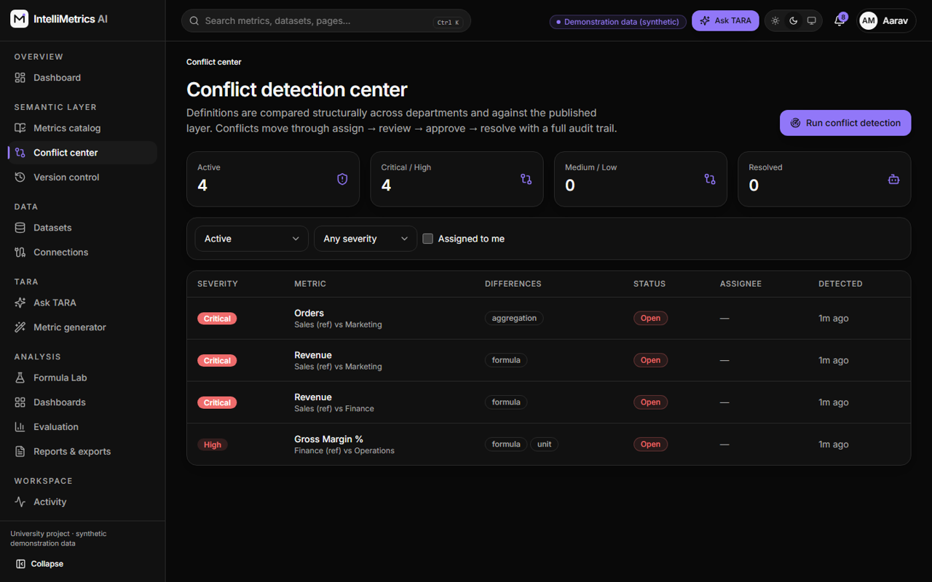
Conflict detection center, dark mode
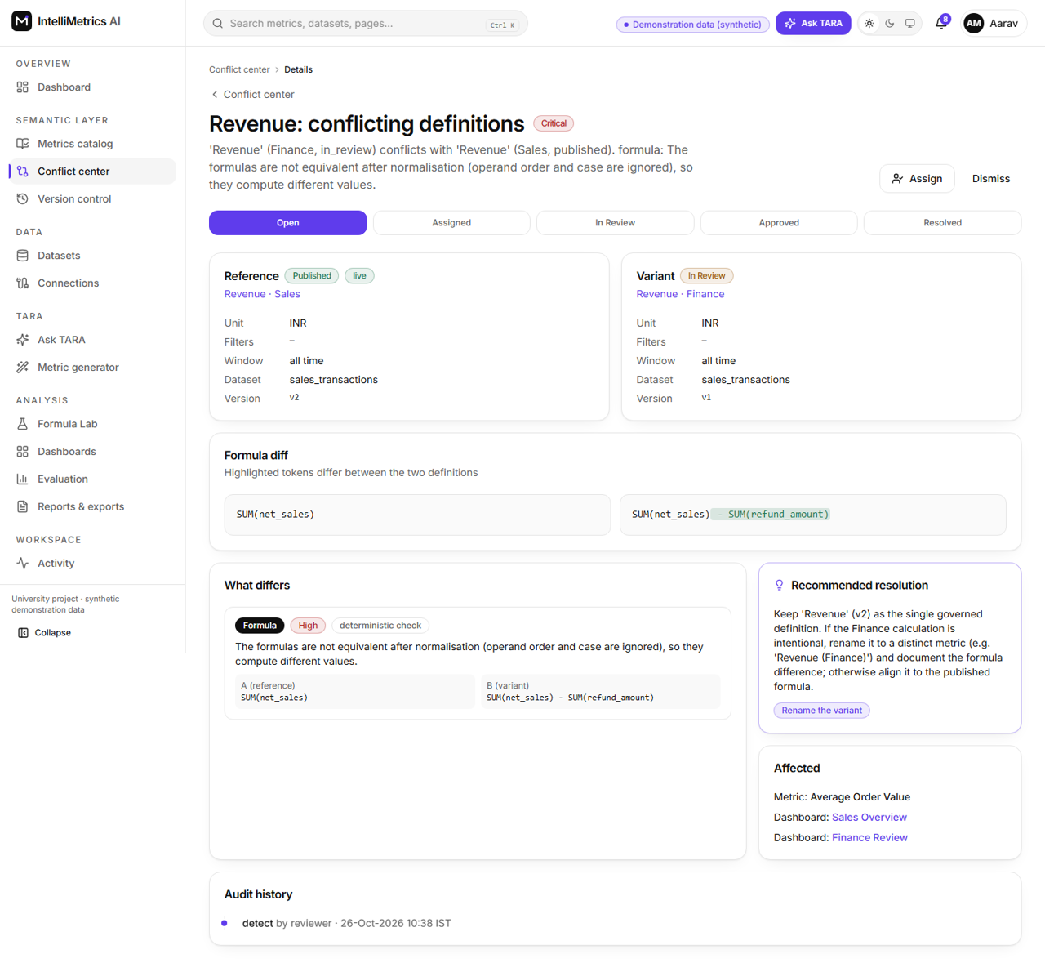
Conflict detail (side-by-side), light mode
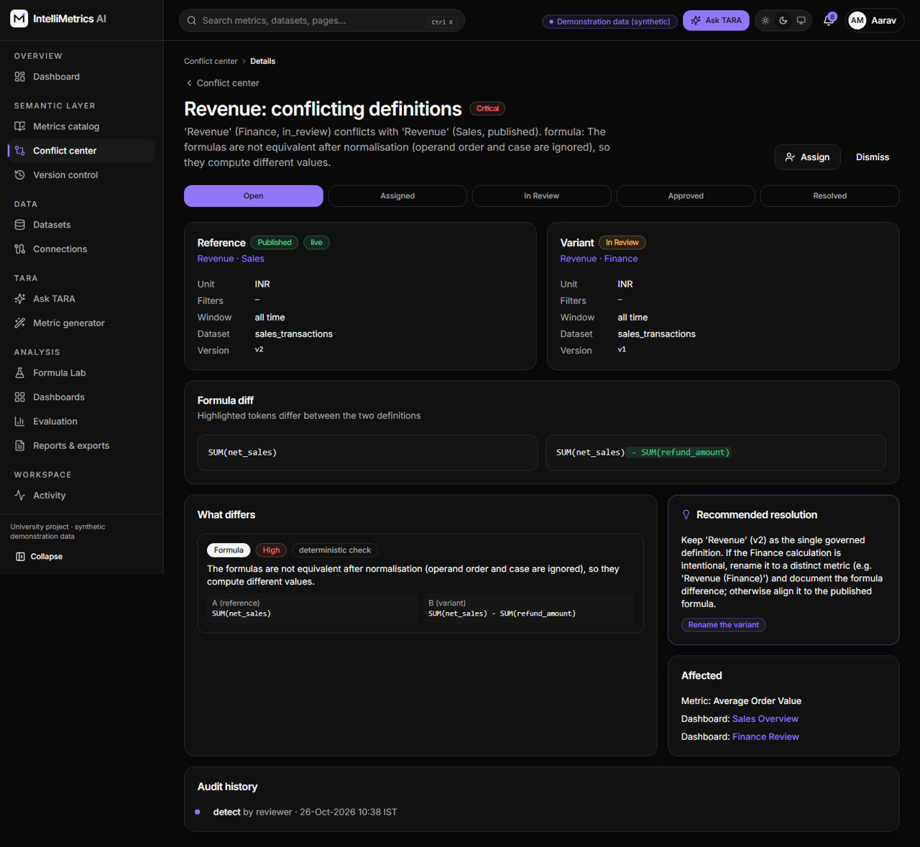
Conflict detail (side-by-side), dark mode

7.2.7 Version control
Every change creates an immutable version. The history page lists versions, compares any two (word-level formula diff) and rolls back. Rolling back never rewrites history: it creates a new version that copies the old definition.
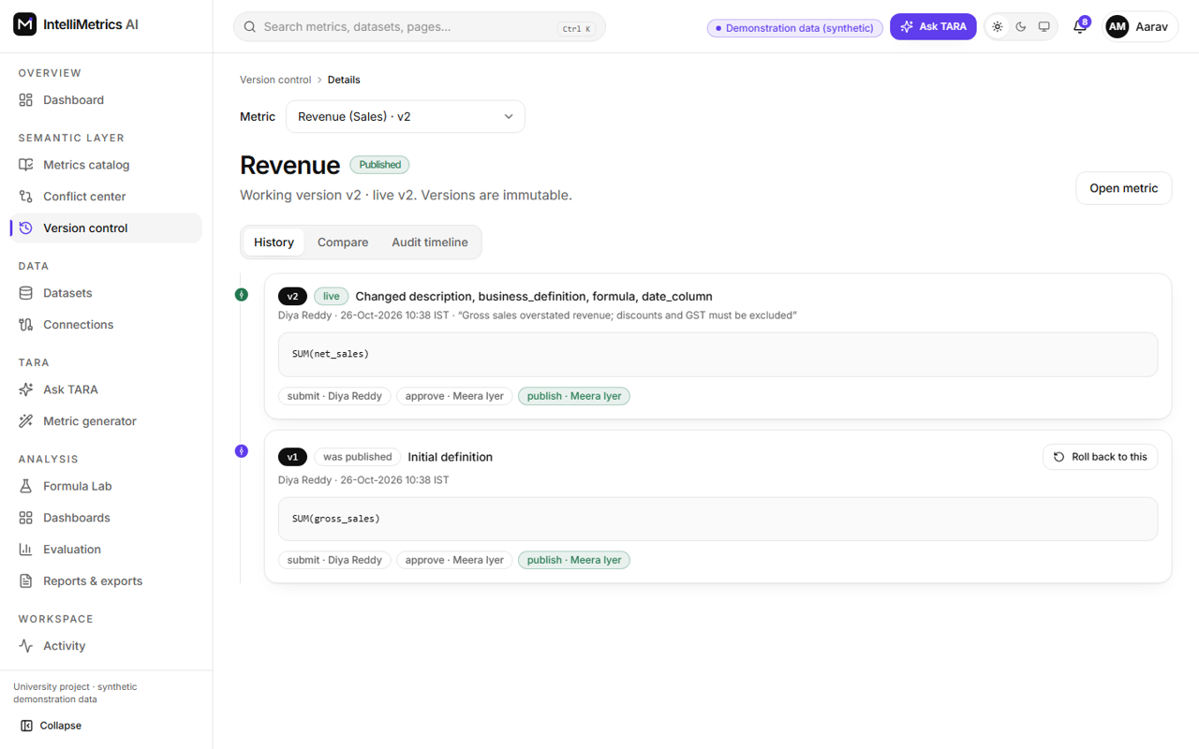
Version control (Revenue history), light mode
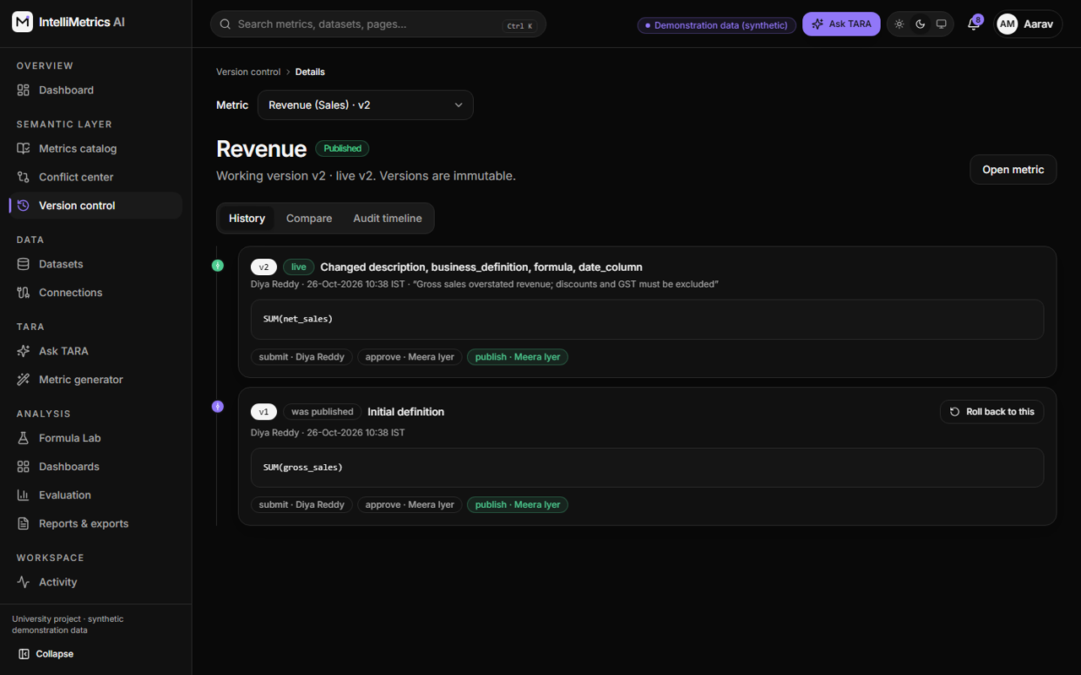
Version control (Revenue history), dark mode
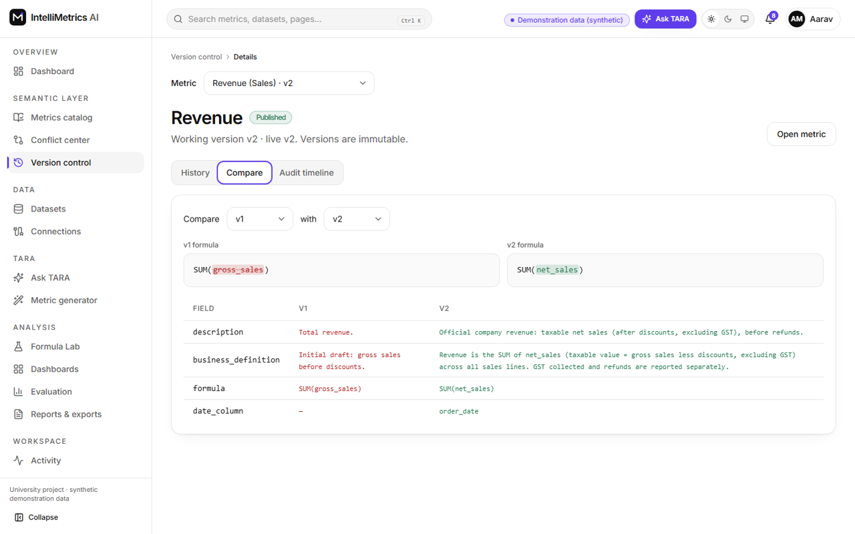
Version compare (diff view), light mode
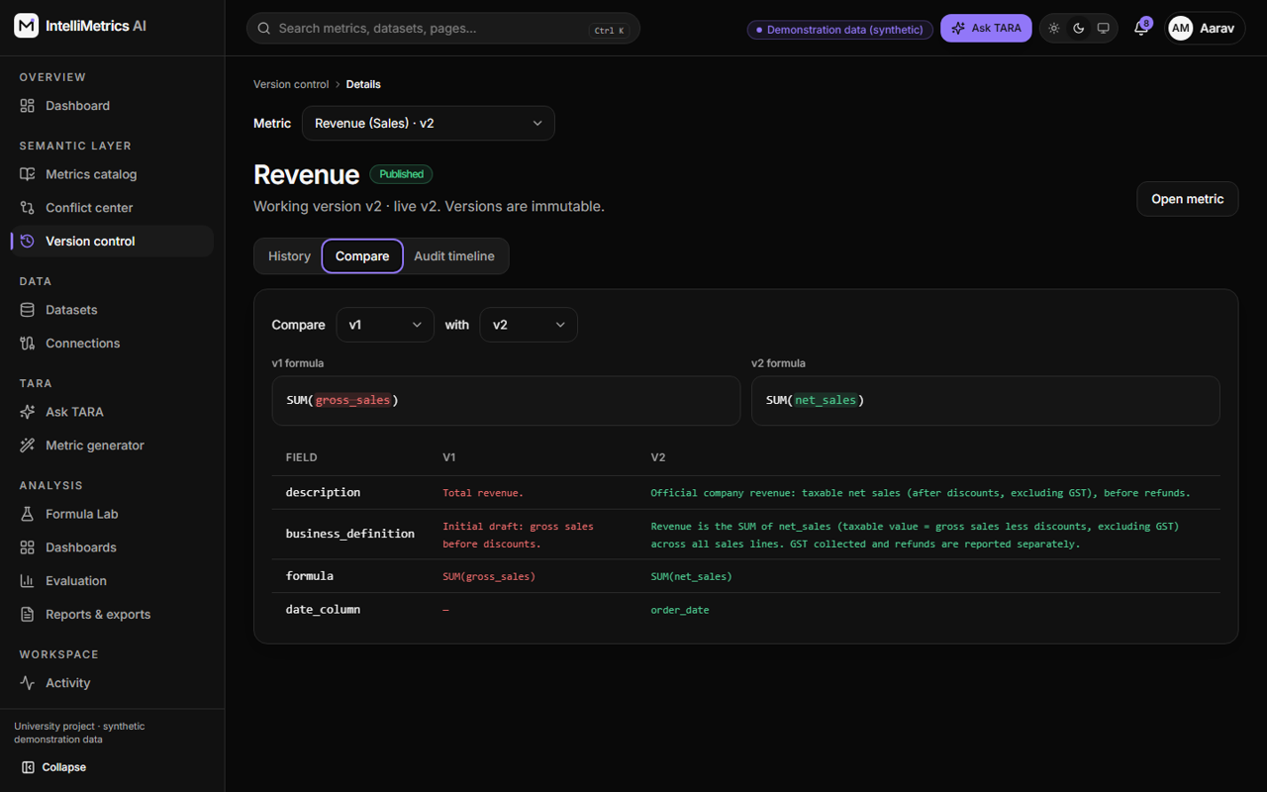
Version compare (diff view), dark mode

7.2.8 Ask TARA
Type a question in plain English. TARA turns it into a checked query plan, runs it on approved metrics only, and shows the answer as text, table and chart, with the definition used, the date range and the filters. If the question cannot be answered from the data it says so.
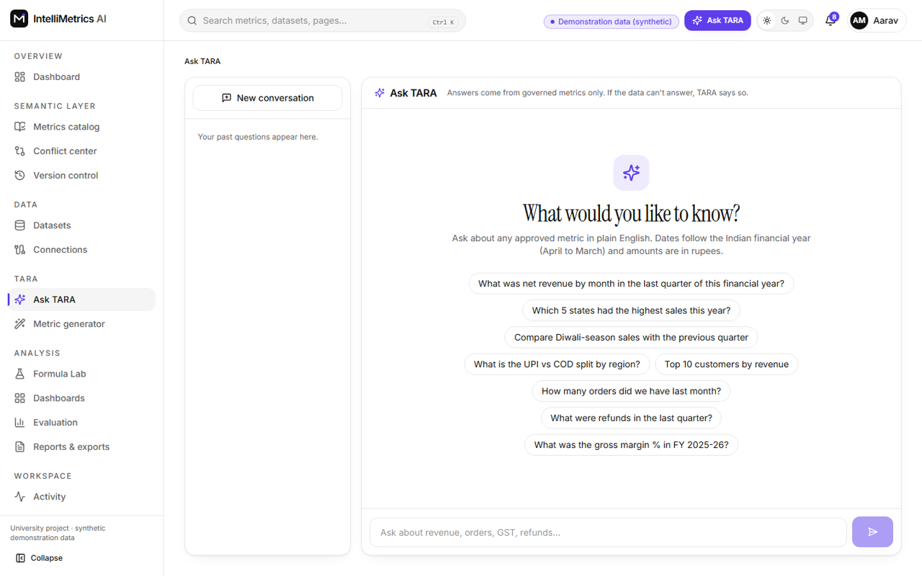
Ask TARA: suggested Indian questions, light mode
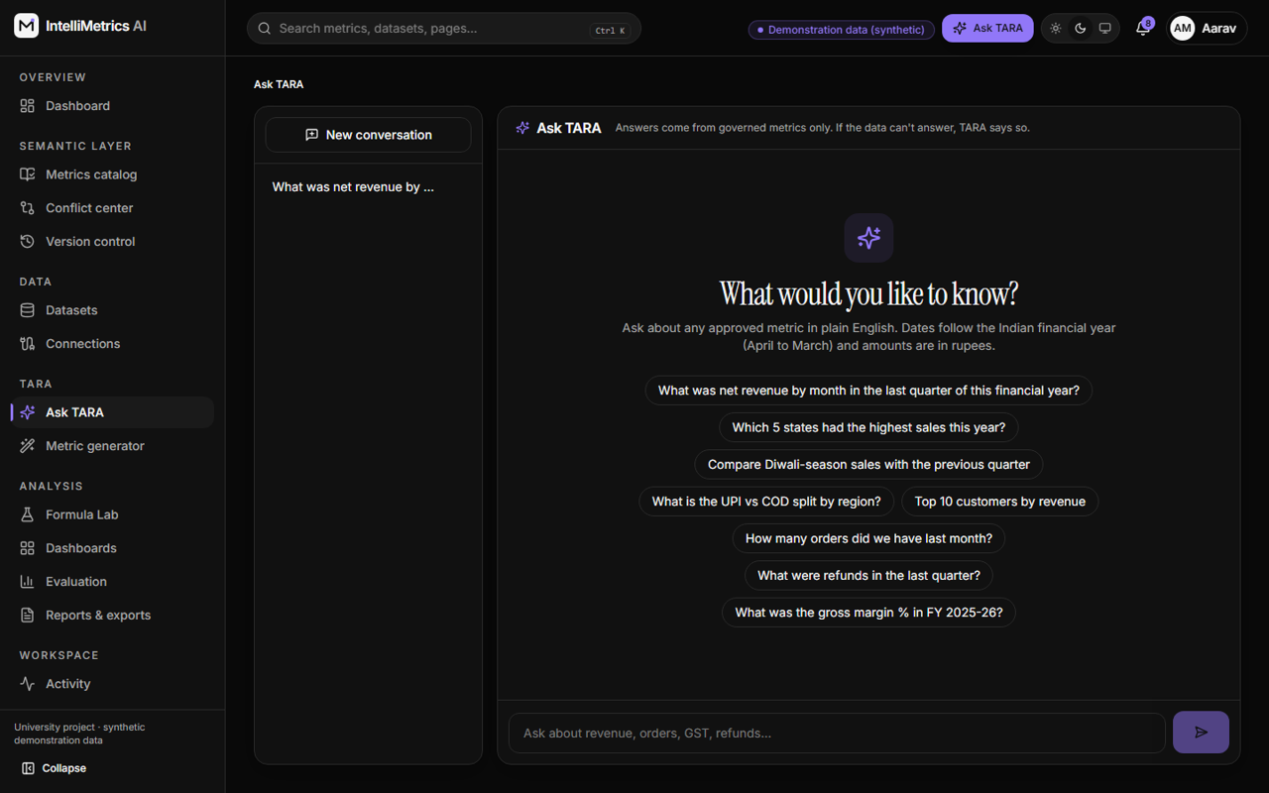
Ask TARA: suggested Indian questions, dark mode
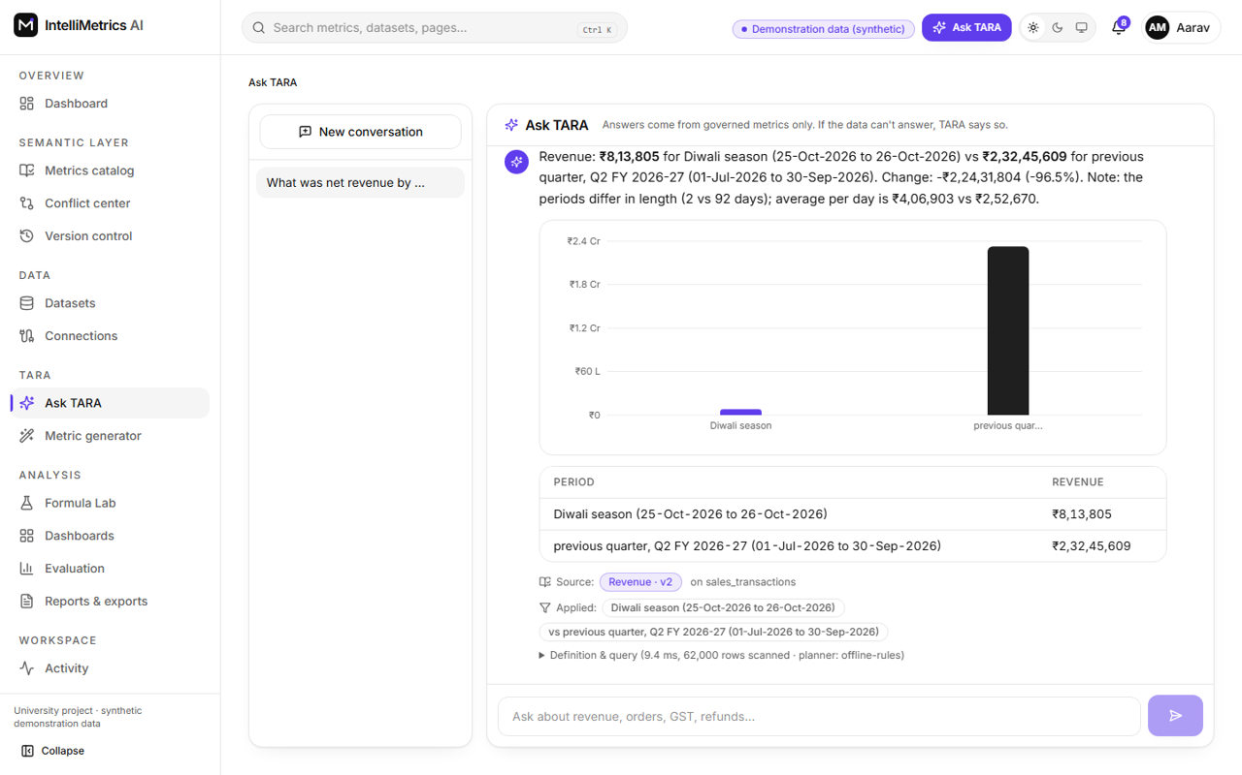
Ask TARA: answers with chart, table, sources and applied filters, light mode
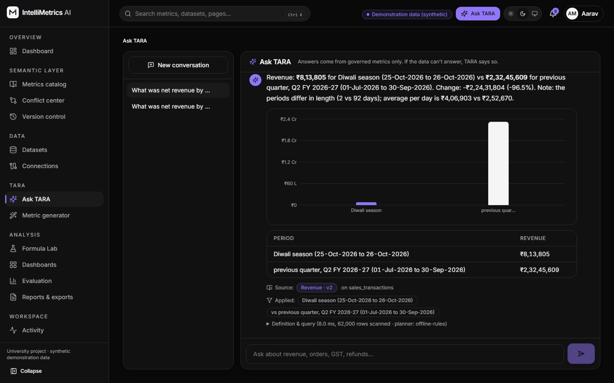
Ask TARA: answers with chart, table, sources and applied filters, dark mode

7.2.9 Dashboards
Saved dashboards with KPI, line, bar, pie and table widgets. Edit layout enables drag-and-resize. Dashboards can follow the latest published definition of each metric or be pinned to a version. Export as PNG, PDF or CSV.
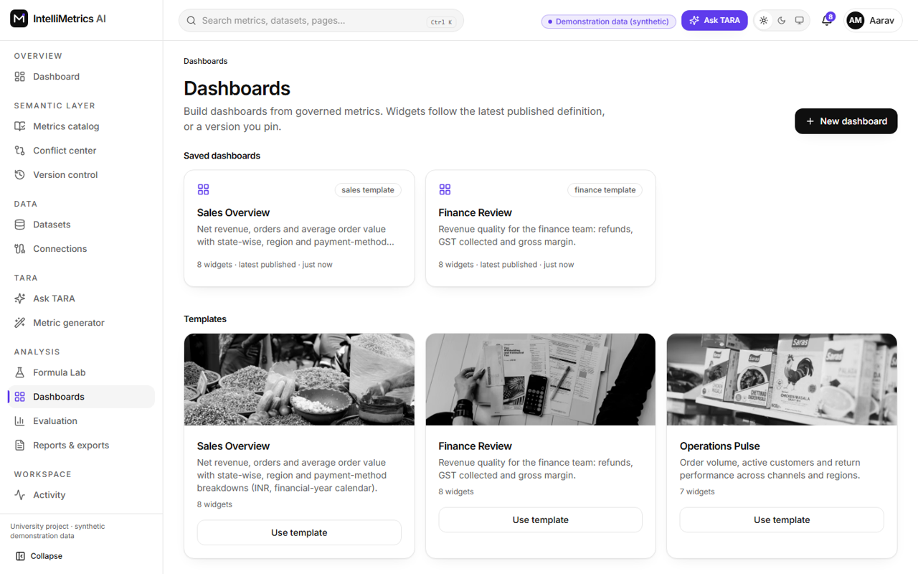
Saved dashboards and templates, light mode
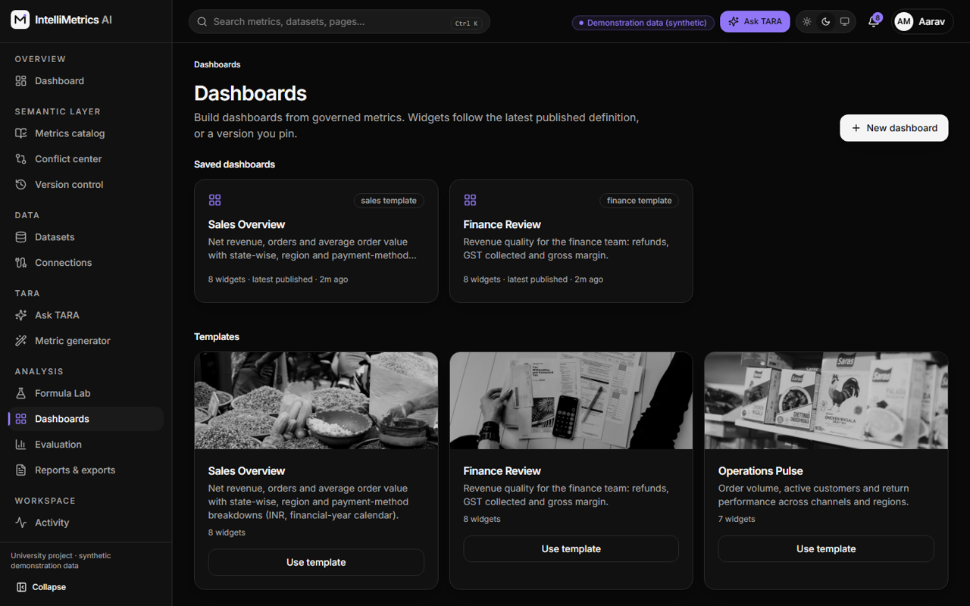
Saved dashboards and templates, dark mode
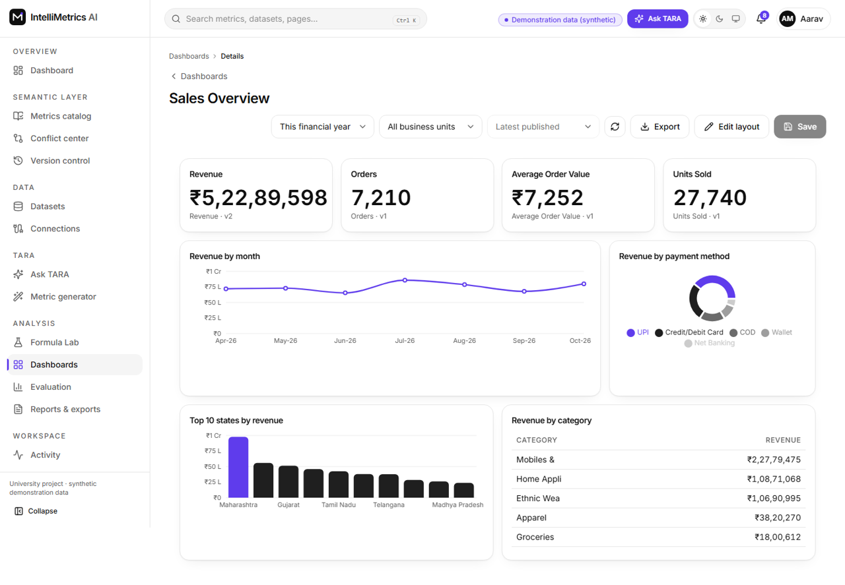
Dashboard builder (Sales Overview), light mode
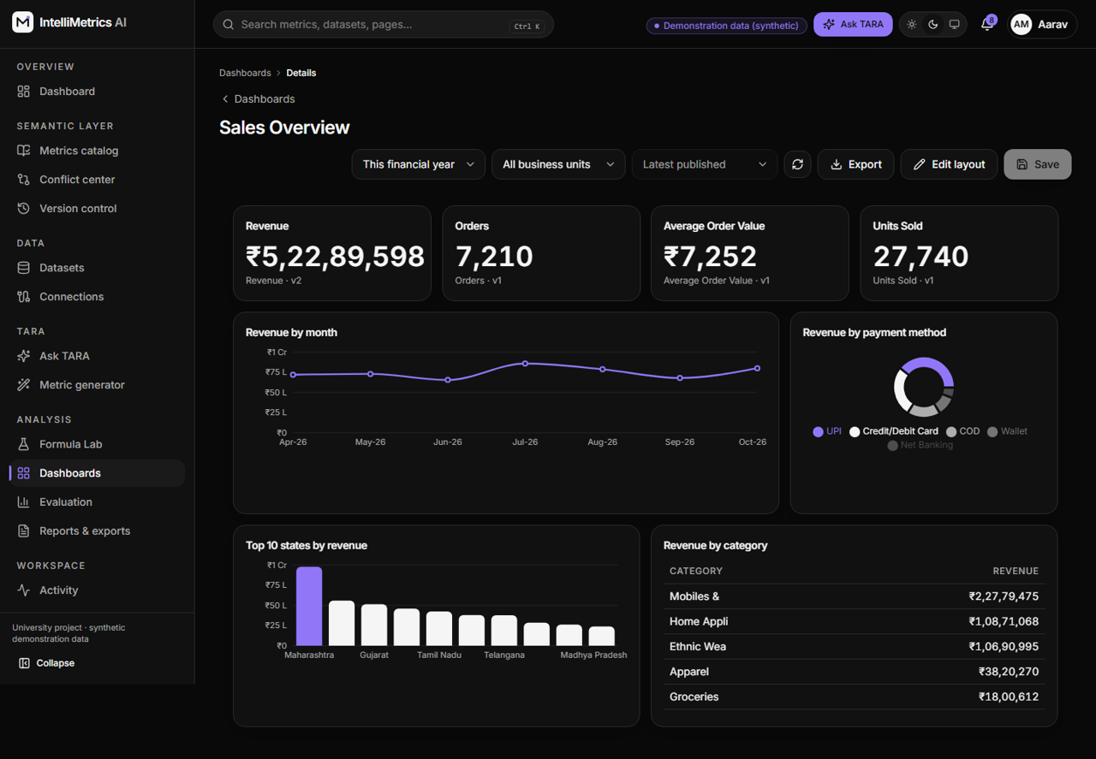
Dashboard builder (Sales Overview), dark mode
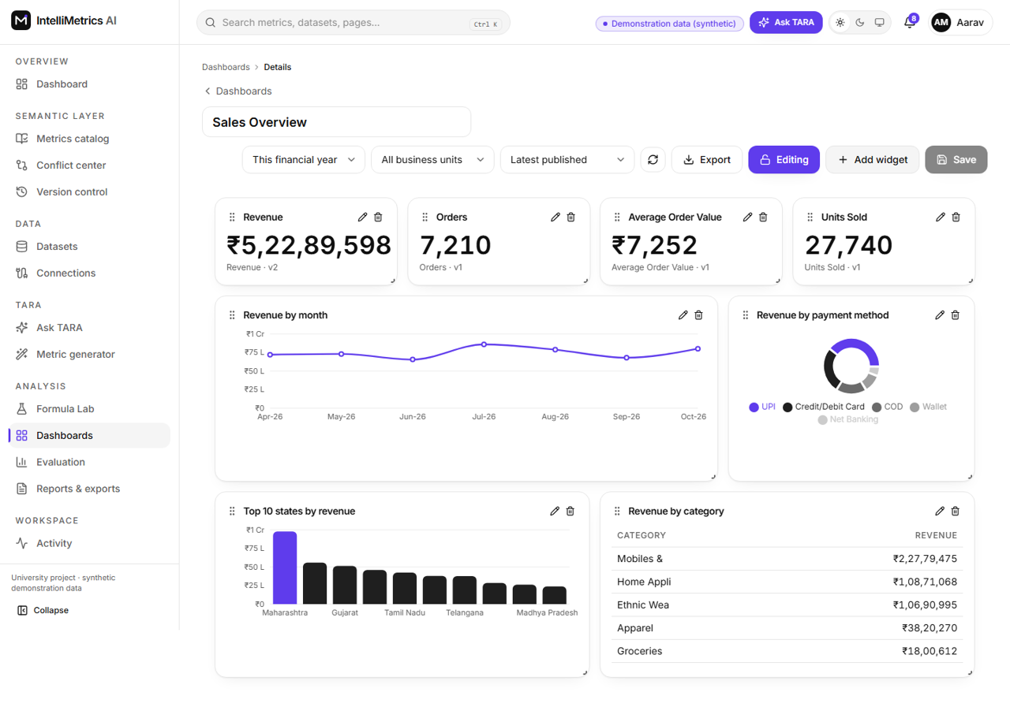
Dashboard builder in edit mode (drag handles), light mode
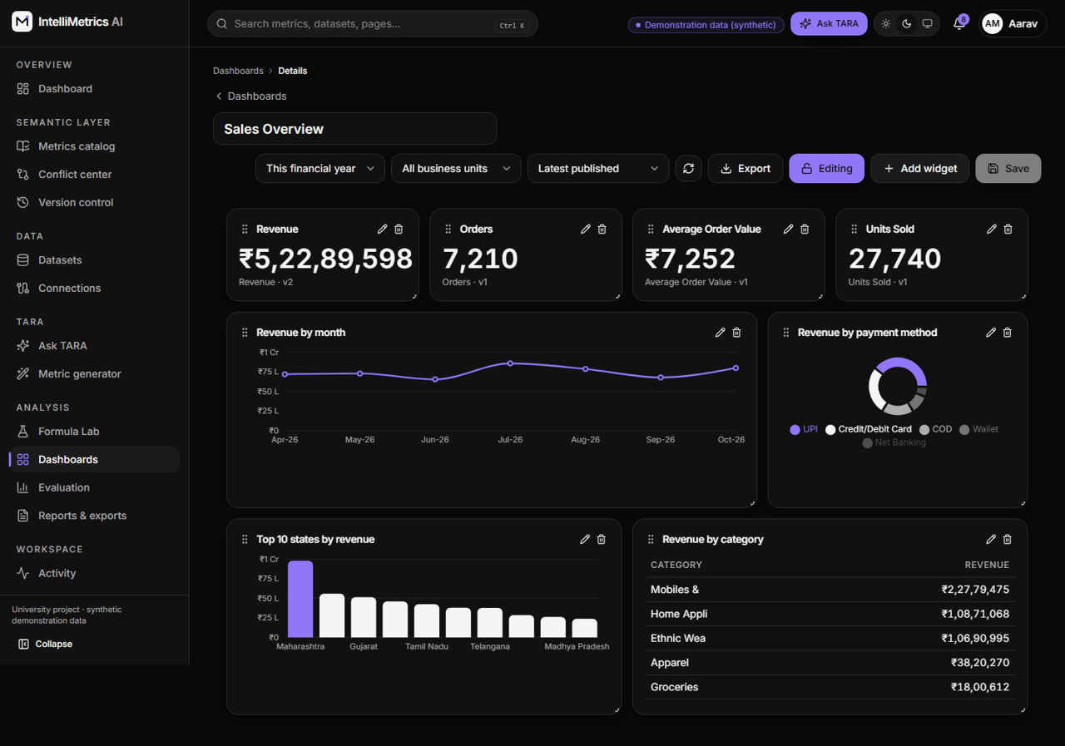
Dashboard builder in edit mode (drag handles), dark mode

7.2.10 Evaluation and reports
Run evaluation measures processing time, query latency, validation pass rate, query success rate, conflict-detection precision and recall on 27 labelled cases, and the AI suggestion acceptance rate. Reports can be exported in CSV, Excel or PDF with rupee formatting and IST timestamps.
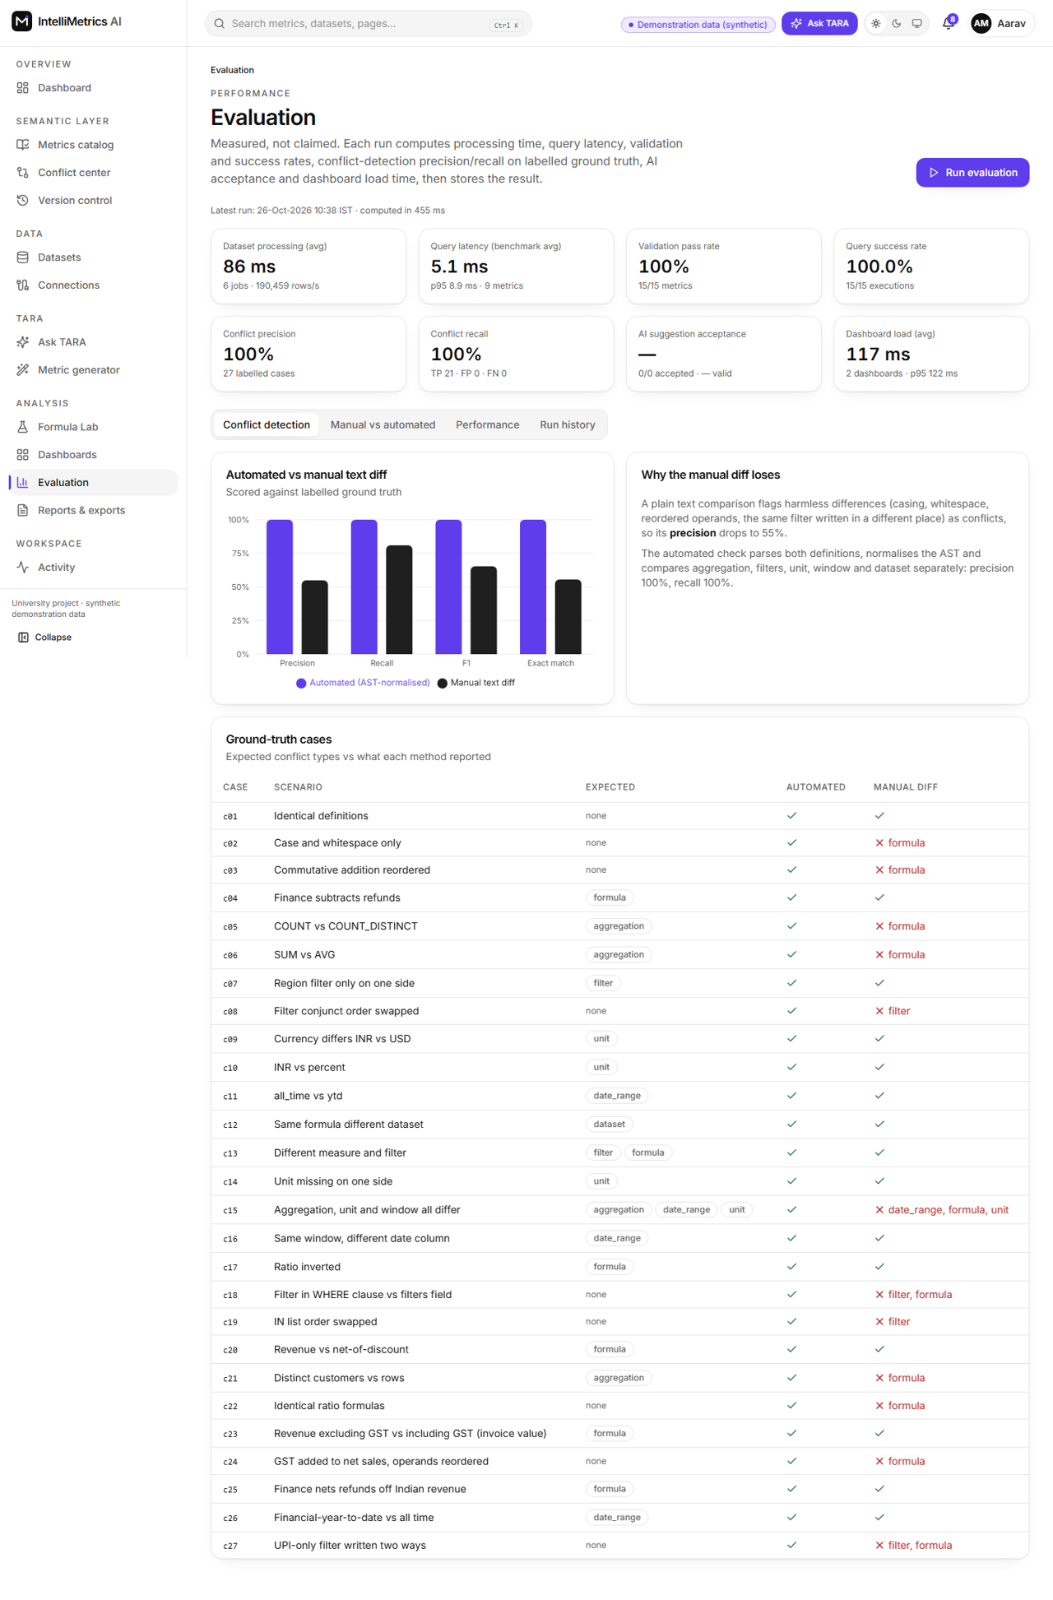
Performance evaluation, light mode
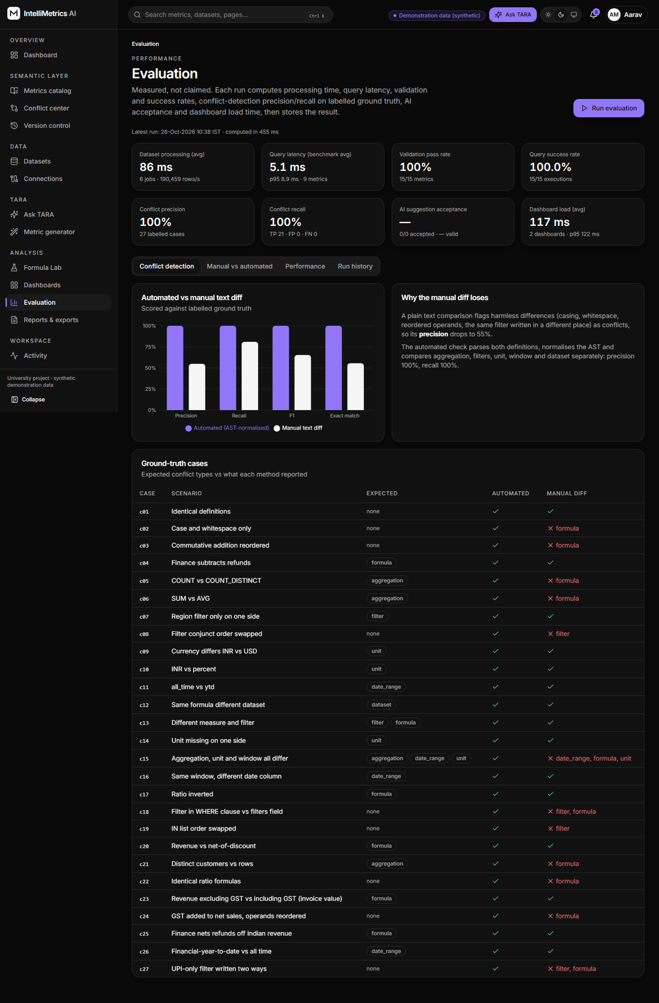
Performance evaluation, dark mode
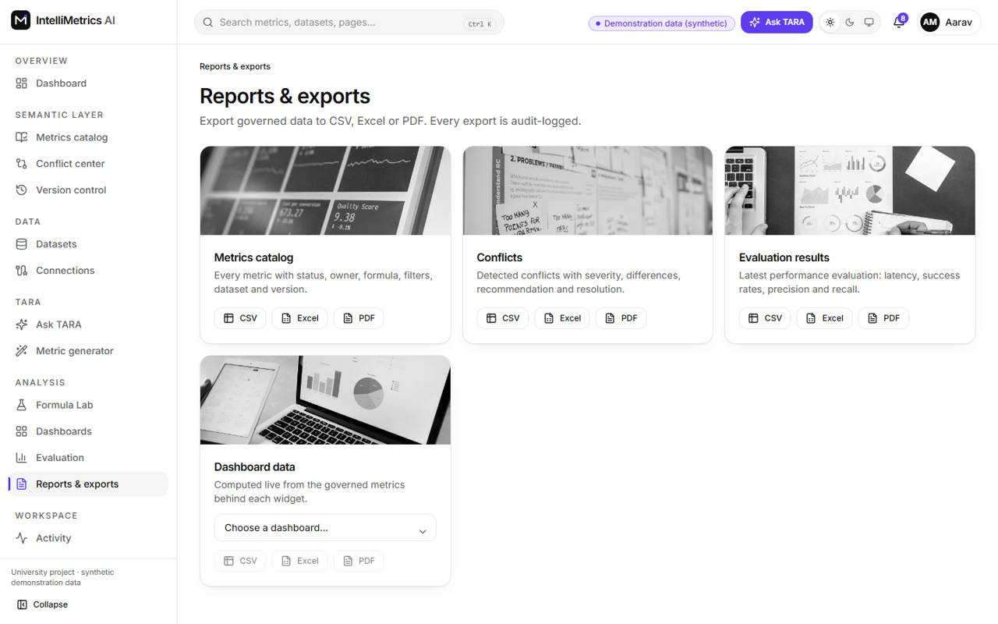
Reports and exports, light mode
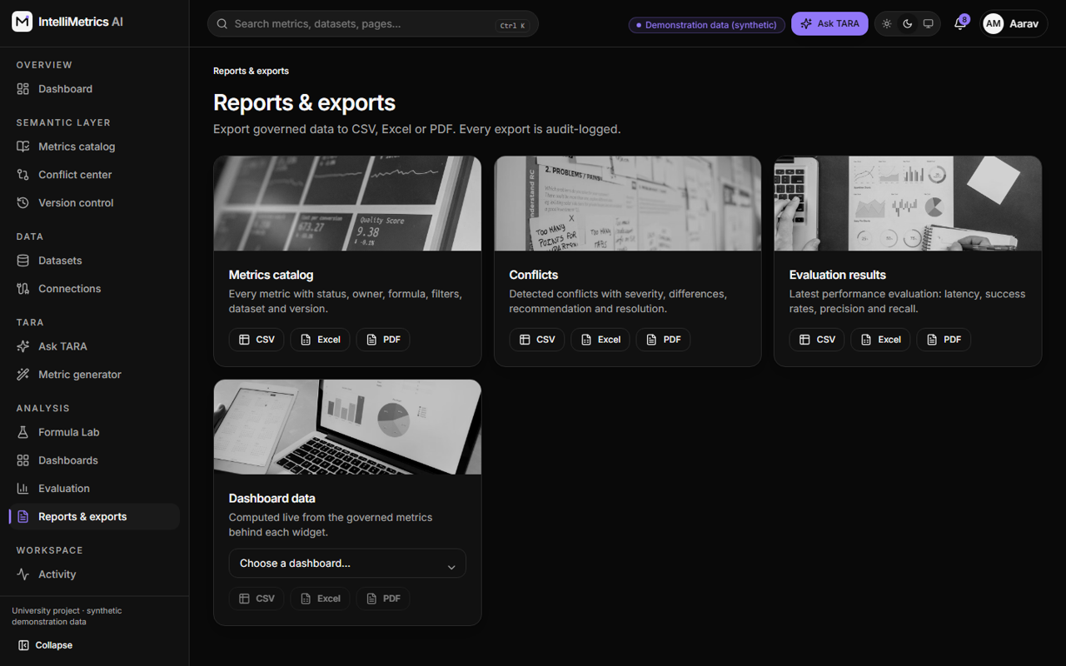
Reports and exports, dark mode

7.2.11 Profile, administration, settings and activity
Admins manage users and roles, and read the audit log (who did what, when, from where). Settings show the AI mode, query limits and API usage.
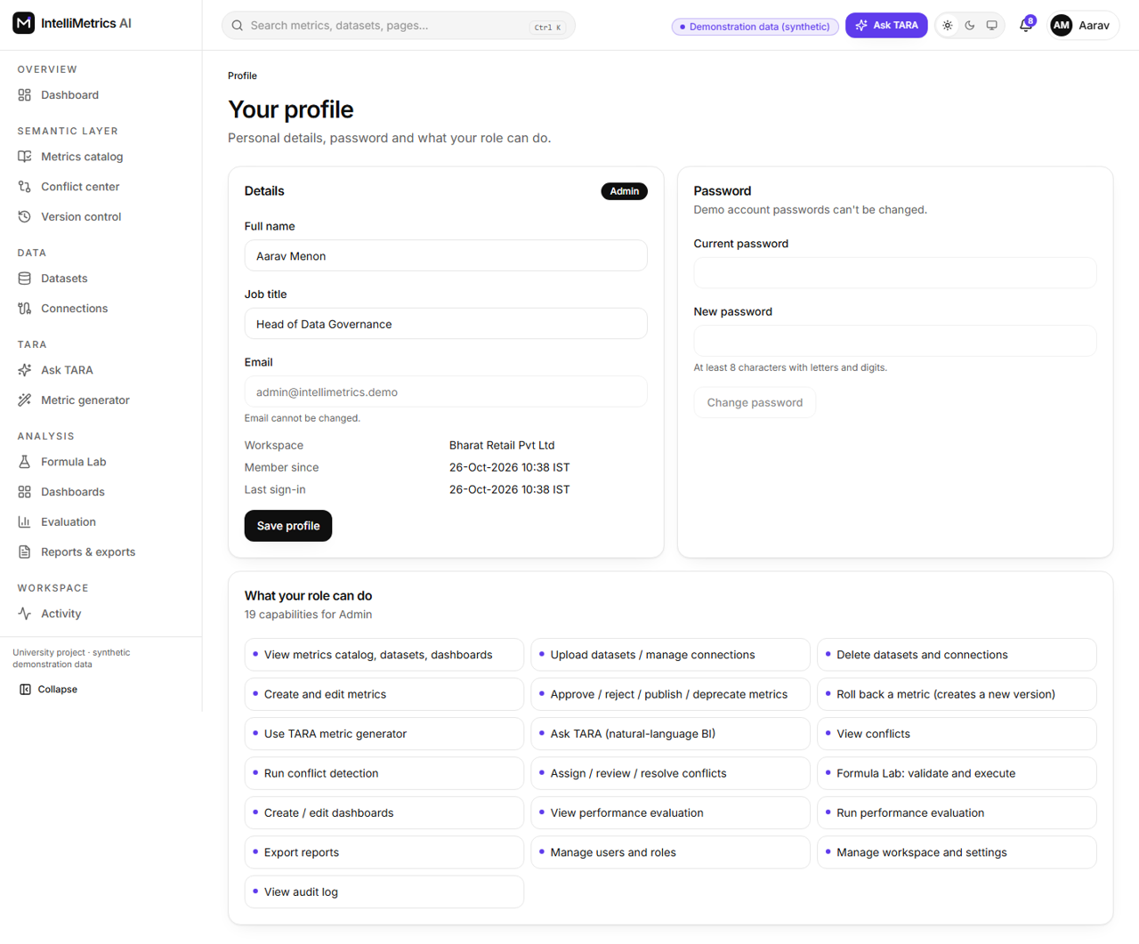
User profile, light mode
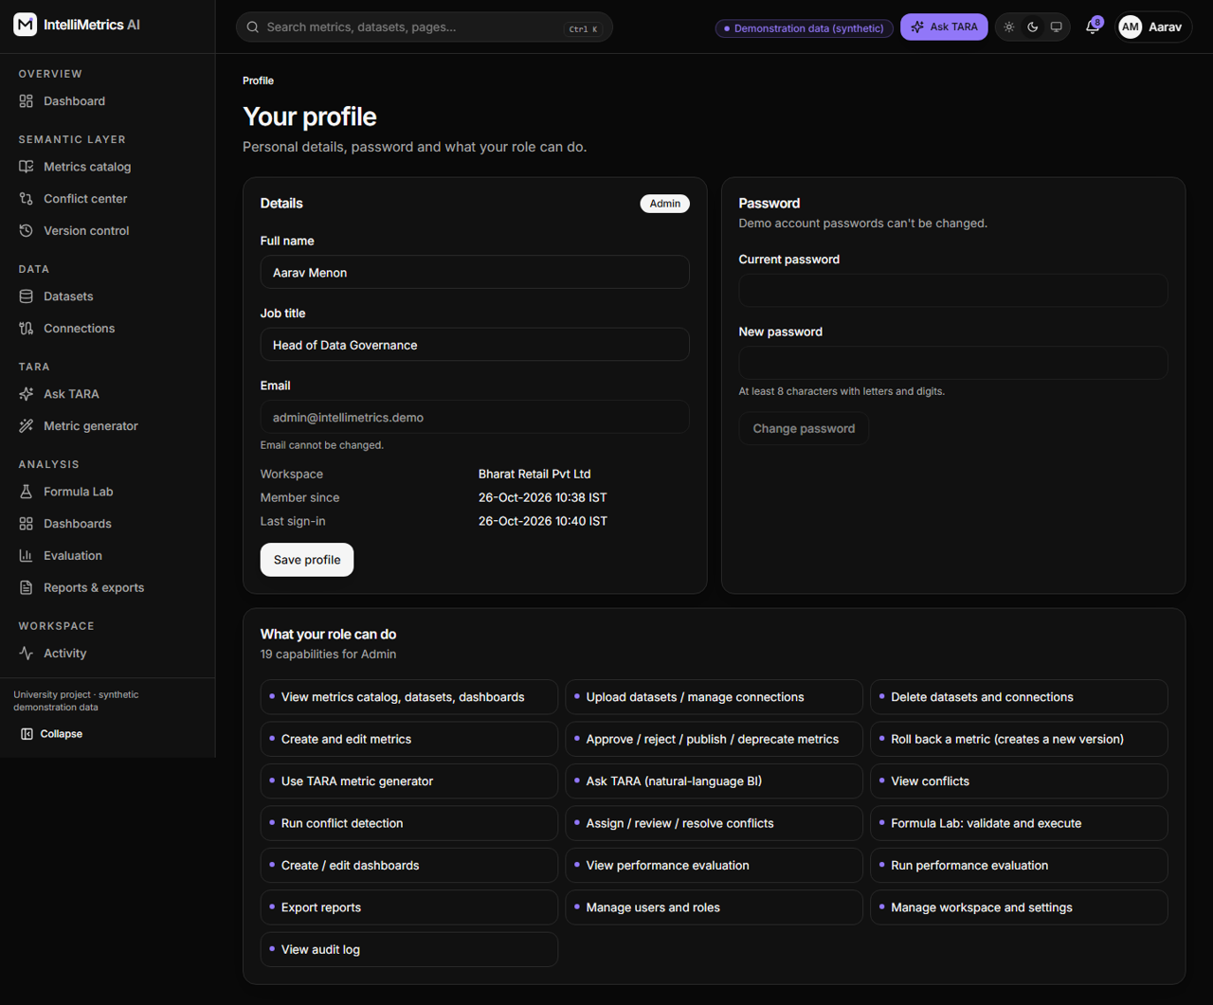
User profile, dark mode
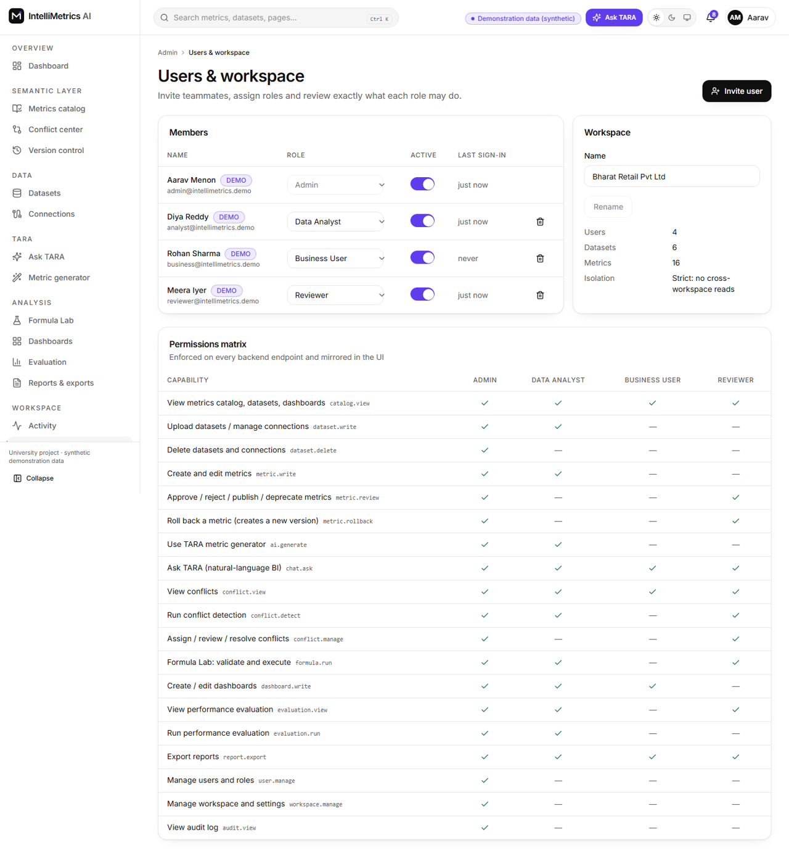
Workspace and user management, light mode
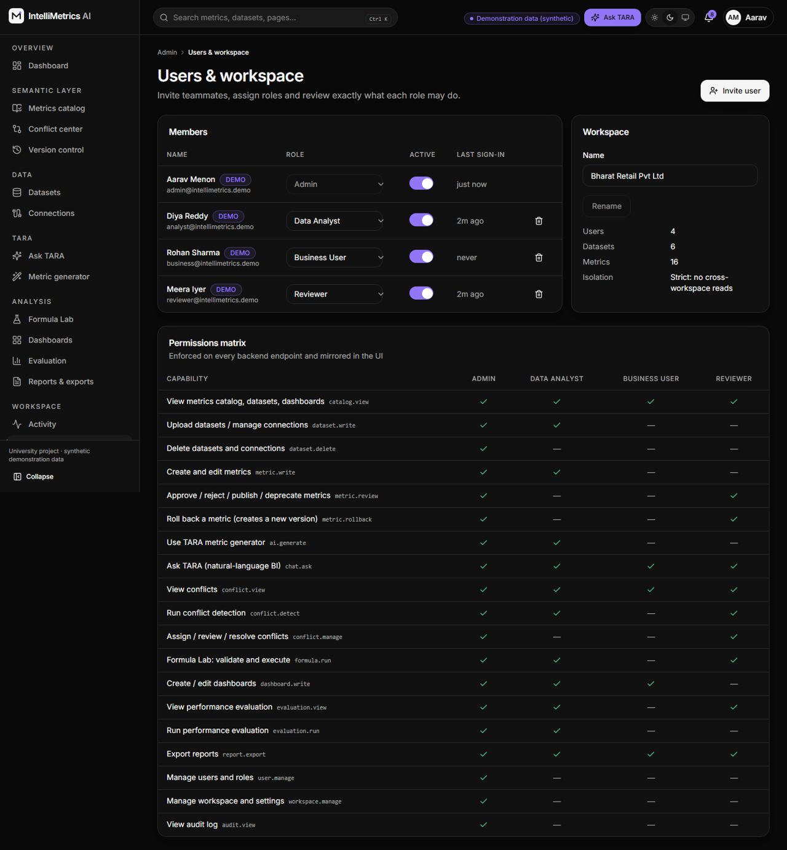
Workspace and user management, dark mode
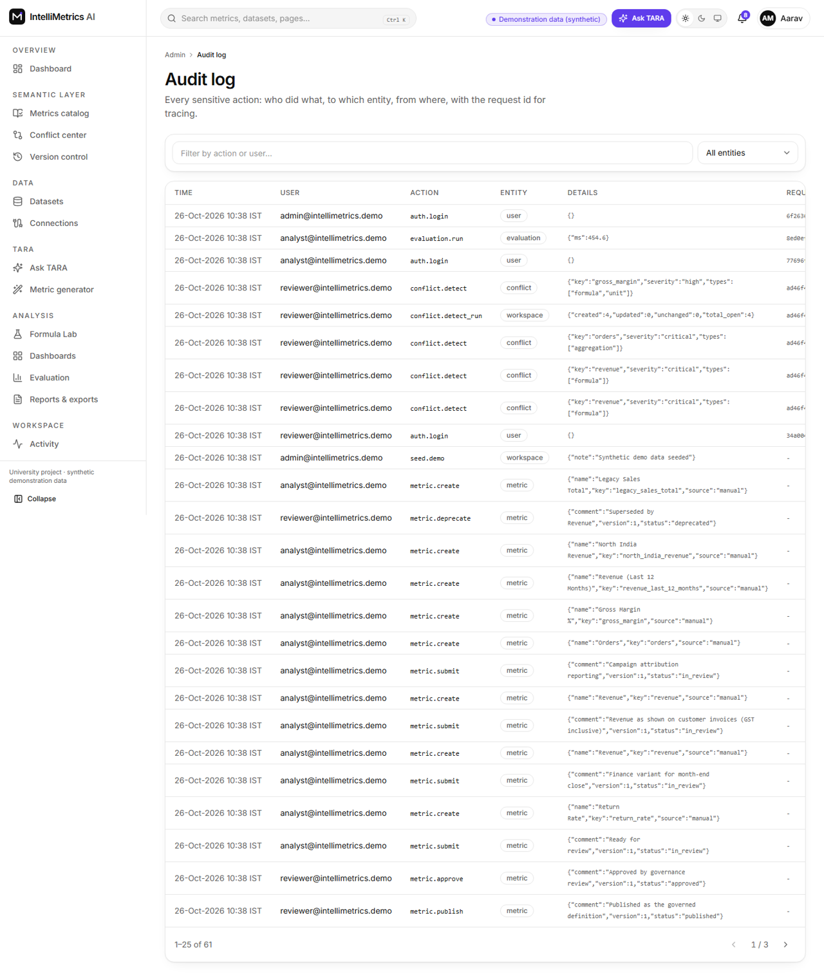
Audit log, light mode
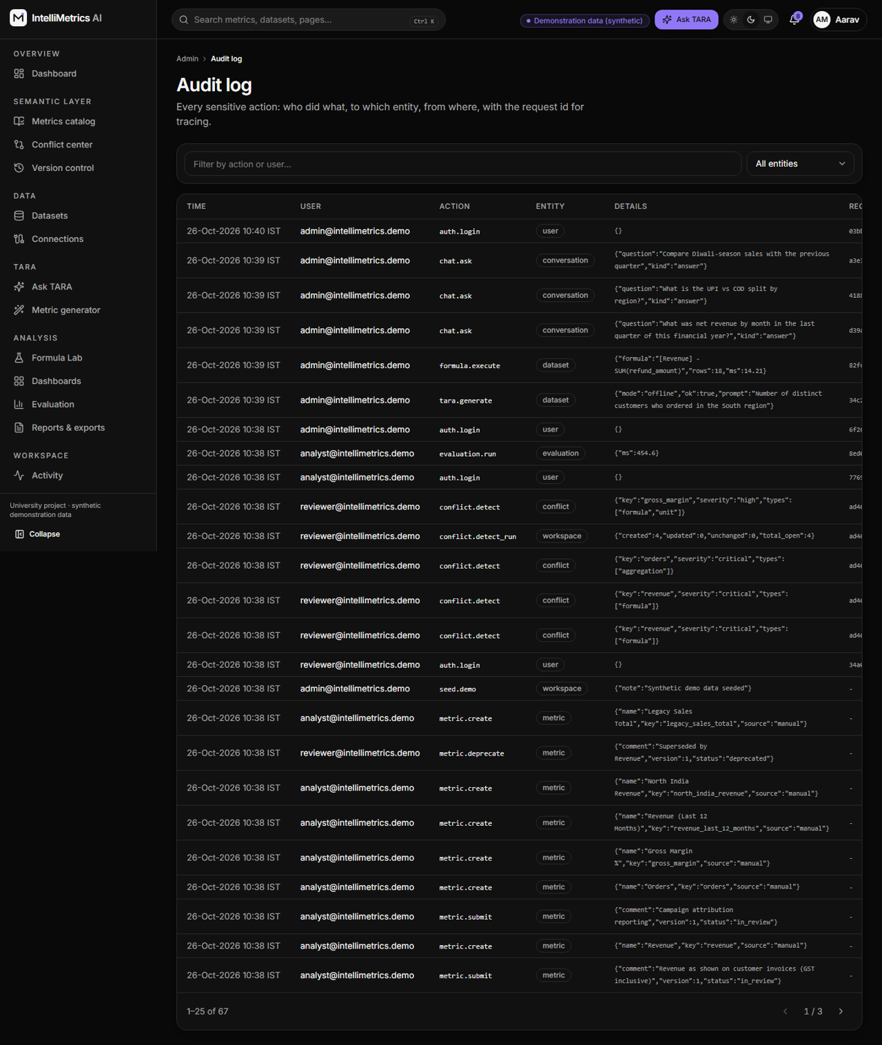
Audit log, dark mode
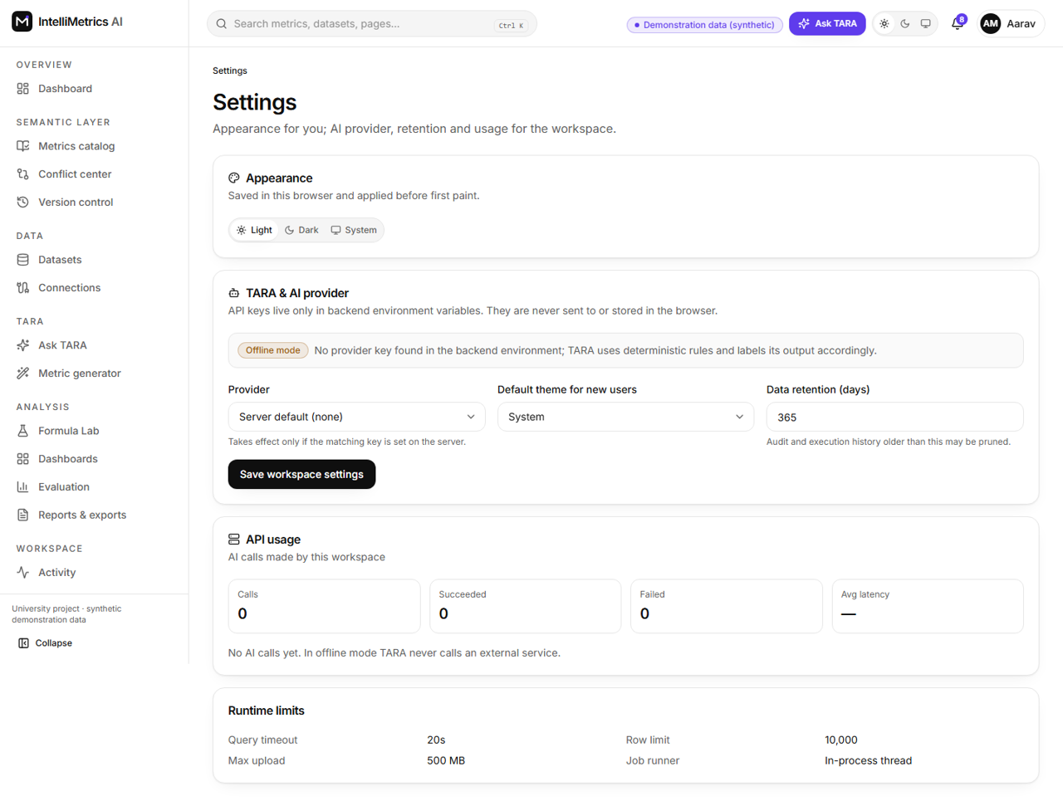
Application settings, light mode
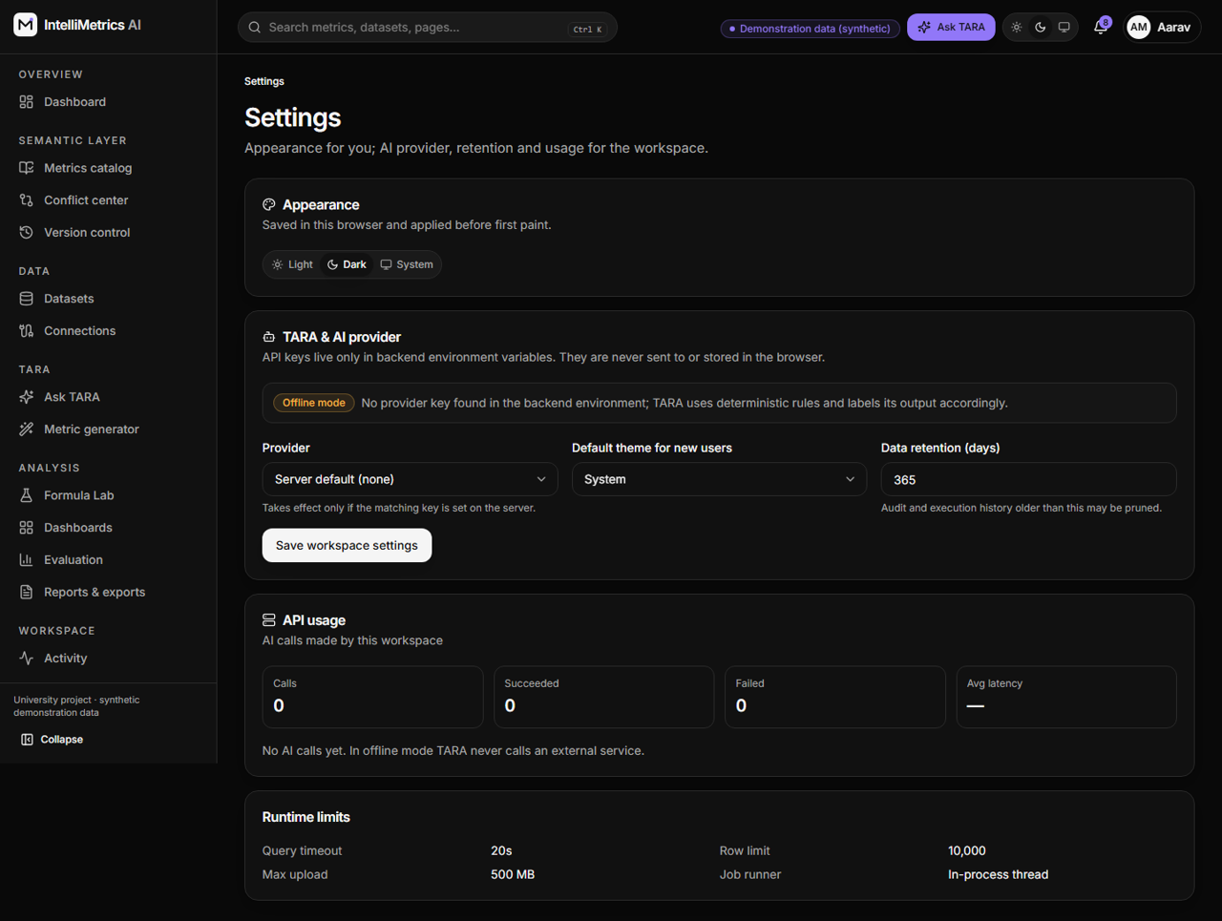
Application settings, dark mode
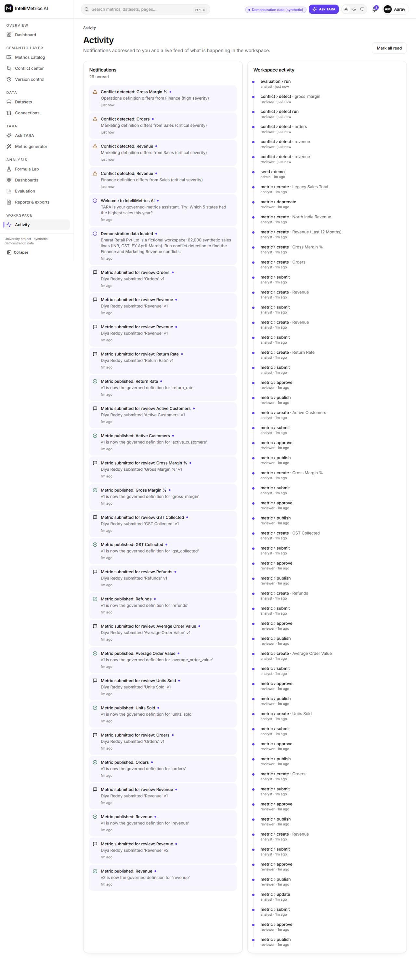
Notifications and activity, light mode
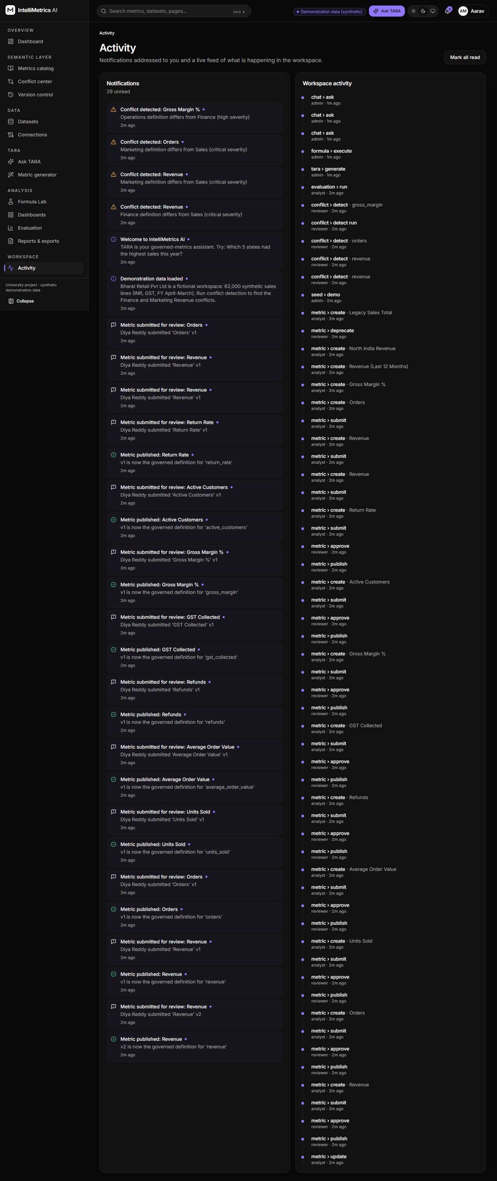
Notifications and activity, dark mode

7.3 Phone-sized screens
The layout adapts to phone widths (390 px was checked).
Mobile: landing page
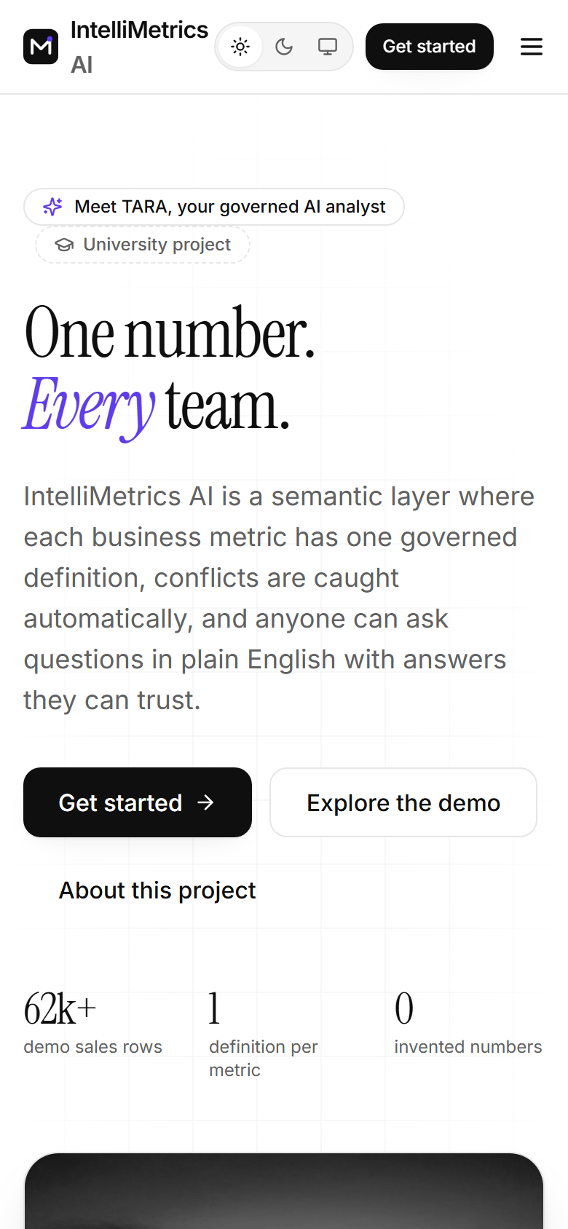
Mobile: landing page, light mode
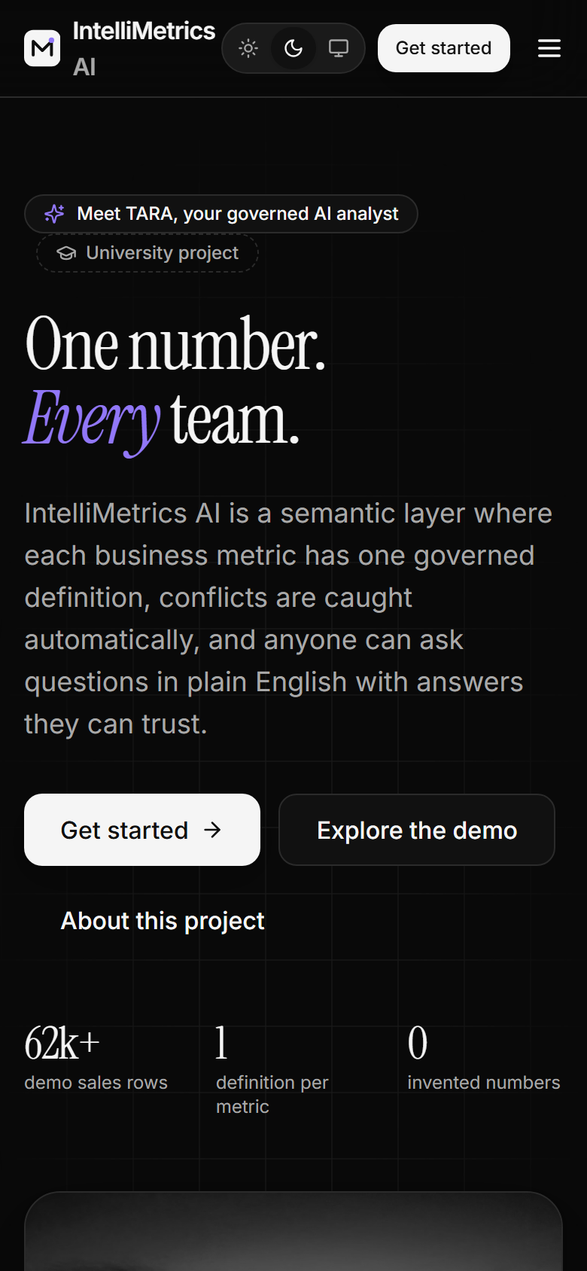
Mobile: landing page, dark mode
Mobile: dashboard
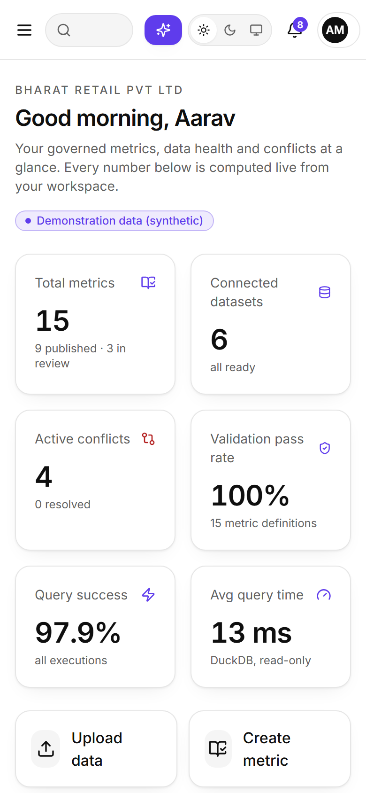
Mobile: dashboard, light mode
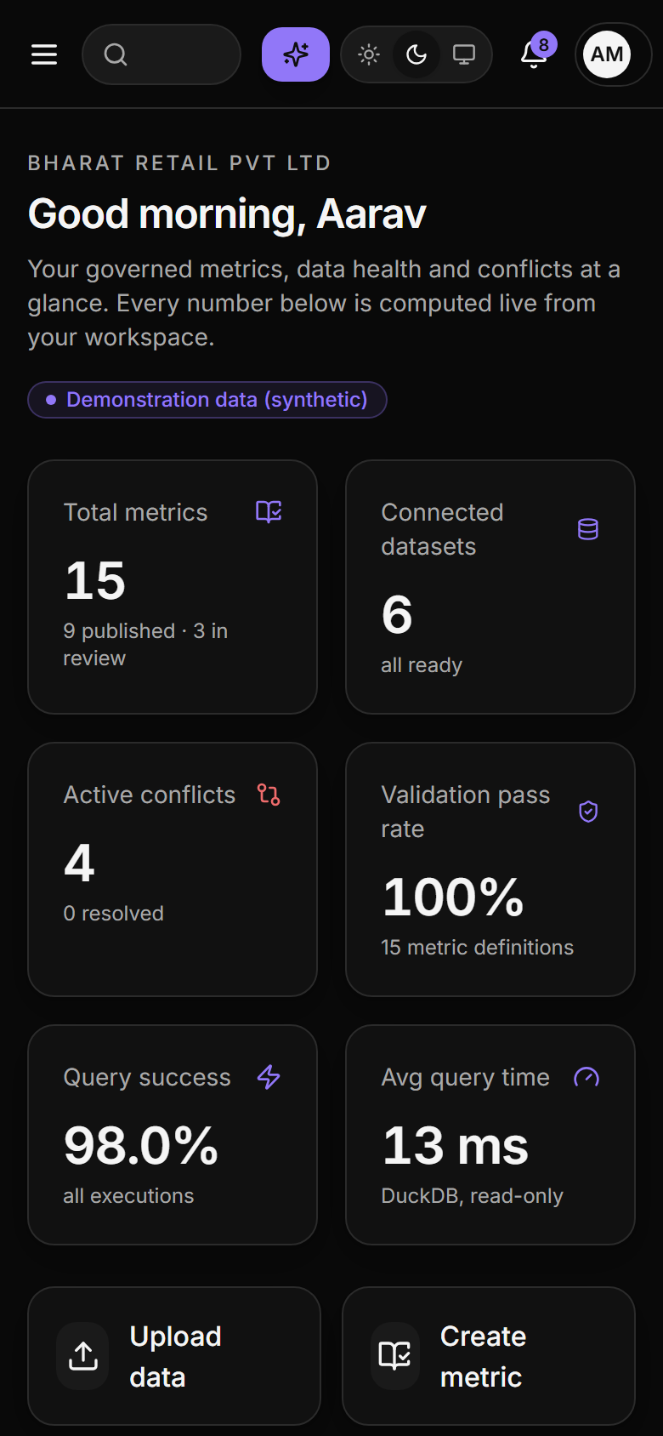
Mobile: dashboard, dark mode
Mobile: Ask TARA
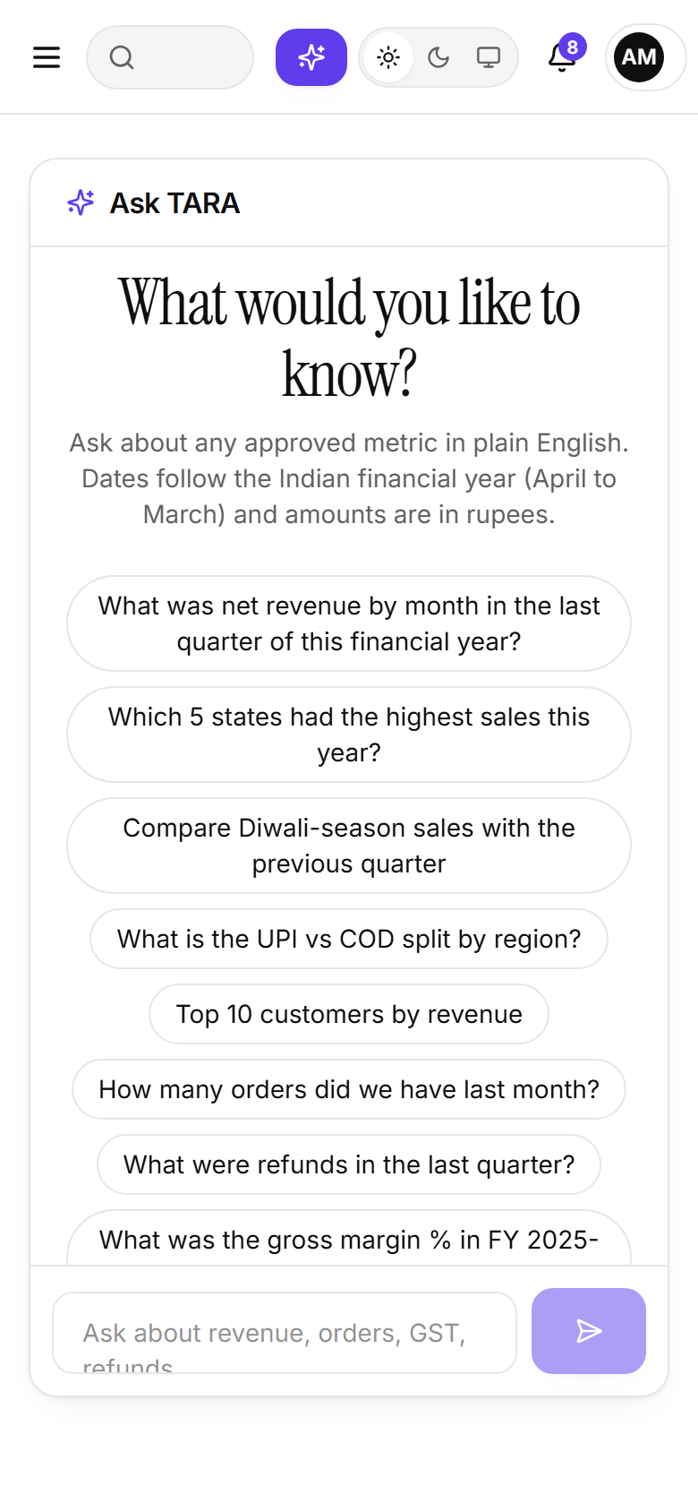
Mobile: Ask TARA, light mode
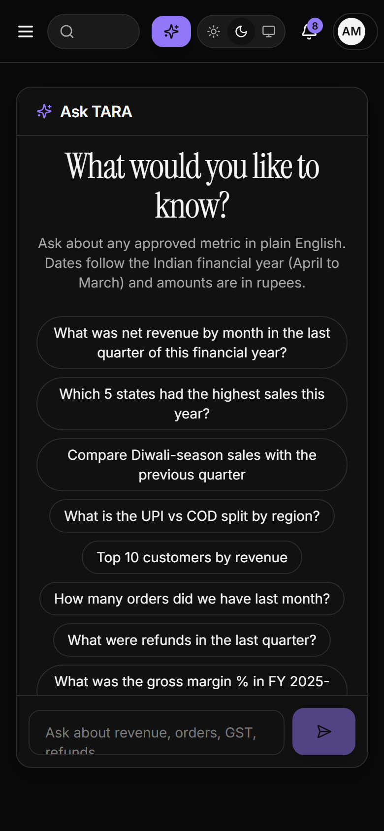
Mobile: Ask TARA, dark mode

8 A ten-minute walkthrough
Use the desktop browser at http://localhost:5173 (or the port you chose).
Step | Sign in as | Do this | You should see
1 | Meera Iyer (Reviewer) | Open Conflict detection, click Run conflict detection | Conflicts for Revenue: the Finance version subtracts refunds; the Marketing version uses the GST-inclusive invoice value
2 | Meera Iyer | Open the Finance conflict; Assign to Meera Iyer, Start review, Approve, then Resolve by renaming the variant (for example to Net Revenue) and adding a note | The renamed metric becomes version 2, and the “Audit history” lists every step
3 | Diya Reddy (Analyst) | Open Formula Lab, choose sales_transactions, enter [Revenue] - SUM(refund_amount), group by state, Execute | A table of rupee values by state, with rows scanned and duration
4 | Diya Reddy | Replace the formula with SUM(net_sales); DROP TABLE users | A red error, “Nothing was executed”
5 | Rohan Sharma (Business User) | Open Ask TARA and click each suggested question in turn | See below
6 | Rohan Sharma | Ask “What is the weather in Delhi?” | A refusal saying TARA could not match the question to an approved metric; no number is invented
7 | Rohan Sharma | Open Dashboards, then Sales Overview | KPI cards, trend line and breakdowns in rupees
8 | Aarav Menon (Admin) | Open Audit log | Every action above with user, time (IST) and request id
9 | Suresh Naidu (other workspace) | Open Metrics and Datasets | Only Sagar Foods data; nothing from Bharat Retail
The suggested questions in step 5 are:
- What was net revenue by month in the last quarter of this financial year? A monthly line or bar of the last completed April–March quarter.
- Which 5 states had the highest sales this year? A ranked table and bar chart; “this year” means the financial year to date from 1 April.
- Compare Diwali-season sales with the previous quarter. Two labelled date ranges, both totals, and a per-day note because the periods differ in length.
- What is the UPI vs COD split by region? A grouped chart with each payment method’s share of the region.
- Top 10 customers by revenue. A ranked table.
Every answer lists the metric and version used, the date range in DD-MMM-YYYY, and the filters applied.

9 Understanding Indian conventions in the application
Topic | How the application behaves
Currency | Rupee symbol, lakh/crore digit grouping (12,45,300), compact forms ₹45 L and ₹1.2 Cr
Financial year | 1 April to 31 March. Q1 = April–June, Q2 = July–September, Q3 = October–December, Q4 = January–March. “This year” means the financial year to date
Dates and time | DD-MMM-YYYY, times in IST (Asia/Kolkata)
GST | net_sales is the taxable value excluding GST; net_amount is the invoice value including GST. The two Revenue definitions differ by exactly the GST, which is why the GST conflict is detected
Festivals | Diwali, Dussehra, Pongal/Sankranti, Eid, Holi and the End-of-Season sale have date windows that TARA understands (“Diwali-season”)
Payment methods | UPI, card, net banking, wallet and cash on delivery (COD)

10 Troubleshooting
Problem | Cause and fix
python -m app.seed says the database is locked | The back end is still running. Stop it, then seed again
Browser shows “Failed to fetch” or a blank page | The back end is not running on port 8000. Start it and reload
Page loads but images are grey gradients | Offline, or the photo host is blocked. Harmless; the application is fully usable
Dataset stays on pending | In the no-Docker route a background thread processes it; check the back-end console for an error. With Celery, make sure a worker and Redis are running
Everything works but TARA says “offline deterministic mode” | Expected without an AI key. Set AI_PROVIDER and the key in the back-end environment to enable live AI
Login fails for a demo account | The database was seeded before the accounts changed. Run scripts\reset-demo.ps1
Port already in use | Change --port for uvicorn (and VITE_API_PROXY for the front end), or stop the other program
npm install is slow | First install downloads about 300 MB of packages; later runs are cached

11 Running the tests
cd backend; python -m pytest tests -q
cd frontend; npx vitest run
cd frontend; npx playwright install chromium; npx playwright test
The Testing Report lists what each suite covers and the measured results.

