System Architecture and Design
Devi Priya, Priyanka, Akshay and Bhaskar

System Architecture and Design
Architecture, data design and API reference (generated from the code)
Project title | IntelliMetrics AI: A Governed Semantic Layer with TARA, an AI Assistant for Trusted Business Metrics
Document | System Architecture and Design
Team members | Devi Priya, Priyanka, Akshay and Bhaskar
Guide | Dr. Asesh Kumar Tripathy
Institution | KL University
Academic year | 2026-27
Date | 24-Oct-2026 (IST)
Status | University project: academic capstone with synthetic demonstration data

Table of contents
- 1 Overview
- 2 High-level architecture
- 3 Component diagram
- 4 Deployment diagram
- 5 Request flow: Ask TARA
- 6 Dataset ingestion pipeline
- 7 Formula compile pipeline
  - 7.1 Grammar
- 8 Conflict detection flow
- 9 State machines
- 10 Security architecture
  - 10.1 Role-based access control
  - 10.2 Workspace isolation
  - 10.3 Other controls
- 11 Indian calendar and planner
- 12 Data design
  - 12.1 Entity-relationship diagram
  - 12.2 Data dictionary
- 13 API reference summary
- 14 Use cases by role

1 Overview
IntelliMetrics AI is a three-layer web application with a separate background-job layer. This document describes the architecture with diagrams, the data design (ER diagram and data dictionary) and the API. The API reference, data dictionary, permission matrix and statistics in this document are generated from the source code by docs/tools/gen_reference.py; they are not hand-written, so they cannot drift from the implementation.
Fact (generated) | Value
API endpoints | 96
Routers | 16
Database tables | 20
Role capabilities | 19
Back-end source | 46 Python files, 7,115 lines
Back-end tests | 7 files, 1,072 lines
Front-end source | 54 TypeScript files, 4,707 lines; 25 page components
End-to-end tests | 2 files, 292 lines

2 High-level architecture
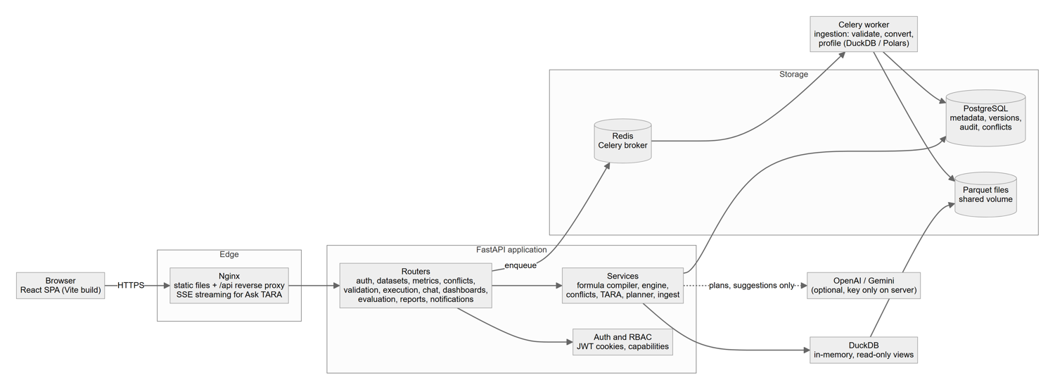
High-level architecture
The browser talks only to Nginx (production) or the Vite dev proxy (development), so the SPA and API share one origin and the httpOnly cookies are first-party. FastAPI authenticates every request, authorises it by capability, filters every query by workspace, and delegates work to services. Long-running ingestion is placed on a Celery queue (Redis) and executed by a worker. Analytical queries are never sent to PostgreSQL: they run in DuckDB over Parquet files produced by ingestion.

3 Component diagram
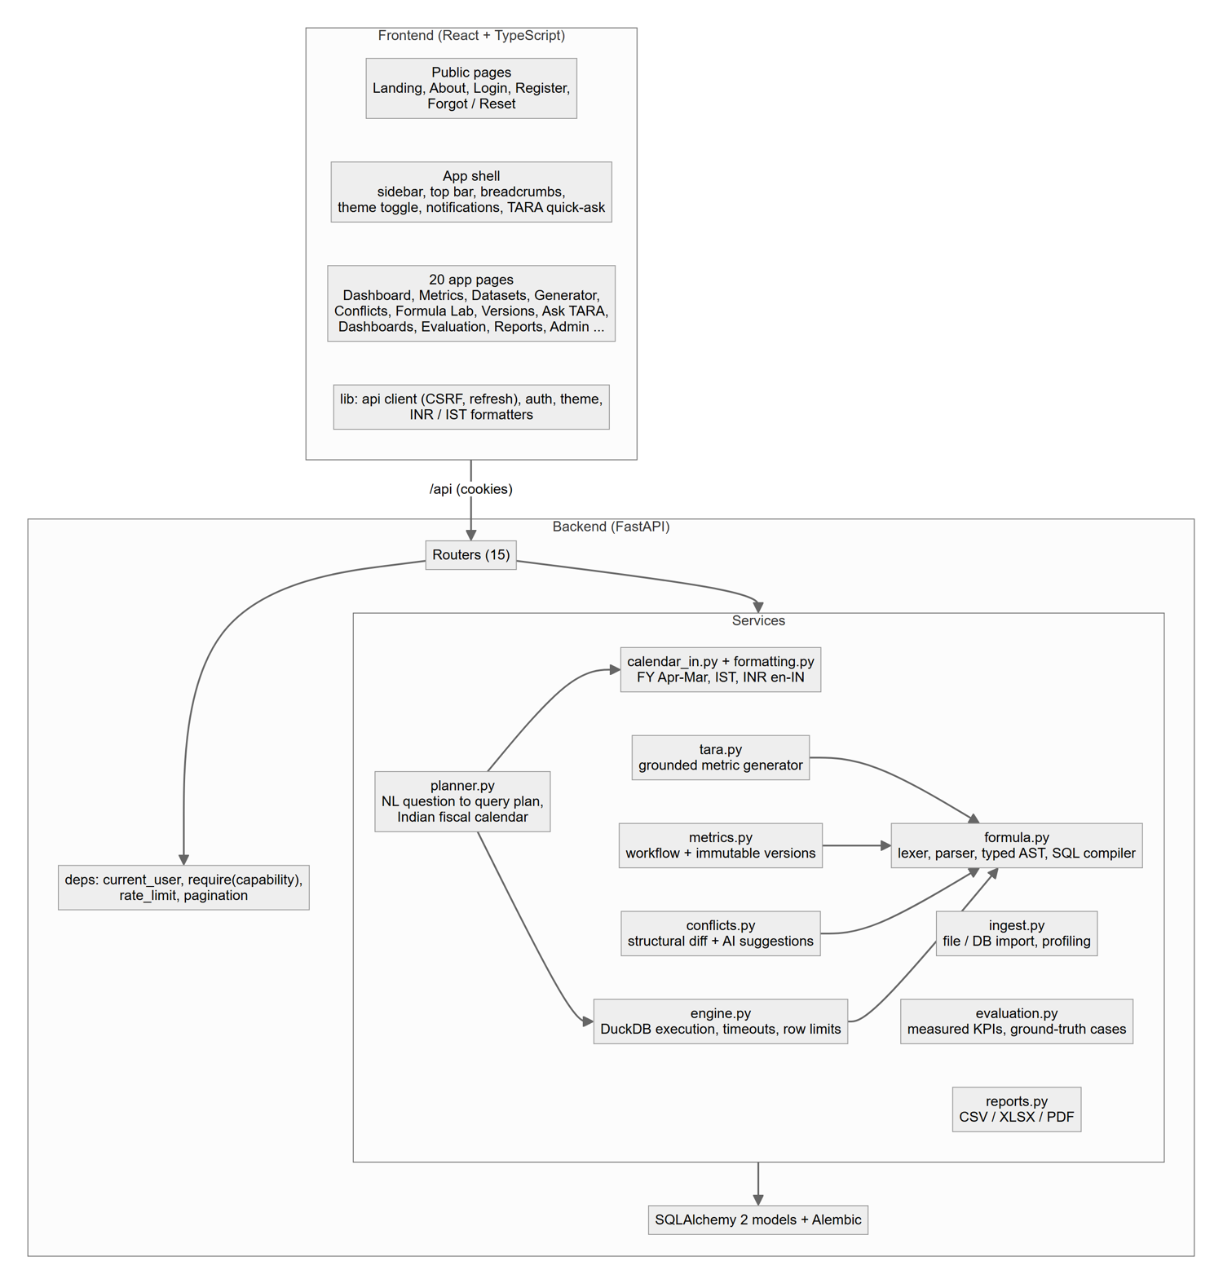
Components of the front end and back end
Responsibilities are layered so that safety-critical logic exists once: the formula compiler is used by the Formula Lab, metric validation, the TARA generator, the Ask TARA pipeline, dashboards and the evaluation module. The planner only produces a query plan; the engine executes it.

4 Deployment diagram
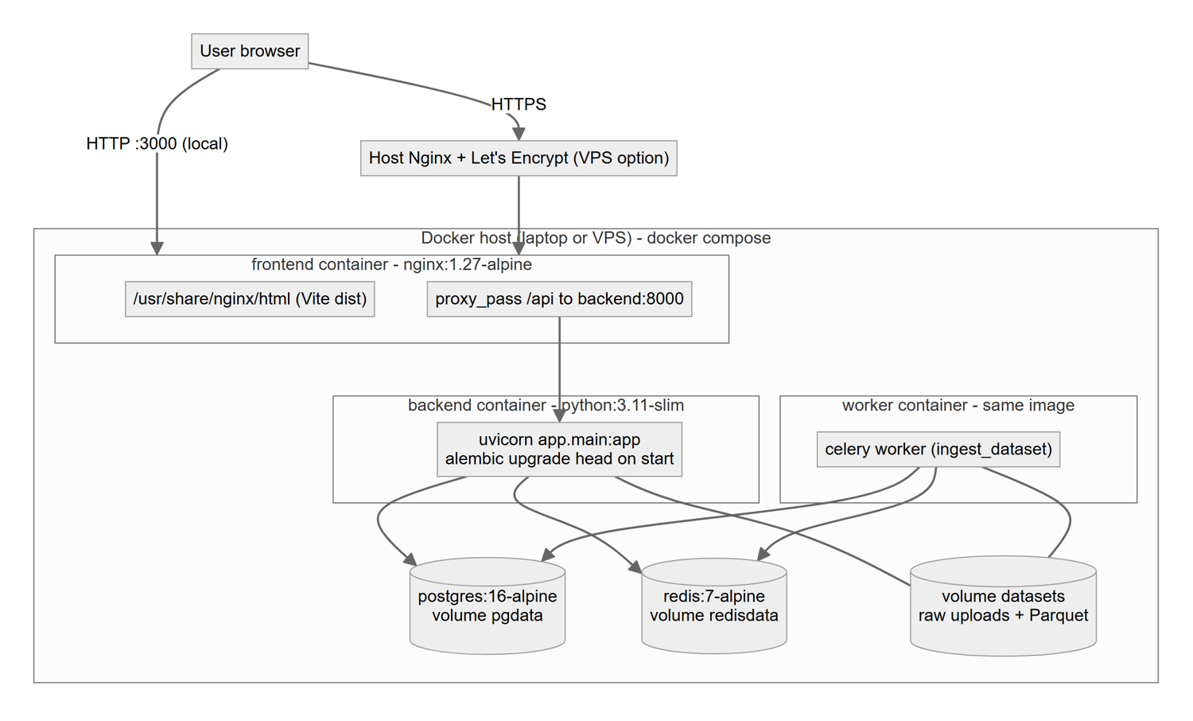
Docker Compose deployment (and optional VPS TLS terminator)
Persistent volumes: pgdata (PostgreSQL), redisdata (Redis append-only file) and datasets (raw uploads and Parquet), the last mounted in both the API and the worker so the worker’s output is visible to the API. The backend container runs alembic upgrade head on every start and seeds the demonstration data when AUTO_SEED=true and the database is empty.

5 Request flow: Ask TARA
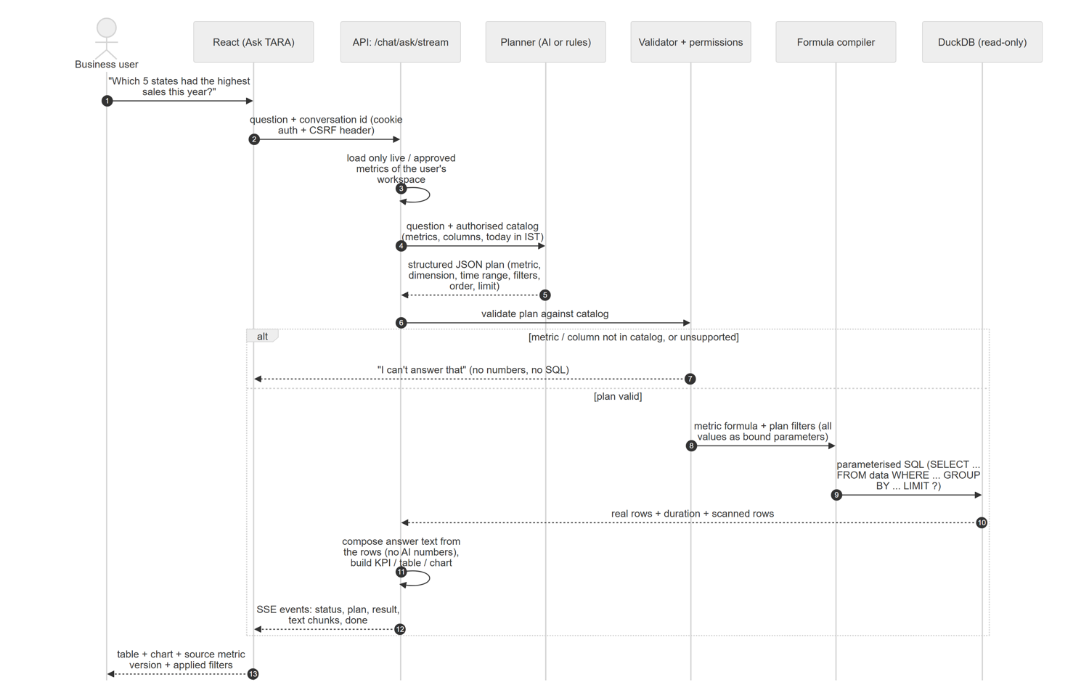
Sequence of an Ask TARA question
Key safety properties of this flow:
- The planner receives only the authorised catalog (live or approved metrics of the user’s own workspace on ready datasets) and today’s date in IST.
- Its output is a JSON plan, validated by Pydantic and then by validate_plan, which rejects unknown metrics or columns; a forged plan cannot reach the database.
- The SQL is produced by the same compiler as in the Formula Lab; every value is a bound parameter.
- The answer text is composed from the returned rows; the AI does not write the figures.

6 Dataset ingestion pipeline
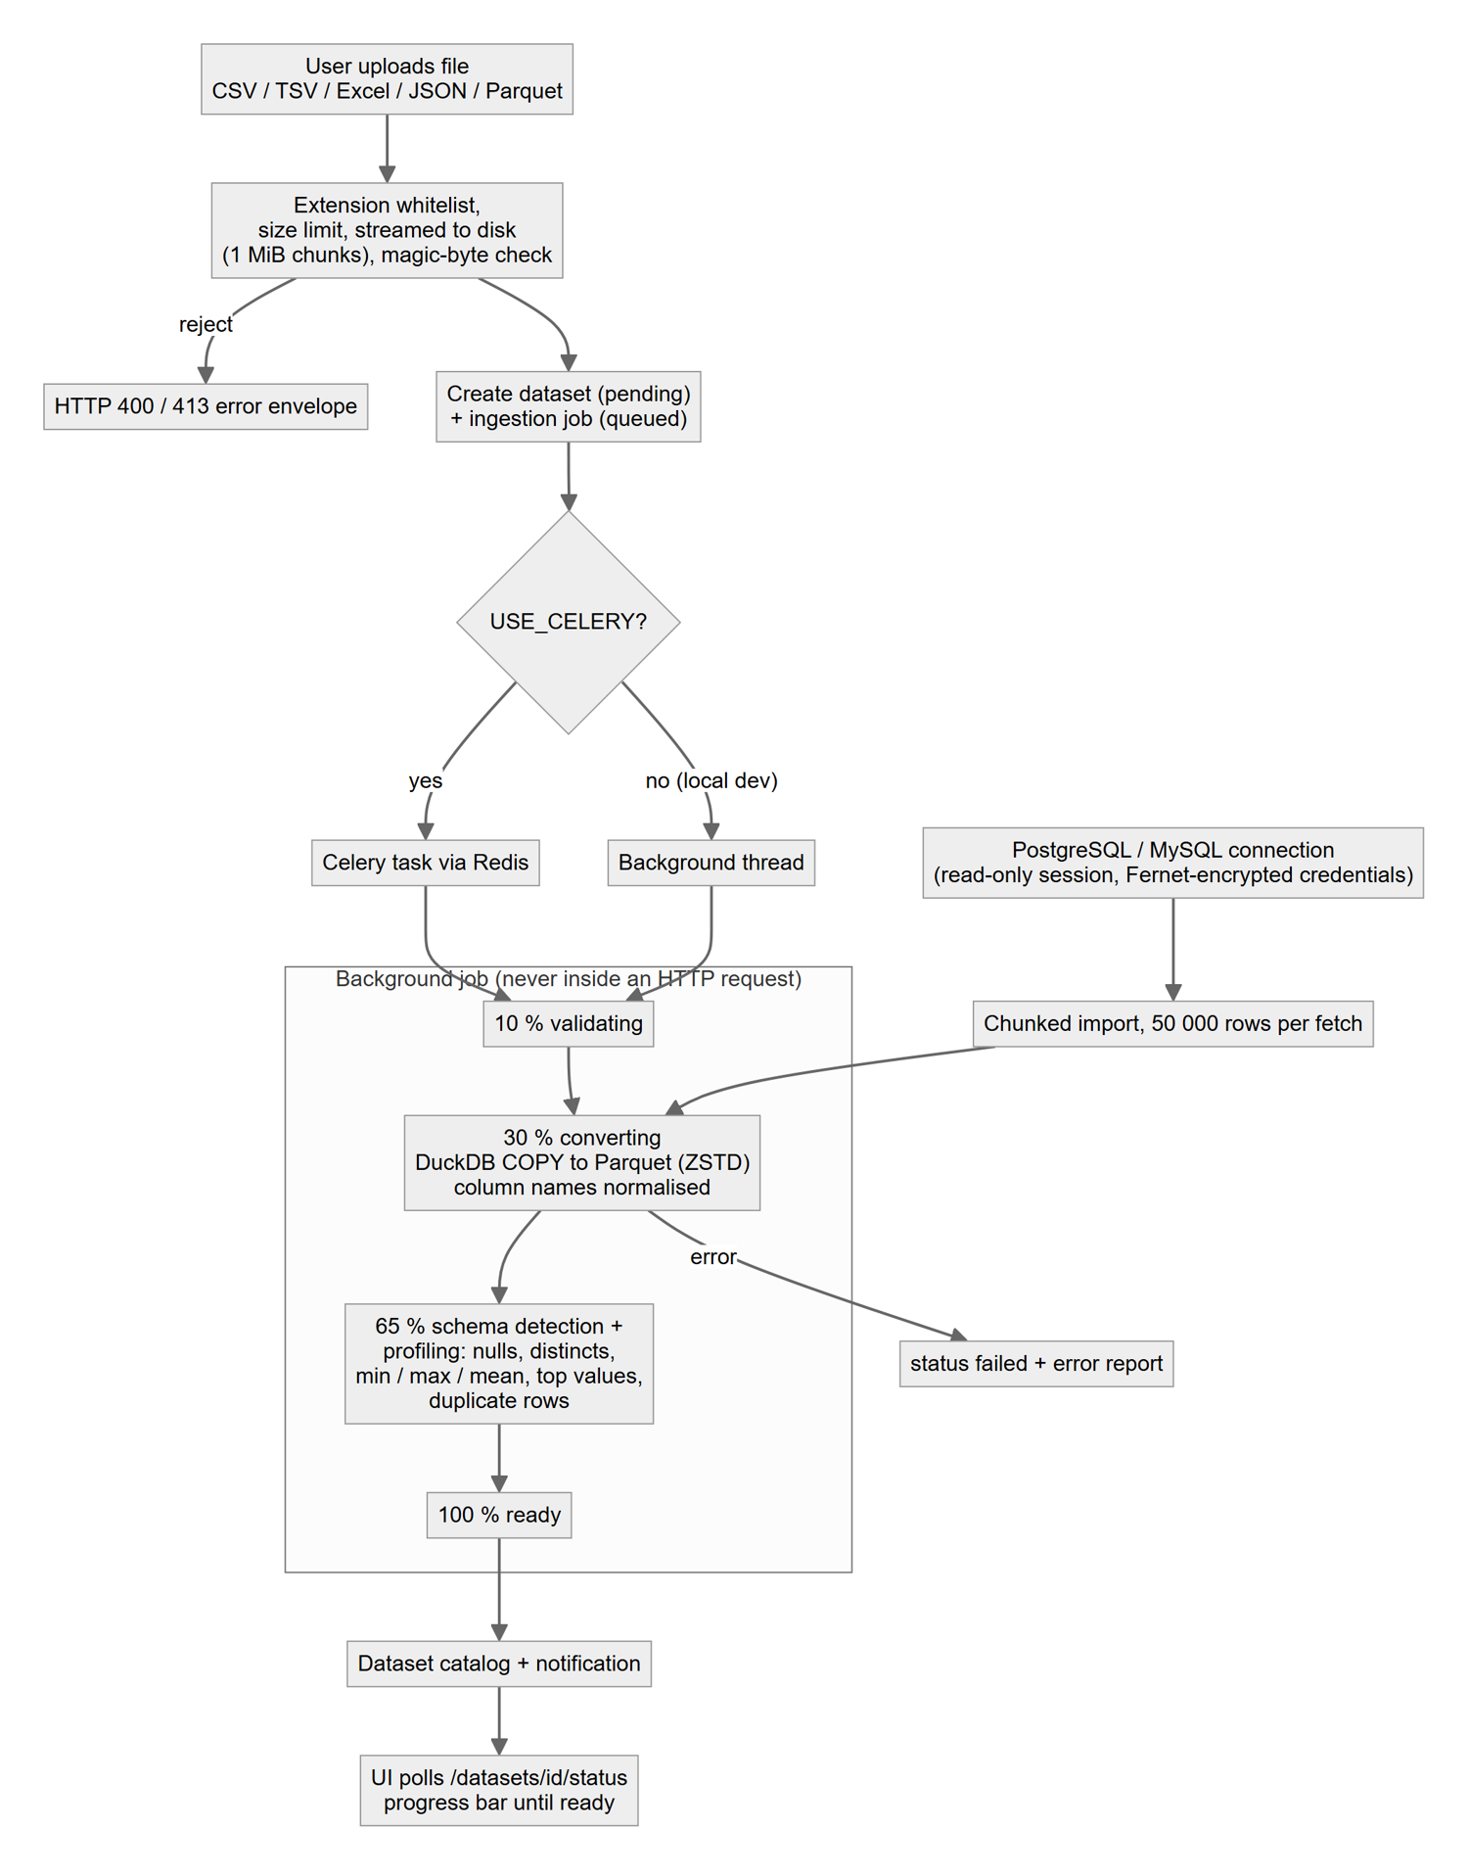
Ingestion pipeline
Uploads are streamed to disk in 1 MiB chunks with an extension whitelist, a size limit and a magic-byte check. The job converts to ZSTD-compressed Parquet with DuckDB COPY (CSV rejects are recorded in an error report), normalises column names to snake_case, detects the schema and the default date column, and profiles every column in a single scan (null counts, approximate distinct counts, min, max, mean, standard deviation, top values) plus a duplicate-row count. External PostgreSQL/MySQL tables are streamed in 50,000-row chunks through a read-only session into a PyArrow Parquet writer.

7 Formula compile pipeline
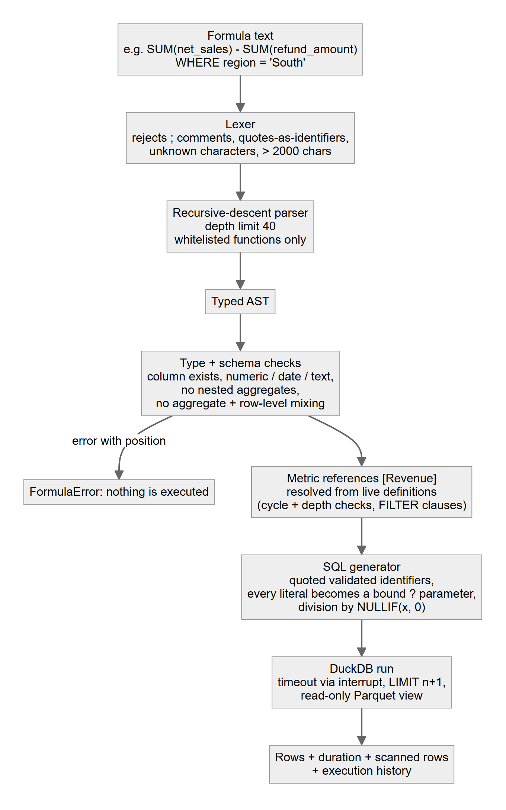
Formula lexer, parser, type checker and SQL generator

7.1 Grammar
formula := expr [ WHERE bool ]
expr := term (('+' | '-') term)*
term := unary (('*' | '/' | '%') unary)*
unary := '-' unary | primary
primary := NUMBER | STRING | DATE STRING | TRUE | FALSE | NULL
| '(' expr ')' | call | IDENT | '[' Metric Name ']'
call := NAME '(' [ '*' | arg (',' arg)* ] ')' -- whitelisted NAME only
bool := and (OR and)* ; and := not (AND not)* ; not := [NOT] cmp
cmp := expr (('='|'!='|'<>'|'<'|'<='|'>'|'>=') expr
| [NOT] IN '(' expr (',' expr)* ')' | [NOT] BETWEEN expr AND expr
| [NOT] LIKE STRING | IS [NOT] NULL) | '(' bool ')'
aggregates: SUM AVG MIN MAX COUNT COUNT_DISTINCT MEDIAN STDDEV SUMIF COUNTIF AVGIF
scalars: ABS ROUND COALESCE IF NULLIF UPPER LOWER YEAR MONTH LENGTH
Limits: 2,000 characters, nesting depth 40, 200 items per IN list, 10,000 returned rows, 20-second timeout (all configurable). Semantic rules: columns must exist (a close-match suggestion is offered), SUM/AVG/MEDIAN/STDDEV require numeric input, text and date comparisons are type-checked, ISO date strings are coerced to dates, aggregates cannot be nested or mixed with row-level columns, a top-level formula must be a numeric aggregate expression, metric references must be live and defined on the same dataset.

8 Conflict detection flow
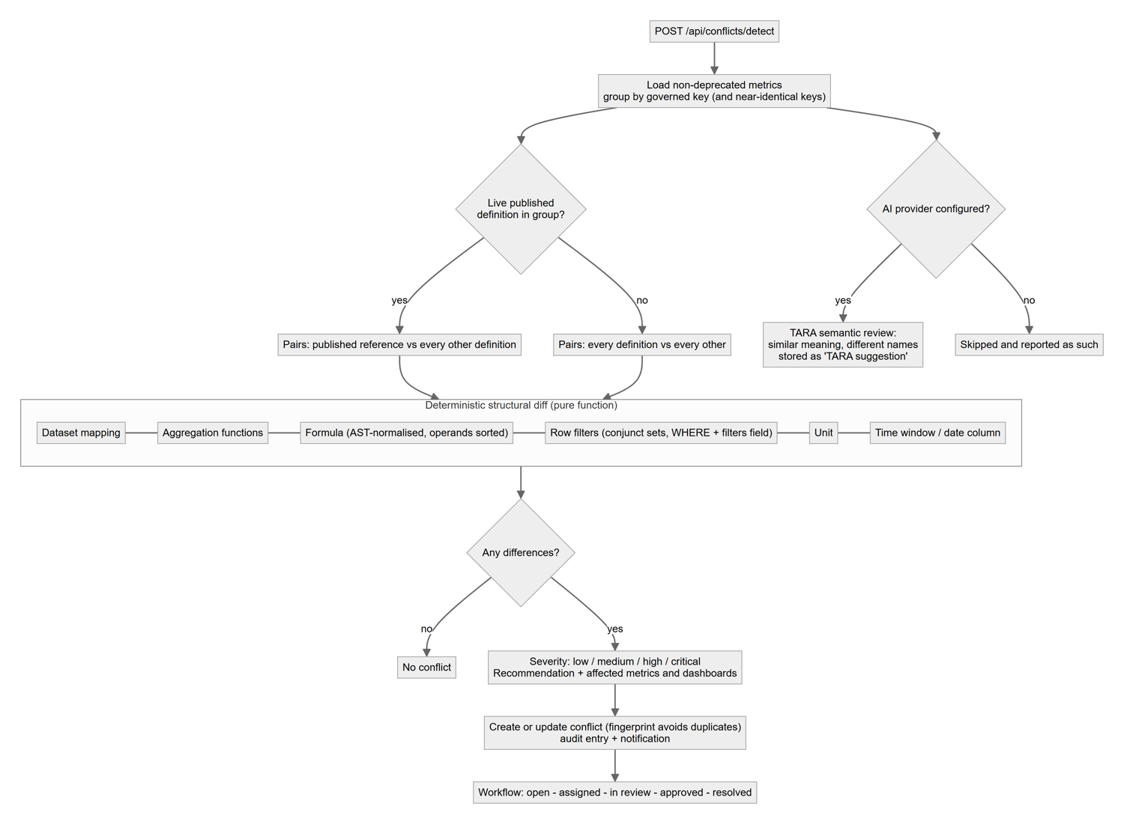
Conflict detection
Severity rules: the maximum severity of the differences, raised to critical when the reference is live and the variant is already in review/approved/published with a formula, aggregation or dataset difference, or when three or more difference types are present together with a high one.

9 State machines
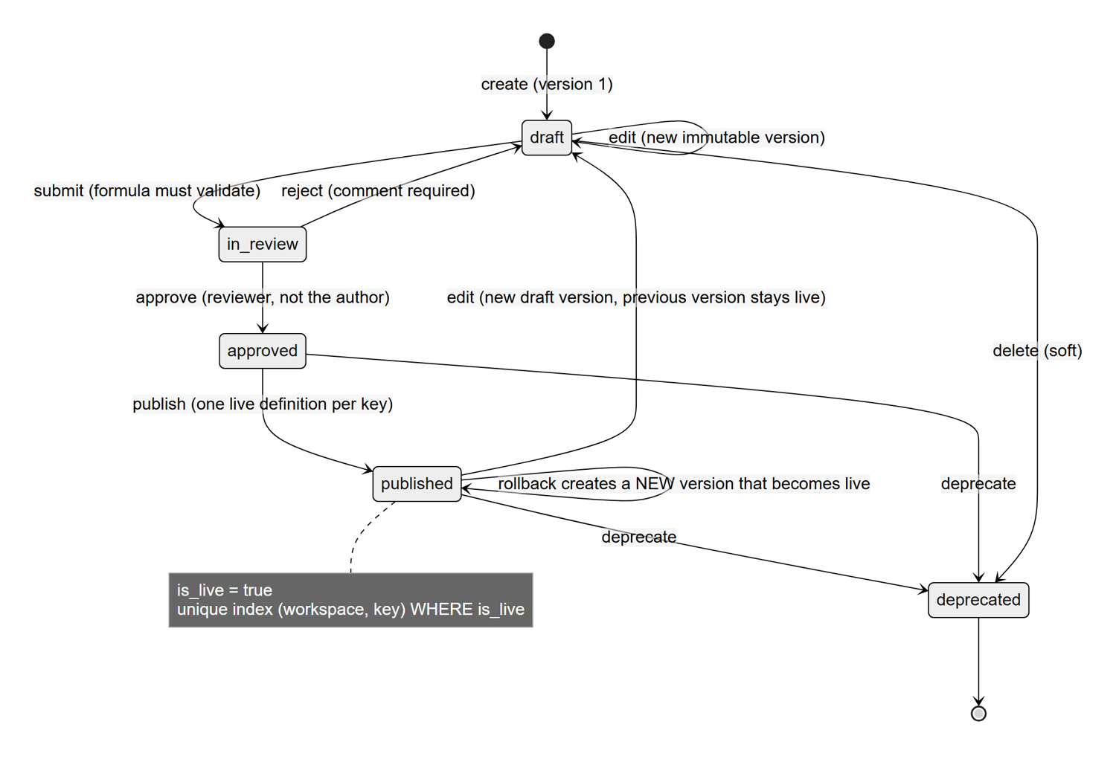
Metric lifecycle and version policy
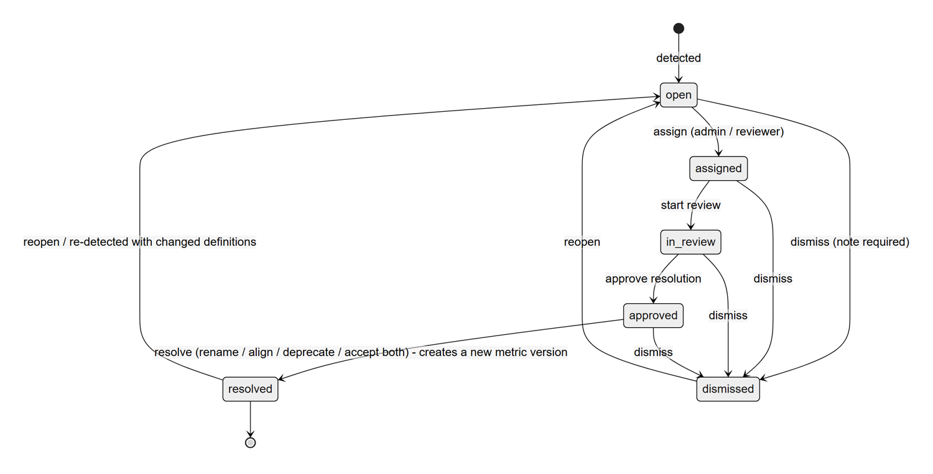
Conflict workflow
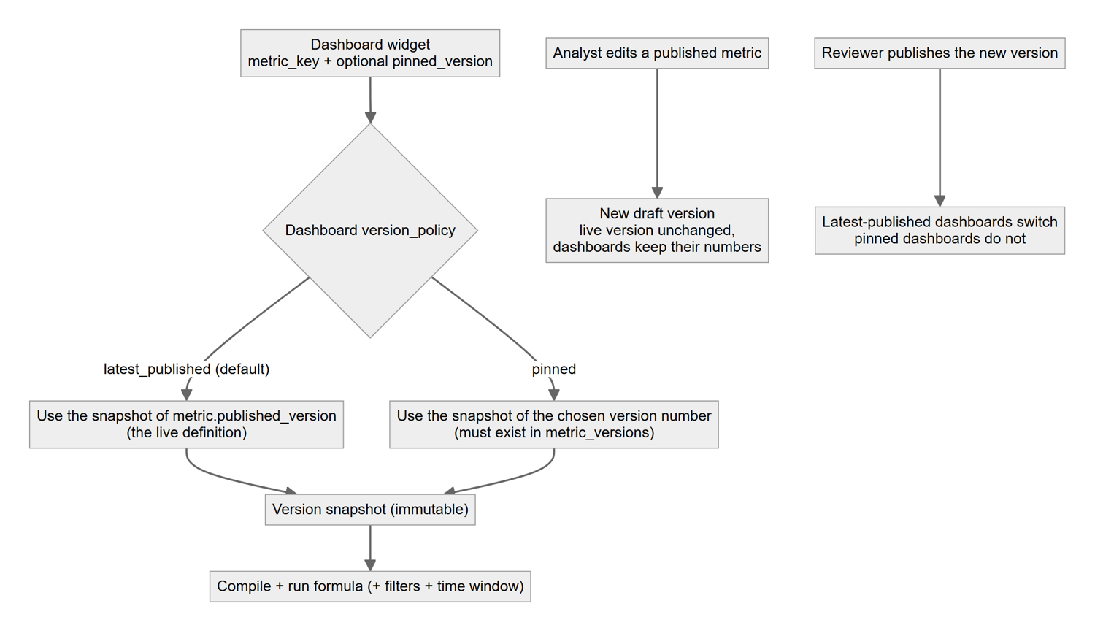
Dashboard version policy: latest published or pinned

10 Security architecture

10.1 Role-based access control
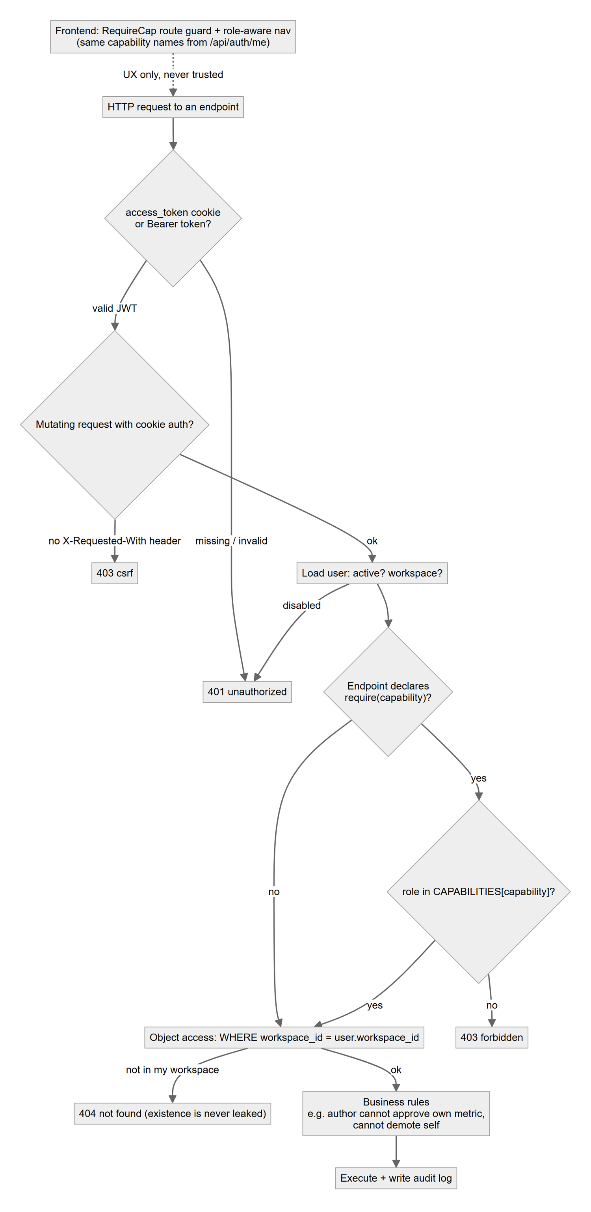
Permission flow for every request
Capability | Admin | Data Analyst | Business User | Reviewer
View metrics catalog, datasets, dashboards (catalog.view) | Yes | Yes | Yes | Yes
Upload datasets / manage connections (dataset.write) | Yes | Yes | - | -
Delete datasets and connections (dataset.delete) | Yes | - | - | -
Create and edit metrics (metric.write) | Yes | Yes | - | -
Approve / reject / publish / deprecate metrics (metric.review) | Yes | - | - | Yes
Roll back a metric (creates a new version) (metric.rollback) | Yes | - | - | Yes
Use TARA metric generator (ai.generate) | Yes | Yes | - | -
Ask TARA (natural-language BI) (chat.ask) | Yes | Yes | Yes | Yes
View conflicts (conflict.view) | Yes | Yes | Yes | Yes
Run conflict detection (conflict.detect) | Yes | Yes | - | Yes
Assign / review / resolve conflicts (conflict.manage) | Yes | - | - | Yes
Formula Lab: validate and execute (formula.run) | Yes | Yes | - | Yes
Create / edit dashboards (dashboard.write) | Yes | Yes | Yes | -
View performance evaluation (evaluation.view) | Yes | Yes | - | Yes
Run performance evaluation (evaluation.run) | Yes | Yes | - | -
Export reports (report.export) | Yes | Yes | Yes | Yes
Manage users and roles (user.manage) | Yes | - | - | -
Manage workspace and settings (workspace.manage) | Yes | - | - | -
View audit log (audit.view) | Yes | - | - | -
Additional rules enforced in code: an author cannot approve their own metric (except an Admin); rejection requires a comment; users cannot demote or deactivate themselves; demo-account passwords cannot be changed; every sensitive action is audit-logged with user, entity, details, IP and request id.

10.2 Workspace isolation
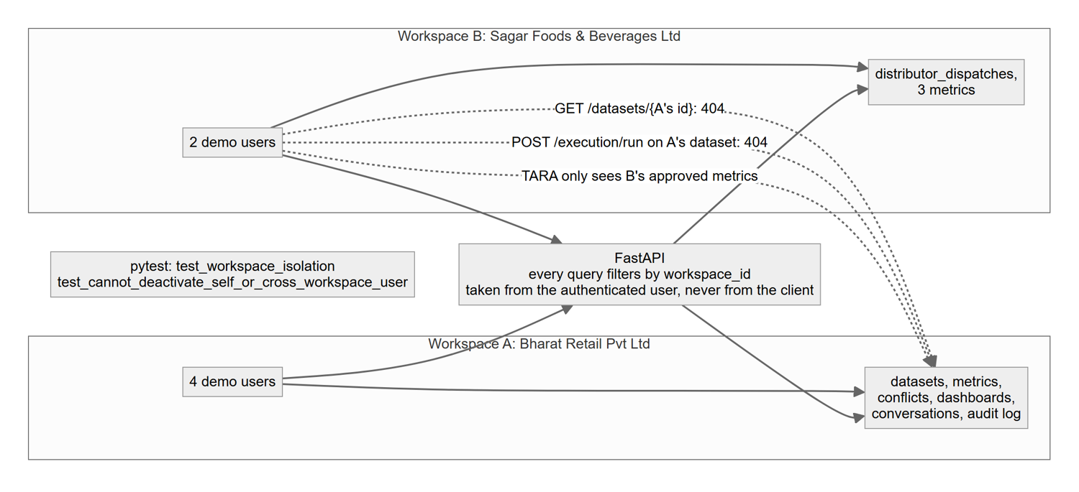
Workspace isolation

10.3 Other controls
Control | Implementation
Password storage | Argon2id hashes (argon2-cffi)
Sessions | JWT access token (15 min) and rotating refresh token (7 days, stored hashed) in httpOnly, SameSite cookies; Secure when COOKIE_SECURE=true
CSRF | State-changing cookie-authenticated requests must carry X-Requested-With: IntelliMetrics
Rate limiting | Sliding window per IP on authentication routes (per process)
Secrets | Environment variables only; connection passwords encrypted with Fernet; AI keys never reach the browser
Input validation | Pydantic v2 on every request; consistent error envelope with request id
SQL safety | No raw SQL accepted; restricted grammar; parameters; read-only DuckDB views; timeouts and row limits
Upload safety | Extension whitelist, size limit, magic-byte sniffing, binary rejection, stored outside the web root
Immutability | ORM guard plus database trigger on metric_versions

11 Indian calendar and planner
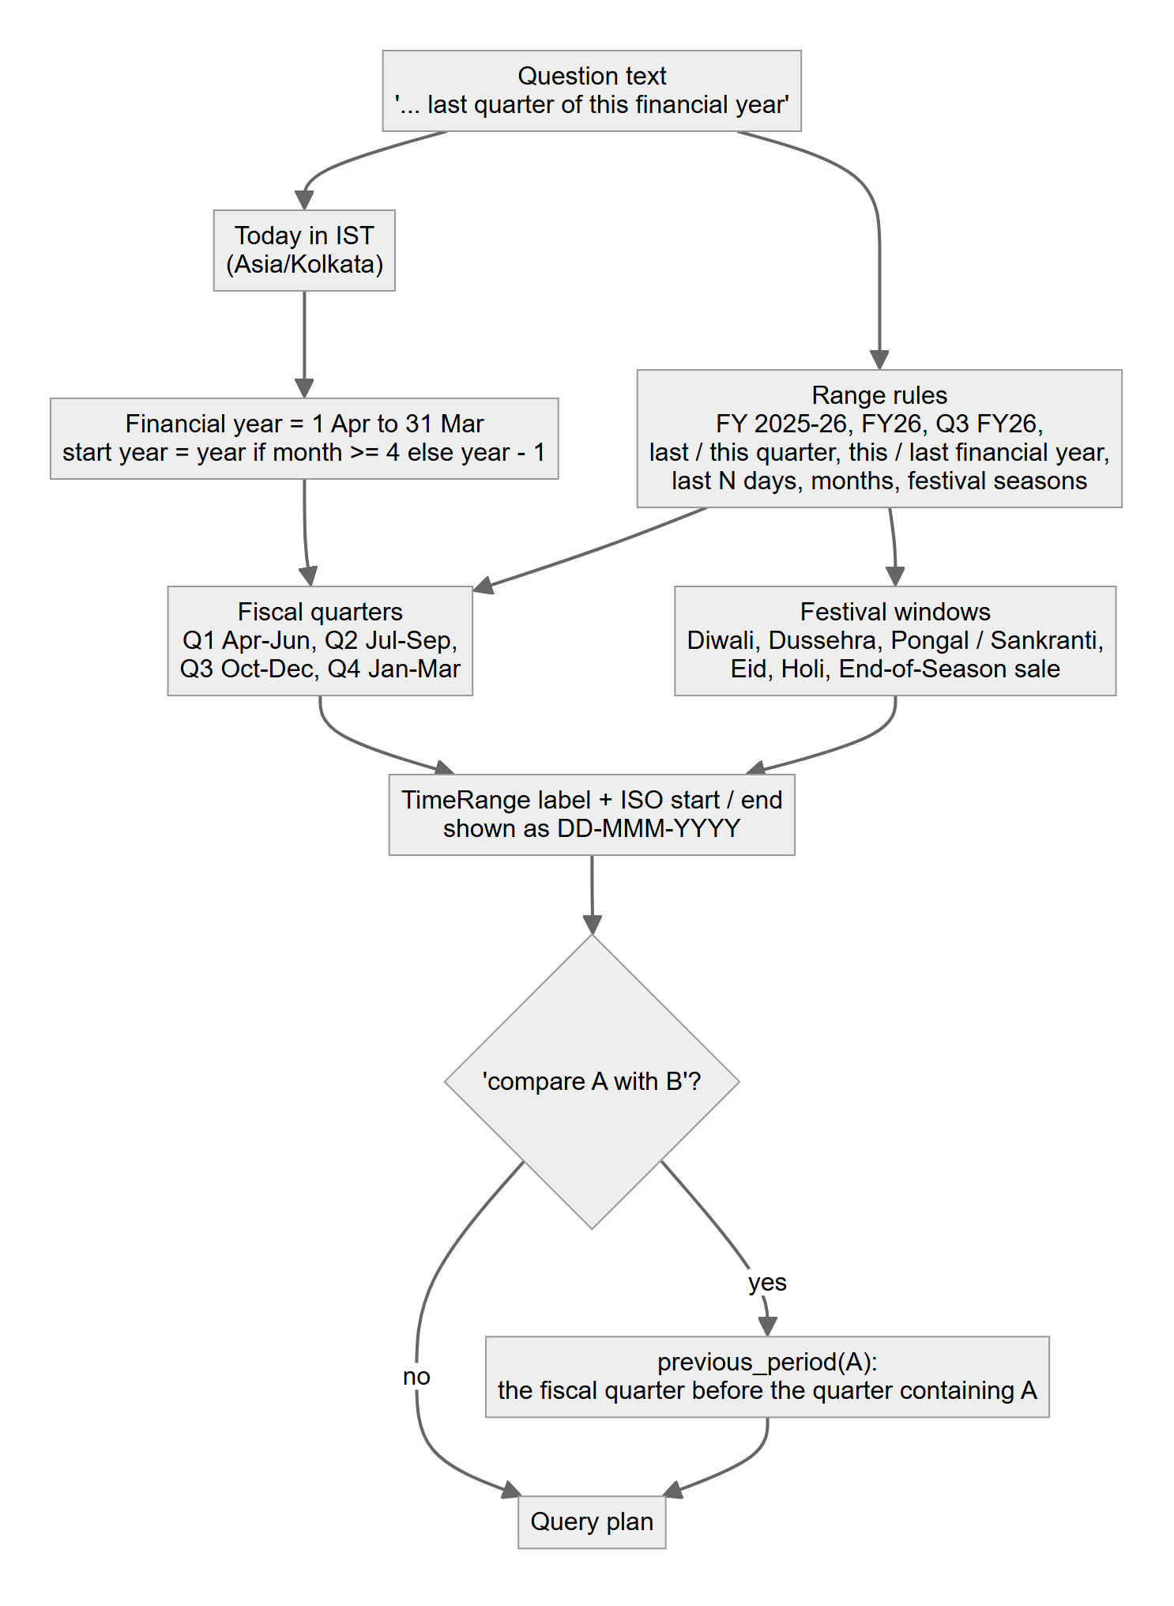
Fiscal calendar handling in the planner

12 Data design

12.1 Entity-relationship diagram
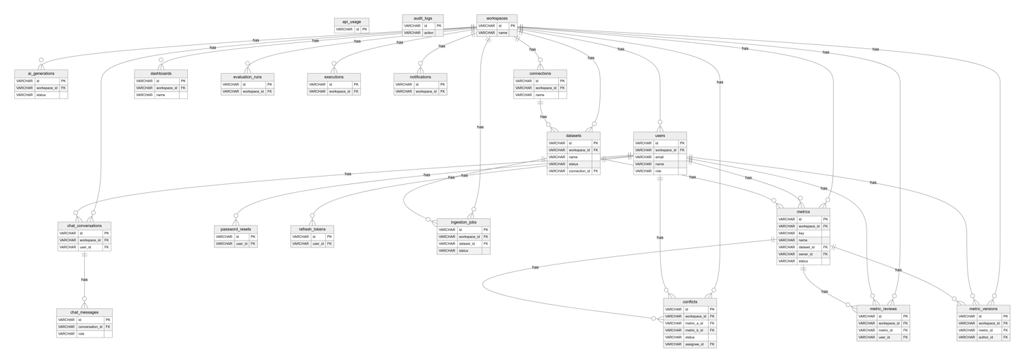
Entity-relationship diagram (keys and identifying columns; all columns are listed in the data dictionary)
The diagram is wide; for a legible full-size version open docs/diagrams/er.svg (zoomable vector) or docs/diagrams/er.png. Notes: every business table references workspaces (tenant boundary). metrics holds the working copy; metric_versions holds immutable snapshots; metric_reviews is the append-only approval log; conflicts references the reference metric and the variant; dashboards.widgets is a JSON layout whose entries reference metric keys and optional pinned version numbers; ingestion_jobs and executions are the telemetry that the evaluation module analyses.

12.2 Data dictionary
api_usage: AI provider call log used for usage statistics.
Column | Type | Null | Key / constraint
id | VARCHAR | no | PK
workspace_id | VARCHAR | no | indexed
provider | VARCHAR | no
kind | VARCHAR | no
tokens_est | INTEGER | no
latency_ms | FLOAT | no
ok | BOOLEAN | no
created_at | DATETIME | no
audit_logs: Audit trail of every sensitive action with user, entity, details, IP and request id.
Column | Type | Null | Key / constraint
id | VARCHAR | no | PK
workspace_id | VARCHAR | yes | indexed
user_id | VARCHAR | yes
user_email | VARCHAR | yes
action | VARCHAR | no | indexed
entity_type | VARCHAR | yes | indexed
entity_id | VARCHAR | yes | indexed
details | JSON | no
ip | VARCHAR | yes
request_id | VARCHAR | yes
created_at | DATETIME | no | indexed
workspaces: Tenant boundary. Every other table carries a workspace_id; settings JSON holds AI provider, theme and retention.
Column | Type | Null | Key / constraint
id | VARCHAR | no | PK
name | VARCHAR | no
slug | VARCHAR | no | unique
is_demo | BOOLEAN | no
settings | JSON | no
created_at | DATETIME | no
ai_generations: TARA metric-generator suggestions with mode (ai/offline), validity, acceptance and latency.
Column | Type | Null | Key / constraint
id | VARCHAR | no | PK
workspace_id | VARCHAR | no | FK -> workspaces.id, indexed
user_id | VARCHAR | yes
prompt | TEXT | no
dataset_id | VARCHAR | yes
mode | VARCHAR | no
provider | VARCHAR | yes
latency_ms | FLOAT | no
output | JSON | no
valid | BOOLEAN | no
status | VARCHAR | no
metric_id | VARCHAR | yes
accepted | BOOLEAN | no
error | TEXT | yes
created_at | DATETIME | no
connections: External PostgreSQL/MySQL connections; the password is Fernet-encrypted at rest.
Column | Type | Null | Key / constraint
id | VARCHAR | no | PK
workspace_id | VARCHAR | no | FK -> workspaces.id, indexed
name | VARCHAR | no
kind | VARCHAR | no
host | VARCHAR | no
port | INTEGER | no
database | VARCHAR | no
username | VARCHAR | no
password_enc | TEXT | no
options | JSON | no
last_status | VARCHAR | yes
last_error | TEXT | yes
last_tested_at | DATETIME | yes
created_by | VARCHAR | yes
created_at | DATETIME | no
dashboards: Saved dashboards: widget layout JSON, filters and the version policy (latest_published or pinned).
Column | Type | Null | Key / constraint
id | VARCHAR | no | PK
workspace_id | VARCHAR | no | FK -> workspaces.id, indexed
name | VARCHAR | no
description | TEXT | yes
widgets | JSON | no
filters | JSON | no
version_policy | VARCHAR | no
template | VARCHAR | yes
created_by | VARCHAR | yes
created_at | DATETIME | no
updated_at | DATETIME | no
evaluation_runs: Stored results of each performance evaluation run.
Column | Type | Null | Key / constraint
id | VARCHAR | no | PK
workspace_id | VARCHAR | no | FK -> workspaces.id, indexed
user_id | VARCHAR | yes
results | JSON | no
duration_ms | FLOAT | no
created_at | DATETIME | no
executions: History of validations and executions (Formula Lab, Ask TARA, dashboards) with duration, scanned rows and error.
Column | Type | Null | Key / constraint
id | VARCHAR | no | PK
workspace_id | VARCHAR | no | FK -> workspaces.id, indexed
user_id | VARCHAR | yes
dataset_id | VARCHAR | yes
kind | VARCHAR | no
expression | TEXT | yes
ok | BOOLEAN | no
duration_ms | FLOAT | no
scanned_rows | BIGINT | no
row_count | BIGINT | no
error | TEXT | yes
sql_text | TEXT | yes
created_at | DATETIME | no | indexed
notifications: In-app notifications per workspace or user with per-user read state.
Column | Type | Null | Key / constraint
id | VARCHAR | no | PK
workspace_id | VARCHAR | no | FK -> workspaces.id, indexed
user_id | VARCHAR | yes | indexed
title | VARCHAR | no
body | TEXT | yes
kind | VARCHAR | no
link | VARCHAR | yes
read_by | JSON | no
created_at | DATETIME | no | indexed
users: Accounts with an Argon2 password hash, a role (admin, data_analyst, business_user, reviewer) and a workspace.
Column | Type | Null | Key / constraint
id | VARCHAR | no | PK
workspace_id | VARCHAR | no | FK -> workspaces.id, indexed
email | VARCHAR | no | unique
name | VARCHAR | no
password_hash | VARCHAR | no
role | VARCHAR | no
is_active | BOOLEAN | no
is_demo | BOOLEAN | no
avatar_url | VARCHAR | yes
title | VARCHAR | yes
created_at | DATETIME | no
last_login | DATETIME | yes
chat_conversations: Ask TARA conversations per user.
Column | Type | Null | Key / constraint
id | VARCHAR | no | PK
workspace_id | VARCHAR | no | FK -> workspaces.id, indexed
user_id | VARCHAR | no | FK -> users.id, indexed
title | VARCHAR | no
created_at | DATETIME | no
updated_at | DATETIME | no
datasets: Dataset catalog: format, status/progress, detected schema, column profile and the Parquet path produced by ingestion.
Column | Type | Null | Key / constraint
id | VARCHAR | no | PK
workspace_id | VARCHAR | no | FK -> workspaces.id, indexed
name | VARCHAR | no
description | TEXT | yes
source_type | VARCHAR | no
file_format | VARCHAR | yes
original_filename | VARCHAR | yes
raw_path | VARCHAR | yes
parquet_path | VARCHAR | yes
size_bytes | BIGINT | no
row_count | BIGINT | no
column_count | INTEGER | no
status | VARCHAR | no
progress | INTEGER | no
stage | VARCHAR | yes
error | TEXT | yes
schema_json | JSON | no
profile | JSON | no
date_column | VARCHAR | yes
connection_id | VARCHAR | yes | FK -> connections.id
source_table | VARCHAR | yes
is_demo | BOOLEAN | no
created_by | VARCHAR | yes
created_at | DATETIME | no
updated_at | DATETIME | no
password_resets: Single-use, hashed, one-hour password reset tokens.
Column | Type | Null | Key / constraint
id | VARCHAR | no | PK
user_id | VARCHAR | no | FK -> users.id, indexed
token_hash | VARCHAR | no | unique
expires_at | DATETIME | no
used | BOOLEAN | no
created_at | DATETIME | no
refresh_tokens: Hashed, rotating refresh tokens (httpOnly cookie) with expiry and revocation flag.
Column | Type | Null | Key / constraint
id | VARCHAR | no | PK
user_id | VARCHAR | no | FK -> users.id, indexed
token_hash | VARCHAR | no | unique
expires_at | DATETIME | no
revoked | BOOLEAN | no
created_at | DATETIME | no
chat_messages: Messages with the structured answer payload (table, chart, sources, applied filters).
Column | Type | Null | Key / constraint
id | VARCHAR | no | PK
conversation_id | VARCHAR | no | FK -> chat_conversations.id, indexed
role | VARCHAR | no
content | TEXT | no
payload | JSON | no
created_at | DATETIME | no
ingestion_jobs: One row per background ingestion run: stage, progress, duration, runner and error report.
Column | Type | Null | Key / constraint
id | VARCHAR | no | PK
workspace_id | VARCHAR | no | FK -> workspaces.id, indexed
dataset_id | VARCHAR | no | FK -> datasets.id, indexed
status | VARCHAR | no
stage | VARCHAR | yes
progress | INTEGER | no
rows | INTEGER | no
bytes | BIGINT | no
duration_ms | INTEGER | yes
error_report | JSON | no
runner | VARCHAR | yes
created_at | DATETIME | no
finished_at | DATETIME | yes
metrics: Governed metric definitions (working copy). A partial unique index allows only one live definition per workspace and key.
Column | Type | Null | Key / constraint
id | VARCHAR | no | PK
workspace_id | VARCHAR | no | FK -> workspaces.id, indexed
key | VARCHAR | no | indexed
name | VARCHAR | no
description | TEXT | yes
business_definition | TEXT | yes
formula | TEXT | no
filters | TEXT | yes
aggregation | VARCHAR | yes
unit | VARCHAR | yes
time_window | VARCHAR | no
date_column | VARCHAR | yes
dataset_id | VARCHAR | yes | FK -> datasets.id
department | VARCHAR | yes
category | VARCHAR | yes
owner_id | VARCHAR | yes | FK -> users.id
status | VARCHAR | no
version | INTEGER | no
published_version | INTEGER | yes
is_live | BOOLEAN | no
depends_on | JSON | no
source | VARCHAR | no
created_at | DATETIME | no
updated_at | DATETIME | no
Unique index uq_metric_live_key on (workspace_id, key) WHERE is_live IS TRUE (partial)
conflicts: Detected definition conflicts with differences, severity, recommendation, affected objects and workflow status.
Column | Type | Null | Key / constraint
id | VARCHAR | no | PK
workspace_id | VARCHAR | no | FK -> workspaces.id, indexed
metric_key | VARCHAR | no | indexed
metric_a_id | VARCHAR | no | FK -> metrics.id
metric_b_id | VARCHAR | no | FK -> metrics.id
conflict_type | VARCHAR | no
severity | VARCHAR | no
differences | JSON | no
explanation | TEXT | no
recommendation | TEXT | no
recommended_action | VARCHAR | yes
affected | JSON | no
fingerprint | VARCHAR | no
status | VARCHAR | no
assignee_id | VARCHAR | yes | FK -> users.id
resolution_action | VARCHAR | yes
resolution_note | TEXT | yes
detected_at | DATETIME | no
resolved_at | DATETIME | yes
metric_reviews: Append-only approval workflow events: submit, approve, reject, publish, deprecate.
Column | Type | Null | Key / constraint
id | VARCHAR | no | PK
workspace_id | VARCHAR | no | FK -> workspaces.id, indexed
metric_id | VARCHAR | no | FK -> metrics.id, indexed
version | INTEGER | no
user_id | VARCHAR | yes | FK -> users.id
decision | VARCHAR | no
comment | TEXT | yes
created_at | DATETIME | no
metric_versions: Immutable version snapshots. UPDATE/DELETE are blocked by an ORM guard and a database trigger.
Column | Type | Null | Key / constraint
id | VARCHAR | no | PK
workspace_id | VARCHAR | no | FK -> workspaces.id, indexed
metric_id | VARCHAR | no | FK -> metrics.id, indexed
number | INTEGER | no
snapshot | JSON | no
change_summary | VARCHAR | no
reason | TEXT | yes
author_id | VARCHAR | yes | FK -> users.id
rollback_of | INTEGER | yes
created_at | DATETIME | no

13 API reference summary
All endpoints are under /api (health at /health); interactive OpenAPI documentation is served at /docs and the schema at /openapi.json. Errors use one envelope: {"error": {"code", "message", "details", "request_id"}}. The Roles allowed column is derived from the require(capability) dependency on each route and the permission matrix.
Authentication (auth router)
Method | Path | Purpose | Capability | Roles allowed
POST | /api/auth/change-password | change password | - | any signed-in user
POST | /api/auth/forgot-password | forgot password | - | public (no login)
POST | /api/auth/login | login | - | public (no login)
POST | /api/auth/logout | logout | - | public (no login)
GET | /api/auth/me | me | - | any signed-in user
PATCH | /api/auth/me | update me | - | any signed-in user
POST | /api/auth/refresh | refresh | - | public (no login)
POST | /api/auth/register | register | - | public (no login)
POST | /api/auth/reset-password | reset password | - | public (no login)
Workspaces, settings, audit log (workspaces router)
Method | Path | Purpose | Capability | Roles allowed
GET | /api/admin/api-usage | api usage | workspace.manage | Admin
GET | /api/admin/audit-logs | audit logs | audit.view | Admin
GET | /api/permissions/matrix | permissions matrix | - | any signed-in user
GET | /api/workspaces/current | get workspace | - | any signed-in user
PATCH | /api/workspaces/current | rename workspace | workspace.manage | Admin
GET | /api/workspaces/current/settings | get settings | - | any signed-in user
PUT | /api/workspaces/current/settings | put settings | workspace.manage | Admin
Users and roles (users router)
Method | Path | Purpose | Capability | Roles allowed
GET | /api/users | list users | - | any signed-in user
POST | /api/users | invite user | user.manage | Admin
DELETE | /api/users/{user_id} | remove user | user.manage | Admin
PATCH | /api/users/{user_id} | patch user | user.manage | Admin
Datasets, uploads and connections (datasets router)
Method | Path | Purpose | Capability | Roles allowed
GET | /api/connections | list connections | - | any signed-in user
POST | /api/connections | create connection | dataset.write | Admin, Analyst
DELETE | /api/connections/{cid} | delete conn | dataset.delete | Admin
POST | /api/connections/{cid}/import | conn import | dataset.write | Admin, Analyst
GET | /api/connections/{cid}/tables | conn tables | dataset.write | Admin, Analyst
POST | /api/connections/{cid}/test | test conn | dataset.write | Admin, Analyst
GET | /api/datasets | list datasets | - | any signed-in user
POST | /api/datasets/upload | upload dataset | dataset.write | Admin, Analyst
DELETE | /api/datasets/{dataset_id} | delete dataset | dataset.delete | Admin
GET | /api/datasets/{dataset_id} | get dataset | - | any signed-in user
GET | /api/datasets/{dataset_id}/jobs | dataset jobs | - | any signed-in user
GET | /api/datasets/{dataset_id}/preview | preview | - | any signed-in user
POST | /api/datasets/{dataset_id}/reprocess | reprocess | dataset.write | Admin, Analyst
GET | /api/datasets/{dataset_id}/status | dataset status | - | any signed-in user
Metrics, workflow and versions (metrics router)
Method | Path | Purpose | Capability | Roles allowed
GET | /api/metrics | list metrics | - | any signed-in user
POST | /api/metrics | create | metric.write | Admin, Analyst
GET | /api/metrics/facets | facets | - | any signed-in user
GET | /api/metrics/graph | graph | - | any signed-in user
DELETE | /api/metrics/{mid} | delete | metric.write | Admin, Analyst
GET | /api/metrics/{mid} | detail | - | any signed-in user
PATCH | /api/metrics/{mid} | update | metric.write | Admin, Analyst
POST | /api/metrics/{mid}/approve | metric approve | metric.review | Admin, Reviewer
GET | /api/metrics/{mid}/audit | metric audit | - | any signed-in user
POST | /api/metrics/{mid}/deprecate | metric deprecate | metric.review | Admin, Reviewer
GET | /api/metrics/{mid}/diff | diff | - | any signed-in user
POST | /api/metrics/{mid}/publish | metric publish | metric.review | Admin, Reviewer
POST | /api/metrics/{mid}/reject | metric reject | metric.review | Admin, Reviewer
POST | /api/metrics/{mid}/rollback | rollback | metric.rollback | Admin, Reviewer
POST | /api/metrics/{mid}/submit | metric submit | metric.write | Admin, Analyst
GET | /api/metrics/{mid}/versions | versions | - | any signed-in user
GET | /api/versions/recent | recent versions | - | any signed-in user
TARA metric generator (ai router)
Method | Path | Purpose | Capability | Roles allowed
POST | /api/ai/generate-metric | generate | ai.generate | Admin, Analyst
GET | /api/ai/generations | generations | ai.generate | Admin, Analyst
POST | /api/ai/generations/{gid}/discard | discard | ai.generate | Admin, Analyst
POST | /api/ai/generations/{gid}/save | save | metric.write | Admin, Analyst
GET | /api/ai/status | status | - | any signed-in user
Conflict detection (conflicts router)
Method | Path | Purpose | Capability | Roles allowed
GET | /api/conflicts | list conflicts | conflict.view | Admin, Analyst, Business, Reviewer
POST | /api/conflicts/detect | detect | conflict.detect | Admin, Analyst, Reviewer
GET | /api/conflicts/{cid} | detail | conflict.view | Admin, Analyst, Business, Reviewer
POST | /api/conflicts/{cid}/approve | approve | conflict.manage | Admin, Reviewer
POST | /api/conflicts/{cid}/assign | assign | conflict.manage | Admin, Reviewer
POST | /api/conflicts/{cid}/dismiss | dismiss | conflict.manage | Admin, Reviewer
GET | /api/conflicts/{cid}/events | events | conflict.view | Admin, Analyst, Business, Reviewer
POST | /api/conflicts/{cid}/reopen | reopen | conflict.manage | Admin, Reviewer
POST | /api/conflicts/{cid}/resolve | resolve | conflict.manage | Admin, Reviewer
POST | /api/conflicts/{cid}/review | start review | conflict.manage | Admin, Reviewer
Formula validation (validation router)
Method | Path | Purpose | Capability | Roles allowed
POST | /api/validation/formula | validate formula | formula.run | Admin, Analyst, Reviewer
Formula execution (execution router)
Method | Path | Purpose | Capability | Roles allowed
GET | /api/execution/history | history | formula.run | Admin, Analyst, Reviewer
POST | /api/execution/run | run | formula.run | Admin, Analyst, Reviewer
Ask TARA (chat router)
Method | Path | Purpose | Capability | Roles allowed
POST | /api/chat/ask | ask | chat.ask | Admin, Analyst, Business, Reviewer
POST | /api/chat/ask/stream | ask stream | chat.ask | Admin, Analyst, Business, Reviewer
GET | /api/chat/conversations | conversations | chat.ask | Admin, Analyst, Business, Reviewer
DELETE | /api/chat/conversations/{cid} | delete conversation | chat.ask | Admin, Analyst, Business, Reviewer
GET | /api/chat/conversations/{cid} | conversation | chat.ask | Admin, Analyst, Business, Reviewer
GET | /api/chat/suggestions | get suggestions | chat.ask | Admin, Analyst, Business, Reviewer
Dashboards (dashboards router)
Method | Path | Purpose | Capability | Roles allowed
GET | /api/dashboards | list dashboards | - | any signed-in user
POST | /api/dashboards | create | dashboard.write | Admin, Analyst, Business
POST | /api/dashboards/from-template | from template | dashboard.write | Admin, Analyst, Business
GET | /api/dashboards/templates | templates | - | any signed-in user
POST | /api/dashboards/widget-data | preview widget | - | any signed-in user
DELETE | /api/dashboards/{did} | delete | dashboard.write | Admin, Analyst, Business
GET | /api/dashboards/{did} | get | - | any signed-in user
PATCH | /api/dashboards/{did} | update | dashboard.write | Admin, Analyst, Business
POST | /api/dashboards/{did}/data | data | - | any signed-in user
Evaluation (evaluation router)
Method | Path | Purpose | Capability | Roles allowed
GET | /api/evaluation/cases | cases | evaluation.view | Admin, Analyst, Reviewer
GET | /api/evaluation/latest | latest | evaluation.view | Admin, Analyst, Reviewer
POST | /api/evaluation/run | run | evaluation.run | Admin, Analyst
GET | /api/evaluation/runs | runs | evaluation.view | Admin, Analyst, Reviewer
GET | /api/evaluation/runs/{rid} | get run | evaluation.view | Admin, Analyst, Reviewer
Reports and exports (reports router)
Method | Path | Purpose | Capability | Roles allowed
GET | /api/reports/{kind} | export | report.export | Admin, Analyst, Business, Reviewer
Notifications and activity (notifications router)
Method | Path | Purpose | Capability | Roles allowed
GET | /api/activity | activity | - | any signed-in user
GET | /api/notifications | list notifications | - | any signed-in user
POST | /api/notifications/read-all | mark all | - | any signed-in user
POST | /api/notifications/{nid}/read | mark read | - | any signed-in user
Main dashboard (overview router)
Method | Path | Purpose | Capability | Roles allowed
GET | /api/overview | overview | - | any signed-in user
Health (health router)
Method | Path | Purpose | Capability | Roles allowed
GET | /health | health | - | public (no login)

14 Use cases by role
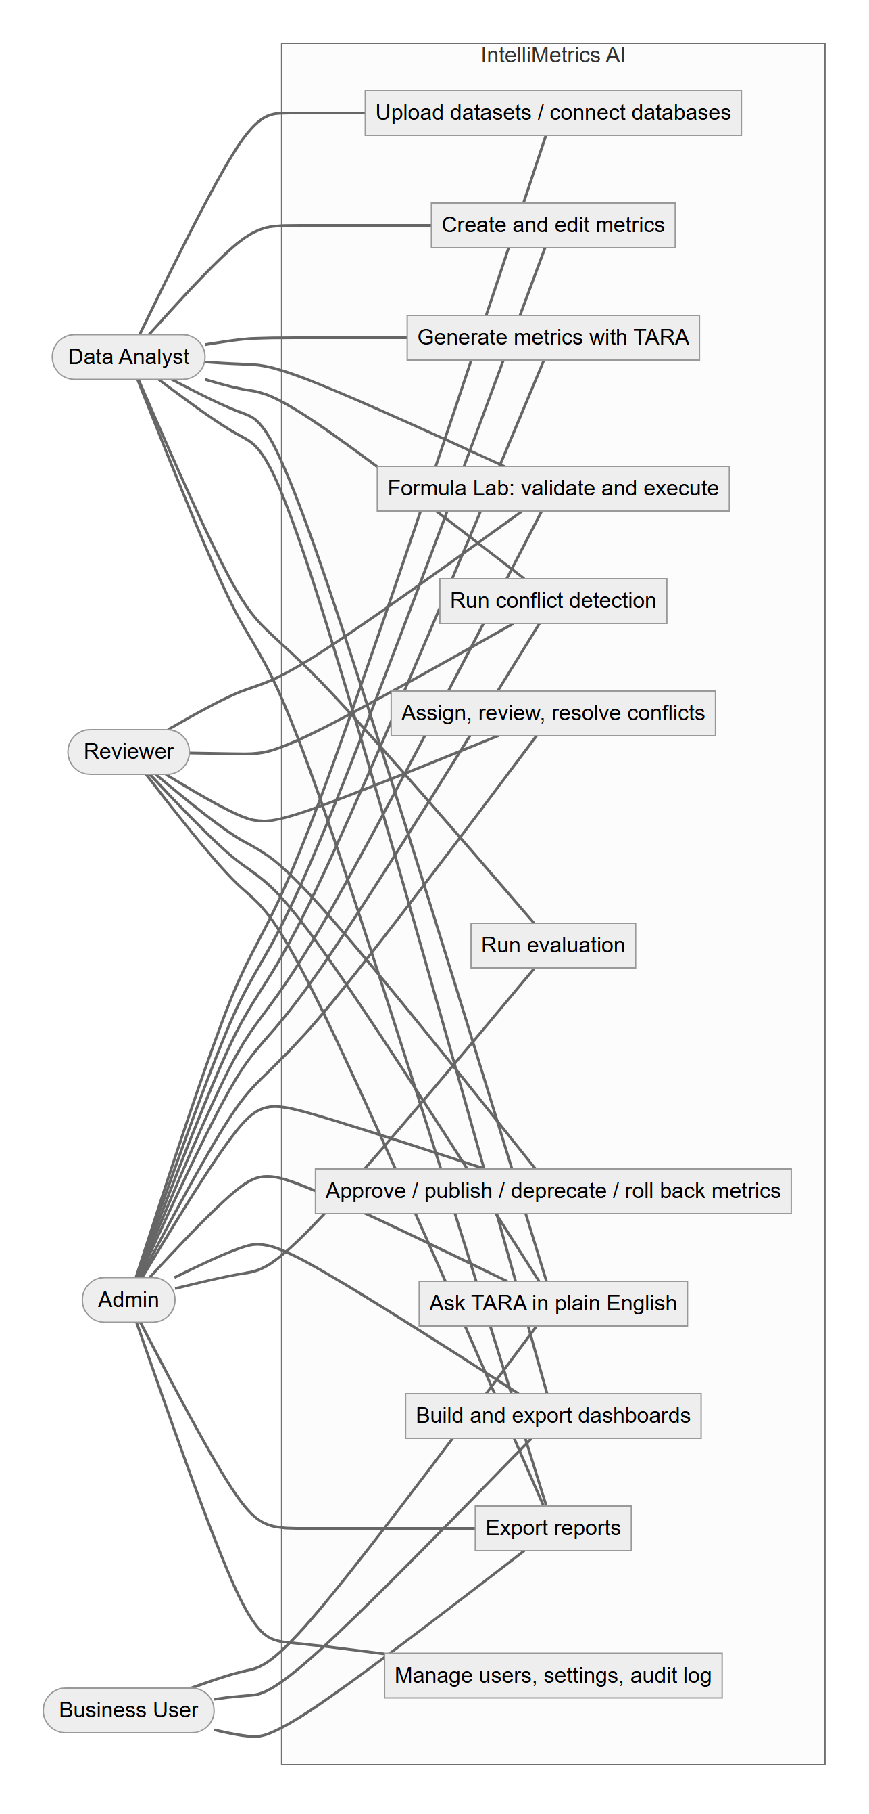
Use cases by role

