**MARKET BASKET INSIGHTS**

**Description:**

The "Market Basket Insights" project aims to analyze customer purchase behavior in a retail environment to extract valuable insights that can be used to optimize product placement, marketing strategies, and overall store efficiency. By understanding which products are frequently purchased together, we can improve cross-selling, inventory management, and customer experience.

**PROBLEM DEFINITION AND DESIGN THINKING**

**Problem Understanding:**

The retail industry faces several challenges, including the need to enhance revenue, reduce waste, and provide personalized shopping experiences. To address these challenges, it's crucial to:

1. Identify which products are often purchased together by customers.

2. Understand the factors influencing customer purchasing decisions.

3. Improve product placement and store layout to maximize sales.

4. Enhance customer satisfaction through tailored recommendations.

**Solution for Solving This Problem:**

To solve the problem of market basket analysis, we will employ data analytics and machine learning techniques. The key steps in our solution include:

**Data Collection:**

Gather transaction data, including purchase history, product details, timestamps, and customer information.

**Data Preprocessing:**

Clean and preprocess the data to handle missing values, outliers, and ensure data quality.

**Market Basket Analysis:**

Utilize association rule mining algorithms like Apriori or FP-growth to identify frequently co-purchased items. This will help establish product associations and uncover buying patterns.

**Customer Segmentation:**

Segment customers based on their purchasing behavior, demographics, and preferences. Clustering techniques like K-means or hierarchical clustering can be applied.

**Recommender System:**

Develop a recommendation engine that provides personalized product recommendations to customers based on their shopping history and preferences.

**Visualization and Reporting:**

Create visualizations and reports to communicate insights to stakeholders, allowing them to make informed decisions.

**Proposed System Designs:**

The proposed system for Market Basket Insights will comprise several components:

**Data Collection Module:**

This module will collect transaction data from various sources such as point-of-sale systems, online sales, and customer surveys.

**Data Preprocessing Module:**

Clean, transform, and integrate data from multiple sources into a structured format suitable for analysis.

**Market Basket Analysis Module:**

Implement association rule mining algorithms to discover item associations and purchase patterns.

**Customer Segmentation Module:**

Utilize clustering algorithms to segment customers into distinct groups based on their behavior and preferences.

**Recommender System Module:**

Develop a recommendation engine that generates personalized product recommendations for customers in real-time.

**Visualization and Reporting Module:**

Create dashboards and reports using tools like Tableau or Power BI to visualize insights, trends, and recommendations.

**Integration with Store Operations:**

Implement strategies to integrate the insights generated into store operations, including product placement, pricing, and marketing campaigns.

**Dataset link :**

<https://www.kaggle.com/datasets/aslanahmedov/market-basket-analysis>

**INNOVATION**

**Data Integration and Collection:**

* Set up data connectors to collect data from various sources, including point-of-sale systems, e-commerce platforms, and customer interactions.
* Implement data pipelines to ensure continuous data flow.

**Data Preprocessing and Cleaning:**

* Clean and preprocess the collected data to handle missing values, outliers, and inconsistencies.
* Transform and standardize data into a format suitable for analysis.

**Association Rule Mining:**

* Apply advanced association rule mining algorithms, such as Apriori or FP-growth, to discover item sets frequently purchased together.
* Establish criteria for selecting meaningful association rules, considering factors like support, confidence, and lift.

**Personalization Engine Development:**

* Develop machine learning models and recommendation engines.
* Utilize customer behaviour, purchase history, and demographic data to create personalized product recommendations.

**Real-time Analytics and Recommendation Updates:**

* Implement real-time analytics systems using technologies like Apache Kafka and Spark Streaming.
* Ensure recommendations are updated as new data becomes available to adapt to changing customer behaviours.

**Cross-channel Data Integration:**

* Build data integration solutions to combine online and offline sales data.
* Create a centralized data repository for a holistic view of customer behaviour across various channels.

**Marketing Campaigns and Dynamic Pricing:**

* Utilize the insights generated from MBA to design targeted marketing campaigns.
* Implement dynamic pricing strategies based on demand and basket composition.

**Sustainability Initiatives:**

* Develop sustainability programs based on customer preferences.
* Promote eco-friendly and responsible consumption by recommending green products.

**Mobile App Development:**

* Create user-friendly mobile apps that provide convenient shopping and data collection options.
* Utilize mobile data to enhance recommendations and in-store experiences.

**Testing and Optimization:**

* Conduct rigorous testing of the system to ensure accuracy, reliability, and performance.
* Continuously optimize the algorithms, models, and data processes to improve results.

**Deployment:**

* Deploy the system in the production environment, ensuring it can handle the load and real-time requirements.
* Monitor system performance, data accuracy, and security.

**Monitoring and Maintenance:**

* Implement robust monitoring and maintenance protocols to address any issues that arise.
* Continuously update the system to keep up with changing customer preferences and technological advancements.

**Feedback and Improvement:**

* Collect feedback from customers and internal teams to identify areas for improvement.
* Use this feedback to make iterative enhancements to the system.

**Reporting and Decision-Making:**

* Generate reports and dashboards for business stakeholders to make data-driven decisions.
* Utilize insights for strategic planning and resource allocation.

**Dataset Link:**

<https://www.kaggle.com/datasets/aslanahmedov/market-basket-analysis>

**DEVELOPMENT PART 1**

**Step 1** : **Data Loading**

We'll start by loading the dataset using pandas.



**OUTPUT :**

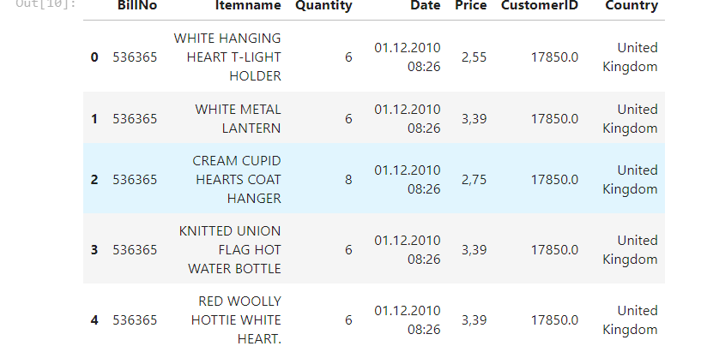

**Explanation:**

* We import the pandas library to work with data.
* We use the read_csv function to read the data from the "Assignment-1_Data.csv"

file and store it in the data DataFrame.

* We display the first few rows of the dataset using the head() function to understand the data structure.

**Step 2 : Data Exploration**

In this step, we'll perform some basic data exploration to better understand the dataset.



**OUTPUT** :

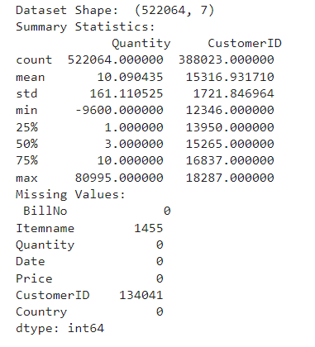

**Explanation:**

* We use the shape attribute to get the dimensions of the dataset (number of rows and columns).
* describe() provides summary statistics (mean, min, max, etc.) for numerical columns in the dataset.
* isnull().sum() is used to count missing values in each column.

**Step 3 : Data Preprocessing**

Now, let's perform some data preprocessing steps.

**OUTPUT** :

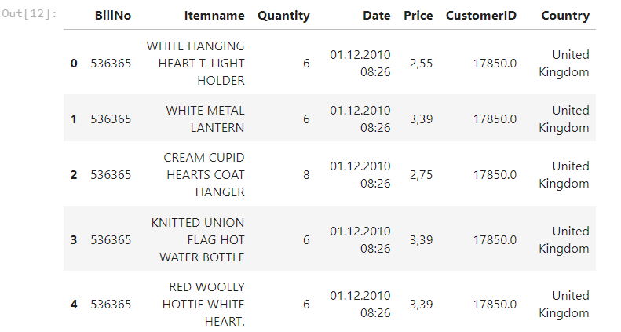

**Explanation:**

* We can choose to either drop rows with missing values (NaN) or fill them based on the problem's requirements. In this example, we drop them.
* We calculate the dimensions of the cleaned dataset after removing missing values.
* We check for duplicate rows using the duplicated() function.
* We calculate the number of unique values in each column using nunique().
* We check the data types of each column using dtypes.

**Step 4: Basic Analysis**

Now, we'll perform some basic analysis to understand the data distribution.



**OUTPUT** :

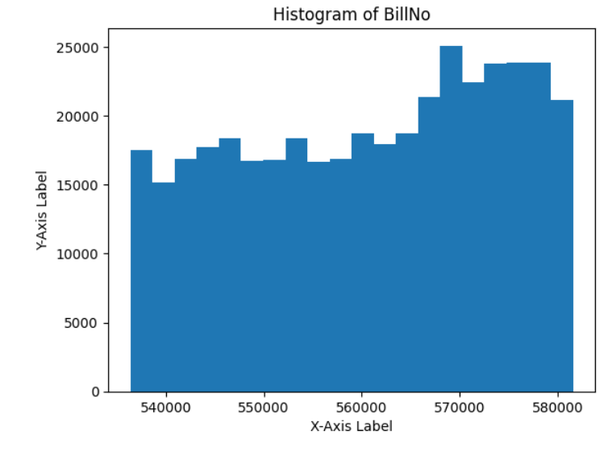

**Explanation:**

* We can count the occurrences of each unique value in a specific column using value_counts().

Grouping and aggregation are often useful for summarizing data.

* We demonstrate a simple histogram plot using matplotlib.

**DEVELOPMENT PART 2**



**OUTPUT :**

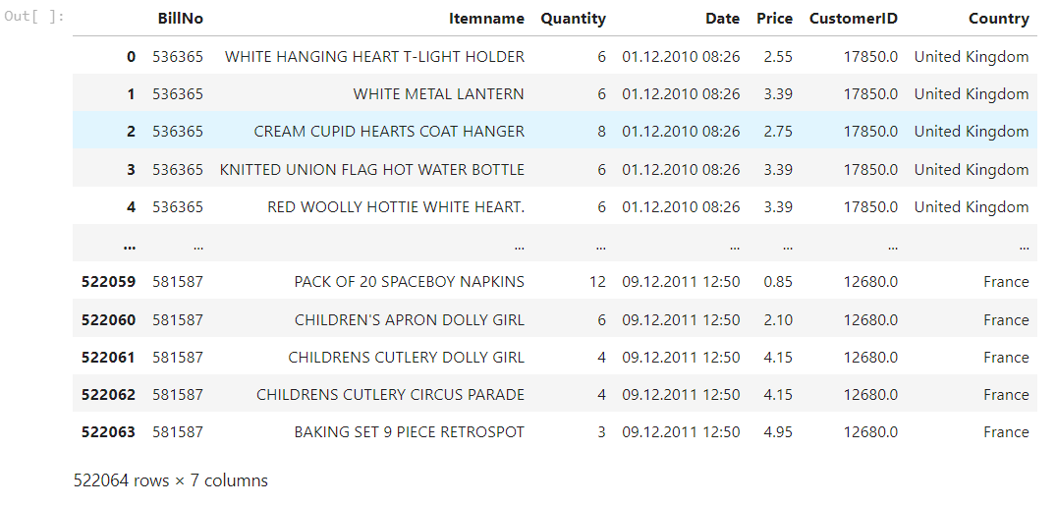

**Initial Exploration :**

We'll perform an initial exploration of the dataset to understand its structure and characteristics.



**OUTPUT:**

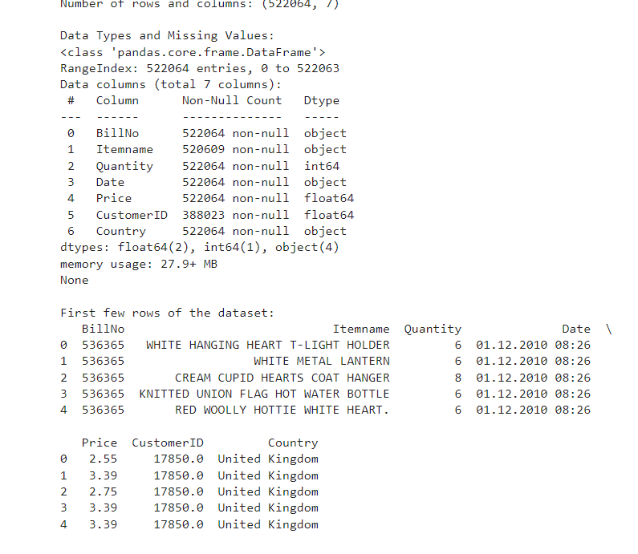

**Preprocessing :**

We'll preprocess the data to ensure it's ready for analysis.



**OUTPUT :**

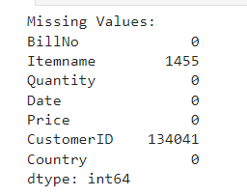



**OUTPUT:**

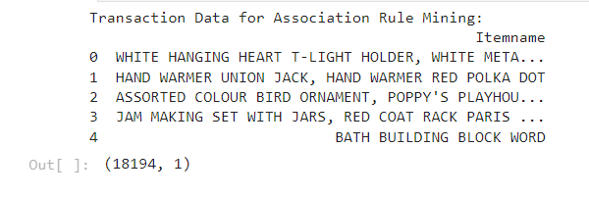

**Formatting the transaction data in a suitable format for analysis**

Developing the preprocessed data into analysis. Split the 'Itemname' column in transaction_data into individual items using str.split(', ', expand=True).Concatenate the original DataFrame (transaction_data) with the items DataFrame (items_df) using pd.concat.Drop the original 'Itemname' column since individual items are now in separate columns.Display the resulting DataFrame.

*# Split the 'Itemname' column into individual items*

items_df **=** transaction_data['Itemname']**.**str**.**split(', ', expand**=True**)

*# Concatenate the original DataFrame with the new items DataFrame*

transaction_data **=** pd**.**concat([transaction_data, items_df], axis**=**1)

*# Drop the original 'Itemname' column*

transaction_data **=** transaction_data**.**drop('Itemname', axis**=**1)

*# Display the resulting DataFrame*

print(transaction_data**.**head())

**OUTPUT:**

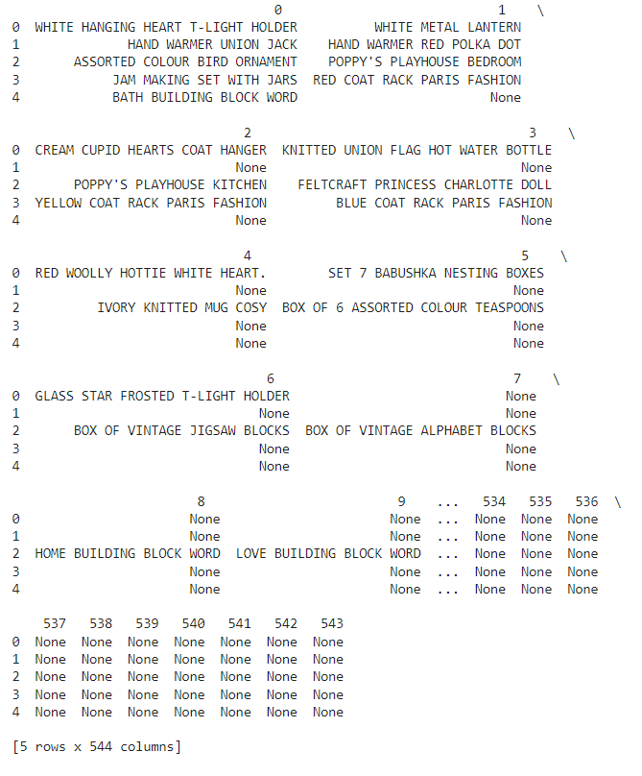**Association Rules - Data Mining**

**Converting Items to Boolean Columns**

To prepare the data for association rule mining, we convert the items in the transaction_data DataFrame into boolean columns using one-hot encoding. This is achieved through the pd.get_dummies function, which creates a new DataFrame (df_encoded) with boolean columns representing the presence or absence of each item.

**Association Rule Mining :**

We apply the Apriori algorithm to perform association rule mining on the encoded transaction data. The min_support parameter is set to 0.007 to filter out infrequent itemsets. The resulting frequent itemsets are then used to generate association rules based on a minimum confidence threshold of 0.5. Finally, we print the generated association rules.



**OUTPUT:**

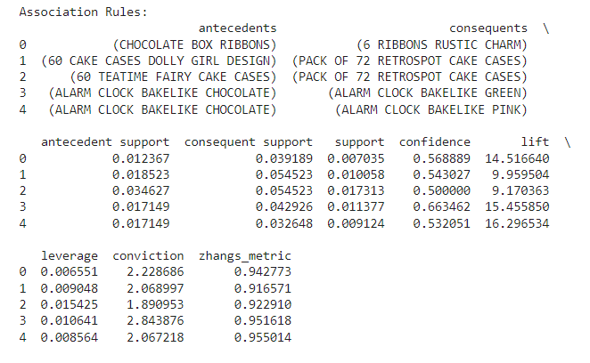**Visualization**

**Visualizing Market Basket Analysis Results**

We use matplotlib and seaborn libraries to create a scatterplot visualizing the results of the market basket analysis. The plot depicts the relationship between support, confidence, and lift for the generated association rules.



**OUTPUT:**

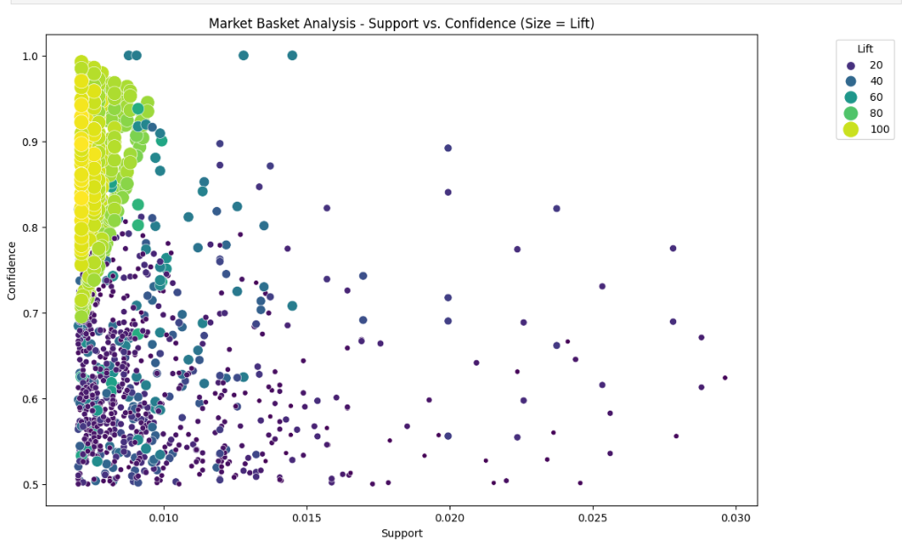

**CONCLUSION** **:**

**Phase 1:** Problem definition and design thinking helped establish the foundation for the market basket analysis project.

**Phase 2:** Data selection and preprocessing ensured the dataset was ready for association analysis.

**Phase 3:** Development Part 1 involved loading, cleaning, and exploring the data to prepare for association analysis.

**Phase 4:** Development Part 2 included selecting and training a machine learning model for insights generation.

**Phase 5:** Project documentation and submission ensured the project's findings and code were well-documented and accessible for review and use.