WEEK 2 INTERNSHIP TASK REPORT
Data Visualization and Storytelling with Python
  - Virtual Data Science with Python Apprentice Intern
Prepared by: [Enter your full name]

1. Introduction
This project demonstrates how data visualization can transform numerical data into a clear story for a non-technical audience. The public Iris dataset was selected because it contains measurements for three flower species and supports meaningful comparisons, distributions, relationships, and correlations. Python, Pandas, Matplotlib, and Scikit-learn were used.

2. Objectives
- Create a coherent visual narrative from a public dataset.
- Develop at least five visualizations using different chart types.
- Explain the purpose and insight of each visualization.
- Identify trends, differences, relationships, and useful implications.
- Communicate analytical findings clearly to a non-technical audience.

3. Dataset and Method
The Iris dataset contains 150 observations from setosa, versicolor, and virginica. Four numeric features are analyzed: sepal length, sepal width, petal length, and petal width. The dataset was loaded with Scikit-learn, organized using Pandas, and visualized using Matplotlib.
from sklearn.datasets import load_iris
import pandas as pd
iris = load_iris(as_frame=True)
df = iris.frame.copy()
df["species"] = df["target"].map(dict(enumerate(iris.target_names)))

4. Data Story and Visual Analysis

4.1 Petal Length vs Petal Width
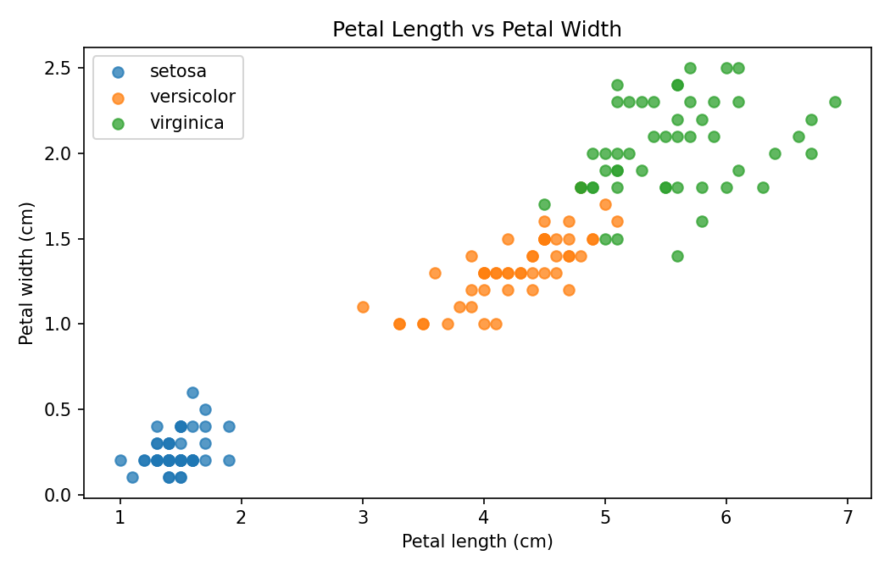
A scatter plot shows relationships and group separation. Setosa forms a clearly lower measurement cluster, while versicolor and virginica occupy higher ranges. This makes the relationship easy to understand visually.

4.2 Petal Length Distribution
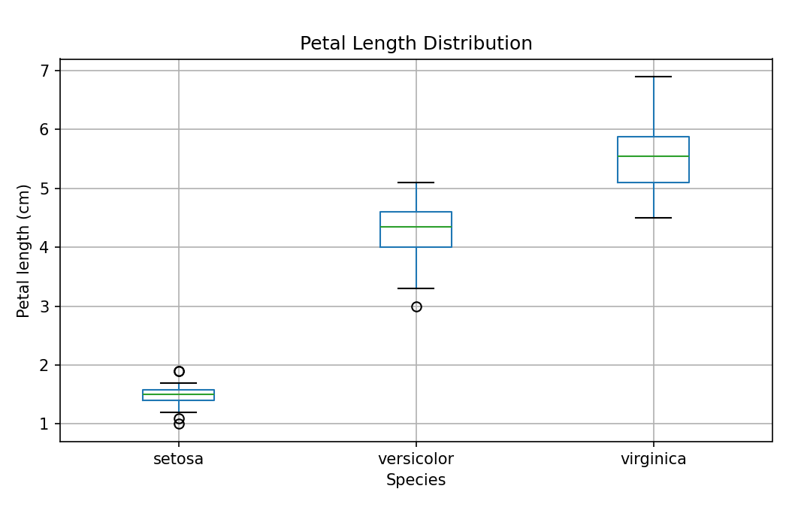
The box plot compares median, spread, and unusual observations. Petal length is substantially different across species, with setosa smallest and virginica generally largest.

4.3 Average Measurements
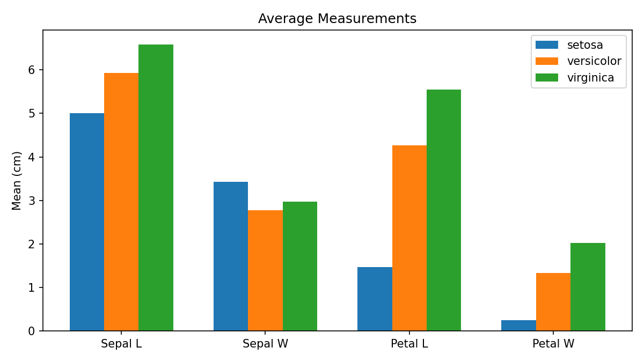
The grouped bar chart compares average feature values. It gives a quick summary of how the typical flower measurements differ among species.

4.4 Correlation Map
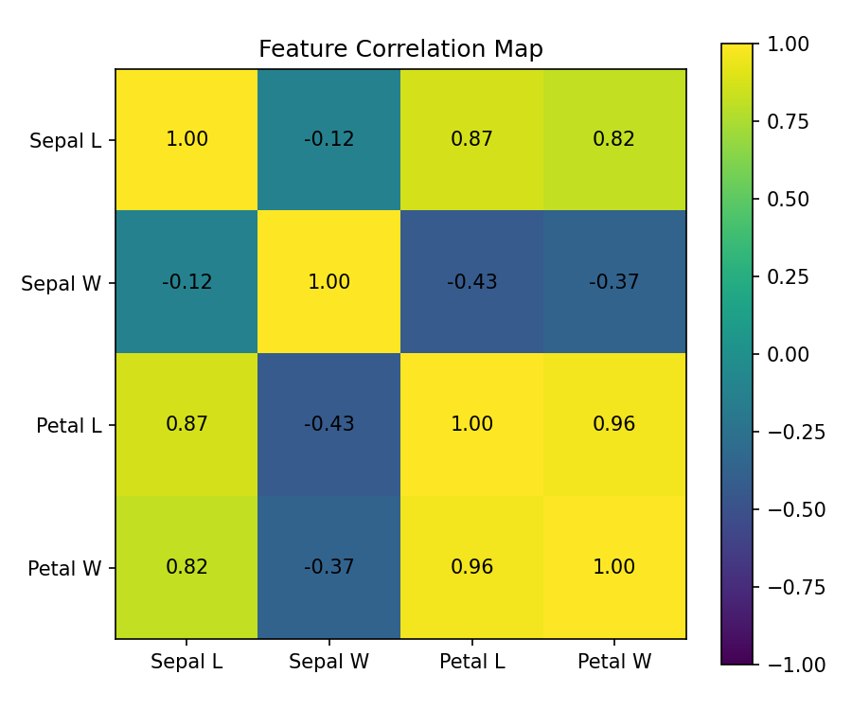
The correlation map summarizes relationships among measurements. Petal length and petal width have a strong positive correlation of 0.96, showing that larger petals tend to be wider.

4.5 Petal Length Distribution by Species
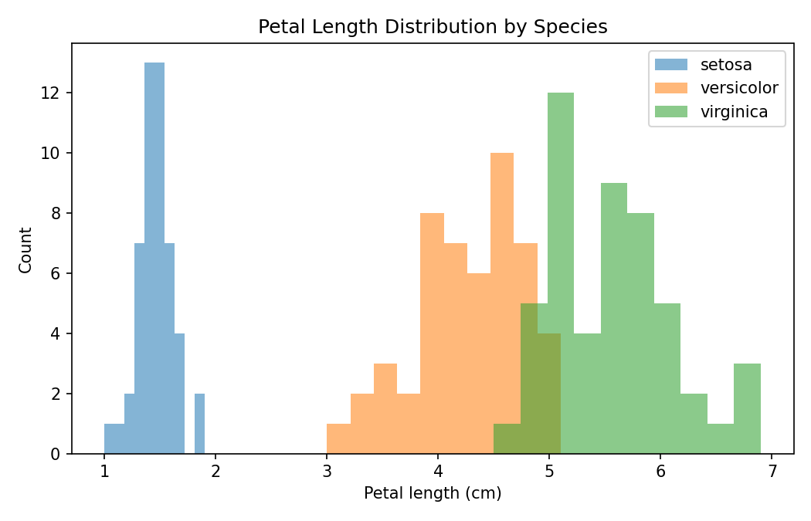
The histogram shows the shape and overlap of petal-length distributions. It reinforces that setosa is separated from the other groups and that versicolor and virginica occupy progressively larger ranges.

5. Overall Insights
- Petal measurements provide the clearest visual separation among the species.
- Setosa is visually distinct using petal length and width.
- Virginica generally has the largest petal measurements, while setosa has the smallest.
- Petal length and petal width are strongly positively related.
- Different chart types communicate different questions: distributions, comparisons, relationships, and correlations.

6. Business and Scientific Implications
Although the Iris dataset is scientific rather than commercial, the same storytelling methods can be applied to sales, customer, finance, healthcare, manufacturing, or operational datasets. Clear visual separation can help identify useful segments, unusual observations, and important variables. In scientific analysis, these patterns can guide feature selection and future classification experiments.

7. Conclusion
The project demonstrates that effective data storytelling combines appropriate charts with simple explanations. Five visualizations were used to move from overall comparisons to detailed relationships. The analysis indicates that petal length and petal width are particularly informative for distinguishing Iris species. This workflow provides a foundation for dashboards, classification models, and future analytical projects.

8. Sample Python Code
# Scatter plot
for species, group in df.groupby("species"):
plt.scatter(group["petal_length_cm"], group["petal_width_cm"], label=species)
plt.xlabel("Petal length (cm)")
plt.ylabel("Petal width (cm)")
plt.legend()
plt.show()
# Correlation
print(df[["sepal_length_cm","sepal_width_cm",
"petal_length_cm","petal_width_cm"]].corr())

9. References
UCI Machine Learning Repository – Iris Dataset: https://archive.ics.uci.edu/dataset/53/iris
Scikit-learn documentation: https://scikit-learn.org/
Matplotlib documentation: https://matplotlib.org/

