WEEK 1 INTERNSHIP TASK REPORT
Data Acquisition, Cleaning, and Exploratory Data Analysis (EDA)
  - Virtual Data Science with Python Apprentice Intern
Internship period: 04 September 2026 – 09 October 2026
Prepared by: [G.Karthik]
Dataset: Iris flower measurements (150 observations; 3 species)

1. Introduction
This report documents a small, reproducible data-science workflow using the public Iris dataset. The work covers data acquisition, inspection, data-quality checks, preprocessing, descriptive statistics, visualization, and interpretation. The Iris dataset contains measurements of sepals and petals for three iris species and is commonly used for learning data analysis and classification.

2. Objective
- Load a publicly available dataset using Python.
- Inspect its structure, columns, data types, and quality.
- Check for missing values and duplicate records, and validate numeric data types.
- Create at least three visualizations and explain the patterns they reveal.
- Summarize findings and recommend possible follow-up analysis.

3. Dataset and Acquisition
Dataset: Iris flower dataset. Source reference: UCI Machine Learning Repository, Iris dataset (https://archive.ics.uci.edu/dataset/53/iris). For reproducibility, this report loads the same classic dataset through scikit-learn's built-in dataset loader, so a separate CSV download is not required. The dataset has four numeric measurement features and a species label.
Python libraries: pandas, matplotlib, and scikit-learn.

4. Methodology

4.1 Load and inspect the data
The first step is to load the data into a pandas DataFrame and inspect the first rows, shape, data types, and summary statistics.
from sklearn.datasets import load_iris
import pandas as pd
iris = load_iris(as_frame=True)
df = iris.frame.copy()
df.head()
df.shape
df.info()
df.describe()

4.2 Data cleaning and preprocessing
Quality audit results: 150 rows were loaded. Missing values found: 0. Exact duplicate rows found before cleaning: 1. Rows after duplicate removal: 149. Missing values after preprocessing: 0; duplicate rows after preprocessing: 0.
Rationale: missing values were counted before deciding on an imputation strategy. Because this dataset contains no missing values, imputation was not necessary. Exact duplicate rows were removed as a standard quality safeguard; any removed row should be reviewed in a real project to ensure it is not a legitimate repeated measurement. Numeric measurement columns were explicitly converted with pandas.to_numeric. A separate readable species label was added from the dataset's target ID.
# Check data quality
print(df.isna().sum())
print("Duplicate rows:", df.duplicated().sum())
# Remove exact duplicate rows
df = df.drop_duplicates().copy()
# Convert measurement columns to numeric values
measurement_cols = [
"sepal_length_cm", "sepal_width_cm",
"petal_length_cm", "petal_width_cm"
]
for col in measurement_cols:
df[col] = pd.to_numeric(df[col], errors="coerce")
# Check the cleaned data again
print(df.isna().sum())
print(df.dtypes)

4.3 Descriptive statistics
The cleaned dataset contains 149 records across three species. Use counts, means, standard deviations, minimums, and maximums to understand the scale and spread of each feature.
print(df["species"].value_counts())
print(df.groupby("species")[measurement_cols].mean().round(2))
print(df[measurement_cols].describe().round(2))

5. Exploratory Data Analysis and Visualizations

5.1 Visualization 1: Petal length distribution
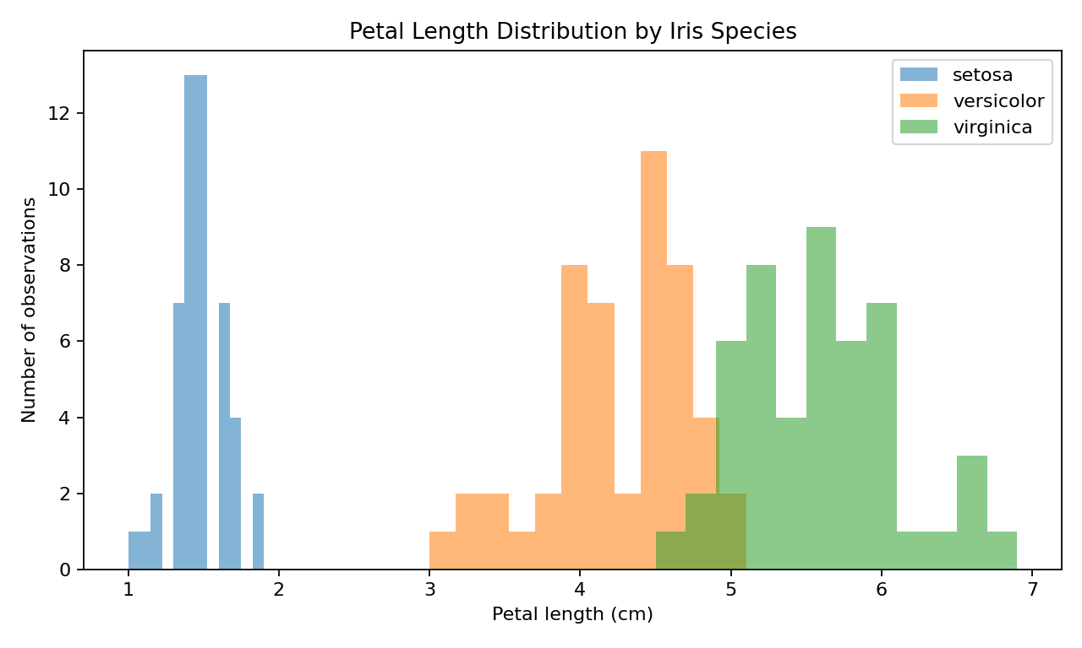
Interpretation: petal length distributions differ noticeably by species. Setosa generally has the shortest petals, while virginica tends to have the longest. Versicolor commonly falls between the other two groups. This suggests petal length may be a useful feature for distinguishing species.

5.2 Visualization 2: Petal length versus petal width
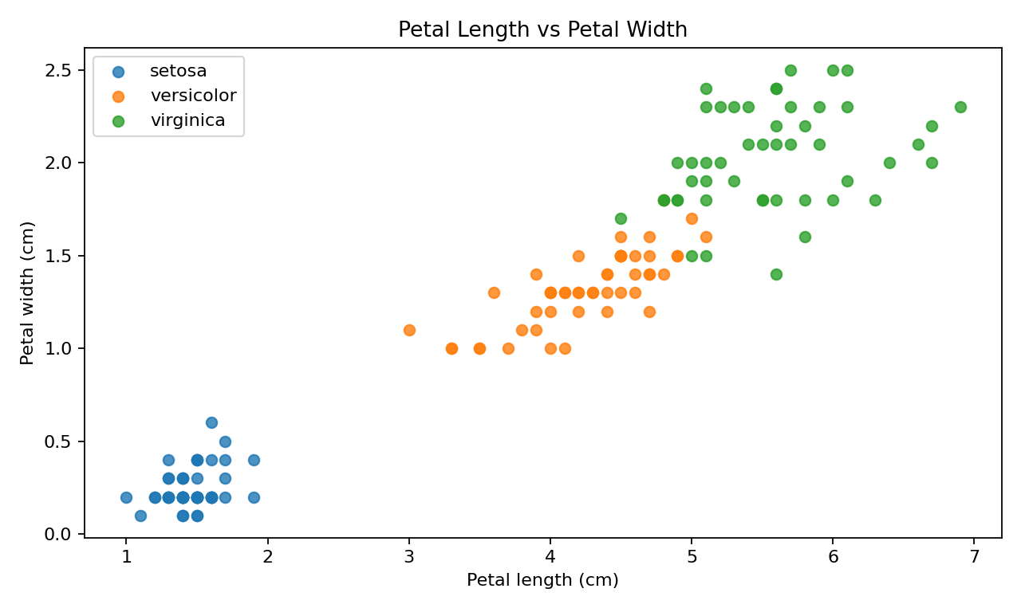
Interpretation: petal length and petal width show a strong positive relationship (correlation approximately 0.96). Larger petal lengths are generally associated with larger petal widths. The setosa group forms a clearly separate cluster, while versicolor and virginica are closer but still show differences in their measurement ranges.

5.3 Visualization 3: Correlation heatmap
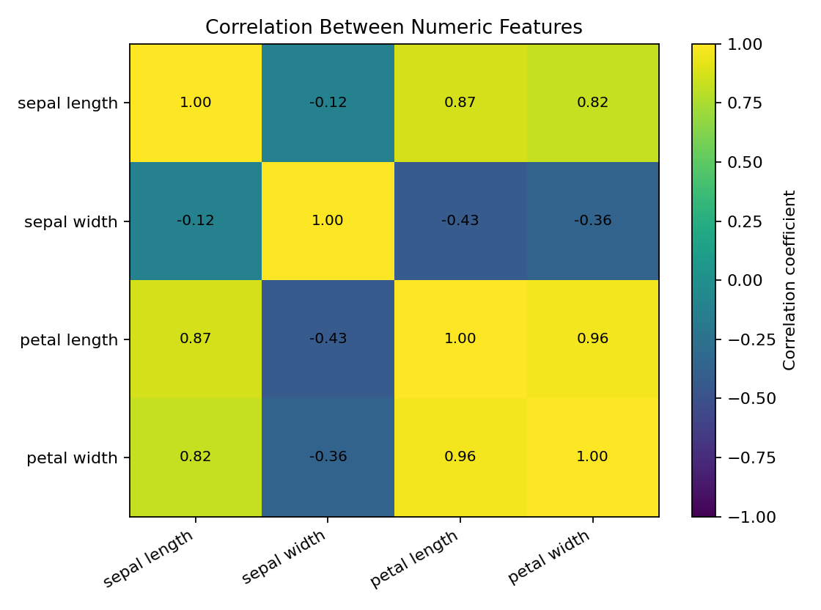
Interpretation: petal length and petal width have a strong positive correlation (0.96). Sepal length and sepal width have a weaker negative correlation (-0.12). Correlation describes association, not causation. The heatmap helps identify features that may carry similar information.

6. Selected Summary Results
Species | Sepal length | Sepal width | Petal length | Petal width
setosa | 5.01 | 3.43 | 1.46 | 0.25
versicolor | 5.94 | 2.77 | 4.26 | 1.33
virginica | 6.60 | 2.98 | 5.56 | 2.03
Note: values are mean measurements in centimetres, rounded to two decimal places.

7. Main Insights
- The dataset is balanced: each species has 50 observations in the original dataset.
- Setosa is distinguishable from the other species using petal measurements.
- Petal length and petal width move together strongly, making them promising predictive features.
- Sepal measurements overlap more across species than petal measurements, so they may be less effective alone.
- The initial data-quality audit found no missing values; cleaning should still be documented rather than assumed.

8. Limitations and Further Work
This is a small, clean, well-known teaching dataset and may not represent the challenges of a real business dataset. The analysis is descriptive and does not prove causation. Further work could include building a classification model, using a train/test split, evaluating accuracy and a confusion matrix, and testing the workflow on a larger dataset with missing values, inconsistent formats, or outliers.

9. Conclusion
The task demonstrates a complete introductory data preparation and EDA workflow in Python. The data was loaded, inspected, checked for missing and duplicate records, converted to suitable data types, summarized, and visualized. The visual analysis shows that petal measurements are particularly informative for separating Iris species. This workflow provides a foundation for later predictive modelling.

10. References
UCI Machine Learning Repository — Iris dataset: https://archive.ics.uci.edu/dataset/53/iris
scikit-learn documentation — toy datasets: https://scikit-learn.org/stable/datasets/toy_dataset.html
pandas documentation: https://pandas.pydata.org/docs/
Matplotlib documentation: https://matplotlib.org/stable/

Appendix: Complete reproducible starter code
import pandas as pd
import matplotlib.pyplot as plt
from sklearn.datasets import load_iris
# Acquire/load public Iris dataset
iris = load_iris(as_frame=True)
df = iris.frame.copy()
df.columns = [
"sepal_length_cm", "sepal_width_cm",
"petal_length_cm", "petal_width_cm", "species_id"
]
species_names = dict(enumerate(iris.target_names))
df["species"] = df["species_id"].map(species_names)
# Audit
print("Shape:", df.shape)
print("Missing values before cleaning:\n", df.isna().sum())
print("Duplicate rows before cleaning:", df.duplicated().sum())
# Clean
df = df.drop_duplicates().copy()
measurement_cols = [
"sepal_length_cm", "sepal_width_cm",
"petal_length_cm", "petal_width_cm"
]
for col in measurement_cols:
df[col] = pd.to_numeric(df[col], errors="coerce")
print("Missing values after cleaning:\n", df.isna().sum())
print(df.describe().round(2))
# Visualization 1: histogram
for species, group in df.groupby("species"):
plt.hist(group["petal_length_cm"], alpha=0.5, label=species, bins=12)
plt.xlabel("Petal length (cm)")
plt.ylabel("Count")
plt.title("Petal Length by Species")
plt.legend()
plt.show()
# Visualization 2: scatter plot
for species, group in df.groupby("species"):
plt.scatter(group["petal_length_cm"], group["petal_width_cm"], label=species)
plt.xlabel("Petal length (cm)")
plt.ylabel("Petal width (cm)")
plt.title("Petal Length vs Petal Width")
plt.legend()
plt.show()
# Visualization 3: correlation matrix
print(df[measurement_cols].corr().round(2))
df[measurement_cols].corr().plot(kind="bar", figsize=(8, 4))
plt.title("Feature Correlation Overview")
plt.tight_layout()
plt.show()

