Twitter

Twitter code was running till yesterday from today its not running . we are not able to get the tweets from url if this is the url <https://twitter.com/EYnews> earlier we used get the tweets from this compony url suddenly now we are not able to get the tweets now .

Now it is asking for login like this :

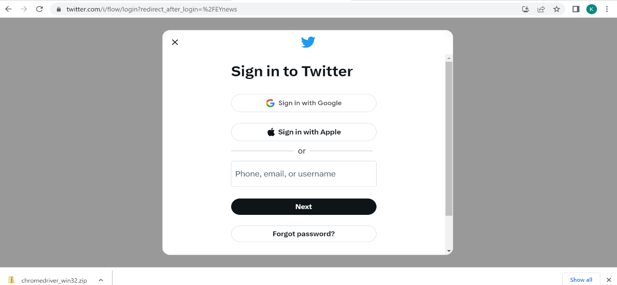

In other method we should go with twitter Api should create a twitter developer account and for twitter developer account approval is needed it take few days for approval

This is the code I used for twitter ;

[CTML/code review folder/twitter_test.py at main · entomoml/CTML · GitHub](https://github.com/entomoml/CTML/blob/main/code%20review%20folder/twitter_test.py)

Linkdin

Linkdin code is running able to extract the posts and in comments were not able to extract fully only around 60% of the were able to see

This is the code I used for linkdin;

[CTML/code review folder/linkdin.py at main · entomoml/CTML · GitHub](https://github.com/entomoml/CTML/blob/main/code%20review%20folder/linkdin.py)

If we try to log in to linkdin we cant extract the data it will block the linkdin account

Facebook

In Facebook there is a input proxy password we have to enter the key If remove the input the code will not run for long time I tried alternative methods but it did not worked

This is the code used for Facebook;

[CTML/code review folder/facebook.py at main · entomoml/CTML · GitHub](https://github.com/entomoml/CTML/blob/main/code%20review%20folder/facebook.py)