gstzeR

rax **Invoice**

**Original for Recipient**

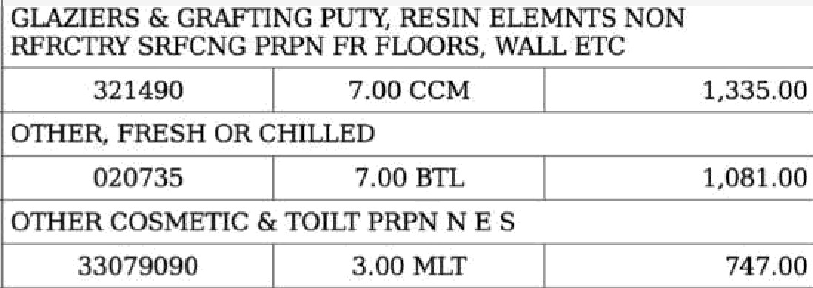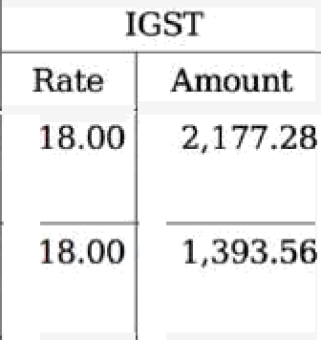

Details of Invoice:

Invoice Number: 17-18/)H/97 Invoice Date: July 26, 2017

Invoice Amount: INR 47,925.00 Reverse charge applicable: No

Details of Consignee (Shipped To):

**Cipla Ltd**

State: Rajasthan - 757166 State Code: RJ - 08

GSTIN: **08AKOCX6349PIZL**

Supplier:

CloudZen 8nftware Labs Pvt. Ltd.

State: Jharkhand State Code: JH - 20

GSTIN: **20QXOCCS424D** 1 Z5

Details of Buyer (Bill To):

**Cipla Ltd**

State: Rajasthan - 757166 State Code: RJ - 08

CSTIN: **08AKOCX6349PI ZL**

|  |  |  |  |  |  |
| --- | --- | --- | --- | --- | --- |
| Des p o **Taxable** Value IGST  HSN/ SAC  Oty Unit Rate Rate Amount | | | | | Total |
|  | O R LCHD WO BRC N 200 /M2 | 12,D!26.00 | \ B.OO | Z, 1 77.2B | 14,273.28 |
|  | 0713 9 7 00 U 0 00 | 7,742 00 | 18.00 | 1,393.56 | 9,135.56 |
| 3 | GLAZ1ERS & GRAFTING PUTY, RESIN ELEMNTS NON RFRCTRY SRFCNG PRPN FR FLOORS, WALL ETC | 9,345.00 | 28.00 | 2,6t6.60 | 1l,961.60 |
|  | 32149D 7. DO CCM 1,335.00 |  |  |  |  |
| 4 | OTHER, FRESH OR CHILLED | 7.567.00 | 2B.00 | 2, T 18.76 | 9,685.76 |
|  | 020735 7.00 BTL **1,08100** |  |  |  |  |
| 5 | OTHER COSMETIC 6r TOILT PRPN N E S | 2,241.00 | 28.00 | 627.48 | **2,868.48** |
|  | 22079090 2.00 MLT 747.00 |  |  |  |  |
|  | Total Amounts (INR) |  |  | 8,933.68 | **47,924.68** |
|  |  |  |  | Rounding | 0.32 |
| Invoice Tntal (in figures): **INR 47,925.00** | | | | | |
| Invoice Total amount in words: **Forty** seven thousand, nine hundred and twenty five | | | | | |

You have not specified any notes that should appear in the Invoice. Please customize this information in the following page https //mv tistzen in/- demo/a/ystins/1/update/

www.cloud zen.in EfiOE

CIN: ABCD.. ..

Authorized Signatory

CloudZen Software Labs Pvt. Ltd.