**VISVESVARAYA TECHNOLOGICAL UNIVERSITY**

**BELAGAVI-590018**



**A Mini Project Report**

**On**

**“SMART HOME AND CROP MONITORING IMPLEMENTATION USING CISCO PACKET TRACER”**

Submitted by

**KARTHIK G NAYAK (1DT18EC040)**

**MAHESH G (1DT18EC048)**

**BHAVANI PRASAD R (1DT19EC402)**

**KISHOR K (1DT19EC407)**

Under the Guidance of

**Vishwanath MB**

**(Asst Professor, Dept. of ECE)**



**Department of Electronics and Communication Engineering**

**DAYANANDA SAGAR ACADEMY OF TECHNOLOGY AND MANAGEMENT**

**Accredited 3 years by NBA, New Delhi, (Validity: 26-07-2018 to 30-06-2021)**

Udayapura, Kanakapura Road, Bengaluru-560082

2020-2021

**DAYANANDA SAGAR ACADEMY OF TECHNOLOGY AND MANAGEMENT**

**Accredited 3 years by NBA, New Delhi, (Validity: 26-07-2018 to 30-06-2021)**

Udayapura, Kanakapura Road, Bengaluru-560082

2020-2021

**Department of Electronics and Communication Engineering**



**CERTIFICATE**

This is to certify that the mini project work entitled “**SMART HOME AND CROP MONITORING IMPLEMENTATION USING CISCO PACKET TRACER**”is carried out by**KARTHIK G NAYAK (1DT18EC040), MAHESH G(1DT18EC048), BHAVANI PRASAD R(1DT149C402) and KISHOR K(1DT19EC407),** bonafide students of **DAYANANDA SAGAR ACADEMY OF TECHNOLOGY AND MANAGEMENT**in **Bachelor of Engineeringin Electronics and Communication Engineering** of the **Visvesvaraya Technological University, Belagavi**during the year **2020-2021**. It is certified that all corrections/ suggestions indicated for internal assessment have been incorporated in the report. The mini project report has been approved as it satisfies the academic requirements with respect of mini project work prescribed for the award of Bachelor of Engineering Degree.

Name &Signature of the guideName &Signature of the HOD Signature of the principal

Vishwanath MB Dr. R. Manjunatha Prasad Dr. B.R. Lakshmikantha

External Viva

Sl.No. Name of the Examiner Signature with date

1.

2.

**ACKNOWLEDGEMENT**

We wish to express our sincere gratitude to everyone who helped and guided us in completing this project work.

We are grateful to **Dr. B. R. Lakshmikantha, Principal of DSATM, and Bengaluru** for having encouraged us in our academic endeavours.

We are thankful to **Dr. R. Manjunatha Prasad, Professor and Head of Department of Electronics and Communication Engineering** for encouraging us to aim higher.

We would like to express our gratitude to our mini project coordinator **Dr. Madhumathy P**, **Professor in Department of Electronics and Communication Engineering** for constant motivation, support and guidance.

We would like to express our sincere thanks to our Guide**Mr. Vishwanath M B AssociateProfessor in Department of Electronics and Communication Engineering** for constant guidance.

We are also thankful to all faculty members of the Department of Electronics and Communication Engineering for their assistance and encouragement.

**Karthik G Nayak (1DT18EC040)**

**Mahesh G (1DT18EC048)**

**Bhavani Prasad (1DT19EC402)**

**Kishor K (1DT19EC407)**

**ABSTRACT**

The technology has been growing from day to day in human life. The necessity for the development of technology is to lead human life comfortably. The basic need of human to lead his/her life comfortably is a home. A home with updated latest technology which means a smart home. This project gives the basic idea use cisco packet tracer to implement smart home. One is needed to create a smart home when electronic devices are switched on and off. Smart home development is achieved by simulation via testing system, network setup and wireless home gateway computer network equipment required by a smart home network cisco packet tracer using Internet Thing (IoT)/IoE command. The software chosen for the simulations is Cisco Packet Tracer, the tool's main strength is to offer a variety of network components that represent a real network, and then interconnect and configure devices to create a network. Cisco implemented (IoT) functionalities in the latest version of the platform, and now it is possible to add all the smart devices, sensors, actuators and also devices, which simulate microcontrollers like Arduino or Raspberry Pi to the network. All IoT devices can be run on generic programs or modified by Java, Python or Blocky programming them. This makes Cisco Packet Tracer a perfect method to construct functional simulations for IoT.

The Internet of Things (IOT) has been denoted as a new wave of information and communication technology (ICT) advancements. The IOT is a multidisciplinary concept that encompasses a wide range of several technologies, application domains, device capabilities, and operational strategies, etc. The ongoing IOT research activities are directed towards the definition and design of standards and open architectures which isstill have the issues requiring a global consensus before the final deployment. This project also gives overview about IOT technologies and applications related to agriculture with comparison of other survey papers and proposed a novel irrigation management system. Our main objective of this work is to for Farming where various new technologies to yield higher growth of the crops and their water supply.

**TABLE OF CONTENTS**

**Page no.**

ABSTRACT

LIST OF FIGURES

LIST OF TABLES

CHAPTER 1: INTRODUCTION

* 1. OVERVIEW

1.2 DEFINITION OF INTERNET OF THINGS

1.3 HISTORY

CHAPTER 2:

2.1 LITERATURE SURVEY

2.2 PROBLEM STATEMENT

2.3 OBJECTIVES

CHAPTER 3: DESIGN AND IMPLEMENTATION

3.1 BLOCK DIAGRAM

3.2 ALGORITHM

3.3 FLOWCHART

3.3.1 FLOW CHART REPRESENTATION

3.3.1.1 HOME GATWAY

3.3.1.2 SMART PHONE

3.3.1.3 IOT DEVICE REGISTRATION

3.4 SYSTEM REQUIREMENTS

3.4.1 DEVICE USED FOR DESIGN

3.4.1.1 ROUTER

3.4.1.2 SWITCH

3.4.1.3 DNS IOE AND CENTRAL OFFICE SERVER

3.4.1.4 IOT CLOUD

3.4.1.5 CABLE MODEM

3.4.1.6 HOME GATEWAY

3.4.1.7 MCU(MICRO CONTROLLER UNIT)

3.4.1.8 CELLUAR TOWER

3.4.1.9 SMART DEVICES

3.5 IMPLEMENTATION

3.5.1 DEVICE CONFIGURATION

3.5.2 CONNECTION OF ALL IOT DEVICES

3.5.3 REGISTER OF IOT DEVICES

3.5.4 ENABLE OF DNS SERVER

3.5.5 MONITORING AND CONTROLLING IOT DEVICES

THROUGH REMOTE DEVICES

3.6 LIST OF COMPONENT USED FOR IMPLEMENTATION

CHAPTER 4: RESULTS

4.1 LAWN SPRINKLER AUTOMATION

4.2 AIR CONDTIONER AND FURNACE ARE AUTOMATED BASED ON TEMPERATURE

4.3 RFID BASED LOCK AND UNLOCK SYSTEM

4.4 MOTION DETECTOR

4.5 REMOTELY CONTROLLED GARAGE DOOR SYSTEM

4.6 DETECTION OF SMOKE BY CO2 DETECTOR

APPLICATIONS

ADVANTAGES

CONCLUSION

REFERENCES

**LIST OF FIGURESRi**

**Figure no Title Page no**

Fig 3.1 Block diagram of Smart home automation

Fig 3.2 Home gateway with associated smart objects

Fig 3.3.1 Smart phone desktop

Fig 3.3.2 Smart phone IOT login page

Fig 3.3.3 List of IOT monitoring devices

Fig 3.4.1 Registration of devices

Fig 3.4.2 IOT monitoring in server

Fig 3.5.1.1 Router used for smart automation

Fig 3.5.1.2 Switch for connection

Fig 3.5.1.3 Central office Server

Fig 3.5.1.4 IOT cloud

Fig 3.5.1.5 Cable modem

Fig 3.5.1.6 Home Gateway

Fig 3.5.1.7 Micro controller unit

Fig 3.5.1.8 Cellular Tower

Fig 3.5.1.9 Smart device

Fig 3.6.1 Smart home architecture

Fig 3.6.2.1 ISP server provides IP to central office server

Fig 3.6.2.3 IP configuration of IOT server

Fig 3.6.3 Connection of devices through homegateway

Fig 3.6.4 Registration of IOT devices to IOT server

Fig 3.6.5 Assigning IP address to DNS server

Fig 3.6.6.1 Applicatins of PC desktop browser

Fig 3.6.6.2 IOT server login through web

Fig 3.6.6.3 Monitoring and controlling IOT devices

Fig 3.6.6.4 Conditions for automation

Fig 4 Monitoring and controlling smart devices

Fig 4.1 Irrigation Management

Fig 4.2 Automation of Air condtioner and Furnace are automated based on temperature

Fig 4.3 RFID Based door lock and unclock system

Fig 4.4 Motion Detector

Fig 4.5 Remotely controlled garage door system

Fig 4.6 Detection of smoke by Co2 detector

|  |
| --- |
| **IST OF TABLES**  **Title Table No. Page No.**  1. Table showing the required components for smart home |

**Smart Home Automation and Crop Monitoring Using Cisco Packet Tracer**

**CHAPTER 1**

**INTRODUCTION**

**1.1 OVERVIEW**

Smart home is a living home that include smart object to improve home activities in advance, that can be automating activities of home without users' involvement such monitoring home environment condition by various sensor (Temperature, Humidity, smoke, wind, sound) then ventilate the environment based on sensor information. Smart home can provide different function rather than providing safety that is security by providing more automate security using different alarm system such siren sound, LCD display and sending email to legitimate user if security issue is detected by sensor. Home automation states managing and controlling home objects by using micro-controller or computer technology. Automation is popular because it provides ease, efficiency and secure environment. In this project all smart appliance is registered to home gateway and controlled by legitimate person. Smart Home reduces user's involvement in monitoring home settings and controlling home appliances by including different sensor in home automation. IOT (Internet of Things) is a system in which people, objects with a specific identity and moving capacity information without needing a dual human-to-human origin, i.e., destination or contact between people and computers IoT and IoE are a well-versed technology which optimizes the life based on smart sensors and smart devices which operate together on the internet. All (IoE) web is a theory that extends machine-to-machine communication (M2M) emphasis of the Internet of Things (IoT) to describe a more complex system that also includes people and processes.

There are many techniques available for the precision agriculture to monitor and control, environment for the growth of many crops. Due to unequal distribution of rain water, it is very difficult to requirement needed farmer to manage the water equally to all the crops in whole farm it requires some irrigation method that suitable for any weather condition, soil types and variety of crops. Irrigation management is an important factor in agriculture allows the farmer to improve the cultivation in a way the plants need. According to the requirement of the crops the threshold will be set, if the any environmental condition like temperature, soil conditions and humidity goes below or above the threshold value, then IOT sense the changing in parameters are monitored simultaneously and all the data will be transmitted to farmers, according to that farmer will take the controlling decision and send to the system. The system will run the actuator and control the parameter. Types of sensors used and controlling action that are taken according to them Temperature control - Growth of plantation depends on photosynthesis methods that is depends upon the radiation from the sun.

Irrigation management is an important factor in agriculture allows the farmer to improve the cultivation in a way the plants need. According to the requirement of the crops the threshold will be set, if the any environmental condition like temperature, soil conditions and humidity goes below or above the threshold value, then IOT sense the changing in parameters are monitored simultaneously and all the data will be transmitted to farmers, according to that farmer will take the controlling decision and send to the system.

In this project all necessary required home appliances are registered to home gateway service and this can be controlled by the corresponding legitimate person. This project deals with the designing of smart home with the new released version of cisco packet tracer 7.2 version which has all updated devices. The cisco packet tracer simulator 7.2 is used to design as well as the designing of the Internet of everything devices with classically networking devices. In this project the smart home is designed by using the home appliances such as smart light, smart door, smart fan and smart window etc

**Smart Home Automation and Crop Monitoring Using Cisco Packet Tracer**

**1.2 Definition of internet of things**

It is a network that consists of different objects which has the capability to organize things automatically, it also has ability to share information and give reactions and actions towards the environment.

Internet of things (IOT) is a network which allows objects and users to communicate each other by giving a unique address to every object to identify which users are accessing to what resource of the network easily. It also describes a world of network in which every object is connected to the network so that data can be shared. Everybody already has a smart phone, but a phone is not smart rather it helps its user to make smarter decisions.

**1.3 HISTORY**

IOT technology provides a means to transfer new innovations about industry, agriculture and energy distribution by adding important information with the help of sensors. According to Cisco there are a number of companies and research organizations which provides the impacts of IOT on the internet and the economy in the next five or ten years. In the research that had been done by Morgan Stanley states that more than 24 billion devices will be connected to the internet in the year of 2019. The Hawaii Company also predicts that100 billion IOT connections will be performed in the year of 2025.In economic concern McKinsey Global Institute indicates that the economic impacts of the IOT in the global will be as much as $3.9 to $11.1 trillion by 2025.

The internet of things was first introduced by pioneer Kevin Ashton in 1999 to define that the objects of the physical globe can be connected to the internet by sensors. He provided that the ability of connecting RFID (radio frequency Identification) used in business to internet to track goods/materials ready selling without the need of the human intervention. Today's internet of things has an ability to describe different objects, devices and sensors to connect to the internet. As a result, internet of things is generally new concept, but the idea of integrating computers and networks to manage and control things had existed in this world for around several decades. In the late 1970's systems that are used to remotely control the electrical grids trough the smart phones were already in use in the market. In 1990's wireless technology that provides machine to machine company communication and industrials to control materials and operation was very popular at that time.

**Smart Home Automation and Crop Monitoring Using Cisco Packet Tracer**

**CHAPTER 2**

**2.1 LITERATURE SURVEY**

Ahmed Abdi “Designing Smart Campus Using Internet of Things “international Journal of Computer Science Trends and Technology (IJCST) – Volume 6 Issue 3, May - June 2018

This paper helps us to investigate the concept of the internet of things and its relevance in campus context. Internet of things is a new technology that is used for the interconnection of the devices with the help of the internet connection. It enables the devices to sense and monitor devices remotely. It has been shown how to successfully build a smart campus that will contain progressed ICT'S to consequently screen and control each activity and events inside a campus using IoT smart devices. In order to show the feasibility of the work a simulation tool is used for designing a smart campus portion named smart office.

Nazmul Hossain, Md. Alam Hossain, Rafia Sultana & Farzana Akter Lima” A Security Framework for IOT based Smart Home Automation System” Global Journal of Computer Science and Technology - Volume 18 Issue 3 Version 1.0 Year 2018

A smart system was built in which system controls all the instruments of the house through mobile phones or computers. It also gives an idea of how the process is preferable for real-time home security controlled and maintaining from fire accidents with quick solution. This also tell us how system gives us better-secured home and controlled theft issues in our house. The proposed system consults the sensor data like temperature, motion, gas, light sensors, and activates a scheme following the necessity.

Tanushree Sonkar, Ashok Verma “IoT Based Low Cost and Intelligent Module for Smart Irrigation System” INTERNATIONAL JOURNAL OF SCIENTIFIC PROGRESS AND RESEARCH (IJSPR) - Issue 168, Volume 68, Number 01, February 2020

The proposed system gives us an idea how to work for Farming with various new technologies to yield higher growth of the crops and their water supply. It is also going to check the temperature, humidity, and soil moisture. The paper is all about automated control features with latest electronic technology using microcontroller which turns the pumping motor ON and OFF on detecting the dampness content of the earth and GSM phone line. It works automatically and hence reduces the man power.

Andrea Finardi “IoT Simulations with Cisco Packet Trace” Helsinki Metropolia University of Applied Sciences Master of Engineering Information Technology Master’s Thesis 4 th June 2018

The main objective of the thesis work was aiming to deliver practical IoT simulations using the Cisco Packet Tracer tool to support the Internet of Things. This thesis work was aiming to build practical cases, through an IoT simulator, the various IoT sensor-based components, network landscapes where all the devices are connected and backend intelligence where logic and analysis of sensor-based data can be gathered and analyzed. This also give us an idea of how Cisco Packet Tracer offers also the possibility to a more low-lever IoT simulation using microcontroller, sensors and actuators.

**2.2 PROBLEM STATEMENT**

In these modern days, they are many people who give precious value to their time as well as to their business. So, in day-to-day life, they are using so many home appliances to get their work done. So major problem comes when one of the appliances failed to load the work.

**Smart Home Automation and Crop Monitoring Using Cisco Packet Tracer**

In this time home automation comes to solve the real-world problems. This will help us to monitor, control and it collects all the information and used to detect problem before the actual problem arise from device. So, it can be used remotely by using smart device, by this we have control on our home at tip of the finger.

**2.3 OBJECTIVES**

* The project aims at designing an advanced home automation system using cisco packet tracers
* The main objective of the functions is to improve the quality of life.
* The proposed system develops a smart home system that gives the user complete control over all remotely controllable aspects of the system.
* The objective of the system is to control home appliance anytime from anywhere in the world and efficiently utilize power by controlling appliances properly.
* Another main objective is to work for farming where various new technology to yield higher growth of the crops and their water supply.

**Smart Home Automation and Crop Monitoring Using Cisco Packet Tracer**

**CHAPTER 3**

**DESIGN AND IMPLEMENTATION**

**3.1 BLOCK DIAGRAM**

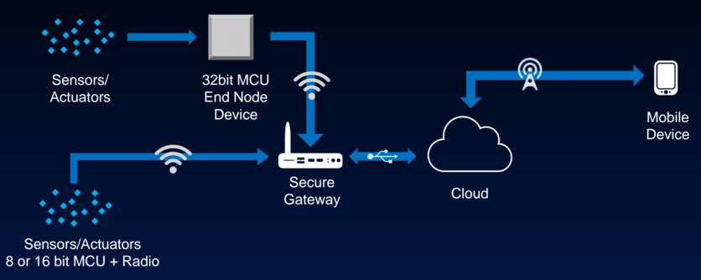

**Fig 3.1 Block Diagram of Smart Home Automation**

This is the block diagram of smart home automation. There is sensors and actuators. Sensors are used to sense the activity by using heat, light, sound etc. And actuators are device which uses the signal from the sensors and it converted into mechanical motion. For e.g., electric door locks in auto mobiles.

There are some smart devices which are wirelessly connected to the secure home gateway, home gateway is device which bridges the network access between connected LAN hosts to a WAN. As you know, if anything wants to work on remotely networking take a major role. The router and network devices are maintained by ISP (internet service provider) it may Airtel, Jio etc. And router is used to route the network in between home to cellular network by using IP addresses.

After connecting all devices to home gateway, it will transfer all the information collected by the smart devices to the cloud. A cloud is the internet-based provision of storage. In simple words it’s a branch of servers used to store the information and it also has networking power to route the network. The main reason to connect home gateway to cloud is using this technology we can access our smart home from anywhere in the world using smart phone. Connect router to the different types of servers with the help of copper-straight through cable. DNS is a domain name system it converts domain name to IP address. IOE server is also called as registration server which is used to register all smart devices to the network.

All these router and server configuration are done by writing some command in the CLI (command line interface). It contains IP addresses, Host name, DHCP addresses, and routing the network to different devices by writing some commands.

Smart home automation faces different types of topology day by day. So, by connecting all devices to the cloud, servers etc. the devises will communicate with each other and detect problem before the shutdown of that devices in future. And can send alert to the user phone to fix it.

**Smart Home Automation and Crop Monitoring Using Cisco Packet Tracer**

All these router and server configuration are done by writing some command in the CLI (command line interface). It contains IP addresses, Host name, DHCP addresses, and routing the network to different devices by writing some commands.

Smart home automation faces different types of topology day by day. So, by connecting all devices to the cloud, servers etc. the devises will communicate with each other and detect problem before the shutdown of that devices in future. And can send alert to the user phone to fix it.

**3.2 Algorithm**

Steps for implementing smart home are as follows:

Step 1: Start the project.

Step 2: Open the .pkt extension file and save the file.

Step 3: Add the required components to the work space.

Step 4: Connect all devices in work space using cables.

Step 5: Configure the device and setup internet service provider router.

Step 6: Add Home gateway to the network.

Step 7: Connect smart Devices to the home gateway.

Step 8: Add end user device to the network.

Step 9: Automate the activities in smart home.

Step 10: Test your simulation.

Step 11: Stop.

**3.3 FLOW CHART**

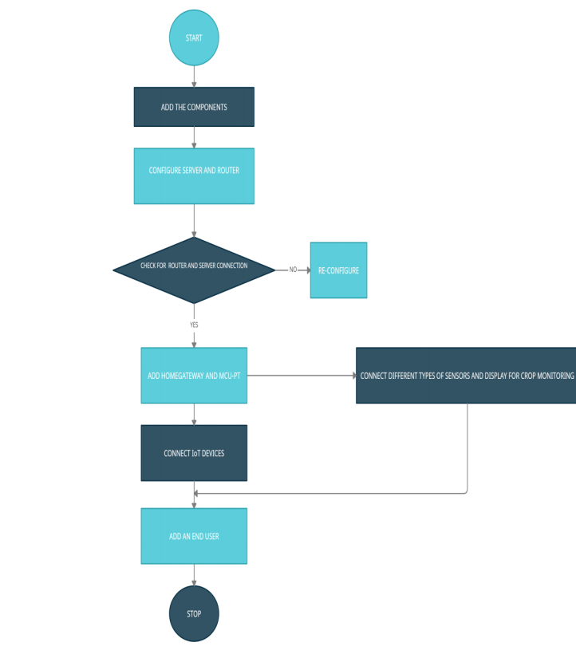

**Smart Home Automation and Crop Monitoring Using Cisco Packet Tracer**

**3.3.1 Flow Chart representation**

**3.3.1.1 Home gateway**

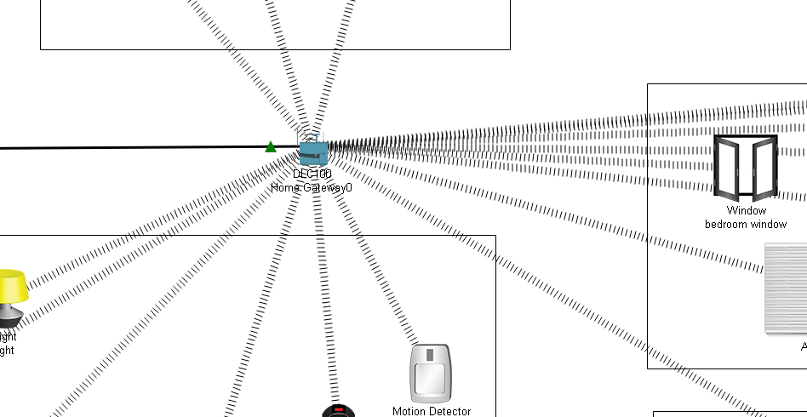

**Fig 3.2: - Home gateway with associated smart objects**

The IoT smart devices can directly register with the home gateway IoT service or network database. It offers a wireless service on channel 6 that is provided with the SSID (service set identifier) and 4 Ethernet ports. We can also setup WEP/WPA-PSK/WPA2 passphrase to wireless links for safer connections. The fig 3.3.1.1. Indicates that the smart objects are associated to the home gateway by Wireless medium for local and remote control of smart devices. The home gateway is connected through WAN Ethernet port to the internet. We can easily manage the IoT system with the help of home gateway and web interface. The internal IP address for the home gateway is 192.168.25.10, can also be reached via its IP address in front of the Internet. Home portal can also be used as a DHCP server assigns IP addresses to any, connected smart device.

**3.3.1.2 SMART PHONE**

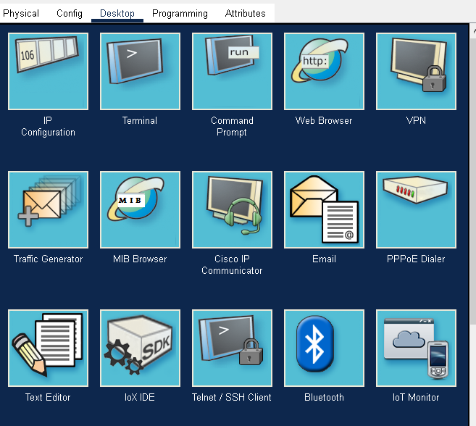 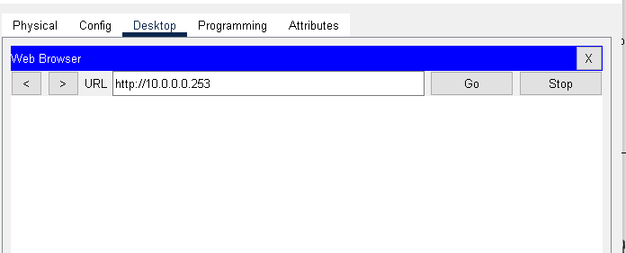

**Fig 3.3.1 :- Smart phone desktop Fig 3.3.2:- Smart phone IOT login page**

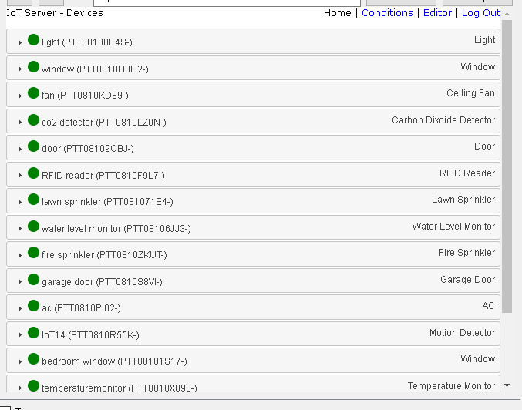

**Fig 3.3.3:- List of IOT monitoring devices**

**Smart Home Automation and Crop Monitoring Using Cisco Packet Tracer**

**3.3.1.3 IoT Device Registration**

This server provides IOT services to the users present at remote. All the IoT smart devices are connected and registered to the the IoT server. To get the service and to control the devices, user needs to login the IoT server by entering username and password. IP address (10.0.0.253) and its URL (www.ioe.org) of IoT server is entered in the DNS server (having IP address 10.0.0.254) of network. The smart devices were remotely connected to the IoT server sharing the same username and password credentials. Connection also was established by using the static IP of the IoT server hosted in the same IoT network as shown in figure 3.2.4(a) and figure

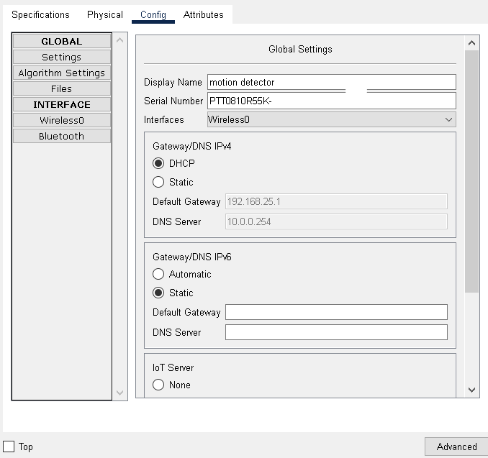 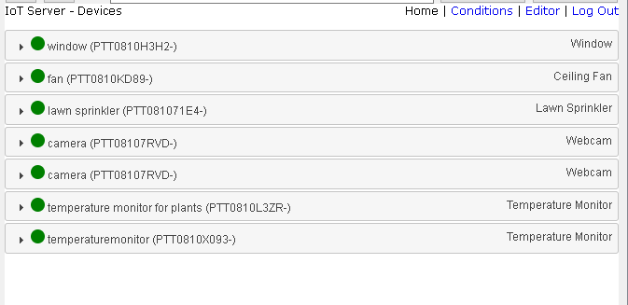

**Fig 3.4.1:- Registration of devices Fig3.4.2:- IOT monitoring in server**

**3.4 SYSTEM REQURIEMENTS**

Cisco packet tracer is a cisco proprietary multiplatform tool that enables possibility to create networks and IOT simulation without need of a hardware or pre – existing network. The tool is free of charge, runs on the major operating system and it is downloadable from cisco NetAcad page for all the users who are having a valid NetAcad account. The tool was built in order to allow users to experiment networking without having a need of costly network infrastructure and lengthy hardware setup procedures. Some of the components used in the project are as follows.

**3.4.1Devices Used for Design**

**3.4.1.1 Router:** -

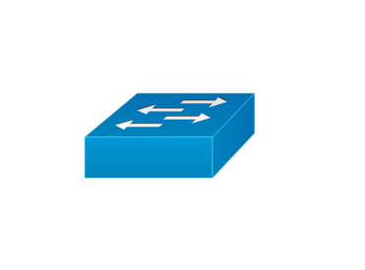

**Fig 3.5.1.1: - Router used for smart automation**.

A router is a networking device those forwards data packets between computer networks. Routers perform the traffic directing functions on the Internet. Data sent through the internet, such as a web page or email, is in the form of data packets. A packet is typically forwarded from one router to another router through the networks that constitute an internetwork (e.g., the Internet) until it reaches its destination node.

**Smart Home Automation and Crop Monitoring Using Cisco Packet Tracer**

A router is connected to two or more data lines from different IP networks. When a data packet comes in on one of the lines, the router reads the network address information in the packet header to determine the ultimate destination. Then, using information in its routing table or routing policy, it directs the packet to the next network on its journey.

The most familiar type of IP routers is home and small office routers that simply forward IP packets between the home computers and the Internet. More sophisticated routers, such as enterprise routers, connect large business or ISP networks up to the powerful core routers that forward data at high speed along the optical fiber lines of the Internet backbone.

**3.4.1.2 Switch:** -



**Fig 3.5.1.2: - switch for connection.**

A switch is a device in a computer network that connects other devices together. Multiple data cables are plugged into a switch to enable communication between different networked devices. Switches manage the flow of data across a network by transmitting a received network packet only to the one or more devices for which the packet is intended. Each networked device connected to a switch can be identified by its network address, allowing the switch to direct the flow of traffic maximizing the security and efficiency of the network.

A switch is more intelligent than an Ethernet hub, which simply retransmits packets out of every port of the hub except the port on which the packet was received, unable to distinguish different recipients, and achieving an overall lower network efficiency.

An Ethernet switch operates at the data link layer (Layer 2) of the OSI model to create a separate collision domain for each switch port. Each device connected to a switch port can transfer data to any of the other ports at any time and the transmissions will not interfere. Because broadcasts are still being forwarded to all connected devices by the switch, the newly formed network segment continues to be a broadcast domain.

**3.4.1.3 DNS, IOE and Central Office Servers:** -

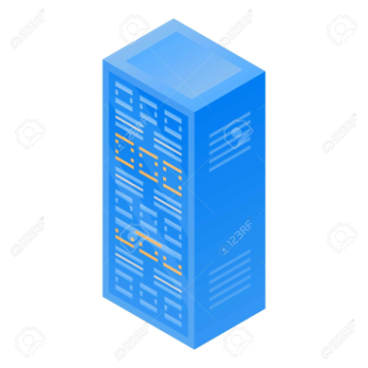

**Fig 3.5.1.3: - Central office server**

**Smart Home Automation and Crop Monitoring Using Cisco Packet Tracer**

The Domain Name System (DNS) is the phonebook of the Internet. When user’s type domain names such as ‘google.com’ or ‘nytimes.com’ into web browsers, DNS is responsible for finding the correct IP address for those sites. Browsers then use those addresses to communicate with origin servers or CDN edge servers to access website information. And IOE servers are used to control smart thing registered on it and provide difference functionalities. IoE applications range from digital sensor tools/interfaces used for remote appliances to smarter and more well-connected mobile devices, industrial machine learning systems and other types of distributed hardware that have recently become more intelligent and automated. The IoE term is driving much discussion about its future. For example, organizations like Cisco use the term in its branding to refer to the potential of modern and future technology. The central office server gets all IP information from the ISP automatically after configuring DHCP server, DNS server and default router on the ISP router. It can also be used to connect a cell tower to the router and the router to the cell tower for transferring of information between them.

**3.4.1.4 IoT Cloud:** -



**Fig 3.5.1.4:- IoT Cloud**

IoT clouds offer an efficient, flexible, and scalable model for delivering the infrastructure and services needed to power IoT devices and applications for businesses with limited resources. IoT clouds offer on-demand, cost-efficient hyper scale so organizations can leverage the significant potential of IoT without having to build the underlying infrastructure and services from scratch. IoT clouds offer an efficient, flexible, and scalable model for delivering the infrastructure and services needed to power IoT devices and applications for businesses with limited resources. IoT clouds offer on-demand, cost-efficient hyperscale so organizations can leverage the significant potential of IoT without having to build the underlying infrastructure and services from scratch. Cloud services enable IoT remote device lifecycle management that plays a key role in enabling a 360-degree data view of the device infrastructure. Certain cloud providers offer multiple IoT device lifecycle tools that can ease the update and setup of firmware and software over the air (FOTA).

**3.4.1.5 Cable modem: -**



**Fig 3.5.1.5: - cable modem**

**Smart Home Automation and Crop Monitoring Using Cisco Packet Tracer**

Cablemodem, modem used to convert analog data signals to digital form and vice versa, for transmission or receipt over cable television lines, especially for connecting to the Internet. A cable modem modulates and demodulates signals like a telephone modem but is a much more complex device. Data can be transferred over cable lines much more quickly than over traditional phone lines. Transmission rates range from about 8 megabits per second (Mbps) for basic services to some 50 Mbps for premium services. Cable Internet access is regarded as a replacement for slower dial-up, ISDN, and DSL connections.

**3.4.1.6 Home Gateway:** -

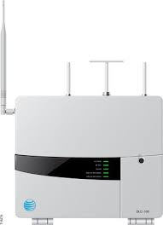

**Fig 3.5.1.6: - Home gateway**

A home/residential gateway is a gateway that allows the connection of a local area network (LAN) to a wide area network (WAN). So, a home gateway actually helps to connect a smaller network to a larger network or directly helps in connecting to the internet. For e.g., if you have a Wi-Fi router in your home and all the home devices are connected to it but the devices require to access the internet then there is a requirement of home gateway which enables them to connect the larger network that is internet. So, the gateway facility is provided by the router.

**3.4.1.7 MCU (Micro Controller Unit): -**

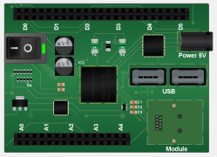

**Fig 3.5.1.7: - Micro controller unit**

A microcontroller is a compact integrated circuit designed to govern a specific operation in an embedded system. A typical microcontroller includes a processor, memory and input/output (I/O) peripherals on a single chip. A microcontroller is embedded inside of a system to control a singular function in a device. It does this by interpreting data it receives from its I/O peripherals using its central processor. The temporary information that the microcontroller receives is stored in its data memory, where the processor accesses it and uses instructions stored in its program memory to decipher and apply the incoming data. It then uses its I/O peripherals to communicate and enact the appropriate action.

**Smart Home Automation and Crop Monitoring Using Cisco Packet Tracer**

**3.4.1.8 Cellular Tower:** -

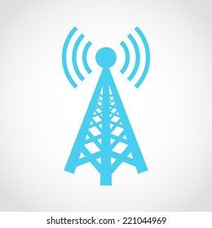

**Fig 3.5.1.8: -cellular tower**

A cell tower houses the electronic communications equipment along with an antenna to support cellular communication in a network. A cell tower is usually an elevated structure with the antenna, transmitters and receivers located at the top. A cell tower also known as cellular tower or cell site. Cell towers are grouped in geographical locations where the population density is high and there are likely to be large numbers of cell phone users. This helps in avoiding saturation of the available capacity, which could result in busy signals and unhappy consumers. Cell phones are designed to be aware of the nearest tower. This is shown to the user in the form of signal strength, which represents the connectivity strength between the user’s location and the nearest tower providing the service. When a user makes a call, the radio signal emitted searches for the nearest tower. The receiving antenna of the cell tower then picks up the radio signal and starts the process of finding the caller. Once found, the radio signals are transmitted back to the user and the communication is established with back-and-forth passing of the radio signals.

**3.4.1.9 Smart Devices:** -

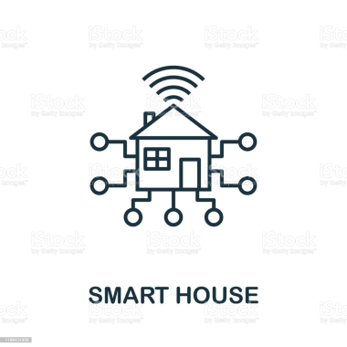

**Fig 3.5.1.9: - smart device**

A smart device, as the name suggests, is an electronic gadget that is able to connect, share and interact with its user and other smart devices. Although usually small in size, smart devices typically have the computing power of a few gigabytes. Smart devices are interactive electronic gadgets that understand simple commands sent by users and help in daily activities. Some of the most commonly used smart devices are smartphones, tablets, smart watches, smart glasses and other personal electronics. While many smart devices are small, portable personal electronics, they are in fact defined by their ability to connect to a network to share and interact remotely. Many TV sets and refrigerators are also therefore considered smart devices.

**3.5 IMPLEMENTATION**

For implementing smart home, I used different sensor, smart device and detector to make smarter. The following figure represents the home architecture that connected each other using wireless and wired medium.

**Smart Home Automation and Crop Monitoring Using Cisco Packet Tracer**

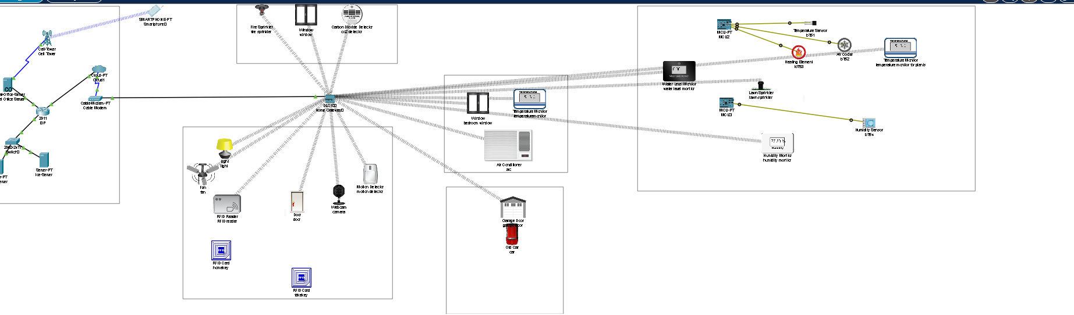

**Fig 3.6.1: - Smart home architecture**

**3.5.1 Device configuration**

**Assigning hostname and Ip address for ISP router**

Router>

Router>enable

Router#conf term

Router#int g0/0

Router#ip address 10.0.0.1 255.255.255.0

Router#no shutdown

Router#int g0/2

Router#ip address 209.165.201.225 255.255.255.224

Router#no shutdown

Router#int g0/1

Router#ip address 209.165.200.225 255.255.255.224

Router#no shutdown

Router#exit

Configuring dhcp server for cell and Home Gateway:

dhcp server for cell

Router#ip dhcp excluded-address 20.165.201.225 209.165.201.229

Router#ip dhcp pool CELL

Router#network 209.165.201.224 255.255.255.224

Router#default-router 209.165.201.225

**Smart Home Automation and Crop Monitoring Using Cisco Packet Tracer**

Router#dns-server 10.0.0.254

Router#exit

Router#ip dhcp excluded-address 209.165.200.225 209.165.201.229

Router#ip dhcp pool WAN

Router#network 209.165.200.224 255.255.255.224

Router#default-routrt 209.165.200.225

Router#dns-server 10.0.0.254

Router#exit

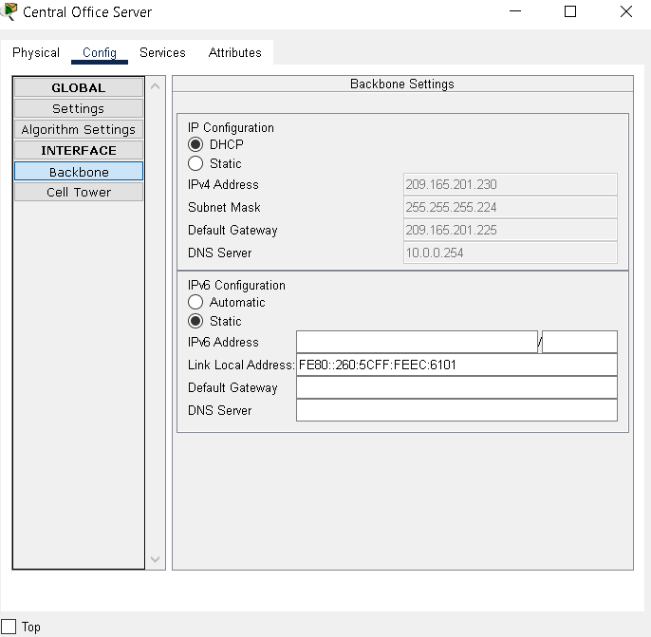 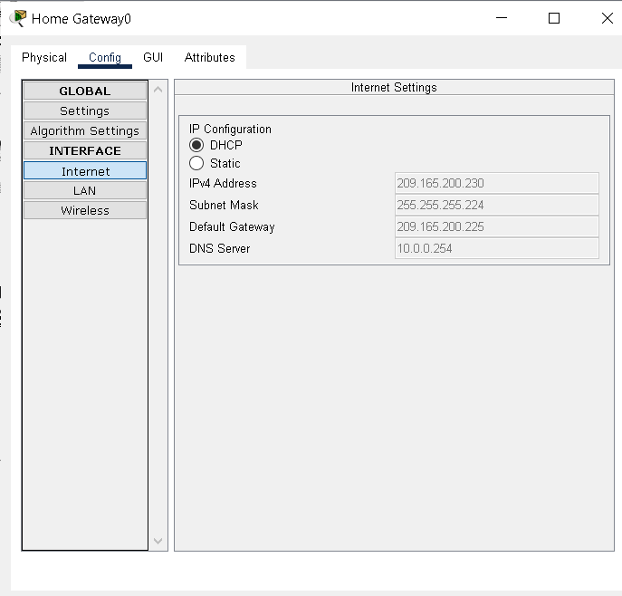

**Fig 3.6.2.1: - ISP server provides IP Fig 3.6.2.2: -ISP server provides IP address to Central office server address to home gateway**

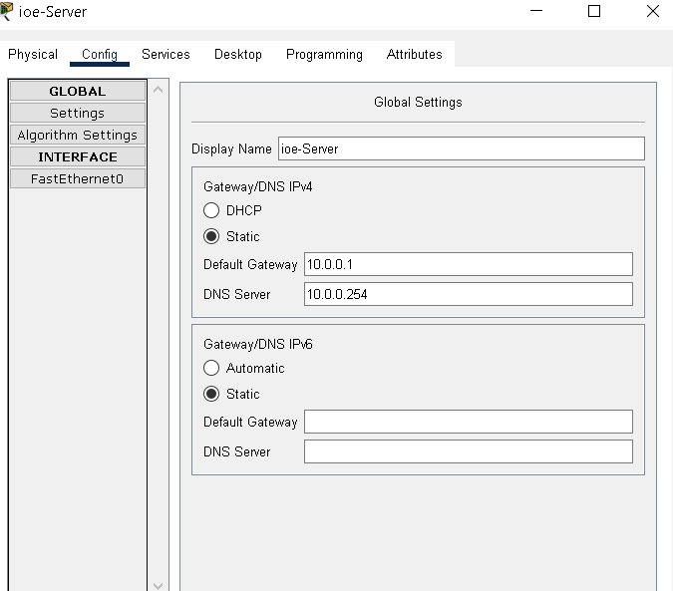

**Fig 3.6.2.3: - IP configuration of IoT server**

**3.5.2 Connect all IOT devices**

Steps for connecting IoT devices with home gateway wireless:

Step 1: Click on the IOT device.

Step 2: Go to advanced setting.

**Smart Home Automation and Crop Monitoring Using Cisco Packet Tracer**

Step 3: Go to the I/O config

Step 4: Select PT-IOT-NM-1W (for wireless connection).

Step 5: Go to config.

Step 6: Select wireless (in wireless connection).

Step 7: Enter passkey of the WIFI network.



**Fig 3.6.3: - connection of devices through home gateway**

**3.5.3 Register all IOT devices in IoT server**

Steps for registering IoT devices in IoT server:

Step 1: Click on the IoT devices.

Step 2: Click on the config.

Step 3: Enter IOT server IP address, username, and password.



**.Fig 3.6.4: - Registration of IOT devices to IOT server**

**3.5.4 Enable DNS services like HTTP, DNS**

Steps for enabling DNS services like HTTP, DNS:

Step 1: Click on the DNS server.

Step 2: Click on the service.

Step 3: Enable different services like HTTP, DNS etc.

**Smart Home Automation and Crop Monitoring Using Cisco Packet Tracer**

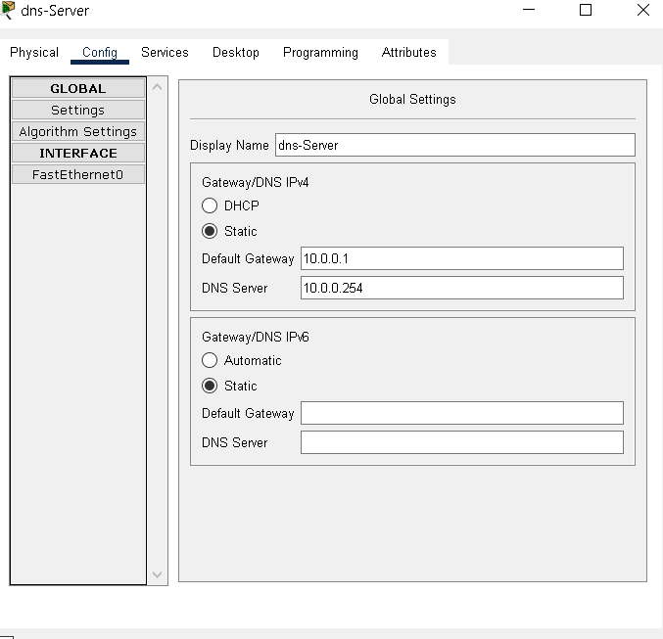

**Fig 3.6.3: - Assigning IP address to DNS server**

Steps for assigning IP address to DNS server statically:

Step 1: Click on the IoT server.

Step 2: Click on the config.

Step 3: Select static.

Step 4: Assign IP address to IoT server

**3.5.5 Monitoring and controlling IoT devices through remote devices**

Steps for controlling and monitoring IoT devices:

Step 1: Click on the remote device like smartphone, laptop, tablet or PC.

Step 2: Select IoT monitor application from the device desktop.

Step 3: Register if new user and enter IP address and login credentials.

Step 4: Control and monitor your IoT devices.

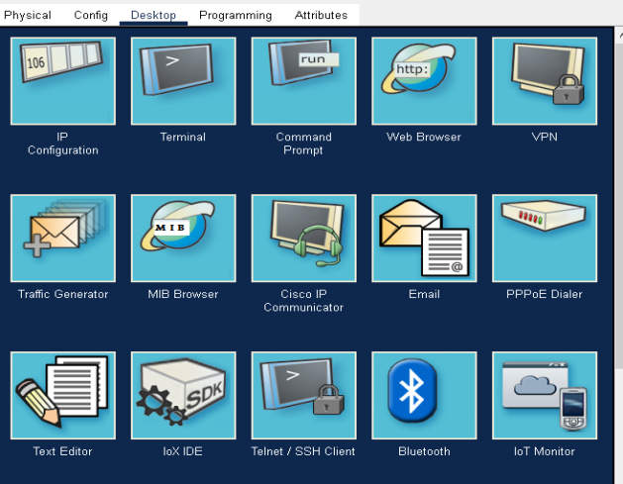 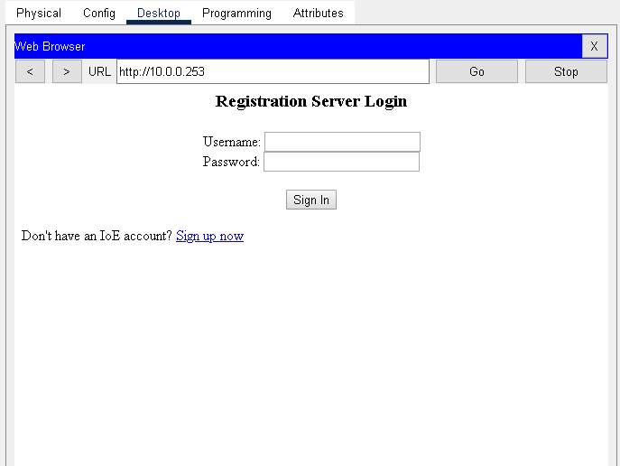

**Fig 3.6.6.1: - Applications on PC desktop Fig 3.6.6.2: - IOT server login through web browser**

**Smart Home Automation and Crop Monitoring Using Cisco Packet Tracer**

 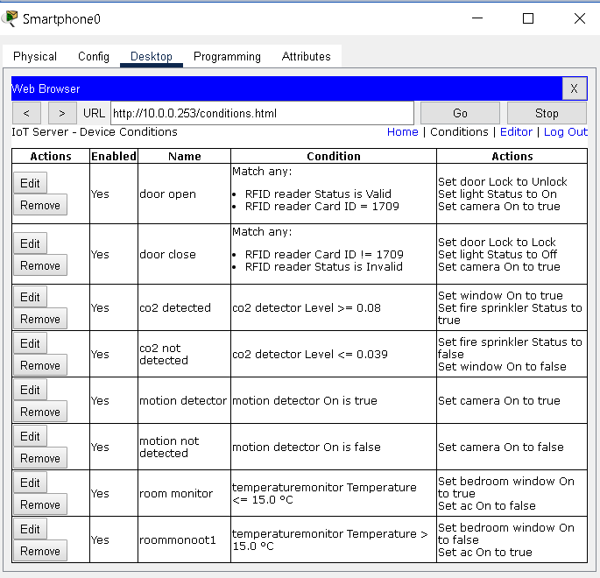

**Fig 3.6.6.3: - monitoring and controlling IOT devices Fig 3.6.6.4: - conditions for automation**

**3.6 List of components used for implementation**

|  |  |  |
| --- | --- | --- |
| **SL NO** | **Device** | **Function** |
| 1. | Central office server | Used for connecting cellular system to the router. |
| 2. | Router | Used to interconnect home with cellular network. |
| 3. | Cable modem | Used for connecting home with internet |
| 4. | IOT server | To control registered smart IOT device |
| 5. | End devices | Connect to home gateway to access smart objects |
| 6. | Home gateway | Used for registering and providing ip address for iot devices |
| 7. | Fan | Used for ventilation |
| 8. | Web cam | Records the environment |
| 9. | Light | Provide light |
| 10. | Motion detector | Detects a motion |
| 11. | Smart door | Connect to home gateway and provides function based event |
| 12. | Cell tower | Provide coverage for user to control home appliances from remote area |
| 13. | Co2 detector | Detects level of co2 in the kitchen |
| 14. | Water level monitor | Used for detection of water level |
| 15. | Lawn sprinkler | Used to sprinkle water |
| 16. | Temperature sensor | Used for sensing the temperature |
| 17. | Old car | Used to simulate different scenario in home design since it affect, co, co2 and smoke level |
| 18. | Air conditioner | Used to cool the room |
| 19. | Smart window | Controlling the window remotely |
| 20. | Humidifier | Controls humidity in the atmosphere |
| 21. | RFID reader | Read the ID of an RFID card |
| 22. | RFID card | Interacts with the RFID reader |

**Smart Home Automation and Crop Monitoring Using Cisco Packet Tracer**

**CHAPTER 4**

**RESULTS**

The smart home environment offers automation along with smart control and monitoring of smart devices:

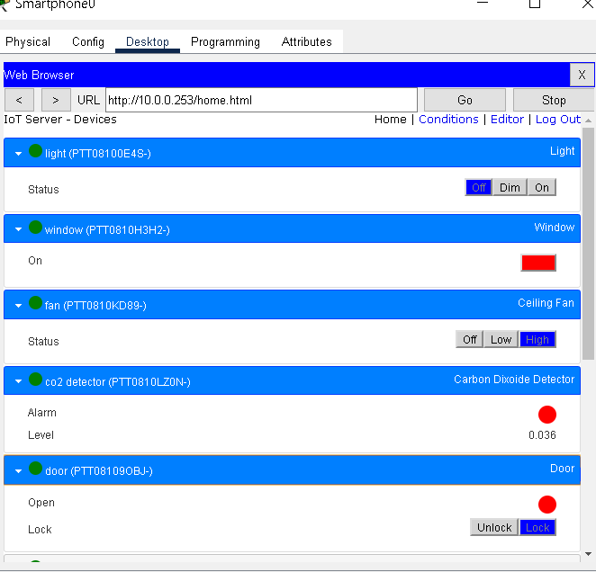

**Fig 4: - Monitoring and controlling smart devices**

**4.1 Lawn sprinklers automation .**

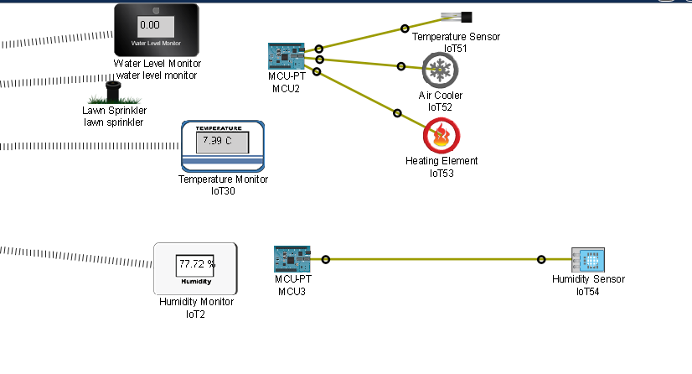

**Fig 4.1:- Irrigation Management**

The fig shows the lawn sprinkler is set to one based on the condition made on Home gateway that is if water level is more than 5 cm the lawn sprinkler on else off. If the humidity is less than 80% then set lawn sprinkler in on state.

**Smart Home Automation and Crop Monitoring Using Cisco Packet Tracer**

**4.2 Air Conditioner and Furnace are automated based on the temperature**

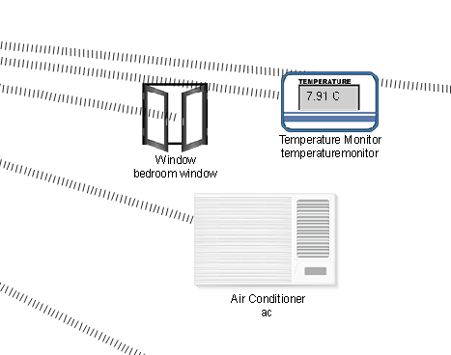

**Fig 4.2: - Automation of Air conditioner and Furnace based on the temperature**

In figure 4.2 when the living room temperature is above 200 C air conditioner is automatically power on and when the temperature is below 20 C furnace is switched on.

**4.3 RFID Based Door Lock and Unlock System**

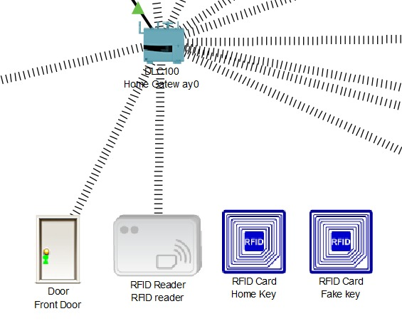

**Fig 4.3:- RFID Based Door Lock and Unlock System**

In this figure whenever we scan original home key to the RFID reader the door will open through communicating with reader and home gateway. If we scan fake id to reader then door will locked automatically and alert will given to the user.

**Smart Home Automation and Crop Monitoring Using Cisco Packet Tracer**

**4.4 Motion Detector**

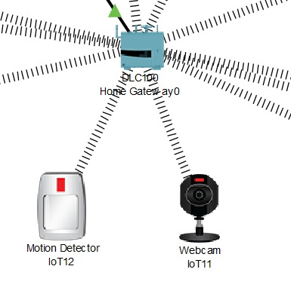

**Fig 4.4:- Motion Detector**

In this both of the devices wirelessly connected to the home gateway and whenever the motion is detected in the detector, motion detector will glow up and recording will start in camera. And if there is no any motion detected it will automatically get off and camera will on standby mode.

**4.5 Remotely Controlled Garage Door System**

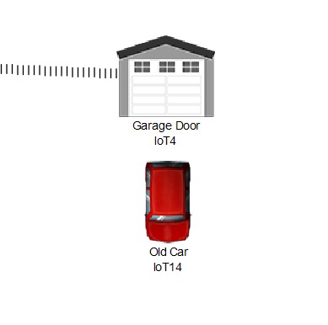

**Fig 4.5:-remotely controlled garage door system**

In this whenever the car comes above garage door the door will remotely open by the user by clicking open button in the smart phone application. And it can manage anywhere from faraway places.

**Smart Home Automation and Crop Monitoring Using Cisco Packet Tracer**

**4.6 Detection of Smoke by CO2 Detector**

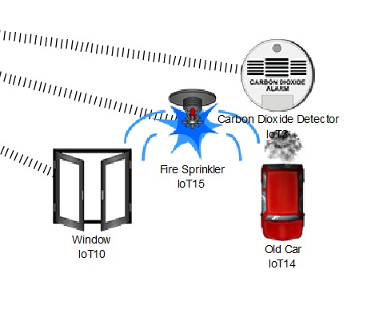

**Fig 4.6:- Detection of smoke by CO2 Detector**

In this working model this is the main part whenever there is fire in the house the co2 detector will detect the smoke and when it crosses above certain level it will start by opening the window and sprinkling the water from fire sprinkler. So when smoke crosses below that level then this will automatically switch off.

**Smart Home Automation and Crop Monitoring Using Cisco Packet Tracer**

**ADVANTAGES**

1. Managing all of your home devices from one place. The convenience factor here is enormous. Being able to keep all of the technology in your home connected through one interface is a massive step forward for technology and home management. Theoretically, all you’ll have to do is learn how to use one app on your smartphone and tablet, and you’ll be able to tap into countless functions and devices throughout your home. This cuts way back on the learning curve for new users, makes it easier to access the functionality you truly want for your home.
2. Flexibility for new devices and appliances. Smart home systems tend to be wonderfully flexible when it comes to the accommodation of new devices and appliances and other technology. No matter how state-of-the-art your appliances seem today, there will be newer, more impressive models developed as time goes on. Beyond that, you’ll probably add to your suite of devices as you replace the older ones or discover new technology to accompany your indoor and outdoor spaces. Being able to integrate these newcomers seamlessly will make your job as a homeowner much easier, and allow you to keep upgrading to the latest lifestyle technology.
3. Maximizing home security. When you incorporate security and surveillance features in your smart home network, your home security can skyrocket. There are tons of options here -- only a few dozen of which are currently being explored. For example, home automation systems can connect motion detectors, surveillance cameras, automated door locks, and other tangible security measures throughout your home so you can activate them from one mobile device before heading to bed. You can also choose to receive security alerts on your various devices depending on the time of day an alert goes off, and monitor activities in real-time whether you’re in the house or halfway around the globe.
4. Remote control of home functions. Don’t underestimate the power of being able to control your home’s functions from a distance. On an exceptionally hot day, you can order your house to become cooler in just enough time before you get home from work. If you’re in a hurry to get dinner started but you’re still at the store, you can have your oven start to preheat while you’re still on your way home. You can even check to see if you left the lights on, who is at your front door, or make sure you turned off all your media while you’re away.
5. Increased energy efficiency. Depending on how you use your smart-home technology, it’s possible to make your space more energy-efficient. For example, you can have more precise control over the heating and cooling of your home with a programmable smart thermostat that learns your schedule and temperature preferences, and then suggests the best energy efficient settings throughout the day. Lights and motorized shades can be programed to switch to an evening mode as the sun sets, or lights can turn on and off automatically when you enter or leave the room, so you never have to worry about wasting energy.
6. Improved appliance functionality. Smart homes can also help you run your appliances better. A smart TV will help you find better apps and channels to locate your favourite programming. A smart oven will assist you with cooking your chicken to perfection -- without ever worrying about overcooking or undercooking it. An intelligently designed home theatre and audio system can make managing your movie and music collection effortless when entertaining guests. Ultimately, connecting your appliances and other systems with automation technology will improve your appliance effectiveness and overall make your home life much easier and enjoyable!

**Smart Home Automation and Crop Monitoring Using Cisco Packet Tracer**

1. Home management insights. There’s also something to be said for your ability to tap into insights on how your home operates. You can monitor how often you watch TV (and what you watch), what kind of meals you cook in your oven, the type of foods you keep in your refrigerator, and your energy consumption habits over time. From these insights, you may be able to analyse your daily habits and behaviours, and make adjustments to live the lifestyle you desire.
2. The sheer amount of consumer interest generated by smart home technology means the world’s biggest tech companies and innovators have entered a race to outdo one another. That means bigger, better smart home tech is constantly being developed to match our digital needs and the industry is on a tremendous upward trajectory.
3. Convenience is one of the biggest reasons that people build and purchase smart homes. These homes give users remote access to systems including heating and cooling systems, intercoms, music and multimedia devices throughout the home. Integrated hard drives allow homeowners to watch video or listen to audio in any room; video intercoms make it easy to communicate with others in the home or visitors at the door. All of these smart home technologies streamline common tasks.
4. Smart homes include advanced security systems with cameras, motion sensors and a link to the local police station or a private security company. Smart homes may also use key cards or fingerprint identification in place of conventional locks, making it harder for someone to break in.
5. Smart homes offer enhanced energy-efficiency. Lights can shut off automatically when no one is in a room, and the thermostat can be set to let the indoor temperature drop during the day before returning it to a more comfortable level just before residents arrive in the evening. All of these automated tasks, along with modern, energy-efficient appliances, combine to save on electricity, water and natural gas, thereby reducing the strain on natural resources.
6. When it comes time to sell a smart home, sellers will have an abundance of effective selling points. Whichever advantage of a smart home appeals to a given buyer, the seller can explain the system and discuss how it makes life easier. Homes with automated systems have the potential to sell for much more than comparable homes with conventional technologies. Automating a home can be a worthwhile investment in increasing its market value and attracting possible buyers in the future.

**Smart Home Automation and Crop Monitoring Using Cisco Packet Tracer**

**APPLICATIONS**

* Home automation technology is growing drastically and its demand is increasing in a wide range of sectors which results in: - Increase in enhanced performance, it enhances human comfort, it improves energy efficiency of the room.
* It is used to assist in growing of agricultural crops, maintenance of landscapes, and revegetation of disturbed soils in dry areas and during periods of inadequate rainfall.
* By using CISCO packet tracers in home Automation and crop Monitoring it benifts in a relastic simulation and visualiztion of IOT devices.
* CISCO packet tracers provides two operating modes to visulaze the behaviour of a network i.e.s real time mode and simulation mode.
* The real time mode gives a variable alternative to real equipment and allows them to gain configuration practice before working with real equpiment.
* In simulation mode the user see and control time intervals working of data transfer and propagation of data across a network.
* Permits users to design , build, configure smart home, smart city by providing smart objects use for them. Provide board to control smart object Provide detector for sensor for crop monitoring.

**Smart Home Automation and Crop Monitoring Using Cisco Packet Tracer**

**CONCLUSION**

The main aim of this project was to design and implement IoT based home automation and crop monitoring system. The motivation behind the work is due to the innovative technology and hike in smart device usage. The security measures are very expository and IoT technology makes our surroundings more smart. In this project cisco packet tracer is utilized provides various opportunities for making simulation easy. The netcad sessions and previous research analysis are very beneficial for the implementation process of smart home. From the outcome of the project we can convey that the IoT devices can be monitored and controlled through end devices of the user and there is a chance to apply this smart home model in real life. Cisco packet tracer also includes microcontroller that can be used to make communication between devices. We can use python or java script language to program the microcontroller, in this way if a microcontroller is used in the IOE system then work will be more faster and reliable.

**Smart Home Automation and Crop Monitoring Using Cisco Packet Tracer**

**REFERENCES**

1. Tanishka and Prof. Shikha Gupta, “Designing Smart Home (IOT) Using Cisco Packet Tracer 7.2 Simulator”, International Journal for Modern Trends in Science and Technology, 6(12): 208-218, 2020.
2. IMPLEMENTING SMART HOME USING CISCO PACKET TRACER SIMULATOR” by Isa Shemsi CSE Department, SIT, Symbiosis International University, Pune, India.
3. “Designing Smart Home Using Cisco Packet Tracer 7.2 Simulator” by Pitcheri Praveen Kumar, Murali Krishna, MR Ramprakash, Assistant Professor Department of Electronics and Communication Engineering Anurag Group of Institutions.
4. “Implementation Of Smart Home by Using Packet Tracer” by G.L.P Ashok & P. Saleem Akram are currently working as Asst. Professors and M. Sai Neelima, J. Nagasaikumar, A.Vamshi are Graduate Students in ECE Dept., at KONERU LAKSHMAIAH EDUCATION FOUNDATION, Vaddeswaram, Guntur (D.T), A.P, INDIA.
5. “DESIGN AND ANALYSIS OF SECURE SMART HOME FOR ELDERLY PEOPLE“Mayada Elsaid, Sara Altuwaijri, Nouf Aljammaz and Anees Ara Computer Science Department, College of Computer & Information Sciences, Prince Sultan University, Riyadh, Saudi Arabia.
6. “A Security Framework for IOT based Smart Home Automation System” By Nazmul Hossain, Md. Alam Hossain, Rafia Sultana & Farzana Akter Lima Assistant Professor, Department of Computer Science & Engineering, Jessore University of Science & Technology (JUST), Jessore-7408, Bangladesh.
7. “Agricultural Crop Monitoring Sensors using” IoT-A Study Kavitha B C, Shilpa D P, Thanushree K S, Swathi A M, Ranjitha M K Dept of ECE, BGSIT, BG Nagar, Karnataka.
8. “Internet-of-Things (IoT) based Smart Agriculture: Towards Making the Fields Talk” Muhammad Ayaz1 (Senior Member, IEEE), Mohammad Ammad-uddin1 (Senior Member, IEEE), Zubair Sharif2, Ali Mansour3 (Senior Member, IEEE), and el-Hadi M. Aggoune1 (Senior Member, IEEE) 1Sensor Networks and Cellular Systems Research Centres, University of Tabuk, Tabuk 71491, Saudi Arabia 2CS Department, COMSATS University Islamabad, Sahiwal, Pakistan 3Lab STICC, UMR 6285 CNRS, ENSTA Bretagne, 2, Rue F. Verny, 29806, Brest Cedex 9, France Corresponding author: Muhammad Ayaz (e-mail: ayazsharif@ut.edu.sa). This work was supported in part by the SNCS Research Center and in part by the Deanship of Scientific Research at The University of Tabuk, Tabuk, Saudi Arabia.