**Ansible and Jenkins integration**

**Create two VMs instance in google cloud and install the Jenkins and Ansible respectively.**



**Detail ssh connection document is available in the below**: To connect the ansible and Jenkins server.



**Ansible Installation**:

#1. Run the below command from root user:

sudo -i

rpm -Uvh https://dl.fedoraproject.org/pub/epel/epel-release-latest-7.noarch.rpm

#2. Install Ansible: yum install -y ansible

yum install -y ansible

#Check the ansible version

echo" Output:

ansible --version

#Ansible installed at the location --> /etc/Ansible

**Jenkins installation with Tomcat server**:

**Java is the pre-requisite for Jenkins**

**Below is the document to install Java, Jenkins, Tomcat, Git, Maven. Just open the document and select all and copy paste it in your VM and it will install all the required tools.**



**Tomcat and Jenkins setup:**



**Once you installed the Jenkins we need to configure the tools in global section**:



Below section describes the sample playbook creation process and access SNOW module.

**Pre-requisites before access the service now module creation:**

**Python version 3 is mandatory for SNOW module.**

**Python3 installation in red hat**:

sudo yum -y install <https://centos7.iuscommunity.org/ius-release.rpm>

sudo yum -y install python36u

alias python="/usr/bin/python3.6" # to change the default version of python.

pynow module is required to connect the SNOW instance link and execute the below steps.

**pynow module installation:**

pip install --upgrade pip

yum install pip

pip install pysnow

python –version

**SNOW instance creation**

**Creating SNOW instance**: Follow the below procedures.

<https://developer.servicenow.com>

first time login users can see below picture to create a snow instance:

Click the manage menu and select the instance below: It will give you a developer snow instance for you to manage the portal:

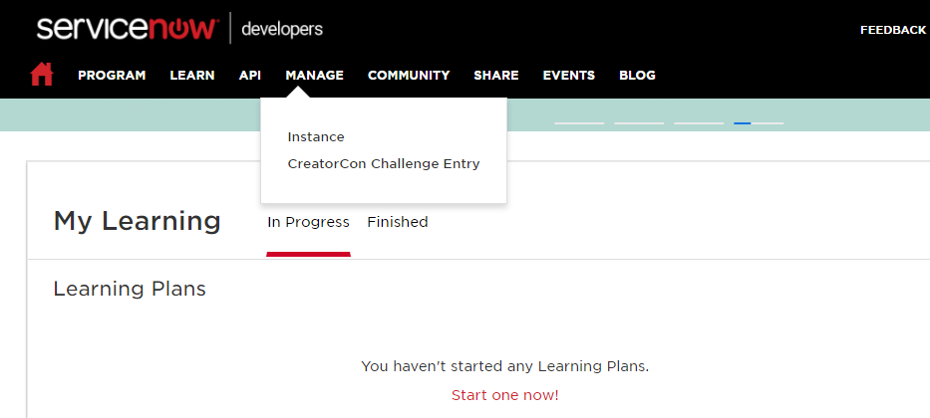

if the snow instance is already created you can see the below picture:

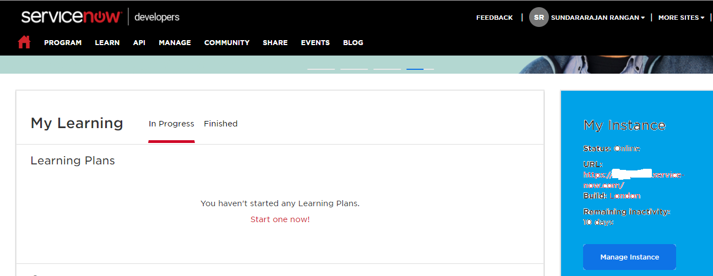

We will get the unique server instance to access the SNOW.

Service now requirements

Ansible playbook:

**Step 1**: Before you create a Ansible playbook check the python version.

**Step 2**: SNOW module will work only in python version 3 and above.

**Step 3**: Provide the alias name for the latest installed python like below.

alias python="/usr/bin/python3.6"

**Step 4**: Run python in the command VM command prompt and check if the latest version is being displayed.

Command prompt: python

**Step 5**: Create a playbook like below. [ex: vi create_change.yml] The file extension should be .yml ( YAML file)



**Step 5**: Execute the playbook.

ansible-playbook create_change.yml

**Step 6**: Check the developer SNOW instance the change would be created at the top.

Passing variable in our playbook and see the below example:

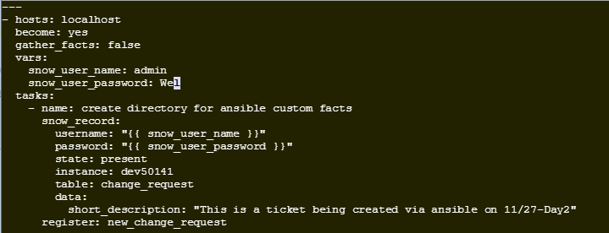

Using ansible-vault to encrypt the sensitive details in the playbook:

Follow is the example to encrypt the particular variable of string:

ansible-vault encrypt_string admin --ask-vault-pass

ansible-vault encrypt_string password --ask-vault-pass

Once you encrypted the fields and you have to copy the contents into your playbook as below:

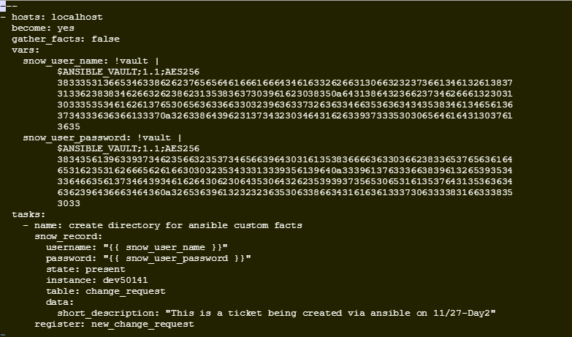

Run the playbook using –ask-vault-pass as below:

ansible-playbook test_var.yml --ask-vault-pass