Playbook:



CSV File creation

Copy the excel file value and paste in the csv extension file

vi file.csv

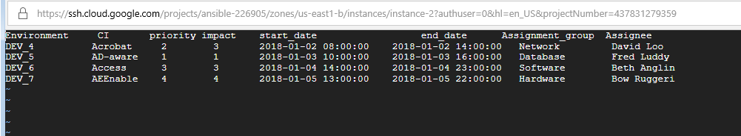

**Parameters Passed to playbook from csv file**

Environment

Configuration item

Priority

Impact

Planned start date(Date & Time)

Planned end date(Date & Time)

Assignment group

Assigned to

**Pre-check for Time zone:**

In Order to set the right date and time in the service now CHG #, Make sure you have the same time zone Set in the google cloud instance as well as in the Service now.

In the **Google Cloud instance** print the date command and find out the timezone



**Servicenow:**

And set GMT time Zone in Service now System Settings.

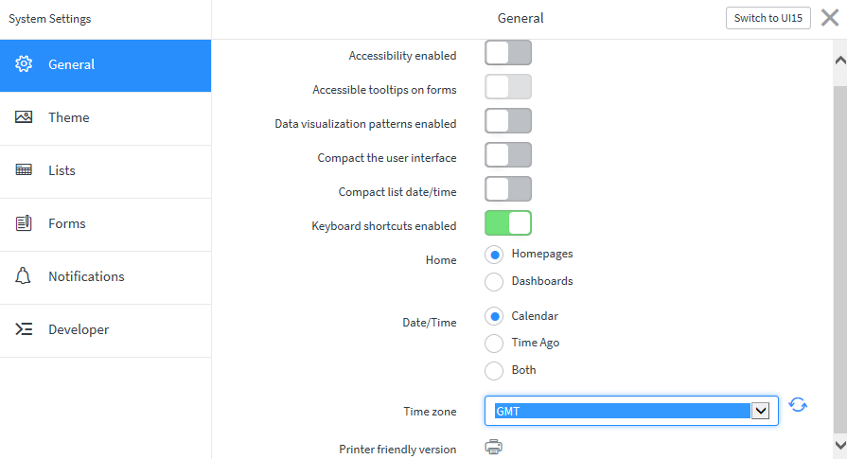

**Run the playbook**

ansible-playbook service.yaml

4 changes have been created in snow.

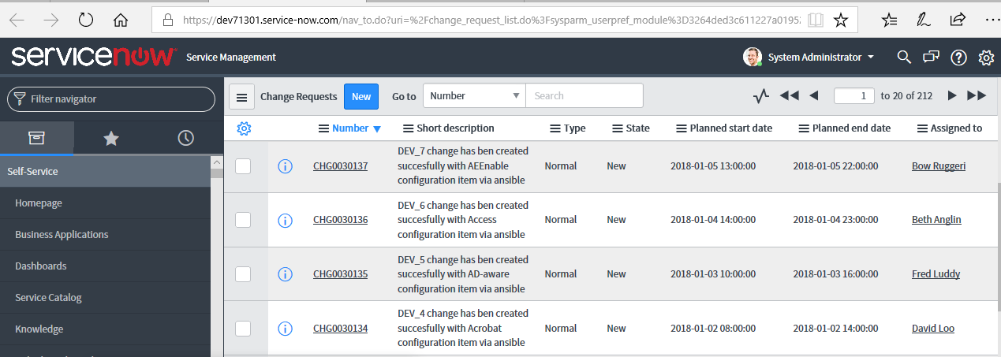

And defined parameters passed to change.

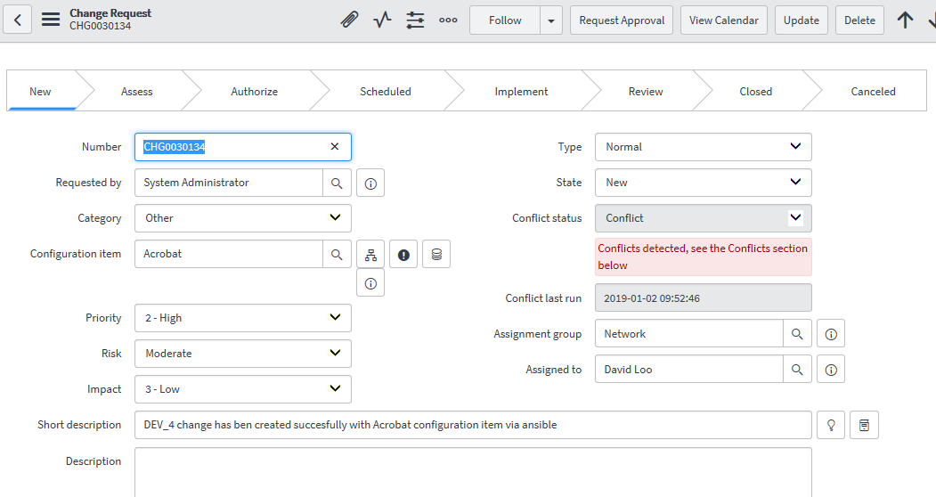

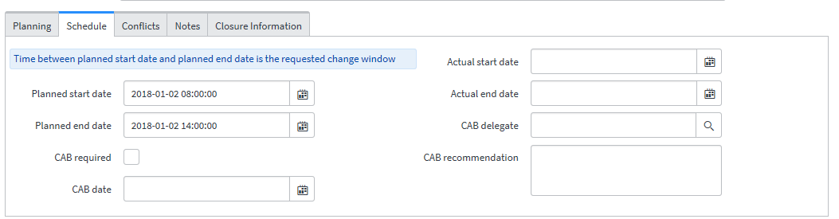

**Playbook screenshots**

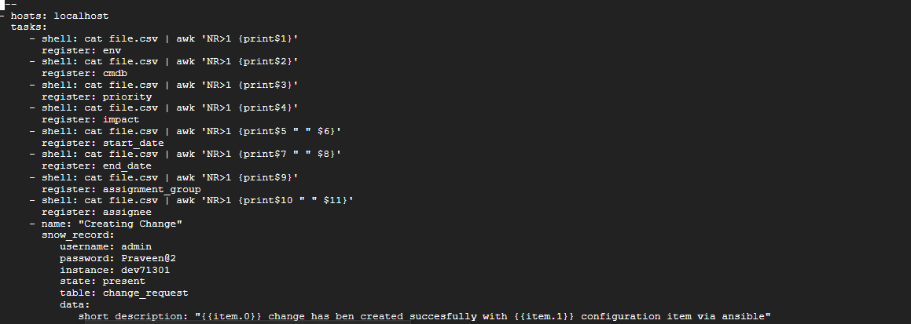

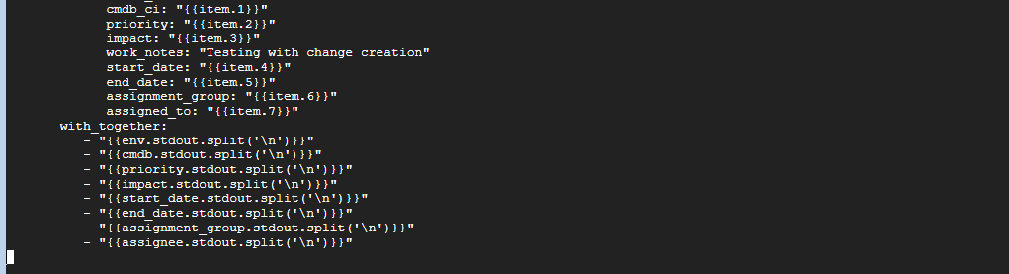

File.csv

