NAME: - A. VARDHAN REDDY

ID NUMBER: - 2100032328

COURSE – 1 :- (LINKEDIN)

Getting Started with Network Administration

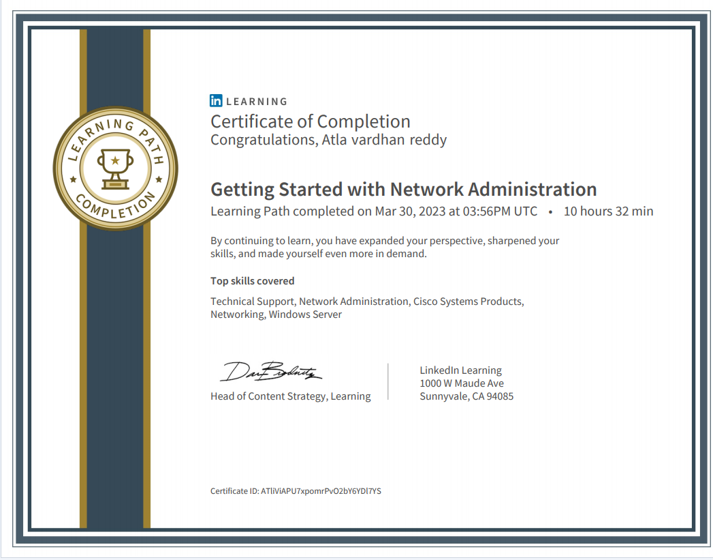

COURSE – 2: - COURSERA

THE BITS AND BYTES OF COMPUTER NETWORK

COURSE – 3: -

INTRODUCTION TO NETWORKS

