Audience Sensitivity, Content Compliance & Format Preference
Analysis of the France Top 50 Playlist
Research paper prepared for Atlantic Recording Corporation | Data: 2024-05-18 to 2025-11-27 | 27,750 chart slots, 725 unique tracks

Abstract
We analyse 27,750 daily chart slots from the France Top 50 playlist (2024-05-18 to 2025-11-27) to understand how explicit content, release format, album size and song duration relate to chart performance. Contrary to the common view of France as a content-sensitive market, explicit tracks hold 56.3% of all slots and 63.0% of the Top 10. The picture is more nuanced once performance is considered: clean tracks score higher on popularity (80.9 vs 73.7) and stay on the chart longer (49 vs 33 days on average per track). Album tracks take slightly more slots than singles (single-to-album-track ratio 0.89), but singles are more popular (80.8 vs 73.3), over-index at the top of the chart, and last more than twice as long. Track popularity falls steadily as releases get bigger (Album Size Impact Index 91; releases of 18+ tracks average 71.2 vs 80.9 for singles). Duration is essentially neutral for rank (Spearman rho = 0.008); the average chart track lasts 3.09 minutes. We close with recommendations on release format, explicit-content management, album sizing and playlist pitching.

1. Background and objectives
France is often described as a market that is sensitive to lyrical content, more critical of explicit material, oriented toward structured album formats and loyal to artist catalogues. For Atlantic Recording Corporation, the practical questions are how to set release formats, how to manage explicit-content risk, how to pitch to playlists and how to localise global releases. Atlantic has daily France Top 50 snapshots but no consolidated view of how content attributes relate to chart performance. This paper addresses four questions:
- How does explicit content perform relative to clean content?
- Do French charts favour singles or album tracks?
- How does song duration align with listener acceptance?
- Do larger albums dilute or strengthen individual-track performance?

2. Data and method

2.1 Dataset
The file contains 27,800 rows with ten fields (date, position, song, artist, popularity, duration_ms, album_type, total_tracks, is_explicit, album_cover_url). Each row is one track in one daily snapshot, so a track that stays on the chart for 100 days appears 100 times. Unless stated otherwise, shares and averages are therefore chart-slot weighted (they describe what listeners see on the chart on a typical day), and we also report unique-track views where the distinction matters.

2.2 Validation and preparation
Check | Finding | Action
Fifty entries per day | 554 of 555 days have exactly 50. 1-Mar-2025 has 100 rows (two copies of the snapshot). | Kept first record per date and position: 27,750 rows.
Date coverage | 555 snapshot days across 559 calendar days. Missing: 2025-03-14, 2025-03-25, 2025-07-11, 2025-08-13. | Left as gaps; no interpolation.
Date format | Stored as dd-mm-yyyy text. | Parsed to dates.
Duration | Milliseconds; 1 row with duration 0. | Converted to minutes; zero excluded from duration statistics.
Album type labels | album / single / compilation (9 compilation rows, all Christmas or Halloween compilations). | Title-cased; compilations treated as album-type for the single vs album-track split.
Explicit flag consistency | 5 tracks carry different flags on different days (97 rows). | Majority flag applied so each track has one status.
Missing values | 1 missing song title; 73 rows with popularity 0 (treated as not-reported). | Title set to '(unknown)'; popularity 0 excluded from popularity statistics.

2.3 Derived fields and definitions
- Duration buckets: Short (<2:30), Medium (2:30 to 3:30), Long (>3:30).
- Release size buckets (total_tracks): Single (1), EP/short (2-7), Standard (8-12), Full album (13-17), Deluxe/large (18+).
- Rank tiers: Top 10, Top 25 and Top 50 (cumulative, so Top 50 is the whole playlist).
- Statistics: Mann-Whitney U tests for popularity differences, Spearman rank correlations, and a chi-square test for tier differences in explicit share. With ~27,000 observations nearly any difference is 'significant', so we focus on effect sizes.

3. Findings

3.1 Explicit content sensitivity
Explicit tracks are the majority of the France Top 50: 56.3% of slots, a clean-to-explicit ratio of 0.78. Explicit share rises toward the top of the chart: 63.0% in the Top 10 versus 57.8% in the Top 25 and 56.3% across all 50 (Top 10 vs the rest, chi-square p < 0.001). Position 3 is the most explicit slot at 73%.
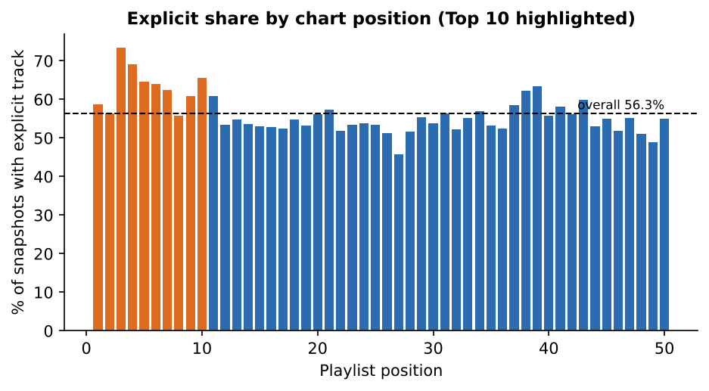
Figure 1. Share of daily snapshots in which each chart position holds an explicit track.
Popularity tells a different story. Clean tracks average 80.9 on the popularity score and explicit tracks 73.7 (a 7-point gap, p < 0.001), and the gap persists in every tier (Top 10: 82.0 vs 76.4). Explicit tracks nonetheless enter the chart at least as high: their average position is 24.9 versus 26.2 for clean tracks. The reconciliation is turnover. Explicit tracks make up 65.8% of unique tracks but only 56.3% of slots, because they leave sooner: the average explicit track stays 33 days (median 7) versus 49 days (median 13.5) for clean tracks.
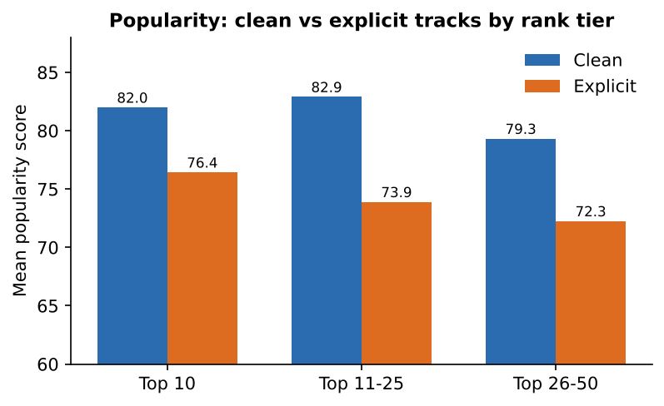
Figure 2. Mean popularity of clean and explicit tracks by rank tier.
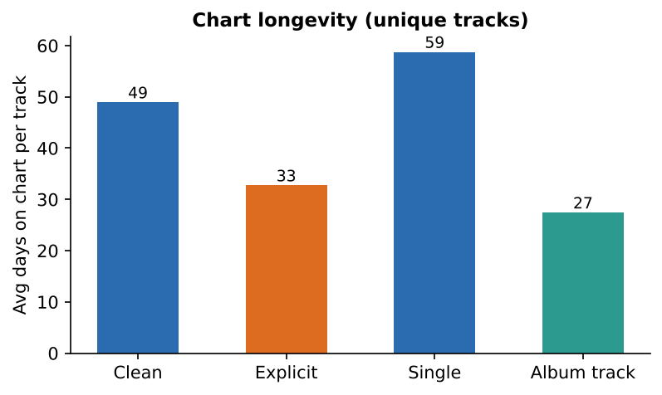
Figure 3. Average days on chart per unique track (explicit vs clean, single vs album track).
The share is also not static. Monthly explicit share ranged from 44% (Jul 2025) to 67% (Oct 2024), with a clear dip through spring and summer 2025 and a rebound in autumn 2025, which suggests that seasonal and release-calendar effects matter as much as any stable preference.
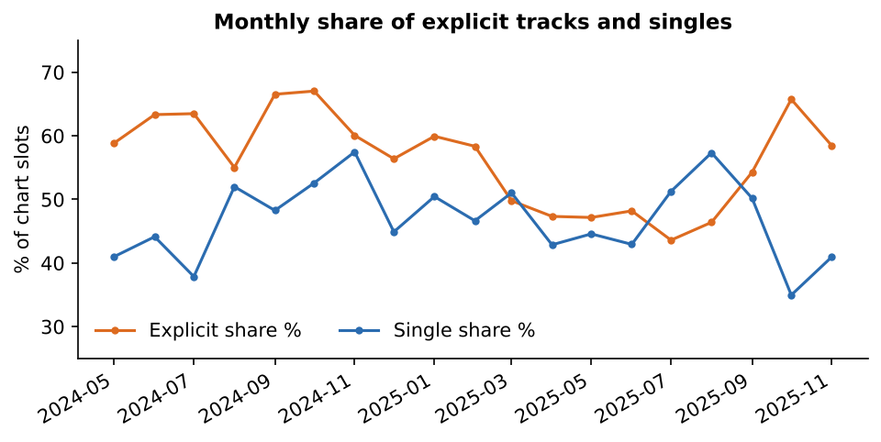
Figure 4. Monthly share of explicit tracks and of singles in the Top 50.

3.2 Release format preference
Singles account for 47.1% of slots and album tracks for 52.9% (ratio 0.89). The split is close to even and flips at the top: singles are 50.8% of the Top 10. Singles are also more popular (80.8 vs 73.3) and have a rank-weighted Content Acceptance Score of 105 (album tracks 95).
Looking at unique tracks, singles are only 34.6% of the catalogue that reaches the chart, but they stay on it for 59 days on average versus 27 for album tracks. Album releases therefore produce many short-lived chart entries, whereas singles produce fewer, longer-lived ones.
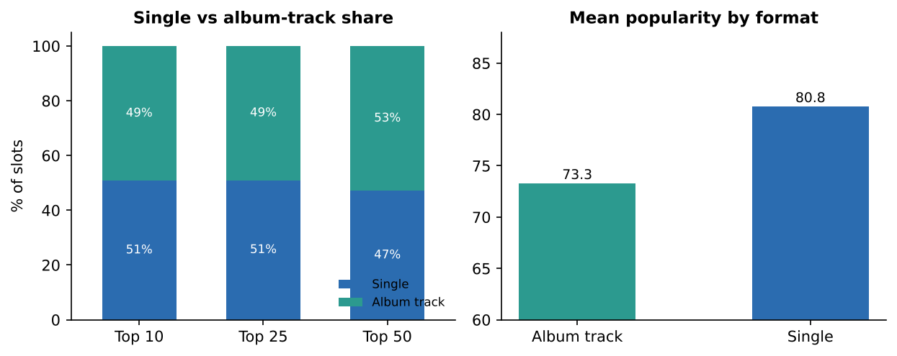
Figure 5. Format mix by rank tier (left) and mean popularity by format (right).
Combining the two flags shows the dominant profile clearly:
Profile | Share of slots | Avg position | Avg popularity
Explicit album track | 38.3% | 26.1 | 71.9
Clean single | 29.1% | 25.1 | 82.9
Explicit single | 18.0% | 22.6 | 77.4
Clean album track | 14.6% | 28.5 | 77.0

Explicit album tracks fill the most slots (typically rap albums with several simultaneous entries), while clean singles score best on popularity and explicit singles sit highest on the chart (average position 22.6).

3.3 Album structure impact
Releases of one track (singles) occupy 40.8% of slots, full albums of 13 to 17 tracks 27.6%, and deluxe-size releases of 18+ tracks 12.3%. Popularity declines monotonically with release size, from 80.9 for singles to 78.5, 76.1, 73.3 and 71.2; average chart position worsens from 23.6 to 29.0. Across all tracks the Spearman correlation between release size and popularity is -0.35; restricted to album tracks it is still negative (-0.11). The Album Size Impact Index (popularity of tracks from releases with more than 10 tracks divided by those with 10 or fewer, x100) is 91.
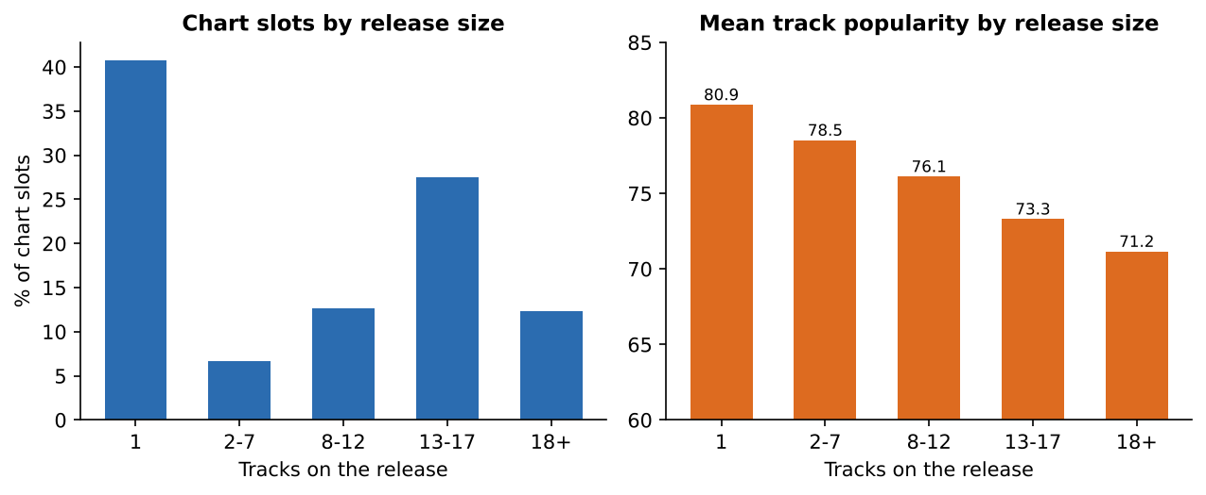
Figure 6. Chart slots (left) and mean track popularity (right) by release size.
Interpretation: large releases produce more chart entries but each entry is weaker. This is consistent with dilution, where listening is spread across many tracks, rather than concentration on a few. It is an association, not proof of causation: big deluxe editions are also released by artists whose catalogues chart together, and new tracks are most popular in their first days.

3.4 Song duration preference
Chart tracks are tightly clustered around three minutes: mean 3.09 minutes, median 3.00. By bucket, 12.9% of slots are Short, 63.6% Medium and 23.5% Long. Duration has no measurable relationship with rank (Spearman rho = 0.008, p = 0.19) and only a weak positive one with popularity (rho = 0.10); Long tracks average 79.1 popularity versus 75.9 for Medium.
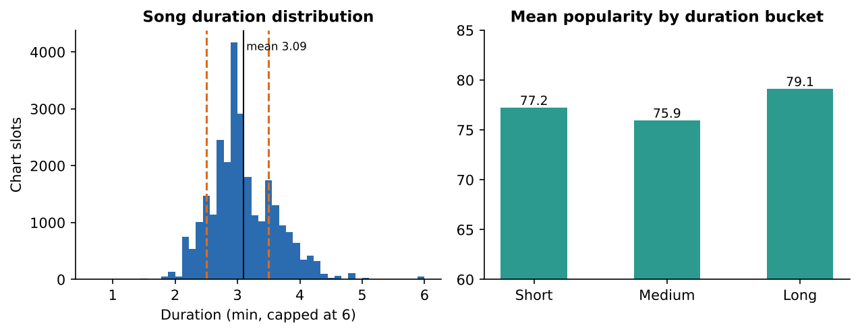
Figure 7. Duration distribution (dashed lines mark the bucket cut-offs) and popularity by duration bucket.
Explicit tracks are slightly longer than clean tracks (3.13 vs 3.04 minutes) and singles slightly shorter than album tracks (3.02 vs 3.16). Length is a structural norm in this market rather than a lever for acceptance.

3.5 Content attribute concentration
Attribute density across tiers shows where content preferences become sharper toward the top of the chart.
Tier | Explicit | Single | Avg duration (min) | Avg release size | Avg popularity
Top 10 | 63.0% | 50.8% | 3.09 | 8.0 | 78.5
Top 25 | 57.8% | 51.0% | 3.08 | 8.2 | 78.2
Top 50 | 56.3% | 47.1% | 3.09 | 9.0 | 76.8

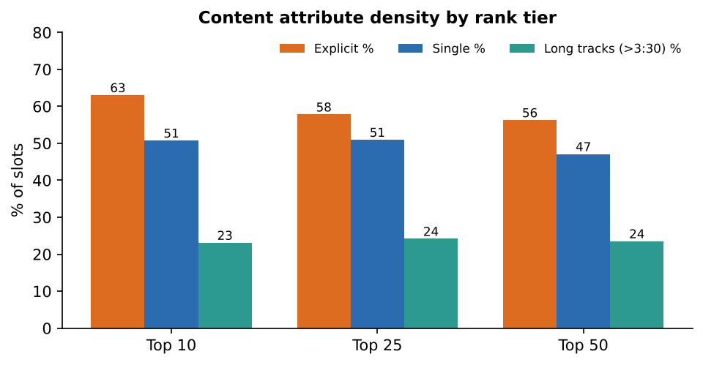
Figure 8. Explicit share, single share and long-track share by rank tier.
The tiers differ mainly on explicit content (+7 points in the Top 10) and, to a lesser degree, release size (the Top 10 averages 8.0 tracks per release versus 9.0 for the Top 50). Duration mix is almost identical across tiers. The preferred content profiles in the Top 10, as a share of Top 10 slots, are:
Content profile (Top 10) | Share
Explicit | Album track | Medium (2:30-3:30) | 29.0%
Clean | Single | Medium (2:30-3:30) | 21.3%
Explicit | Single | Long (>3:30) | 12.0%
Explicit | Single | Medium (2:30-3:30) | 9.0%
Explicit | Album track | Long (>3:30) | 7.1%
Clean | Album track | Medium (2:30-3:30) | 6.3%

The rank-weighted Content Acceptance Score (100 = neutral) is 102 for explicit and 97 for clean tracks, 105 for singles and 95 for album tracks, 107 for one-track releases against 86 for 18+ track releases, and between 98 and 100 across duration buckets.

4. Key performance indicators
KPI | Value | Reading
Explicit Content Share | 56.3% | Explicit is the majority; audience sensitivity is not visible as avoidance.
Clean Content Dominance Ratio | 0.78 | 0.78 clean tracks per explicit track; explicit leads on volume.
Single vs Album Track Ratio | 0.89 | Album tracks lead slightly overall; singles lead in the Top 10 (1.03).
Average Song Duration | 3.09 min | Tight three-minute norm; not a rank driver.
Album Size Impact Index | 91 | Below 100: tracks on larger releases are less popular (dilution).
Content Acceptance Score (explicit / clean / single) | 102 / 97 / 105 | Rank-weighted index; above 100 means over-represented in top positions.

5. Insights and recommendations

Insights
- Explicit content is mainstream, not a niche. It holds 56% of slots and 63% of the Top 10, so an explicit flag is not a barrier to chart success in France.
- Clean content is steadier. Clean tracks are more popular (81 vs 74) and last about 1.5x as long on the chart; explicit tracks are a faster-moving, higher-turnover segment.
- Singles are the stronger format per track. They over-index at the top, score higher on popularity and last more than twice as long as album tracks, even though album releases supply more total entries.
- Bigger releases dilute individual tracks. Popularity drops about 10 points from singles to 18+ track releases.
- Duration is neutral. Keep tracks near the three-minute norm but do not cut longer tracks for fear of rejection.
- The market moves seasonally. Explicit share swung between 44% and 67% across months.

Recommendations for Atlantic
- Release format: run single-led campaigns. Lead with one or two focus singles to build chart life, then release the album, and pitch two or three focus tracks rather than the whole tracklist.
- Explicit-content risk management: do not strip explicit content from rap and urban releases; it performs. Instead, prepare clean edits for playlists, radio and seasonal windows where clean content over-performs, and A/B test their effect on popularity and longevity (the data here is observational).
- Playlist pitching: target slots by profile. For Top 10 ambitions, explicit album-track and clean-single profiles are the two largest; for sustained presence, favour singles.
- Album sizing: keep standard releases in the 8 to 17 track range and treat deluxe expansions of 18+ tracks as catalogue extensions with their own focus-track promotion rather than as the primary release.
- Localisation of global releases: no duration edit is needed for France; spend localisation effort on content flags (clean versions) and release timing.
- Monitoring: use the accompanying Streamlit dashboard to track explicit share, format mix and the Content Acceptance Score by month and tier.

6. Limitations
- Chart presence reflects listening behaviour, not stated attitudes. The dataset cannot separate audience sensitivity from supply (how much explicit music is released) or from algorithmic exposure.
- Popularity is a platform score driven by recent streams, so it is partly mechanically related to rank and to newness; differences between groups should be read as associations.
- Explicit flags are track-level labels, not a measure of how explicit the lyrics are, and there is no lyrics, genre or artist-level data.
- Slot-weighted statistics are dominated by long-running tracks (the top three tracks appear 400+ days each). We report unique-track views alongside to limit this.
- About 18 months of data from one market; four days are missing and one duplicated snapshot was removed. Seasonality cannot be separated from year-on-year trends with this span.

7. Conclusion
The data does not support the idea that French listeners avoid explicit content: explicit tracks lead the Top 10. What it does support is a market that rewards focus. Singles last longer and score higher per track, large releases dilute individual tracks, and clean content is steadier even while explicit content leads on volume. A France-specific strategy should therefore combine single-led releases, compact albums, and a deliberate explicit/clean versioning plan rather than treating explicit content as a compliance problem to be removed.

Appendix: KPI definitions
KPI | Definition
Explicit Content Share | Explicit slots / all slots x 100.
Clean Content Dominance Ratio | Clean slots / explicit slots (above 1 means clean leads).
Single vs Album Track Ratio | Single slots / album-type slots (album + compilation).
Average Song Duration | Mean duration_ms / 60,000 over slots with a valid duration.
Album Size Impact Index | 100 x mean popularity of tracks on releases with more than 10 tracks / mean popularity of tracks on releases with 10 or fewer. Below 100 = dilution.
Content Acceptance Score | 100 x rank-weighted share / plain share of an attribute value, with weight (51 - position) / 50. Above 100 = over-represented near the top.

