**DAY – 1**

Classes are the advanced versions of Structures in C program.

C++ doesn’t have classes and only have objects. The problem is rectified in Java by using classes.

**Execution process:**

* The program is taken into java Compiler which in turn provides a byte code with a **.class** extension.
* The byte code is taken into respective JVMs i.e. Windows JVM or Mac JVM and the code output is

**Sandboxing:**

A Cloned copy of testing environment. Eg. Fire cracking with children. If there are any errors occurs in c program then it will directly impact effects in OS.

**Java Architecture:**

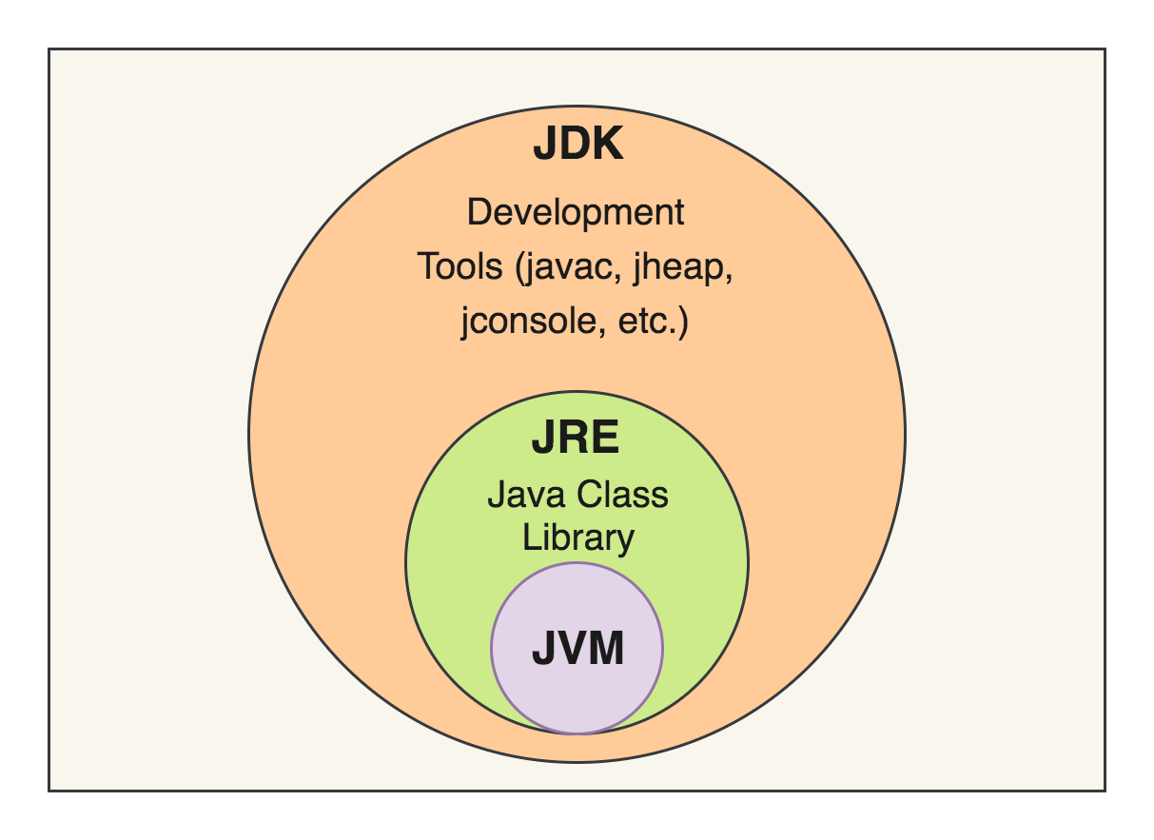

Kernel – An admin of an OS.

JVM uses JIT for fast compilation. Objects are taken into heap and stacks.

JDK is platform is dependent and java is platform independent since all the JDK platforms create the same type of byte code (.class files).

**Class and Objects:**

It contains the blueprint of the objects which usually have a state and behavior.

State usually don’t change often and is a noun. Eg., Age, Salary.

Behaviors may change often and is verbs. Eg., isActive()

Objects are the real world entities.

**Syntax:** Class obj1 = new Class();