Computer Graphics I- 3D Rendering web Application

Karthik Hubli, 01689129

ABSTRACT

The project is a web portal which allows a user to create a 3D object using either the coordinate system or by ‘drawing’ a 2 D version of the object and render the 3-D view of the same. The user will be able to apply 3D transformations to the created object. The application allows the user to view the created object from multiple views. Other features include the ability to change the position and intensity of light, generate different projections of the object and edit the perspective projection vanishing points. The application allows the user to create texture, environmental mappings for the object.

The application can be used to render a 3D view of any arbitrary object and analyze it quickly without having to install and run complicated and heavy applications. It is a simple way to do basic design of any 3D object.

Table of Contents

1. Introduction 1

2. Analysis and Design 1

3. Description 1

4. TeCHNOLOGY STACK 2

6. Limitation of the System 5

7. Conclusion and Future Work 5

8. Reference 5

Introduction
The application will be a web-based application utilizing webGL to render 3D images. Since it is completely online, the user need not install any software. The performance is independent of the user hardware. The application can be used to make initial models of complex 3D figures without much prior set-up. The application will provide various methods to input the 2D representations and will be highly flexible.

Analysis and Design

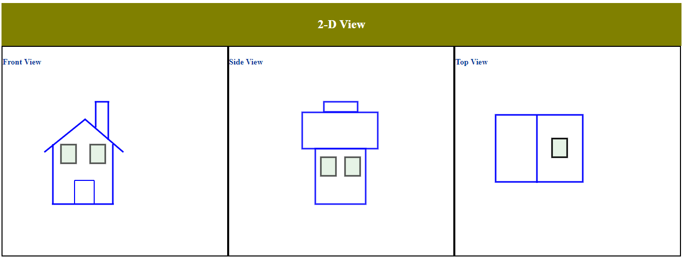

The user will enter the three 2D view of the object to be rendered. The above fig shows the initial layout of the application. The user can draw using the keypad/mouse etc or can enter the coordinated of the vertices. Once the user is satisfied with his representation of the 2D view, he can render the same in 3D and change various parameters like light, depth, material etc and view their effects.

Description

Technology Stack
4.1 HTML5/CSS3
4.2 WebGL
4.3 JavaScript

Limitation of the System

Conclusion and Future Work

Reference

