**Technical**

**MANUAL**

*3D view system*

**Revision Sheet**

|  |  |  |
| --- | --- | --- |
| **Release No.** | **Date** | **Revision Description** |
| Rev. 0 | 3/25/2018 | User Manual Template and Checklist |
|  |  |  |
|  |  |  |
|  |  |  |
|  |  |  |
|  |  |  |
|  |  |  |

**USER'S MANUAL**

**TABLE OF CONTENTS**

Page #

A. GENERAL INFORMATION A-1

B. SYSTEM SUMMARY B-1

C. GETTING STARTED C-1

D. USING the SYSTEM D-1

A. Appendix D-1

**1.0 GENERAL INFORMATION**

# GENERAL INFORMATION

**2.0 SYSTEM SUMMARY**

# SYSTEM SUMMARY

## 2.1 System Configuration

The makes use of javascript with webGL. The following items are required.

1. A modern web-browser (Chrome, FireFox,Safari, Edge, IE v10)
2. Enable javascript on your browser. Chick [here](https://www.enable-javascript.com/) for steps to enable javascript.

## 2.2 User Access Levels

**3.0 GETTING STARTED**

# GETTING STARTED

## 3.1 Logging On

## 3.2 System Menu

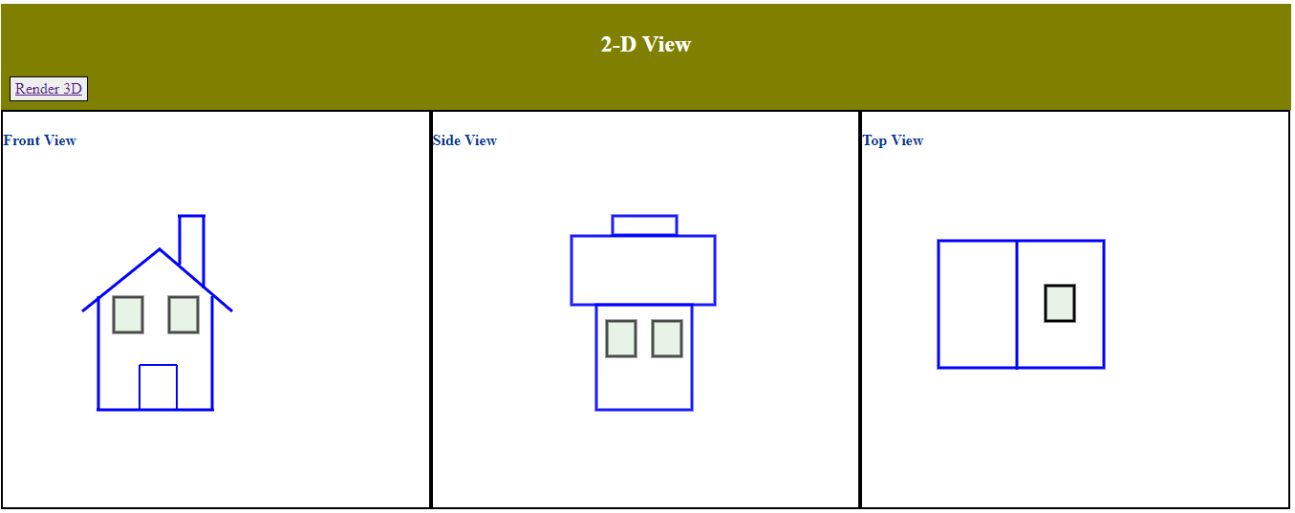

The home page consists of canvas to draw the 3 different 2-D views.

1. Draw/Input the desired 2-D views.
2. Click on ‘Render 3D’ to view the 3D view.

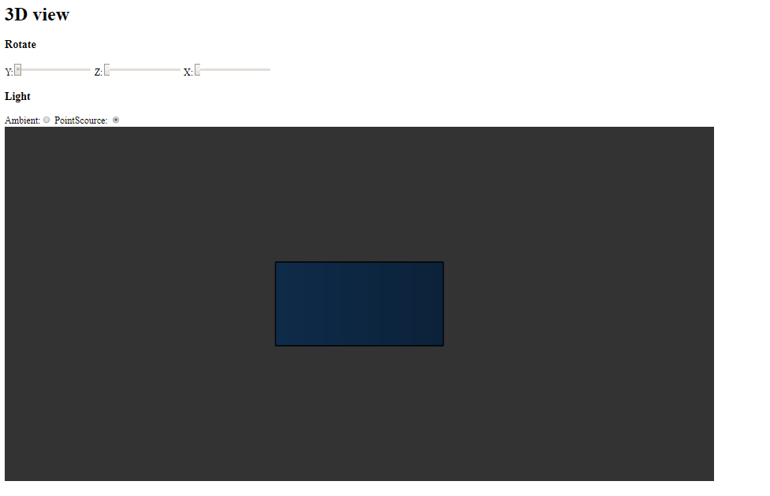

The 3D view page collects all the data from 2D view and renders a 3D version.

1. Use ‘Rotate X/Y/Z’ sliders to rotate and view different sides and edges of the 3D model.
2. Toggle between ambient light and point source light using the radio buttons ‘Ambient’ and ‘Point Source’. The point source light is placed on the right side of the 3D model.

## 3.4 Exit System

**4.0 USING THE SYSTEM**

# USING the SYSTEM

## Caveats and Exceptions

The services that iNiTech provides to you are subject to the following Terms of Use ("TOU"). iNiTech reserves the right to update the TOU at any time without notice to you. The most current version of the TOU can be reviewed by clicking on the "Terms of Use" hypertext link located at the bottom of Microsoft Connect Web pages

**10.0 APPENDIX**

# Appendix